AQA COMP4 Project Documentation

G-SIM

N-Body Gravitational Forces Simulator

James Middleton

Candidate Number: 7080

Center Name: Trent College

Center Number: 23240

Table of Contents

Table of Contents 2

Analysis 10

Background 10

Description of Current System 11

Identification of Prospective Users 13

Existing Alternative Systems 14

Example 1 14

Example 2 - Astra 15

Objectives Resulting From Existing Systems 16

Limitations 17

General 17

Specific 17

Objectives 18

The User’s Objectives 18

Resulting Objective List 21

Proposed Methods 22

Calculating Net Force 22

Using Net Force 25

Chosen Method 26

Data Flow Diagram 27

Data Dictionary 28

Data Volumes 30

Design 31

Overall System Design 31

Modular Design 32

Summary 32

Form Design 33

Exception Handling 43

Updates 44

Code Design 46

Design Data Dictionary 77

Main Form (Form/Class) 77

Changes (Shared Class) 80

Game Loop (Shared Class) 82

Trails (Shared Class) 84

Body (Class) 86

Change (Private Class Within Changes) 88

Vector (Class) 89

Body Methods (Module) 91

File Handling (Module) 92

Graphics Methods (Module) 92

Mouse Methods (Module) 94

Other Methods (Module) 96

Painting Methods (Module) 97

Scene Methods (Module) 99

Updates And Errors (Module) 101

Updating Methods (Module) 102

Description of record structure 103

Validation Design 104

Limit Validation 104

Standard Validation 106

Identification of Storage Media 108

Suitable Algorithms 109

Main Form (Form/Class) 110

Changes (Shared Class) 124

Game Loop (Shared Class) 130

Trails (Shared Class) 134

Body (Class) 138

Change (Private Class Within Changes) 147

Vector (Class) 148

Body Methods (Module) 153

File Handling (Module) 155

Graphics Methods (Module) 164

Mouse Methods (Module) 165

Other Methods (Module) 179

Painting Methods (Module) 182

Scene Methods (Module) 186

Updates And Errors (Module) 192

Updating Methods (Module) 194

Testing Strategy 199

Black Box Testing 200

White Box Testing 200

Unit Testing 201

Integration Testing 201

Stress Testing 201

Compatibility Testing 202

Performance Testing 202

Usability Testing 202

Visibility Testing 203

Recovery Testing 203

Security Testing 203

Technical Solution 204

MainForm.vb (Form/Class) 204

Changes.vb (Shared Class) 215

GameLoop.vb (Shared Class) 219

Trails.vb (Shared Class) 221

Body.vb (Class) 225

Vector.vb (Class) 231

BodyMethods.vb (Module) 234

FileHandling.vb (Module) 236

GraphicsMethods.vb (Module) 244

MouseMethods.vb (Module) 245

OtherMethods.vb (Module) 256

PaintingMethods.vb (Module) 259

SceneMethods.vb (Module) 262

UpdatesAndErrors.vb (Module) 266

UpdatingMethods.vb (Module) 268

VersionCheck.php (PHP Page) 273

Download.php (PHP Page) 274

Project Resources 275

Images 275

Scenes 277

Testing 287

Black Box Testing 287

White Box Testing 303

Stress Testing 304

Many Bodies 305

Large Timescale 313

Compatibility Testing 315

Performance Testing 316

Usability Testing 318

Positives 318

Negatives 318

Conclusion Of Usability 319

Visibility Testing 320

Problem 321

Solution 321

Recovery Testing 323

System Maintenance 325

System Overview 325

Conventions 326

Form Navigation Overview 328

Detailed Walkthrough Of System 330

Starting The System 330

Viewing The Scene 330

Editing The Scene 330

System Files 331

Game Loop 331

Updating The Scene 331

Comparison Of Designed And Implemented Methods And Variables 332

Main Form (Form/Class) 333

Changes (Shared Class) 341

Game Loop (Shared Class) 344

Trails (Shared Class) 348

Body (Class) 351

Change (Private Class Within Changes) 356

Vector (Class) 357

Body Methods (Module) 361

File Handling (Module) 363

Graphics Methods (Module) 366

Mouse Methods (Module) 367

Other Methods (Module) 371

Painting Methods (Module) 373

Scene Methods (Module) 376

Updates And Errors (Module) 381

Updating Methods (Module) 382

Download (PHP Page) 385

Version Check (PHP Page) 385

Comparison Of Pseudo And Real Code 386

Main Form (Form/Class) 387

Changes (Shared Class) 399

Game Loop (Shared Class) 403

Trails (Shared Class) 407

Body (Class) 410

Change (Private Class Within Changes) 417

Vector (Class) 418

Body Methods (Module) 422

File Handling (Module) 424

Graphics Methods (Module) 431

Mouse Methods (Module) 432

Other Methods (Module) 441

Painting Methods (Module) 443

Scene Methods (Module) 446

Updates And Errors (Module) 450

Updating Methods (Module) 452

Download (PHP Page) 457

Version Check (PHP Page) 457

Appraisal 458

Checking Objectives 458

Required Objectives 458

Potential Objectives 461

User Feedback 463

Positives 463

Improvements 463

Possible Improvements 464

User Ideas 465

Developer Ideas 466

Appendices 470

Appendix 1 - Answers To User Requirements 470

Appendix 2 - Black Box Screenshots 472

Appendix 3 - Answers To Usability Questions From Primary User 612

Appendix 4 - Comparison Of Anti-Aliased Vs Non-AntiAliased Graphics 613

Appendix 5 - Proof Of Fading Trails Implementation 614

Appendix 6 - Final Review Of System 615

Appendix 7 - Credits (Endnotes) 617

# Analysis

## Background

My physics teacher, Dr. McKenna, has taught our year 13 class about “Newton’s Law of Gravitation” (sometimes referred to as the inverse-square law). In the Physics A2 syllabus, we are expected to understand the interaction due to gravitation between two bodies in free space. On a more general note, Newton’s Law of Gravitation can be explained visually by a number of bodies, n, in a free space interaction. Both of these simulations are in a closed system where no other external forces are acting on the bodies, which allows us to solely demonstrate the interaction between bodies.

To show this simulation in class, Dr McKenna could use manual methods which would involve drawing the bodies on the whiteboard and using Newton’s equation to calculate how much they have moved in certain time and then redraw the bodies – repeating these steps until he has found what is required. The reason that I say “[he] *could* use” is that this simulation run by hand is intractable so chooses not to spend time performing it.

This method would require a lot of time and concentration to work and is very difficult for a class to understand. Also, the class would be over by the time he’d calculated the 3rd step of the simulation – you’ll see what I mean further on in the document (see “Description of Current System”).

For this reason, Dr. McKenna came to me, knowing that I was studying computing A-Level, and asked me to create a program that simulates this law. He explained that it would make it a lot easier for the class to understand such a complicated concept. Thus, I decided to create an n-body gravitational forces simulation for my project.

## Description of Current System

*The following Data Flow Diagram shows the simplified way in which he would currently complete this simulation:*

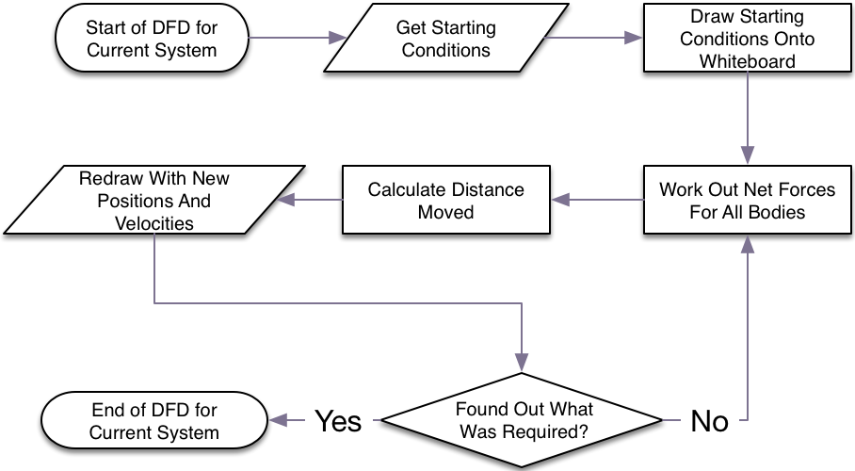

*The full process he would go through at the moment to simulate an example is described as follows:*

Keep in mind that when multiplying and dividing the length of vector arrows, the length should be measured with a ruler and then redrawn whilst measuring with a ruler. Also, instead of using vector arrows in the simulation, vectors could be resolved in the horizontal and vertical axis using trigonometry for more accurate results.

1. Process start conditions
   1. Create random starting conditions in head OR extract conditions from a question/example
   2. Draw conditions on whiteboard:
      1. Represent objects as circles
      2. Decide on a scale for distances in the interaction
      3. Decide on a position for each object to be, in correspondence with the scale
      4. Draw the objects on the board
      5. Decide a scale for the force and momentum vectors which are to be drawn on the board (must both have the same value for ease)
      6. Draw a vector arrow (with a ruler) from each object’s centre showing the object’s momentum in correspondence with the scale
2. Draw a vector arrow of net force for each object
   1. Calculate the net force for that object, *o1*
      1. For each other body, *o2*, calculate the force between *o1* and *o2*
         1. Use the equation $F=\frac{G⋅m_{1}⋅m_{2}}{r^{2}}$, where:
            1. *F* is the force attracting *o1* and *o2*
            2. *G* is the Universal Gravitational Constant =
            3. *m1* is the mass of *o1*
            4. *m2* is the mass of *o2*
            5. *r* is the distance between the two centre of masses of *o1* and *o2*, must be measured from the whiteboard
      2. For each calculated force, draw the force as a force vector from the centre of the body which the net force is being calculated for towards the body which this force is pulling, remembering the scale
      3. Take these arrows and redraw them one by one end to end (rub out each arrow as it’s redrawn)
      4. Draw an arrow from the start of the trail of arrows (the centre of *o1*) to the end of the trail of arrows
      5. Rub out the trail of arrows, just keeping the arrow linking the tips of the trail
3. Decide on a time change between the two frames of the simulation (the smaller the time change, the more accurate the simulation because momentum is constantly changing due to a constant force)
4. Set the new position of each object
   1. Note down the measured length of the momentum arrow of the object in cm and then convert to *Ns* by multiplying by the scale for momentum
   2. Take this momentum and divide by the object’s mass to give velocity
   3. Multiply velocity by the time change to give displacement
   4. Calculate the physical distance that the object will have moved along the whiteboard by dividing displacement by the scale factor
   5. Redraw the object, moving it in the direction of the momentum arrow with the distance calculated in the previous step
   6. Redraw the momentum arrow so that it originates from the redrawn object
5. Work out new momentum for each object
   1. Redraw the net force vector arrow as the same arrow but with the length multiplied by the time change (in seconds) to produce an impulse vector arrow (because $I=ft$)
   2. Redraw the impulse vector arrow so that its start touches the end of the momentum arrow
   3. Draw a new arrow from the centre of the object to the end of the impulse arrow
   4. Rub out existing momentum and impulse arrows
6. Pat yourself on the back, you’ve just worked out the next step of the simulation. Now repeat from step 2 to work out another.

It’s clear to see from this list of steps that this is very complicated and will take a considerable amount of time for any amount of bodies in the simulation. I explicitly stated every single minute step (e.g. the vector arrow addition and scales for vector arrows) to show how many processes a human has to perform. Whether they’re used to performing this process or not, they are going to struggle to do it quickly and it will be very impractical.

I can’t include photographic evidence of this algorithm in action because nobody uses it due to its tedious nature.

Given these reasons, an n-body simulation would suit a computer perfectly: it can process lots of statements very quickly, saving the teacher an aching arm and resulting in a smooth simulation ultimately helping students to understand the inverse-square law.

## Identification of Prospective Users

The users of the project will be Dr. McKenna, other Physics staff and Year 13 students.

Dr. McKenna is used to using a Windows computer but does not have a sophisticated technical capability so the design must be intuitive for him to use and must follow a design similar to that of other Windows Forms applications (i.e. use standard controls used throughout Windows).

Other Physics staff are similar in terms of technical capability.

All of the students have good technical capability as they are more used to using computers as part of their lives.

## Existing Alternative Systems

I felt that good way to create some objectives was to look at what was wrong with the existing simulations demonstrating the law of gravitation.

### Example 1

One example is the “N-Body Gravity Simulator”[1] coded in JavaScript which has fantastic graphics and representation of bodies but is limited by its lack of features such as vector arrows to show velocity or changing the scene. 3D being projected onto a 2D screen makes it more difficult for students to understand where each body and so makes it difficult to grasp the gravitation law. The viewport manipulations are limited to rotating around the central point and zoom in and out so the user cannot move (pan) around the scene.

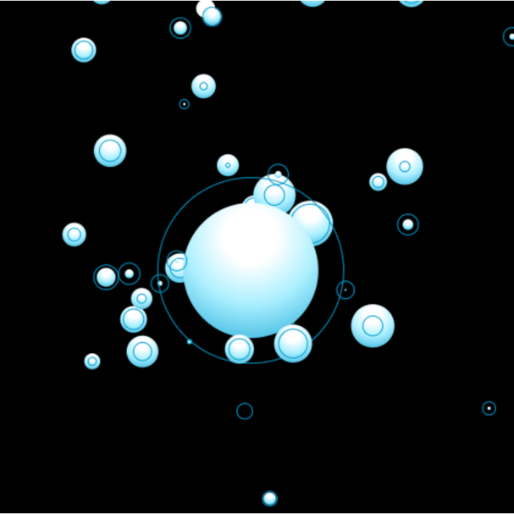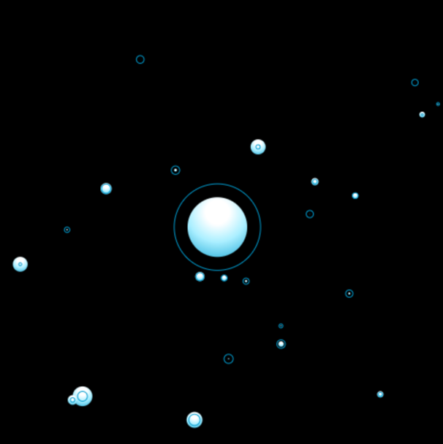

As shown above, when collisions occur in this simulation, the colliding bodies merge together – I have zoomed out which is why the most massive body looks smaller. This does make collision handling computationally easier but would not happen in reality so is not a true representation, although for the project’s purpose it is fine.

Also, the simulation only allows for a pre-set body set so the user cannot add bodies or change the scene to see how the interaction changes, which would be very useful to help understanding and is a point which Dr. McKenna requires.

### Example 2 - Astra

Another example which is more similar to what I have in mind is Astra[2] which is a Flash based simulation (coded in ActionScript) which has many more features and is much more complicated than the previous.

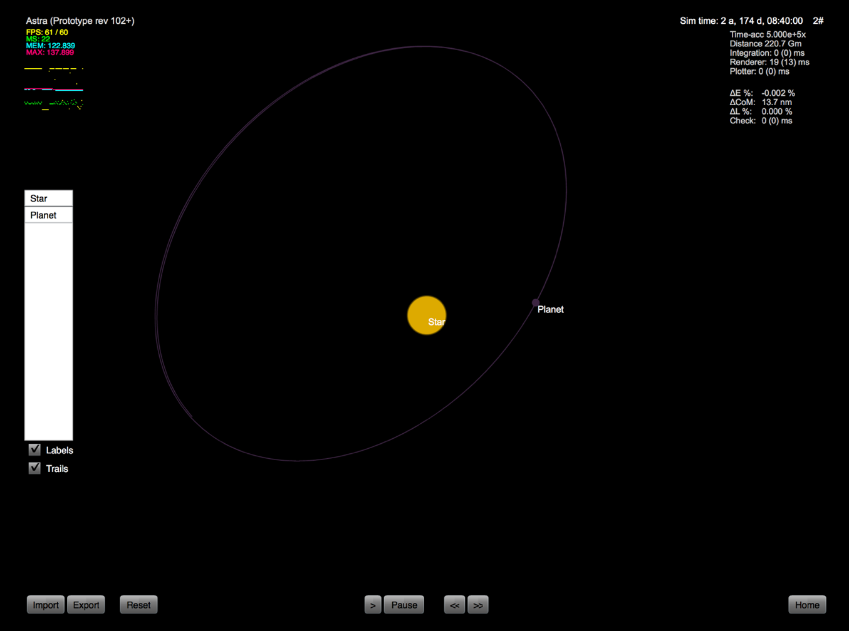

The user inputs the bodies which they want in the simulation before the simulation begins. This allows for a custom simulation, but does not allow the user to change the bodies in the simulation part way through. The simulation is 3D and uses the same central point rotation as the previous example but does not allow zooming so is more limiting to see what is happening in the simulation. The graphics are not as sophisticated as the previous but each body has a label which is a nice touch. I like that this program has pre-set simulations – a feature which I need to include. I also love that you can enable trails for the bodies (show their path where they’ve been).

The UI is reasonably intuitive and displays interesting technical information such as the time interval between frames (separated into individual parts), the timescale (called “time-acc” for time acceleration), total simulated time and percentage error.

### Objectives Resulting From Existing Systems

I went through these systems with Dr. McKenna and there are a number of limitations/problems which he would like me to address in my program. Also, there are some features from the examples which he wishes for me to carry through to my program. These are listed below:

* use a 2D simulation because 3D doesn’t help students to understand gravitation
* be able to move (pan) the viewport around the simulation (there will be no need for any sort of rotation with 2D)
* be able to zoom in and out
* display the frame rate
* allow changing of the time scale
* display the time factor of the simulation in terms of real time
* allow replaying the simulation
* play and pause
* be able to load a pre-set scene
* be able to edit the scene (add/edit bodies) mid-simulation
* perhaps allow for each body to have trails
* perhaps allow for each body to have its own colour

## Limitations

### General

* Time available - The main constraint for the project is the limited amount of time that I have in order to complete it. The project must be completed by 21st March 2016.
* Programming skills - The language which I’ll be using to create the solution is VB.NET because it is the language which I understand the best and everybody else at my school uses so I can get help if I need it.
* VB.NET constraints – Graphics in VB.NET aren’t very sophisticated without huge amounts of work put into to creating a Graphics Engine so I cannot create a 3D simulation and must instead use relatively simplistic 2D graphics. If possible I will anti-alias the objects drawn on the form to make it look smoother.

### Specific

* Knowledge – My knowledge of allowing mouse manipulations is very limited because I haven’t done anything like it before.
* Knowledge – My knowledge of circle-circle 2D collisions is very limited too and seems very difficult to achieve.

## Objectives

In order to create my objective list, I have looked at problems with existing systems and thought about the project’s limitations. In order to finalise my list and create specific objectives tailored to my user, I have created a document of questions to answer about what he requires from the project which can be found in Appendix 1. This is summarised below.

### The User’s Objectives

I gave Dr. McKenna a list of questions to answer digitally. The answered document can be found in Appendix 1. With him answering the document, I have a better understanding of what he requires from the project and how I can efficiently help student’s understanding. I will try and summarise what he requires from the project within this section.

#### Performance

The simulation needs to be able to allow for multiple bodies whilst giving a smooth simulation. Suitable goals for this objective are a minimum of 10 bodies (to create a medium-sized solar system) whilst giving a frame rate of at least 20 frames per second.

#### Accuracy

I would also like the simulation to be accurate, but I would not be able to test this objective. It would require me to input all of my variables into a program which used the same scales and coordinate grid as mine which would be practically impossible to execute.

#### Body properties

Each body must have a position in space, a velocity and a mass. No adjustable size, colour or any other properties per body are required. Each body’s size will be proportional to its mass as this allows observers to quickly grasp the differences in masses between bodies and also it will be easier for the user to add bodies.

#### Saving The Scene

Dr. McKenna feels that it is not essential for the scene to be saved for future viewing. If I get time, I will add this feature because I feel that it would be beneficial for the user to be able to do this and to share the scene with others.

#### Sample Scenes

He would like the project to include a set of pre-created interesting scenes so I will include that feature. Some ideas I which thought of are:

* a solar system (the Milky Way),
* a single planet orbiting a larger body (Earth and Moon),
* a planet with its moon who also has its own moon,
* a number of interesting orbits.

Upon considering the Milky Way idea, I decided that it would be very difficult to add a body such as Saturn. Also, I do not plan for the application to allow adding of specific masses so creating any specific solar system will not be possible. This means that creating an Earth and Moon simulation will also not be possible but a scene with a general planet and its moon will be so I shall create that instead.

#### Timescale

He wishes for there to be an adjustable timescale in the project (i.e. speed up or slow down movements) and for the simulation to be replayed. These are so that the user can see clearly how the bodies are interacting, especially useful if the bodies are moving quickly or the simulation is playing too slowly.

#### Zoom

He would also like to be able to zoom in and out of the simulation and pan around. This feature lets the user see an overall picture of the simulation taking place or zoom in to see interactions closer.

The user must also be able to pause the simulation and add/edit bodies, to see how the interaction changes part way through an existing interaction. To do this, I shall include a pause button which changes to a play button when the simulation is paused.

#### Vector Arrows

Dr. McKenna also asks to me to include vector arrows to the simulation, so that the user can see the velocity and/or net force of each body (from the centre of the body), which would help with understanding Newton’s Law of Gravitation.

#### Visibility

I know from being in Dr. McKenna’s lessons that the project will be displayed on a physically large screen (a projector), which means that smaller objects should not be such an issue but I must still make sure that they are visible. Classrooms are a maximum of 10m long as a maximum and the projector displays on average throughout the college are about 1.8-2.0 meters in diagonal length. I need to make sure that my project can be seen clearly from these distances on screens of such sizes. This only applies to the UI though, because the view of the scene will have the ability to be zoomed in and out.

I believe the projectors that the project will be displayed on are of 640 by 480 pixels. This means that standard UI elements (controls) are of a size which can be seen from anywhere in the classroom. I need to remember though, that the project will also be used on smaller screens (e.g. standard computer monitors) and will be developed on a smaller screen (15.6” screen laptop). This means that it will primarily be designed around a smaller screen so I shall have to test once created that it seems okay being displayed on a larger screen.

#### Collisions

The last question in Appendix 1 was asked to check if it would be okay for the application to close on the event of a collision in case creating collisions were too difficult. To this he responded that this would not be acceptable and that I had to create a collision management system.

### Resulting Objective List

*The completed list of requirements for the project are as follows:*

1. The program must have a GUI (Graphical User Interface) and be intuitive and clearly visible for all users. The appearance of the controls on the program must be uniform with those used in windows to make it easiest for the users.
2. The view of the simulation and the simulation itself must be 2D.
3. The simulation must allow for multiple bodies (at least 10).
4. The simulation must include any sort of collision detection and handling so that the simulation doesn’t have to stop when bodies collide.
5. The simulation must be smooth (minimum of 20 fps) whilst simulating a scene with 10 bodies on a school computer.
6. The simulation must display the amount of frames per second which it is calculating and rendering.
7. The user must be able to select a pre-set simulation which does interesting things. These include:
   1. a (general) solar system,
   2. a planet with its moon,
   3. a planet with its moon who also has its own moon,
   4. a number of more interesting orbits.
8. The simulation must be able to have its timescale changed from 1 second per second up to the maximum decided later on in the “Validation Design” section of the Design.
9. The user must be able to replay the scene with visually similar results.
10. The user must be able to zoom in and out.
11. The user must be able to pan around the scene.
12. The user must be able to pause (and then play) the simulation.
13. The simulation must allow the user to add and remove bodies both before the simulation is started and after it has started.
14. The user must be able to edit the properties of each body. Including:
    1. Position,
    2. Mass,
    3. Velocity.
15. The user must have to only set one property of a body out of size and mass. One should be calculated from the other.
16. The simulation must allow for an option to show vector arrows (most likely just lines) of velocity of each body. This must be able to be toggled on and off.

*The list of potential additions given enough time for the project are as follows:*

1. Allow the scene to be saved for future viewing (and if so allow loading of the scene).
2. Anti-alias the display of the sprites to smoothen the simulation.
3. Allows the scene to hold (and display) trails and have a toggle for visibility of trails on the UI.
   1. Possibly make the trails become more transparent as parts of the trail become older.
4. Allow the body to have its individual colour so that all bodies are not the same colour. This does not need to be able to be changed individually.
5. Allow the user to disable and re-enable gravity in the simulation.

## Proposed Methods

Most of the processing will be used trying to calculate the net force of each body so this is where I have spent most of my time researching. These methods are very complicated to understand and explain on paper. The ones that I have researched include: Brute Force ($O(n^{2})$), Barnes-Hut ($O(n⋅\log{n})$) and Ordinary Differential Equations (no general time complexity).

### Calculating Net Force

#### Brute Force

$$O(n^{2})$$

By far the easiest method to understand and certainly the most efficient for when n is small.

Brute Force is the method that was explained in great detail earlier in the documentation, the method which Dr. McKenna would use. Brute Force simply involves calculating the force of attraction between every other body using $F=\frac{G⋅m_{1}⋅m_{2}}{r^{2}}$ and add up these force vectors by resolving to give the net force on that body. In this equation *F* is the attractive force between the bodies, *G* is the Universal Gravitational Constant ($G=6.67428×{10}^{-11}N⋅m^{2}⋅Kg^{2}$), *m* is the mass of each body and *r* is the distance between their centres of masses.

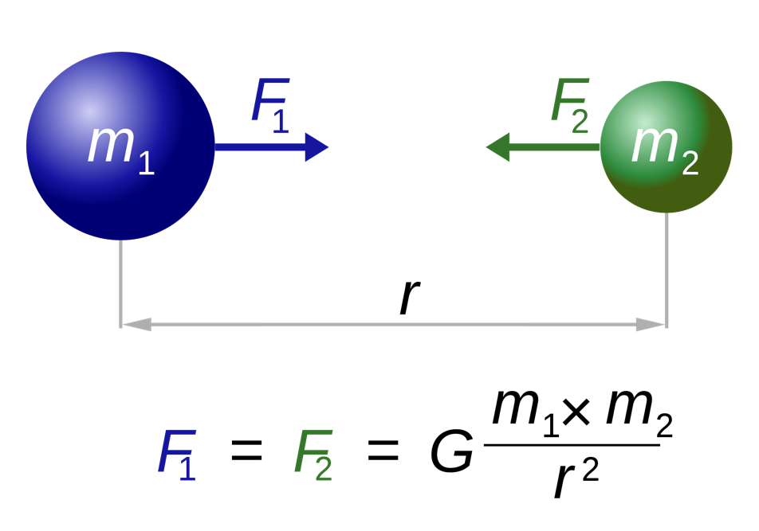

In Brute Force, *every* body is accounted for and no approximations are made. This means that although it may be much more inefficient than other methods as n becomes greater, it gives the most accurate results for the required (small) number of bodies in my program.

#### Barnes-Hut Method[3]

Probably the most common method for increasing efficiency when calculating net forces on each object is the Barnes-Hut Method - although only when n becomes large, is the difference noticeable.

This method forms a structure called a ‘quad-tree’ when working with a 2D surface, (‘oct-tree’ when working with 3D). The image below shows how the quad-tree is formed, in this instance, working on the bottom left quarter.

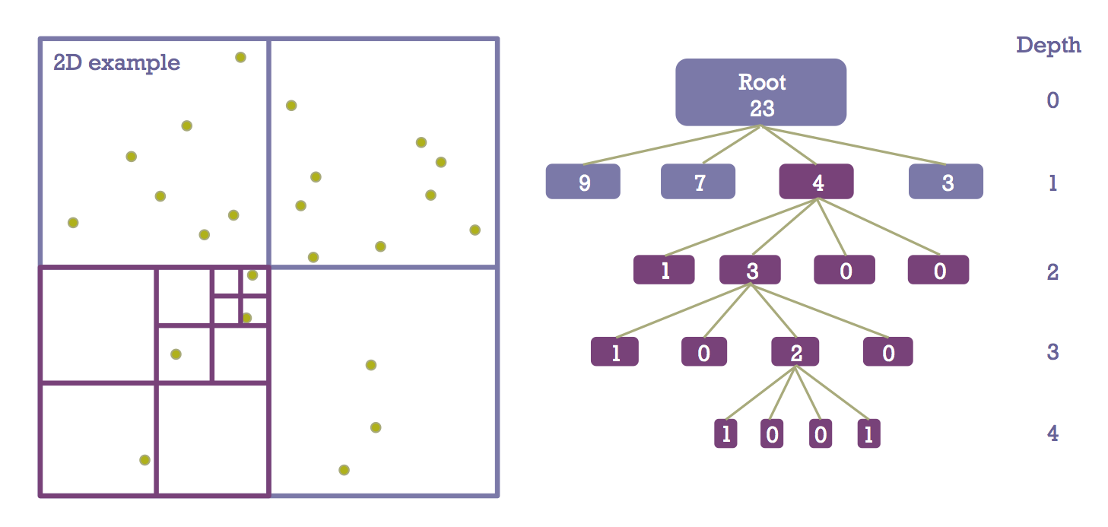

Each body is put into a box where there are no more than 2 bodies in a box. If there are 2 bodies in a smallest box, then the box is quartered further until this is not the case. The example above shows the corresponding quad-tree structure (oct-tree in 3D) which represents the scene. As this is an example, only the bottom left quarter of the root box is being divided down.

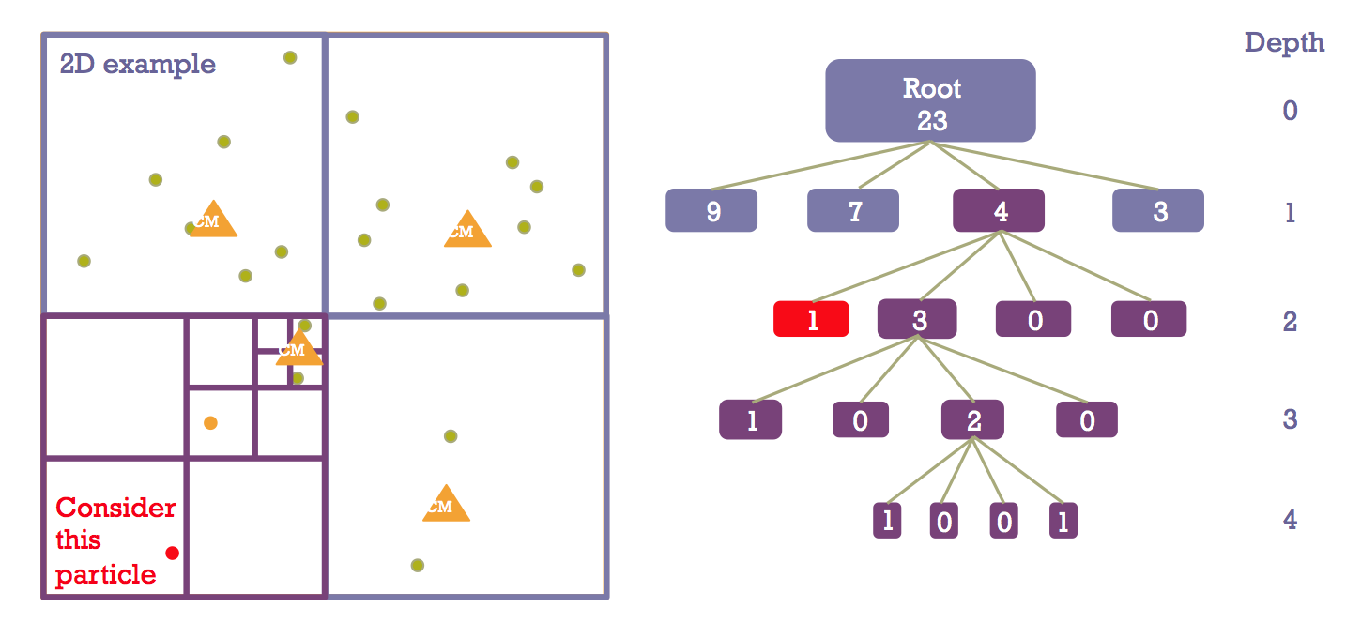

For the considered particle *p* in the example, we can calculate the force on it using a recursive calculation:

Begin at the root of the **tree**. Working on the children of the root, where each child represents a cell on the grid (as explained earlier). Take $l$ to be the width of the cell $C$, then if we say that $D$ is the distance from the centre of mass of $C$ to $p$, then if $l÷D<θ$ where $θ$ is an accuracy parameter, then approximate the force of all bodies in *C* by using the centre of mass of *C*. Otherwise, move down to level 2 (cell $C$’s cells and repeat with all of $C$’s children’s cells.

This method works because as *r* becomes greater in Newton's Law of Gravitation, $F=\frac{G⋅m_{1}⋅m_{2}}{r^{2}}$, the force becomes smaller at a square rate. Therefore, as bodies are further away, they become less significant so can be approximated with very similar results to the actual value.

#### Ordinary Differential Equations

*No general time complexity.*

By far the most complicated of all of the researched methods is the ODEs. Differential equations are equations which need to be integrated in order to solve them. These specifically are second-order differential equations so will need to be integrated twice.

|  |  |
| --- | --- |
| ../../../../Desktop/tex-22.png | ../../../../Desktop/tex-25.png |
| Shown above[4] are the two second order differential equations for the acceleration of each body in a two body simulation. | Shown above[5] are the three second order differential equations for the acceleration of each body in a three body simulation. |

As more bodies are added, more terms are added to each equation and more equations for each body’s accelerations are produced.

The net force given the calculated acceleration can be calculated by using $F=ma$, so multiplying it by the body’s mass.

I do not have the time nor the skill to be able to either find an existing ODE solver and integrate it into VB.NET or make my own second order differential equation solver. Thus, this method is not feasible.

### Using Net Force

After calculating the net force, the program must then use this to find out the displacement of each body. To begin, it should calculate the acceleration, $\underline{a}=\frac{\underline{F}}{m}$ and then calculate the displacement using $\underline{x}=\underline{v}Δt$ where $\underline{v}=\underline{u}+\underline{a}Δt$ (standard $F=ma$ and suvat equations).

### Chosen Method

I believe that the most appropriate method given an n-body simulation of such a type (where there are relatively few bodies, which have masses and considerable sizes (i.e. not negligible), and have to collide with each other) would be the Brute Force method.

I have chosen the method for the following reasons:

* It requires the least code and so least time to code,
* It is the least complex to understand properly and to implement,
* It provides the most accurate results (doesn’t approximate),
* There is a very small *n* so $O(n^{2})$ shouldn’t matter much so approximations aren’t required.

## Data Flow Diagram

The following data flow diagram gives an abstracted view of how data will flow through the application. Note that when the user chooses to change the scene, this will be equivalent to starting the flowchart again from “Initial Conditions”.

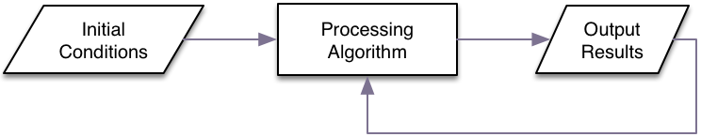

## Data Dictionary

The global variables are listed below. If a variable is a numeric type and not stated signed (allows negative values) then assume unsigned (positive only).

| Variable | Data Type | Contents Description |
| --- | --- | --- |
| Current Scale | A real number. | The scale at which the scene grid is being rendered (allows for zooming in and out). |
| Current View Position | Needs two integers (signed). | The top-left position of the viewport on the scene grid (allows for panning around the scene). |
| FPS | Integer. | Stores the amount of frames rendered in the last second. This will be shown on the form. |
| Timescale | A real number (signed). | Used to change the speed at which interactions and movements happen in the simulation (the multiple of real time). Negative means that the simulation is rewinding. |
| Current Body Index | Integer. | The index of the body which is currently selected by the user. Allows for removal and editing. |
| Body Array | Array of the user-defined Body type. | Stores the properties of each body. |
| Copies Of Body Array | Array of array of the user-defined Body type. | This will store copies of “Body Array”. It will allow the user to replay the simulation with exactly the same results. |
| Show Velocity | Boolean. | This will store whether the velocity arrows or lines are currently being shown. |

The variables required for non-essential objectives are shown below:

|  |  |  |
| --- | --- | --- |
| Variable | Data Type | Contents Description |
| Enable Gravity | Boolean | This will store whether gravitational forces should be enabled in the simulation. |
| Trails Array | Array of array of points | This will store the points of the trail for each body. |
| Show Trails | Boolean. | This will store whether trails are currently being shown. |

The user-defined type *Body* will need the following fields.

|  |  |  |
| --- | --- | --- |
| Field | Data Type | Contents Description |
| Velocity | Two signed real number. | Stores both the x velocity and y velocity (represents a 2D vector). |
| Position | Two signed real numbers. | Stores both the x position and y position of the body’s top-left point. |
| Mass | Large real number. | Stores the mass of the body in Kg. |
| Size | Large real number. | Stores the diameter in terms of grid units. |
| Colour | System-defined colour type. | Stores the colour of the body. |

## Data Volumes

The potential limiting factor of the simulation will be the processing power not the amount of storage required.

When n = 10, this will be circa 102 = 100 processes given the $O(n^{2})$ which, approximating each single process to require 1Hz of the CPU, will require 0.1 KHz which will give a hypothetical frame rate of 107fps on a single 2 GHz core. This shows that processing power is not an issue with such low values of n. In fact, given a 20fps simulation on a 2GHz processor with 4 cores (8GHz total), we can say that $framerate≈\frac{processing frequency}{n^{2}}$ which gives $n≈\sqrt{\frac{8×{10}^{9}}{20}}≈20000$ bodies which is great!

Of course, I need to take into account the other features which require computation but this shows that the chosen method of brute force will work very well for the required amount of bodies.

# Design

## Overall System Design

I am creating a teaching aid for my physics teacher, Dr. McKenna, which must help students to understand Newton’s Law of Gravitation for the Physics A2 level (Year 13). The tool must be easy to use and setup. It must simulate real physics as if the simulation is a solar system. The users must be able to manipulate the objects, both at the beginning, or part way through the simulation so they can see how the change that they’ve made can vastly affect the outcome.

Below is the much simplified IPSO table for my project (an expanded IPSO diagram can be seen below in “Modular Design”:

|  |  |  |  |
| --- | --- | --- | --- |
| Input | Process | Storage | Output |
| * Add bodies * Edit bodies * Removes bodies * Change simulation and view options | * Calculate net force for each body * Calculate new positions of the bodies * Detect and manage collisions | * Save scene to a file * Load scene from a file | * Render up-to-date view to the screen * Display information of the selected body |

## Modular Design

### Summary

By taking a modular approach to designing the project, I will be able to create code for each small part of the project. This has a multitude of advantages:

* I can see where methods will be repeated, so instead of writing the code multiple times, I can store the code in a function that could be used a number of times.
* After coding each module, I know that the modules work by themselves which increases debugging efficiency further down the line.
* Should the module need to be changed, I only need to alter it once, thereby saving time.
* *Creating* the project becomes much easier. I can clearly see which functions my program needs to perform, where the functions will be called from and how all of the code should work together.

I have created a diagram which contains all the features the program will have. Each of these features are grouped by Input, Process, Storage and Output. Then, for each complicated feature, I have broken them down into sub-features.



Each of these features will be explained in either “Form Design” or “Code Design” or both where appropriate.

### Form Design

As this is a teaching aid, the application should be very easy and quick to set-up. Dr McKenna doesn’t want to waste half of the lesson to create a simple interaction. To achieve this, all input shall be done through the mouse with no keyboard. Not only will this be more intuitive for the user, but it will also simplify my task of input validation later on.

Although this approach does have its downsides like the user cannot input precise values, the application is not made to be a scientific tool and only needs for the viewers to understand the concept of what is going on. So, in the case of this project, entering precise values would get in the way of its sole purpose.

From the features diagram, I have created the following form design diagram. The end elements represent controls on the form and their parents are regions by which the elements are grouped.

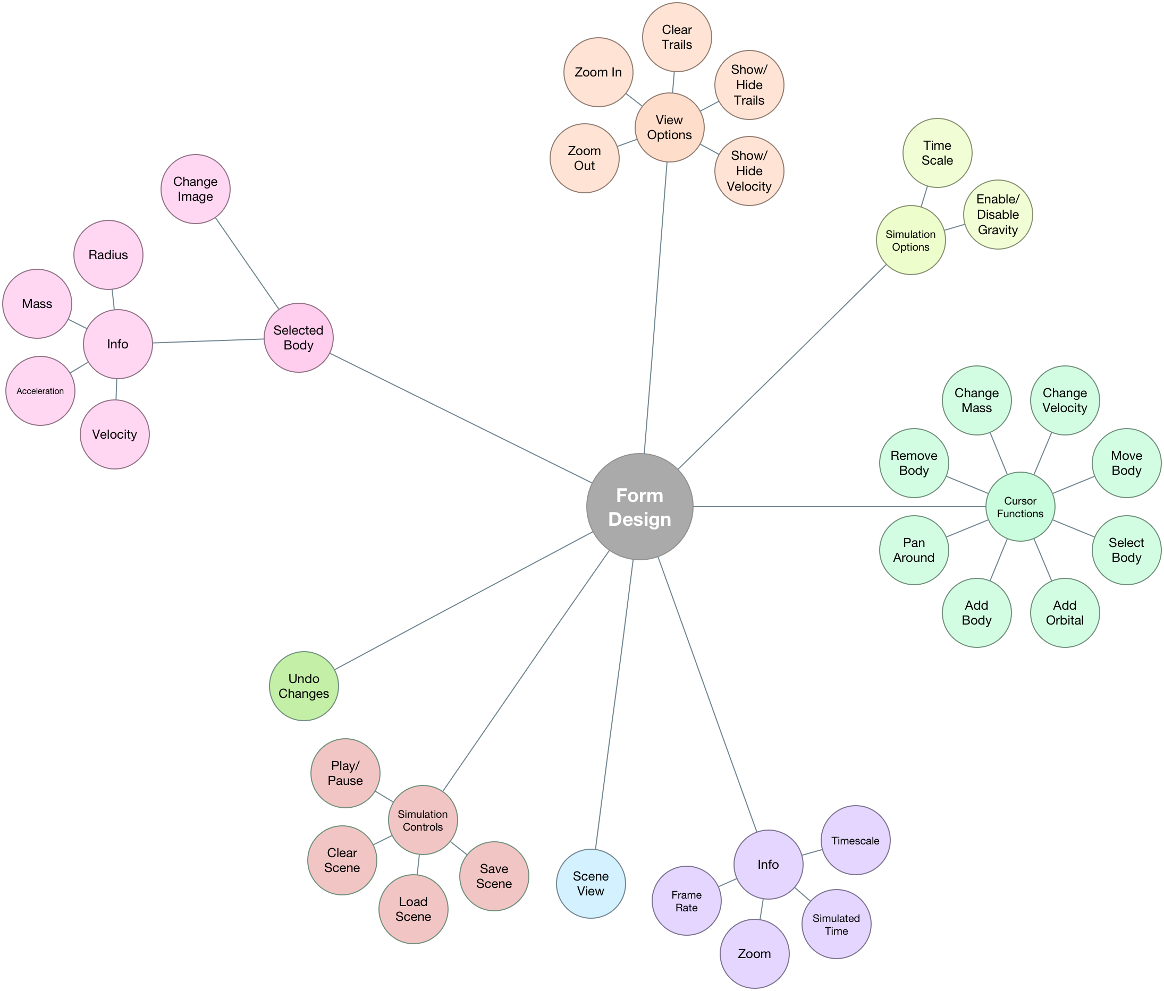

Using this form design diagram, I created the following form:

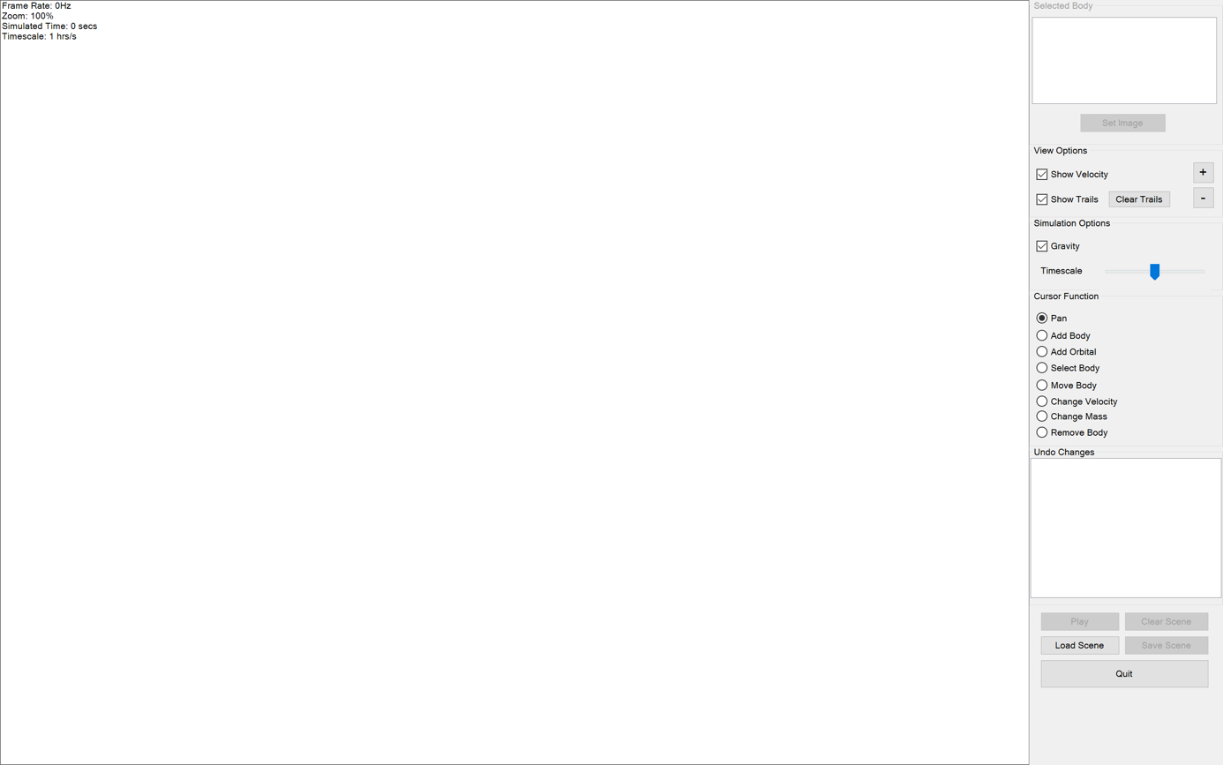

I decided to make the form full-screen to allow the experience of using it more immersive. Full screen also hides the windows taskbar and the title bar which allows the user to see more of the simulation and less of what isn’t important.

The screen is largely broken down into two areas: the controls and the view.

The user controls are grouped in a panel to the right of the form. They are then grouped further into group-boxes which is representative of the form design diagram.

The view will show the scene as it is being played and changed and also contains the info area (as you can see from the form design).

In order to create this form, I used Visual Studio’s Forms Designer and added all of the standard Windows controls. To show the info-area (top-left), I simply painted a string on the form load event. Also on the form load event, I disabled all of the buttons which shouldn’t be enabled when there are no bodies/when the program has just loaded. I then took a screenshot of the form after it had loaded.

This is a diagram showing the names of each of the controls:

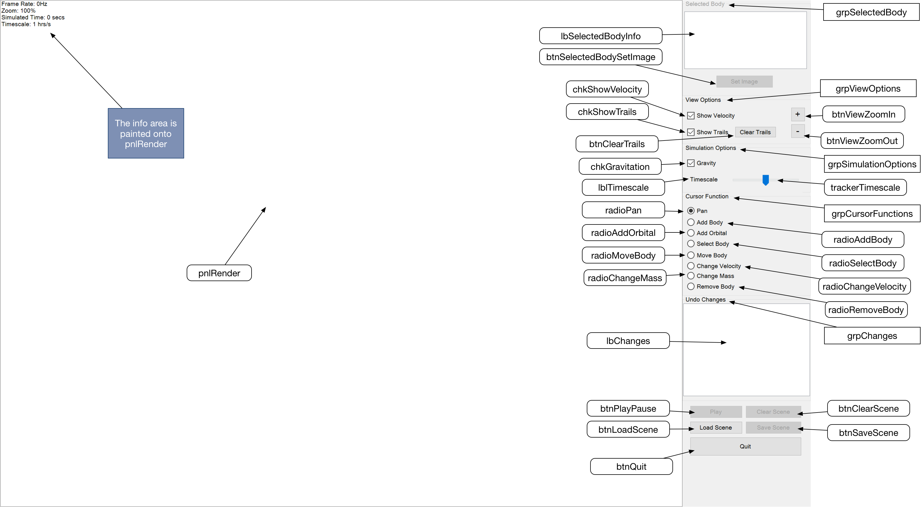

Note that as stated in the diagram, the info area Is not a control, just painted onto pnlRender when the form loads and thereafter. Also keep in mind that the controls beginning with “grp” are group boxes and hold many different components within them (these are annotated by a square box instead of the usual rounded box. For group boxes, I shall only point toward the heading of the box.

Throughout the design, when referring to a control, I will either use its name or it’s text in quotation marks (“”).

#### Scene View

The large white square on the form. This is where the simulation will be rendered to.

Below I have shown my design for the body, velocity line and trails explained below the design. I have decided to implement the trails because I feel it will be a very useful feature and improve the appearance of the scene.

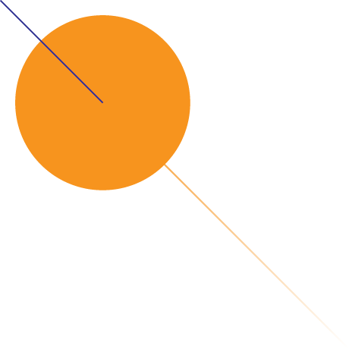

Ideally, this is what the trails will look like – fade as they become further from the body. I made this with Adobe Illustrator.

##### Bodies

I will represent each body as a circle as discussed in the Analysis. I will fill the circle with the colour in the body’s Colour property.

##### Velocity Line

I plan to show velocity by drawing a blue line coming from the centre of the body. The length of the line will be proportional to the body’s velocity. I think it would be suitable to make the length of the line equal to the distance moved by the body in one hour.

##### Trails

To show the trails, every frame I will store the centre of each body and then draw lines between each point when painting.

##### Zooming

When the user scrolls using their mouse on the scene view, I shall increase or decrease the ZoomScale global and then paint will use this global to decide how to render the view.

#### Info

Located in the top-left of the scene view, this is where simulation and view information will be drawn. These aren’t controls, instead they are strings drawn by the graphics of the panel.

##### Timescale

This displays the factor of time which is applied to the simulation. This value is the amount of simulated time per second.

##### Simulated Time

This shows the cumulative time which has been simulated by the application. This will be stored in terms of seconds but shall be represented in terms of seconds, hours, days or years as shown in the form.

##### Zoom

Shows the zoom of the view in terms of percentage of the initial zoom. So this starts at 100%, when zoomed in it increases, when zoomed out it decreases.

##### frame rate

Displays the amount of frames processed and painted to the form every second.

#### Selected Body

The group-box in the top-right of the form. In this group-box, there is (Selected Body) Info and a button to change the image of the selected body. Controls in this group-box will use a timer which ticks every 200ms in order to update.

##### Set Or Change Image

A button which, when clicked, prompts the user to select an image file from their hard drive. When the user selects an image, the selected body will be represented by an image. If the selected body is using an image on the timer tick, then the text of the button will change to “Change Image”. Upon clicking the button in this state, the user will be offered the option of removing the current image or setting a new one.

##### Info/Properties

This is a list-box which will be used to display meaningful properties such as: radius, mass, acceleration and velocity. (Note that the velocity and acceleration will be magnitudes, as having them in terms of x and y would mean nothing to the user.) This will update every 200ms or so.

#### View Options

This provides the user with a way to change what the view shows and how it shows it.

##### Zoom in / Zoom Out

Two buttons with a plus and a minus respectively. While one of the buttons is held down, a timer ticks every 50ms and zooms the view in or out, painting the new view to the Scene View each time.

##### Clear Trails

A button used to clear the current state of the trails left by the bodies. The trails will have a maximum length but in case they make the view really messy, the user can clear them.

##### Show/Hide Trails

A checkbox which allows the user to show the trails (default) or hide the trails completely.

##### Show/Hide Velocity

A checkbox which allows the user to hide the velocity arrows and then show them again when they want.

#### Simulation Options

Allows the user to change the way the simulation behaves.

##### Gravity

A checkbox which allows the user to turn gravity on (default) or off.

##### Time Scale

Changes how fast the simulation progresses. Uses a slider (TrackBar) in combination with a timer so that the user can move slide the bar left or right to decrease and increase the time scale. When the user stops holding their mouse on the bar, it snaps back to the centre.

#### Cursor Functions

Allows the user to change the function of their cursor within the application.

##### Pan

Allows the user to change where the view is looking at. They can use their mouse to drag around inside the Scene View and move the view.

##### Add Body

The user moves their cursor to where they want the centre of the body to be and then drag to define the radius of the body.

##### Add Orbital

As the user moves their mouse, the application will draw a circle around the body which has the greatest gravitational force on that point. They then follow the same procedure as “Add Body”. After they have created the body and let go of the mouse, the application will set the velocity of that body to orbit the body with the greatest gravitational force.

##### Select Body

Allows the user to change which body is selected. See “Selected Body” above for the effects of changing the selected body.

##### Move Body

Allows the user to drag bodies around the scene to change their positions.

##### Change Velocity

Allows the user to drag around the scene to change the end-point of the closest body’s velocity line.

##### Change Mass

This lets the user drag from inside a body to set the radius of it and in turn, the mass is calculated.

##### Remove Body

When the user clicks a body, it is removed from the array and its trail is removed.

#### Undo Changes

This will be displayed as a ListBox and will list all the changes made to the scene.

I have designed it to look like the following. I created this by adding some strings to the changes list box and then took a screenshot.

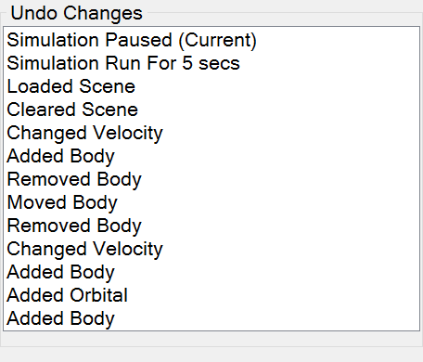

The list shall have the most recent change at the top and the oldest at the bottom. When the user clicks an element, the scene rolls back to when that element was created. The changes which are more recent than the change they clicked will remain in the list until a new change is added. This is why I have included a “(Current)” marker so that the user knows which state the scene is currently in. The changes which will be recorded include:

* Add Body
* Add Orbital
* Move Body
* Change Velocity
* Change Mass
* Remove Body
* Clear Scene
* Load Scene
* Simulation Paused
* Simulation Run

##### Simulation Run

This type of change will be stored automatically while the simulation is running. I think a suitable interval between recordings is 5 seconds.

##### Simulation Paused

This is stored when the user pauses the simulation. I have included this because the scene can change between the last change of type SimulationRun and when the user pauses the simulation.

##### Others

The others are self-explanatory: as they make changes to the scene, I shall store them in “Undo Changes”. “Clear Scene” and “Load Scene” will be discussed under “Simulation Controls”.

#### Simulation Controls

The un-named panel located in the bottom-right. This is where the other controls go.

##### Play/Pause

Plays and pauses the simulation. Useful if the user wishes to amend changes to the scene.

##### Load Scene

Allows the user to load from a file which was saved using G-Sim.

##### Save Scene

A button which allows the user to sIave the current state of the application so they can resume another time. This saves both the body array and also some settings.

##### Clear Scene

Clears the scene completely by removing each body and clearing the trails.

##### Quit

This button is required as the application is full-screen so gives them an intuitive way to exit.

### Exception Handling

Whenever an unhandled exception occurs, I want to be able to manage it and inform myself of it so that I can try to create a fix.

To do this, I shall assign a handler to the application’s unhandled exception event[6]. I plan to include the exception information in an email which I will send to my email address.

After the email has been sent (should take a couple of seconds), I shall display a message box informing the user what has happened. It shouldn’t contain any exception details in the message box as this means nothing to a normal user. The program should then close.

Although perhaps it is not ideal for the program to close, it prevents it from malfunctioning. In the future, this aspect of the program should dump the scene to a file and then automatically load it when the program is next started. This would be much nicer for the user, especially if they had spent a long time trying to create the scene.

### Updates

I would also like to let the application check whether any updates are available. To go about doing this, I think I shall check for updates when the form first loads.

I have managed to find a free web hosting company through which I registered a free sub domain at jamesmiddleton.esy.es. I shall create a PHP page on the website which the program will reference.

This is an SFTP client called CyberDuck and below is showing the connection to the hosting server and the file structure for the project.

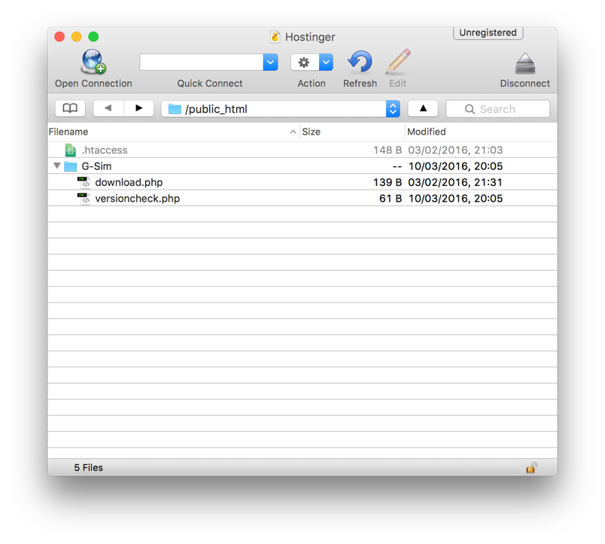

Visual Studio allows you to change the “Assembly Version” of the application which I will use to compare against the latest version found on my website. If the program sees that there is a newer version, then it will display a message box showing the differences between versions (with respect to numbers not details) and will allow the user to go to my website to download it.

I will not host the executable myself, I will only link to it. For hosting the executable, I plan to use mega.nz because they allow for a large amount of storage and pose no download limits to users.

The contents of the two files shown are on the following page.

This image shows the contents of the ‘versioncheck.php’ file:

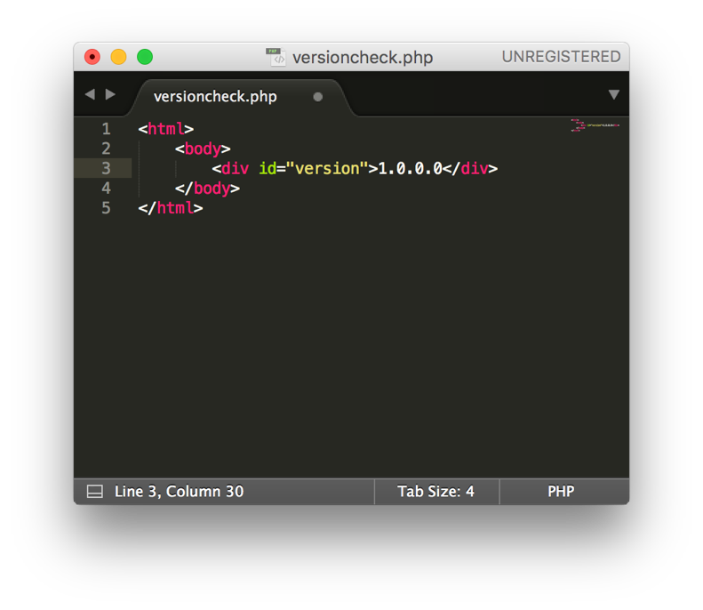

This is the webpage which the program will reference to ensure that it is up-to-date. Then this shown the contents of the ‘download.php’ file:

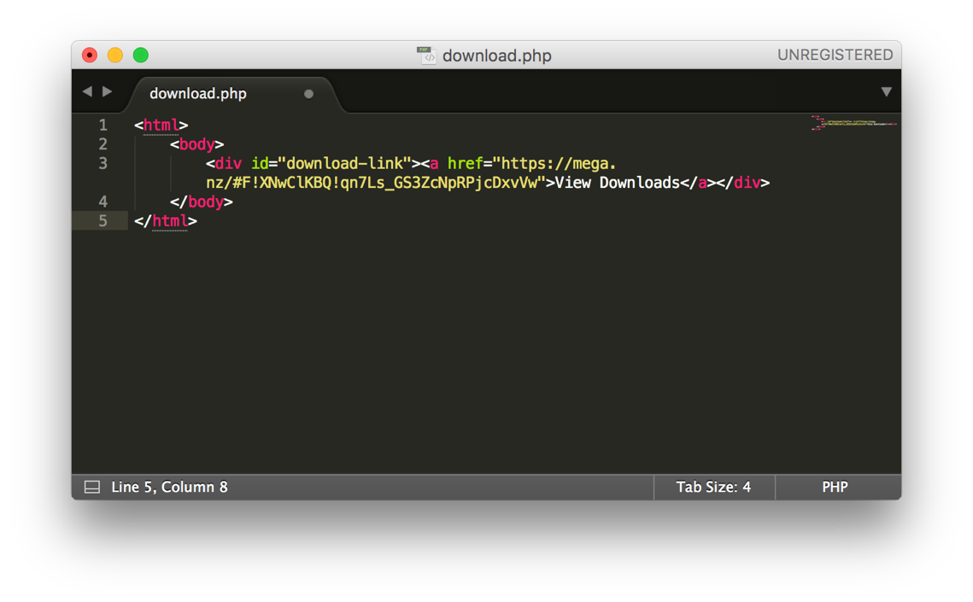

This is the webpage which will be linked to in order to let the user download the program. As you can see, I have correctly set up a link to mega.nz after having uploaded the executable.

### Code Design

I will try to design my code in a way which is both easy to understand and compute.

For each code base, I have created a class diagram including both the variables and the methods. These are separated into “Public” and “Private” for each.

Each of these methods will be explained in terms of their purpose and also what they will do.

Variables can be seen as part of the class diagrams alongside an appropriate type. Variables will not be explained until later in the Design Data Dictionary.

#### Main Form (Form/Class)

##### Class Diagram

This class diagram had to be split in half as it is so big. The piece to the right goes above the piece on the left.

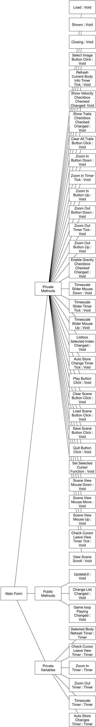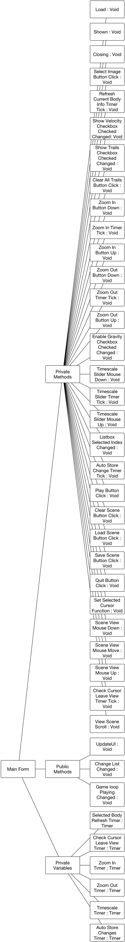

##### Methods

There are many handlers in the main form which do very similar things. These have been grouped together by their control type which can be seen in square brackets, “ [ ] ”.

|  |  |  |  |
| --- | --- | --- | --- |
| Access Level | Name | Type | Description |
| Private | Load | Void | Handles the loading of the application. Sets up all of the variables, application data resources, adds the unhandled exception handler and prepares for the form to show. |
| Private | Shown | Void | Paints a blank frame to the view and then checks for updates. |
| Private | Closing | Void | Pauses the game loop on close. |
| Private | [Checkbox] Checked Changed | Void | Sets the corresponding global to be equal to its checkbox’s checked property and then paint a frame. |
| Private | [Timer] Tick | Void | Refresh Current Body: Clears and updates the selected body info.  Zoom Timers: Zoom In or Out respective of the timer.  Timescale: Changes the timescale with respect to the displacement of the timescale slider.  Check Cursor: Checks if the mouse is outside of the view and if so disables the orbital ring as well as the mouse label.  Auto Store: Stores a “SimulationRun” change as the simulation is running. |
| Private | [Button] Click | Void | Performs the necessary actions to give the required result. |
| Private | [Button] Mouse Down | Void | Starts the respective timer. |
| Private | [Button] Mouse Up | Void | Stops the respective timer. |
| Private | Listbox Selected Index Changed | Void | This refers to the changes list box and so rolls back the scene to when the selected change was created. |
| Private | Scene View Mouse Down, Move, Up | Void | Executes the necessary code in order to perform the respective stage of a the selected cursor function. |
| Private | Scene View Scroll | Void | Zooms in or out depending on which way the user has scrolled. |
| Public | UpdateUI | Void | Enables or disables the controls which shouldn’t be used when there are no bodies. These include: grpSelectedBody, btnPlayPause, btnClearScene, btnSaveScene. |
| Public | Change List Changed | Void | This is a method which will be called externally by changes. It will update the change list box. |
| Public | Game Loop Playing Changed | Void | This is a method which will be called externally by GameLoop. It will update the change list box. |

#### Changes (Shared Class)

I will use this class to store all of the changes made to the scene and so it will allow the form’s “Undo Changes” section to function properly.

##### Class Diagram

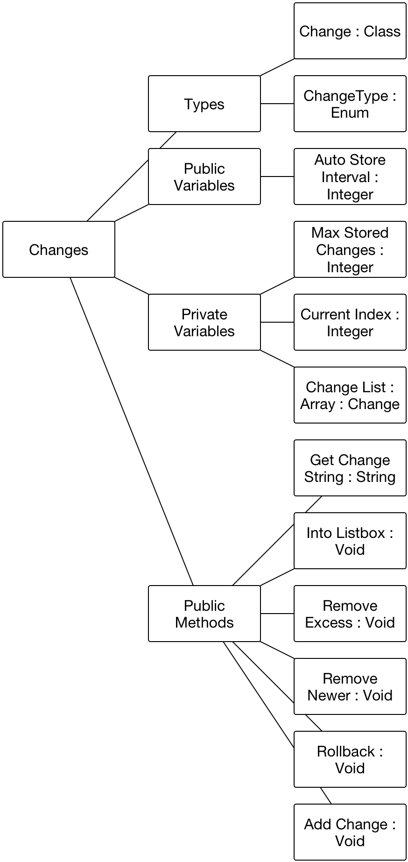

##### Methods

|  |  |  |  |
| --- | --- | --- | --- |
| Access Level | Name | Type | Description |
| Public | GetChangeString | String | Gets the description of the given Change which will be added to the changes list on the main form. |
| Public | IntoListbox | Void | Enumerates all of the changes in the ChangeList into the given list box. The list box needs to be cleared beforehand. |
| Public | RemoveExcess | Void | Removes the oldest changes if the number of stored changes exceeds MaxStoredChanges. |
| Public | RemoveNewer | Void | Removes changes which are newer than index which has been passed. This will be used when the user has undone a change and then makes a new change. |
| Public | Rollback | Void | Reverts the state of BodyDatas to that which is stored in the change who’s index is passed. |
| Public | AddChange | Void | This adds a change to ChangeList given its change type. |

#### Game Loop (Shared Class)

This class will allow me to display and update the simulation. There are many ways of creating a game loop, two of which I have discussed below: using a timer and using a background thread.

##### Designing The Game Loop

###### Using A Timer

The approach which will be taken by most people is to use a timer and then to update and paint on every timer tick. The downside to this is that the time step is fixed which will generate problems when more bodies are added. As the complexity and number of operations for the computer to perform will increase, the time taken for a tick handler to be processed will also increase. When this length of time becomes greater than the tick interval, the simulation would represent a time step which was incorrect and the bodies would appear to move more slowly.

Apparently the tick event handler is processed on a separate thread[7] so the main form would still remain responsive but the simulation would very easily become behind. This means when the simulation is requested to stop, the queued timer ticks would have to be executed first before the simulation actually came to a stop.

As my application is computationally challenging, $O(n^{2})$, both of these issues could very easily occur.

Another issue with Timer is that it is very inaccurate and has a resolution limited to 15ms[8]. This means that each timer tick is ±15ms in time from where it is supposed to occur. This will cause unsmooth playback. I originally set out to make my application as smooth as computationally possible, after discovering this, I knew timer was not the way to achieve this.

Because of these reasons I was very reluctant to use a timer, and so I looked to other methods.

###### My Chosen Method

I plan to create a static class (meaning it cannot be instantiated) which contains the loop and all procedures required to interface with it. I will attempt to make the loop run in a background thread and not on the main thread in which the main form is run. This means that the user will still be able to interact with the main form whilst the game loop is running.

The advantage with my chosen method is that the time step is not fixed, it varies. The loop will record the time, using a high-resolution timer, the Stopwatch[9] class, taken to complete the latest iteration of the loop and passes that as a parameter into Update. The update procedure will then use this value as the time step to create real-time movements and interactions.

Shown below is a much simplified flowchart to represent the Game Loop where Running is a variable changed by the other procedures in the loop’s class to begin or stop the game loop.

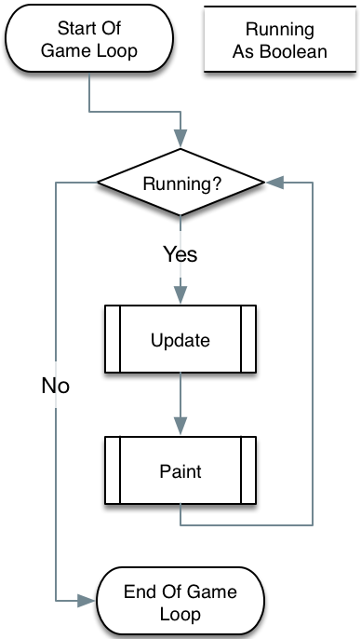

The frame rate (FPS) will also be retrieved from the game loop class. Every time the loop runs, I shall increment a variable which stores the amount of frames in the recorded second. After a second has elapsed, I shall change the value of FPS so that it equals this variable.

The “Simulated Time” displayed on the form is calculated in a similar way. After a second, the value of “Time Scale” is added to the simulated time variable (because the time scale is the simulated time *per second*).

All of this can be represented by the flow-chart below.

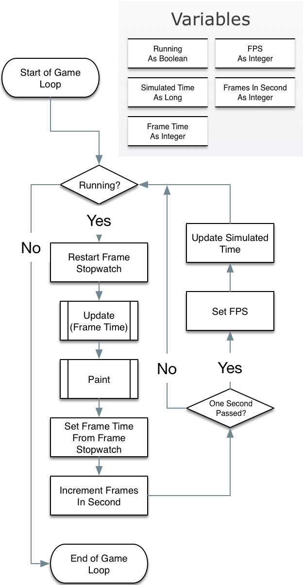

##### Resulting Class Diagram

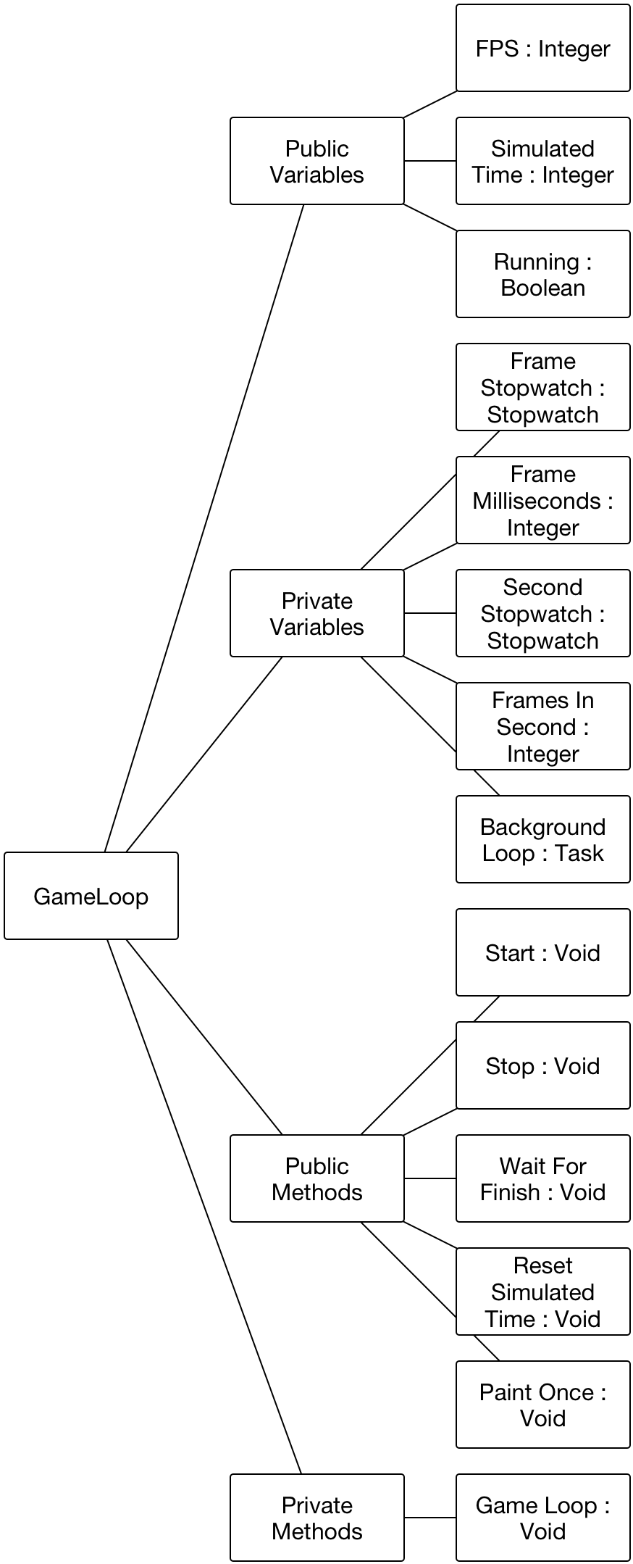

##### Methods

|  |  |  |  |
| --- | --- | --- | --- |
| Access Level | Name | Type | Description |
| Public | Start | Void | Assigns the background loop to a new instance of Task and then executes in asynchronously. |
| Public | Stop | Void | Tells the background loop to stop and then waits until it finishes. |
| Public | Wait For Finish | Void | Waits for the task to finish. |
| Public | Reset Simulated Time | Void | Sets the simulated time variable to zero. |
| Public | Paint Once | Void | Paints a single frame to the view. |
| Private | Game Loop | Void | The main loop which is run in the background. |

#### Trails (Shared Class)

The trails class will be used to store the centre points of bodies and form a trail left behind the body. In this class, there are no variables which are public. Like the game loop class, this class will have methods which perform all the necessary functions to manipulate and interface with the trails array.

##### Class Diagram

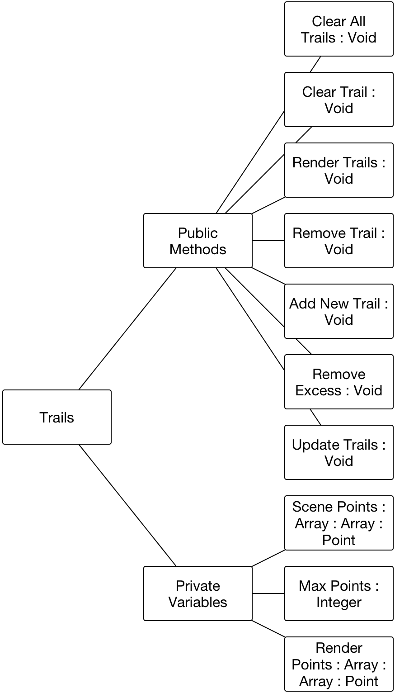

##### Methods

|  |  |  |  |
| --- | --- | --- | --- |
| Access Level | Name | Type | Description |
| Public | ClearAllTrails | Void | Clears all of the trail from the ScenePoints array. Then re-adds a trail per body in the array. |
| Public | ClearTrail | Void | Clears the points of an individual trail. |
| Public | RenderTrails | Void | Render all of the trails to the view. |
| Public | RemoveTrail | Void | Removes a trail array from the ScenePoints array. This will be called when a body is removed. |
| Public | AddNewTrail | Void | Allocates space for a new set of points to be stored. This will be called when a body is added. |
| Public | RemoveExcess | Void | Removes the oldest points from each array of points who have more points than the MaxPoints value. |
| Public | UpdateTrails | Void | Adds all of the current centres of the bodies to the corresponding arrays in ScenePoints. |

#### Body (Class)

This will be the class which has instances stored in the “BodyDatas” array.

###### Class Diagram

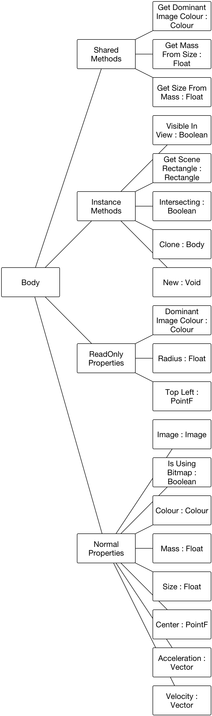

###### Methods

|  |  |  |  |
| --- | --- | --- | --- |
| Access Level | Name | Type | Description |
| Shared | Get Dominant Image Colour | Colour | Returns the mathematically average colour of the given image. |
| Shared | Get Mass From Size, Get Size From Mass | Float | Returns the mass or size of the body given the other. |
| Public | Visible In View | Boolean | Returns whether there is any part of the body which is visible by the view. Useful for reducing computation. |
| Public | Get Scene Rectangle | Rectangle | Returns the scene rectangle corresponding to the body. |
| Public | Intersecting | Boolean | Calculates whether this body is intersecting with the parameter body. |
| Public | Clone | Body | Returns the shallow-clone of the current body. |
| Public | New | Void | Sets the values of the instance of a body to blank or null. |

#### Change (Private Class Inside Changes)

This is the class which will have instances stored in the array and it will store all the data required for the user to roll back their changes. A new change class will be created and stored when “Add Change” is called.

I shall create this class under Changes and it will be private so can only be accessed within Changes (where it is required).

##### Class Diagram

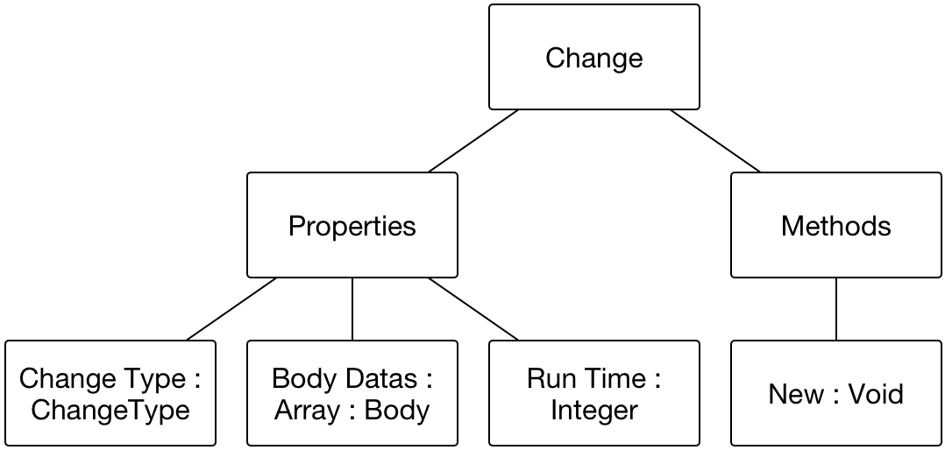

##### Methods

|  |  |  |  |
| --- | --- | --- | --- |
| Access Level | Name | Type | Description |
| Public | New | Void | Initialises the instance and sets the variables to the passed values. |

#### Vector (Class)

##### Class Diagram

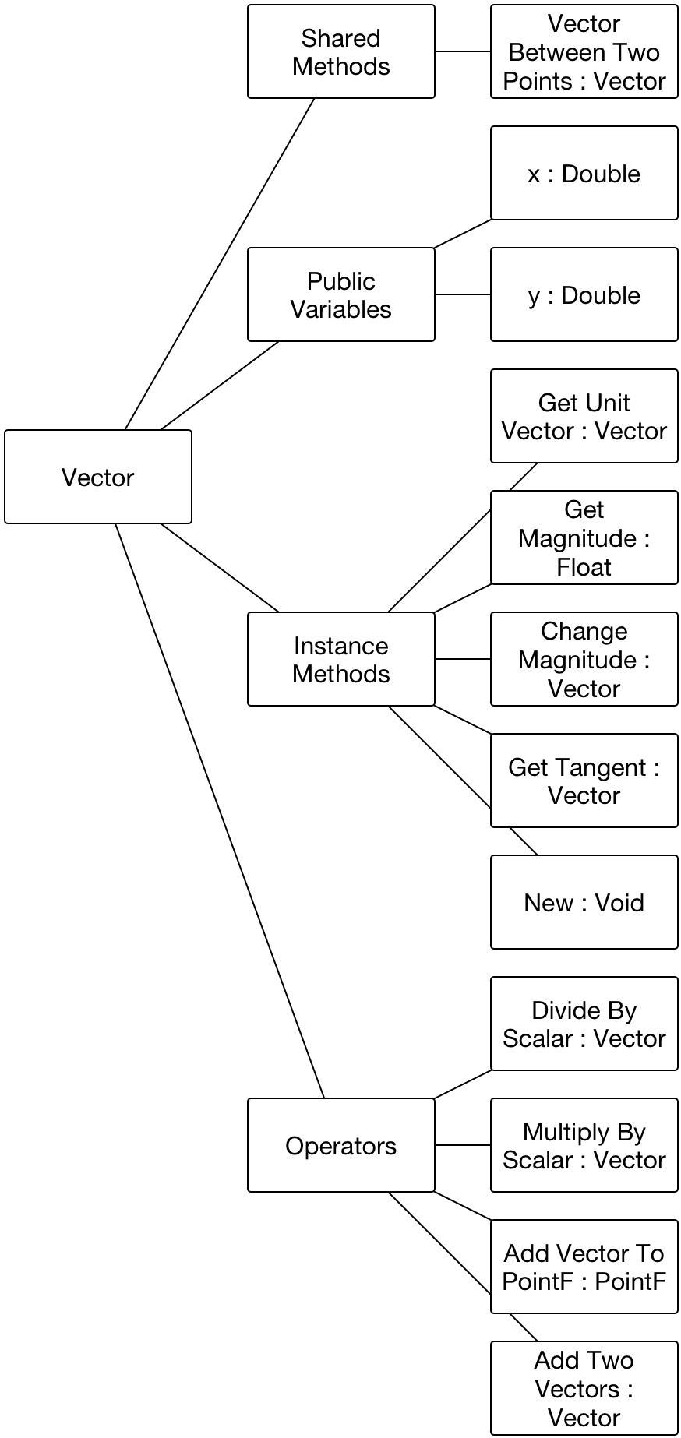

##### Methods

This class contains Operators, this is where there are two variables on either side of an operator (e.g. ‘+’, ‘-‘, ‘/’, ‘*’) and then this returns a result depending on the types of the two variables.

|  |  |  |  |
| --- | --- | --- | --- |
| Access Level | Name | Type | Description |
| Shared | VectorBetweenTwoPoints | Vector | Returns the vector from the first given point to the second. |
| Public | GetUnitVector | Vector | Returns the unit vector of the instance. |
| Public | GetMagnitude | Float | Returns the magnitude or the length of the instance. |
| Public | ChangeMagnitude | Vector | Returns the vector which is in the same direction as the instance but has a different length or magnitude. |
| Public | GetTangent | Vector | Returns the clockwise tangent of the instance vector. |
| Public | New | Void | Sets the x and y to the given values. If no values are given then sets them both to 0. |
| Shared | DivideByScalar (‘/’) | Vector | Divides the each of the components of the vector on the left by the scalar on the right. |
| Shared | MultiplyByScalar (‘*’) | Vector | Multiplies the each of the components of the vector on the right by the scalar on the left. |
| Shared | AddVectorToPointF (‘+’) | PointF | Adds the components of the vector on the left to the components of the PointF on the right. |
| Shared | AddTwoVectors (‘+’) | Vector | Adds the components of the two vector together. |

#### Body Methods (Module)

##### Class Diagram

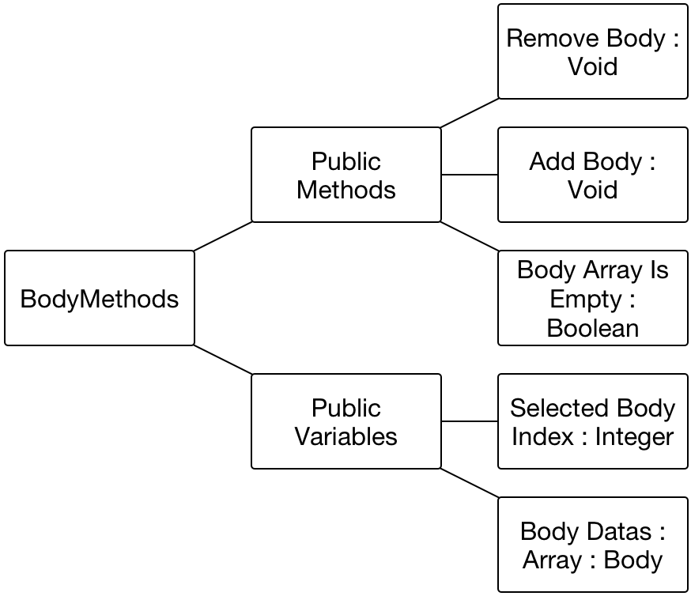

##### Methods

|  |  |  |  |
| --- | --- | --- | --- |
| Access Level | Name | Type | Description |
| Public | RemoveBody | Void | Removes a body at the specified index from BodyDatas. |
| Public | AddBody | Void | Adds the given body to BodyDatas. |
| Public | BodyArrayIsEmpty | Boolean | Returns a value indicating whether there are any bodies in BodyDatas. |

#### File Handling (Module)

##### Class Diagram

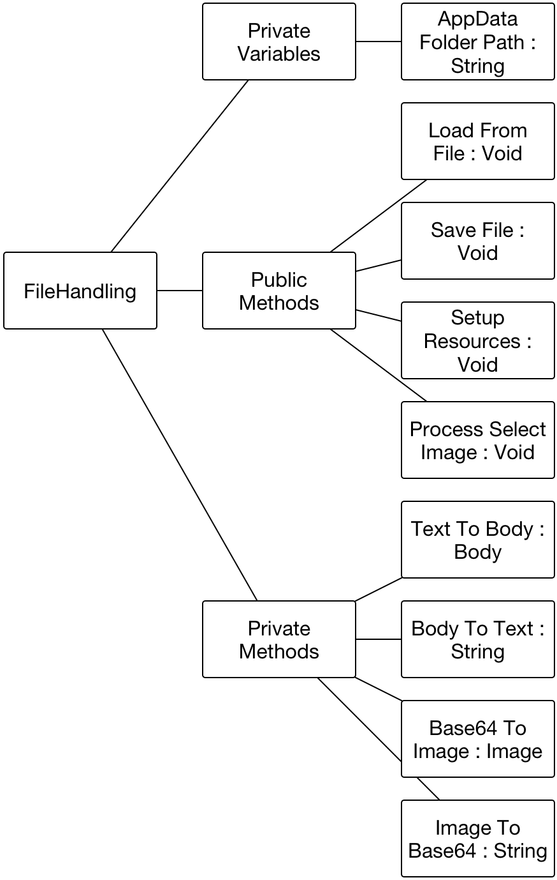

##### Methods

|  |  |  |  |
| --- | --- | --- | --- |
| Access Level | Name | Type | Description |
| Public | LoadFromFile | Void | Runs through the necessary code to load a file including letting the user select a file. |
| Public | SaveFile | Void | This lets the user choose where to save the file and then saves the current state of the scene along with some other options. |
| Public | SetupResources | Void | Copies all of the resources into the application data folder |
| Public | ProcessSelectImage | Void | Runs the necessary code to let the user select an image for the selected body. |
| Private | TextToBody | Body | Converts a CSV line into a body and then returns the body. |
| Private | BodyToText | String | Converts a body to a CSV line. |
| Private | Base64ToImage | Image | Converts a base64 string into an image. This will be used for reading an image from the scene file. |
| Private | ImageToBase64 | String | Converts an image into a base64 string. Used for storing a body’s image into a scene file. |

#### Graphics Methods (Module)

##### Class Diagram

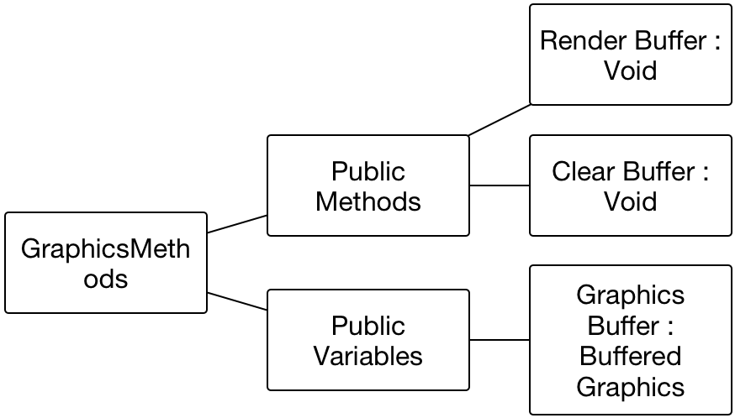

##### Methods

|  |  |  |  |
| --- | --- | --- | --- |
| Access Level | Name | Type | Description |
| Public | RenderBuffer | Void | Renders whatever is in the buffer to the view. |
| Public | ClearBuffer | Void | Clears the buffer with white. |

#### Mouse Methods (Module)

##### Class Diagram

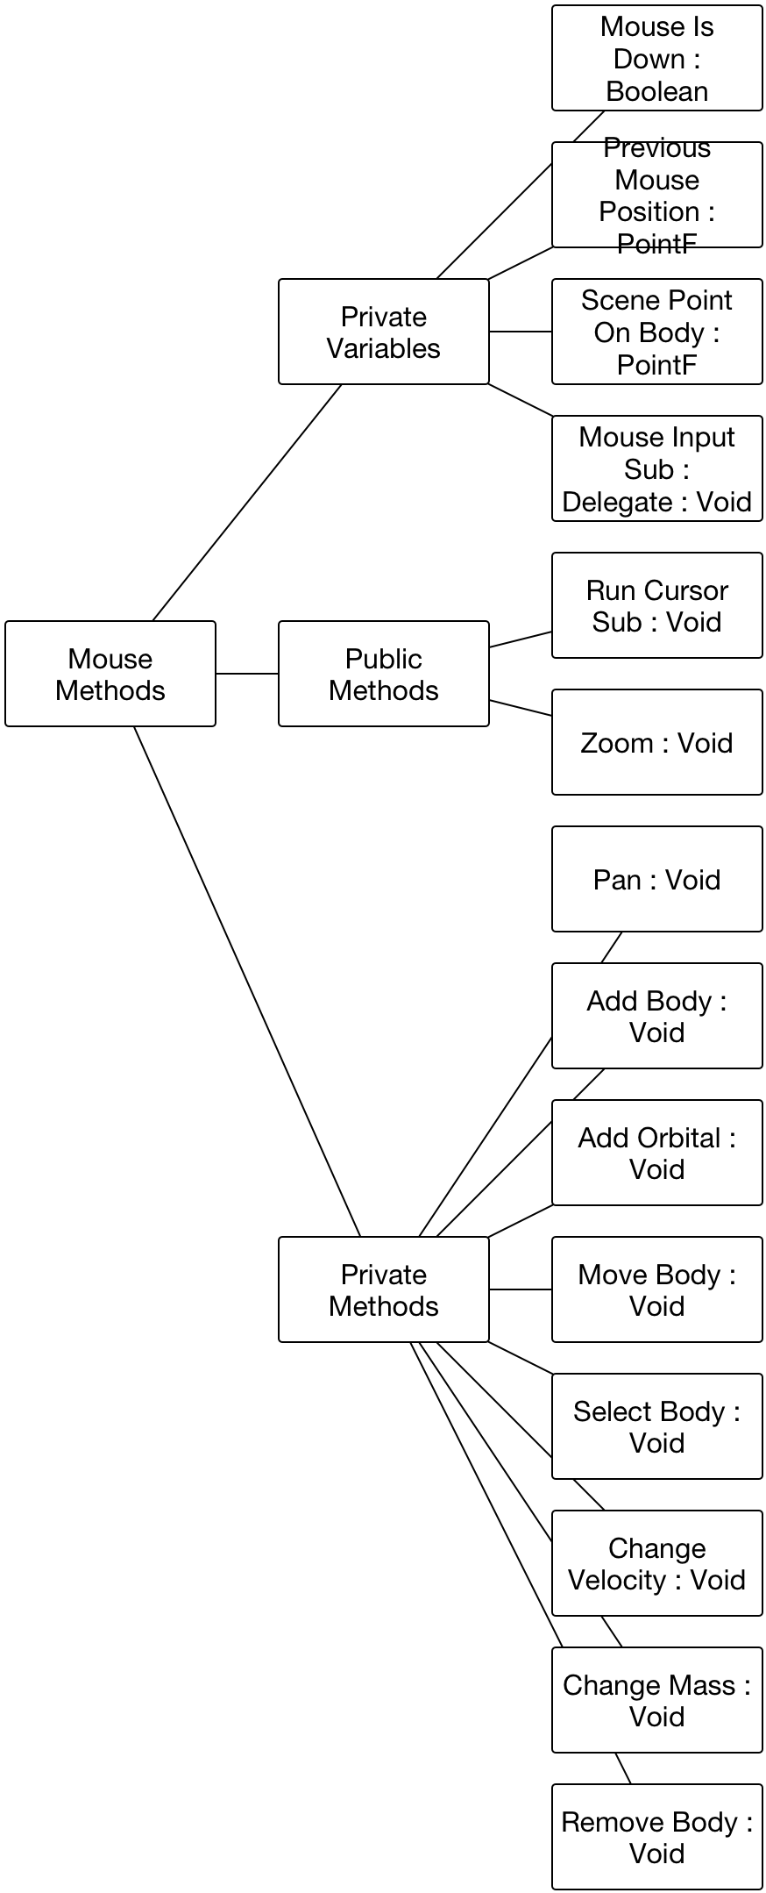

##### Methods

|  |  |  |  |
| --- | --- | --- | --- |
| Access Level | Name | Type | Description |
| Public | RunCursorSub | Void | Runs the cursor method which corresponds to the selected cursor function radio. An event type is also a required parameter which indicates whether the mouse has been just pressed, moved or just released. |
| Public | Zoom | Void | Zooms in or out with respect to the passed delta parameter. |
| Private | Pan | Void | Performs the required tasks to perform the corresponding cursor functions. All have 3 stages to them which are ‘Down’, ‘Move’ and ‘Up’ – these are processed when the respective event type parameter is passed from RunCursorSub. |
| Private | AddBody | Void |
| Private | AddOrbital | Void |
| Private | MoveBody | Void |
| Private | SelectBody | Void |
| Private | ChangeVelocity | Void |
| Private | ChangeMass | Void |
| Private | RemoveBody | Void |

#### Other Methods (Module)

##### Class Diagram

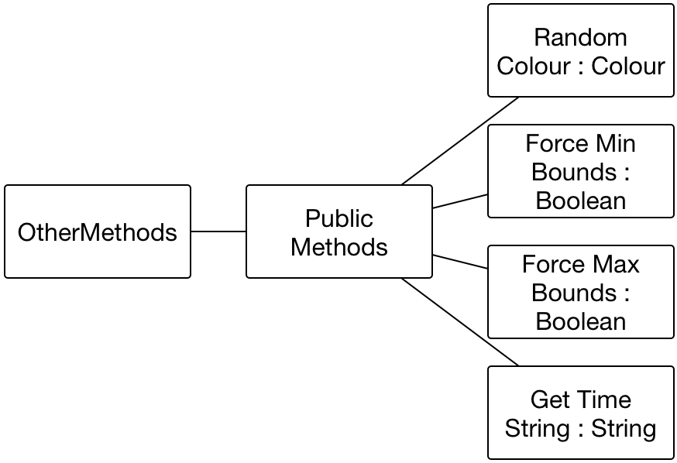

##### Methods

|  |  |  |  |
| --- | --- | --- | --- |
| Access Level | Name | Type | Description |
| Public | RandomColour | Colour | Returns a solid colour with randomly generated red, green and blue components. |
| Public | ForceMinBounds | Boolean | Ensures that the value which is passed by reference is no lower than the minimum parameter. If it is lower, then the value will be changed to the passed minimum and a False will be returned. Otherwise, it is left as is and True is returned. |
| Public | ForceMaxBounds | Boolean | Ensures that the value which is passed by reference is no greater than the maximum parameter. If it is greater, then the value will be changed to the passed maximum and a False will be returned. Otherwise, it is left as is and True is returned. |
| Public | GetTimeString | String | Returns a string which shows a length of time in terms of sensible units. The parameter must be in terms of seconds. |

#### Painting Methods (Module)

##### Class Diagram

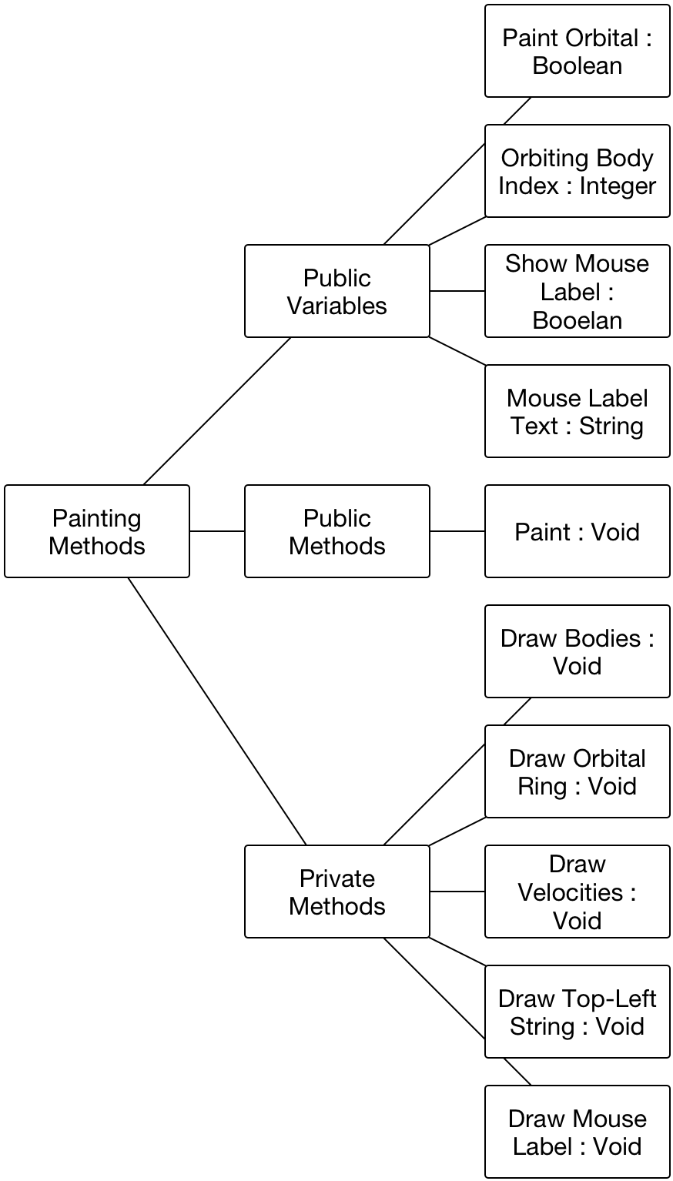

##### Methods

|  |  |  |  |
| --- | --- | --- | --- |
| Access Level | Name | Type | Description |
| Public | Paint | Void | Calls all of the necessary procedures in order to paint a single frame to the view. |
| Private | DrawBodies | Void | Draws all of the bodies to the view. If their VisibleInView method returns False then they are not drawn because they cannot be seen. |
| Private | DrawOrbitalRing | Void | Draws the ring to show where the orbital’s path when the user is using Add Orbital. |
| Private | DrawVelocity | Void | Draws the velocity lines from all of the bodies. |
| Private | DrawTopLeftString | Void | Draws the info string to the top-left of the view. |

#### Scene Methods (Module)

##### Class Diagram

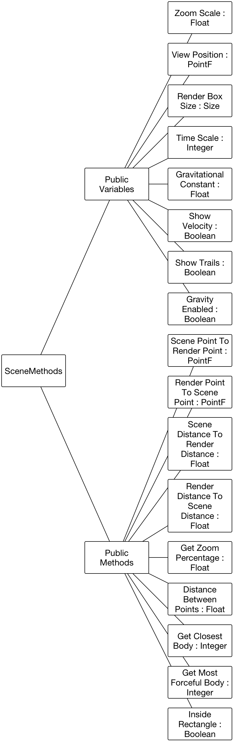

##### Methods

|  |  |  |  |
| --- | --- | --- | --- |
| Access Level | Name | Type | Description |
| Public | ScenePointToRenderPoint | PointF | Finds which render point represents the passed scene point. |
| Public | RenderPointToScenePoint | PointF | Returns which point on the scene is represented by the passed render point. |
| Public | SceneDistanceToRenderDistance | Float | Converts a passed distance on the scene into a render distance. |
| Public | RenderDistanceToSceneDistance | Float | Converts a passed render distance to a scene distance. |
| Public | GetZoomPercentage | Float | Returns the percentage which the current value of zoom is f its original value. |
| Public | DistanceBetweenPoints | Float | Calculates and returns the distance between two passed points. |
| Public | GetClosestBody | Integer | Calculates and returns index of the body which is closest to the passed scene point. |
| Public | GetMostForcefulBody | Integer | Calculates and returns the index of the body who has the greatest force on the passed scene point. |
| Public | InsideRectangle | Boolean | Calculates whether the passed point is inside the passed rectangle. |

#### Updates And Errors (Module)

This module will simply contain two methods which are used for global exception handling and version checking.

##### Class Diagram

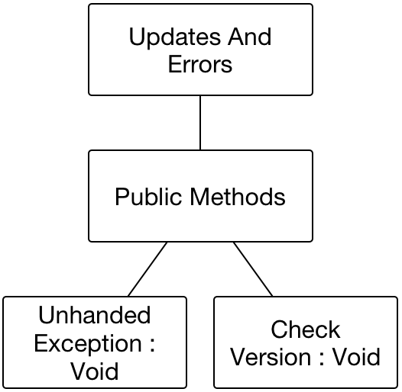

##### Methods

|  |  |  |  |
| --- | --- | --- | --- |
| Access Level | Name | Type | Description |
| Public | Unhandled Exception | Void | Manages an unhandled exception by emailing me and then quitting the program. |
| Public | Check Version | Void | References my website to ensure that the latest version of the program has been downloaded. If there is a newer version, then a message box is shown which allows the user to download the latest version. |

#### Updating Methods (Module)

##### Class Diagram

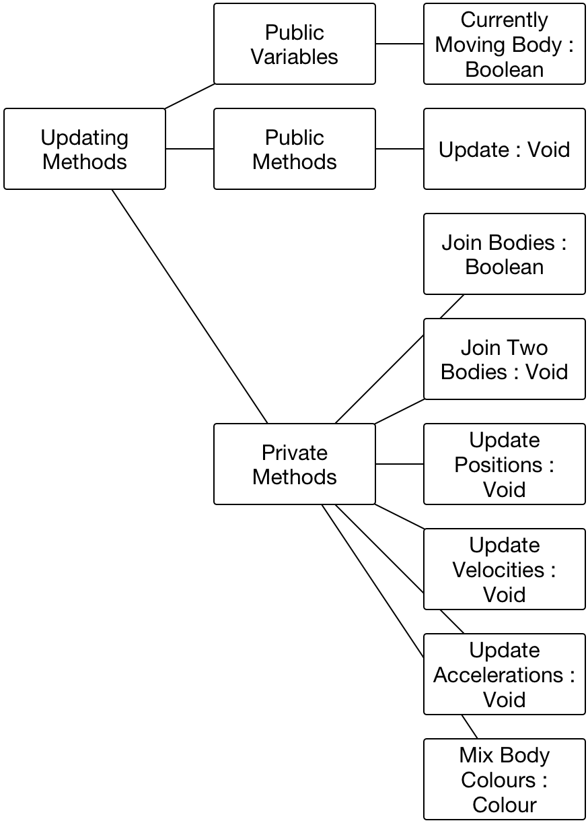

##### Methods

|  |  |  |  |
| --- | --- | --- | --- |
| Access Level | Name | Type | Description |
| Public | Update | Void | The method which is called to perform a full iteration of updating. Calls all of the necessary procedures required to do this. |
| Private | JoinBodies | Boolean | Checks for any intersections and resolves them. If there are intersections, then for each intersection, it calls JoinTwoBodies and will return True. If there are no intersections then returns False. |
| Private | JoinTwoBodies | Void | Joins the two passed bodies by summing their masses, using momentums to calculate the new velocity and then mixes their colours with respect to their masses by calling MixBodyColours. |
| Private | UpdatePositions | Void | For each body, calculates where it should move to due to its velocity and the passed delta. |
| Private | UpdateVelocities | Void | For each body, calculates what its new velocity should be due to its acceleration and the passed delta. |
| Private | UpdateAccelerations | Void | Calculates the net acceleration for each body using brute force. |
| Private | MixBodyColours | Colour | Takes in two bodies as input and mixes their colour with respect to their masses. This means if the mass of one body is greater, then its colour will have a greater effect on the output. |

## Design Data Dictionary

This section goes through each code base alongside their class diagram and explains the variables which will be stored.

### Main Form (Form/Class)

#### Class Diagram

This class diagram had to be split in half as it is so big. The piece to the right goes above the piece on the left.



#### Variables

|  |  |  |  |
| --- | --- | --- | --- |
| Access Level | Name | Type | Description |
| Private | Selected Body Refresh Timer | Timer | The timer who’s tick refreshes the information in the selected body info. |
| Private | Check Cursor Leave View Timer | Timer | The timer who’s tick disables the orbital ring and the mouse label if the cursor goes outside of the view. |
| Private | Zoom In Timer | Timer | The timer who’s tick zooms in the view and paints a frame to show it. |
| Private | Zoom Out Timer | Timer | The timer who’s tick zooms out the view and paints a frame to show it. |
| Private | Timescale Timer | Timer | The timer who’s tick changes the timescale with respect to the displacement of the timescale slider from the centre point. |
| Private | Auto Store Changes Timer | Timer | The timer who’s tick stores a “SimulationRun” change. |

### Changes (Shared Class)

#### Class Diagram



#### Variables

|  |  |  |  |
| --- | --- | --- | --- |
| Access Level | Name | Type | Description |
| Public | AutoStoreInterval | Integer | Holds the amount of time between every automatically change of the type “SimulationRun”. |
| Private | MaxStoredChanges | Integer | The maximum amount of changes allowed to be stored. |
| Private | Current Index | Integer | This holds the index of the change which represents the current state of the body array. Also used to indicate which change should have the “(Current)” marker next to it. |
| Private | Change List Array | Array (Of Change) | Holds all of the changes which have been added. |

### Game Loop (Shared Class)

#### Class Diagram



#### Variables

|  |  |  |  |
| --- | --- | --- | --- |
| Access Level | Name | Type | Description |
| Public | FPS | Integer | Holds the amount of frames which were processed and rendered in the last second. The value which is written to “FPS” in the info area. |
| Public | Simulated Time | Integer | Holds the amount of time, in seconds which has been simulated since the scene was cleared. |
| Public | Running | Boolean | Holds the value which indicates whether the game loop is currently playing. |
| Private | FrameStopwatch | Stopwatch | The stopwatch which records the amount of time for the current frame to be processed. |
| Private | FrameMilliseconds | Integer | Holds the amount of milliseconds taken for the most recent iteration of the game loop to compute. Used to be passed into the update procedure as the delta. |
| Private | SecondStopwatch | Stopwatch | Used to detect when a second has passed (the game loop will then update the fps and simulated time). |
| Private | FramesInSecond | Integer | The amount of frames in the current second. |
| Private | BackgroundLoop | Task | The background task in which the game loop itself will run. Allows for multithreading. |

### Trails (Shared Class)

#### Class Diagram



#### Variables

|  |  |  |  |
| --- | --- | --- | --- |
| Access Level | Name | Type | Description |
| Private | ScenePoints | Array (Of Array (Of PointF) ) | Holds the scene points for the trail for each body in the scene. |
| Private | Max Points | Integer | The maximum amount of points per body which will be stored. |
| Private | Render Points | Array (Of Array (Of PointF) ) | This holds the current representation of the scene points array considering the zoom and view position. This array can be used to directly render to the screen. |

### Body (Class)

#### Class Diagram



#### Variables

|  |  |  |  |
| --- | --- | --- | --- |
| Access Level | Name | Type | Description |
| Public ReadOnly | DominantImageColour | Colour | Holds the value of the average colour of the body’s image. |
| Public ReadOnly | Radius | Float | Calculates half of the body’s size value. |
| Public ReadOnly | TopLeft | PointF | Returns the top-left scene point. |
| Public | Image | Image | The image by which the the body can be rendered. This can be null. |
| Public | IsUsingBitmap | Boolean | The value which indicates whether the body should be rendered as a bitmap or not (a solid colour). |
| Public | Colour | Colour | The colour that the body should be rendered. |
| Public | Mass | Float | The mass of the body. |
| Public | Size | Float | The height or width (they are the same as it is a circle) of the body. |
| Public | Center | PointF | The centre point of the body. |
| Public | Acceleration | Vector | The current acceleration of the body. |
| Public | Velocity | Vector | The velocity of the body. |

### Change (Private Class Within Changes)

#### Class Diagram



#### Variables

|  |  |  |  |
| --- | --- | --- | --- |
| Access Level | Name | Type | Description |
| Public | ChangeType | ChangeType | Holds the type of change which was made in order to store this change. |
| Public | BodyDatas | Array (Of Body) | Holds the copy of the BodyDatas array which was made when this Change was made. |
| Public | RunTime | Integer | This variable has a value of 0 when the type of change is not “SimulationRun”. Otherwise, this will be an automatic change and will store the amount of seconds that the simulation had been running for. |

### Vector (Class)

#### Class Diagram



#### Variables

|  |  |  |  |
| --- | --- | --- | --- |
| Access Level | Name | Type | Description |
| Public | x | Double | The horizontal component of the vector. Can also be known as *i*. |
| Public | y | Double | The vertical component of the vector. Can also be known as *j*. |

### Body Methods (Module)

#### Class Diagram



#### Variables

|  |  |  |  |
| --- | --- | --- | --- |
| Access Level | Name | Type | Description |
| Public | SelectedBodyIndex | Integer | The index of the body which is current selected. |
| Public | BodyDatas | Array (Of Body) | The array in which the data for each of the bodies is stored. |

### File Handling (Module)

#### Class Diagram



#### Variables

|  |  |  |  |
| --- | --- | --- | --- |
| Access Level | Name | Type | Description |
| Private | AppData Folder Path | String | Stores the path of the programs application data folder. |

### Graphics Methods (Module)

#### Class DIagram



#### Variables

|  |  |  |  |
| --- | --- | --- | --- |
| Access Level | Name | Type | Description |
| Public | GraphicsBuffer | BufferedGraphics | Allows for the simulation to be buffered. |

### Mouse Methods (Module)

#### Class Diagram



#### Variables

|  |  |  |  |
| --- | --- | --- | --- |
| Access Level | Name | Type | Description |
| Private | MouseIsDown | Boolean | Indicates whether the mouse is currently being held down. |
| Private | PreviousMousePosition | PointF | Used to calculate during pan how much the view should be moved from the previous. |
| Private | ScenePointOnBody | PointF | Used in move body to ensure that the position of the mouse maintains the same position on the body. |
| Private | MouseInputSub | Delegate (Of Void) | Used within the RunCursorSub method to reduce code. |

### Other Methods (Module)

#### Class Diagram



#### Variables

None.

### Painting Methods (Module)

#### Class Diagram



#### Variables

|  |  |  |  |
| --- | --- | --- | --- |
| Access Level | Name | Type | Description |
| Public | PaintOrbital | Boolean | Indicates whether the orbital ring should be painted. This can only true when the user is currently using Add Orbital. |
| Public | OrbitingBodyIndex | Integer | The index of the body which the user is about to create an orbital around, while using Add Orbital. This is the index of the body which has a ring around it. |
| Public | ShowMouseLabel | Boolean | Indicates whether the mouse label should be drawn. |
| Public | MouseLabelText | String | The string which will be painted to the mouse label. |

### Scene Methods (Module)

#### Class Diagram



#### Variables

|  |  |  |  |
| --- | --- | --- | --- |
| Access Level | Name | Type | Description |
| Public | ZoomScale | Float | The amount which the view is currently zoomed. |
| Public | ViewPosition | PointF | The position of the top-left point of the view on the scene. |
| Public | RenderBoxSize | Size | The size of the view in terms of rendering units. |
| Public | Timescale | Integer | The value of the timescale in terms of seconds. |
| Public | BigG | Float | The value of the universal gravitational constant used by the simulation. |
| Public | ShowVelocity | Boolean | The value which indicates whether the velocity lines should be drawn from the bodies. |
| Public | ShowTrails | Boolean | The value which indicates whether the trails should be drawn. |
| Public | GravityEnabled | Boolean | The value which indicates whether the bodies should experience a force due to gravitation. If this is false then the body’s velocities remain constant. |

### Updates And Errors (Module)

#### Class Diagram



#### Variables

None.

### Updating Methods (Module)

#### Class Diagram



#### Variables

|  |  |  |  |
| --- | --- | --- | --- |
| Access Level | Name | Type | Description |
| Public | CurrentlyMovingBody | Boolean | Indicates whether the selected body is currently being dragged by the user. When this is True, then the selected body will not move due to its velocity. |

## Description of record structure

In order to save the current state of the scene, I will create a simple CSV file in which the base properties are stored. The most difficult part is to try and convert *Image* to text in order to store it. After researching, I found that I could convert it to a base64 string[10] composed of [a-z], [A-Z], [0-9] and [+, /].

In the partial example below, there are 4 bodies, the last has an image of earth assigned to it. The base64 string is very long (only a fifth of the file is shown) but it successfully stores the image property. This was created using my prototype application which uses smaller bodies (as you can see from the values). Also note that this application used to view the file (TextEdit) forces a wrap around the text, so the long base64 value is actually on one line.

I will also be including some global variables so that the file includes almost a full snapshot of the application at the time the user saves it. The save feature will just be a standard button and will open up a SaveFileDialog for the user to choose where and what the name should be of the file. I have chosen the extension ‘.gsim’ because I plan on calling my application “G-Sim”.

When opening the file, I shall just run through all of the values in the file (separating them by commas and line breaks) and change the variables in the simulation / global modules accordingly.

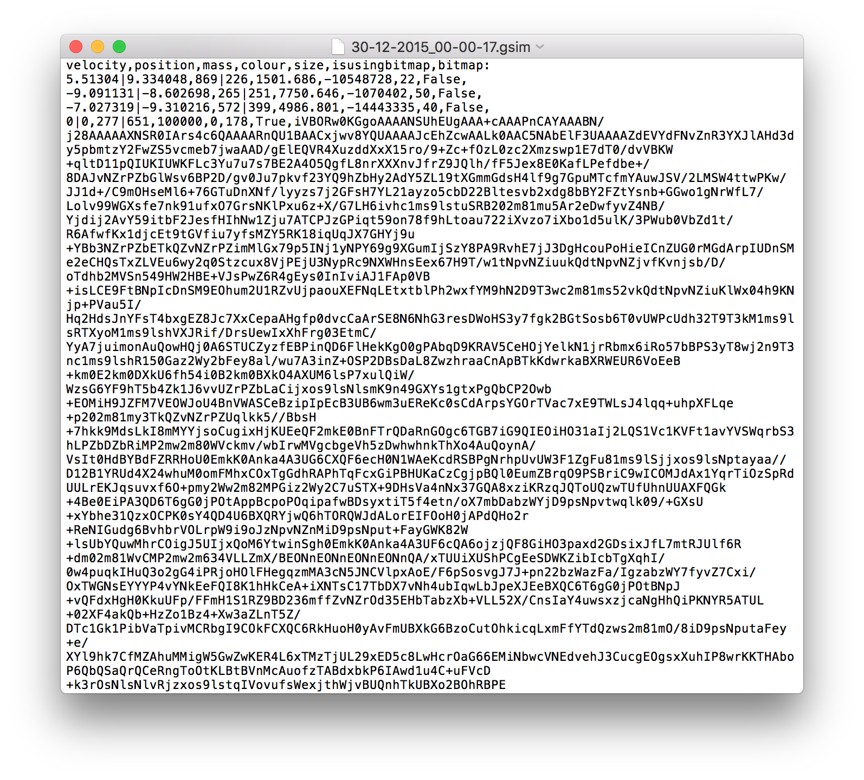

## Validation Design

Validating user input is essential to creating a reliable application. Fortunately, due to the way that I have designed the program (only mouse input), I require very little validation. The validation which I do require is discussed below.

The validation is split into two sections, limit validation and standard validation. Limit validation is more to do with designing the limits of the application and ensuring that the user cannot pass these limits such as the number of bodies in the scene or the velocity of a body. What I refer to as ‘standard’ validation, is non-numeric validation such as trying to set a corrupt image of a body or creating a body inside another.

The way which I will be making sure variables are within certain bounds is to use my “Force Min Bounds” and “Force Max Bounds” methods which will be under the OtherMethods module. They work by checking if a variable is within the given bounds and if not then sets the variables equal to the given closest bound. These methods are functions which return True when the value has not been changed, False otherwise.

### Limit Validation

#### TimeScale

This shall limit the value of time scale similar to how zoom is limited. Within the time scale property’s “Set”, I shall not allow the value of time scale to exceed the bounds. No message box will be displayed.

#### Number of Bodies

I do not think it is viable to limit the amount of bodies which the user is allowed to add. This is because, thinking outside of the application being used in Trent College, there will be computers which can simulate a very large amount of bodies so it is not fair to limit the application in this way. The user can decide for themselves how many bodies their computers can handle.

#### Scene Grid

I decided to use PointF for the positions. This is a structure composed of two floating point variables – one for x and one for y. The maximum value of a Float type in VB.Net (Single) is 3.40282347E+38[11].

From this maximum, I produced my scene grid boundary of 1E+35 by 1E+35 as it is large enough to hold any scene which the user will create and an easy number to remember.

#### Viewport Position

Given the scene grid limit, the maximum viewport position should also be ± 1E+35 in both axes. If possible then whenever the viewport location is changed then it should be checked that no part of the view sees outside of the bounds.

No message box should be shown.

#### Zoom

With the zoom value, it increases as the view is zoomed in and decrease as it Is zoomed out. I shall set the minimum zoom percentage to be 0.1% and the maximum to be 10000%, allowing for 100x zoom either way. The percentage will be a value out of the initial value though, so I need to decide on an initial value.

I shall experiment with different values for zoom as I am working on the implementation, then the upper and lower boundaries shall be calculated and implemented from that value.

No message box should be displayed when trying to exceed or go below these values.

#### Time Scale

Considering that a year in terms of seconds gives $60×60×24×365=31,536,000$ which can easily be represented as a standard 32-bit integer which has a maximum value of ±2,147,483,647. If I chose to use a 32-bit integer, then the maximum time scale would be just over 69 years/second which is plenty. I’ll limit the scale to 50 years/second because this is a nice round number and I don’t believe anybody will be using the simulation at a rate greater than that. This gives a max value for the timescale variable to be $60×60×24 ×365×50=1,576,800,000$.

50 years per second may seem somewhat over-the-top, but it is up to the user to decide how they use the application and they should be limited as little as possible. If they see that the simulation is going crazy and becoming incredibly inaccurate then they should learn and reduce it. I shall talk about this in the user manual so that they know of these potential issues.

#### Velocities

The absolute maximum velocity for any planet in any interaction is the speed of light which approximately equals 3x10^8 so I think this would be a suitable maximum for the magnitude. I shall ensure that whenever the velocity tries to exceed this, it shall be set to the speed of light using the ChangeMagnitude function in the vector class.

#### Body Mass

The only way that the user will be able to make a mass go out of bounds is either when they are adding a body or changing the mass of a body.

Using the method discussed at the beginning of “Validation Design”, I shall display a message box saying “The maximum allowed mass of a body is 10^35Kg”, then setting the mass to 10^35Kg.

It is possible that when large bodies join together, they could create a mass which is greater than 10^35Kg. For this reason, the mass of the body will be checked whenever it is changed. In the case of bodies joining, no message box should be displayed.

### Standard Validation

#### Creating Bodies Inside Each Other

This can only occur when the user is adding a body and their cursor is inside a body when they press down on the mouse.

I shall display a message box saying “You cannot add a body inside another body”.

#### Adding a Body Out of the Range of the Scene

If I properly implement the “Viewport Position” validation, then this cannot happen. I am only concerned about whether the *centre* is within the bounds of the scene, not each edge of the body.

#### Body Moving Out of Range of the Scene

When the simulation is playing and a body moves out of range of the scene, it needs to be removed. No message box will be displayed.

#### Creating Bodies of Zero Mass

This can only occur when the user is adding a body.

When the user releases their mouse button, I shall check whether the body they have just added actually has mass and if not then remove the body and display a message box saying “You cannot add a body of mass 0Kg. To create a body, move your mouse to where you want the centre to be and then drag to define its mass/size.”.

#### Setting A Corrupt Image

This can occur either when clicking “Set Image” or when loading from a CSV. The loading file method will have inbuilt error checking to prevent loading corrupted data in addition to images.

When I am trying to set the image property of the body, I shall create a try block enclosing the necessary code. When the try block catches an exception, I shall stop the process, set the image to null and set the IsUsingBitmap property to False to avoid trying to render a corrupt image.

#### Loading a Corrupt File

This can only happen when the user has clicked “Load Scene” and selected a corrupt gsim file.

I will have a header row above the settings/options line and above the body lines. If either of these two do not look how they should then I assume that the file is corrupted and stop the method, returning to the application how it was before clicking “Load Scene”.

The user can obviously tamper with the gsim file as it is in plaintext and change values to their choosing. One way of checking if the values have been tampered with would be to hash the file with MD5 for example and add that hash string to the end of the file. So long as the values do not cause the program to crash then there is no problem so checking the values should not be an issue. To ensure that the file does not crash the program, the call to the LoadScene function shall have a try block enclosing it.

#### Cursor Functions When No Bodies

I have a function named BodyArrayEmpty() which checks if there are any bodies. Whenever the user pressed down on their mouse, I shall call this function. If there are bodies, then any cursor function can be used but if not then only add body and zooming will be enabled.

## Identification of Storage Media

Fortunately, this project is not top secret so does not require any encryption or security. It will be stored on a HDD, SSD, USB stick or anything the user wants to put it onto.

I plan for the application to be a standalone exe file, there is no need to install program and it will be much easier to copy a single exe file to another computer.

The application will be able to be downloaded from a cloud service online. I shall give a link to anyone who wishes to use the application. It will also be on GitHub for others to view the source code and to help the coding community.

It is likely that updates to the program will be made so I shall distribute these updates over a cloud service (I plan to use mega.nz). The program will check (upon start-up) if there are any updates available by comparing the downloaded version to a version on a webpage (this will be as a string). If there is a more up-to-date version, then the program will notify the user and direct them to a webpage which will forward them to the cloud service to download the file.

As can be seen in “Description of Record Structure”, the “.gsim” file will be stored with plaintext contents generated by values in the application at the time of saving. There is no need to encrypt these files or restrict editing. If the user chooses to edit the file and sets out-of-range values, then the program will simply not load the file.

## Suitable Algorithms

As I have now designed the project and the methods and variables it must contain, I can begin to code the modules. In this section, I have included the pseudo-code for each of the modules / classes.

In VB.Net, properties have both a get and a set method. For each property, I have created a function and procedure to get and set respectively. When I code an access of a property (e.g. DECLARE x = Velocity), assume that it will be calling the “get_” method for the corresponding property (e.g. DECLARE x = Velocity, the same as DECLARE x = get_Velocity()) . Likewise when setting a property (e.g. Center = PointF(0, 0), the same as Call set_Center(PointF(0, 0))). I have written my pseudo code this way because it will be easier to transition to VB.Net code and also it improves readability.

### Main Form (Form/Class)

|  |  |
| --- | --- |
| Name | Description |
| Load | Starting at the beginning, I shall have a handler on the form load event which initialises the necessary objects. The interval values for the timers are in terms of milliseconds. |
| PROCEDURE LoadApplication() Handles application load  Add handler to the global unhandled exception event  Set RenderBoxSize = pnlRender.Size  Call SetupResources()  Initialise the graphics buffer  Enable anti-aliasing on the buffer  Clear the buffer with white  Set CurrentBodyRefreshTimer.Interval = 500  Start CurrentBodyRefreshTimer  Set CheckCursorLeaveViewTimer.Interval = 50  Start CheckCursorLeaveViewTimer  Set TimescaleTimer.Interval = 200  Set ZoomInTimer.Interval = 50  Set ZoomOutTimer.Interval = 50  Set AutoStoreSimulationChangesTimer.Interval = 5000  Call UpdateUI()  END PROCEDURE | |

|  |  |
| --- | --- |
| Name | Description |
| Shown | When the form is first shown, this algorithm is run. It simply paints a frame and then checks for updates. |
| PROCEDURE ShownHandler() Handles application shown  Call GameLoop.PaintOnce()  Call UpdatesAndErrors.CheckVersion()  END PROCEDURE | |

|  |  |
| --- | --- |
| Name | Description |
| Closing | When the form begins to close, the game loop is paused. |
| PROCEDURE ExitHandler() Handles application exit  Call GameLoop.Pause()  END PROCEDURE | |

|  |  |
| --- | --- |
| Name | Description |
| UpdateUI | This method will update the UI by disabling certain components when there are no bodies and enable them when there are bodies. |
| PROCEDURE UpdateUI()  IF BodyArrayEmpty() THEN  Disable grpSelectedBody  Disable btnPlayPause  Disable btnSaveScene  Disable btnClearScene  ELSE  Enable grpSelectedBody  Enable btnPlayPause  Enable btnSaveScene  Enable btnClearScene  END IF  Call GameLoop.PaintOnce()  END PROCEDURE | |

|  |  |
| --- | --- |
| Name | Description |
| Select Image Button Click | This button will just run a method placed in “File Handling” which guides the user through setting an image. |
| PROCEDURE SetImageSelectedBody()  Call ProcessSelectImage()  END PROCEDURE | |

|  |  |
| --- | --- |
| Name | Description |
| Refresh Current Body Info Timer Tick | On every tick of RefreshCurrentBodyInfoTimer, the info in “Selected Body” needs to be updated. This can be done by the following code. |
| PROCEDURE RefreshCurrentBodyInfo() Handles SelectedBodyRefreshTimer.Tick    IF BodyArrayEmpty() THEN  Clear lbSelectedBodyInfo  Set btnSelectedBodySetImage.Text = "Set Image"  RETURN  END IF  Clear lbSelectedBodyInfo  Add BodyDatas(SelectedBodyIndex).Mass to lbSelectedBodyInfo  Add BodyDatas(SelectedBodyIndex).Radius to lbSelectedBodyInfo  Add BodyDatas(SelectedBodyIndex).Velocity.Magnitude to lbSelectedBodyInfo  Add BodyDatas(SelectedBodyIndex).Acceleration.Magnitude to lbSelectedBodyInfo  IF BodyDatas(SelectedBodyIndex).IsUsingBitmap THEN  Set btnSelectedBodySetImage.Text = "Change Image"  ELSE  Set btnSelectedBodySetImage.Text = "Set Image"  END IF  END PROCEDURE | |

|  |  |
| --- | --- |
| Name | Description |
| Show Velocity Checkbox Checked Changed | This simply sets the ShowVelocity global in PaintingMethods equal to whether it is checked and then paints a frame. |
| PROCEDURE ShowVelocity_CheckedChanged() Handles chkShowVelocity.CheckedChanged  Set ShowVelocity = chkShowVelocity.Checked  Call GameLoop.PaintOnce()  END PROCEDURE | |

|  |  |
| --- | --- |
| Name | Description |
| Show Trails Checkbox Checked Changed | This simply sets the ShowTrails global in PaintingMethods equal to whether it is checked and then paints a frame. |
| PROCEDURE ShowTrails_CheckedChanged() Handles "Show Trails" checked changed  Set ShowTrails = “Show Trails” checked property  Call GameLoop.PaintOnce()  END PROCEDURE | |

|  |  |
| --- | --- |
| Name | Description |
| Clear All Trails Button Click | Calls a method inside the Trails class to clear the trails and then paints a frame. |
| PROCEDURE ClearAllTrails() Handles "Clear Trails" button click  Call Trails.ClearAllTrails()  Call GameLoop.PaintOnce()  END PROCEDURE | |

|  |  |
| --- | --- |
| Name | Description |
| Zoom In Button Down | Starts ZoomInTimer. |
| PROCEDURE ZoomIn_MouseDown() Handles ZoomIn button MouseDown  Start ZoomInTimer  END PROCEDURE | |

|  |  |
| --- | --- |
| Name | Description |
| Zoom In Timer Tick | On the tick event of ZoomInTimer, the method inside MouseMethods is called and told to zoom in using the centre point. Then show the changes on the screen. |
| PROCEDURE ZoomInTick() Handles ZoomInTimer.Tick  Call ZoomInOut(1, RenderBoxSize.Width / 2, RenderBoxSize.Height / 2)  END PROCEDURE | |

|  |  |
| --- | --- |
| Name | Description |
| Zoom In Button Up | Stops ZoomInTimer to stop zooming in. |
| PROCEDURE ZoomIn_MouseUp() Handles ZoomIn button MouseUp  Stop ZoomInTimer  END PROCEDURE | |

|  |  |
| --- | --- |
| Name | Description |
| Zoom Out Button Down | Starts ZoomOutTimer. |
| PROCEDURE ZoomOut_MouseDown() Handles ZoomOut button MouseDown  Start ZoomOutTimer  END PROCEDURE | |

|  |  |
| --- | --- |
| Name | Description |
| Zoom Out Timer Tick | On the tick event of ZoomOutTimer, the method inside MouseMethods is called and told to zoom out using the centre point. Then show the changes on the screen. |
| PROCEDURE ZoomOutTick() Handles ZoomOutTimer.Tick  Call ZoomInOut(-1, RenderBoxSize.Width / 2, RenderBoxSize.Height / 2)  END PROCEDURE | |

|  |  |
| --- | --- |
| Name | Description |
| Zoom Out Button Up | Stops ZoomOutTimer to stop zooming out. |
| PROCEDURE ZoomOut_MouseUp() Handles ZoomOut button MouseUp  Stop ZoomOutTimer  END PROCEDURE | |

|  |  |
| --- | --- |
| Name | Description |
| Enable Gravity Checkbox Checked Changed | Simply updates the GravitationEnabled global in UpdatingMethods to whether the checkbox is checked and then paints a frame. |
| PROCEDURE Gravity_CheckedChanged() Handles "Gravity" checkbox 's CheckedChanged  Set GravitationEnabled = "Enable Gravity " checkbox 's checked property  Call GameLoop.PaintOnce()  END PROCEDURE | |

|  |  |
| --- | --- |
| Name | Description |
| Timescale Slider Mouse Down | Starts the TimescaleTimer to begin detecting changes to the Timescale slider. |
| PROCEDURE trackerTimescale_MouseDown() Handles trackerTimescale.MouseDown  Start TimescaleTimer  END PROCEDURE | |

|  |  |
| --- | --- |
| Name | Description |
| Timescale Slider Timer Tick | I will set the slider to have a minimum of -5 and a maximum of 5. This means that the midpoint will be 0. 0 will be where the slider usually is. Whenever the slider is not at 0, then the time scale should be changed. |
| PROCEDURE TimescaleTimer_Tick() Handles TimescaleTimer.Tick  Set Timescale *= 1 + (its value / 50)  Call GameLoop.PaintOnce()  END PROCEDURE | |

|  |  |
| --- | --- |
| Name | Description |
| Timescale Slider Mouse Up | Stops the TimescaleTimer and sets the slider back to the midpoint (0). Defocuses the slider so that the user cannot use keyboard input. |
| PROCEDURE trackerTimescale_MouseUp() Handles trackerTimescale.MouseUp  Stop TimescaleTimer  Set Timescale slider 's value to 0  Defocus the slider //so it cannot be changed with arrow keys  END PROCEDURE | |

|  |  |
| --- | --- |
| Name | Description |
| Change List Changed | Updates the list box to show the new changes by using the ChangesIntoListBox in Changes. |
| PROCEDURE ChangeListHasChanged()  Clear lbChanges  Call Changes.ChangesIntoListbox(lbChanges)  END PROCEDURE | |

|  |  |
| --- | --- |
| Name | Description |
| Listbox Selected Index Changed | Occurs when the user clicks an element in the list box. As the list box will be displayed in the opposite order to what is contained in the ChangeList array in Changes, the index of an item in the list box differs to the index of the corresponding item in the array. This algorithm calculates the index of the item in the array in Changes and then uses the RollBackChanges method in Changes to revert the scene to show the selected element in the list box. |
| PROCEDURE Changes_SelectedIndexChanged() Handles lbChanges.SelectedIndexChanged  //Don’t run this if its set to -1 (see below where the index is changed)  IF lbChanges.SelectedIndex = -1 THEN RETURN  Call GameLoop.StoreAndPause()  DECLARE OldestToNewestIndex As Integer = (length of UndoChanges list box) – 1 – (SelectedIndex)  Call Changes.RollbackChanges(OldestToNewestIndex)  Set lbChanges.SelectedIndex = -1 //to deselect the selected item  Call UpdateUI()  Call GameLoop.ContinueStored()  END PROCDURE | |

|  |  |
| --- | --- |
| Name | Description |
| Auto Store Change Timer Tick | This timer will be started and stopped as the simulation is. Every tick, store a change of type “SimulationRun”. |
| PROCEDURE AutoStoreSimulationWhileRunning() Handles AutoStoreSimulationChangesTimer.Tick  Call Changes.AddChange(ChangeType.SimulationRun)  END PROCEDURE | |

|  |  |
| --- | --- |
| Name | Description |
| Play/Pause Button Click | Toggles the playing state of GameLoop. If it pauses, then it adds a change of type “SimulationPaused”. |
| PROCEDURE TogglePlayPause() Handles btnPlayPause.Click  IF GameLoop.Playing Then  Call GameLoop.Pause()  Call Changes.AddChange(ChangeType.SimulationPaused)  ELSE  Call GameLoop.Start()  END IF  END PROCEDURE | |

|  |  |
| --- | --- |
| Name | Description |
| Gameloop Playing Changed | The method which is run when the playing state of GameLoop is changed. Changes the text of btnPlayPause and starts or stops the AutoStoreChangeTimer. |
| PROCEDURE GameLoopStateChanged()  IF GameLoop.Running Then  Set btnPlayPause.Text = "Pause"  Start AutoStoreChangesTimer  ELSE  Set btnPlayPause.Text = "Play"  Stop AutoStoreChangesTimer  END IF  END PROCEDURE | |

|  |  |
| --- | --- |
| Name | Description |
| Clear Scene Button Click | Clears the scene, clears the trails and resets the GameLoop.SimulatedTime value, then adds a change of type “ClearSimulation” then paints a frame. |
| PROCEDURE ClearScene() Handles btnClearSimulation.Click  Call GameLoop.Pause()  Set BodyDatas = NULL  Call Trails.ClearAllTrails()  Call GameLoop.ResetSimulatedTime()  Call Changes.AddChange(ChangeType.ClearSimulation)  Call UpdateUI()  END PROCEDURE | |

|  |  |
| --- | --- |
| Name | Description |
| Load Scene Button Click | Runs the LoadCSVFile in FileHandling, adds a change of type “LoadScene” then paints a frame. |
| PROCEDURE LoadScene() Handles btnLoadScene.Click  Call FileHandling.LoadCSVFile()  Call Change.AddChange(ChangeType.LoadScene)  Call UpdateUI()  END PROCEDURE | |

|  |  |
| --- | --- |
| Name | Description |
| Save Scene Button Click | Calls the SaveCSVFile method in FileHandling. |
| PROCEDURE SaveScene() Handles btnSaveScene.Click  Call SaveCSVFile()  END PROCEDURE | |

|  |  |
| --- | --- |
| Name | Description |
| Quit Button Click | Exits the form and so the application. |
| PROCEDURE Quit() Handles btnQuit.Click  Exit Application  END PROCEDURE | |

|  |  |
| --- | --- |
| Name | Description |
| Set Selected Cursor Function | Sets the value of SelectedRadio in MouseMethods so that the mouse methods know which function to perform. |
| PROCEDURE SetSelectedCursorFunction()  //Runs through each radio in mouse function and returns the MouseFunction corresponding to the selected radio  IF radioAddBody.Checked Then  Set SelectedRadio = MouseFunction.AddBody  ELSEIF radioAddOrbital.Checked Then  Set SelectedRadio = MouseFunction.AddOrbital  ELSEIF radioChangeMass.Checked Then  Set SelectedRadio = MouseFunction.ChangeMass  ELSEIF radioChangeVelocity.Checked Then  Set SelectedRadio = MouseFunction.ChangeVelocity  ELSEIF radioMoveBody.Checked Then  Set SelectedRadio = MouseFunction.MoveBody  ELSEIF radioMoveView.Checked Then  Set SelectedRadio = MouseFunction.Pan  ELSEIF radioRemoveBody.Checked Then  Set SelectedRadio = MouseFunction.RemoveBody  ELSEIF radioSelectBody.Checked Then  Set SelectedRadio = MouseFunction.SelectBody  END IF  END PROCEDURE | |

|  |  |
| --- | --- |
| Name | Description |
| Scene View Mouse Down | Calls the “Set Selected Cursor Function” procedure, then calls RunCursorSub in MouseMethods passing the correct values, then finally calls UpdateUI(). |
| PROCEDURE View_MouseDown() Handles pnlRender.MouseDown  Call SetSelectedCursorFunction()  Call RunCursorSub(EventType.Down, Cursor.Location)  Call UpdateUI()  END PROCEDURE | |

|  |  |
| --- | --- |
| Name | Description |
| Scene View Mouse Move | Calls the “Set Selected Cursor Function” procedure, then calls RunCursorSub in MouseMethods passing the correct values, then finally calls UpdateUI(). |
| PROCEDURE View_MouseMove() Handles pnlRender.MouseMove  Call SetSelectedCursorFunction()  Call RunCursorSub(EventType.Move, Cursor.Location)  Call UpdateUI()  END PROCEDURE | |

|  |  |
| --- | --- |
| Name | Description |
| Scene View Mouse Up | Calls the “Set Selected Cursor Function” procedure, then calls RunCursorSub in MouseMethods passing the correct values, then finally calls UpdateUI(). |
| PROCEDURE View_MouseUp() Handles pnlRender.MouseUp  Call SetSelectedCursorFunction()  Call RunCursorSub(EventType.Up, Cursor.Location)  Call UpdateUI()  END PROCEDURE | |

|  |  |
| --- | --- |
| Name | Description |
| Check Cursor Leave View Timer Tick | This is required because of the orbital ring. When the cursor is moved out of the view then the orbital ring should not be displayed. This handler will check where the mouse is and if it’s outside of the rendering panel then change the value of the PaintOrbital global to False as well as ShowMouseLabel. |
| PROCEDURE CheckCursorStillInView() Handles CheckCursorLeaveViewTimer.Tick  DECLARE MousePosition As PointF = Cursor.Position    IF NOT InsideRectangle(MousePosition, Rectangle(PointF(0, 0), RenderBoxSize)) THEN  Set PaintOrbital = False  Set ShowMouseLabel = False  Call GameLoop.PaintOnce()  END IF  END PROCEDURE | |

|  |  |
| --- | --- |
| Name | Description |
| Scene View Scroll | This procedure zooms the view with respect to the amount that has been scrolled (the mouse *delta*). |
| PROCEDURE View_MouseWheel() Handles pnlRender.MouseWheel  DECLARE Delta As Integer = GetMouseDelta()  Call ZoomInOut(Delta, Cursor.Location)  Call GameLoop.PaintOnce()  END PROCEDURE | |

### Changes (Shared Class)

|  |  |
| --- | --- |
| Name | Description |
| Add Change | Adds a change of the given type. Performs a shallow clone of each body in BodyDatas to store with the corresponding change so that the scene can be reverted. Proceeds to calculate the running time of the simulation since it was played by adding the auto store interval (seconds) to the run time of the previous change in the list (0 if there isn’t one). Removes any excess changes too.  Note that no trails are stored in a change. |
| PROCEDURE AddChange(ChangeType As ChangeType)  Call RemoveNewerChanges(CurrentIndex)  DECLARE BodyDatas As Body()  IF BodyArrayEmpty() THEN  Set the size of BodyDatas (local) to 0  ELSE  Set the size of BodyDatas (local) to (BodyMethods.BodyDatas.Length - 1)  FOR i As Integer = 0 to BodyDatas.Length - 1  BodyDatas(i) = BodyMethods.BodyDatas(i).Clone()  Next  END IF  DECLARE RunTime = 0  IF ChangeType = ChangeType.SimulationRunTime THEN  Set RunTime = AutoStoreWhileRunningIntervalSeconds  DECLARE i = ChangeList.Count - 1  WHILE ChangeList(i).ChangeType = ChangeType.SimulationRunTime And i > 0  Set RunTime += AutoStoreWhileRunningIntervalSeconds  Set i -= 1  ENDWHILE  END IF  Add Change(ChangeType, BodyDatas, RunTime) to ChangeList  Call RemoveExcess()  Set CurrentIndex = ChangeList.Count - 1  Raise the ListChanged event  END PROCEDURE | |

|  |  |
| --- | --- |
| Name | Description |
| Rollback Changes | Restores the bodies of the change at the given index and assigns them each a new trail. |
| PROCEDURE RollbackChanges(OldestToNewestIndex As Integer)  Call Trails.RemoveAllTrails()  IF NOT ChangeList(OldestToNewestIndex).BodyDatas.Count = 0 THEN  FOR BodyDatasIndex As Integer = 0 TO ChangeList(OldestToNewestIndex).BodyDatas.Count - 1  Set BodyDatas(BodyDatasIndex) = ChangeList(OldestToNewestIndex).BodyDatas(BodyDatasIndex).Clone()  END FOR  END IF  IF NOT BodyArrayEmpty() THEN  FOR i As Integer = 0 TO BodyDatas.Length - 1  Call Trails.AddBodyTrail()  Next  END IF  Set CurrentIndex = OldestToNewestIndex  Raise the ListChanged event  END PROCEDURE | |

|  |  |
| --- | --- |
| Name | Description |
| Remove Newer Changes | Removes all of the changes which are newer than the given index. |
| PROCEDURE RemoveNewerChanges(AfterIndex As Integer)  IF NOT AfterIndex = ChangeList.Count - 1 THEN  Remove (ChangeList.Count - AfterIndex - 1) changes from ChangeList starting from (AfterIndex + 1)  Raise the ListChanged event  END IF  END PROCEDURE | |

|  |  |
| --- | --- |
| Name | Description |
| Remove Excess | Removes changes which are older than the MaxStoredChanges constant |
| PROCEDURE RemoveExcess()  IF ChangeList.Count > MaxStoredChanges THEN  Remove (ChangeList.Count - MaxStoredChanges) changes from ChangeList starting at 0  END IF  END PROCEDURE | |

|  |  |
| --- | --- |
| Name | Description |
| Changes Into Listbox | Enumerates all of the changes in the array into the list box in a way that means that the newest change is at index 0 (the top).Each change is represented by its description which is returned from GetChangeString. The “(Current)” marker is given to the change which has that index CurrentIndex. |
| PROCEDURE ChangesIntoListBox(ByRef lb As ListBox)  IF ChangeList.Count = 0 THEN RETURN  FOR i = (ChangeList.Count - 1) TO 0 Step -1  IF i = CurrentIndex THEN  Add (GetChangeString(ChangeList(i)) + " (Current)") to lb  ELSE  Add GetChangeString(ChangeList(i)) to lb  END IF  Next  END PROCEDURE | |

|  |  |
| --- | --- |
| Name | Description |
| Get Change String | Returns the description which corresponds to the given change. This will be used to represent changes in the list box on the form. |
| FUNCTION GetChangeString(change As Change) As String  SELECT Case change.ChangeType  Case ChangeType.AddBody  RETURN "Added Body"  Case ChangeType.AddOrbital  RETURN "Added Orbital"  Case ChangeType.MoveBody  RETURN "Moved Body"  Case ChangeType.ChangeVelocity  RETURN "Changed Velocity"  Case ChangeType.ChangeMass  RETURN "Changed Mass"  Case ChangeType.RemoveBody  RETURN "Removed Body"  Case ChangeType.SimulationRunTime  RETURN "Simulation Run For " + GetTimeString(change.RunTime, 1)  Case ChangeType.SimulationPaused  RETURN "Simulation Paused"  Case ChangeType.ClearSimulation  RETURN "Cleared Scene"  Case ChangeType.LoadScene  RETURN "Loaded Scene"  Case ELSE  RETURN ""  END SELECT  END FUNCTION | |

|  |  |
| --- | --- |
| Name | Description |
| Change Type | This is an enumeration which will store the type of change in a change stored in the ChangeList array. This will be used to work out what should be printed to the list box. |
| ENUM ChangeType  AddBody  AddOrbital  MoveBody  ChangeVelocity  ChangeMass  RemoveBody  SimulationRunTime  SimulationPaused  ClearSimulation  LoadScene  END ENUM | |

|  |  |
| --- | --- |
| Name | Description |
| List Has Changed Handler | Simply calls the *handler* on the main form. It is done this way because methods cannot be handlers of a shared class’ event. |
| PROCEDURE ListHasChanged() handles the ListChanged event  Call MainForm.ChangeListHasChanged()  END PROCEDURE | |

### Game Loop (Shared Class)

|  |  |
| --- | --- |
| Name | Description |
| Running | The running property will have it’s get method as public but will only be able to be set from within the GameLoop class (private). When the running value is changed, the game loop will call mainform’s method to let it know. |
| FUNCTION get_Running() RETURNS Boolean  RETURN _Running  END FUNCTION  PROCEDURE set_Running(value As Boolean)  Set _Running = value  Call MainForm.GameLoopStateChanged()  END Set | |

|  |  |
| --- | --- |
| Name | Description |
| Game Loop | The main loop which is used to continuously update and paint to the view. |
| PROCEDURE Game_Loop()  Restart SecondStopwatch  WHILE Running  Restart FrameStopwatch  Call Update(FrameMilliseconds / 1000)  Paint()  Set FramesInSecond += 1  IF SecondStopwatch.ElapsedMilliseconds > 999 THEN  Set FPS = 1000 * FramesInSecond / SecondStopwatch.ElapsedMilliseconds  Set FramesInSecond = 0  Set SimulatedTime += Timescale * SecondStopwatch.ElapsedMilliseconds / 1000  Restart SecondStopwatch  END IF  Set FrameMilliseconds = FrameStopwatch.ElapsedMilliseconds  ENDWHILE  Stop SecondStopwatch  Stop FrameStopwatch  END PROCEDURE | |

|  |  |
| --- | --- |
| Name | Description |
| Wait For Finish | Waits for bgLoop to finish executing. |
| PROCEDURE Wait()  IF bgLoop IS NULL THEN  RETURN  END IF  Wait bgLoop  END PROCEDURE | |

|  |  |
| --- | --- |
| Name | Description |
| Start | Starts the game loop running. |
| PROCEDURE Start()  IF NOT Running THEN  Set Running = True  Set bgLoop = new background thread using Game_Loop()  Start bgLoop on separate thread  END IF  END PROCEDURE | |

|  |  |
| --- | --- |
| Name | Description |
| Stop/Pause | Requests for the loop to stop if it is running. It then waits until its execution finishes. |
| PROCEDURE Pause()  IF Running THEN  Set Running = False  Call Wait()  END IF  END PROCEDURE | |

|  |  |
| --- | --- |
| Name | Description |
| Paint Once | Paints a single frame to the view and resets the FPS and FramesInSecond so that an invalid FPS doesn’t appear. |
| PROCEDURE PaintOnce()  IF NOT Running And NOT GraphicsMethods.BufferEmpty() THEN  Set FPS = 0  Set FramesInSecond = 0  Call PaintingMethods.Paint()  END IF  END PROCEDURE | |

|  |  |
| --- | --- |
| Name | Description |
| Reset Simulated Time | Sets SimulatedTime to zero. Will be used when clearing the scene. |
| PROCEDURE ResetSimulatedTime()  Set SimulatedTime = 0  END PROCEDURE | |

|  |  |
| --- | --- |
| Name | Description |
| Store And Pause | I decided to include this method and the one below because quite often in the application, I will have to pause the simulation to let the user do something and then continue playing if it were playing before.  This method will store the state of the game loop in a variable which can be used when the code calls ContinueStored(). |
| PROCEDURE StoreAndPause()  Set StoredState = Running  Call Pause()  END PROCEDURE | |

|  |  |
| --- | --- |
| Name | Description |
| Continue Stored | I decided to include this method and the one above because quite often in the application, I will have to pause the simulation to let the user do something and then continue playing if it were playing before.  This method will be called to continue playing if it were before. |
| PROCEDURE ContinueStored()  IF NOT StoredState = Running THEN  IF StoredState THEN  Call Start()  END IF  END IF  END PROCEDURE | |

### Trails (Shared Class)

|  |  |
| --- | --- |
| Name | Description |
| Update Trails | Updates the trails array with the new positions by adding them to the respective array inside the trails array. |
| PROCEDURE UpdateTrails()  IF BodyArrayEmpty() THEN  RETURN  END IF  FOR BodyDatasIndex = 0 TO BodyDatas.Length - 1  DECLARE ScenePointsIndex = BodyDatasIndex  DECLARE SceneCenterPoint As PointF = BodyDatas(BodyDatasIndex).Center  Add SceneCenterPoint to ScenePoints(ScenePointsIndex)  Call RemoveExcessPoints(ScenePointsIndex)  Next  END PROCEDURE | |

|  |  |
| --- | --- |
| Name | Description |
| Remove Excess Points | Runs through each of the trail arrays and checks if the number of points in it exceed MaxBodyPoints and if so then remove the oldest points. |
| PROCEDURE RemoveExcessPoints(ScenePointsIndex As Integer)  DECLARE NumberOfPointsToRemove = ScenePoints(ScenePointsIndex).Count - MaxBodyPoints  IF NumberOfPointsToRemove > 0 THEN  FOR n = 0 TO NumberOfPointsToRemove  ScenePoints(ScenePointsIndex).RemoveAt(0)  Next  END IF  END PROCEDURE | |

|  |  |
| --- | --- |
| Name | Description |
| Add Body Trail | Adds a new list of points to ScenePoints to the end of the array to allocate space for trails of a new body. |
| PROCEDURE AddBodyTrail()  Add a new list of points to ScenePoints  END PROCEDURE | |

|  |  |
| --- | --- |
| Name | Description |
| Remove Body Trail | Removes a body’s trail at the specified index. Used when removing a body. |
| PROCEDURE RemoveBodyTrail(index As Integer)  Remove a list of points from ScenePoints at index  END PROCEDURE | |

|  |  |
| --- | --- |
| Name | Description |
| Remove All Trails | Removes all of the point lists in ScenePoints. |
| PROCEDURE RemoveAllTrails()  Remove all points from ScenePoints  END PROCEDURE | |

|  |  |
| --- | --- |
| Name | Description |
| Render Trails | Renders the trails to the view. If the size of the body who’s trail is being rendered is rendered at 2 pixels or smaller, then the trail is not drawn to save computation. |
| PROCEDURE RenderTrails()  Remove all points from RenderPoints  FOR ScenePointsIndex = 0 TO ScenePoints.Count - 1  Add a new list of points to RenderPoints  IF SceneDistanceToRenderDistance(BodyDatas(ScenePointsIndex).Size) > 2 THEN  FOR PointIndex = 0 TO ScenePoints(ScenePointsIndex).Count - 1  DECLARE RenderPoint As PointF = ScenePointtoRenderPoint(ScenePoints(ScenePointsIndex)(PointIndex))  Add RenderPoint to RenderPoints(ScenePointsIndex)  Next  END IF  ENDFOR  FOR RenderPointsIndex = 0 TO RenderPoints.Count - 1  IF RenderPoints(RenderPointsIndex).Count >= 2 THEN  DECLARE BodyIndex = RenderPointsIndex  DECLARE BaseColour  IF BodyDatas(BodyIndex).IsUsingBitmap THEN  Set BaseColour = BodyDatas(BodyIndex).GetDominantImageColour()  ELSE  Set BaseColour = BodyDatas(BodyIndex).Colour  END IF  DECLARE RenderingColour = BaseColour with (alpha = BaseAlpha)  Draw lines connecting all of the points in RenderPoints(RenderPoints) with (colour = RenderingColour, width = 1)  END IF  ENDFOR  END PROCEDURE | |

|  |  |
| --- | --- |
| Name | Description |
| Clear Trail | Clears the points of the trail at the specified index. |
| PROCEDURE ClearTrail(i As Integer)  Remove all points in ScenePoints(i)  END PROCEDURE | |

|  |  |
| --- | --- |
| Name | Description |
| Clear All Trails | Removes all of the point lists and then re-adds a point list for each body present in BodyDatas. Used when btnClearScene is clicked. |
| PROCEDURE ClearAllTrails()  Remove all lists in ScenePoints  IF NOT BodyArrayEmpty() THEN  IF BodyDatas.Length > 0 THEN  FOREACH Body IN BodyDatas  Add a new list to ScenePoints  END FOREACH  END IF  END IF  END PROCEDURE | |

### Body (Class)

|  |  |
| --- | --- |
| Name | Description |
| Constructor | This will take no parameters. It will generate an empty body. |
| PROCEDURE New()  Set Velocity = Vector()  Set Acceleration = Vector()  Set Center = Position()  Set Mass = 0  Set IsUsingBitmap = False  Set Image = NULL  Set Colour = NULL  END PROCEDURE | |

|  |  |
| --- | --- |
| Name | Description |
| Clone | This will take no parameters and will perform a shallow clone of the body. |
| PROCEDURE Clone()  RETURN (language defined clone function)  END PROCEDURE | |

|  |  |
| --- | --- |
| Name | Description |
| Velocity | Gets and sets the velocity of the body. When setting, the maximum value is the speed of light (299792458 meters per second). |
| FUNCTION get_Velocity()  RETURN _Velocity  END FUNCTION  PROCEDURE set_Velocity(value As Vector, Optional ThrowExceptionOnOutOfBounds As Boolean = False)    IF value.Magnitude() > 299792458 THEN  Set _Velocity = value.ChangeMagnitude(299792458)  IF ThrowExceptionOnOutOfBounds THEN  Throw a new exception  END IF  ELSE  Set _Velocity = value  END IF  END PROCEDURE | |

|  |  |
| --- | --- |
| Name | Description |
| Acceleration | Gets and sets the acceleration of the body. Nothing special needs to happen as there are no limits. |
| FUNCTION get_Acceleration()  RETURN _Acceleration  END FUNCTION  PROCEDURE set_Acceleration(value As Vector)  Set _Acceleration = value  END PROCEDURE | |

|  |  |
| --- | --- |
| Name | Description |
| Center | Gets and sets the centre of the body. The maximum value for each component when setting is ±10 ^ 35 grid units. |
| FUNCTION get_Center()  RETURN _Center  END FUNCTION  PROCEDURE set_Center(value As PointF, Optional ThrowExceptionOnOutOfBounds As Boolean = False)  DECLARE x = value.X  DECLARE y = value.Y  DECLARE xChanged As Boolean = Not ForceMaxBounds(x, 10 ^ 35, True)  DECLARE yChanged As Boolean = Not ForceMaxBounds(y, 10 ^ 35, True)  _Center = New PointF(x, y)  IF (xChanged OR yChanged ) AND ThrowExceptionOnOutOfBounds THEN  Throw a new exception  END IF  END PROCEDURE | |

|  |  |
| --- | --- |
| Name | Description |
| Size | Gets and sets the size of the body. Nothing special needs to happen as there are no limits. |
| FUNCTION get_Size()  RETURN _Center  END FUNCTION  PROCEDURE set_Size(value As Single)  Set _Center = value  END PROCEDURE | |

|  |  |
| --- | --- |
| Name | Description |
| Mass | Gets and sets the mass of the body. The maximum value when setting is 10 ^ 35 Kg. |
| FUNCTION get_Mass()  RETURN _Mass  END FUNCTION  PROCEDURE set_Mass(value, Optional ThrowExceptionOnOutOfBounds As Boolean = False)  DECLARE ValueChanged = Not ForceMaxBounds(value, 10 ^ 35, False)  Set _Mass = value  Set Size = GetSizeFromMass(Mass)  IF ValueChanged AND ThrowExceptionOnOutOfBounds THEN  Throw a new exception  END IF  END PROCEDURE | |

|  |  |
| --- | --- |
| Name | Description |
| Colour | Gets and sets the colour of the body. Nothing special needs to happen. |
| FUNCTION get_Colour()  RETURN _Colour  END FUNCTION  PROCEDURE set_Colour(value)  Set _Colour = value  END PROCEDURE | |

|  |  |
| --- | --- |
| Name | Description |
| Is Using Bitmap | Gets and sets the IsUsingBitmap flag of the body. |
| FUNCTION get_IsUsingBitmap()  RETURN _IsUsingBitmap  END FUNCTION  PROCEDURE set_IsUsingBitmap(value)  Set _IsUsingBitmap = value  END PROCEDURE | |

|  |  |
| --- | --- |
| Name | Description |
| Image | Gets and sets the image of the body. Dominant image colour is updated on setting. |
| FUNCTION get_Image()  RETURN _Image  END FUNCTION  PROCEDURE set_Image(value As Image)  Set _Image = value  IF _Image IS NOT NULL THEN  _DominantImageColour = GetDominantImageColour(Image)  END IF  END PROCEDURE | |

|  |  |
| --- | --- |
| Name | Description |
| Top Left | Gets the top-left scene position of the body.  Note that the coordinate grid is (0, 0) at the top left, not bottom left. |
| FUNCTION get_TopLeft()  RETURN (  Center.X - Radius,  Center.Y - Radius  )  END FUNCTION | |

|  |  |
| --- | --- |
| Name | Description |
| Radius | Gets the radius of body. |
| FUNCTION get_Radius()  RETURN (Size / 2)  END FUNCTION | |

|  |  |
| --- | --- |
| Name | Description |
| Get Dominant Image Colour | Calculates the mathematically average colour of a given image. |
| PROCEDURE GetDominantImageColour(img As Image)  DECLARE totalR = 0  DECLARE totalG = 0  DECLARE totalB = 0  DECLARE totalPixels = 0  For y = 0 to number of vertical pixels in Image  For x = 0 to number of horizontal pixels in Image  DECLARE pixel = get colour of current pixel (x, y) in img  IF pixel.A > 200 THEN  totalR += pixel.R  totalG += pixel.G  totalB += pixel.B  totalPixels += 1  END IF  IF totalPixels = 0 THEN  Throw a new exception  RETURN Color.Grey  END IF  DECLARE averageR = totalR / totalPixels  DECLARE averageG = totalG / totalPixels  DECLARE averageB = totalB / totalPixels  RETURN a colour with R = averageR, G = averageG, B = averageB  END PROCEDURE | |

|  |  |
| --- | --- |
| Name | Description |
| Get Size From Mass | Returns the size of a body given a mass. |
| FUNCTION GetSizeFromMass(mass As Single)  Return 2 * Math.Power(3 * mass / (4 * π * 5000), 1 / 3)  END FUNCTION | |

|  |  |
| --- | --- |
| Name | Description |
| Get Mass From Size | Returns the mass of a body given the size. |
| FUNCTION GetMassFromSize(radius As Single)  Return 4 / 3 * π * radius ^ 3 * 5000  END FUNCTION | |

|  |  |
| --- | --- |
| Name | Description |
| Intersecting | Calculates and returns whether the instance body is intersecting with the given body. |
| FUNCTION Intersecting(bodyIntersectingWith)  DECLARE SumRadiiSquared = (Radius + bodyIntersectingWith.Radius) ^ 2  DECLARE DistanceCentersSquared = (Center.X - bodyIntersectingWith.Center.X) ^ 2 + (Center.Y - bodyIntersectingWith.Center.Y) ^ 2  RETURN (DistanceCentersSquared <= SumRadiiSquared)  END FUNCTION | |

|  |  |
| --- | --- |
| Name | Description |
| Visible In View | Calculates and returns whether the body instance is visible in the view in its current state. |
| FUNCTION VisibleInView() returns Boolean  DECLARE topLeft As PointF = (Center.X - Radius, Center.Y - Radius)  DECLARE topRight As PointF = (Center.X + Radius, Center.Y - Radius)  DECLARE bottomRight As PointF = (Center.X + Radius, Center.Y + Radius)  DECLARE bottomLeft As PointF = (Center.X - Radius, Center.Y + Radius)  DECLARE ViewportSceneRect As Rectangle = GetViewportSceneRectangle()  FOREACH p As PointF IN {topLeft, topRight, bottomRight, bottomLeft}  IF InsideRectangle(p, ViewportSceneRect) THEN  RETURN True  END IF  ENDFOREACH  DECLARE ScenePointCenterViewport As PointF = (  (ViewportSceneRect.Left + ViewportSceneRect.Right) / 2,  (ViewportSceneRect.Top + ViewportSceneRect.Bottom) / 2  )  DECLARE BodySceneRectangle As Rectangle = (topLeft, Size(Size, Size))  IF InsideRectangle(ScenePointCenterViewport, GetSceneRectangle()) THEN  RETURN True  END IF  RETURN False  END FUNCTION | |

|  |  |
| --- | --- |
| Name | Description |
| Get Scene Rectangle | Returns the rectangle containing the body instance on the scene grid. |
| FUNCTION GetSceneRectangle() As Rectangle  RETURN Rectangle(  TopLeft,  New SizeF(Size, Size)  )  END FUNCTION | |

|  |  |
| --- | --- |
| Name | Description |
| Get Render Rectangle | Returns the rectangle on the screen (render) in which the body instance will be contained. |
| FUNCTION RenderRectangle() As Rectangle  DECLARE RenderDistance As Integer = SceneDistanceToRenderDistance(Size)  RETURN Rectangle(  ScenePointToRenderPoint(TopLeft),  Size(RenderDistance, RenderDistance)  )  END FUNCTION | |

### Change (Private Class Within Changes)

|  |  |
| --- | --- |
| Name | Description |
| Constructor | In this method’s pseudo code, “this” refers to the instance. Sets all of the properties of the change with the given parameters. |
| PROCEDURE New(ChangeType As ChangeType, BodyDatas As Body(), RunTime As Integer)  Set this.ChangeType = ChangeType  Set this.BodyDatas = BodyDatas  Set this.RunTime = RunTime  END PROCEDURE | |

### Vector (Class)

|  |  |
| --- | --- |
| Name | Description |
| Constructor | Initialises an instance of Vector with the given components. |
| PROCEDURE New(Optional xValue = 0, Optional yValue = 0)  x = xValue  y = yValue  END PROCEDURE | |

|  |  |
| --- | --- |
| Name | Description |
| Vector Between | Returns the vector from p1 to p2. The points must use the same scaling and coordinate grid (i.e. both can be either scene or render points, not a mix). |
| FUNCTION VectorBetween(p1 As PointF, p2 As PointF) As Vector  DECLARE changeX = p2.X - p1.X  DECLARE changeY = p2.Y - p1.Y  RETURN Vector(changeX, changeY)  END FUNCTION | |

|  |  |
| --- | --- |
| Name | Description |
| Unit Vector | Returns and calculates the unit vector of the vector instance. A unit vector is one who’s length or magnitude is 1. |
| FUNCTION UnitVector() As Vector  DECLARE magnitude = Magnitude()  DECLARE xValue  DECLARE yValue  IF magnitude = 0 THEN  Set xValue = 0  Set yValue = 0  ELSE  Set xValue = x  Set yValue = y  END IF  RETURN Vector(xValue, yValue)  END FUNCTION | |

|  |  |
| --- | --- |
| Name | Description |
| Magnitude Squared | Returns the squared magnitude of the vector instance. |
| FUNCTION MagnitudeSquared() As Double  RETURN x^2 + y^2  END FUNCTION | |

|  |  |
| --- | --- |
| Name | Description |
| Magnitude | Returns the magnitude of the vector instance. |
| FUNCTION Magnitude() As Double  RETURN Sqrt(x ^ 2 + y ^ 2)  END FUNCTION | |

|  |  |
| --- | --- |
| Name | Description |
| Change Magnitude | Returns a vector which has the same direction as the vector instance but has the specified length. |
| FUNCTION ChangeMagnitude(magnitude As Double) As Vector  DECLARE UnitVector As Vector = Me.UnitVector()  RETURN magnitude * UnitVector  END FUNCTION | |

|  |  |
| --- | --- |
| Name | Description |
| Tangent | Returns a vector which is a tangent of the vector instance. |
| FUNCTION Tangent() As Vector  RETURN Vector(-y, x)  END FUNCTION | |

|  |  |
| --- | --- |
| Name | Description |
| Add Vector To Vector | Adds the vector on the left side to the vector on the right by adding each component. |
| OPERATOR +(left As Vector, right As Vector) As Vector  RETURN Vector(  left.x + right.x,  left.y + right.y  )  END OPERATOR | |

|  |  |
| --- | --- |
| Name | Description |
| Add Vector To Point | Adds the x and y components of a vector and a point together. |
| OPERATOR +(left As PointF, right As Vector) As PointF  RETURN PointF(  left.X + right.x,  left.Y + right.y  )  END OPERATOR | |

|  |  |
| --- | --- |
| Name | Description |
| Multiply Vector By Scalar | Multiplies both of the components of the vector by the scalar. |
| OPERATOR *(left As Double, right As Vector) As Vector  RETURN Vector(  scalar * right.x,  scalar * right.y  )  END OPERATOR | |

|  |  |
| --- | --- |
| Name | Description |
| Divide Vector By Scalar | Divides both of the components of the vector by the scalar. |
| OPERATOR /(left As Vector, right As Double) As Vector  RETURN Vector(  left.x / right,  left.y / right  )  END OPERATOR | |

|  |  |
| --- | --- |
| Name | Description |
| Divide Vector By Vector | Divides the components of the left vector by the components of the right vector. |
| OPERATOR /(left As Vector, right As Vector) As Vector  RETURN Vector(  left.x / right.x,  left.y / right.y  )  END OPERATOR | |

|  |  |
| --- | --- |
| Name | Description |
| Negate Vector | Returns the vector with components which are negative of the given vector. |
| OPERATOR -(right As Vector) As Vector  RETURN Vector(-right.x, -right.y)  END OPERATOR | |

|  |  |
| --- | --- |
| Name | Description |
| Subtract Vector From Vector | Subtracts the left vector from the right vector and returns the result. |
| OPERATOR -(left As Vector, right As Vector) As Vector  RETURN Vector(  left.x - right.x,  left.y - right.y  )  END OPERATOR | |

### Body Methods (Module)

|  |  |
| --- | --- |
| Name | Description |
| Body Array Empty | Returns True if BodyDatas has bodies in it, False otherwise. |
| FUNCTION BodyArrayEmpty() As Boolean  IF BodyDatas IS NULL THEN  RETURN True  ELSEIF BodyDatas.Length = 0 THEN  RETURN True  END IF  RETURN False  END FUNCTION | |

|  |  |
| --- | --- |
| Name | Description |
| Add Body | Adds the given Body to the array, resizing the array if necessary. Sets SelectedBodyIndex if it has an empty value, assigns a trail to the body and then updates the UI too. |
| PROCEDURE AddBody(b As Body)  IF BodyDatas IS NULL THEN  Change size of BodyDatas to 1  Set BodyDatas(0) = b  ELSE  Change size of BodyDatas to (current size + 1)  BodyDatas(BodyDatas.Length - 1) = b  END IF  IF SelectedBodyIndex = -1 THEN  SelectedBodyIndex = BodyDatas.Length - 1  END IF  Call Trails.AddBodyTrail()  Call MainForm.UpdateUI()  END PROCEDURE | |

|  |  |
| --- | --- |
| Name | Description |
| Remove Body | Removes the body from the array at the specified index and decrements SelectedBodyIndex if the value is out of range of the array. Then updates the UI. |
| PROCEDURE RemoveBody(i As Integer)  Call Trails.RemoveBodyTrail(i)  Remove body from BodyDatas at i  IF SelectedBodyIndex >= BodyDatas.Length THEN  Set SelectedBodyIndex = BodyDatas.Length - 1  END IF  Call MainForm.UpdateUI()  END PROCEDURE | |

### File Handling (Module)

|  |  |
| --- | --- |
| Name | Description |
| Save File | Takes the user through saving the scene to a file. |
| PROCEDURE SaveCSVFile()  DECLARE sfd As (a system-defined save file dialog)  WITH sfd  Set the initial directory to be the desktop  Set the extension to be ".gsim"  Set the default filename to be the time and date  Set title to be "Save G-Sim Scene Information"  END WITH  IF sfd "Save" was clicked THEN  DECLARE stringToWrite As String = ""  //Define lambdas to simplifying following code  DECLARE add = PROCEDURE(x As String)  stringToWrite += x  END PROCEDURE  DECLARE newLine = PROCEDURE()  add(the newLine constant for the system)  END PROCEDURE  Call add(InitialHeaderRowString)  Call newLine()  FOR i As Integer = 1 TO 3  SELECT Case i  Case 1 //viewport  Call add(ViewPosition.X + "|" + ViewPosition.Y)  Case 2 //zoom  Call add(ZoomScale)  Case 3 //timescale  Call add(Timescale)  END SELECT  IF NOT i = 3 THEN  Call add(",")  END IF  END FOR  Call newLine()  Call add(BodyHeaderRowString)  Call newLine()  For Each b As Body In BodyDatas  Call add(GetCSVLine(b))  Call newLine()  Next  TRY  Write stringToWrite to the file specified in sfd  CATCH Exception  Call MessageBox("The file is currently in use by another process. Try again after closing the process.")  RETURN  END TRY  Call MessageBox("Scene saved successfully")  Show the saved file in the file explorer  END IF  END PROCEDURE | |

|  |  |
| --- | --- |
| Name | Description |
| Load File | Takes the user through loading a scene file. |
| PROCEDURE LoadCSVFile()  DECLARE ofd As (a system defined open file dialog)  WITH ofd  Set initial directory to the desktop  Set the extensions to ".gsim"  Set the title to "Load G-Sim Scene Information"  END WITH  IF ofd "Open" was clicked THEN  DECLARE fileContents As String = file contents of the file specified in ofd  DECLARE lines As String() = split fileContents into each line  DECLARE LinesIndex As Integer = 0  DO UNTIL LinesIndex = lines.Count  Set lines(LinesIndex) = trim spaces from lines(LinesIndex)  IF lines(LinesIndex) is empty THEN  Remove string from lines at LinesIndex  LinesIndex -= 1  END IF  LinesIndex += 1  END DO  DECLARE InitialHeaderRowIndex As Integer = find which element in lines contains InitialHeaderRowString  IF InitialHeaderRowIndex = -1 THEN  Call MessageBox("Initial header row corrupt in " + ofd.SafeFileName)  RETURN  END IF  DECLARE BodyHeaderRowIndex As Integer = find which element in lines contains BodyHeaderRowString  IF BodyHeaderRowIndex = -1 THEN  Call MessageBox("Body header row corrupt in " + ofd.SafeFileName)  RETURN  END IF  DECLARE SettingsValues As String() = split lines(InitialHeaderRowIndex + 1) using ","  DECLARE ViewportSplitValues As String() = split SettingsValues(0) using "|"  ViewPosition = PointF(  ViewportSplitValues(0),  ViewportSplitValues(1)  )  ZoomScale = SettingsValues(1)  Timescale = SettingsValues(2)  FOR i As Integer = (BodyHeaderRowIndex + 1) TO (lines.Length - 1)  DECLARE addingBody As Body = CSVToBody(lines(i))  IF addingBody IS NULL THEN  //There was an error reading this line  Call MessageBox("Line " + i + " containing a body is corrupted")  ELSE  //This line is okay  AddBody(addingBody)  END IF  END FOR  Call MessageBox("Load completed")  END IF  END PROCEDURE | |

|  |  |
| --- | --- |
| Name | Description |
| Setup Resources | Copies all of the resources within the executable to the windows application data folder. |
| PROCEDURE SetupResources()  Set AppDataFolderPath = Appdata + "\G-Sim"  Create folder with path AppDataFolderPath  Create folder with path AppDataFolderPath + "\Images"  Create folder with path AppDataFolderPath + "\Scenes"  DECLARE resources As Dictionary = dictionary of project resources  FOREACH dictEntry As DictionaryElement IN resources  IF dictEntry is an image THEN  DECLARE FilePath As String = AppDataFolderPath + "\Images\" + dictEntry.Key + ".png"  IF NOT a file exists at FilePath THEN  Save dictEntry.Value as a image to FilePath  END IF  ELSEIF dictEntry is a byte array THEN  DECLARE FilePath As String = AppDataFolderPath + "\Scenes\" + dictEntry.Key + ".gsim"  IF NOT a file exists at FilePath THEN  Save dictEntry.Value as plaintext to FilePath  END IF  END IF  END FOREACH  END SUB | |

|  |  |
| --- | --- |
| Name | Description |
| Process Select Image | Guides the user through setting an image. |
| PROCEDURE ProcessSelectImage(Optional SelfCalled As Boolean = False)  //Lets the procedure call itself while GameLoop retains the correct origional state  IF NOT SelfCalled THEN  Call GameLoop.StoreAndPause()  END IF  IF NOT BodyDatas(SelectedBodyIndex).IsUsingBitmap THEN  IF MessageBox(  "A box will appear after clicking 'OK' for you to select the image file.  Supported file types are BMP, GIF, JPEG/JPG, PNG, TIFF.  You can find image files to download by searching online.  Try not to use JPEG/JPG files As they do not support transparency and will result in a white square being shown around the body.  Also, TRY and find images which are circular and whos edges are close to the edge of the image.  A folder has been created which holds the images for all planets in the Solar System apart from Saturn. You can use these or you can find your own.  Press 'OK' to continue.") with "Ok" and "Cancel" buttons = "Cancel" result THEN  Call GameLoop.ContinueStored()  RETURN  END IF  DECLARE ofd As (a system defined open file dialog)  WITH ofd  Set the filter to open only image files  Set the initial directory to AppImagesFolderPath  Set the title to "Select an Image"  END WITH  IF ofd "Cancel" is clicked THEN  Call GameLoop.ContinueStored()  RETURN  END IF  DECLARE NewImage As Bitmap  TRY  DECLARE OrigImage As Image = create an image from the file specified in ofd  //Lower resolution of image to reduce computation  NewImage = Bitmap using OrigImage of size (200, 200)  CATCH Exception  //Error reading specified image  Call MessageBox("Failure reading the specified image. Either try loading it again, redownload the image or find a new image.")  Call GameLoop.ContinueStored()  RETURN  END TRY  Set BodyDatas(SelectedBodyIndex).Image = NewImage  Set BodyDatas(SelectedBodyIndex).IsUsingBitmap = True  ELSE  //The body already has an image  DECLARE result = MessageBox("Do you want to set a new image (Yes), remove the current image (No) or keep the image as it is (Cancel)?") with "Yes", "No" and "Cancel" buttons  IF result = MsgBoxResult.Yes THEN  Set BodyDatas(SelectedBodyIndex).IsUsingBitmap = False  Call ProcessSelectImage(True)  RETURN  ELSEIF result = MsgBoxResult.No THEN  Set BodyDatas(SelectedBodyIndex).IsUsingBitmap = False  Set BodyDatas(SelectedBodyIndex).Image = NULL  END IF  END IF  Call GameLoop.PaintOnce()  Call GameLoop.ContinueStored()  END PROCEDURE | |

|  |  |
| --- | --- |
| Name | Description |
| Body To CSV Line | Returns the CSV line of the given body. |
| FUNCTION GetCSVLine(b As Body) As String  DECLARE ReturnString As String = ""  DECLARE numElements = 7  For i As Integer = 1 TO numElements  SELECT Case i  Case 1 //velocity  Set ReturnString += (  b.Velocity.x & "|" &  b.Velocity.y  )  Case 2 //position  Set ReturnString += (  b.Center.X & "|" &  b.Center.Y  )  Case 3 //mass  Set ReturnString += b.Mass  Case 4 //colour  Set ReturnString += convert b.Colour to a string  Case 5 //size  Set ReturnString += b.Size  Case 6 //isusingbitmap  Set ReturnString += b.IsUsingBitmap  Case 7 //image  IF NOT b.Image IS NULL THEN  Set ReturnString += ImageToBase64(b.Image)  END IF  END SELECT  IF NOT i = numElements THEN  Set ReturnString += ","  END IF  Next  RETURN ReturnString  END FUNCTION | |

|  |  |
| --- | --- |
| Name | Description |
| CSV Line To Body | Converts a CSV line to a body and returns it. |
| FUNCTION CSVToBody(line As String) As Body  DECLARE rtnBody As Body  TRY  DECLARE elements As String() = split line using ","  FOR i As Integer = 0 TO elements.Count - 1  Set elements(i) = trim spaces from elements(i)  END FOR  DECLARE SplitVelocityValues As String() = split elements(0) using "|"  Set rtnBody.Velocity = Vector(  SplitVelocityValues(0),  SplitVelocityValues(1)  )  DECLARE SplitCenterValues As String() = split elements(1) using "|"  Set rtnBody.Center = PointF(  SplitCenterValues(0),  SplitCenterValues(1)  )  Set rtnBody.Mass = elements(2)  Set rtnBody.Colour = convert elements(3) to a colour  Set rtnBody.Size = elements(4)  Set rtnBody.IsUsingBitmap = parse a Boolean from elements(5))  TRY  Set rtnBody.Image = Base64ToImage(elements(6))  CATCH Exception  //The image was either null or has become corrupted  Set rtnBody.Image = NULL  Set rtnBody.IsUsingBitmap = False  END TRY  CATCH Exception  //This is checked for to prevent null bodies being added to the BodyDatas array  RETURN NULL  END TRY  RETURN rtnBody  END FUNCTION | |

|  |  |
| --- | --- |
| Name | Description |
| Image To Base64 | Returns the base64 string of the given image. |
| FUNCTION ImageToBase64(img As Image) As String  DECLARE byteArray As Byte() = get bytes from img  DECLARE base64 As String = convert byteArray to base64  RETURN base64  END FUNCTION | |

|  |  |
| --- | --- |
| Name | Description |
| Base64 To Image | Returns the image represented by the given base64 string. |
| FUNCTION Base64ToImage(base64 As String) As Image  DECLARE imageBytes As Byte() = convert base64 to byte array  DECLARE img As Image = convert byteArray to Image  RETURN img  END FUNCTION | |

### Graphics Methods (Module)

|  |  |
| --- | --- |
| Name | Description |
| Clear Buffer | Sets all of the pixels in the buffer to white. |
| PROCEDURE ClearBuffer()  Clear g with white  END PROCEDURE | |

|  |  |
| --- | --- |
| Name | Description |
| Render Buffer | Renders the buffer to the the view. |
| PROCEDURE RenderBuffer()  Render g to rendering panel  END PROCEDURE | |

|  |  |
| --- | --- |
| Name | Description |
| Buffer Empty | Checks if the graphics buffer currently has no object assigned to it. Used to prevent any object reference exceptions. |
| FUNCTION BufferEmpty() As Boolean  RETURN (g IS NULL)  END FUNCTION | |

### Mouse Methods (Module)

|  |  |
| --- | --- |
| Name | Description |
| Mouse Function Enumeration | Enumeration of all of the possible mouse functions. There is one for each radio on the form. |
| ENUM MouseFunction  MoveView  AddBody  AddOrbital  SelectBody  MoveBody  ChangeVelocity  ChangeMass  RemoveBody  END ENUM | |

|  |  |
| --- | --- |
| Name | Description |
| Run Cursor Sub | This method calls the cursor sub which corresponds to the currently selected cursor function. Also updates MouseIsDown when necessary |
| PROCEDURE RunCursorSub(e As EventType, RenderMouse As PointF)  Set MouseMethods.RenderMouse = RenderMouse  IF e = EventType.Down THEN  Set MouseIsDown = True  ELSEIF e = EventType.Up THEN  IF MouseIsDown THEN  Set MouseIsDown = False    ELSE  RETURN  END IF  ELSEIF e = EventType.Move THEN  //Handled within the procedures themselves  END IF  DECLARE ProcedureToExecute As CursorProcedureDelegate  SELECT Case SelectedRadio  Case MouseFunction.MoveView  Set ProcedureToExecute = reference of CursorPanAround  Case MouseFunction.AddBody  Set ProcedureToExecute = reference of CursorAddBody  Case MouseFunction.AddOrbital  Set ProcedureToExecute = reference of CursorAddOrbitalBody  Case MouseFunction.SelectBody  Set ProcedureToExecute = reference of CursorSelectBody  Case MouseFunction.MoveBody  Set ProcedureToExecute = reference of CursorMoveBody  Case MouseFunction.ChangeVelocity  Set ProcedureToExecute = reference of CursorChangeVelocity  Case MouseFunction.ChangeMass  Set ProcedureToExecute = reference of CursorChangeMass  Case MouseFunction.RemoveBody  Set ProcedureToExecute = reference of CursorRemoveBody  END SELECT  ProcedureToExecute(e)  END PROCEDURE | |

|  |  |
| --- | --- |
| Name | Description |
| Update Gravitating Body | This has been given its own method as it is required in updating methods when the selected cursor is “Add Orbital”, the simulation is playing but the mouse is not moving. |
| PROCEDURE UpdateGravitatingBody()  IF NOT MouseIsDown THEN  DECLARE SceneMouse As PointF = RenderPointToScenePoint(RenderMouse)  Set OrbitingBodyIndex = GetMostForcefulBody(SceneMouse)  Set MouseLabelText = DistanceBetween(BodyDatas(OrbitingBodyIndex).Center, SceneMouse) + "m"  END IF  END PROCEDURE | |

|  |  |
| --- | --- |
| Name | Description |
| Zoom | This zooms in or out depending on the value of Delta. |
| PROCEDURE ZoomInOut(Delta As Integer, RenderMouse As PointF)  DECLARE ScenePointCursorBeforeZoom As PointF = RenderPointToScenePoint(RenderMouse)  IF Delta < 0 THEN  ZoomScale *= 1 + 1 / 50  ELSEIF Delta > 0 THEN  ZoomScale /= 1 + 1 / 50  ELSEIF Delta = 0 THEN  RETURN  END IF  DECLARE ScenePointCursorAfterZoom As PointF = ScenePointCursorBeforeZoom  DECLARE RenderPointCursorAfterZoom As PointF = ScenePointToRenderPoint(ScenePointCursorAfterZoom)  DECLARE RenderPointTopLeftAfterZoom As PointF = PointF(  RenderPointCursorAfterZoom.X - RenderMouse.X,  RenderPointCursorAfterZoom.Y - RenderMouse.Y  )  Set ViewPosition = RenderPointToScenePoint(RenderPointTopLeftAfterZoom)  END PROCEDURE | |

|  |  |
| --- | --- |
| Name | Description |
| Select Body From Point | I created this method because there are many cursor procedures which will require this function. |
| FUNCTION SelectBodyFromPoint(RenderMouse As PointF, Optional AcceptClosestBody As Boolean = True) As Boolean  DECLARE SceneMouse As PointF = RenderPointToScenePoint(RenderMouse)  DECLARE ClosestBody As Integer = -1  DECLARE ClosestDistanceSquared As Double = -1  FOR i As Integer = 0 TO BodyDatas.Length - 1  DECLARE DistanceSquared As Double = Vector.VectorBetween(SceneMouse, BodyDatas(i).Center).MagnitudeSquared()  IF DistanceSquared < BodyDatas(i).Radius ^ 2 THEN  Set SelectedBodyIndex = i  RETURN True  END IF  DECLARE SetBodyAsClosest = PROCEDURE()  Set ClosestDistanceSquared = DistanceSquared  Set ClosestBody = i  END PROCEDURE  IF ClosestDistanceSquared = -1 THEN  Call SetBodyAsClosest()  ELSE  IF DistanceSquared < ClosestDistanceSquared THEN  Call SetBodyAsClosest()  END IF  END IF  Next  IF AcceptClosestBody THEN  Set SelectedBodyIndex = ClosestBody  RETURN True  END IF  RETURN False  END FUNCTION | |

|  |  |
| --- | --- |
| Name | Description |
| Pan | Moves the viewport around with respect to the amount moved by the mouse. |
| PROCEDURE CursorPanAround(e As EventType)  IF e = EventType.Down THEN  Set PreviousMousePosition = RenderMouse  ELSEIF e = EventType.Move And MouseIsDown THEN  DECLARE RenderMouseChange As SizeF = SizeF(  RenderMouse.X - PreviousMousePosition.X,  RenderMouse.Y - PreviousMousePosition.Y  )  Set ViewPosition = PointF(  ViewPosition.X - RenderDistanceToSceneDistance(RenderMouseChange.Width),  ViewPosition.Y - RenderDistanceToSceneDistance(RenderMouseChange.Height)  )  Set PreviousMousePosition = RenderMouse  ELSEIF e = EventType.Up THEN  //Nothing needs to happen  END IF  END PROCEDURE | |

|  |  |
| --- | --- |
| Name | Description |
| Add Body | Adds a body to the scene by creating the body when the mouse is pressed, changing the size with respect to the mouse when the mouse is moved. |
| PROCEDURE CursorAddBody(e As EventType)  IF e = EventType.Down THEN  Call GameLoop.StoreAndPause()  IF NOT BodyArrayEmpty() THEN  DECLARE SceneMouse As PointF = RenderPointToScenePoint(RenderMouse)  FOR i = 0 TO BodyDatas.Length - 1  IF DistanceBetween(SceneMouse, BodyDatas(i).Center) < BodyDatas(i).Radius THEN  Call MessageBox("Creating a body inside another body gives unexpected results so it has been disabled in this application.")  Set MouseIsDown = False  Call GameLoop.ContinueStored()  RETURN  END IF  ENDFOR  END IF  DECLARE body As Body  Set body.Colour = GetRandomColour()  Set body.Mass = 0  TRY  Set body.Center(True) = RenderPointToScenePoint(RenderMouse)  CATCH Exception  Call MessageBox("You can't create a body here. The point you have selected is out of bounds of the simulation.")  Set MouseIsDown = False  Call GameLoop.ContinueStored()  RETURN  END TRY  Set body.Velocity = New Vector(0, 0)  Call AddBody(body)  Set SelectedBodyIndex = BodyDatas.Count - 1  Set MouseLabelText = ""  Set ShowMouseLabel = True  ELSEIF e = EventType.Move And MouseIsDown THEN  Call CursorChangeMass(EventType.Move)  ELSEIF e = EventType.Up THEN  Set ShowMouseLabel = False  IF BodyDatas(SelectedBodyIndex).Mass = 0 THEN  Call RemoveBody(SelectedBodyIndex)  Call GameLoop.PaintOnce()  Call MessageBox("You cannot create a body with mass 0Kg. To create a body, move your cursor to where you want the center of the body to be and THEN drag to define its mass.")  ELSE  Call Changes.AddChange(Changes.ChangeType.AddBody)  END IF  Call GameLoop.PaintOnce()  Call GameLoop.ContinueStored()  END IF  END PROCEDURE | |

|  |  |
| --- | --- |
| Name | Description |
| Add Orbital | Adds an orbital by deciding which body to orbit around before the mouse is pressed. This causes the paint sub to show a circle around the body to orbit. When the mouse is pressed, a body is created where the mouse’s center is and then (same as Add Body) changes the size/mass as the mouse is moved. |
| PROCEDURE CursorAddOrbitalBody(e As EventType)  IF BodyArrayEmpty() THEN RETURN  DECLARE SceneMouse As PointF = RenderPointToScenePoint(RenderMouse)  IF e = EventType.Move AND NOT MouseIsDown THEN  Set PaintOrbital = True  Set ShowMouseLabel = True  Set UpdateGravitatingBody()  ELSEIF e = EventType.Down THEN  Call CursorAddBody(EventType.Down)  //Loop is also paused within this method  Set PaintOrbital = False  Set ShowMouseLabel = False  ELSEIF e = EventType.Move And MouseIsDown THEN  Call CursorChangeMass(EventType.Move)  ELSEIF e = EventType.Up THEN  IF BodyDatas(SelectedBodyIndex).Mass = 0 THEN  Call RemoveBody(SelectedBodyIndex)  Call MessageBox("You cannot create a body with mass 0Kg. To create a body, move your cursor to where you want the center of the body to be and THEN drag to define its mass.")  ELSE  DECLARE VectorBodyToCursor As Vector = Vector.VectorBetween(BodyDatas(OrbitingBodyIndex).Center, SceneMouse)  DECLARE OrbitalVelocityMagnitude As Float = Math.Sqrt(BigG * BodyDatas(OrbitingBodyIndex).Mass / VectorBodyToCursor.Magnitude)  DECLARE RelativeVelocity As Vector = VectorBodyToCursor.Tangent.ChangeMagnitude(OrbitalVelocityMagnitude)  Set BodyDatas(SelectedBodyIndex).Velocity = RelativeVelocity + BodyDatas(OrbitingBodyIndex).Velocity  Call Changes.AddChange(Changes.ChangeType.AddOrbital)  END IF  Call GameLoop.ContinueStored()  END IF  END PROCEDURE | |

|  |  |
| --- | --- |
| Name | Description |
| Move Body | Move the body which is being held down on with respect to the amount that the mouse is moved. |
| PROCEDURE CursorMoveBody(e As EventType)  IF BodyArrayEmpty() THEN RETURN  IF e = EventType.Down THEN  Call GameLoop.StoreAndPause()  Set MovingBody = True  IF NOT SelectBodyFromPoint(RenderMouse, False) THEN  Set MovingBody = False  Set MouseIsDown = False  RETURN  END IF  DECLARE SceneMouse As PointF = RenderPointToScenePoint(RenderMouse)  Set ScenePointOnBody = PointF(  SceneMouse.X - BodyDatas(SelectedBodyIndex).Center.X,  SceneMouse.Y - BodyDatas(SelectedBodyIndex).Center.Y  )  ELSEIF e = EventType.Move And MouseIsDown THEN  DECLARE SceneMouse As PointF = RenderPointToScenePoint(RenderMouse)  Set BodyDatas(SelectedBodyIndex).Center = PointF(  SceneMouse.X - ScenePointOnBody.X,  SceneMouse.Y - ScenePointOnBody.Y  )  Call JoinBodies()  Call Trails.ClearTrail(SelectedBodyIndex)  ELSEIF e = EventType.Up THEN  Set MovingBody = False  Call Changes.AddChange(Changes.ChangeType.MoveBody)  Call GameLoop.ContinueStored()  END IF  END PROCEDURE | |

|  |  |
| --- | --- |
| Name | Description |
| Select Body | Selects the body which is clicked. |
| PROCEDURE CursorSelectBody(e As EventType)  IF BodyArrayEmpty() THEN RETURN  IF e = EventType.Down THEN  //Do nothing  ELSEIF e = EventType.Move And MouseIsDown THEN  //Do nothing  ELSEIF e = EventType.Up THEN  Call SelectBodyFromPoint(RenderMouse, False)  END IF  END PROCEDURE | |

|  |  |
| --- | --- |
| Name | Description |
| Change Velocity | Changes the velocity of the selected body (if mouse is dragged in white space) or the body which is clicked on. Moves the end point of the velocity line when the mouse is held down and moved. |
| PROCEDURE CursorChangeVelocity(e As EventType)  IF BodyArrayEmpty() THEN RETURN  IF e = EventType.Down THEN  Call GameLoop.StoreAndPause()  Call SelectBodyFromPoint(RenderMouse)  Set ShowMouseLabel = True  Call CursorChangeVelocity(EventType.Move)  ELSEIF e = EventType.Move And MouseIsDown THEN  DECLARE RenderVelocityEndPoint As PointF = RenderMouse  DECLARE SceneVelocityEndPoint As PointF = RenderPointToScenePoint(RenderVelocityEndPoint)  DECLARE VelocityVector As Vector = Vector.VectorBetween(BodyDatas(SelectedBodyIndex).Center, SceneVelocityEndPoint)  TRY  Set BodyDatas(SelectedBodyIndex).Velocity(True) = 1 / 3600 * VelocityVector  CATCH Exception  //The velocity is greater than the maximum  Set MouseIsDown = False  Set ShowMouseLabel = False  Call GameLoop.PaintOnce()  Call MessageBox("The maximum magnitude of velocity which can be set is the speed of light (299792458m/s).")  END TRY  Set MouseLabelText = BodyDatas(SelectedBodyIndex).Velocity.Magnitude + "m/s"  ELSEIF e = EventType.Up THEN  Set ShowMouseLabel = False  Call GameLoop.PaintOnce()  Call Changes.AddChange(Changes.ChangeType.ChangeVelocity)  GameLoop.ContinueStored()  END IF  END PROCEDURE | |

|  |  |
| --- | --- |
| Name | Description |
| Change Mass | Changes the mass of the selected body (if mouse is dragged in white space) or the body which is clicked on. Moves the closest part of the circumference when the mouse is held down and moved in order to change the size which in turn changes the mass. |
| PROCEDURE CursorChangeMass(e As EventType)  IF BodyArrayEmpty() THEN RETURN  IF e = EventType.Down THEN  Call GameLoop.StoreAndPause()  Call SelectBodyFromPoint(RenderMouse)  Set MouseLabelText = ""  Set ShowMouseLabel = True  ELSEIF e = EventType.Move And MouseIsDown THEN  DECLARE SceneMousePosition As PointF = RenderPointToScenePoint(RenderMouse)  DECLARE RadiusVector As Vector = Vector(  SceneMousePosition.X - BodyDatas(SelectedBodyIndex).Center.X,  SceneMousePosition.Y - BodyDatas(SelectedBodyIndex).Center.Y  )  DECLARE Radius As Float = RadiusVector.Magnitude()  TRY  Set BodyDatas(SelectedBodyIndex).Mass(True) = Body.GetMassFromSize(Radius)  CATCH Exception  //Mass is greater than the maximum  Set MouseIsDown = False  Set ShowMouseLabel = False  Call Changes.AddChange(Changes.ChangeType.ChangeMass)  Call GameLoop.PaintOnce()  Call MessageBox("The maximum mass supported by the application is 10 ^ 35Kg. The body will be created with mass 10 ^ 35Kg.")  END TRY  Set MouseLabelText = BodyDatas(SelectedBodyIndex).Mass + "Kg"  IF JoinBodies() THEN  Set ShowMouseLabel = False  Set MouseIsDown = False  Call GameLoop.PaintOnce()  Call MessageBox("One or more bodies have joined. To prevent undesired changes, I have paused what you were doing.")  END IF  ELSEIF e = EventType.Up THEN  Set ShowMouseLabel = False  IF BodyDatas(SelectedBodyIndex).Mass = 0 THEN  Invoke an action on the MainForm which selects the most recent change in the change-list box  Call GameLoop.PaintOnce()  Call MessageBox("You cannot set the mass of a body to be 0Kg. The body has been restored to how it was before changing the mass.")  RETURN  END IF  Call Changes.AddChange(Changes.ChangeType.ChangeMass)  Call GameLoop.ContinueStored()  END IF  END PROCEDURE | |

|  |  |
| --- | --- |
| Name | Description |
| Remove Body | Removes the body which is clicked on. |
| PROCEDURE CursorRemoveBody(e As EventType)  IF BodyArrayEmpty() THEN RETURN  IF e = EventType.Down THEN  Call GameLoop.StoreAndPause()  ELSEIF e = EventType.Move THEN  //Don't do anything  ELSEIF e = EventType.Up THEN  IF SelectBodyFromPoint(RenderMouse, False) THEN  Call RemoveBody(SelectedBodyIndex)  END IF  Call Changes.AddChange(Changes.ChangeType.RemoveBody)  Call GameLoop.ContinueStored()  END IF  END PROCEDURE | |

### Other Methods (Module)

|  |  |
| --- | --- |
| Name | Description |
| Get Time String | Returns a length of time (given in terms of seconds) in a more appropriate unit rounded to the given number of decimal places. This is so that (e.g.) 2.31x10^35 seconds isn’t printed because that’s pretty ugly. |
| FUNCTION GetTimeString(seconds, decimals As Integer) As String  DECLARE NegativeTime = (seconds < 0)  DECLARE time = Math.Abs(seconds)  DECLARE returnValue = FUNCTION() As String  DECLARE multiply As Integer  IF NegativeTime THEN  Set multiply = -1  ELSEIF  Set multiply = 1  END IF  RETURN (round time to value of decimals dp) * multiply  END FUNCTION  IF time < 60 THEN  RETURN returnValue() + " secs"  ELSE  time /= 60  END IF  IF time < 60 THEN  RETURN returnValue() + " mins"  ELSE  time /= 60  END IF  IF time < 24 THEN  RETURN returnValue() + " hrs"  ELSE  time /= 24  END IF  IF time < 365 THEN  RETURN returnValue() + " days"  ELSE  time /= 365  END IF  RETURN returnValue() + " years"  END FUNCTION | |

|  |  |
| --- | --- |
| Name | Description |
| Force Max Bounds | Checks if the given value is less than the given Maximum. Note that if CheckNegative is True then the magnitude of value is considered. If it is out of bounds then it is set equal to Maximum. |
| FUNCTION ForceMaxBounds(ByRef value As Double, ByVal Maximum As Double, ByVal CheckNegative As Boolean) As Boolean  IF value > Maximum THEN  Set value = Maximum  RETURN False  ELSEIF CheckNegative AND value < -Maximum THEN  Set value = -Maximum  RETURN False  END IF  RETURN True  END FUNCTION | |

|  |  |
| --- | --- |
| Name | Description |
| Force Min Bound | Checks if the given value is greater than the given Minimum. If it is out of bounds then it is set equal to Minimum. |
| FUNCTION ForceMinBound(ByRef value As Double, ByVal Minimum As Double) As Boolean  IF value < Minimum THEN  Set value = Minimum  RETURN False  END IF  RETURN True  END FUNCTION | |

|  |  |
| --- | --- |
| Name | Description |
| Get Random Colour | Returns a solid colour with random R, G and B components. |
| FUNCTION GetRandomColour() As Color  DECLARE R As Integer = Math.Floor(RandomNumber(0, 255))  DECLARE G As Integer = Math.Floor(RandomNumber(0, 255))  DECLARE B As Integer = Math.Floor(RandomNumber(0, 255))  RETURN Color(R, G, B)  END FUNCTION | |

|  |  |
| --- | --- |
| Name | Description |
| Random Number | Returns a random number given the upper and lower bound. |
| FUNCTION RandomNumber(lowerBound As Double, upperBound As Double) As Double  Randomize()  DECLARE Random As Double = system defined random function  RETURN (upperBound - lowerBound + 1) * Random + lowerBound  END FUNCTION | |

### Painting Methods (Module)

|  |  |
| --- | --- |
| Name | Description |
| Paint | Performs all of the necessary tasks to paint a single frame. All of the painting to the view is done in this method. |
| PROCEDURE Paint()  Call ClearBuffer()  IF BodyArrayEmpty() THEN  //Render a blank view with info  Call DrawInfo()  Call RenderBuffer()  RETURN  END IF  IF ShowTrails THEN  Call Trails.RenderTrails()  END IF  IF PaintOrbital THEN  Call DrawOrbitalRing()  END IF  Call DrawBodies()  IF ShowVelocity THEN  Call DrawVelocities()  END IF  IF ShowMouseLabel THEN  Call DrawMouseLabel()  END IF  Call DrawTopLeftString()  Call RenderBuffer()  END PROCEDURE | |

|  |  |
| --- | --- |
| Name | Description |
| Draw Bodies | Draws all of the bodies to the view which are visible. |
| PROCEDURE DrawBodies()  FOR i = 0 TO BodyDatas.Length - 1  //Reduces useless computation  IF BodyDatas(i).VisibleInView THEN  IF BodyDatas(i).IsUsingBitmap THEN  //Draw body using image  g.Graphics.DrawImage(BodyDatas(i).Image, BodyDatas(i).RenderRectangle)  ELSE  //Draw body using solid colour  g.Graphics.FillEllipse(New SolidBrush(BodyDatas(i).Colour), BodyDatas(i).RenderRectangle)  END IF  END IF  ENDFOR  END PROCEDURE | |

|  |  |
| --- | --- |
| Name | Description |
| Orbital Ring | Draws the ring which shows the path of the orbital which the user is about to create while sing Add Orbital. |
| PROCEDURE DrawOrbitalRing()  DECLARE RenderCenter As PointF  TRY  Set RenderCenter = ScenePointToRenderPoint(BodyDatas(OrbitingBodyIndex).Center)  CATCH Exception  //BodyDatas has been changed mid paint iteration  RETURN  END TRY  DECLARE RenderRadius As Integer = DistanceBetween(RenderCenter, RenderMouse)  DECLARE RenderRectangle As Rectangle = Rectangle(  RenderCenter.X - RenderRadius,  RenderCenter.Y - RenderRadius,  RenderRadius * 2, RenderRadius * 2  )  Draw hollow circle with a blue colour and using RenderRectangle  END PROCEDURE | |

|  |  |
| --- | --- |
| Name | Description |
| Draw Velocities | Draws all of the velocity lines to the view. |
| PROCEDURE DrawVelocities()  FOR i As Integer = 0 TO BodyDatas.Length - 1  DECLARE RenderCenter As PointF = ScenePointToRenderPoint(BodyDatas(i).Center)  DECLARE RenderVelocity As Vector = 3600 * ZoomScale * BodyDatas(i).Velocity  Draw a blue line of width 1 from RenderCenter to (RenderCenter + RenderVelocity)  ENDFOR  END PROCEDURE | |

|  |  |
| --- | --- |
| Name | Description |
| Draw Mouse Label | Draws the mouse label with the string MouseLabelText next to the mouse. Used to provide information when editing the scene. |
| PROCEDURE DrawMouseLabel()  DECLARE StringSize = get size of MouseLabelText if it were rendered  DECLARE RenderPoint As PointF = PointF(RenderMouse.X, RenderMouse.Y - StringSize.Height)  Draw a filled white rectangle at RenderPoint with size StringSize  Draw a black string with text of MouseLabelText at RenderPoint  END PROCEDURE | |

|  |  |
| --- | --- |
| Name | Description |
| Draw Info | Draws the info string to the top-left of the view. |
| PROCEDURE DrawInfo()  DECLARE StringValue As String =  "frame rate: " + GameLoop.FPS + "Hz" + newLine +  "Zoom: " + GetZoomScalePercentage() + "%" + newLine +  "Simulated Time: " + GetTimeString(GameLoop.SimulatedTime, 1) + newLine +  "Time Scale: " + GetTimeString(Timescale, 2) + "/s"  Draw a black string with text StringValue in the top left (0, 0)  END PROCEDURE | |

### Scene Methods (Module)

|  |  |
| --- | --- |
| Name | Description |
| Zoom Scale | Gets and sets the ZoomScale. ZoomScale has a minimum value of 10^-8 and a maximum value of 10^-3. |
| FUNCTION get_ZoomScale() As Float  RETURN _ZoomScale  END FUNCTION  PROCEDURE set_ZoomScale(value As Float)  ForceMinBound(value, 10 ^ -8)  ForceMaxBounds(value, 10 ^ -3, False)  Set _ZoomScale = value  END PROCEDURE | |

|  |  |
| --- | --- |
| Name | Description |
| View Position | Gets and sets the ViewPosition. While setting, it ensures that the view cannot see out of bounds of the scene at all so that bodies cannot be created out of bounds etc. |
| FUNCTION get_ViewPosition() As PointF  RETURN _ViewPosition  END FUNCTION  PROCEDURE set_ViewPosition(value As PointF)  DECLARE ViewSceneWidth As Float = RenderDistanceToSceneDistance(RenderBoxSize.Width)  DECLARE ViewSceneHeight As Float = RenderDistanceToSceneDistance(RenderBoxSize.Height)  DECLARE NewSceneViewRectangle As Rectangle =  Rectangle(value.X, value.Y, ViewSceneWidth, ViewSceneHeight)  IF NewSceneViewRectangle.Left < -10 ^ 35 THEN  Set NewSceneViewRectangle.X = -10 ^ 35  ELSEIF NewSceneViewRectangle.Right > 10 ^ 35 THEN  Set NewSceneViewRectangle.X = 10 ^ 35 - ViewSceneWidth  END IF  IF NewSceneViewRectangle.Top < -10 ^ 35 THEN  Set NewSceneViewRectangle.Y = -10 ^ 35  ELSEIF NewSceneViewRectangle.Bottom > 10 ^ 35 THEN  Set NewSceneViewRectangle.Y = 10 ^ 35 - ViewSceneHeight  END IF  Set _ViewPosition = NewSceneViewRectangle.Location  END PROCEDURE | |

|  |  |
| --- | --- |
| Name | Description |
| Time Scale | Gets and sets the TimeScale. The lower bound is 1 second per second and the higher bound is 50 years per second (note that the bounds are in terms of seconds). |
| FUNCTION get_Timescale() As Float  RETURN _Timescale  END FUNCTION  PROCEDURE set_Timescale(value As Float)  ForceMaxBounds(value, 1576800000)  ForceMinBounds(value, 1)  _Timescale = value  END PROCEDURE | |

|  |  |
| --- | --- |
| Name | Description |
| Get Zoom Scale Percentage | Returns the current value of ZoomScale in terms of a percentage of its initial value. |
| FUNCTION GetZoomScalePercentage() As Float  RETURN ZoomScale / (10 ^ -5) * 100  END FUNCTION | |

|  |  |
| --- | --- |
| Name | Description |
| Scene Point To Render Point | Calculates and returns the point on the screen which represents the given point on the scene. |
| FUNCTION ScenePointToRenderPoint(scenePoint As PointF) As PointF  RETURN PointF(  ZoomScale * (scenePoint.X - ViewPosition.X),  ZoomScale * (scenePoint.Y - ViewPosition.Y)  )  END FUNCTION | |

|  |  |
| --- | --- |
| Name | Description |
| Render Point To Scene Point | Calculates and returns the point on the scene is represented by the given point on the screen. |
| FUNCTION RenderPointToScenePoint(RenderPoint As PointF) As PointF  RETURN PointF(  (RenderPoint.X / ZoomScale) + ViewPosition.X,  (RenderPoint.Y / ZoomScale) + ViewPosition.Y  )  END FUNCTION | |

|  |  |
| --- | --- |
| Name | Description |
| Scene Distance To Render Distance | Converts a distance on the scene to the distance it will be represented by on the screen (in pixels). |
| FUNCTION SceneDistanceToRenderDistance(SceneDistance As Float) As Integer  RETURN Math.Round(SceneDistance * ZoomScale)  END FUNCTION | |

|  |  |
| --- | --- |
| Name | Description |
| Render Distance To Scene Distance | Converts a distance on the screen to the distance it will be represented by on the scene (in grid units). |
| FUNCTION RenderDistanceToSceneDistance(RenderDistance As Integer) As Float  RETURN RenderDistance / ZoomScale  END FUNCTION | |

|  |  |
| --- | --- |
| Name | Description |
| Distance Between Points | Calculates the distance between the two given points given using Pythagoras within the Vector class. |
| FUNCTION DistanceBetween(p1 As PointF, p2 As PointF) As Float  RETURN Vector.VectorBetween(p1, p2).Magnitude  END FUNCTION | |

|  |  |
| --- | --- |
| Name | Description |
| Get Most Forceful Body | Returns the index of the body which has the greatest force on the given point. |
| FUNCTION GetMostForcefulBody(ScenePoint As PointF) As Integer  DECLARE BodyGreatestForce As Integer = -1  DECLARE GreatestForce As Float = -1  For i As Integer = 0 TO BodyDatas.Count - 1  DECLARE CenterBody As PointF = BodyDatas(i).Center  DECLARE DistanceSquared As Float = Vector.VectorBetween(CenterBody, ScenePoint).MagnitudeSquared  DECLARE ForceMagnitude As Float = BodyDatas(i).Mass / DistanceSquared  IF GreatestForce = -1 THEN  Set GreatestForce = ForceMagnitude  Set BodyGreatestForce = i  ELSE  IF ForceMagnitude > GreatestForce THEN  Set GreatestForce = ForceMagnitude  Set BodyGreatestForce = i  END IF  END IF  Next  RETURN BodyGreatestForce  END FUNCTION | |

|  |  |
| --- | --- |
| Name | Description |
| Inside Rectangle | Calculates and returns whether the given point is inside the given rectangle. |
| FUNCTION InsideRectangle(pt As PointF, rect As RectangleF) As Boolean  IF pt.X > rect.Left AND pt.X < rect.Right AND  pt.Y > rect.Top AND pt.Y < rect.Bottom THEN  RETURN True  END IF  RETURN False  END FUNCTION | |

|  |  |
| --- | --- |
| Name | Description |
| Get Viewport Scene Rectangle | Calculates and returns the rectangle on the scene which is represented by the viewport. |
| FUNCTION GetViewportSceneRectangle() As RectangleF  RETURN Rectangle(  ViewPosition.X,  ViewPosition.Y,  RenderDistanceToSceneDistance(RenderBoxSize.Width),  RenderDistanceToSceneDistance(RenderBoxSize.Height)  )  END FUNCTION | |

### Updates And Errors (Module)

|  |  |
| --- | --- |
| Name | Description |
| Global Exception Handler | This method is added as a handler to the application unhandled exception event on application startup within “Main Form”. |
| PROCEDURE UnhandledException_Handler()  DECLARE exInfo As String = GetExceptionInformation()  DECLARE Smtp_Server As (a system defined smtp server class)  DECLARE e_mail As (a system defined mail message class)  //I will be using the iCloud smtp server details  Set credentials of Smtp_Server to be a valid account and password  Set the port of Smtp_Server to 587  Set the ssl of Smtp_Server to True  Set the host of Smtp_Server to "smtp.mail.me.com"  //I shall be sending the email to my own email address  Set the from address to "jamesmiddleton1@me.com"  Set the to address to "jamesmiddleton1@me.com"  Set the subject to "Unhandled Exception in G-Sim"  Set the body to ("The following exception occured when being used by " & GetCurrentUserName() & ":" + newLine + exInfo)  TRY  Send e_mail using Smtp_Server  CATCH Exception  //No internet connection  Call MessageBox("An unhandled exception just occured but you are not connected to the Internet so the developer cannot be contacted.")  Exit application  END TRY  Call MessageBox("A message has been sent to James Middleton containing an error which just occurred. He shall try and fix this as soon as possible.")  Call MessageBox("The application will now close to prevent any harm.")  Exit application  END PROCEDURE | |

|  |  |
| --- | --- |
| Name | Description |
| Check Version | This method requires my website to be functioning correctly. |
| PROCEDURE CheckVersion()  DECLARE RecentVersion As (a system defined version class)  TRY  Set RecentVersion equal to the parsed version of the response from "http://jamesmiddleton.esy.es/G-Sim/versioncheck.php"  CATCH ex As WebException  Print "No internet connection" to the debug log  RETURN  END TRY  DECLARE CurrentVersion As (a system defined version class) = current version of application  IF RecentVersion > CurrentVersion THEN  IF MessageBox(  "There is a more up-to-date version of this application.  This version is " + CurrentVersion + ".  The newer version is " + RecentVersion + ".  Click Ok to go to download the new application.") with "Ok" and "Cancel" buttons has its "Ok" clicked THEN  Open "http://jamesmiddleton.esy.es/G-Sim/download.php" in the default web browser  END IF  END IF  END PROCEDURE | |

### Updating Methods (Module)

|  |  |
| --- | --- |
| Name | Description |
| Update | Updates the scene a single step given the time step in terms of seconds. |
| PROCEDURE Update(delta As Float)  IF SelectedRadio = MouseFunction.AddOrbital  Call UpdateGravitatingBody()  END IF  Call ResetAccelerations()  IF BodyArrayEmpty() THEN RETURN  //Consider Timescale in calculations as well as frame interval  Set delta *= Timescale  IF GravitationEnabled THEN  Call UpdateAccelerations()  Call UpdateVelocitiesFromAccelerations(delta)  END IF  Call UpdatePositions(delta)  Call JoinBodies()  Call Trails.UpdateTrails()  END PROCEDURE | |

|  |  |
| --- | --- |
| Name | Description |
| Join Bodies | Joins all of the bodies which are currently intersecting. Note that the code which actually joins two bodies together is below named “Join Two Bodies”, this method just decides which bodies need joining. |
| FUNCTION JoinBodies() As Boolean  DECLARE Result As Boolean = False  //This value becomes true if a body has been joined  DECLARE i1 As Integer = 0  WHILE i1 < (BodyDatas.Length - 1)  DECLARE i2 = i1 + 1  WHILE i2 < BodyDatas.Length  IF BodyDatas(i1).Intersecting(BodyDatas(i2)) THEN  Call JoinTwoBodies(i1, i2)  Set Result = True  Set i2 -= 1  END IF  Set i2 += 1  END WHILE  Set i1 += 1  END WHILE  RETURN Result  END FUNCTION | |

|  |  |
| --- | --- |
| Name | Description |
| Reset Accelerations | Sets the accelerations of all of the bodies to 0. |
| PROCEDURE ResetAccelerations()  FOR i As Integer = 0 TO (BodyDatas.Count - 1)  Set BodyDatas(i).Acceleration = Vector(0, 0)  END FOR  END PROCEDURE | |

|  |  |
| --- | --- |
| Name | Description |
| Update Accelerations | Goes through each body and calculates their resultant acceleration due to gravitational forces. |
| PROCEDURE UpdateAccelerations()  FOR i1 As Integer = 0 TO (BodyDatas.Length - 2)  For i2 As Integer = (i1 + 1) TO (BodyDatas.Length - 1)  DECLARE p1 As PointF = BodyDatas(i1).Center  DECLARE p2 As PointF = BodyDatas(i2).Center  DECLARE p1p2 As Vector = Vector.VectorBetween(p1, p2)  DECLARE p1p2Distance = p1p2.Magnitude()  DECLARE m1 As Float = BodyDatas(i1).Mass  DECLARE m2 As Float = BodyDatas(i2).Mass  DECLARE forceConstantVector As Vector  IF p1p2Distance = 0 THEN  //Prevent infinite result  Set forceConstantVector = Vector(0, 0)  ELSE  Set forceConstantVector = (BigG / p1p2Distance ^ 3) * p1p2  END IF  Set BodyDatas(i1).Acceleration += m2 * forceConstantVector  Set BodyDatas(i2).Acceleration += -m1 * forceConstantVector  ENDFOR  ENDFOR  END PROCEDURE | |

|  |  |
| --- | --- |
| Name | Description |
| Update Velocities | Goes through each body and updates their velocities from their accelerations given the time step. |
| PROCEDURE UpdateVelocitiesFromAccelerations(delta As Float)  FOR i As Integer = 0 TO (BodyDatas.Length - 1)  BodyDatas(i).Velocity += delta * BodyDatas(i).Acceleration  ENDFOR  END PROCEDURE | |

|  |  |
| --- | --- |
| Name | Description |
| Update Positions | Goes through each body and updates their positions from their velocities given the time step. This method makes sure that a body which is being moved does not have its position updated. |
| PROCEDURE UpdatePositions(delta As Float)  DECLARE i As Integer = 0  WHILE i < BodyDatas.Count  IF NOT (MovingBody AND i = SelectedBodyIndex) THEN  //The user is not currently moving this body  TRY  Set BodyDatas(i).Center += delta * BodyDatas(i).Velocity  CATCH Exception  Call RemoveBody(i)  Set i -= 1  END TRY  END IF  Set i += 1  END WHILE  END PROCEDURE | |

|  |  |
| --- | --- |
| Name | Description |
| Join Two Bodies | Joins the two bodies at the given indexes together. |
| PROCEDURE JoinTwoBodies(i1 As Integer, i2 As Integer)  DECLARE SumOfMasses As Float = BodyDatas(i1).Mass + BodyDatas(i2).Mass  DECLARE NewVelocity As Vector = (BodyDatas(i1).Mass * BodyDatas(i1).Velocity + BodyDatas(i2).Mass * BodyDatas(i2).Velocity) / SumOfMasses  DECLARE VectorBody1Body2 As Vector = Vector.VectorBetween(BodyDatas(i1).Center, BodyDatas(i2).Center)  DECLARE Body1DisplaceVector As Vector = VectorBody1Body2.ChangeMagnitude(BodyDatas(i2).Mass / SumOfMasses * VectorBody1Body2.Magnitude)  DECLARE NewPosition As PointF = Body1DisplaceVector + BodyDatas(i1).Center  DECLARE NewColour As Color = MixBodyColours(BodyDatas(i2), BodyDatas(i1))  //Update body1 to be the joined body  BodyDatas(i1).Mass = SumOfMasses  BodyDatas(i1).Velocity = NewVelocity  BodyDatas(i1).Center = NewPosition  BodyDatas(i1).Colour = NewColour  RemoveBody(i2)  END PROCEDURE | |

|  |  |
| --- | --- |
| Name | Description |
| Mix Body Colours | Mixes the colours of the two given bodies with respect to their masses and returns the result. |
| FUNCTION MixBodyColours(body1 As Body, body2 As Body) As Color  DECLARE r1 As Float = body1.Radius  DECLARE r2 As Float = body2.Radius  DECLARE c1 As Color = body1.Colour  DECLARE c2 As Color = body2.Colour  DECLARE SumOfRadii As Float = r1 + r2  DECLARE R As Integer = (c1.R * r1 + c2.R * r2) / SumOfRadii  DECLARE G As Integer = (c1.G * r1 + c2.G * r2) / SumOfRadii  DECLARE B As Integer = (c1.B * r1 + c2.B * r2) / SumOfRadii  RETURN (colour with components R, G, B and a full alpha)  END FUNCTION | |

## Testing Strategy

In this section, I discuss a number of types of testing and why I should perform them or not. The types of testing which are mentioned in this strategy are:

* Black Box Testing
* White Box Testing
* Unit Testing (not required)
* Integration Testing (not required)
* Stress Testing
* Compatibility Testing
* Performance Testing
* Usability Testing
* Recovery Testing
* Security Testing (not required)

At the end of the testing section, I will create a table which contains all of the objectives. Next to the corresponding objectives, I will have the numbers of the tests which prove that the program meets the objectives.

### Black Box Testing

Black Box Testing involves checking that the program contains all of the required features and that the features work correctly.

In order to carry this testing out, I shall go through the all the features of the program one by one, performing the tests necessary to show that they work correctly. Whilst performing the tests I will take screenshots as evidence that the test has been done and that the program works as I have said. These screenshots will be numbered and found in the Appendix under “Screenshots”.

The testing table will require the following columns:

|  |  |
| --- | --- |
| Number | An integer used to reference the test in the documentation. |
| Input Description | The action needed to perform in order to require the test. |
| Expected Result | What I hope to be the output of the input. |
| Purpose | Why the input needs to be tested. |
| Result and Proof | The real output of the input with verbally annotated proof. |

To distinguish between erroneous and boundary tests against normal input tests, for non-normal tests I will start with “Try to” in the “Input Description”.

### White Box Testing

White Box Testing involves checking the coverage of code statements, paths and conditions.

As my source code contains many thousands of lines of code, testing every part of code with White Box Testing given the time constraint will be unfeasible.

I still need to somehow perform tests which check the outcome of the calculations in my program. Fortunately, I’ve already created something which can do this for me: orbital bodies! The reason is because in order for a body to orbit correctly, the correct gravitational force and acceleration need to be calculated or else the so called *orbital* would fly off into space or join with the body which it is supposed to be orbiting. So creating a test for the orbiting body will cover verifying the calculations in the most efficient way as White Box Testing would normally do, even though it is not technically a White Box Test.

### Unit Testing

Unit Testing involves testing of each individual software components.

Unit Testing is not applicable in my program because all units of code work together to produce an end result in a single form.

### Integration Testing

Integration Testing involves testing individual parts of code before including them into the main program.

This type of testing is not needed if all of the modules are seen to be working together such as in the black box tests. In addition, for the same reason as I’m not including any White Box Testing, there is a huge amount of code that would need to be tested and within the given time constraint is not feasible.

### Stress Testing

This sort of testing involves putting a lot of stress on the program and seeing how it performs under these conditions.

I have thought of two different methods of stress testing my program, for both of these methods I have created a few tests to be performed:

1. Many bodies
   1. Create a scene which has many orbitals around a single star
   2. Create a scene which has many orbitals around a single star where the orbitals also have orbitals around them
   3. Create a scene full of bodies which when played will join after a few seconds
2. Large timescale (required as the time scale has a very high limit)
   1. Create a scene which has a single orbital around a star
   2. Create a scene which has 2 orbitals around a star

These tests will allow me to examine how well the program performs under stress both in terms of magnitude of operations and accuracy of calculation with a large time scale.

### Compatibility Testing

Compatibility testing involves testing that the program works on the required environments.

The environments in this case will be the operating systems. I have been developing the application inside a Virtual Machine which runs the latest version of Windows 10. I have not yet checked that it is compatible with the school computers which run Windows 7.

I have already, whilst developing the application, set the operating framework to be .NET v4.0 which is usually preinstalled on Windows 7. This means there shouldn’t be any compatibility issues with the application.

If this compatibility does fail however then there will be serious issues because the Task class which I’ve used in my program was first distributed in .NET v4.0. In this case, because network users do not have administrator privilages, they will not be able to install the framework for themselves. I will need to get an IT administrator to install it for me on the computers which the users wish to user the application if this happens.

### Performance Testing

This type of testing involves checking whether the program meets the performance specifications defined under “Objectives” in the Analysis.

To carry out performance testing, I shall ensure that the frame rate is greater than that specified in the objectives (20 fps). This should be carried out on a school computer where the program will have its real-world use.

### Usability Testing

Usability Testing involves making sure that the user is happy with the UI and the way which they interact with the application.

In order to do this testing, I shall give the application to the primary user (Dr McKenna) and a number of secondary users (Year 13 students). After they have had chance to use the application, I will present them with a few questions asking about what they thought of the program. This will help largely with knowing what important things to include in the User Manual.

If there are any remarks which imply or state that the application is hard to use then depending on the severity of the remark, I will consider changing the UI to be possibly more user-friendly.

### Visibility Testing

Visibility testing tests that the appropriate audience can view the project on its primary display.

As discussed in my Analysis, the project will primarily be used on a projector so it can be displayed to the class of students. I will have to test that the program can be shown on the projector and seen by the students properly.

In order to perform this testing, I shall just make one test in which I shall take a picture of the projection of the program from the back of the room.

### Recovery Testing

Recovery Testing involves seeing how the program functions after an exception has been thrown or any sort of error has been made.

This type of testing is quite hard to carry out as I will have to try and find a bug in the program which hopefully there aren’t (m)any of! The way which I’ve managed my ‘unhandled’ exceptions globally will hopefully prevent any problems with the program even if there are any bugs. The chances are that a bug in my program will result in an exception which will be caught by my global handling method.

I shall have to try and purposefully create an exception in order to test that the program works okay after. With the way that my global handling method works is that after it has detected an exception, the details are emailed to me and then the program closes after a messagebox informing the user. This is not convenient for the user but ensures that the program does not malfunction.

So to summarise, in order to recovery test, I shall force an exception, let the program handle it, dismiss the messagebox so the program closes automatically and then open it back up to see if it works correctly.

### Security Testing

As discussed in “Identification of Storage Media”, there will be no sort of security required for this application - it is free to use by anybody and is open source and there will be no need for any limitation of the application for any of the users.

# Technical Solution

All of the code is self-commenting (or self explanatory) but I have also included comments which explain each step. I have also created summaries for subs, functions and variables (where appropriate).

## MainForm.vb (Form/Class)

This is what the main form looks like on Windows 10 when first loaded.

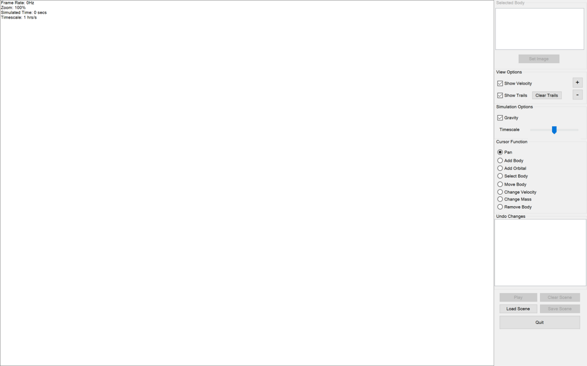

|  |
| --- |
| Public Class MainForm  ''' <summary>  ''' The timer which updates the current body data  ''' </summary>  Private WithEvents SelectedBodyRefreshTimer As New Timer()  ''' <summary>  ''' The timer which checks whether the cursor is still over the view (used for the orbital ring and mouse label visibility)  ''' </summary>  Private WithEvents CheckCursorLeaveViewTimer As New Timer()  ''' <summary>  ''' The timer upon each tick, ZoomScale is increased and the view is zoomed in  ''' </summary>  Private WithEvents ZoomInTimer As New Timer()  ''' <summary>  ''' The timer upon each tick, ZoomScale is decreased and the view is zoomed out  ''' </summary>  Private WithEvents ZoomOutTimer As New Timer()  ''' <summary>  ''' The timer upon each tick, checks whether the user is sliding the time factor tracker and so to update Timescale accordingly  ''' </summary>  Private WithEvents TimescaleTimer As New Timer()  ''' <summary>  ''' The timer upon each tick, if the simulation is running, stores a change using Changes  ''' </summary>  Private WithEvents AutoStoreSimulationChangesTimer As New Timer()  #Region "Loading and Form-Wide Updates"  ''' <summary>  ''' Performs the correct tasks in order to begin the application  ''' </summary>  Private Sub LoadApplication(sender As Object, e As EventArgs) Handles MyBase.Load  'Add the unhandled exception handler before anything else is done  AddHandler My.Application.UnhandledException, AddressOf MyApplication_UnhandledException  'Set the name of the thread (used by some functions because of multithreading)  Threading.Thread.CurrentThread.Name = "MainForm Thread"  'Set the global RenderBoxSize  RenderBoxSize = pnlRender.Size  'Copies the resources into the AppData folder  SetupResources()  'Sets up the graphics buffer and allocate it to pnlRender  g = BufferedGraphicsManager.Current.Allocate(pnlRender.CreateGraphics(), pnlRender.DisplayRectangle)  g.Graphics.InterpolationMode = Drawing2D.InterpolationMode.Low  g.Graphics.SmoothingMode = Drawing2D.SmoothingMode.AntiAlias  ClearBuffer()  'Setup the timers  SelectedBodyRefreshTimer.Interval = 500  SelectedBodyRefreshTimer.Start()  CheckCursorLeaveViewTimer.Interval = 50  CheckCursorLeaveViewTimer.Start()  TimescaleTimer.Interval = 200  ZoomInTimer.Interval = 50  ZoomOutTimer.Interval = 50  AutoStoreSimulationChangesTimer.Interval = Changes.AutoStoreWhileRunningIntervalMilliseconds  'Disable the necessary controls to start  UpdateUI()  End Sub  ''' <summary>  ''' Paints a blank view (otherwise the view starts up grey) and then checks for updates  ''' </summary>  Private Sub MainForm_Shown(sender As Object, e As EventArgs) Handles MyBase.Shown  'Show a blank view (otherwise starts grey)  GameLoop.PaintOnce()  'Check for updates  CheckVersion()  End Sub  ''' <summary>  ''' Stops the graphics loop as the form is closing  ''' </summary>  Private Sub MainForm_FormClosing(sender As Object, e As FormClosingEventArgs) Handles MyBase.FormClosing  GameLoop.Pause()  End Sub  ''' <summary>  ''' Disables/enables controls when body array is (not) empty then repaints  ''' </summary>  Public Sub UpdateUI()  If BodyArrayEmpty() Then 'There are no bodies  'Disable current body controls  grpSelectedBody.Enabled = False  'Disable the Play and SaveScene buttons  btnPlayPause.Enabled = False  btnSaveScene.Enabled = False  'Disable Clear Scene button  btnClearSimulation.Enabled = False  Else 'There are bodies  'Enable current body controls  grpSelectedBody.Enabled = True  'Enable the Play and SaveScene buttons  btnPlayPause.Enabled = True  btnSaveScene.Enabled = True  'Enable Clear Scene button  btnClearSimulation.Enabled = True  End If  'Update the render panel  GameLoop.PaintOnce()  End Sub  #End Region  #Region "Selected Body"  ''' <summary>  ''' Allows the user to add/change/remove the image from the selected body  ''' </summary>  Private Sub SetImageSelectedBody(sender As Object, e As EventArgs) Handles btnSelectedBodySetImage.Click  ProcessSelectImage()  End Sub  ''' <summary>  ''' Updates the selected body information on the UI  ''' </summary>  Private Sub RefreshCurrentBodyInfo() Handles SelectedBodyRefreshTimer.Tick  If BodyArrayEmpty() Then  lbSelectedBodyInfo.Items.Clear()  btnSelectedBodySetImage.Text = "Set Image"  Return  End If  Dim UsingBody As Body  Try  UsingBody = BodyDatas(SelectedBodyIndex).Clone()  Catch ex As Exception  'Catches an exception which is thrown when two threads are accessing the same element  Return  End Try  'Clear the previous information  lbSelectedBodyInfo.Items.Clear()  'Declare a lambda to shorten code and improve readibility  Dim AddLine = Sub(x As String)  lbSelectedBodyInfo.Items.Add(x)  End Sub  'Update the information  With UsingBody  AddLine("Mass: " + .Mass.ToString + "Kg")  AddLine("Radius: " + .Radius.ToString + "m")  AddLine("Velocity magnitude: " + .Velocity.Magnitude.ToString + "m/s")  AddLine("Acceleration magnitude: " + .Acceleration.Magnitude.ToString + "m/s²")  End With  'Update the selected body image button text  If UsingBody.IsUsingBitmap Then  btnSelectedBodySetImage.Text = "Change Image"  Else  btnSelectedBodySetImage.Text = "Set Image"  End If  End Sub  #End Region  #Region "View Options"  ''' <summary>  ''' Updates the ShowVelocity global and repaints  ''' </summary>  Private Sub ShowVelocity_CheckedChanged(sender As Object, e As EventArgs) Handles chkShowVelocity.CheckedChanged  ShowVelocity = chkShowVelocity.Checked  GameLoop.PaintOnce()  End Sub  ''' <summary>  ''' Updates the ShowTrails global and repaints  ''' </summary>  Private Sub ShowTrails_CheckedChanged(sender As Object, e As EventArgs) Handles chkShowTrails.CheckedChanged  ShowTrails = chkShowTrails.Checked  GameLoop.PaintOnce()  End Sub  ''' <summary>  ''' Clears all trails in the scene  ''' </summary>  Private Sub ClearAllTrails(sender As Object, e As EventArgs) Handles btnClearTrails.Click  Trails.ClearAllTrails()  End Sub  ''' <summary>  ''' Starts ZoomInTimer  ''' </summary>  Private Sub btnViewZoomIn_Click(sender As Object, e As EventArgs) Handles btnViewZoomIn.MouseDown  ZoomInTimer.Start()  End Sub  ''' <summary>  ''' Calls MouseInput's ZoomInOut method to increase the ZoomScale global (zoom in)  ''' </summary>  Private Sub ZoomInTick() Handles ZoomInTimer.Tick  ZoomInOut(-1, New Point(RenderBoxSize.Width / 2, RenderBoxSize.Height / 2))  GameLoop.PaintOnce()  End Sub  ''' <summary>  ''' Stops ZoomInTimer  ''' </summary>  Private Sub btnViewZoomIn_MouseUp(sender As Object, e As MouseEventArgs) Handles btnViewZoomIn.MouseUp  ZoomInTimer.Stop()  End Sub  ''' <summary>  ''' Starts ZoomOutTimer  ''' </summary>  Private Sub btnViewZoomOut_Click(sender As Object, e As EventArgs) Handles btnViewZoomOut.MouseDown  ZoomOutTimer.Start()  End Sub  ''' <summary>  ''' Calls MouseInput's ZoomInOut method to decrease the ZoomScale global (zoom out)  ''' </summary>  Private Sub ZoomOutTick() Handles ZoomOutTimer.Tick  ZoomInOut(1, New Point(RenderBoxSize.Width / 2, RenderBoxSize.Height / 2))  GameLoop.PaintOnce()  End Sub  ''' <summary>  ''' Stops ZoomOutTimer  ''' </summary>  Private Sub btnViewZoomOut_MouseUp(sender As Object, e As MouseEventArgs) Handles btnViewZoomOut.MouseUp  ZoomOutTimer.Stop()  End Sub  #End Region  #Region "Simulation Options"  ''' <summary>  ''' Updates the GravitationEnabled and repaints  ''' </summary>  Private Sub EnableGravitation_CheckedChanged(sender As Object, e As EventArgs) Handles chkGravitation.CheckedChanged  GravitationEnabled = chkGravitation.Checked  GameLoop.PaintOnce()  End Sub  ''' <summary>  ''' Starts the TimescaleTimer  ''' </summary>  Private Sub trackerTimescale_MouseDown() Handles trackerTimescale.MouseDown  TimescaleTimer.Start()  End Sub  ''' <summary>  ''' Stops the TimescaleTimer and resets the slider back to the center  ''' </summary>  Private Sub trackerTimescale_MouseUp() Handles trackerTimescale.MouseUp  TimescaleTimer.Stop()  trackerTimescale.Value = 0  pnlRender.Select()  End Sub  ''' <summary>  ''' Updates Timescale with respect to the displacement of the slider  ''' </summary>  Private Sub TimescaleTimer_Tick() Handles TimescaleTimer.Tick  Timescale *= 1 + trackerTimescale.Value / 50  GameLoop.PaintOnce()  End Sub  #End Region  #Region "Undo Changes"  ''' <summary>  ''' Updates the changes listbox (called by Changes)  ''' </summary>  Public Sub ChangeListHasChanged()  lbChanges.Items.Clear()  Changes.ChangesIntoListBox(lbChanges)  End Sub  ''' <summary>  ''' Changes BodyDatas so that it mirrors the selected change in the changes listbox  ''' </summary>  Private Sub Changes_SelectedIndexChanged() Handles lbChanges.SelectedIndexChanged  If lbChanges.SelectedIndex = -1 Then Return  GameLoop.StoreAndPause()  Dim OldestToNewestIndex = lbChanges.Items.Count - 1 - lbChanges.SelectedIndex  Changes.RollbackChanges(OldestToNewestIndex)  lbChanges.SelectedIndex = -1  'Performs single paint within this call  UpdateUI()  GameLoop.ContinueStored()  End Sub  ''' <summary>  ''' Stores a change in Changes with the ChangeType of SimulationRunTime  ''' </summary>  Private Sub AutoStoreSimulationWhileRunning() Handles AutoStoreSimulationChangesTimer.Tick  Try  Changes.AddChange(Changes.ChangeType.SimulationRunTime)  Catch ex As Exception  End Try  End Sub  #End Region  #Region "Other Controls"  ''' <summary>  ''' Starts or stops the loop depending on current state  ''' </summary>  Private Sub TogglePlayPause(sender As Object, e As EventArgs) Handles btnPlayPause.Click  If GameLoop.Running() Then  GameLoop.Pause()  Changes.AddChange(Changes.ChangeType.SimulationPaused)  Else  GameLoop.Start()  End If  End Sub  ''' <summary>  ''' Changes the text of the PlayPause button (called by the GameLoop) and changes the state of the auto-store timer  ''' </summary>  Public Sub GameLoopStateChanged()  If GameLoop.Running Then  btnPlayPause.Text = "Pause"  AutoStoreSimulationChangesTimer.Start()  Else  btnPlayPause.Text = "Play"  AutoStoreSimulationChangesTimer.Stop()  End If  End Sub  ''' <summary>  ''' Removes all bodies from BodyData, removes all trails and then updates the UI  ''' </summary>  Private Sub ClearScene(sender As Object, e As EventArgs) Handles btnClearSimulation.Click  GameLoop.Pause()  BodyDatas = Nothing  Trails.ClearAllTrails()  GameLoop.ResetSimulatedTime()  Changes.AddChange(Changes.ChangeType.ClearSimulaton)  UpdateUI()  End Sub  ''' <summary>  ''' Loads a .gsim file and refreshes applications to show file contents  ''' </summary>  Private Sub LoadScene(sender As Object, e As EventArgs) Handles btnLoadScene.Click  GameLoop.StoreAndPause()  'The scene is already cleared within LoadCSVFile()  If LoadCSVFile() Then  Changes.AddChange(Changes.ChangeType.LoadScene)  UpdateUI()  Else  GameLoop.ContinueStored()  End If  End Sub  ''' <summary>  ''' Guides the user through saving the current state of the application into a .gsim file  ''' </summary>  Private Sub SaveScene(sender As Object, e As EventArgs) Handles btnSaveScene.Click  SaveCSVFile()  End Sub  ''' <summary>  ''' Quits the application  ''' </summary>  Private Sub Quit(sender As Object, e As EventArgs) Handles btnQuit.Click  Application.Exit()  End Sub  #End Region  #Region "Mouse Input"  ''' <summary>  ''' Retrieves the name of the cursor type radio which is selected  ''' </summary>  Private Sub SetSelectedCursorFunction()  'Runs through each radio in mouse function and returns the MouseFunction corresponding to the selected radio  If radioAddBody.Checked Then  SelectedRadio = MouseFunction.AddBody  ElseIf radioAddOrbital.Checked Then  SelectedRadio = MouseFunction.AddOrbital  ElseIf radioChangeMass.Checked Then  SelectedRadio = MouseFunction.ChangeMass  ElseIf radioChangeVelocity.Checked Then  SelectedRadio = MouseFunction.ChangeVelocity  ElseIf radioMoveBody.Checked Then  SelectedRadio = MouseFunction.MoveBody  ElseIf radioMoveView.Checked Then  SelectedRadio = MouseFunction.Pan  ElseIf radioRemoveBody.Checked Then  SelectedRadio = MouseFunction.RemoveBody  ElseIf radioSelectBody.Checked Then  SelectedRadio = MouseFunction.SelectBody  End If  End Sub  ''' <summary>  ''' Performs the correct method for a MouseDown event inside the viewport using the MouseInput module  ''' </summary>  Private Sub View_MouseDown(sender As Object, e As MouseEventArgs) Handles pnlRender.MouseDown  SetSelectedCursorFunction()  RunCursorSub(EventType.Down, e.Location)  UpdateUI()  End Sub  ''' <summary>  ''' Performs the correct method for a MouseMove event inside the viewport using the MouseInput module  ''' </summary>  Private Sub View_MouseMove(sender As Object, e As MouseEventArgs) Handles pnlRender.MouseMove  SetSelectedCursorFunction()  RunCursorSub(EventType.Move, e.Location)  UpdateUI()  End Sub  ''' <summary>  ''' Performs the correct method for a MouseUp event inside the viewport using the MouseInput module  ''' </summary>  Private Sub View_MouseUp(sender As Object, e As MouseEventArgs) Handles pnlRender.MouseUp  SetSelectedCursorFunction()  RunCursorSub(EventType.Up, e.Location)  UpdateUI()  End Sub  ''' <summary>  ''' Checks if the cursor is still over the viewport and if not then stop painting the orbital ring and the mouse label (used for Add Orbital)  ''' </summary>  Private Sub CheckCursorStillInView() Handles CheckCursorLeaveViewTimer.Tick  Dim MousePosition As Point = Cursor.Position  If Not InsideRectangle(MousePosition, New Rectangle(New Point(0, 0), RenderBoxSize)) Then  PaintingMethods.PaintOrbital = False  PaintingMethods.ShowMouseLabel = False  GameLoop.PaintOnce()  End If  End Sub  ''' <summary>  ''' Uses MouseInput to manage changes to the zoom in the form of the mouse wheel  ''' </summary>  Private Sub View_MouseWheel(sender As Object, e As MouseEventArgs) Handles pnlRender.MouseWheel  ZoomInOut(e.Delta, e.Location)  GameLoop.PaintOnce()  End Sub  #End Region  End Class |

## Changes.vb (Shared Class)

This is the class which stores all of the changes and then allows undoing of the changes. It contains the array which holds all of the changes as well as all of the methods required to interface with the changes.

|  |
| --- |
| Public Class Changes  ''' <summary>  ''' The list which holds the changes as the type Change (below)  ''' </summary>  Private Shared ChangeList As New List(Of Change)  ''' <summary>  ''' Holds the index of the currently selected / current state of the BodyDatas  ''' </summary>  Private Shared CurrentIndex As Integer = -1  ''' <summary>  ''' The event which is called upon the list being changed  ''' </summary>  Private Shared Event ListChanged()  ''' <summary>  ''' The constant which holds the max number of changes which should be stored  ''' </summary>  Private Const MaxStoredChanges As Byte = 100  ''' <summary>  ''' The constant which is used by the main form to decide how often the BodyDatas should automatically be stored while running.  ''' </summary>  Public Const AutoStoreWhileRunningIntervalMilliseconds As Integer = 5000  ''' <summary>  ''' Used locally to update the list box when adding ChangeType.SimulationRunTime  ''' </summary>  Private Const AutoStoreWhileRunningIntervalSeconds As Integer = AutoStoreWhileRunningIntervalMilliseconds / 1000  Public Shared Sub AddChange(ChangeType As ChangeType)  'If they are adding a change and the current state is part way through the array and not at the end  'Then remove the newer changes  RemoveNewerChanges(CurrentIndex)  'Used in the next-code block  Dim BodyDatas As Body()  'If the current array is empty  If BodyArrayEmpty() Then  'Set the BodyDatas array to empty  ReDim BodyDatas(0)  Else  'Otherwise fill up the array with shallow-cloned bodies  'This prevents object reference  ReDim BodyDatas(BodyMethods.BodyDatas.Length - 1)  For i As Integer = 0 To BodyDatas.Length - 1  BodyDatas(i) = BodyMethods.BodyDatas(i).Clone()  Next  End If  'Used in the next code-block  Dim RunTime As Long = 0  'If it is a simulation run time change then calculate the seconds which should be displayed  If ChangeType = ChangeType.SimulationRunTime Then  'Find how long the simulation has been running for  RunTime = AutoStoreWhileRunningIntervalSeconds  Dim i = ChangeList.Count - 1  Do While ChangeList(i).ChangeType = ChangeType.SimulationRunTime And i > 0  RunTime += AutoStoreWhileRunningIntervalSeconds  i -= 1  Loop  End If  'Add the new change to the array  ChangeList.Add(New Change(ChangeType, BodyDatas, RunTime))  'Removes the oldest changes if the list is greater than the specified max  RemoveExcess()  'Update the current index to show that the current state it the latest added change  CurrentIndex = ChangeList.Count - 1  'Raise the event so that mainform updates its listbox of changes  RaiseEvent ListChanged()  End Sub  Public Shared Sub RollbackChanges(OldestToNewestIndex As Integer)  Trails.RemoveAllTrails()  If Not IsNothing(ChangeList(OldestToNewestIndex).BodyDatas) Then  If Not ChangeList(OldestToNewestIndex).BodyDatas.Count = 0 Then  ReDim BodyDatas(ChangeList(OldestToNewestIndex).BodyDatas.Count - 1)  For BodyDatasIndex As Integer = 0 To ChangeList(OldestToNewestIndex).BodyDatas.Count - 1  BodyDatas(BodyDatasIndex) = ChangeList(OldestToNewestIndex).BodyDatas(BodyDatasIndex).Clone()  Next  End If  Else  ReDim BodyDatas(0)  End If  If Not BodyArrayEmpty() Then  For Each body In BodyDatas  Trails.AddBodyTrail()  Next  End If  CurrentIndex = OldestToNewestIndex  RaiseEvent ListChanged()  End Sub  Public Shared Sub RemoveNewerChanges(AfterIndex As Integer)  'If there are elements in the array after the specified index  If Not AfterIndex = ChangeList.Count - 1 Then  'Remove a range starting from the element at the index after AfterIndex  'And remove the amount of elements which is the difference between the last index and AfterIndex  ChangeList.RemoveRange(AfterIndex + 1, ChangeList.Count - AfterIndex - 1)  RaiseEvent ListChanged()  End If  End Sub  Public Shared Sub RemoveExcess()  If ChangeList.Count > MaxStoredChanges Then  ChangeList.RemoveRange(0, ChangeList.Count - MaxStoredChanges)  End If  End Sub  Public Shared Sub ChangesIntoListBox(ByRef lb As ListBox)  If ChangeList.Count = 0 Then Return  For i = ChangeList.Count - 1 To 0 Step -1  If i = CurrentIndex Then  lb.Items.Add(GetChangeString(ChangeList(i)) + " (Current)")  Else  lb.Items.Add(GetChangeString(ChangeList(i)))  End If  Next  End Sub  Private Shared Function GetChangeString(change As Change) As String  Dim RunTime As Long = change.RunTime  Select Case change.ChangeType  Case ChangeType.AddBody  Return "Added Body"  Case ChangeType.AddOrbital  Return "Added Orbital"  Case ChangeType.MoveBody  Return "Moved Body"  Case ChangeType.ChangeVelocity  Return "Changed Velocity"  Case ChangeType.ChangeMass  Return "Changed Mass"  Case ChangeType.RemoveBody  Return "Removed Body"  Case ChangeType.SimulationRunTime  Return "Simulation Run For " + GetTimeString(RunTime, 1)  Case ChangeType.SimulationPaused  Return "Simulation Paused"  Case ChangeType.ClearSimulaton  Return "Cleared Scene"  Case ChangeType.LoadScene  Return "Loaded Scene"  Case Else  Return ""  End Select  End Function  Public Enum ChangeType  AddBody  AddOrbital  MoveBody  ChangeVelocity  ChangeMass  RemoveBody  SimulationRunTime  SimulationPaused  ClearSimulaton  LoadScene  End Enum  Private Shared Sub ListHasChanged() Handles Me.ListChanged  MainForm.Invoke(New MethodInvoker(AddressOf MainForm.ChangeListHasChanged))  End Sub  Private Class Change  Public ChangeType As ChangeType  Public BodyDatas As Body()  Public RunTime As Long  Sub New(ChangeType As ChangeType, BodyDatas As Body(), RunTime As Long)  Me.ChangeType = ChangeType  Me.BodyDatas = BodyDatas  Me.RunTime = RunTime  End Sub  End Class  End Class |

## GameLoop.vb (Shared Class)

This is the class which allows the simulation to run. It contains all of the variables for stats about the running of the loop and also many methods required to interface with the loop.

|  |
| --- |
| Public Class GameLoop  Private Shared _Running As Boolean = False  Public Shared Property Running As Boolean  Get  Return _Running  End Get  Private Set(value As Boolean)  _Running = value  MainForm.GameLoopStateChanged()  End Set  End Property  Public Shared Property SimulatedTime As Double = 0  Public Shared FPS As Integer = 0  Private Shared Property FrameMilliseconds As Integer = 0  Private Shared FrameStopwatch As New Stopwatch()  Private Shared SecondStopwatch As New Stopwatch()  Private Shared FramesInSecond As Integer = 0  Private Shared bgLoop As Task  Private Shared Sub Game_Loop()  SecondStopwatch.Restart()  While Running  FrameStopwatch.Restart()  Update(CSng(FrameMilliseconds / 1000))  Paint()  FramesInSecond += 1  If SecondStopwatch.ElapsedMilliseconds > 999 Then  FPS = CInt(1000 * FramesInSecond / SecondStopwatch.ElapsedMilliseconds)  FramesInSecond = 0  SimulatedTime += Timescale * SecondStopwatch.ElapsedMilliseconds / 1000  SecondStopwatch.Restart()  End If  FrameMilliseconds = FrameStopwatch.Elapsed.Milliseconds  End While  SecondStopwatch.Stop()  FrameStopwatch.Stop()  End Sub  Private Shared Sub StartLoop()  bgLoop = New Task(AddressOf Game_Loop)  bgLoop.Start()  End Sub  Shared Sub Start()  If Running = False Then  Running = True  StartLoop()  End If  End Sub  Shared Sub Pause()  If Running Then  Running = False  Wait()  End If  End Sub  Private Shared Sub Wait()  If bgLoop Is Nothing Then  Return  End If  bgLoop.Wait()  End Sub  Shared Sub PaintOnce()  If Not Running And Not BufferEmpty() Then  FPS = 0  FramesInSecond = 0  PaintingMethods.Paint()  End If  End Sub  Shared Sub ResetSimulatedTime()  SimulatedTime = 0  End Sub  Private Shared StoredState As Boolean = False  Public Shared Sub StoreAndPause()  StoredState = Running  Pause()  End Sub  Public Shared Sub ContinueStored()  If Not StoredState = Running Then  If StoredState Then  Start()  End If  End If  End Sub  End Class |

## Trails.vb (Shared Class)

This is the class which is used to store and then to display trails to the screen. It contains the array which all of the points for the trails are stored in as well as methods to easily interface with it.

|  |
| --- |
| Public Class Trails  ''' <summary>  ''' The array which holds the scene points for each body's trail  ''' </summary>  Private Shared ScenePoints As New List(Of List(Of PointF))  ''' <summary>  ''' Holds the value which the MaxBodyPoints variable holds to begin with.  ''' </summary>  Public Const MaxBodyPointsStartValue As Integer = 1000  ''' <summary>  ''' Holds the value which is the max number of points stored for each body.  ''' </summary>  Public Shared MaxBodyPoints As Integer = MaxBodyPointsStartValue  ''' <summary>  ''' Refreshes the values stored in the array  ''' </summary>  Shared Sub UpdateTrails()  'Return if there are no bodies present as there is nothing to update  If BodyArrayEmpty() Then  Return  End If  'First add new points and remove excess  Try  For BodyDatasIndex = 0 To BodyDatas.Length - 1  Dim ScenePointsIndex = BodyDatasIndex  Dim SceneCenterPoint As PointF = BodyDatas(BodyDatasIndex).Center  ScenePoints(ScenePointsIndex).Add(SceneCenterPoint)  RemoveExcessPoints(ScenePointsIndex)  Next  Catch ex As Exception  End Try  End Sub  ''' <summary>  ''' Removes the oldest points in the specified index  ''' </summary>  Private Shared Sub RemoveExcessPoints(ScenePointsIndex As Integer)  Dim NumberOfPointsToRemove As Short = ScenePoints(ScenePointsIndex).Count - MaxBodyPoints  If NumberOfPointsToRemove > 0 Then  For n = 0 To NumberOfPointsToRemove  ScenePoints(ScenePointsIndex).RemoveAt(0)  Next  End If  End Sub  ''' <summary>  ''' Declares a new body on the end of the point list  ''' </summary>  Shared Sub AddBodyTrail()  ScenePoints.Add(New List(Of PointF))  End Sub  ''' <summary>  ''' Removes trail at specified index  ''' </summary>  Shared Sub RemoveBodyTrail(index As UShort)  ScenePoints.RemoveAt(index)  End Sub  ''' <summary>  ''' Removes all the stored body trails in the array  ''' </summary>  Shared Sub RemoveAllTrails()  ScenePoints.Clear()  End Sub  ''' <summary>  ''' Renders the curves from the points stored in this class to the buffer passed as a parameter  ''' </summary>  Shared Sub RenderTrails()  Dim RenderPoints As New List(Of List(Of Point))  Dim SceneViewportRect As RectangleF = GetViewportSceneRectangle()  'Run through each body in the ScenePointsIndexArray  For ScenePointsIndex = 0 To ScenePoints.Count - 1  'Create a new list for the body  RenderPoints.Add(New List(Of Point))  'If the body is really small then don't bother calculating render points  If SceneDistanceToRenderDistance(BodyDatas(ScenePointsIndex).Size) > 2 Then  'Go through each scene point for the current body and calculate render points for that body  For PointIndex = 0 To ScenePoints(ScenePointsIndex).Count - 1  'Convert scene point to render point  Dim RenderPoint As Point = Point.Round(ScenePointToRenderPoint(ScenePoints(ScenePointsIndex)(PointIndex)))  'Add to RenderPoints list  RenderPoints(ScenePointsIndex).Add(RenderPoint)  Next  End If  Next  'Run through each body which has points stored in the RenderPoints array  For RenderPointsIndex As Integer = 0 To RenderPoints.Count - 1  If RenderPoints(RenderPointsIndex).Count >= 2 Then  Dim BodyIndex As Integer = RenderPointsIndex  Dim BaseColour As Color  If BodyDatas(BodyIndex).IsUsingBitmap Then  BaseColour = BodyDatas(BodyIndex).GetDominantImageColour()  Else  BaseColour = BodyDatas(BodyIndex).Colour  End If  Dim BaseLineAlphaPercentage As Single =  SceneDistanceToRenderDistance(BodyDatas(BodyIndex).Size) / 10  Dim BaseLineAlpha As Byte    If BaseLineAlphaPercentage > 1 Then  BaseLineAlpha = 255  Else  BaseLineAlpha = 255 * BaseLineAlphaPercentage  End If  For i As Integer = 1 To RenderPoints(RenderPointsIndex).Count - 1  Dim LineSegmentAlpha As Byte = BaseLineAlpha * i / RenderPoints(RenderPointsIndex).Count  Dim LineSegmentColour As Color = Color.FromArgb(LineSegmentAlpha, BaseColour)  g.Graphics.DrawLine(  New Pen(LineSegmentColour),  RenderPoints(RenderPointsIndex)(i - 1),  RenderPoints(RenderPointsIndex)(i)  )  Next  End If  Next  End Sub  ''' <summary>  ''' Clears the trail of the body at the specified index  ''' </summary>  ''' <param name="i">Index to clear</param>  Shared Sub ClearTrail(i As Integer)  ScenePoints(i).Clear()  End Sub  ''' <summary>  ''' Clears all trails  ''' </summary>  Shared Sub ClearAllTrails()  ScenePoints.Clear()  If Not IsNothing(BodyDatas) Then  If BodyDatas.Length > 0 Then  For n = 1 To BodyDatas.Length  ScenePoints.Add(New List(Of PointF))  Next  End If  End If  End Sub  End Class |

## Body.vb (Class)

|  |
| --- |
| Public Class Body  #Region "Constructor and Clone"  ''' <summary>  ''' Generates an empty body with default / empty values  ''' </summary>  Sub New()  Velocity = New Vector()  Acceleration = New Vector()  Center = New PointF(0, 0)  Mass = 0  IsUsingBitmap = False  Image = Nothing  Colour = Color.Empty  End Sub  Function Clone() As Body  Return DirectCast(MemberwiseClone(), Body)  End Function  #End Region  #Region "Base Properties"  'Variables here are ones used by properties which require additional code in their get or set parts  Private _Velocity As Vector  Private _Center As PointF  Private _Mass As Single  Private _Image As Image  Private _DominantImageColour As Color  ''' <summary>  ''' Gets and sets the velocity of the body (max is 10 ^ 8)  ''' </summary>  Property Velocity(Optional ThrowExceptionOnOutOfBounds As Boolean = False) As Vector  Get  Return _Velocity  End Get  Set(value As Vector)  If value.Magnitude > 299792458 Then  _Velocity = value.ChangeMagnitude(299792458)  If ThrowExceptionOnOutOfBounds Then  Throw New OverflowException("Value is too big")  End If  Else  _Velocity = value  End If  End Set  End Property  ''' <summary>  ''' Gets and sets the acceleration of the body  ''' </summary>  Property Acceleration() As Vector  ''' <summary>  ''' Gets and sets the center of the body (the primary position property) (max is 10 ^ 35, exception is thrown upon setting a value greater than this which can be tested for)  ''' </summary>  Property Center(Optional ThrowExceptionOnOutOfBounds As Boolean = False) As PointF  Get  Return _Center  End Get  Set(value As PointF)  Dim x As Single = value.X  Dim y As Single = value.Y  Dim ValueChanged = Not ForceMaxBounds(x, 10 ^ 35, True) Or Not ForceMaxBounds(y, 10 ^ 35, True)  _Center = New PointF(x, y)  If ValueChanged And ThrowExceptionOnOutOfBounds Then  Throw New OverflowException()  End If  End Set  End Property  ''' <summary>  ''' Gets or sets the height / width of the body on the scene  ''' </summary>  Property Size() As Single  ''' <summary>  ''' Gets and sets the mass of the body (max is 10 ^ 35) [sets the size of the body upon setting]  ''' </summary>  Property Mass(Optional ThrowExceptionOnOutOfBounds As Boolean = False) As Single  Get  Return _Mass  End Get  Set(value As Single)  Dim ValueChanged As Boolean = Not ForceMaxBounds(value, 10 ^ 35, False)  'Update the mass variable to hold the new value  _Mass = value  'Set the size from the new mass  Size = GetSizeFromMass(Mass)  If ValueChanged And ThrowExceptionOnOutOfBounds Then  Throw New OverflowException()  End If  End Set  End Property  ''' <summary>  ''' Gets and sets the colour of the body  ''' </summary>  Property Colour() As Color  ''' <summary>  ''' States whether the body is currently using a bitmap (its image) to be rendered  ''' </summary>  Property IsUsingBitmap() As Boolean  ''' <summary>  ''' Gets and sets the bitmap (image) of the body and generates DominantImageColour from the specified image  ''' </summary>  Property Image() As Image  Get  Return _Image  End Get  Set(value As Image)  _Image = value  If Image IsNot Nothing Then  UpdateDominantImageColour()  End If  End Set  End Property  #End Region  #Region "Calculated Properties"  ''' <summary>  ''' Gets the PointF of the top left of the body  ''' </summary>  ReadOnly Property TopLeft() As PointF  Get  Return New PointF(Center.X - Radius, Center.Y - Radius)  End Get  End Property  ''' <summary>  ''' Gets the radius (half of the size)  ''' </summary>  ReadOnly Property Radius() As Single  Get  Return Size / 2  End Get  End Property  ''' <summary>  ''' Used within the body class to set DominantImageColour  ''' </summary>  Private Sub UpdateDominantImageColour()  If Image Is Nothing Then  Throw New Exception()  Return  End If  Dim bmp As New Bitmap(Image)  _DominantImageColour = GetDominantImageColourFromBitmap(bmp)  End Sub  #End Region  ''' <summary>  ''' Gets the height/width of a body with the specified mass given the density  ''' </summary>  Shared Function GetSizeFromMass(mass As Single) As Single  Return CSng(2 * Math.Pow(3 * mass / (4 * Math.PI * 5000), 1 / 3))  End Function  ''' <summary>  ''' Gets the mass of a body given its size and density  ''' </summary>  Shared Function GetMassFromSize(radius As Single) As Single  Return CSng(4 / 3 * Math.PI * radius ^ 3 * 5000)  End Function  ''' <summary>  ''' Gets the colour which is mathematically average in the set image  ''' </summary>  Public Function GetDominantImageColour() As Color  Return _DominantImageColour  End Function  ''' <summary>  ''' Used within the body class to calculate the dominant colour in the specified bitmap  ''' </summary>  Private Shared Function GetDominantImageColourFromBitmap(bmp As Bitmap) As Color  Dim totalR As ULong = 0  Dim totalG As ULong = 0  Dim totalB As ULong = 0  Dim totalPixels As Long = 0  For y = 0 To bmp.Height - 1 Step 4  For x = 0 To bmp.Width - 1 Step 4  Dim pixel As Color = bmp.GetPixel(x, y)  If pixel.A > 200 Then  totalR += pixel.R  totalG += pixel.G  totalB += pixel.B  totalPixels += 1  End If  Next  Next  If totalPixels = 0 Then  Throw New Exception("Failure reading image")  Return Color.Gray  End If  Dim averageR As Byte = CByte(totalR / totalPixels)  Dim averageG As Byte = CByte(totalG / totalPixels)  Dim averageB As Byte = CByte(totalB / totalPixels)  Return Color.FromArgb(averageR, averageG, averageB)  End Function  ''' <summary>  ''' Calculates whether this body is currently intersecting the specified body  ''' </summary>  Public Function Intersecting(bodyToTest As Body) As Boolean  Dim SumRadiiSquared As Double = (Radius + bodyToTest.Radius) ^ 2  Dim DistanceCentersSquared As Double = (Center.X - bodyToTest.Center.X) ^ 2 + (Center.Y - bodyToTest.Center.Y) ^ 2  Return DistanceCentersSquared <= SumRadiiSquared  End Function  ''' <summary>  ''' Calculates whether the body is visible in the viewport  ''' </summary>  Public Function VisibleInView() As Boolean  Dim topLeft As New PointF(Center.X - Radius, Center.Y - Radius)  Dim topRight As New PointF(Center.X + Radius, Center.Y - Radius)  Dim bottomRight As New PointF(Center.X + Radius, Center.Y + Radius)  Dim bottomLeft As New PointF(Center.X - Radius, Center.Y + Radius)  Dim ViewportSceneRect As RectangleF = GetViewportSceneRectangle()  For Each p As PointF In {topLeft, topRight, bottomRight, bottomLeft}  If InsideRectangle(p, ViewportSceneRect) Then  Return True  End If  Next  Dim ScenePointCenterViewport As New PointF(  (ViewportSceneRect.Left + ViewportSceneRect.Right) / 2,  (ViewportSceneRect.Top + ViewportSceneRect.Bottom) / 2  )  Dim BodySceneRectangle As New RectangleF(topLeft, New SizeF(Size, Size))  If InsideRectangle(ScenePointCenterViewport, GetSceneRectangle()) Then  Return True  End If  Return False  End Function  Public Function GetSceneRectangle() As RectangleF  Return New RectangleF(  TopLeft,  New SizeF(Size, Size)  )  End Function  ''' <summary>  ''' Returns the rectangle which will be used to render the body.  ''' </summary>  Public Function RenderRectangle() As Rectangle  Dim RenderDistance As Integer = SceneDistanceToRenderDistance(Size)  Return New Rectangle(  Point.Round(ScenePointToRenderPoint(TopLeft)),  New Size(RenderDistance, RenderDistance)  )  End Function  End Class |

## Vector.vb (Class)

This is the class which is instantiated by velocity and acceleration in the body. It is also used in many other places in the program, almost anywhere that uses the scene. It has two components for the horizontal and vertical. There are numerous instance methods which return information or return a changed version of the instance as well as a shared method to create a vector between two points. Also in this class are many operators which allow for manipulation of vectors by using other vectors.

|  |
| --- |
| Public Class Vector  Property x As Double  Property y As Double  Sub New(Optional xValue As Double = 0, Optional yValue As Double = 0)  x = xValue  y = yValue  End Sub  ''' <summary>  ''' Calculates a vector from A to B (return a positive j when moving upwards)  ''' </summary>  Public Shared Function VectorBetween(p1 As PointF, p2 As PointF) As Vector  Dim changeX As Double = p2.X - p1.X  Dim changeY As Double = p2.Y - p1.Y  Return New Vector(  changeX,  changeY  )  End Function  ''' <summary>  ''' Returns a vector with each of the inputted components divided by the magnitude of inputted vector  ''' </summary>  Function UnitVector() As Vector  Dim magnitude As Double = Me.Magnitude()  Return New Vector(  IIf(x = 0 And magnitude = 0, 0, x / magnitude),  IIf(y = 0 And magnitude = 0, 0, y / magnitude)  )  End Function  ''' <summary>  ''' Returns the squared magnitude or length of the vector (uses Pythagoras)  ''' </summary>  Function MagnitudeSquared() As Double  Return x ^ 2 + y ^ 2  End Function  ''' <summary>  ''' Returns the magnitude or length of the vector (uses Pythagoras)  ''' </summary>  Function Magnitude() As Double  Return Math.Sqrt(x ^ 2 + y ^ 2)  End Function  Function ChangeMagnitude(magnitude As Double) As Vector  Dim UnitVector As Vector = Me.UnitVector()  Return magnitude * UnitVector  End Function  Function Tangent() As Vector  Return New Vector(-y, x)  End Function  Function SecondaryTangent() As Vector  Return New Vector(y, -x)  End Function  Shared Operator +(left As Vector, right As Vector) As Vector  Return New Vector(  left.x + right.x,  left.y + right.y  )  End Operator  Shared Operator +(left As PointF, right As Vector) As PointF  Return New PointF(  left.X + right.x,  left.Y + right.y  )  End Operator  Shared Operator +(left As Vector, right As PointF) As PointF  Return New PointF(  left.x + right.X,  left.y + right.Y  )  End Operator  Shared Operator *(left As Double, right As Vector) As Vector  Return New Vector(  left * right.x,  left * right.y  )  End Operator  Shared Operator /(left As Vector, right As Double) As Vector  Return New Vector(  left.x / right,  left.y / right  )  End Operator  Shared Operator /(left As Vector, right As Vector) As Vector  Return New Vector(  left.x / right.x,  left.y / right.y  )  End Operator  Shared Operator -(right As Vector) As Vector  Return New Vector(-right.x, -right.y)  End Operator  Shared Operator -(left As Vector, right As Vector) As Vector  Return New Vector(  left.x - right.x,  left.y - right.y  )  End Operator  End Class |

## BodyMethods.vb (Module)

This module contains the body array global as well as the selected body index. It also contains a method to check if the array is empty (or null), a method to add a body and a method to remove a body. All things required to interface with the body array.

|  |
| --- |
| Module BodyMethods  ''' <summary>  ''' The array in which all the bodies in the scene are stored  ''' </summary>  Public BodyDatas() As Body  ''' <summary>  ''' Holds the index of the currently selected body  ''' </summary>  Public SelectedBodyIndex As Integer  ''' <summary>  ''' Returns whether the body array has no bodies in it  ''' </summary>  Public Function BodyArrayEmpty() As Boolean  If IsNothing(BodyDatas) Then  Return True  ElseIf BodyDatas.Length = 0 Then  Return True  End If  Return False  End Function  ''' <summary>  ''' Adds the passed body to the BodyDatas array, resizes the body array when appropriate and creates space for a trail for the new body  ''' </summary>  Public Sub AddBody(b As Body)  'Resize the body array to fit the new body  If IsNothing(BodyDatas) Then  ReDim BodyDatas(0)  BodyDatas(0) = b  Else  ReDim Preserve BodyDatas(BodyDatas.Length)  BodyDatas(BodyDatas.Length - 1) = b  End If  'The value is -1 when there are no bodies in the array so select the just-added body  If SelectedBodyIndex = -1 Then  SelectedBodyIndex = BodyDatas.Length - 1  End If  'Declare in Trails that there is a new body  Trails.AddBodyTrail()  'Show the changes on the form  MainForm.UpdateUI()  End Sub  ''' <summary>  ''' Removes the body and removes the trail at the given index  ''' </summary>  Public Sub RemoveBody(i As UInteger)  'Let Trails know that a body is to be removed  Trails.RemoveBodyTrail(i)  'Convert the body array to a list in order to remove List's RemoveAt method  Dim asList As List(Of Body) = BodyDatas.ToList()  asList.RemoveAt(i)  'Convert it back and update the array  BodyDatas = asList.ToArray()  'Ensure that the currently selected body is in the bounds of the array  If SelectedBodyIndex >= BodyDatas.Length Then  SelectedBodyIndex = BodyDatas.Length - 1  End If  'Fixes a bug caused because the program made a new instance of MainForm when MainForm was referenced.  'This made it set the checked properties of the checkboxes,  'The handler of these checkbox's CheckedChanged event set a global (shared) variable equal to its checked property.  'This changed the global variables read by the simulation so for example,  'the velocity lines would show and the gravity become enabled regardless of the state of the checkboxes  'on the main MainForm instance.  If Threading.Thread.CurrentThread.Name = "MainForm Thread" Then  MainForm.UpdateUI()  End If  End Sub  End Module |

## FileHandling.vb (Module)

This module contains any methods which involve loading or saving files as well as a few private methods to improve readability of code. The public methods include: save file, load file and a method which guides the user through setting the image of a body.

|  |
| --- |
| Module FileHandling  Private InitialHeaderRowString As String = "viewport,zoom,timescale:"  Private BodyHeaderRowString As String = "velocity,position,mass,colour,size,isusingbitmap,bitmap:"  Private AppDataFolderPath As String  ''' <summary>  ''' Returns the CSV line corresponding to the inputted body.  ''' </summary>  Private Function GetCSVLine(b As Body) As String  Dim returnString As String = ""  Dim numElements = 7  For i As Integer = 1 To numElements  Select Case i  Case 1 'velocity  returnString &= (  b.Velocity.x.ToString() & "|" &  b.Velocity.y.ToString()  )  Case 2 'position  returnString &= (  b.Center.X.ToString() & "|" &  b.Center.Y.ToString()  )  Case 3 'mass  returnString &= (b.Mass.ToString())  Case 4 'colour  If Not IsNothing(b.Colour) Then  returnString &= (b.Colour.ToArgb().ToString())  End If  Case 5 'size  returnString &= (b.Size.ToString())  Case 6  returnString &= b.IsUsingBitmap.ToString()  Case 7  If Not IsNothing(b.Image) Then  returnString &= ImageToBase64(b.Image)  End If  End Select  If Not i = numElements Then  returnString &= (",")  End If  Next  Return returnString  End Function  ''' <summary>  ''' Converts a CSV line and gives out a body.  ''' </summary>  Private Function CSVToBody(line As String) As Body  Dim rtnBody As New Body()  Try  Dim elements As String() = line.Split(",")  Array.ForEach(elements, Sub(s) s.Trim())  With rtnBody  .Velocity = New Vector(  elements(0).Split("|")(0),  elements(0).Split("|")(1)  )  .Center = New PointF(  elements(1).Split("|")(0),  elements(1).Split("|")(1)  )  .Mass = elements(2)  .Colour = Color.FromArgb(elements(3))  .Size = elements(4)  .IsUsingBitmap = Boolean.Parse(elements(5))  Try  .Image = Base64ToImage(elements(6))  Catch ex As Exception  .Image = Nothing  .IsUsingBitmap = False  End Try  End With  Catch ex As Exception  Return Nothing  End Try  Return rtnBody  End Function  ''' <summary>  ''' Taks in an image and returns the corresponding base64 code.  ''' </summary>  Private Function ImageToBase64(img As Image) As String  Dim ms As New IO.MemoryStream()  img.Save(ms, Imaging.ImageFormat.Png)  Return Convert.ToBase64String(ms.ToArray())  End Function  ''' <summary>  ''' Takes in base64 code and converts it to an image.  ''' </summary>  Private Function Base64ToImage(base64 As String) As Image  Dim imageBytes As Byte() = Convert.FromBase64String(base64)  Dim MS As New MemoryStream(imageBytes, 0, imageBytes.Length)  MS.Write(imageBytes, 0, imageBytes.Length)  Return Image.FromStream(MS)  End Function  ''' <summary>  ''' Guides the user through saving the scene file.  ''' </summary>  Public Sub SaveCSVFile()  Dim sfd As New SaveFileDialog()  With sfd  .InitialDirectory = My.Computer.FileSystem.SpecialDirectories.Desktop  .DefaultExt = ".gsim"  .Filter = "G-Sim Scene Information (*.gsim)|*.gsim"  .FileName = DateTime.Now.ToString("dd-MM-yyyy") & "_" & DateTime.Now.ToString("HH-mm-ss") & ".gsim"  .Title = "Save G-Sim Scene Information"  End With  If sfd.ShowDialog = DialogResult.OK Then  Dim stringToWrite As String = ""  Dim add = Sub(x As String) stringToWrite &= x  Dim newLine = Sub() add(Environment.NewLine)  add(InitialHeaderRowString)  newLine()  For i As Integer = 1 To 3  Select Case i  Case 1 'viewport  add(ViewPosition.X.ToString() & "|" &  ViewPosition.Y.ToString())  Case 2 'zoom  add(ZoomScale.ToString())  Case 3 'timescale  add(Timescale.ToString())  End Select  If Not i = 3 Then  add(",")  End If  Next  newLine()  add(BodyHeaderRowString)  newLine()  For Each b As Body In BodyDatas  add(GetCSVLine(b))  newLine()  Next  Dim sw As StreamWriter  Try  sw = New IO.StreamWriter(sfd.FileName, False)  Catch ex As IOException  MsgBox("The file is currently being used by another process. Try again after exiting that process.")  Return  End Try  sw.Write(stringToWrite)  sw.Close()  If MsgBox("Scene information saved successfully") = MsgBoxResult.Ok Then  Process.Start("""" & IO.Path.GetDirectoryName(sfd.FileName) & """")  End If  End If  End Sub  ''' <summary>  ''' Guides the user through saving the scene file.  ''' </summary>  ''' <return>If a scene file has been loaded then returns True, else returns False.</return>  Public Function LoadCSVFile() As Boolean  Dim ofd As New OpenFileDialog()  With ofd  .InitialDirectory = AppDataFolderPath & "\Scenes"  .DefaultExt = ".gsim"  .Filter = "G-Sim Scene Information (*.gsim)|*.gsim"  .FileName = "scene.gsim"  .Title = "Load G-Sim Scene Information"  End With  If ofd.ShowDialog() = DialogResult.OK Then  Dim sr As New IO.StreamReader(ofd.FileName)  Dim fileContents As String = sr.ReadToEnd()  sr.Close()  Dim lines As String() = fileContents.Split(vbCrLf)  Dim LinesIndex As Integer = 0  Do Until LinesIndex = lines.Count  lines(LinesIndex) = lines(LinesIndex).Trim()  If lines(LinesIndex) = Environment.NewLine Or lines(LinesIndex) = "" Or lines(LinesIndex) = Nothing Then  Dim list As List(Of String) = lines.ToList  list.RemoveAt(LinesIndex)  lines = list.ToArray()  LinesIndex -= 1  End If  LinesIndex += 1  Loop  Dim InitialHeaderRowIndex As Integer = Array.IndexOf(lines, InitialHeaderRowString)  If InitialHeaderRowIndex = -1 Then  MsgBox("Initial header row corrupt in " & ofd.SafeFileName, MsgBoxStyle.Critical)  Return False  End If  Dim BodyHeaderRowIndex As Integer = Array.IndexOf(lines, BodyHeaderRowString)  If BodyHeaderRowIndex = -1 Then  MsgBox("Body header row corrupt in " & ofd.SafeFileName, MsgBoxStyle.Critical)  Return False  End If  Dim SettingsValues As String() = lines(InitialHeaderRowIndex + 1).Split(",")  Dim ViewportSplitValues As String() = SettingsValues(0).Split("|")  ViewPosition = New PointF(  ViewportSplitValues(0),  ViewportSplitValues(1)  )  ZoomScale = SettingsValues(1)  Timescale = SettingsValues(2)  'Clear the scene  BodyDatas = Nothing  Trails.ClearAllTrails()  GameLoop.ResetSimulatedTime()  'Add each body line  For i As Integer = BodyHeaderRowIndex + 1 To lines.Length - 1  Dim addingBody As Body = CSVToBody(lines(i))  If IsNothing(addingBody) Then  MsgBox("Line " & i & " containing a body is corrupt", MsgBoxStyle.Exclamation)  Else  AddBody(addingBody)  End If  Next  MsgBox("Load completed")  Return True  End If  Return False  End Function  ''' <summary>  ''' Copies all of the images and example scene files into the application data.  ''' </summary>  Public Sub SetupResources()  AppDataFolderPath = Environment.GetFolderPath(Environment.SpecialFolder.ApplicationData) + "\G-Sim"  Directory.CreateDirectory(AppDataFolderPath)  Directory.CreateDirectory(AppDataFolderPath & "\Images")  Directory.CreateDirectory(AppDataFolderPath & "\Scenes")  Dim runTimeResourceSet As Resources.ResourceSet =  My.Resources.ResourceManager.GetResourceSet(Globalization.CultureInfo.CurrentCulture, True, True)  Dim dictEntry As DictionaryEntry  For Each dictEntry In runTimeResourceSet  If dictEntry.Value.GetType() Is GetType(Bitmap) Then  Dim FilePath As String = AppDataFolderPath & "\Images\" & dictEntry.Key.ToString() & ".png"  If Not File.Exists(FilePath) Then  Dim bmp As Bitmap = dictEntry.Value  bmp.Save(FilePath, bmp.RawFormat)  End If  ElseIf dictEntry.Value.GetType() Is GetType(Byte()) Then  Dim FilePath As String = AppDataFolderPath & "\Scenes\" & dictEntry.Key.ToString() & ".gsim"  If Not File.Exists(FilePath) Then  Dim array As Byte() = dictEntry.Value  Dim stream As New FileStream(FilePath, FileMode.Create)  stream.Write(array, 0, array.Length)  stream.Close()  End If  End If  Next  End Sub  ''' <summary>  ''' Guides the user through setting the image of the selected body.  ''' </summary>  ''' <param name="SelfCalled">Used when the image is removed to maintain the stored state of the gameloop when recalled.</param>  Public Sub ProcessSelectImage(Optional SelfCalled As Boolean = False)  'Lets the sub call itself while GameLoop retains the correct origional state  If Not SelfCalled Then  GameLoop.StoreAndPause()  End If  'If the body /doesn't have/ an image then let the user give it an image  If Not BodyDatas(SelectedBodyIndex).IsUsingBitmap Then  'Display a message box announcing the details about adding an image  If MsgBox(  "A box will appear after clicking 'OK' for you to select the image file.  Supported file types are BMP, GIF, JPEG/JPG, PNG, TIFF.  You can find image files to download by searching online.  Try NOT to use JPEG/JPG files As they do not support transparency and will result in a white square being shown around the body.  Also, try and find images which are circular and whos edges are close to the edge of the image.  A folder has been created which holds the images for all planets in the Solar System apart from Saturn. You can use these or you can find your own.  Press 'OK' to continue.",  MsgBoxStyle.OkCancel, "Select an Image") = MsgBoxResult.Cancel Then  'If they cancel adding of the image then leave the sub and continue the loop  GameLoop.ContinueStored()  Return  End If  'Otherwise carry on to add an image  'Declare the OpenFileDialog and prepare it to open the correct filetypes (images)  Dim ofd As New OpenFileDialog()  With ofd  .CheckFileExists = True  .Filter = "Supported Image Files (*.bmp, *.gif, *.jpeg, *.jpg, *.png, *.tiff)|*.bmp;*.gif;*.jpeg;*.jpg;*.png;*.tiff"  .InitialDirectory = AppDataFolderPath & "\Images"  .Title = "Select an Image"  End With  'If they cancel opening an image then leave the sub and continue the loop  If ofd.ShowDialog() = DialogResult.Cancel Then  GameLoop.ContinueStored()  Return  End If  'Declare this variable outside of the try block so that the body image can be set out of the try block  'Because I like to try and have the least amount of code take place in the TRY block as possible  Dim NewImage As Bitmap  'Put the image reading/manipulating code into a TRY block so that if the application attempts to read a corrupt image  'Then it can be handled within the code by a message box saying there was an issue  Try  'Read the image from a file into a variable  Dim OrigImage As Image = Image.FromFile(ofd.FileName)  'Resize the image to reduce computation when rendering  NewImage = New Bitmap(OrigImage, 200, 200)  Catch ex As Exception  'Alert the user of the error and return from the sub  MsgBox("Failure reading the specified image. Either try loading it again, redownload the image or find a new image.", MsgBoxStyle.Exclamation)  GameLoop.ContinueStored()  Return  End Try  'Set the new image and set that the body will be rendered using the bitmap  BodyDatas(SelectedBodyIndex).Image = NewImage  BodyDatas(SelectedBodyIndex).IsUsingBitmap = True  Else  'Let the user know the possible options  Dim result = MsgBox("Do you want to set a new image (Yes), remove the current image (No) or keep the image as it is (Cancel)?", MsgBoxStyle.YesNoCancel, "Change Image")  'Opt to set a new image  If result = MsgBoxResult.Yes Then  'Run the sub again thinking that the body has no image assigned to it  BodyDatas(SelectedBodyIndex).IsUsingBitmap = False  ProcessSelectImage(True)  Return  'Opt to remove the image  ElseIf result = MsgBoxResult.No Then  'Remove the image  BodyDatas(SelectedBodyIndex).IsUsingBitmap = False  BodyDatas(SelectedBodyIndex).Image = Nothing  End If  'If they say cancel then continue running to the end of the sub  End If  'Refresh changes and continue loop  GameLoop.PaintOnce()  GameLoop.ContinueStored()  End Sub  End Module |

## GraphicsMethods.vb (Module)

Simply holds the graphics buffer reference variable as well as methods to quickly manipulate it.

|  |
| --- |
| Module GraphicsMethods  ''' <summary>  ''' The main buffer which everything is painted to before being rendered to the graphics target.  ''' </summary>  Public g As BufferedGraphics  ''' <summary>  ''' Clears the buffer and paints it white.  ''' </summary>  Public Sub ClearBuffer()  g.Graphics.Clear(Color.White)  End Sub  ''' <summary>  ''' Renders the buffer to the default graphics object (the render panel).  ''' </summary>  Public Sub RenderBuffer()  g.Render()  End Sub  ''' <summary>  ''' Returns whether the BufferedGraphics has an object assigned to it.  ''' </summary>  Public Function BufferEmpty() As Boolean  Return IsNothing(g)  End Function  End Module |

## MouseMethods.vb (Module)

This contains all of the mouse globals aswell as all of the methods required to enable custom mouse interaction in the application. This basically means cursor functions. It also contains a few private variables which are required by the methods to store values between different mouse states (down, move and up).

|  |
| --- |
| Module MouseMethods  ''' <summary>  ''' Holds a boolean value which states whether the mouse is down. Also used to bypass finalising operations when errors occur.  ''' </summary>  Private MouseIsDown As Boolean  ''' <summary>  ''' Used in Pan to calculate how much the mouse has moved and so how much to pan the view.  ''' </summary>  Private PreviousRenderMousePosition As Point  ''' <summary>  ''' Used in Move Body so that the cursor is always on the same point on the body.  ''' </summary>  Private ScenePointOnBody As PointF  ''' <summary>  ''' Holds the point on the view of the cursor position.  ''' </summary>  Public RenderMouse As Point  ''' <summary>  ''' Holds the value of the currently selected cursor function radio button on main form.  ''' </summary>  Public SelectedRadio As MouseFunction  ''' <summary>  ''' The delegate for all mouse subs in MouseMethods  ''' </summary>  Private Delegate Sub CursorSubDelegate(e As EventType)  ''' <summary>  ''' Enumeration which holds the different types of mouse events (Up, Move, Down)  ''' </summary>  Public Enum EventType  Down = 1  Move = 0  Up = 2  End Enum  ''' <summary>  ''' Holds values which correspond to the cursor functions on the main form.  ''' </summary>  Public Enum MouseFunction  Empty = 0  Pan  AddBody  AddOrbital  SelectBody  MoveBody  ChangeVelocity  ChangeMass  RemoveBody  End Enum  ''' <summary>  ''' Calculates which body should be selected given the render point of the mouse.  ''' </summary>  ''' <param name="RenderMouse">The render point of the mouse</param>  ''' <param name="AcceptClosestBody">Defines whether the sub should allow selection of a body which is closest to the specified point</param>  ''' <returns>If the method changes the SelectedBodyIndex then return True, else returns False.</returns>  Private Function SelectBodyFromPoint(RenderMouse As Point, Optional AcceptClosestBody As Boolean = True) As Boolean  Dim SceneMouse As PointF = RenderPointToScenePoint(RenderMouse)  Dim ClosestBody As Integer = -1  Dim ClosestDistanceSquared As Double = -1  For i As Integer = 0 To BodyDatas.Length - 1  Dim DistanceSquared As Double = Vector.VectorBetween(SceneMouse, BodyDatas(i).Center).MagnitudeSquared  If DistanceSquared < BodyDatas(i).Radius ^ 2 Then  SelectedBodyIndex = i  Return True  End If  Dim SetBodyAsClosest = Sub()  ClosestDistanceSquared = DistanceSquared  ClosestBody = i  End Sub  If ClosestDistanceSquared = -1 Then  SetBodyAsClosest()  Else  If DistanceSquared < ClosestDistanceSquared Then  SetBodyAsClosest()  End If  End If  Next  If AcceptClosestBody Then  SelectedBodyIndex = ClosestBody  Return True  End If  Return False  End Function  ''' <summary>  ''' Updates the Orbiting Body index and changes the mouse label  ''' </summary>  Public Sub UpdateGravitatingBody()  'If the user has the mouse held down dragging a body and then moves their mouse near a different body  'Then do not update to set that body as the orbiting body  If Not MouseIsDown Then  Dim SceneMouse As PointF = RenderPointToScenePoint(RenderMouse)  OrbitingBodyIndex = GetMostForcefulBody(SceneMouse)  MouseLabelText = DistanceBetween(BodyDatas(OrbitingBodyIndex).Center, SceneMouse).ToString + "m"  End If  End Sub  ''' <summary>  ''' Runs the neccessary cursor sub by referencing the SelectedRadio global  ''' </summary>  ''' <param name="e">The type of mouse event (MouseDown, MouseMove or MouseUp)</param>  ''' <param name="RenderMouse">The render point of the cursor</param>  Sub RunCursorSub(e As EventType, RenderMouse As Point)  MouseMethods.RenderMouse = RenderMouse  If e = EventType.Down Then  MouseIsDown = True  ElseIf e = EventType.Up Then  If MouseIsDown Then  MouseIsDown = False  Else  Return  End If  ElseIf e = EventType.Move Then  'Whether the mouse is down or not is handled within the cursor subs  End If  Dim SubToExecute As CursorSubDelegate  Select Case SelectedRadio  Case MouseFunction.Pan  SubToExecute = AddressOf CursorPan  Case MouseFunction.AddBody  SubToExecute = AddressOf CursorAddBody  Case MouseFunction.AddOrbital  SubToExecute = AddressOf CursorAddOrbitalBody  Case MouseFunction.SelectBody  SubToExecute = AddressOf CursorSelectBody  Case MouseFunction.MoveBody  SubToExecute = AddressOf CursorMoveBody  Case MouseFunction.ChangeVelocity  SubToExecute = AddressOf CursorChangeVelocity  Case MouseFunction.ChangeMass  SubToExecute = AddressOf CursorChangeMass  Case MouseFunction.RemoveBody  SubToExecute = AddressOf CursorRemoveBody  End Select  SubToExecute(e)  End Sub  ''' <summary>  ''' Zooms the view in or out about the mouse pointer depending on the passed Delta parameter  ''' </summary>  Public Sub ZoomInOut(Delta As Integer, RenderMouse As Point)  Dim ScenePointCursorBeforeZoom As PointF = RenderPointToScenePoint(RenderMouse)  If Delta < 0 Then  ZoomScale *= 1 + 1 / 50  ElseIf Delta > 0 Then  ZoomScale /= 1 + 1 / 50  ElseIf Delta = 0 Then  Return  End If  Dim ScenePointCursorAfterZoom = ScenePointCursorBeforeZoom  Dim RenderPointCursorAfterZoom As PointF = ScenePointToRenderPoint(ScenePointCursorAfterZoom)  Dim RenderPointTopLeftAfterZoom As New PointF(  RenderPointCursorAfterZoom.X - RenderMouse.X,  RenderPointCursorAfterZoom.Y - RenderMouse.Y  )  ViewPosition = RenderPointToScenePoint(RenderPointTopLeftAfterZoom)  End Sub  #Region "Private Mouse Methods"  ''' <summary>  ''' Moves the viewport around  ''' </summary>  Private Sub CursorPan(e As EventType)  If e = EventType.Down Then  PreviousRenderMousePosition = RenderMouse  ElseIf e = EventType.Move And MouseIsDown Then  Dim RenderMouseChange As New Size(  RenderMouse.X - PreviousRenderMousePosition.X,  RenderMouse.Y - PreviousRenderMousePosition.Y  )  ViewPosition = New PointF(  ViewPosition.X - RenderDistanceToSceneDistance(RenderMouseChange.Width),  ViewPosition.Y - RenderDistanceToSceneDistance(RenderMouseChange.Height)  )  PreviousRenderMousePosition = RenderMouse  ElseIf e = EventType.Up Then  End If  End Sub  ''' <summary>  ''' Adds a body to the array whos center is the origional mouse position and whos size is however far the user has dragged the mouse  ''' </summary>  Private Sub CursorAddBody(e As EventType)  If e = EventType.Down Then  GameLoop.StoreAndPause()  'Check if they're trying to add a body inside a body and stop them if so  If Not BodyArrayEmpty() Then  Dim SceneMouse As PointF = RenderPointToScenePoint(RenderMouse)  For i = 0 To BodyDatas.Length - 1  If DistanceBetween(SceneMouse, BodyDatas(i).Center) < BodyDatas(i).Radius Then  MsgBox("Creating a body inside another body gives unexpected results so it has been disabled in this application.")  MouseIsDown = False  GameLoop.ContinueStored()  Return  End If  Next  End If  Dim body As New Body()  With body  .Colour = GetRandomColour()  .Mass = 0  Try  .Center(True) = RenderPointToScenePoint(RenderMouse)  Catch ex As OverflowException  MsgBox("You can't create a body here. The maximum position of the center is +/- 10 ^ 35 in either the x or the y direction.")  MouseIsDown = False  GameLoop.ContinueStored()  Return  End Try  .Velocity = New Vector(0, 0)  End With  AddBody(body)  SelectedBodyIndex = BodyDatas.Count - 1  MouseLabelText = ""  ShowMouseLabel = True  ElseIf e = EventType.Move And MouseIsDown Then  CursorChangeMass(EventType.Move)  ElseIf e = EventType.Up Then  ShowMouseLabel = False  If BodyDatas(SelectedBodyIndex).Mass = 0 Then  RemoveBody(SelectedBodyIndex)  GameLoop.PaintOnce()  MsgBox("You cannot create a body with mass 0Kg. To create a body, move your cursor to where you want the center of the body to be and then drag to define its mass.", MsgBoxStyle.Information)  Else  Changes.AddChange(Changes.ChangeType.AddBody)  End If  GameLoop.PaintOnce()  GameLoop.ContinueStored()  End If  End Sub  ''' <summary>  ''' Adds a body which is is created at the point of the users mouse. The user then drags to define the mass.  ''' Calculates which the orbiting body should be by finding which planet has the greatest force on the mouse point.  ''' </summary>  Private Sub CursorAddOrbitalBody(e As EventType)  If BodyArrayEmpty() Then Return  Dim SceneMouse As PointF = RenderPointToScenePoint(RenderMouse)  If e = EventType.Move And Not MouseIsDown Then  PaintOrbital = True  ShowMouseLabel = True  UpdateGravitatingBody()  ElseIf e = EventType.Down Then  'The loop is paused in this method  CursorAddBody(EventType.Down)  PaintOrbital = False  ShowMouseLabel = False  ElseIf e = EventType.Move And MouseIsDown Then  CursorChangeMass(EventType.Move)  ElseIf e = EventType.Up Then  If BodyDatas(SelectedBodyIndex).Mass = 0 Then  RemoveBody(SelectedBodyIndex)  MsgBox("You cannot create a body with mass 0Kg. To create a body, move your cursor to where you want the center of the body to be and then drag to define its mass.", MsgBoxStyle.Information)  Else  'Make a new vector from the orbiting body to the center of the orbital  Dim VectorBodyToCursor As Vector = Vector.VectorBetween(BodyDatas(OrbitingBodyIndex).Center, SceneMouse)  'Calculates the magnitude of the velocity of the orbital using v = √(GM/r)  Dim OrbitalVelocityMagnitude As Single = Math.Sqrt(BigG * BodyDatas(OrbitingBodyIndex).Mass / VectorBodyToCursor.Magnitude)  'Finds the velocity relative to the body that it is orbiting  'Gets the tangent of the vector from the orbiting to the orbital and then makes the magnitude equal to the orbital velocity magnitude  Dim RelativeVelocity As Vector = VectorBodyToCursor.Tangent.ChangeMagnitude(OrbitalVelocityMagnitude)  'Set the new velocity as the calculated relative velocity plus the orbiting body velocity to make it an absolute value  BodyDatas(SelectedBodyIndex).Velocity = RelativeVelocity + BodyDatas(OrbitingBodyIndex).Velocity  Changes.AddChange(Changes.ChangeType.AddOrbital)  End If  GameLoop.ContinueStored()  End If  End Sub  ''' <summary>  ''' Selects a body if the mouse point is over it and the moves it around  ''' </summary>  Private Sub CursorMoveBody(e As EventType)  If BodyArrayEmpty() Then Return  If e = EventType.Down Then  GameLoop.StoreAndPause()  MovingBody = True  If Not SelectBodyFromPoint(RenderMouse, False) Then  MovingBody = False  MouseIsDown = False  Return  End If  Dim SceneMouse As PointF = RenderPointToScenePoint(RenderMouse)  'Find where the mouse is on the body (from the center)  ScenePointOnBody = New PointF() With {  .X = SceneMouse.X - BodyDatas(SelectedBodyIndex).Center.X,  .Y = SceneMouse.Y - BodyDatas(SelectedBodyIndex).Center.Y  }  ElseIf e = EventType.Move And MouseIsDown Then  'Move the body to the correct place according to where the mouse is placed on it  Dim SceneMouse = RenderPointToScenePoint(RenderMouse)  BodyDatas(SelectedBodyIndex).Center = New PointF(  SceneMouse.X - ScenePointOnBody.X,  SceneMouse.Y - ScenePointOnBody.Y  )  JoinBodies()  Trails.ClearTrail(SelectedBodyIndex)  ElseIf e = EventType.Up Then  MovingBody = False  Changes.AddChange(Changes.ChangeType.MoveBody)  GameLoop.ContinueStored()  End If  End Sub  ''' <summary>  ''' Changes the SelectedBodyIndex when the user clicks a body  ''' </summary>  Private Sub CursorSelectBody(e As EventType)  If BodyArrayEmpty() Then Return  If e = EventType.Down Then  ElseIf e = EventType.Move And MouseIsDown Then  ElseIf e = EventType.Up Then  SelectBodyFromPoint(RenderMouse, False)  End If  End Sub  ''' <summary>  ''' Allows the user to drag from inside a body to set the endpoint of its velocity  ''' </summary>  Private Sub CursorChangeVelocity(e As EventType)  If BodyArrayEmpty() Then Return  If e = EventType.Down Then  GameLoop.StoreAndPause()  SelectBodyFromPoint(RenderMouse)  ShowMouseLabel = True  CursorChangeVelocity(EventType.Move)  ElseIf e = EventType.Move And MouseIsDown Then  Dim RenderVelocityEndPoint As PointF = RenderMouse  Dim SceneVelocityEndPoint As PointF = RenderPointToScenePoint(RenderVelocityEndPoint)  Dim VelocityVector As Vector = Vector.VectorBetween(BodyDatas(SelectedBodyIndex).Center, SceneVelocityEndPoint)  Try  BodyDatas(SelectedBodyIndex).Velocity(True) = 1 / 3600 * VelocityVector  Catch ex As Exception  'If this code runs then the velocity is out of bounds  MouseIsDown = False  ShowMouseLabel = False  GameLoop.PaintOnce()  MsgBox("The maximum magnitude of velocity which can be set is the speed of light (299792458m/s).", MsgBoxStyle.Information)  End Try  MouseLabelText = BodyDatas(SelectedBodyIndex).Velocity.Magnitude.ToString + "m/s"  ElseIf e = EventType.Up Then  ShowMouseLabel = False  GameLoop.PaintOnce()  Changes.AddChange(Changes.ChangeType.ChangeVelocity)  GameLoop.ContinueStored()  End If  End Sub  ''' <summary>  ''' Allows the user to drag from inside a body to change the size (and mass) of the body  ''' </summary>  Private Sub CursorChangeMass(e As EventType)  If BodyArrayEmpty() Then Return  If e = EventType.Down Then  GameLoop.StoreAndPause()  SelectBodyFromPoint(RenderMouse)  MouseLabelText = ""  ShowMouseLabel = True  ElseIf e = EventType.Move And MouseIsDown Then  Dim SceneMousePosition As PointF = RenderPointToScenePoint(RenderMouse)  Dim RadiusVector As New Vector(  SceneMousePosition.X - BodyDatas(SelectedBodyIndex).Center.X,  SceneMousePosition.Y - BodyDatas(SelectedBodyIndex).Center.Y  )  Dim Radius As Single = RadiusVector.Magnitude()  Try  BodyDatas(SelectedBodyIndex).Mass(True) = Body.GetMassFromSize(Radius)  Catch ex As Exception  'Stop the mouse input subs thinking that the mouse is still down  'Otherwise this code would run everytime the cursor was moved  MouseIsDown = False  ShowMouseLabel = False  Changes.AddChange(Changes.ChangeType.ChangeMass)  'Update the view  GameLoop.PaintOnce()  'Alert the user of the maximum error  MsgBox("The maximum mass supported by the application is 10 ^ 35Kg. The body will be created with mass 10 ^ 35Kg.", MsgBoxStyle.Information)  End Try  MouseLabelText = BodyDatas(SelectedBodyIndex).Mass.ToString + "Kg"  If JoinBodies() Then  ShowMouseLabel = False  MouseIsDown = False  GameLoop.PaintOnce()  MsgBox("One or more bodies have joined. To prevent undesired changes, G-Sim has paused what you were doing.", MsgBoxStyle.Information)  End If  ElseIf e = EventType.Up Then  ShowMouseLabel = False  If BodyDatas(SelectedBodyIndex).Mass = 0 Then  My.Forms.MainForm.Invoke(Sub()  My.Forms.MainForm.lbChanges.SelectedIndex = 0  End Sub)  GameLoop.PaintOnce()  MsgBox("You cannot set the mass of a body to be 0Kg. The body has been restored to how it was before changing the mass.", MsgBoxStyle.Information)  Return  End If  Changes.AddChange(Changes.ChangeType.ChangeMass)  GameLoop.ContinueStored()  End If  End Sub  ''' <summary>  ''' Removes a body when the user clicks on it  ''' </summary>  Private Sub CursorRemoveBody(e As EventType)  If BodyArrayEmpty() Then Return  If e = EventType.Down Then  GameLoop.StoreAndPause()  ElseIf e = EventType.Move And MouseIsDown Then  ElseIf e = EventType.Up Then  If SelectBodyFromPoint(RenderMouse, False) Then  RemoveBody(SelectedBodyIndex)  Changes.AddChange(Changes.ChangeType.RemoveBody)  End If  GameLoop.ContinueStored()  End If  End Sub  #End Region  End Module |

## OtherMethods.vb (Module)

This module contains all of the miscellaneous methods, including the bound methods (to maintain a certain value between given bounds), the time string method, a custom random number method as well as a random colour method.

|  |
| --- |
| Module OtherMethods  ''' <summary>  ''' Returns the specified number of seconds as a string in terms of secs/mins/hrs/days/years rounded to the given number of decimal places  ''' </summary>  Function GetTimeString(seconds As Double, decimals As Integer) As String  'Store whether the value is negative  Dim NegativeTime As Boolean = seconds < 0  'Use the absolute value in calculations below because it simplifies the code  Dim time As Double = Math.Abs(seconds)  'Return the value rounded to the specified dp  Dim returnValue As Func(Of String) = Function()  Return (Math.Round(time, decimals) * IIf(NegativeTime, -1, 1)).ToString()  End Function  'In seconds  If time < 60 Then  Return returnValue() + " secs"  Else  time /= 60  End If  'In minutes  If time < 60 Then  Return returnValue() + " mins"  Else  time /= 60  End If  'In hours  If time < 24 Then  Return returnValue() + " hrs"  Else  time /= 24  End If  'In days  If time < 365 Then  Return returnValue() + " days"  Else  time /= 365  End If  'In years  Return returnValue() + " years"  End Function  ''' <summary>  ''' Ensures that a variable is less than the specified max (Double)  ''' </summary>  ''' <param name="value">The value to check and change if necessary</param>  ''' <param name="Maximum">The maximum value which value can have</param>  ''' <param name="CheckNegative">States whether the value will ever be negative and so to check if the value is greater than the negative of the specified max</param>  ''' <returns>If the value is changed returns False, if it is left then returns True</returns>  Function ForceMaxBounds(ByRef value As Double, ByVal Maximum As Double, ByVal CheckNegative As Boolean) As Boolean  If value > Maximum Then  value = Maximum  Return False  ElseIf CheckNegative And value < -Maximum Then  value = -Maximum  Return False  End If  Return True  End Function  ''' <summary>  ''' Ensures that a variable is less than the specified max (Single)  ''' </summary>  ''' <param name="value">The value to check and change if necessary</param>  ''' <param name="Maximum">The maximum value which value can have</param>  ''' <param name="CheckNegative">States whether the value will ever be negative and so to check if the value is greater than the negative of the specified max</param>  ''' <returns>If the value is changed returns False, if it is left then returns True</returns>  Function ForceMaxBounds(ByRef value As Single, ByVal Maximum As Single, ByVal CheckNegative As Boolean) As Boolean  If value > Maximum Then  value = Maximum  Return False  ElseIf CheckNegative And value < -Maximum Then  value = -Maximum  Return False  End If  Return True  End Function  ''' <summary>  ''' Ensures that a value is greater than the specified minimum (positive only)  ''' </summary>  ''' <param name="value">The value to check and change if necessary</param>  ''' <param name="Minimum">The lowest value which value can have</param>  ''' <returns>If the value is changed returns False, if it is left then returns True</returns>  Function ForceMinBound(ByRef value As Double, ByVal Minimum As Double) As Boolean  If value < Minimum Then  value = Minimum  Return False  End If  Return True  End Function  ''' <summary>  ''' Generates an entirely random colour  ''' </summary>  Function GetRandomColour() As Color  Dim R As Integer = Math.Floor(RandomNumber(0, 255))  Dim G As Integer = Math.Floor(RandomNumber(0, 255))  Dim B As Integer = Math.Floor(RandomNumber(0, 255))  Return Color.FromArgb(R, G, B)  End Function  ''' <summary>  ''' Generates a random number  ''' </summary>  ''' <param name="lowerBound"></param>  ''' <param name="upperBound"></param>  ''' <returns></returns>  Public Function RandomNumber(lowerBound As Single, upperBound As Single) As Single  Randomize()  Return (upperBound - lowerBound + 1) * Rnd() + lowerBound  End Function  End Module |

## PaintingMethods.vb (Module)

This module includes all of the painting globals as well as all of the methods required to paint frames to the view. The only method accessible outside of the module is Paint() which calls of the necessary private methods to paint a complete frame.

|  |
| --- |
| Module PaintingMethods  ''' <summary>  ''' States whether paint should render an orbital ring  ''' </summary>  Public PaintOrbital As Boolean = False  ''' <summary>  ''' Holds the index of the body which the user wishes to create an orbital around  ''' </summary>  Public OrbitingBodyIndex As Integer = -1  ''' <summary>  ''' States whether paint should display a label next to the cursor with a text of value MouseLabel  ''' </summary>  Public ShowMouseLabel As Boolean = False  ''' <summary>  ''' The string to be rendered inside the label next to the cursor  ''' </summary>  Public MouseLabelText As String = ""  ''' <summary>  ''' The sub in which all graphics are rendered and then painted to the view  ''' </summary>  Sub Paint()  ClearBuffer()  'Render an empty scene (with information) if there are no bodies in the array  If BodyArrayEmpty() Then  DrawTopLeftString()  RenderBuffer()  Return  End If  'Draw trails on bottom  If ShowTrails Then  Trails.RenderTrails()  End If  'Draw orbit circle just above trails  If PaintOrbital Then  DrawOrbitalRing()  End If  'Draw bodies above trails and orbital ring  DrawBodies()  'Draw velocity arrow on top of bodies  If ShowVelocity Then  DrawVelocities()  End If  'Draw mouse label on top of everything else  If ShowMouseLabel Then  DrawMouseLabel()  End If  'Draw technical information on the top  DrawTopLeftString()  'Paint the buffer to the panel  RenderBuffer()  End Sub  Private Sub DrawBodies()  For i = 0 To BodyDatas.Length - 1  'Don't render body if it's not visible (reduces processing)  If BodyDatas(i).VisibleInView Then  If BodyDatas(i).IsUsingBitmap Then  g.Graphics.DrawImage(BodyDatas(i).Image, BodyDatas(i).RenderRectangle)  Else  g.Graphics.FillEllipse(New SolidBrush(BodyDatas(i).Colour), BodyDatas(i).RenderRectangle)  End If  End If  Next  End Sub  Private Sub DrawOrbitalRing()  Dim RenderCenter As Point  Try  RenderCenter = Point.Round(ScenePointToRenderPoint(BodyDatas(OrbitingBodyIndex).Center))  Catch ex As IndexOutOfRangeException  Return  End Try  Dim RenderRadius As Integer = DistanceBetween(RenderCenter, RenderMouse)  Dim RenderRectangle As New Rectangle(  RenderCenter.X - RenderRadius, RenderCenter.Y - RenderRadius,  RenderRadius * 2, RenderRadius * 2  )  g.Graphics.DrawEllipse(Pens.Blue, RenderRectangle)  End Sub  Private Sub DrawVelocities()  For i As Integer = 0 To BodyDatas.Length - 1  Dim RenderCenter As PointF = ScenePointToRenderPoint(BodyDatas(i).Center)  Dim RenderVelocity As Vector = 3600 * ZoomScale * BodyDatas(i).Velocity  g.Graphics.DrawLine(  New Pen(Color.Blue, 1),  RenderCenter,  RenderCenter + RenderVelocity  )  Next  End Sub  Private Sub DrawMouseLabel()  Dim StringSize = g.Graphics.MeasureString(MouseLabelText, Control.DefaultFont)  Dim RenderPoint = New Point(RenderMouse.X, RenderMouse.Y - StringSize.Height)  g.Graphics.FillRectangle(New SolidBrush(Color.White), New Rectangle(RenderPoint, Size.Round(StringSize)))  g.Graphics.DrawString(MouseLabelText, Control.DefaultFont, New SolidBrush(Color.Black), RenderPoint)  End Sub  Private Sub DrawTopLeftString()  g.Graphics.DrawString(  "Frame Rate: " + GameLoop.FPS.ToString + "Hz" + vbCrLf +  "Zoom: " + Math.Round(GetZoomScalePercentage(), 1, MidpointRounding.AwayFromZero).ToString + "%" + vbCrLf +  "Simulated Time: " + GetTimeString(GameLoop.SimulatedTime, 1) + vbCrLf +  "Timescale: " + GetTimeString(Timescale, 2).ToString + "/s",  Control.DefaultFont, New SolidBrush(Color.Black), New Point()  )  End Sub  End Module |

## SceneMethods.vb (Module)

This module contains most of the globals found in the project and also contains all of the methods which are related to the scene and the view.

|  |
| --- |
| Module SceneMethods  Private _ZoomScale As Single = 10 ^ -5  Private _ViewPosition As New PointF(0, 0)  ''' <summary>  ''' Gets and sets the current value for the zoom of the view (min is 10 ^ -8, max is 10 ^ -3) (default is 10 ^ -5)  ''' </summary>  Public Property ZoomScale As Single  Get  Return _ZoomScale  End Get  Set(value As Single)  ForceMinBound(value, 10 ^ -8)  ForceMaxBounds(value, 10 ^ -3, False)  _ZoomScale = value  End Set  End Property  ''' <summary>  ''' Gets the ZoomScale as a percentage of its initial value  ''' </summary>  ''' <returns></returns>  Public Function GetZoomScalePercentage() As Single  Return ZoomScale / (10 ^ -5) * 100  End Function  ''' <summary>  ''' Gets and sets the position of the viewport on the scene (max is 10 ^ 35)  ''' </summary>  Public Property ViewPosition As PointF  Get  Return _ViewPosition  End Get  Set(value As PointF)  Dim ViewSceneWidth As Single = RenderDistanceToSceneDistance(RenderBoxSize.Width)  Dim ViewSceneHeight As Single = RenderDistanceToSceneDistance(RenderBoxSize.Height)  Dim NewSceneViewRectangle As New RectangleF(value.X, value.Y, ViewSceneWidth, ViewSceneHeight)  If NewSceneViewRectangle.Left < -10 ^ 35 Then  NewSceneViewRectangle.X = -10 ^ 35  ElseIf NewSceneViewRectangle.Right > 10 ^ 35 Then  NewSceneViewRectangle.X = 10 ^ 35 - ViewSceneWidth  End If  If NewSceneViewRectangle.Top < -10 ^ 35 Then  NewSceneViewRectangle.Y = -10 ^ 35  ElseIf NewSceneViewRectangle.Bottom > 10 ^ 35 Then  NewSceneViewRectangle.Y = 10 ^ 35 - ViewSceneHeight  End If  _ViewPosition = NewSceneViewRectangle.Location  End Set  End Property  ''' <summary>  ''' The current size of the viewport  ''' </summary>  Public RenderBoxSize As New Size()  ''' <summary>  ''' Gets and sets the time scale in terms of seconds (default is 3600 seconds / 1 hour)  ''' </summary>  Private _Timescale As Single = 3600  Public Property Timescale As Single  Get  Return _Timescale  End Get  Set(value As Single)  ForceMaxBounds(value, 1576800000, False)  ForceMinBound(value, 1)  _Timescale = value  End Set  End Property  ''' <summary>  ''' The value of the universal gravitational constant used in the simulation  ''' </summary>  Public Const BigG As Single = 6.6740831 * 10 ^ -11  ''' <summary>  ''' A UI variable. States whether the velocity line should be rendered  ''' </summary>  Private _ShowVelocity As Boolean = True  Public Property ShowVelocity As Boolean  Get  Return _ShowVelocity  End Get  Set(value As Boolean)  _ShowVelocity = value  End Set  End Property  ''' <summary>  ''' A UI variable. States whether the trails should be rendered  ''' </summary>  Public ShowTrails As Boolean = True  ''' <summary>  ''' A UI variable. States whether the simulation should involve gravitation in the interactions  ''' </summary>  Public GravitationEnabled As Boolean = True  ''' <summary>  ''' Calculates the render point which will represent the given scene point  ''' </summary>  Function ScenePointToRenderPoint(scenePoint As PointF) As PointF  Return New PointF(  ZoomScale * (scenePoint.X - ViewPosition.X),  ZoomScale * (scenePoint.Y - ViewPosition.Y)  )  End Function  ''' <summary>  ''' Calculates the point on the scene which is represented by the given render point  ''' </summary>  Function RenderPointToScenePoint(renderPoint As PointF) As PointF  Return New PointF(  (renderPoint.X / ZoomScale) + ViewPosition.X,  (renderPoint.Y / ZoomScale) + ViewPosition.Y  )  End Function  ''' <summary>  ''' Calculates the render distance of the given scene distance  ''' </summary>  Function SceneDistanceToRenderDistance(SceneDistance As Single) As Integer  Return Math.Round(SceneDistance * ZoomScale)  End Function  ''' <summary>  ''' Calculates the scene distance of the given render distance  ''' </summary>  Function RenderDistanceToSceneDistance(RenderDistance As Integer) As Single  Return RenderDistance / ZoomScale  End Function  ''' <summary>  ''' Calculates the distance between the two specified points  ''' </summary>  Function DistanceBetween(p1 As PointF, p2 As PointF) As Single  Return Vector.VectorBetween(p1, p2).Magnitude  End Function  ''' <summary>  ''' Calculates and returns the index of the body which has the greatest gravitational force on the specified scene point  ''' </summary>  Public Function GetMostForcefulBody(ScenePoint As PointF) As Integer  Dim BodyGreatestForce As Integer = -1  Dim GreatestForce As Single = -1  For i As Integer = 0 To BodyDatas.Count - 1  Dim CenterBody As PointF = BodyDatas(i).Center  Dim DistanceSquared As Single = Vector.VectorBetween(CenterBody, ScenePoint).MagnitudeSquared  Dim ForceMagnitude As Single = BodyDatas(i).Mass / DistanceSquared  If GreatestForce = -1 Then  GreatestForce = ForceMagnitude  BodyGreatestForce = i  Else  If ForceMagnitude > GreatestForce Then  GreatestForce = ForceMagnitude  BodyGreatestForce = i  End If  End If  Next  Return BodyGreatestForce  End Function  ''' <summary>  ''' Finds whether the specified point is inside the given rectangle  ''' </summary>  Public Function InsideRectangle(pt As PointF, rect As RectangleF) As Boolean  If pt.X > rect.Left And pt.X < rect.Right And  pt.Y > rect.Top And pt.Y < rect.Bottom Then  Return True  End If  Return False  End Function  ''' <summary>  ''' Returns the viewport as a rectangle on the scene  ''' </summary>  Public Function GetViewportSceneRectangle() As RectangleF  Return New RectangleF(  ViewPosition.X,  ViewPosition.Y,  RenderDistanceToSceneDistance(RenderBoxSize.Width),  RenderDistanceToSceneDistance(RenderBoxSize.Height)  )  End Function  End Module |

## UpdatesAndErrors.vb (Module)

This module contains the global exception handler method and the method which checks for updates and then guides the user through downloading updates. The exception handler becomes a handler on application load which is handled within frmMain.vb at the beginning of the file.

Note that the credentials for my email account has had the real password replaced for “password” for security purposes.

|  |
| --- |
| Imports System.IO  Imports System.Net  Imports System.Net.Mail  Module UpdatesAndErrors  ''' <summary>  ''' The handler method for an unhandled exception. Sends info about the exception in an email to my email address.  ''' </summary>  Public Sub MyApplication_UnhandledException(  ByVal sender As Object,  ByVal e As ApplicationServices.UnhandledExceptionEventArgs  )  Dim Smtp_Server As New SmtpClient  Dim e_mail As New MailMessage()  Smtp_Server.UseDefaultCredentials = False  Smtp_Server.Credentials = New Net.NetworkCredential("jamesmiddleton1@me.com", "password")  Smtp_Server.Port = 587  Smtp_Server.EnableSsl = True  Smtp_Server.Host = "smtp.mail.me.com"  e_mail = New MailMessage()  e_mail.From = New MailAddress("jamesmiddleton1@me.com")  e_mail.To.Add("jamesmiddleton1@me.com")  e_mail.Subject = "Unhandled Exception in G-Sim"  e_mail.IsBodyHtml = False  e_mail.Body = "The following exception occured when being used by " & Environment.UserName & ":" + vbCrLf + e.Exception.ToString()  Try  Smtp_Server.Send(e_mail)  Catch ex As Exception  MsgBox("An unhandled exception just occured but as you are not connected to the internet, the details have not been sent to the developer.")  MsgBox("The application will now close to prevent any harm.")  e.ExitApplication = True  Return  End Try  MsgBox("A message has been sent to the developer containing details of an error which just occurred. This bug will be fixed as soon as possible.")  MsgBox("The application will now close to prevent any harm.")  e.ExitApplication = True  End Sub  ''' <summary>  ''' Checks if the downloaded application is the newest available. If not then prompts the user to download the new version.  ''' </summary>  Public Sub CheckVersion()  Dim RecentVersion As Version  Dim wResponse As WebResponse  'Catch the connection to server error in the try block  Try  wResponse = WebRequest.Create("http://jamesmiddleton.esy.es/G-Sim/versioncheck.php").GetResponse()  Catch ex As WebException  Debug.Print("No internet connection")  Return  End Try  Dim sr As New StreamReader(wResponse.GetResponseStream())  Dim page As String = sr.ReadToEnd()  Dim browser As New WebBrowser()  browser.DocumentText = page  browser.Document.OpenNew(True)  browser.Document.Write(page)  browser.Refresh()  RecentVersion = Version.Parse(browser.Document.GetElementById("version").InnerText)  Dim CurrentVersion As Version = My.Application.Info.Version  If RecentVersion > CurrentVersion Then  If MsgBox(  "There is a more up-to-date version of this application.  This version is " & CurrentVersion.ToString & ".  The newer version is " & RecentVersion.ToString & ".  Click Ok to go to download the new application.", MsgBoxStyle.OkCancel, "New Update") = MsgBoxResult.Ok Then  Process.Start("http://jamesmiddleton.esy.es/G-Sim/download.php")  End If  End If  End Sub  End Module |

## UpdatingMethods.vb (Module)

This is the module which contains all of the code required to update the scene. The only method accessible outside of the module is Update() which calls all of the necessary methods in order to update the scene a single time.

|  |
| --- |
| Module UpdatingMethods  ''' <summary>  ''' States whether the user is currently moving the selected body  ''' </summary>  Public MovingBody As Boolean = False  ''' <summary>  ''' The sub in which all logic and calculations are performed  ''' </summary>  Sub Update(delta As Single)  'Update the orbiting body if the simulation is playing but the mouse is idle  If SelectedRadio = MouseFunction.AddOrbital Then  UpdateGravitatingBody()  End If  'Set all accelerations to 0  ResetAccelerations()  'Stops graphics loop if there are no bodies to render  If BodyArrayEmpty() Then Return  'Multiply delta by the time factor so speed up or slow down  delta *= Timescale  'Calculate net forces -> calculate accelerations then update body velocities from newly calculated acclerations  If GravitationEnabled Then  UpdateAccelerations()  UpdateVelocitiesFromAccelerations(delta)  End If  'Update the positions from the bodies' velocities  UpdatePositions(delta)  'Manage collisions if collisions are checked on the UI  JoinBodies()  'Update trails buffer  Trails.UpdateTrails()  End Sub  ''' <summary>  ''' Zeros all bodies' accelerations  ''' </summary>  Private Sub ResetAccelerations()  Array.ForEach(BodyDatas, Sub(x) x.Acceleration = New Vector())  End Sub  ''' <summary>  ''' Calculates the net acceleration for all bodies  ''' </summary>  Private Sub UpdateAccelerations()  For i1 As Integer = 0 To BodyDatas.Length - 2  For i2 As Integer = i1 + 1 To BodyDatas.Length - 1  'Declare the two centers of body1 and body2  Dim p1 As PointF = BodyDatas(i1).Center  Dim p2 As PointF = BodyDatas(i2).Center  'Vector from body1 to body2  Dim p1p2 As Vector = Vector.VectorBetween(p1, p2)  'Distance between body1 and body2 centers  Dim p1p2Distance = p1p2.Magnitude()  'Declare the two masses  Dim m1 As Single = BodyDatas(i1).Mass  Dim m2 As Single = BodyDatas(i2).Mass  'ForceConstantVector allows calculating the top part of the force for two bodies only once (reduces calculations)  Dim ForceConstantVector As Vector  If p1p2Distance = 0 Then  'Prevents divide by 0 error  'If it is being divided by 0 then just return 0  'Note that this shouldn't ever happen but just to be safe  ForceConstantVector = New Vector()  Else  'Set the top of the equation  ForceConstantVector = (BigG / p1p2Distance ^ 3) * p1p2  End If  'Perform calculations for the body pair to reduce computation by a half  BodyDatas(i1).Acceleration += m2 * ForceConstantVector  BodyDatas(i2).Acceleration += -m1 * ForceConstantVector  Next  Next  End Sub  ''' <summary>  ''' Changes the velocities due to the accelerations  ''' </summary>  Private Sub UpdateVelocitiesFromAccelerations(delta As Single)  For i As Integer = 0 To BodyDatas.Length - 1  BodyDatas(i).Velocity += delta * BodyDatas(i).Acceleration  Next  End Sub  ''' <summary>  ''' Updates the positions from the velocities  ''' </summary>  Private Sub UpdatePositions(delta As Single)  'This procedure uses a WHILE loop instead of a for because the number of iterations  'can change part way through if a body has moved outside of the scene bounds (1E35 units)  Dim i = 0  While i < BodyDatas.Count  'This IF statement checks if this is the body which is currently  'being moved by the user, doesn't change the position if so  If Not (MovingBody And i = SelectedBodyIndex) Then  Try  'Try to update the position with the exception flag as True  BodyDatas(i).Center(True) += delta * BodyDatas(i).Velocity  Catch ex As OverflowException  'So that if an exception is caught then it means that the body has moved outside of  'the scene bounds  RemoveBody(i)  i -= 1  End Try  End If  i += 1  End While  End Sub  ''' <summary>  ''' Finds all the bodies which are intersecting and performs a join on them  ''' </summary>  ''' <return>If the method joins any bodies then returns True, otherwise False</return>  Public Function JoinBodies() As Boolean  'This variable was needed to check if any joinings occured  Dim Result As Boolean = False  Dim i1 = 0  While i1 < BodyDatas.Length - 1  Dim i2 = i1 + 1  While i2 < BodyDatas.Length  If BodyDatas(i1).Intersecting(BodyDatas(i2)) Then  JoinTwoBodies(i1, i2)  'Update the result to say that bodies have joined  Result = True  'bodyi2 becomes removed so the index needs to decrement  i2 -= 1  End If  i2 += 1  End While  i1 += 1  End While  Return Result  End Function  ''' <summary>  ''' Joins the bodies at the two specified indexes. Replaces the first body with the joined body and removes the second.  ''' </summary>  Private Sub JoinTwoBodies(i1 As Integer, i2 As Integer)  'Calculate the mass of the new body (add two body's masses)  Dim SumOfMasses As Single = BodyDatas(i1).Mass + BodyDatas(i2).Mass  'Add the momentums of each body to calculate the new momentum  'Divide the new momentum by the new mass (p=mv) to get the new velocity  Dim NewVelocity As Vector = (BodyDatas(i1).Mass * BodyDatas(i1).Velocity + BodyDatas(i2).Mass * BodyDatas(i2).Velocity) / SumOfMasses  'Calculate the unit normal (direction of movement)  Dim VectorBody1Body2 As Vector = Vector.VectorBetween(BodyDatas(i1).Center, BodyDatas(i2).Center)  'Calculate by how much the large body should move by using proportions  Dim Body1DisplaceVector As Vector = VectorBody1Body2.ChangeMagnitude(BodyDatas(i2).Mass / SumOfMasses * VectorBody1Body2.Magnitude)  'Add vector displacement to position  Dim NewPosition As PointF = Body1DisplaceVector + BodyDatas(i1).Center  'Calculate new colour by mixing the two colours weighted by their radii  Dim NewColour As Color = MixBodyColours(BodyDatas(i2), BodyDatas(i1))  'If the more massive body is using an image then preserve that image for the joined body  Dim NewIsUsingBitmap As Boolean  Dim NewImage As Image  If BodyDatas(i1).Mass > BodyDatas(i2).Mass And BodyDatas(i1).IsUsingBitmap Then  NewIsUsingBitmap = True  NewImage = BodyDatas(i1).Image  ElseIf BodyDatas(i2).Mass > BodyDatas(i1).Mass And BodyDatas(i2).IsUsingBitmap Then  NewIsUsingBitmap = True  NewImage = BodyDatas(i2).Image  End If  'Set body1 equal to the joined body  With BodyDatas(i1)  .Mass = SumOfMasses  .Velocity = NewVelocity  .Center = NewPosition  .Colour = NewColour  .IsUsingBitmap = NewIsUsingBitmap  If NewIsUsingBitmap Then  .Image = NewImage  End If  End With  'Then remove the second body  RemoveBody(i2)  End Sub  ''' <summary>  ''' Used by JoinBodies to calculate the new colour of two bodies propertional to their radius  ''' </summary>  Private Function MixBodyColours(body1 As Body, body2 As Body) As Color  Dim r1 = body1.Radius  Dim r2 = body2.Radius  Dim c1 = body1.Colour  Dim c2 = body2.Colour  Dim SumOfRadii As Double = r1 + r2  Dim R = (c1.R * r1 + c2.R * r2) / SumOfRadii  Dim G = (c1.G * r1 + c2.G * r2) / SumOfRadii  Dim B = (c1.B * r1 + c2.B * r2) / SumOfRadii  Return Color.FromArgb(R, G, B)  End Function  End Module |

## VersionCheck.php (PHP Page)

This is the page which has been uploaded to my website to check if the version which the user has downloaded is the most up-to-date version.

|  |
| --- |
| <html>  <body>  <div id="version">1.0.0.0</div>  </body>  </html> |

As the program is updated, its version will increase. If the program had a version of 2.3.0.0 then the file would show:

|  |
| --- |
| <html>  <body>  <div id="version">2.3.0.0</div>  </body>  </html> |

## Download.php (PHP Page)

This is the page which the program will link to and is where the user will be directed to the cloud service, mega.nz, where the executable is stored.

|  |
| --- |
| <html>  <body>  <div id="download-link"><a href="https://mega.nz/#F!XNwClKBQ!qn7Ls_GS3ZcNpRPjcDxvVw">View Downloads</a></div>  </body>  </html> |

## Project Resources

‘Resources’ is the term used in Visual Studio to bundle files and data into the executable. In this project, the resources include images for the planets and pre-created scene files. They are copied into the application data folder on load.

Here, I will show each of the images which are included along with their name. I will then show all of the premade scenes including a screenshot of how each looks after a few seconds and also the contents of the file for the starting conditions.

### Images

|  |  |
| --- | --- |
| ../../../../../../Volumes/C/Users/James/AppData/Roaming/G-Sim | ../../../../../../Volumes/C/Users/James/AppData/Roaming/G-Sim/I |
| Earth.png | Jupiter.png |
| ../../../../../../Volumes/C/Users/James/AppData/Roaming/G-Si | ../../../../../../Volumes/C/Users/James/AppData/Roaming/G-Sim/I |
| Mars.png | Mercury.png |
| ../../../../../../Volumes/C/Users/James/AppData/Roaming/G-Si | ../../../../../../Volumes/C/Users/James/AppData/Roaming/G-Sim/I |
| Moon.png | Neptune.png |
| ../../../../../../Volumes/C/Users/James/AppData/Roaming/G-Sim | ../../../../../../Volumes/C/Users/James/AppData/Roaming/G-S |
| Pluto.png | Sun.png |
| ../../../../../../Volumes/C/Users/James/AppData/Roaming/G-Sim/ | ../../../../../../Volumes/C/Users/James/AppData/Roaming/G-Sim |
| Uranus.png | Venus.png |

### Scenes

#### Planet And Moon

The planet and moon scene looks like this:

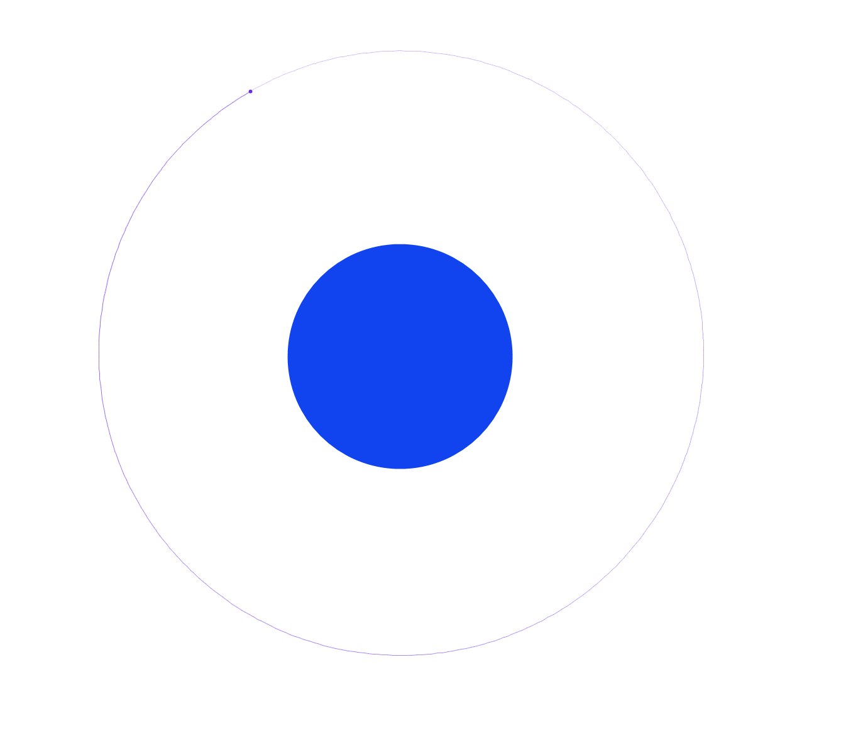

The file contents are shown below:

|  |
| --- |
| viewport,zoom,timescale:  0|0,1E-05,4935.387  velocity,position,mass,colour,size,isusingbitmap,bitmap:  0|0,1.19E+08|7.91E+07,1.203907E+26,-15645457,3.58268E+07,False,  265.302383610943|12867.1656051308,1.673E+08|7.79E+07,4.739076E+20,-9884954,565685.4,False, |

#### Planet And Moon With Moon

The planet and moon with moon scene looks like this:

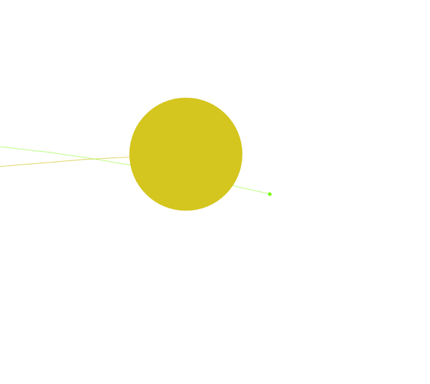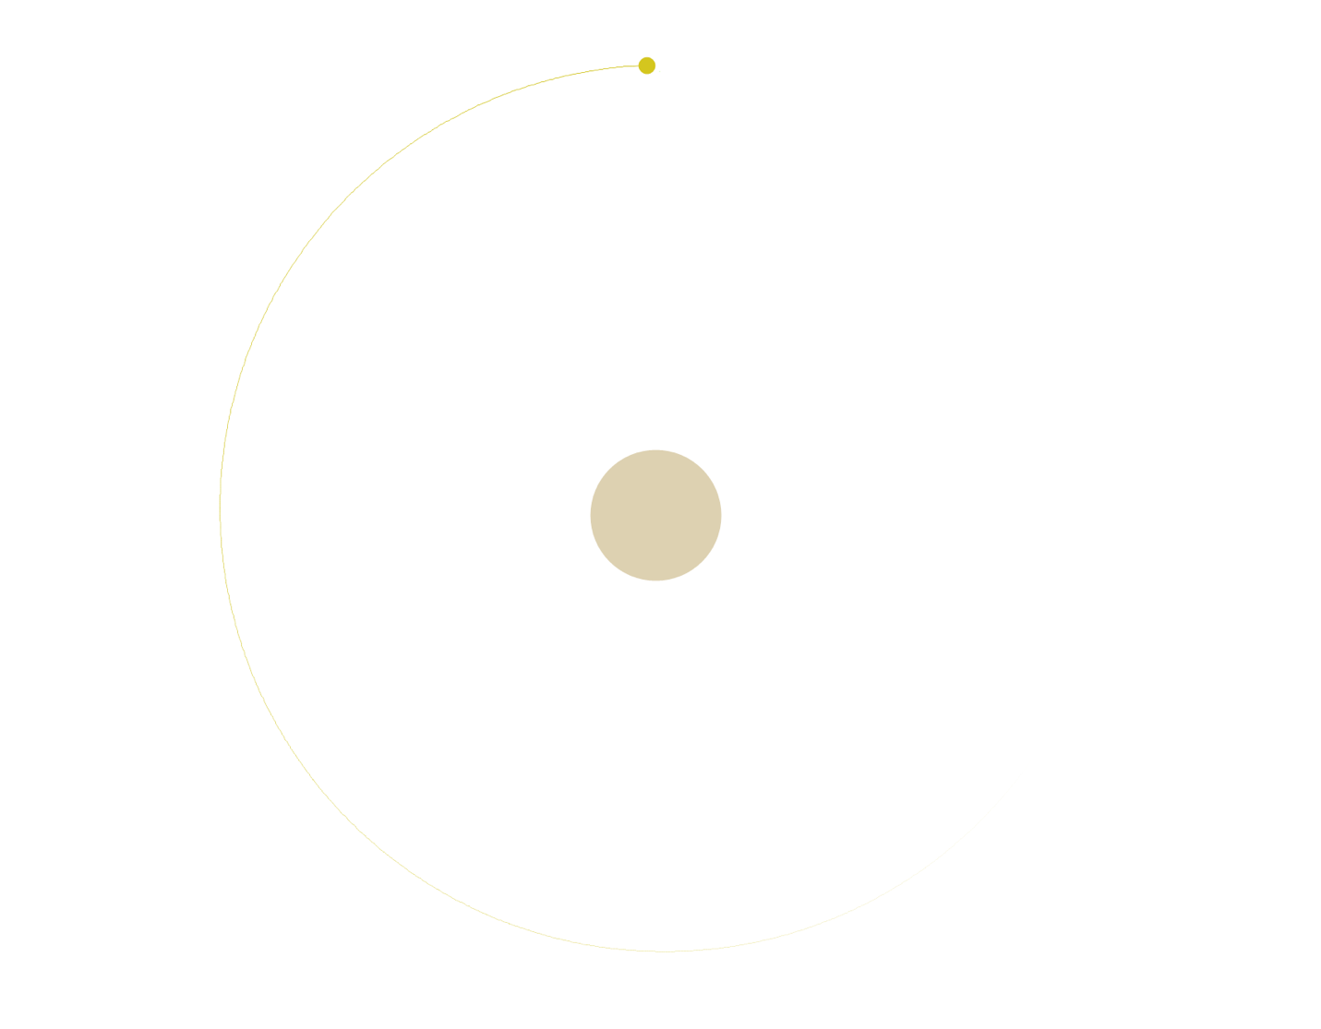

The file contents are shown below:

|  |
| --- |
| viewport,zoom,timescale:  -4.05939E+07|-7368679,8.367552E-06,4935.387  velocity,position,mass,colour,size,isusingbitmap,bitmap:  0|0,1.084914E+08|7.930427E+07,5.268681E+25,-2240077,2.720055E+07,False,  -2938.14453023378|5348.19154552628,1.912587E+08|1.229911E+08,1.187441E+23,-2898635,3566272,False,  -2009.10422149648|3993.98492086217,1.888356E+08|1.212731E+08,3.624758E+18,-8588014,111456,False, |

#### Solar System

The solar system scene looks like this:

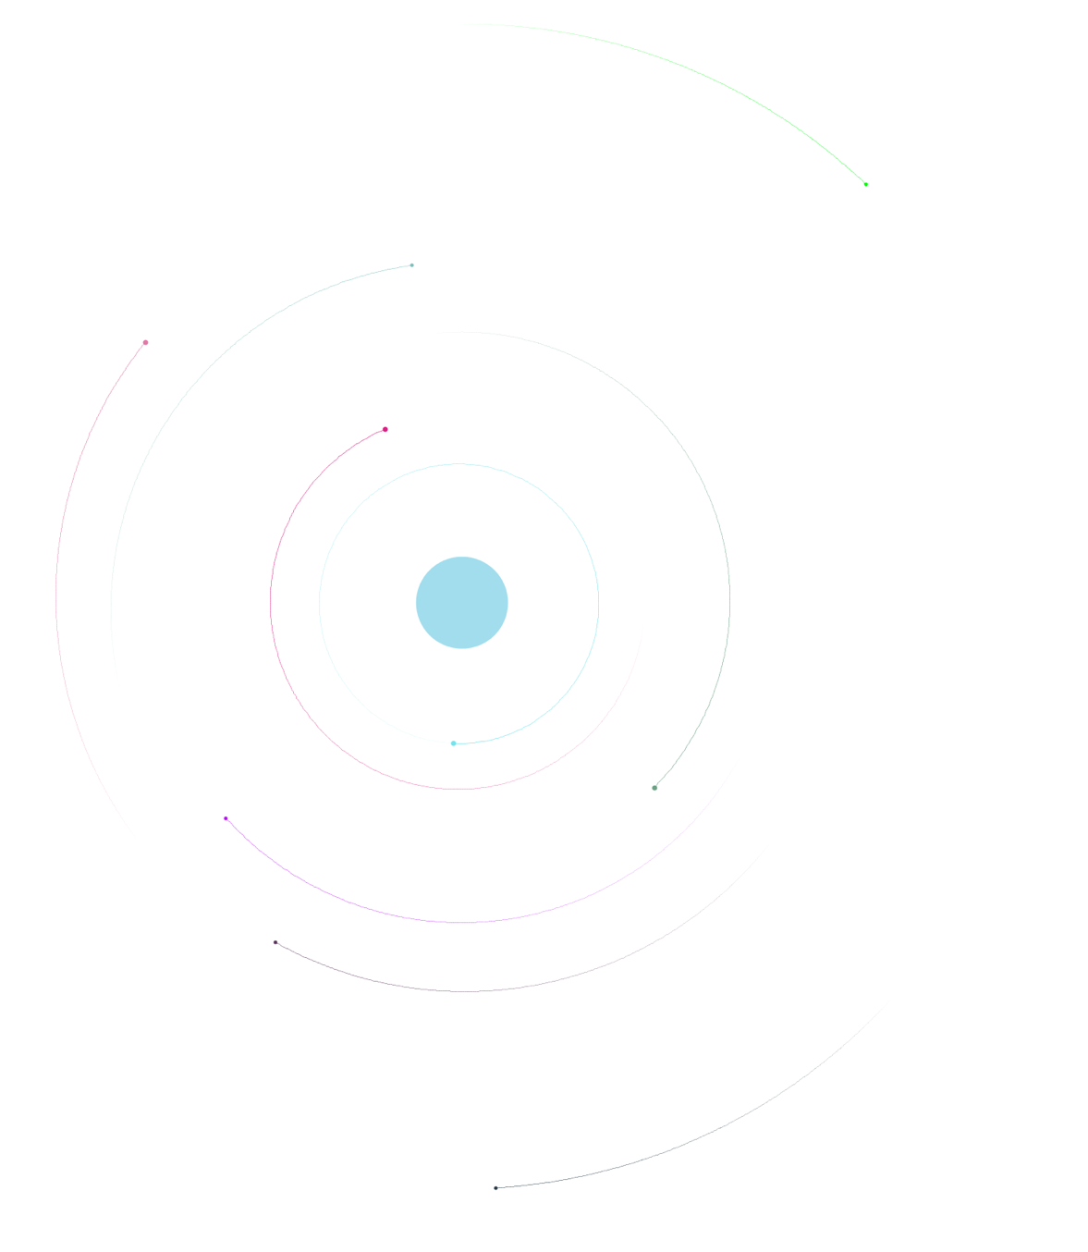

The file contents are shown below:

|  |
| --- |
| viewport,zoom,timescale:  -5.051319E+07|-1.453924E+07,8.367552E-06,4935.387  velocity,position,mass,colour,size,isusingbitmap,bitmap:  0.650949989901153|-0.897331491438765,9.90599E+07|7.652926E+07,1.294754E+25,-6038036,1.703751E+07,False,  -5584.67785920843|1478.01632724898,1.049765E+08|1.017164E+08,2.287975E+21,-8723477,956080,False,  4110.02391546974|-520.679243542364,9.291098E+07|2.689014E+07,2.287918E+21,-9395833,956072,False,  -492.709852222759|5091.26374560793,1.327333E+08|7.989565E+07,2.28786E+21,-2414460,956064,False,  -1822.65603905767|3367.98574617317,1.504661E+08|1.050793E+08,9.652234E+20,-4515331,717056,False,  -2077.40718621801|-2719.6927867451,3.924628E+07|1.207296E+08,2.287975E+21,-2131033,956080,False,  2849.4249757233|-47.5583435370173,9.81004E+07|-3.041084E+07,9.652234E+20,-16318953,717056,False,  -2119.37453247961|2722.31204165322,1.56122E+08|1.208851E+08,8.088401E+20,-10864549,676028,False,  -878.688475710439|-3506.38608784837,3.602362E+07|9.347354E+07,9.652234E+20,-8339268,717056,False,  -1907.22127130801|2088.19098682929,1.784162E+08|1.499038E+08,9.652234E+20,-14009271,717056,False, |

#### Huge Spiral

The huge spiral scene looks like this:

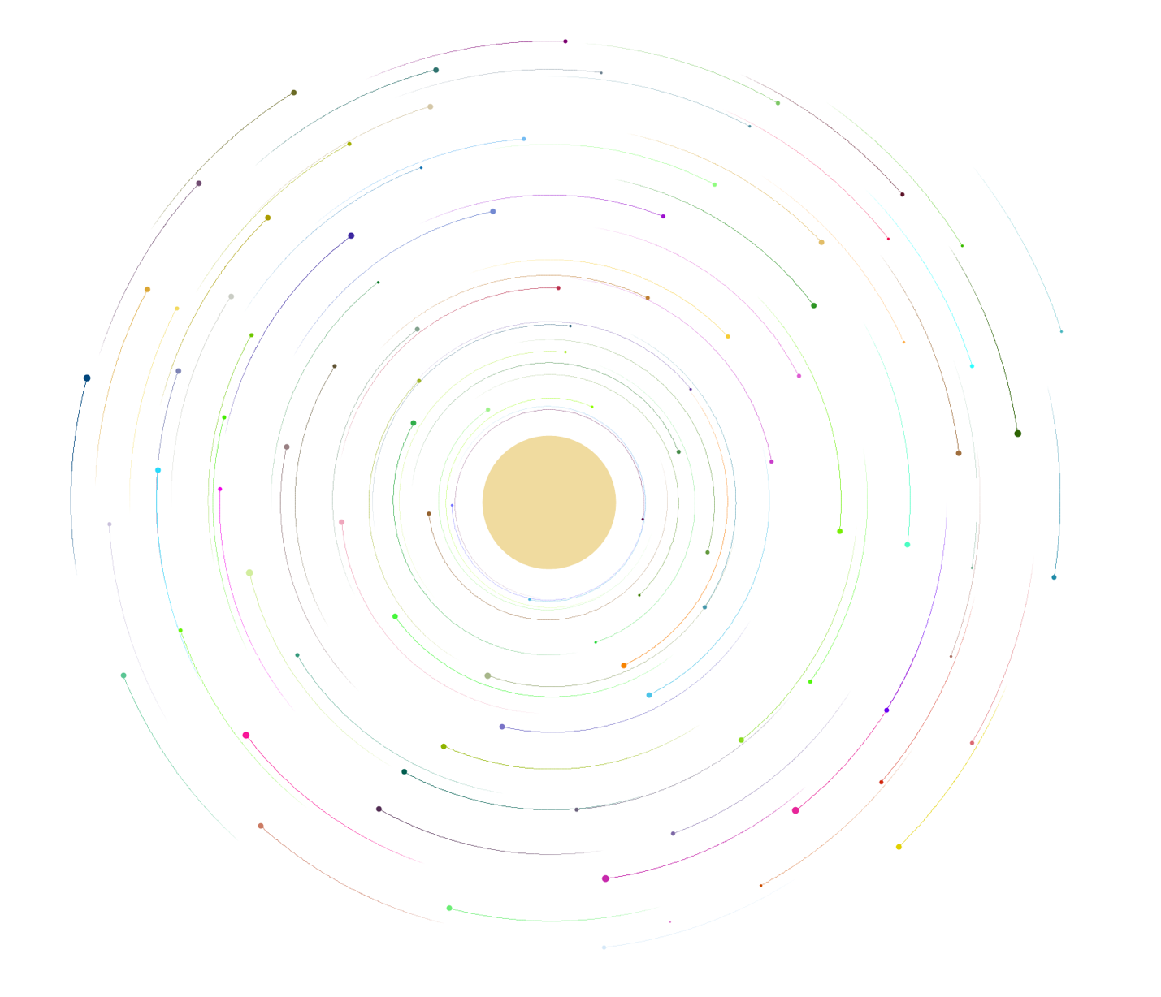

The file contents are shown on the following below and on the following page:

|  |
| --- |
| viewport,zoom,timescale:  -5.632641E+08|-3.86128E+08,1.716267E-06,3600  velocity,position,mass,colour,size,isusingbitmap,bitmap:  0|0,1.132042E+08|7.8252E+07,3.530786E+27,-1058142,1.104844E+08,False,  17511.4824319749|45821.6974032741,2.046818E+08|4.154442E+07,1.118559E+23,-7052233,3495936,False,  41048.2825960562|-9203.6479956086,8.407117E+07|-5.342915E+07,1.118559E+23,-10053308,3495936,False,  23875.1379045432|-26185.6374601672,-2.72169E+07|-4.818522E+07,1.118559E+23,-4292804,3495936,False,  21919.8126882134|22297.7379165758,2.850888E+08|-9.305005E+07,2.651509E+23,-8459222,4661312,False,  -29487.2558624152|23723.839712175,2.16335E+08|2.041066E+08,2.6514E+23,-11471798,4661248,False,  -34120.8309617357|-19540.5589683075,3.862368E+07|2.093505E+08,9.374887E+22,-6311117,3296091,False,  -16624.6660640409|-29000.8006637788,-6.975107E+07|1.813828E+08,1.118682E+23,-10464459,3496064,False,  5872.39837154334|-28856.8324856841,-1.554021E+08|2.28993E+07,3.705444E+23,-12833379,5211434,False,  7341.13613328799|-35971.5455502336,-5.92632E+07|4.212707E+07,9.3745E+22,-4705970,3296045,False,  25874.5788674543|-257.030487547235,1.097082E+08|-2.748399E+08,3.31425E+22,-11104097,2330624,False,  14238.2121471514|18007.1496420241,4.639654E+08|-2.002595E+08,3.314387E+22,-11618370,2330656,False,  8558.10365729616|24318.5740133128,4.47651E+08|-4.061062E+07,3.31425E+22,-8540524,2330624,False,  -2561.98423821992|30259.1368328693,3.678266E+08|9.747978E+07,2.6514E+23,-7546314,4661248,False,  -30793.3112598883|-4869.98812845007,7.533126E+07|3.194732E+08,1.118559E+23,-12871299,3495936,False,  -12822.5489625861|-26197.27158639,-1.36757E+08|2.011933E+08,9.374887E+22,-11671274,3296091,False,  -12869.1402638863|-21979.6753585766,-2.020149E+08|2.612072E+08,1.310072E+23,-3489061,3685040,False,  7451.8772368276|-23378.4395308176,-2.596982E+08|-4.294128E+07,2.651509E+23,-9417103,4661312,False,  18943.6794224476|-16745.5728223114,-1.309304E+08|-2.002595E+08,2.651455E+23,-13405329,4661280,False,  23963.8578441919|-9200.78481604922,-1.498106E+07|-2.567775E+08,3.314387E+22,-9074795,2330656,False,  19874.9498817481|13810.8104985275,3.427722E+08|-2.532815E+08,3.314387E+22,-12666620,2330656,False,  22688.8263813769|14750.1881356682,2.885848E+08|-1.926849E+08,3.314387E+22,-283308,2330656,False,  27850.9343944687|-4799.95853625094,6.309542E+07|-2.142433E+08,1.11859E+23,-6948217,3495968,False,  21371.0310988296|-18154.4709753634,-8.140426E+07|-1.518987E+08,1.310072E+23,-8798736,3685040,False,  4177.15507717873|-45252.5430746662,-414528|6.601613E+07,1.118621E+23,-12023221,3496000,False,  31661.8646762139|4964.97283140463,1.499117E+08|-1.49568E+08,9.374114E+22,-2268207,3296000,False,  27648.4051845324|-12944.7967540855,5994752|-1.524814E+08,1.11859E+23,-6477876,3495968,False,  -36424.3708517401|-1557.62387100464,1.056296E+08|2.5305E+08,2.6514E+23,-1136451,4661248,False,  -21192.7664472111|-16644.5466422574,-8.723088E+07|3.317091E+08,1.118682E+23,-9309655,3496064,False,  -28765.0451910614|9382.88892015026,1.930286E+08|3.206385E+08,2.6514E+23,-16425135,4661248,False,  -20265.5008112708|18085.350458785,3.258751E+08|3.136466E+08,5.178857E+23,-3853910,5826688,False,  -8963.07413718691|22270.8407659309,4.925158E+08|2.285782E+08,2.651618E+23,-2044666,4661376,False,  -9116.76729030662|25130.1632164588,4.231793E+08|1.877921E+08,5.178516E+23,-1757544,5826560,False,  -25704.0778905533|-8766.13015411877,1.007334E+07|3.777392E+08,5.178857E+23,-645735,5826688,False,  -2750.8572543387|23991.6476264957,5.146568E+08|1.225341E+08,1.118621E+23,-2462860,3496000,False,  5302.11654378758|22954.2875489254,5.257274E+08|-1.905222E+07,1.9419E+23,-14120026,4201646,False,  737.148455680324|-25024.2759995233,-2.626115E+08|6.485082E+07,2.651509E+23,-2447807,4661312,False,  -715.104701109783|-27429.3459270079,-1.996843E+08|8.407859E+07,2.651509E+23,-3486267,4661312,False,  9003.40553734019|34550.5664317061,2.897501E+08|3.16392E+07,2.6514E+23,-11352858,4661248,False,  4989.75422859385|29413.2774567572,3.730705E+08|3.280451E+07,9.374114E+22,-10554316,3296000,False,  35479.5215826731|16696.2444874694,1.784621E+08|-6.216906E+07,1.118559E+23,-12019799,3495936,False,  32388.7230833212|-11567.3995228311,4.619827E+07|-1.111125E+08,1.118559E+23,-668601,3495936,False,  26964.9572723997|5693.17794487619,1.772968E+08|-2.276445E+08,2.651455E+23,-1983378,4661280,False,  13439.9726176233|-22702.6552018459,-1.792911E+08|-9.538067E+07,9.374114E+22,-5984492,3296000,False,  15172.6248100146|-27206.0865739694,-9.888406E+07|-4.235862E+07,2.651509E+23,-9073456,4661312,False,  -53963.7216384549|-3519.39229217257,1.079602E+08|1.574938E+08,3.31425E+22,-10811832,2330624,False,  54955.3423767163|3718.80184741178,1.184481E+08|-407104,3.31425E+22,-8881665,2330624,False,  38110.634706135|-28318.3279285887,5.085952E+07|-6816352,3.31425E+22,-12353269,2330624,False,  41958.5732824865|14490.8440450648,1.522424E+08|-3.594934E+07,3.31425E+22,-12790196,2330624,False,  35565.8371412094|3151.4066555056,1.295187E+08|-1.076165E+08,1.118621E+23,-3651383,3496000,False,  24262.1051900149|-31619.0122512826,-4493184|-1.322563E+07,3.314523E+22,-10008157,2330688,False,  -1213.80902794778|-31963.6214405549,-1.169465E+08|8.582656E+07,3.314523E+22,-16485340,2330688,False,  -16166.0315259136|-32569.7971774894,-4.760998E+07|1.557458E+08,1.941826E+23,-7953520,4201592,False,  -5424.5359545046|-28374.500546852,-1.64142E+08|1.295261E+08,1.118559E+23,-9386995,3495936,False,  -6117.07404596235|-26202.2771985297,-2.037628E+08|1.499192E+08,2.6514E+23,-8551245,4661248,False,  -873.408421517958|-26027.6054982853,-2.340612E+08|8.815722E+07,1.118559E+23,-861846,3495936,False,  -12653.7045369387|-23890.5815121322,-1.740472E+08|2.29161E+08,2.6514E+23,-12985607,4661248,False,  -18784.9983958401|-22529.5184892734,-9.71361E+07|2.518847E+08,1.118559E+23,-1173790,3495936,False,  -23075.4079228495|-22821.8336950359,-4.411402E+07|2.349875E+08,2.6514E+23,-6717052,4661248,False,  -26158.5731164121|-15202.1052805891,-1.614637E+07|2.979148E+08,5.178516E+23,-2888542,5826560,False,  -26943.0369590334|18018.1555906419,2.378934E+08|2.623725E+08,2.6514E+23,-7425789,4661248,False,  -17941.0095537981|29832.1499878929,2.798449E+08|1.761389E+08,2.6514E+23,-8817211,4661248,False,  -7411.20342262491|37911.1818603829,2.670264E+08|1.062197E+08,3.705566E+23,-5720435,5211491,False,  25639.8357153486|30704.4950513338,2.262402E+08|-1.846957E+07,2.651509E+23,-687076,4661312,False,  13857.0411800141|24427.8262982186,3.730705E+08|-7.149162E+07,2.6514E+23,-11076412,4661248,False,  15669.7776171586|21102.5644111479,3.870543E+08|-1.27427E+08,2.651455E+23,-6394303,4661280,False,  13128.3825694686|20713.6682734454,4.44155E+08|-1.344189E+08,5.178601E+23,-13606130,5826592,False,  17784.353810944|18025.2259825197,3.748185E+08|-1.816144E+08,1.11859E+23,-12714241,3495968,False,  23551.6996993704|10443.9300762081,2.571212E+08|-2.474549E+08,3.314387E+22,-1305005,2330656,False,  28921.5358575966|5771.62481200237,1.662262E+08|-1.897716E+08,2.651455E+23,-13396947,4661280,False,  15002.5297549897|-23860.1086333789,-1.390876E+08|-7.964886E+07,3.314523E+22,-14780750,2330688,False,  17947.1851793078|-19254.8943877156,-1.355916E+08|-1.559773E+08,2.651455E+23,-2766678,4661280,False,  6473.05079392848|-25939.4513996582,-2.090068E+08|-1572416,2.651509E+23,-5662198,4661312,False,  -7125.04457981045|-39673.5628847886,-3.071286E+07|1.03889E+08,3.314523E+22,-14460811,2330688,False,  -28499.334440496|-33283.8959049309,1.881325E+07|1.580764E+08,3.31425E+22,-5314757,2330624,False,  -43201.085609393|28013.2090183207,1.615649E+08|1.516671E+08,3.31425E+22,-7013116,2330624,False,  -42761.3167862347|8388.59598777636,1.370932E+08|2.023586E+08,2.651618E+23,-13062833,4661376,False,  -13610.9553587804|50255.8263244809,1.988552E+08|1.009757E+08,1.118559E+23,-6098800,3495936,False,  16876.0072226991|-51011.5222853243,3.57104E+07|5.378029E+07,3.314523E+22,-11028770,2330688,False,  -46.9783174114622|26683.8648961593,4.42407E+08|7.766934E+07,1.941826E+23,-9894419,4201592,False,  -18956.7378356557|23525.4426584182,3.130565E+08|2.390662E+08,9.374114E+22,-9542018,3296000,False,  -27971.0489652223|4316.17569605349,1.58069E+08|3.666687E+08,2.6514E+23,-11391149,4661248,False,  -14189.9821298755|21102.0079307525,4.156047E+08|2.80435E+08,3.31425E+22,-3584762,2330624,False,  -20989.8593655308|13758.7161845835,3.183005E+08|3.893924E+08,1.118559E+23,-2627081,3495936,False,  -25043.2204616634|6833.90275104801,2.052644E+08|4.132815E+08,2.6514E+23,-9311109,4661248,False,  -24772.00285336|-6121.10729835617,2.638784E+07|4.272653E+08,2.6514E+23,-3572890,4661248,False,  -18384.2710837376|-16682.0230301905,-1.437489E+08|3.590941E+08,2.651618E+23,-10500971,4661376,False,  -3945.43488804776|-24067.1480894105,-2.777607E+08|1.394313E+08,5.178686E+23,-16430724,5826624,False,  13652.1678808304|-20122.725151593,-2.165814E+08|-1.478201E+08,2.651455E+23,-9737685,4661280,False,  22829.0094111559|-9909.0847278519,-3.828742E+07|-2.725093E+08,1.118559E+23,-8781714,3495936,False,  24838.2759769109|1872.42365855513,1.417545E+08|-3.02225E+08,1.118559E+23,-8272020,3495936,False,  22511.5366788923|10104.1887670863,2.716877E+08|-2.765879E+08,1.118621E+23,-10741973,3496000,False,  3104.63473340179|25508.3549748841,4.674614E+08|3.396982E+07,3.314523E+22,-6002339,2330688,False,  -5601.09261145392|24916.6260682739,4.657135E+08|1.557458E+08,1.118559E+23,-3134692,3495936,False,  -18451.5116115138|17629.6212708437,3.631653E+08|3.40449E+08,4.142813E+21,-3393616,1165312,False,  -15045.7049194397|23905.9581666852,3.631653E+08|2.338222E+08,1.118559E+23,-8557916,3495936,False, |

#### Orbit 1

Orbit 1 looks like this:

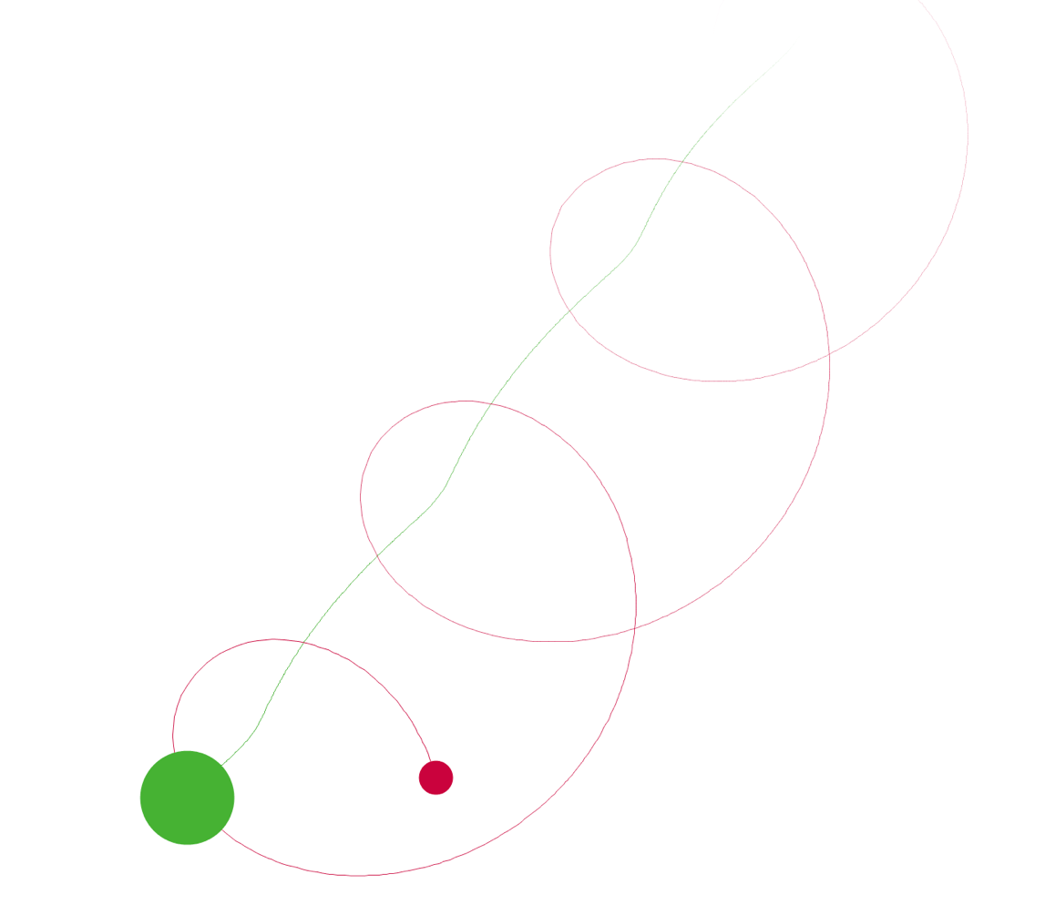

The file contents are shown below:

|  |
| --- |
| viewport,zoom,timescale:  -5.234438E+08|2.31034E+08,4.101968E-06,4935.387  velocity,position,mass,colour,size,isusingbitmap,bitmap:  -1981.66909438485|1815.7700701372,-2.211066E+08|4.00162E+08,7.243254E+25,-11816900,3.02451E+07,False,  10087.830453137|2333.32648488658,-1.983008E+08|3.636148E+08,3.392632E+24,-3666624,1.090242E+07,False, |

#### Orbit 2

Orbit 2 looks like this:

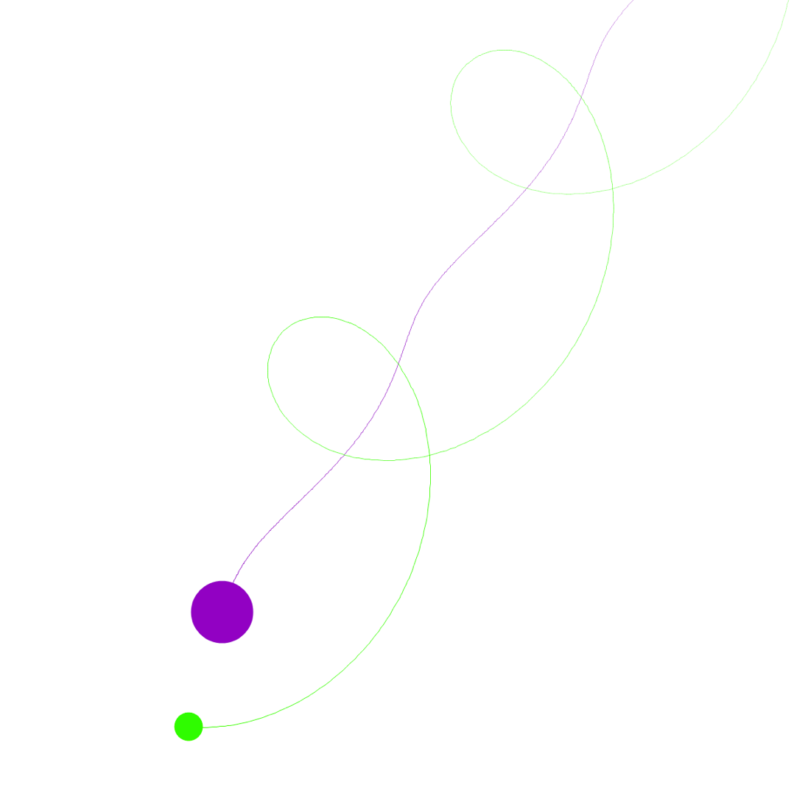

The file contents are shown below:

|  |
| --- |
| viewport,zoom,timescale:  -1.361069E+09|1.109891E+09,2.872032E-06,13437.04  velocity,position,mass,colour,size,isusingbitmap,bitmap:  -1635.64988590802|2309.30973669281,-9.139686E+08|1.327992E+09,9.184983E+25,-7267392,3.273683E+07,False,  -6149.0970811406|9760.6845818483,-8.41009E+08|1.359346E+09,8.750772E+24,-12584434,1.495177E+07,False, |

#### Orbit 3

Orbit 3 looks like this:

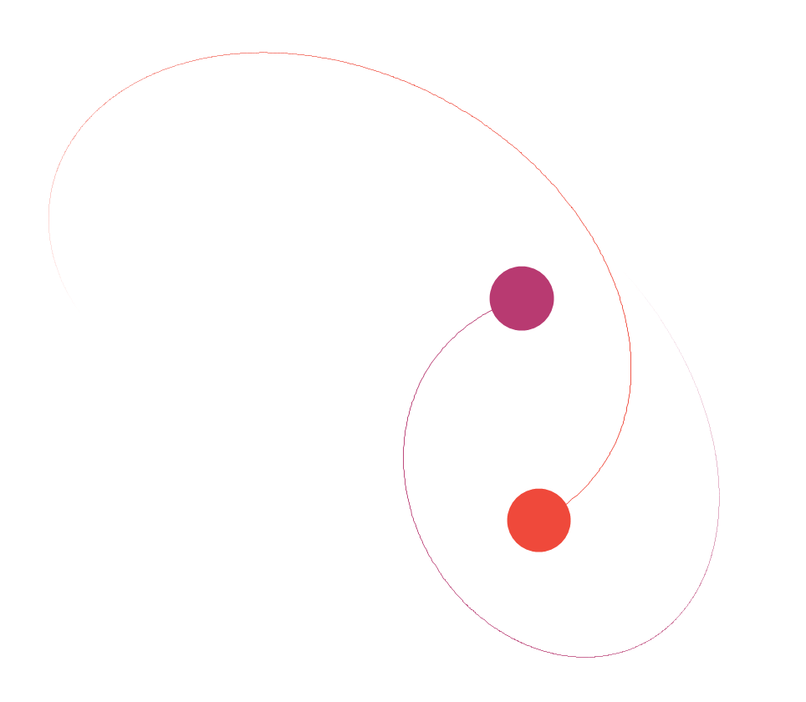

The file contents look like this:

|  |
| --- |
| viewport,zoom,timescale:  -2.088935E+09|1.732582E+09,1.300716E-06,13437.04  velocity,position,mass,colour,size,isusingbitmap,bitmap:  6790.08083760397|-9961.76753041298,-1.199105E+09|2.360048E+09,5.376436E+26,-4703631,5.899863E+07,False,  -5226.13167669476|11516.1474775412,-1.031153E+09|2.434962E+09,5.192112E+26,-1095365,5.831655E+07,False, |

#### Orbit 4

Orbit 4 looks like this:

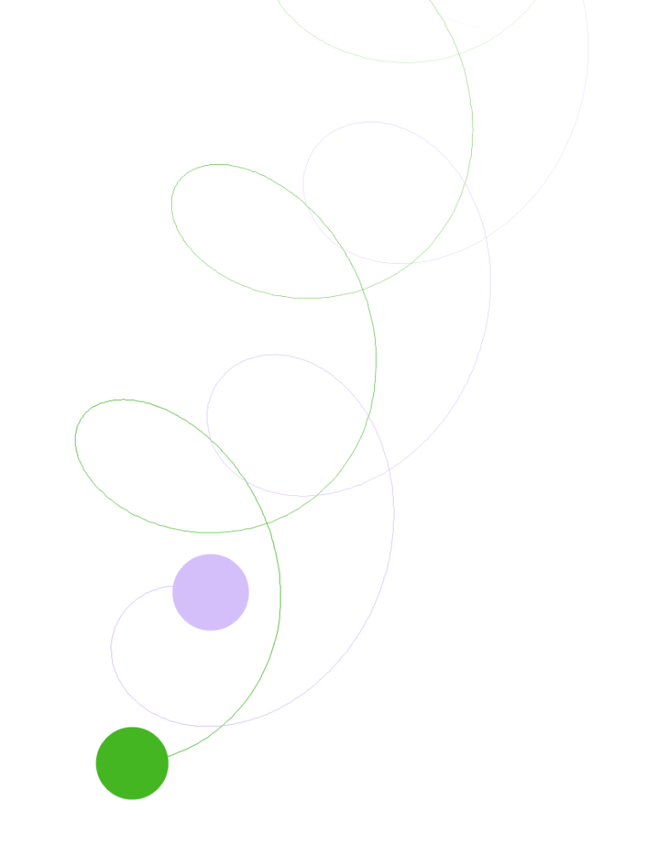

The file contents are shown below:

|  |
| --- |
| viewport,zoom,timescale:  -2.773895E+09|2.226726E+09,8.086831E-07,13437.04  velocity,position,mass,colour,size,isusingbitmap,bitmap:  -1492.79921429965|-8914.6394899124,-1.643433E+09|2.945605E+09,3.904252E+27,-11946963,1.1425E+08,False,  -2981.18330032864|18081.9499211284,-1.148182E+09|3.113217E+09,4.496421E+27,-2899719,1.197566E+08,False, |

#### Orbit 5

Orbit 5 looks like this:

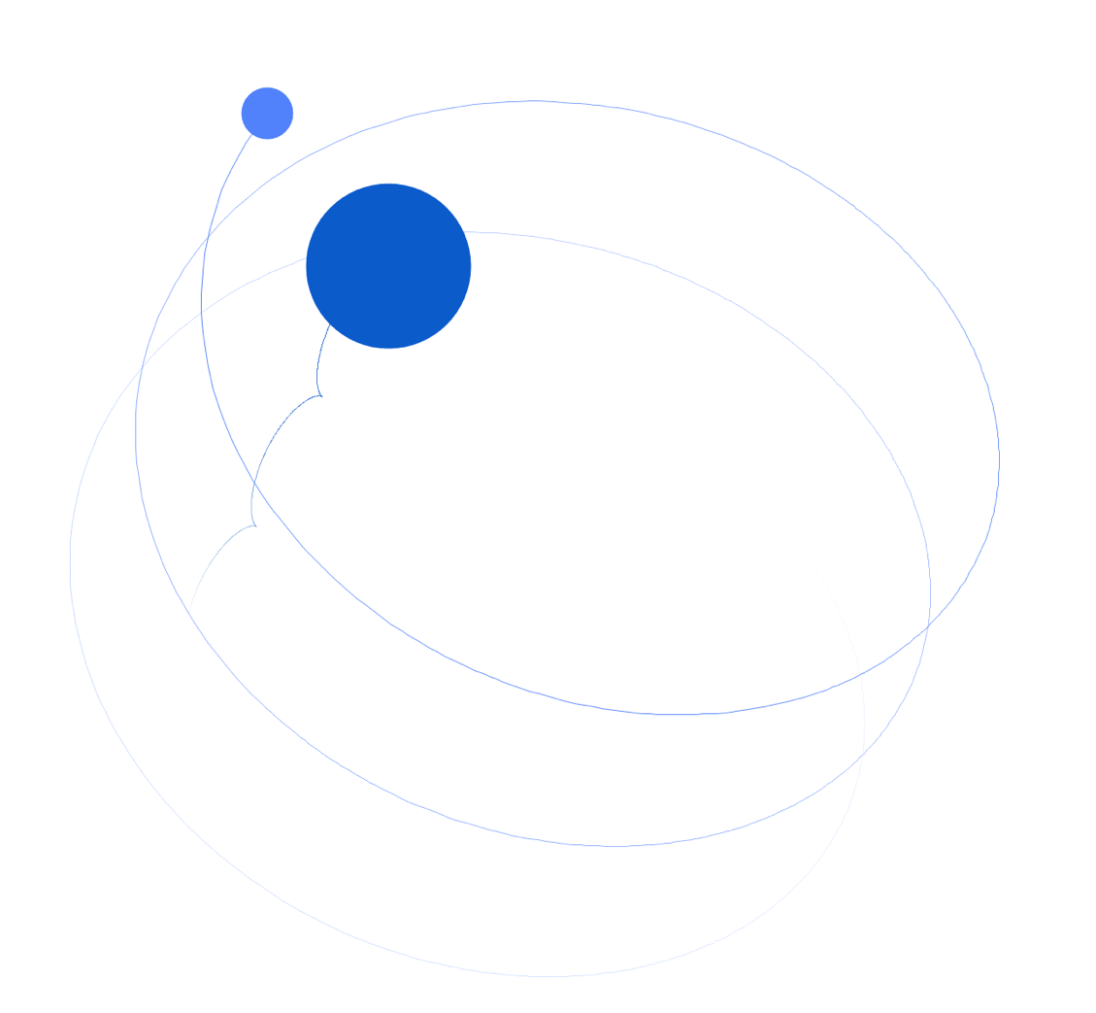

The file contents are shown below:

|  |
| --- |
| viewport,zoom,timescale:  -3.345194E+09|2.71641E+09,8.086831E-07,13437.04  velocity,position,mass,colour,size,isusingbitmap,bitmap:  639.415590566529|-4191.57228889361,-2.107738E+09|3.233057E+09,4.305478E+28,-15376696,2.543027E+08,False,  32682.0943025821|30079.6811630879,-1.232836E+09|3.038523E+09,1.328249E+27,-11172616,7.975726E+07,False, |

# Testing

## Black Box Testing

Note that all screenshots that are referenced can be found in Appendix 2.

| No | Input Description | Expected Result | Purpose | Result and Proof |
| --- | --- | --- | --- | --- |
|  | Try to click the “Set Image” button when there are no bodies. | The user cannot click the button and so nothing happens. | Stop the code trying to set the image of a body which isn’t there. | As expected. See in screenshot 1 that the “Set Image” button is disabled when there are no bodies. |
|  | Click “Set Image” when the selected body doesn’t already have an image. | The user is shown a dialog in which they select the image file to be used for the body’s image. This image is given to the currently selected body and changes displayed in the view. | To ensure that the *set image* functionality works correctly. | As expected. See in screenshot 2 that the “Set Image” button becomes enabled when the scene is not empty and that when clicked, the “Select Image” information window appears. Screenshot 3 then shows that when the user says “Ok” to the previous window, the pre-downloaded planets are shown for the user to select or they can use their own. Screenshot 4 then shows proof that setting an image works correctly, in this case I selected Earth. |
|  | Click “Set Image” when the selected body already has an image. | A dialog box is shown with “Replace”, “Remove” and “Cancel” options (not these terms but implied through explanation because message boxes have set buttons). | Ensure that the user is correctly given these choices. | As expected. Screenshot 5 shows the dialog box noted in the expected result of this test. |
|  | Select to replace the image (as a response to Test 3’s result). | The program continues to perform processes which are tested under Test 7. | To check that the user can easily replace the image of the selected body. | As expected. Screenshot 6 shows the result of clicking “Yes” on the “Change Image” dialog which has 3 options. As expected, the program continues to perform as if the “Set Image” button was clicked and the body had no image. Screenshot 7 and 8 are proof of this; in this case, I chose Jupiter. |
|  | Select to remove the image (as a response to Test 8’s result). | The image of the selected body is removed. The body should now be represented by its original colour in the view. | To check that the user can remove the image of the selected body. | As expected. Screenshot 9 is a result of clicking “No” on the “Change Image” dialog. The image is removed as it is supposed to. |
|  | Select to cancel the operation (as a response to Test 8’s result). | The program returns to the main form, no dialogs are shown and no changes are made. | If the user changes their mind after clicking the “Set Image” button, then they can cancel their choice. This test tests that this happens. | As expected. Screenshot 10 is a result of clicking “Cancel” on the “Change Image” dialog. The image stays as it was and the program continues normally. |
|  | Uncheck the “Show Velocities”checkbox. | The velocity lines disappear immediately and in future playback. | Check that the user can disable the velocity lines if they choose. | As expected. I created a body, gave it a velocity as can be seen in screenshot 11. I then unchecked the “Show Velocities” checkbox and the velocity line disappeared (screenshot 12). See that the velocity still exists though as it can be seen in the “Selected Body” info. |
|  | Check the “Show Velocities” checkbox. | The velocity lines appear immediately and in future playback. | Check that the user can enable the velocity lines if they choose. | As expected. Screenshot 13 shows that when I rechecked “Show Velocities”, the velocity line reappeared. |
|  | Uncheck the “Show Trails” checkbox. | The trail lines disappear immediately and in future playback. | Check that the user can disable the trails if they choose. | As expected. I allowed the simulation to play for a few seconds and then paused it. Screenshot 14 shows the program after pausing and before unchecking “Show Trails”. Screenshot 15 shows how it looked after unchecking, it disappears as expected. |
|  | Check the “Show Trails” checkbox. | The trail lines appear immediately and in future playback. | Check that the user can disable the trails if they choose. | As expected. After performing Test 9, I then rechecked “Show Trails” and the trails reappeared. |
|  | Click the “Clear Trails” button. | All stored trails should be removed and should be shown in view. | If the trails become too messy for the view then the user can clear them. | As expected. See the existing trails in screenshot 16. I then clicked “Clear Trails” and the trails were cleared as expected (screenshot 17). See also that the “Show Trails” checkbox is still selected which means that the trails were definitely cleared. |
|  | Click the “+” button (Zoom In). | The view should zoom in and update immediately. | To ensure that the user can zoom in without having to scroll. | As expected. Clicking the zoom button a single time does not really produce a noticeable change (screenshot 18) notice that the zoom has increased from 100% to 102% in the “Info” part of the form. This can be compared against screenshot 17. When the “+” button is held down for a few seconds though, the changes are much more visible. As you can see in screenshot 19, the body is magnified much more and is at 143%. |
|  | Click the “-” button (Zoom Out). | The view should zoom out and update immediately. | To ensure that the user can zoom out without having to scroll. | As expected. As with the “+” button (Test 12), clicking the zoom does not produce a noticeable difference (no evidence) but when held, everything is scaled much more visibly. See screenshot 20 and how the body and the velocity line have been scaled down considerably (53%). |
|  | Uncheck the “Gravity” checkbox. | Nothing if the simulation is paused but if playing then disable the gravitational forces. | Check that gravity can be disabled. | As expected. For this test, I created a large star-like body and created a planet to orbit around it (screenshot 21). I played the scene with gravity on (finishes with screenshot 22). I then played the scene after unchecking “Gravity” (screenshot 23 to 24). As you can see in 23 and 24, the gravity is clearly off because the trail is straight even though both orbitals have the velocity necessary to orbit the star. |
|  | Check the “Gravity” checkbox. | Nothing if the simulation is paused but if playing then enables the gravitational forces. | Check that gravity can be enabled. | As expected. As demonstrated in Test 14, the gravity checkbox works successfully both checked and unchecked. |
|  | Drag the “Time Scale” slider to the left. | The time scale decreases at a rate propotional to the amount that it is displaced and changes are shown in info. | Test that the user can decrease the time scale. | As expected. Before touching the “Time Scale” slider, the time scale was at 1 hour per second (screenshot 25). After I started sliding the slider to the left, the time scale started to decrease (screenshots 26 and 27). |
|  | Drag the “Time Scale” slider to the right. | The time scale increases at a rate propotional to the amount that it is displaced and changes are shown in info. | Test that the user can increase the time scale. | As expected. Screenshot 28 shows the untouched time scale at its default (1 hour per second) and then in 29, I am increasing the time scale using the slider as can be seen. |
|  | Try to drag the “Time Scale” slider somewhere not within the control’s bounds. | The time scale should decrease or increase depending on which side the mouse is, at a rate which is proportional to the maximum displacement of the slider. | Test that the custom time scale slider doesn’t break. | As expected. In screenshot 30, I dragged the mouse while held down on the slider all the way down to the bottom-left of the screen. As expected, the time scale decreased at the same rate as if it were held down at the lowest value. |
|  | Select “Pan”. | The previously selected radio should become unselected and the “Pan” radio should become selected. | Test that the user can select “Pan”. | As expected. From screenshot 27 to 28, I changed my selection of mouse function from “Add Body” to “Pan”. As expected, “Pan” became the only selected radio. |
|  | Drag around inside the view when there are no bodies and “Pan” is selected. | The view should move but no visible change should be seen. | Check that program doesn’t crash upon panning when there are no bodies. | As expected. Cannot be shown by screenshots but the test has been carried out and the program continued to run as normal. |
|  | Drag around inside the view when there are bodies and “Pan” is selected. | The view should move and the view moving will be visible as the bodies will be rendered in different places depending on where the user has dragged to. | Test that the “Pan” cursor function works correctly. | As expected. Screenshots 31 to 35 demonstrate that “Pan” works correctly. |
|  | Select “Add Body”. | The previously selected radio should become unselected and the “Add Body” radio should become selected. | Test that the user can select “Add Body”. | As expected.Screenshot 36 shows that “Add Body” can be selected (note that “Pan” is the default mouse function. |
|  | Try and make a body of 0Kg by clicking in the view. | A messagebox should pop-up and announce an error. The Body created upon the mouse down should be removed too. Nothing visual should occur in the view. | Test that the user cannot add a body of 0Kg. | As expected.When clicking in the view whilst “Add Body” is selected, the error messagebox appears as expected. This can be seen in screenshot 37 and then screenshot 38 shows that after the dialog has been dismissed, the program is as it was before trying to add the massless body. |
|  | Drag in the view to a normal body size. | The body should become larger as the user drags their mouse from the center. This should be shown in the view. | Ensure the user can add a body correctly. | As expected.Screenshots 38 to 43 show the progression of adding a normal size body. The mouse is lifted on number 43. Everything happens as expected. |
|  | Try to drag in the view to create a body with a mass which is out of range. | The body which is being created shold disappear immediately from the view and a messagebox showing the error should be displayed. | Limit the mass of the body which is being added. | As expected.Screenshots 44 to 48 show the progression of creating an oversized body. In screenshot 48, when the body reaches a size too large, the messagebox is shown as expected and the body’s mass is set to the maximum. Screenshot 49 shows the state of the application after dismissing the messagebox. |
|  | Select “Add Orbital”. | The previously selected radio should become unselected and the “Add Orbital” radio should become selected. | Test that the user can select “Add Orbital”. | As expected.Screenshot 50 shows that “Add Orbital” can be selected correctly. |
|  | Try to create an orbital when there are no bodies. | No orbital rings should appear and nothing should happen. | Ensure that the user cannot make an orbital around a body which isn’t there. | As expected.This cannot be shown using a screenshot but has been tested and works as expected. |
|  | Try to create an orbital when there are bodies. | As the mouse is moved, orbital rings should be formed around the body which has the strongest gravitational force on the point where the mouse is and should change as needed. The user should then be able to add a body as normal as if they were using “Add Body”. The only difference is that when they raise their mouse, the velocity of the added body should be set to make it an orbital of the body shown to have a line around it. | Test that the user can correctly add an orbital body. | As expected.In screenshot 51, I create a body which is to be used as the star, in screenshot 52, the orbital lines can be seen as expected and in screenshot 53, I set the mass of the orbital and the program automatically sets the velocity so that it orbits. |
|  | Try to create an orbital when there are bodies which is too big. | Same as normally creating an orbital and then when dragged to be too big, the body should be removed and then a message box appear announcing the error. | Limit the mass of the body which is being added. | As expected.In screenshot 54, I first created the smaller body which is sort of a star. I then proceeded to create an orbital (the larger body) which has a mass that exceeded the maximum. As can be seen, the messagebox is shown as expected and the orbital’s mass is set to the max mass. |
|  | Select “Select Body”. | The previously selected radio should become unselected and the “Select Body” radio should become selected. | Ensure that the user can select a body correctly. | As expected.Screenshot 55 shows that I can correctly select the “Select Body” cursor functions. |
|  | Select a body. | No changes should be visible apart from those in the “Current Body” section of the form (implying that the selected body has been changed. The selected body should now be the one which was just selected. | Test that the “Select Body” cursor function works properly. | As expected.In screenshot 56, the larger body is selected. As you can see from the “Selected Body” info in screenshot 57, I have selected the smaller body. |
|  | Try to select a body which isn’t there by clicking white space whilst “Select Body” is selected. | Nothing should happen. | Ensure that the program doesn’t crash. | As expected. This cannot be shown using a screenshot but has been tested and works as expected. |
|  | Select “Move Body”. | The previously selected radio should become unselected and the “Move Body” radio should become selected. | Ensure that the user can select to move a body. | As expected.“Move Body” can be seen selected in screenshot 58. |
|  | Try to drag around in white space while “Move Body” is selected. | Nothing happens. | Ensure that the program doesn’t crash. | As expected.This cannot be shown using a screenshot but has been tested and works as expected. |
|  | Move a body. | The body which is under the mouse should become the currently selected body and then as the user moves their mouse, the newly selected body should move accordingly. | Ensure that the user can easily move a body. | As expected.Screenshots 59 to 61 show me moving a body amongst other bodies. |
|  | Drag a body to somewhere out of bounds (very difficult to show, proby of this happening is near 0). | The body will be removed, changes shown in the view then a messagebox should appear with what has happened. | Prevent the program crashing upon a body becoming out of range. | As expected.This cannot be shown using a screenshot as I cannot move the view so far that I can create a body which is out of bounds. The way that I have designed the view however, no part of the view is ever out of bounds and the user needs to place their mouse where they want the center of the body to be. If they cannot put their mouse out of bounds then they cannot create a body which is out of bounds. |
|  | Select “Change Velocity”. | The previously selected radio should become unselected and the “Select Body” radio should become selected. | Ensure that the user can select to change the velocity of a body. | As expected.Screenshot 62 shows that “Change Velocity” can be selected correctly. |
|  | Change the velocity of a body by dragging from inside the body to the point where the velocity line should end. | The body which is under the mouse when it is pressed down should become the selected body, then the velocity of the newly selected body should change according to the mouse position everytime the mouse is moved. These changes should be shown in the “Selected Body” info in the form. | Ensure that changing of the velocity of a certain body works correctly. | As expected.Screenshots 63 to 67 shows me changing the velocity of a body which I added. |
|  | Change the velocity of the selected body by dragging in white space. | The body which is currently selected should have the endpoint of its velocity line set to the mouse point and changes should be shown in the view and also in the “Selected Body” info. | Let the user change the velocity of the selected body without having to find it. | As expected.The velocity line can be seen to jump from screenshot 67 to 68 and then I am seen moving changing the velocity up to screenshot 70. |
|  | Try to change the velocity of a body either way (previous two tests) but make the velocity larger than the limit (speed of light). | The velocity of the (newly [if appropriate]) selected body should become equal to the speed of light in the same direction as the user was trying to set. A messagebox should then appear saying what has happened. | Prevent the program crashing upon a velocity component becoming out of range. | As expected.Upon testing, it was not possible to try and set a speed of light by dragging from inside the body. Screenshot 71 shows me creating the body, then in screenshot 72 I have panned the view to be far to the top-right of the body. Then in screenshot 73, I try and set the velocity to be greater than the speed of light. As expected, the velocity has the direction of the velocity that I was trying to set but with a magnitude equal to the speed of light (can be seen in the “Selected Body” info box. The messagebox also appears showing the error that the user produced. |
|  | Select “Change Mass”. | The previously selected radio should become unselected and the “Change Mass” radio should become selected. | Ensure that the user can select to change the mass of a body. | As expected.See screenshot 74, “Change Mass” becomes selected. |
|  | Change the mass of a certain body by dragging from inside a body outward. | The body under the mouse when it is pressed down should become the selected body. The body’s edge should then move to the position of the cursor. | Test that the changing of mass of a certain body works correctly. | As expected.In screenshot 75, I have created a body. Then from screenshot 76 to 79, I show the progression of dragging from inside a body. (Note that in this case because the selected body is the body which I drag from, I could have dragged the mouse in the white space and then the body would’ve jumped to the mouse.) |
|  | Change the mass of the selected body by dragging in white space. | The edge of the selected body should jump to the cursor’s position and should be shown in the view as well as the mass shown in the form’s “Selected Body” info box. | Check that the user can change the mass of the selected body without having to find it. | As expected.In screenshot 80, I place my mouse on the white space then press down and begin to move (seen in screenshot 81). I continue to expand the body (screenshot 80-83). |
|  | Try to change the mass either way (previous two tests) but make the mass go above the maximum. | The mass of the (newly [if appropriate]) selected body should become equal to the maximum limit and a messagebox should appear. | Prevent the mass of the body overflowing. | As expected. Screenshots 84 and 85 show me trying to create a body which is too big. In screenshot 85, you can see that the mass has been set to the maximum (shown in “Selected Body” info) and the messagebox has appeared. |
|  | Try to change the mass either way (as in previous test) but set the mass to be 0Kg. | Changes the mass as normal but upon mouse release, the changes made by the most recent changing of mass are undone and a messagebox is shown. | Ensure that the user cannot set the mass of a body to be 0Kg. | As expected. In screenshot 86, I begin to change the mass of a body which I created beforehand. Then in screenshot 87, the mouse is still held down and shows that it is possible to drag to 0Kg (albeit very difficult). Then in screenshot 88, I let go of the mouse and show that it is not possible to change the mass to 0Kg – the messagebox appears as expected and the program undoes the changes that the user has made in the last action. |
|  | Select “Remove Body”. | The previously selected radio should become unselected and the “Remove Body” radio should become selected. | Ensure that the user can select to remove a body. | As expected. Screenshot 89 shows that “Remove Body” can be selected. |
|  | Remove a body by clicking on it in the view. | The body should be removed from view and if that body was the selected body then the selected body index becomes equal to the index of the most recently added body in the array. If the body which is removed was the last body then the necessary controls described earlier in the document should become disabled. | Ensure that the user can remove a body correctly and limit the controls that they can access if it is the last body and thus there are no bodies left after the operation. | As expected. In screenshot 89, you can see that I’ve created 2 bodies. Then screenshot 90 shows that I have removed the upper-left larger body. |
|  | Try to remove a body which isn’t there by clicking in white space. | Nothing should happen. | Ensure that the program doesn’t crash. | As expected.This cannot be shown using a screenshot but has been tested and works as expected. |
|  | Add a change. | If the changes list is empty then a change will be added, otherwise the newly added change will be seen at the top of the listbox. The item added to the listbox will be represented by a description string. | Ensure that changes are added correctly. | As expected.Screenshot 91 shows that I have created multiple changes using various functions. (Note that the most recent changes are on the top of the listbox.) |
|  | Try to undo a change by clicking an item in the changes listbox. | The body data which was stored upon the selected change being added should be restored and be visible in the view. | Ensure that the changes feature works correctly. | As expected.Screenshots 92-94 show me rolling back changes from the point which I was at in screenshot 91. |
|  | Add a new change after a less recent change has been selected. | The changes which are more recent than the selected change should be removed and the new change should be added above the selected change. The “(Current)” marker should also change to the most recently added change. | Ensrue that changes functions correctly under these conditions. | As expected.In screenshot 95, I created a new scene with 3 bodies where I made 4 changes. I then rolled back to the second oldest change that I’d made in screenshot 96. I then began to add a new change by changing the velocity of one of the bodies (screenshot 97). Screenshot 98 shows when I left go of the mouse. See that the changes more recent than the one which was selected have been removed (“Changed Velocity” [note the “Changed Velocity which is present is new] and “Added Body”). Also the “(Current)” marker has moved to show the newest change, mirroring the state of the scene. |
|  | Click “Play” when there are bodies and the simulation is paused. | The simulation should begin from the point which was visible in the view before the button was clicked. The info in “Selected Body” should also begin to update every so often. | Ensure that the simulation is played correctly. | As expected.100-103. In screenshot 99, I had created a scene in which a body orbits a star. I then clicked “Play” and the results can be seen in screenshots 100 to 103. |
|  | Click “Pause” (the play button) when the simulation is playing and there are bodies. | The simulation should stop and the view should be maintained. | Ensure that the simulation can be paused. | As expected.Pause can be seen working from when I was playing the scene in screenshot 103 to where the scene is paused in screenshot 104. |
|  | Try and click “Play” when there are no bodies. | The user will not be able to click the button so nothing will happen. | Disable playing of nothing and therefore accessing null values. | As expected.In many screenshots where there are no bodies in the scene, the “Play” button can be seen as disabled or grayed out (e.g. 50 and 74). |
|  | Click “Clear Scene” when there are bodies in the scene. | All bodies and trails should disappear from the scene and the view and the scene should pause (if it was previously playing). | Test that the user can quickly remove everything from the scene. | As expected.In screenshot 105, I had created a scene where two bodies were orbiting a star then I cleared the scene. The results can be seen in screenshot 106. The changes listbox shows proof that this works. |
|  | Try to click “Clear Scene” when there are no bodies in the scene. | The user will not be able to click the button so nothing will happen. | Wouldn’t make a difference if the user could click, however, seems more natural to disable the use of a clear button when the thing is already cleared. | As expected.Same as the “Play” button (the “Clear Scene” button is disabled at the same time as the “Play” button). In many screenshots where there are no bodies in the scene, the “Clear Scene” button can be seen as disabled or grayed out (e.g. 50 and 74). |
|  | Click “Load Scene” regardless of whether the scene has contents or not. | If playing, then the simulation will pause. If the simulation has contents, then they are overwritten. The user is presented with a file selection box and they can select a file containing the scene information. Upon choosing of a file, the file is loaded, values shown in “Scene View” and “Info” and a messagebox informing the user the load has completed. | Test that a scene data file can be loaded correctly. | As expected.After clicking the “Load Scene” button, the file selection box appeared (screenshot 107) with the custom file filter which only allowed loading of gsim files. I proceeded to load a scene which I had created and saved beforehand which resided on my desktop (screenshot 108). Upon completion of the load, I was presented with an info box which told me that the load was complete (screenshot 109). |
|  | Click “Save Scene” when there are bodies in the scene. | If playing, then the simulation will pause. The user is presented with a path selection box in order to save their file. After confirming their location, values are gathered from many places in the application and consolidated into a single file which is formatted with a CSV-like style. A messagebox then informs users that the save has finished. | Ensure that the scene can be saved and stored correctly. | As expected.After loading the scene file on my desktop for Test 57, I made a change to the scene by adding an orbital (see screenshot 110). Upon clicking the “Save Scene” button I was presented with a window which allowed me to select where I was to save the scene file as canbe seen in screenshot 111. I then confirmed to save using the default filename (containing time and date) and on the desktop. I was informed that the file had successfully saved by a messagebox in screenshot 113 and then had the folder containing the file shown (screenshot 114). |
|  | Try to click “Save Scene” when there are no bodies in the scene. | The user will not be able to click the button so nothing will happen. | Tests that the application disables the user from pointlessly saving scene information. | As expected.Same as the “Play” and “Load Scene” buttons. This can be many screenshots where there are no bodies in the scene, the “Clear Scene” button can be seen as disabled or grayed out (e.g. 50 and 74). |
|  | Click “Quit”. | The application should close immediately after pausing the simulation if it was playing. | Test that the application can correctly exit. | As expected.In screenshot 115, I am seen clicking the “Quit” button and then screenshot 116 shows immediately after the button is clicked. The program is closed and my computer returns to the previous screen. |

There are also some tests which I missed out which can be found below. I chose not to place these in the above table as there are many references which would need to be changed.

| No | Input Description | Expected Result | Purpose | Result and Proof |
| --- | --- | --- | --- | --- |
|  | Load the program. | The form should appear and application data should be copied into the AppData folder. | Ensure that the program loads correctly and that the data is copied into the correct folder. | As expected. The evidence of the form loading properly is screenshot 117. |
|  | Move body into another body. | The body which is being moved should join to the other body and so its mass (and size), velocity and colour should change accordingly. | Ensure that the joining of bodies works correctly when moving a body into another. | As expected. Screenshot 118 shows that I have already made 2 bodies, each of which has a velocity, I then move the green body into the brown body. Screenshot 119 shows the result of the collision, no messagebox is shown as expected. |
|  | Add a body and drag so that it joins another body. | The bodies should join together and then a messagebox should show (stopping the adding process). | Ensure that the user does not ruin their scene by an incorrect mouse movement. | As expected. Screenshot 120 shows me already having the beige body in the scene and I am then adding another body and making it grow. Screenshot 121 shows when the bodies have intersected and the messagebox is shown as expected. |
|  | Change mass of a body so that it joins another body. | When the bodies intersect, they join and a messagebox is shown to prevent the user possibly causing damage to the scene. | Ensure that the user does not ruin their scene by an incorrect mouse movement. | As expected. Screenshot 122 shows that I have already created two bodies, I am then seen dragging to change the mass of the brown body. Screenshot 123 shows the result of the bodies joining due to the change of mass, the messagebox I shown as expected. |
|  | Roll out a fake update and open the application. Follow through the updating process to the point where the newer executable would be downloaded. | When the form is loaded, a messagebox appears showing the current version and the newer version, allowing the user to download the newer version. | Ensure that the update detection and hyperlink work correctly. | As expected. By this point, there had been a few updates already and of course I have the newest one downloaded. The version downloaded is 1.3.1.0, I changed the latest version in the PHP file to be 1.3.2.0. The changed file contents along with the FTP program used can be seen in screenshot 136. Screenshot 137 shows the program after loaded - as expected, the messagebox appears comparing the two version numbers. I then proceed to click “OK” which takes me to a page on my website (screenshot 138). I follow the link on the webpage through to mega.nz in which all of the versions are stored (screenshot 139). As version 1.3.2.0 doesn’t actually exist, I show how the program would be downloaded (v1.3.1.0) in screenshot 140 (by using the right click or you can just double click it too). |
|  | Try to exceed and deceed the bounds of the timescale. | When the timescale ha reached its min or max, it should not be able to go any higher or lower. No messagebox should be displayed. | Ensure that the timescale cannot make the program crash. | As expected. Screenshot 124 shows me decreasing the timescale and then screenshot 125 shows that the timescale does not decrease after becoming 1 second per second (notice that my mouse is dragging the timescale slider to the left). Then the same is shown by screenshot 126 and screenshot 127 for trying to exceed the maximum (which was decided in the design to be 50 years per second. |
|  | Make a scene, play it for a moment and then check that all of the mouse functions work properly. | The simulation should pause to allow the user to make changes to the scene. | Ensure that the user can change the scene after it has been played. | As expected. Screenshot 128 shows me having made a scene and then played it for a little over 10 seconds. I then add a body (the green body) using “Add Body” in screenshot 129. I then use “Add Orbital” as seen in screenshot 131. I then use “Move Body” to move the dark green body to the other side of the beige body in screenshot 132. I then use “Remove Body” in screenshot 133 to remove the orange orbital. “Change Velocity” can be seen being used in screenshot 134 to change the velocity of the beige body. Finally, I test “Change Mass” to make the dark green body smaller in screenshot 135. |
|  | Make a scene, play it and then use all of the cursor functions whilst it is playing. | Every time the mouse is pressed down, the simulation should pause itself. Then, when the mouse is released, the simulation should play again (from the point where it left off but with the changes made). | Check that the simulation pauses to let the user make changes easily. Also, check that the program doesn’t crash when changes are made whilst the simulation is playing. | As expected. This test cannot be shown with screenshots but it has been carried out. All of the mouse functions cause the simulation to pause and then they can be used as normal. After the mouse has been released, the simulation continues. |

## White Box Testing

For White Box Testing, I decided in my Test Strategy that although not a typical White Box Test, I would test that the Orbital Body orbits correctly.

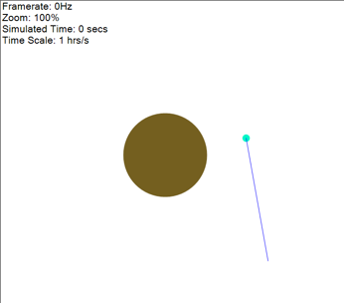In order to do this, I simply added a large body, put an orbital around it and played it. The image to the right shows the scene which I created in order to carry out this test.

I proceeded to play the scene and left it for a while.

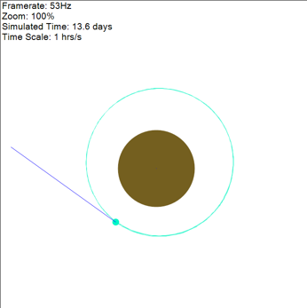Upon leaving it to play, I noticed that the trail’s center which was left by the orbital did not align exactly with the larger body’s center. This can be seen in the second image down on the right.

I then observed the velocity because a perfect orbital will have a velocity that varies very little as it orbits. The velocity seemed to change quite a lot (around 1000 m/s). It was far from a perfect orbital. The velocities are shown below alongside the respective scenes.

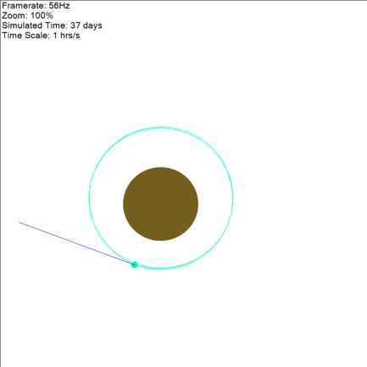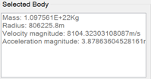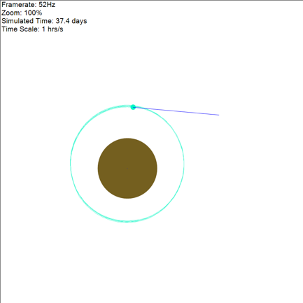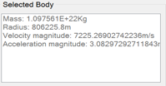

After observing the orbitals for a while, I also noticed that the larger body along with the smaller body were very very slowly moving down the scene. This can be noticed very slightly between the two pairs of pictures if the “Simulated Time” is compared.

There is no viable reason which I can think of which would cause this to happen. As this application is a teaching aid and this issue only occurs over a long period of time, it is okay to let the program pass this test. If the purpose of the application was anything other, then I would look into this problem further but this will not affect the goal of teaching students about gravitational forces.

## Stress Testing

The following tests were decided to be performed in the Testing Strategy for stress testing:

1. Many bodies
   1. Create a scene which has many orbitals around a single star
   2. Create a scene which has many orbitals around a single star where the orbitals also have orbitals around them
   3. Create a scene full of bodies which when played will join after a few seconds
2. Large timescale (required as the time scale has a very high limit)
   1. Create a scene which has a single orbital around a star
   2. Create a scene which has 2 orbitals around a star

I shall perform each of these tests and place their results under the respective headings in this section.

### Many Bodies

#### Create A Scene Which Has Many Orbitals Around A Single Star

This is the scene which I created to perform this test (note that they are velocity lines and not trails):

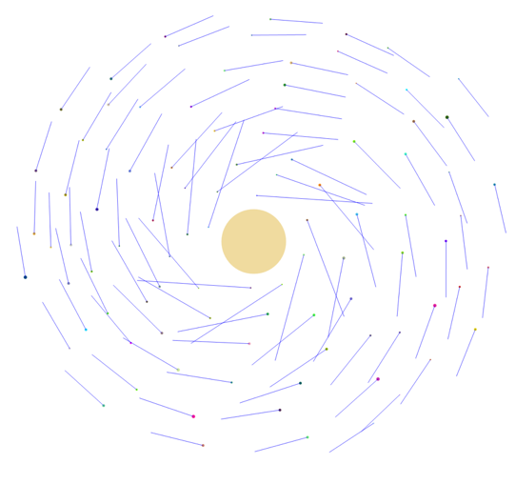After looking inside the file which I saved containing the scene, I found that there were in total 95 orbitals and then the one central star. After testing this, I found that to begin with, the frame rates found were very similar to the frame rates of much smaller scenes – about 60Hz.

##### The Issue

After a while though, the frame rate began to drop significantly to about 10Hz. I worked out that this was because of trails becoming longer and longer. Each time the frame was rendered, the program was having to draw more lines.

This will be an issue as the user will have to click the “Clear Trails” button everytime there simulation slows down. Below, I explain how I fix this issue.

##### The Fix

A possible way of combating this would be to say that if the frame rate drops below a certain rate and the trails are being shown then decrease the maximum trail length and then increase the trail length if the frame rate rises over another frame rate.

After thinking about the problem for a while I decided on the following bounds for when to decrease the trail length and when to increase it. The maximum trail length will only increase if the value of the max length at that time is less than the original value. Also, I shall design the code so that the trail length cannot go below a certain value.

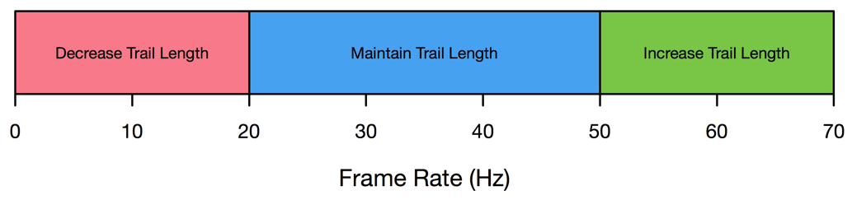

As the frame rate is only updated every second, checking whether the trail length should increase or decrease should not be done every frame. Instead, I shall include this trail length code in the same place as the frame rate is set which is in the main game loop procedure.

This is the current code for the game loop:

|  |
| --- |
| Private Shared Sub Game_Loop()  SecondStopwatch.Restart()  While Running  FrameStopwatch.Restart()  Update(CSng(FrameMilliseconds / 1000))  Paint()  FramesInSecond += 1  If SecondStopwatch.ElapsedMilliseconds > 999 Then  FPS = CInt(1000 * FramesInSecond / SecondStopwatch.ElapsedMilliseconds)  FramesInSecond = 0  SimulatedTime += Timescale * SecondStopwatch.ElapsedMilliseconds / 1000  SecondStopwatch.Restart()  End If  FrameMilliseconds = FrameStopwatch.Elapsed.Milliseconds  End While  SecondStopwatch.Stop()  FrameStopwatch.Stop()  End Sub |

In order to add this functionality, I shall have to make the MaxBodyPoints in Trails a public variable. The original declaration was:

|  |
| --- |
| Private Shared MaxBodyPoints As Integer = 1000 |

But has been changed to:

|  |
| --- |
| Public Const MaxBodyPointsStartValue As Integer = 1000  Public Shared MaxBodyPoints As Integer = 1000 |

I included a new variable so that I only had one value to change in the code in order to change the starting value of MaxBodyPoints.

The code which I changed the game loop procedure to was as follows:

|  |
| --- |
| Private Shared Sub Game_Loop()  SecondStopwatch.Restart()  While Running  FrameStopwatch.Restart()  Update(CSng(FrameMilliseconds / 1000))  Paint()  FramesInSecond += 1  If SecondStopwatch.ElapsedMilliseconds > 999 Then  FPS = CInt(1000 * FramesInSecond / SecondStopwatch.ElapsedMilliseconds)  FramesInSecond = 0  SimulatedTime += Timescale * SecondStopwatch.ElapsedMilliseconds / 1000  If ShowTrails Then  If FPS < 10 And Trails.MaxBodyPoints >= 200 Then  Trails.MaxBodyPoints -= 100  ElseIf FPS < 20 And Trails.MaxBodyPoints >= 110 Then  Trails.MaxBodyPoints -= 10  ElseIf FPS > 60 And Trails.MaxBodyPoints < Trails.MaxBodyPointsStartValue - 100 Then  Trails.MaxBodyPoints += 100  ElseIf FPS > 50 And Trails.MaxBodyPoints < Trails.MaxBodyPointsStartValue - 10 Then  Trails.MaxBodyPoints += 10  End If  End If  SecondStopwatch.Restart()  End If  FrameMilliseconds = FrameStopwatch.Elapsed.Milliseconds  End While  SecondStopwatch.Stop()  FrameStopwatch.Stop()  End Sub |

In order to test that the new code was working correctly, everytime that the MaxBodyPoints changed I printed the new value to the debug log alongside the FPS at the time that the value was changed. The code which I used to test this is the following:

|  |
| --- |
| If ShowTrails Then  Dim changed As Boolean = True  Dim origMax As Integer = Trails.MaxBodyPoints  If FPS < 10 And Trails.MaxBodyPoints >= 200 Then  Trails.MaxBodyPoints -= 100  ElseIf FPS < 20 And Trails.MaxBodyPoints >= 110 Then  Trails.MaxBodyPoints -= 10  ElseIf FPS > 60 And Trails.MaxBodyPoints <= Trails.MaxBodyPointsStartValue - 100 Then  Trails.MaxBodyPoints += 100  ElseIf FPS > 50 And Trails.MaxBodyPoints <= Trails.MaxBodyPointsStartValue - 10 Then  Trails.MaxBodyPoints += 10  Else  changed = False  End If  If changed Then  Debug.Print("Time: " + Now.ToLongTimeString() +  " FPS: " + FPS.ToString() +  " Max: " + Trails.MaxBodyPoints.ToString() +  " (" + (Trails.MaxBodyPoints - origMax).ToString() + ")")  End If  End If |

I then loaded the original scene that I’d used to perform this test and copied the output from the debug log and removed the lines which were not relevant. This can be seen below.

|  |
| --- |
| Time: 20:26:36 FPS: 19 Max: 990 (-10)  Time: 20:26:37 FPS: 18 Max: 980 (-10)  Time: 20:26:38 FPS: 17 Max: 970 (-10)  Time: 20:26:39 FPS: 17 Max: 960 (-10)  Time: 20:26:40 FPS: 16 Max: 950 (-10)  Time: 20:26:41 FPS: 16 Max: 940 (-10)  Time: 20:26:42 FPS: 15 Max: 930 (-10)  Time: 20:26:43 FPS: 14 Max: 920 (-10)  Time: 20:26:44 FPS: 14 Max: 910 (-10)  Time: 20:26:45 FPS: 14 Max: 900 (-10)  Time: 20:26:46 FPS: 13 Max: 890 (-10)  Time: 20:26:47 FPS: 13 Max: 880 (-10)  Time: 20:26:48 FPS: 13 Max: 870 (-10)  Time: 20:26:49 FPS: 13 Max: 860 (-10)  Time: 20:26:50 FPS: 12 Max: 850 (-10)  Time: 20:26:51 FPS: 12 Max: 840 (-10)  Time: 20:26:52 FPS: 11 Max: 830 (-10)  Time: 20:26:53 FPS: 11 Max: 820 (-10)  Time: 20:26:54 FPS: 11 Max: 810 (-10)  Time: 20:26:55 FPS: 11 Max: 800 (-10)  Time: 20:26:56 FPS: 10 Max: 790 (-10)  Time: 20:26:57 FPS: 10 Max: 780 (-10)  Time: 20:26:59 FPS: 10 Max: 770 (-10)  Time: 20:27:00 FPS: 9 Max: 670 (-100)  Time: 20:27:01 FPS: 10 Max: 660 (-10)  Time: 20:27:02 FPS: 9 Max: 560 (-100)  Time: 20:27:03 FPS: 10 Max: 550 (-10)  Time: 20:27:04 FPS: 10 Max: 540 (-10)  Time: 20:27:05 FPS: 10 Max: 530 (-10)  Time: 20:27:06 FPS: 10 Max: 520 (-10)  Time: 20:27:07 FPS: 11 Max: 510 (-10)  Time: 20:27:08 FPS: 11 Max: 500 (-10)  Time: 20:27:09 FPS: 11 Max: 490 (-10)  Time: 20:27:10 FPS: 11 Max: 480 (-10)  Time: 20:27:11 FPS: 11 Max: 470 (-10)  Time: 20:27:12 FPS: 11 Max: 460 (-10)  Time: 20:27:13 FPS: 11 Max: 450 (-10)  Time: 20:27:14 FPS: 12 Max: 440 (-10)  Time: 20:27:15 FPS: 12 Max: 430 (-10)  Time: 20:27:16 FPS: 12 Max: 420 (-10)  Time: 20:27:17 FPS: 12 Max: 410 (-10)  Time: 20:27:18 FPS: 12 Max: 400 (-10)  Time: 20:27:19 FPS: 13 Max: 390 (-10)  Time: 20:27:20 FPS: 13 Max: 380 (-10)  Time: 20:27:21 FPS: 13 Max: 370 (-10)  Time: 20:27:22 FPS: 14 Max: 360 (-10)  Time: 20:27:24 FPS: 14 Max: 350 (-10)  Time: 20:27:25 FPS: 14 Max: 340 (-10)  Time: 20:27:26 FPS: 15 Max: 330 (-10)  Time: 20:27:27 FPS: 16 Max: 320 (-10)  Time: 20:27:28 FPS: 17 Max: 310 (-10)  Time: 20:27:29 FPS: 17 Max: 300 (-10)  Time: 20:27:30 FPS: 18 Max: 290 (-10)  Time: 20:27:31 FPS: 19 Max: 280 (-10)  Time: 20:27:32 FPS: 19 Max: 270 (-10)  Time: 20:28:07 FPS: 51 Max: 280 (10)  Time: 20:28:08 FPS: 51 Max: 290 (10)  Time: 20:28:09 FPS: 54 Max: 300 (10)  Time: 20:28:10 FPS: 55 Max: 310 (10)  Time: 20:28:11 FPS: 53 Max: 320 (10)  Time: 20:28:35 FPS: 51 Max: 330 (10)  Time: 20:28:36 FPS: 51 Max: 340 (10)  Time: 20:28:37 FPS: 53 Max: 350 (10)  Time: 20:28:38 FPS: 53 Max: 360 (10)  Time: 20:28:39 FPS: 54 Max: 370 (10)  Time: 20:28:40 FPS: 54 Max: 380 (10)  Time: 20:28:41 FPS: 52 Max: 390 (10)  Time: 20:28:42 FPS: 51 Max: 400 (10)  Time: 20:28:46 FPS: 51 Max: 410 (10)  Time: 20:28:51 FPS: 51 Max: 420 (10)  Time: 20:28:52 FPS: 51 Max: 430 (10)  Time: 20:28:53 FPS: 51 Max: 440 (10)  Time: 20:28:54 FPS: 51 Max: 450 (10)  Time: 20:28:56 FPS: 51 Max: 460 (10)  Time: 20:30:23 FPS: 52 Max: 470 (10)  Time: 20:30:24 FPS: 52 Max: 480 (10)  Time: 20:30:29 FPS: 51 Max: 490 (10)  Time: 20:30:33 FPS: 51 Max: 500 (10)  Time: 20:30:49 FPS: 53 Max: 510 (10)  Time: 20:30:50 FPS: 51 Max: 520 (10)  Time: 20:30:51 FPS: 53 Max: 530 (10)  Time: 20:30:52 FPS: 53 Max: 540 (10)  Time: 20:30:53 FPS: 52 Max: 550 (10)  Time: 20:30:54 FPS: 52 Max: 560 (10)  Time: 20:31:01 FPS: 52 Max: 570 (10)  Time: 20:31:02 FPS: 56 Max: 580 (10)  Time: 20:31:03 FPS: 55 Max: 590 (10)  Time: 20:31:04 FPS: 53 Max: 600 (10)  Time: 20:31:05 FPS: 54 Max: 610 (10)  Time: 20:31:06 FPS: 55 Max: 620 (10)  Time: 20:31:07 FPS: 52 Max: 630 (10)  Time: 20:31:08 FPS: 53 Max: 640 (10)  Time: 20:31:09 FPS: 53 Max: 650 (10)  Time: 20:31:10 FPS: 52 Max: 660 (10)  Time: 20:31:11 FPS: 52 Max: 670 (10)  Time: 20:31:12 FPS: 52 Max: 680 (10)  Time: 20:31:13 FPS: 51 Max: 690 (10)  Time: 20:31:15 FPS: 51 Max: 700 (10)  Time: 20:31:17 FPS: 51 Max: 710 (10)  Time: 20:31:21 FPS: 52 Max: 720 (10)  Time: 20:31:23 FPS: 51 Max: 730 (10)  Time: 20:31:24 FPS: 52 Max: 740 (10)  Time: 20:31:29 FPS: 51 Max: 750 (10)  Time: 20:31:31 FPS: 52 Max: 760 (10)  Time: 20:31:35 FPS: 52 Max: 770 (10)  Time: 20:31:39 FPS: 52 Max: 780 (10)  Time: 20:31:41 FPS: 52 Max: 790 (10)  Time: 20:31:43 FPS: 54 Max: 800 (10)  Time: 20:31:44 FPS: 53 Max: 810 (10)  Time: 20:31:46 FPS: 54 Max: 820 (10)  Time: 20:31:47 FPS: 52 Max: 830 (10)  Time: 20:31:49 FPS: 53 Max: 840 (10)  Time: 20:31:50 FPS: 52 Max: 850 (10)  Time: 20:31:54 FPS: 51 Max: 860 (10)  Time: 20:31:55 FPS: 51 Max: 870 (10)  Time: 20:31:59 FPS: 51 Max: 880 (10)  Time: 20:32:01 FPS: 51 Max: 890 (10)  Time: 20:32:11 FPS: 51 Max: 900 (10)  Time: 20:32:12 FPS: 52 Max: 910 (10)  Time: 20:32:18 FPS: 52 Max: 920 (10)  Time: 20:32:21 FPS: 51 Max: 930 (10)  Time: 20:32:24 FPS: 55 Max: 940 (10)  Time: 20:32:29 FPS: 51 Max: 950 (10)  Time: 20:32:56 FPS: 64 Max: 960 (10)  Time: 20:32:57 FPS: 70 Max: 970 (10)  Time: 20:32:58 FPS: 72 Max: 980 (10)  Time: 20:32:59 FPS: 71 Max: 990 (10)  Time: 20:33:00 FPS: 60 Max: 1000 (10) |

This shows that the fix which I have applied to the program works perfectly well. Notice that the max trail length does not exceed the original value (1000) as origionally planned. This prevents the trails becoming too long when either run on a fast computer. Note that these tests were performed on a MacBook Pro with a quad-core i7 processor so the FPS values will be much lower on school computers.

This is what my simulation looked like after running it for about 7 minutes and shows that the frame rate steadies over a prolonged period of time. The reason for there being less bodies is that, due to gravitational attraction they collide and join to become a single body.

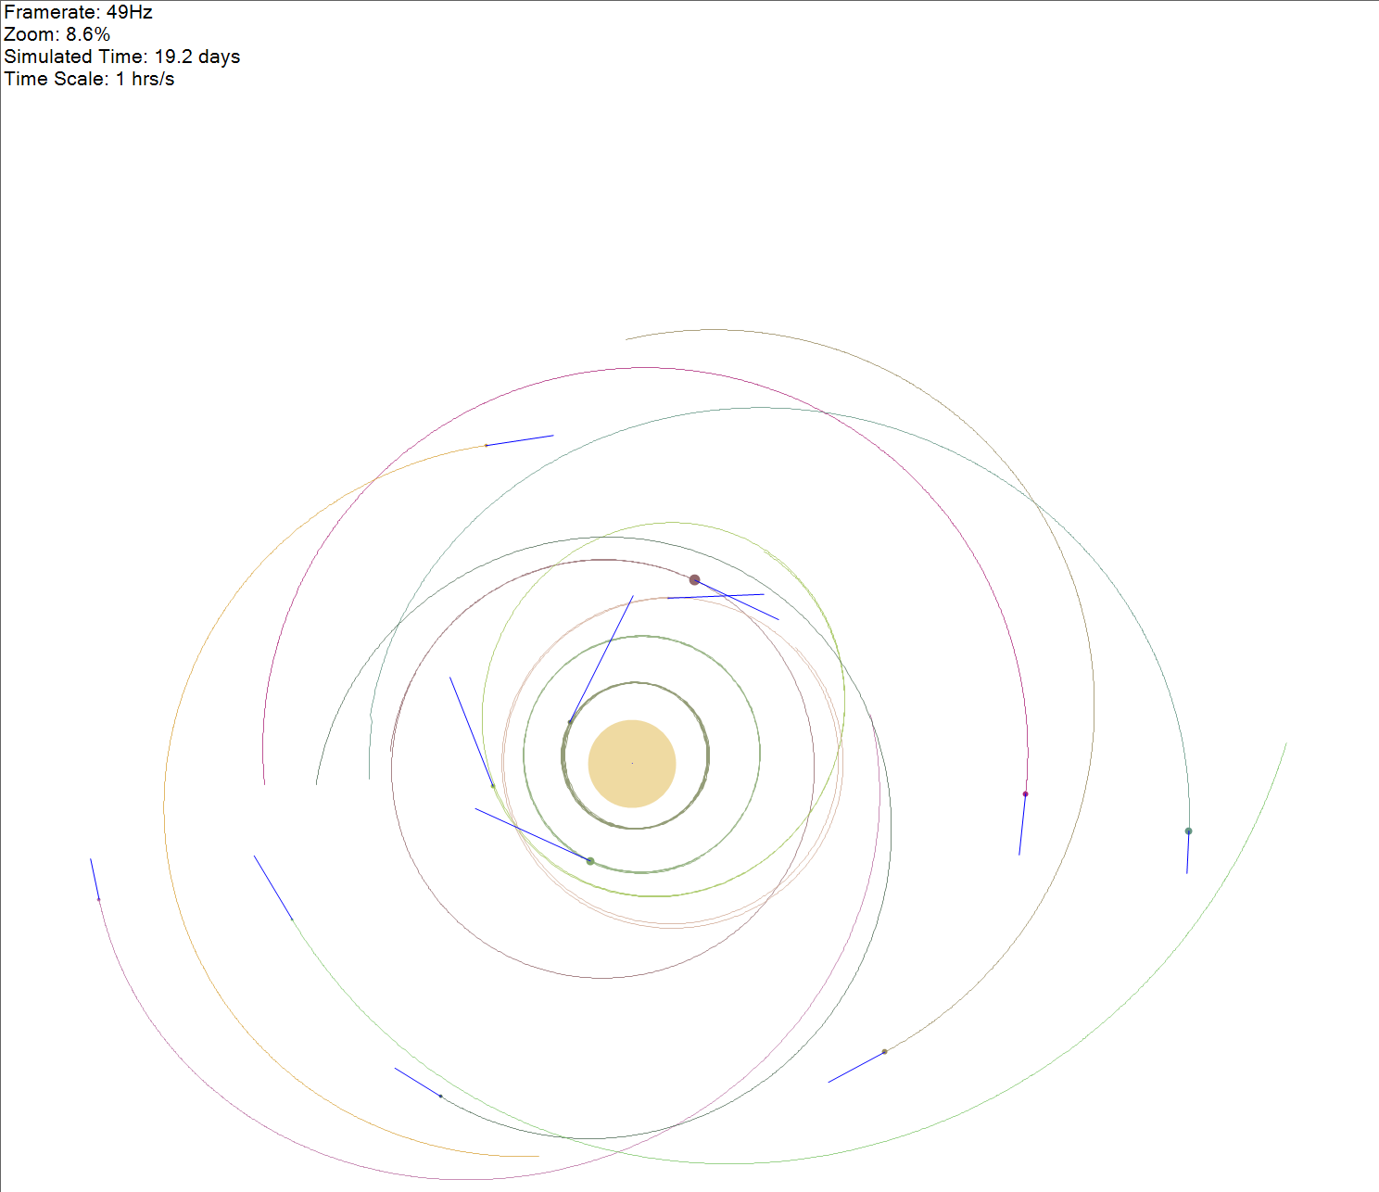

#### Create a scene which has many orbitals around a single star where the orbitals also have orbitals around them

Taking into account the previous fix, I do not feel there is any need to perform this test. It possesses the same purpose as the previous test.

#### Create a scene full of bodies which when played will join after a few seconds

For this test, I created a scene full of bodies and observed how well they joined and performed as a whole with respect to the frame rate.

This is the scene which I created:

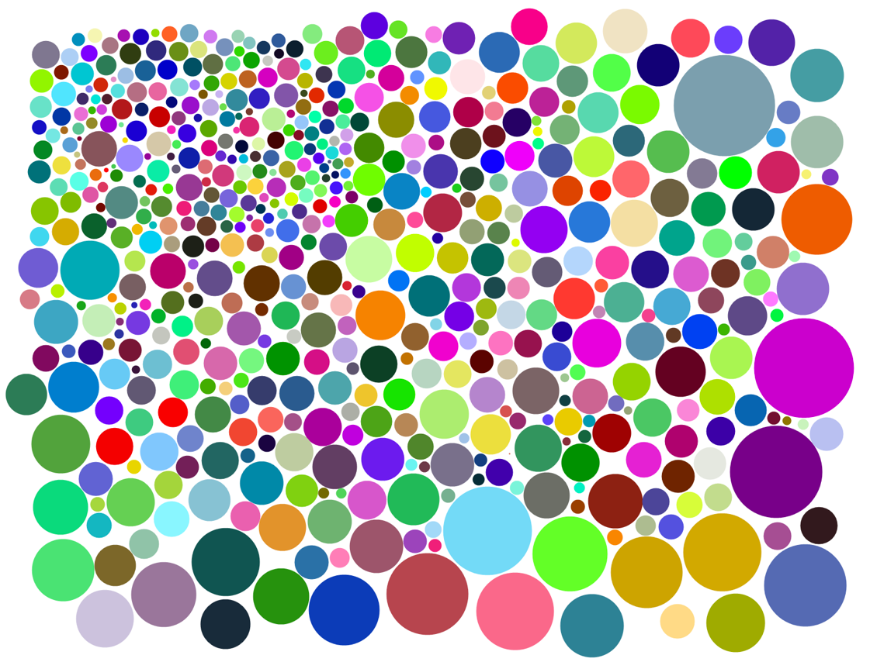

After counting the body lines in the saved file, I found there was 589 bodies in this scene. Yes, I did have to check twice!

I reduced the timescale greatly in order to take screenshots as the simulation was playing. The simulation progressed so quickly that the timescale had to be reduced to 11 seconds per second.

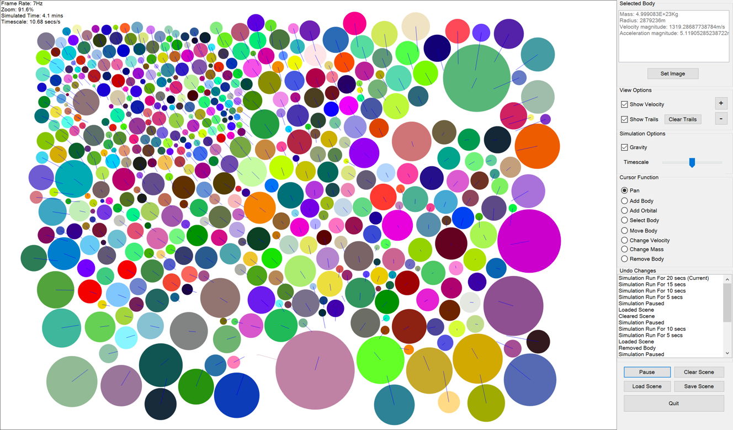

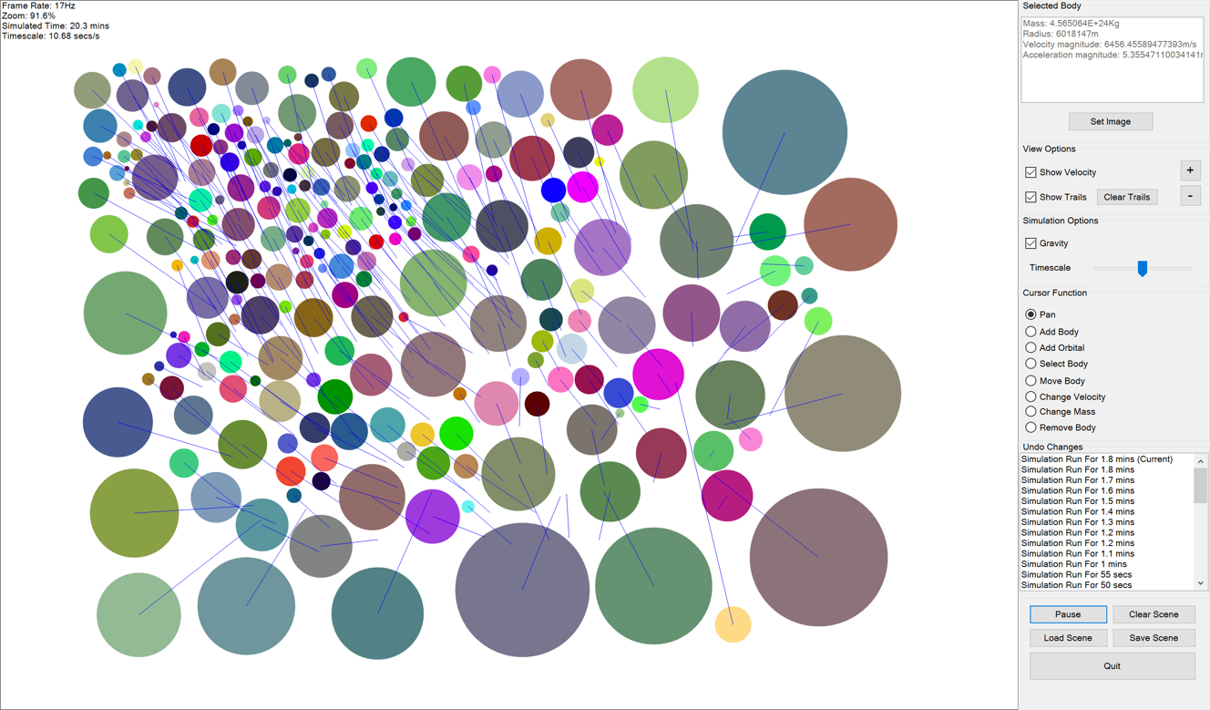

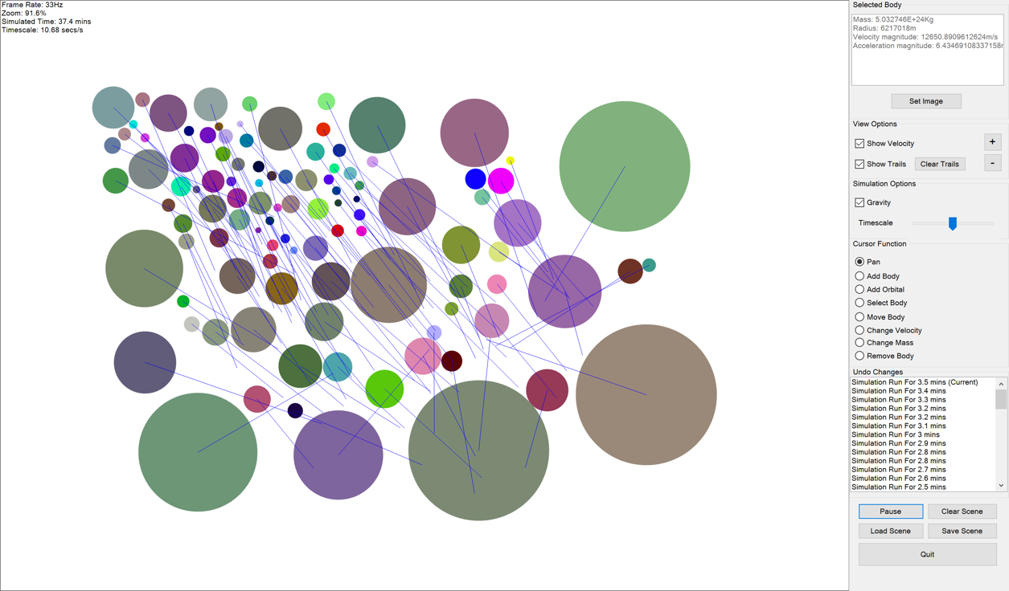

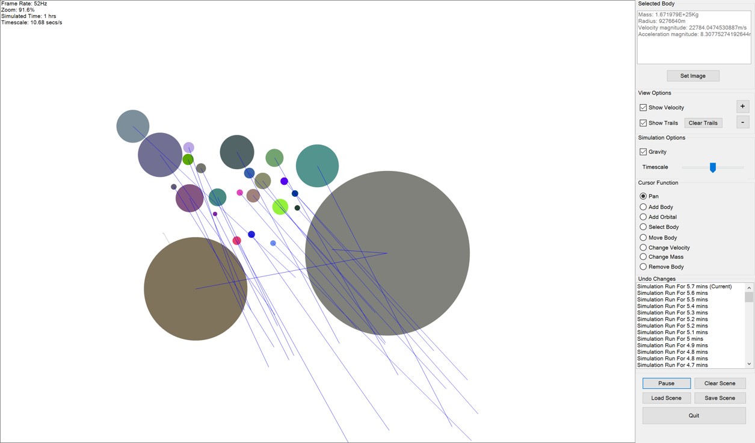

The frame rate did start quite slow (about 8Hz) but soon increased (to 17Hz after 20 minutes being simulated). This is perfectly suitable considering the amount of bodies that the computer had to process.

### Large Timescale

I decided to perform this method of stress testing because the timescale has a very high limit (50 years/second). I shall see how the program performs working under varying timescales. For both of the tests, I shall gradually increase the timescale and record the highest time scale which I consider to be acceptable. I shall then include in the document the screenshots for how the simulation looks with these time scales being used.

At the end of this method of testing, depending on how severely the accuracy is reduced, I may decide to change the maximum time scale that the program allows.

#### Create a Scene Which Has a Single Orbital Around a Star

For this test, I shall create orbitals at 3 different radii and at 3 different time scales and then take a screenshot of the simulation after it running for 5 seconds. I have represented these screenshots in a table which can be found below.

|  |  |  |  |  |
| --- | --- | --- | --- | --- |
|  | | Radius of Orbit (x10^7m) | | |
| 2 | 5 | 10 |
| Time Scale (hrs/s) | 4 |  |  |  |
| 10 |  |  |  |
| 24 |  |  |  |

As can be seen from the table, the accuracy of orbits depends greatly on both the time scale and the radius of the orbit.

#### Create a Scene Which Has 2 Orbitals Around A Star

As I have established now in my own head how I shall go about limiting the timescale from the previous test, this test is superfluous and I feel that this test will serve no benefit if it is carried out.

#### Conclusion Of Timescale Limit

Because of this variation of accuracy seen from the single orbital, it would not be sensible to limit the timescale of the program. It would greatly reduce the functionality and extent of what the user can use the program for. I would not want to limit the user in this way. I feel that they can choose themselves what an appropriate timescale is. If they see that the simulation is becoming inaccurate, then they can rollback their changes and then replay the simulation with a lower timescale.

## Compatibility Testing

To perform Compatibility Testing, I tried to run the program on a school computer operating on Windows 7.

The school computer ran the program surprisingly well (you can see this in Performance Testing) – just as well if not better than my laptop. This is a screenshot showing the program on the school computer with Windows 7.

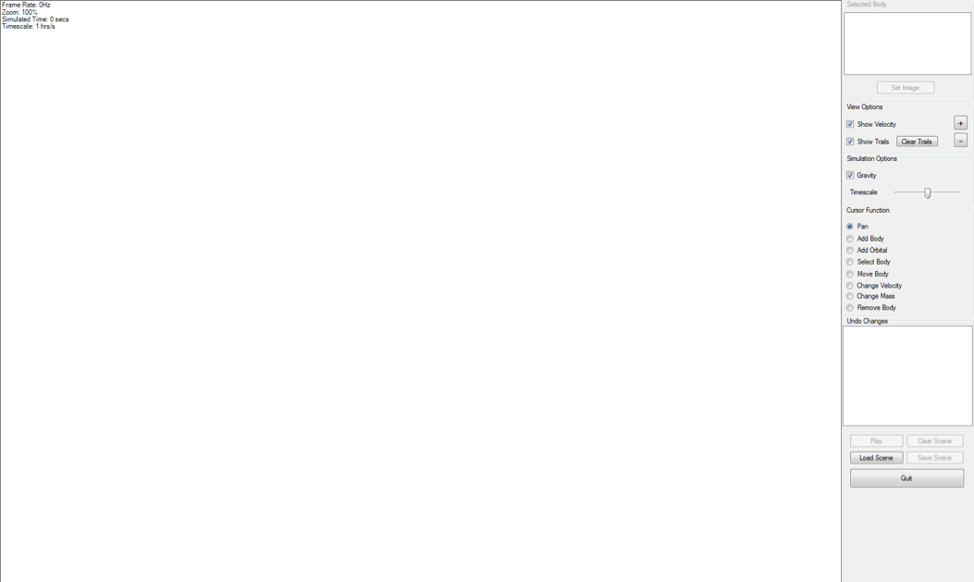

The program loaded up perfectly and worked as expected.

## Performance Testing

To complete Performance Testing, I just had to run the program on the school computer and see how it performed. I was surprised to see that it ran very well, simpler scenes would run at over 100fps as shown below.

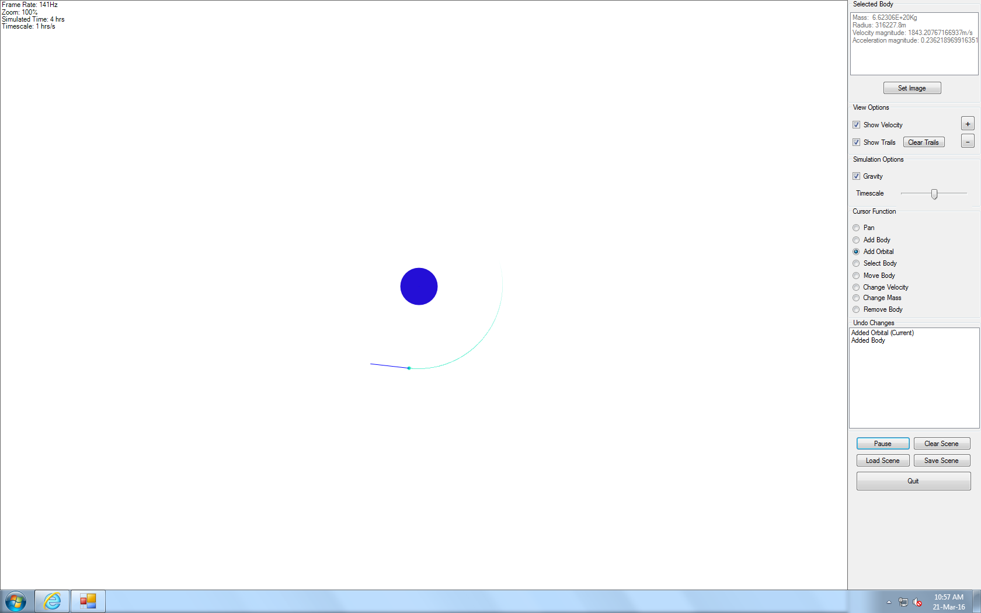

The test was though to see how it ran with a lot of bodies on the school computer. I loaded the “Spiral.gsim” which was automatically stored upon loading the application. The simulation’s frame rate dropped as the trails became longer but then because of the trail length code, the frame rate stopped dropping and maintained around 19/20Hz. This screenshot shows the simulation being played on the school computer.

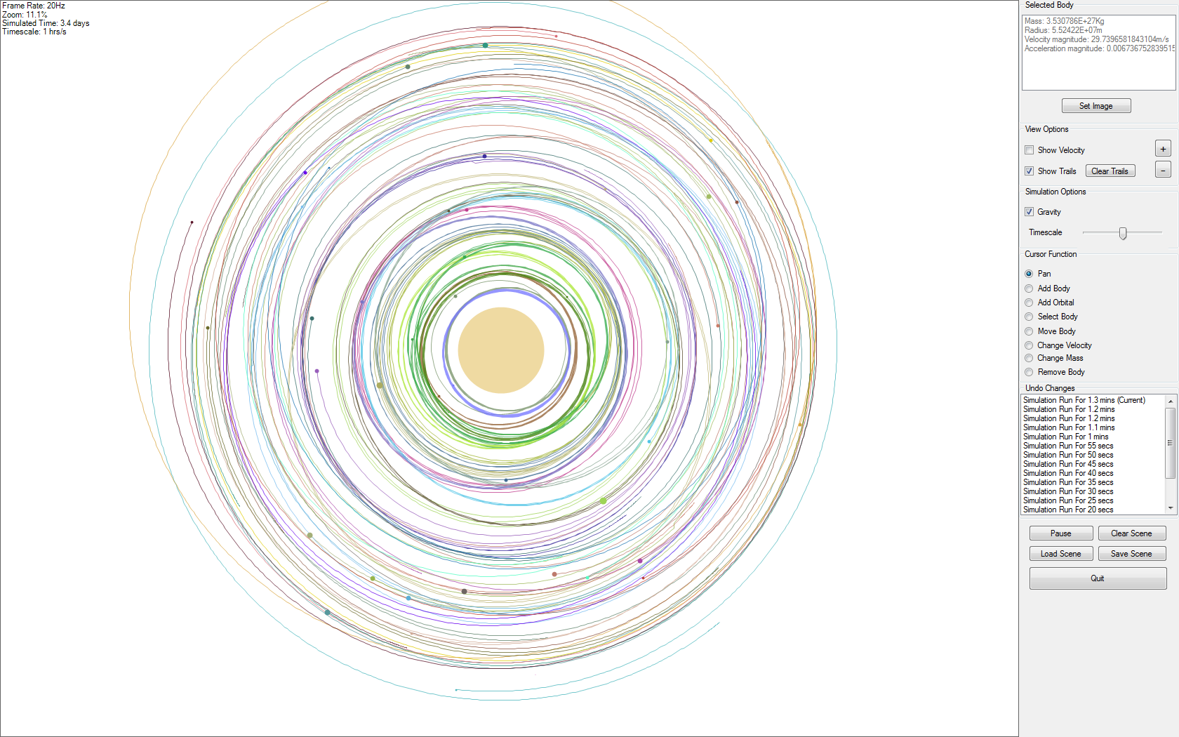

I also realised that I needed to test my objective which was “the simulation must be smooth (minimum of 20 fps) whilst simulating a scene with 10 bodies on a school computer” which I didn’t account for in the Test Strategy. I performed this test and the frame rate whilst having 10 bodies varied around 40Hz. Evidence of this is shown below.

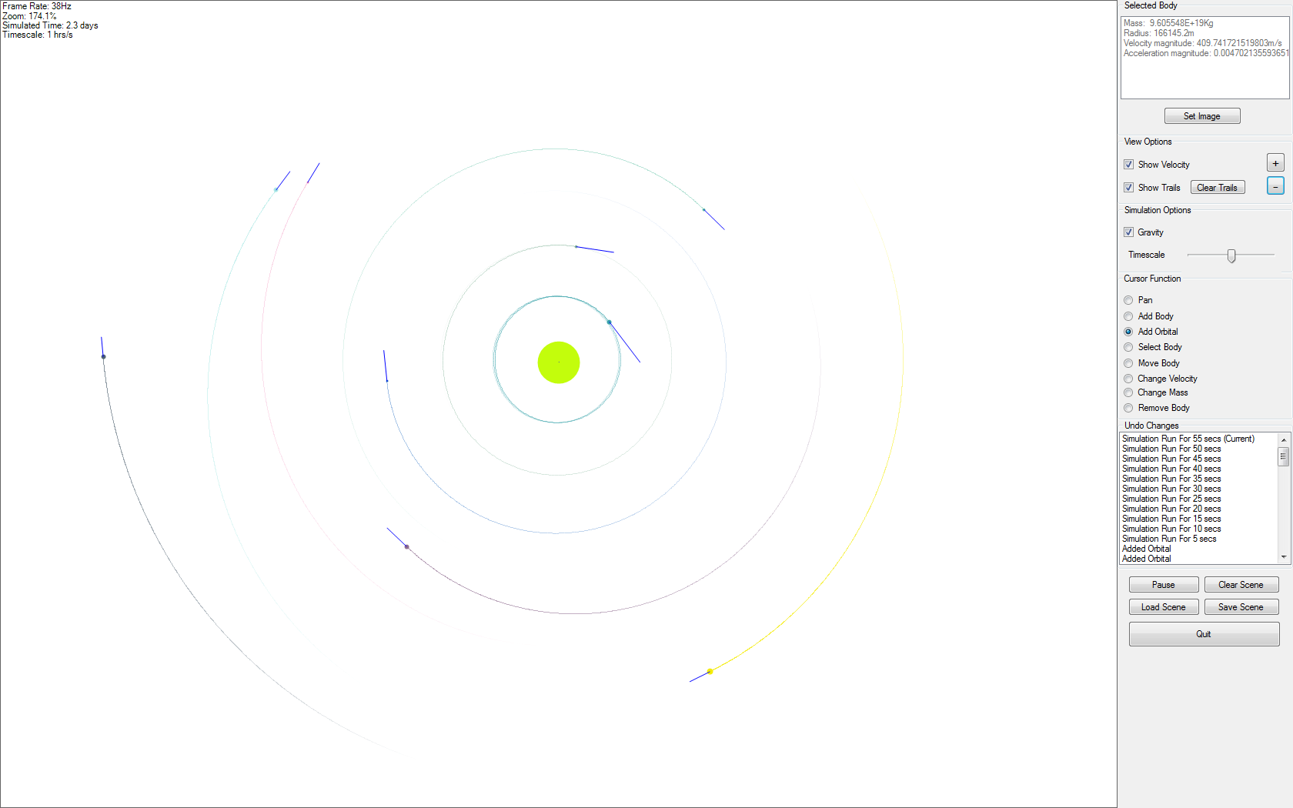

## Usability Testing

I am performing Usability Testing so that the primary user (Dr. McKenna) has a chance to see the program and give feedback before I get him to write a formal review for the Appraisal. I am hoping this will allow me to improve my application before the final review.

The answered questions for each user can be found in Appendix 3.

I sent Dr McKenna the link to the cloud service which hosts the executable and he found that downloading the file was very easily achieved.

### Positives

Looking at his answers to the usability questions, I have summarised the following positive points:

* The design of the form is “professional and clean”
* The functionality of the form is “intuitive”
* The view displays the scene well
* The simulation seems accurate to the eye
* The application contains all of the features required for its use as a teaching aid
* The velocity property in the selected body info is especially useful

### Negatives

In his answers, Dr McKenna talks about an “error message” popping up whilst he was using the “Add Body” function. I am assuming that he is referring to the global exception handler, which sent me an email containing the exception details:

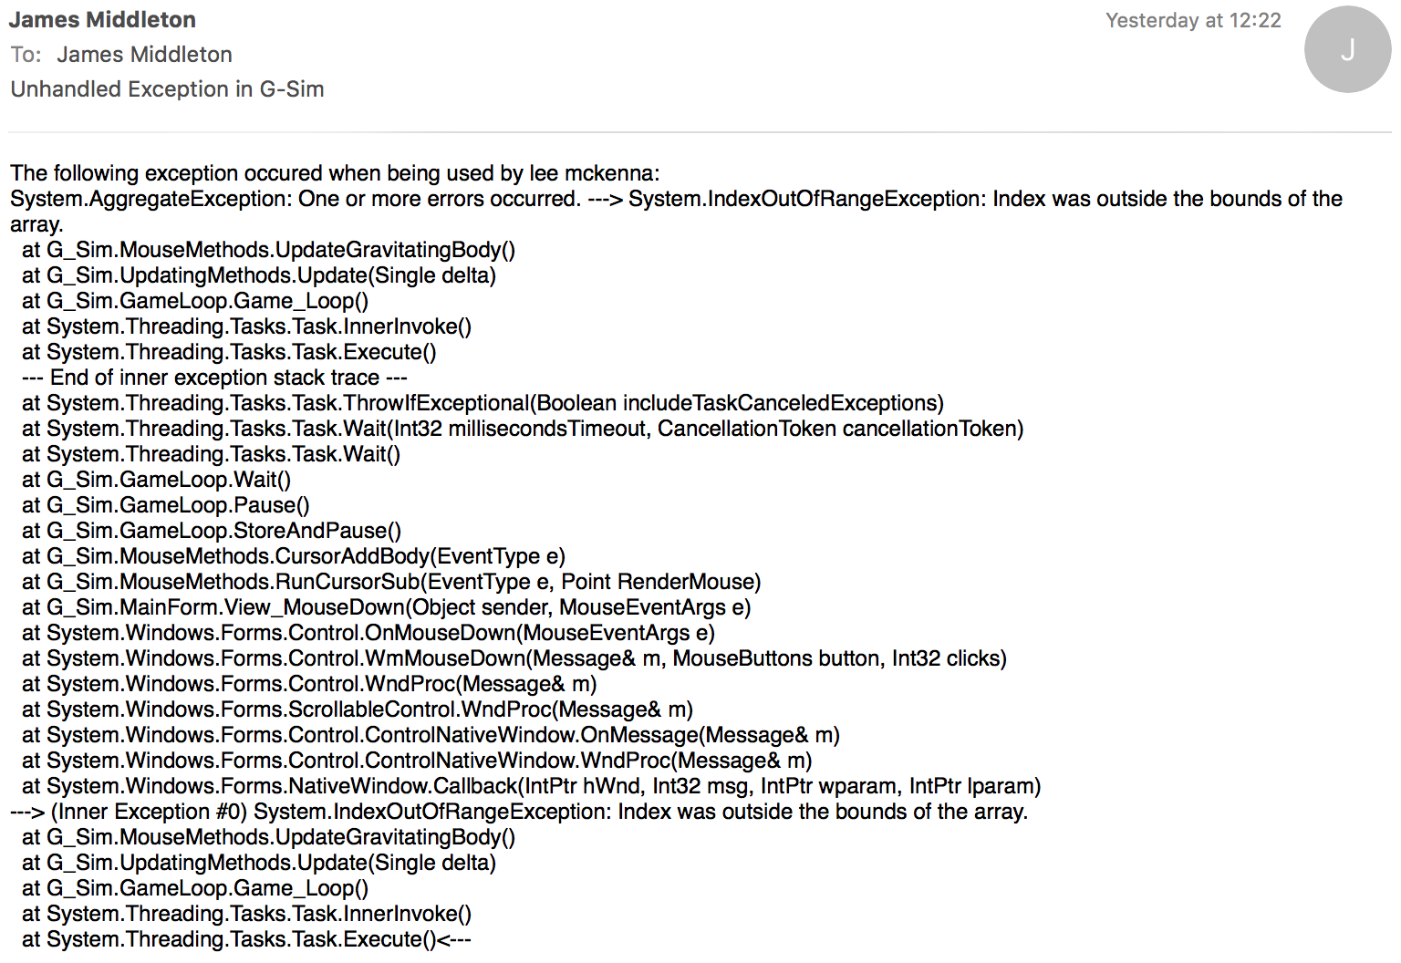

This shows that the simulation was running at the time of the error (because the Update method is called from Game_Loop). It also shows that it occurred at the instant which he pressed his mouse while using “Add Body”. This doesn’t explain why “index was outside the bounds of the array”. This shows that the detail contained in the exception messages is not entirely efficient to fix a bug. I will include a point of adding additional information to the “Possible Improvements” section of the Appraisal.

### Conclusion Of Usability

I have concluded from this that the application seems to be reasonably reliable (as there was only a single error throughout the whole time that it was being used) and everybody likes it who has used it.

## Visibility Testing

For this testing as discussed in the test strategy, I have only one test in which I checked how visible the projection application was from the back of the room where it will be shown.

The evidence of the visibility can be seen below:

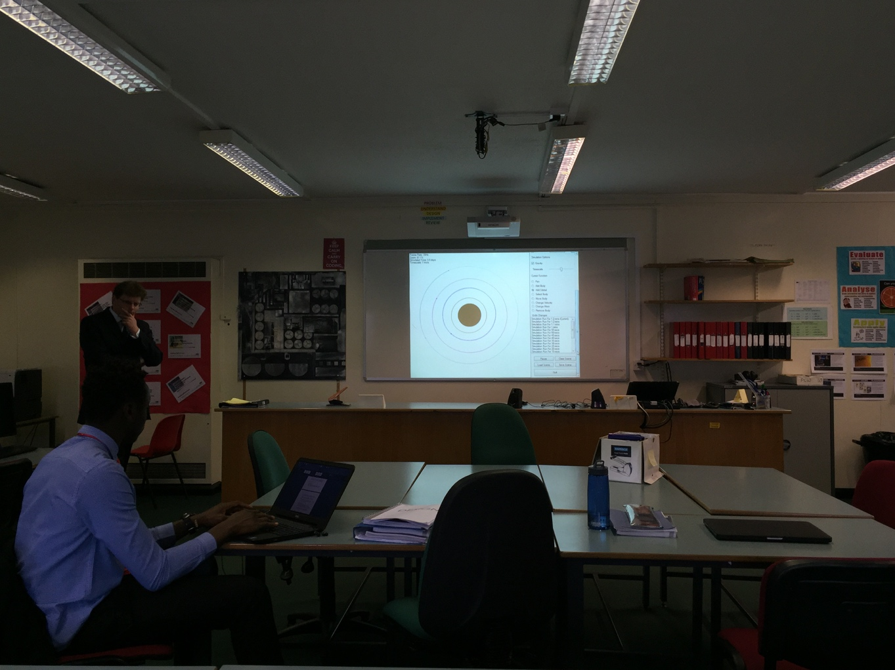

The visibility of the controls and the scene was fine from the back as shown in the image above.

### Problem

I did notice when performing the test that all of the controls in the panel to the right of the form did not display fully (as the resolution of the projector is low). So instead of having one-click access to all of the controls, I sometimes had to scroll the panel to display the control I wanted.

### Solution

To combat this, I squished the controls in the panel upward so that they would all fit on the screen at the same time.

This is what the form looked like origionally (as a screenshot on my laptop):

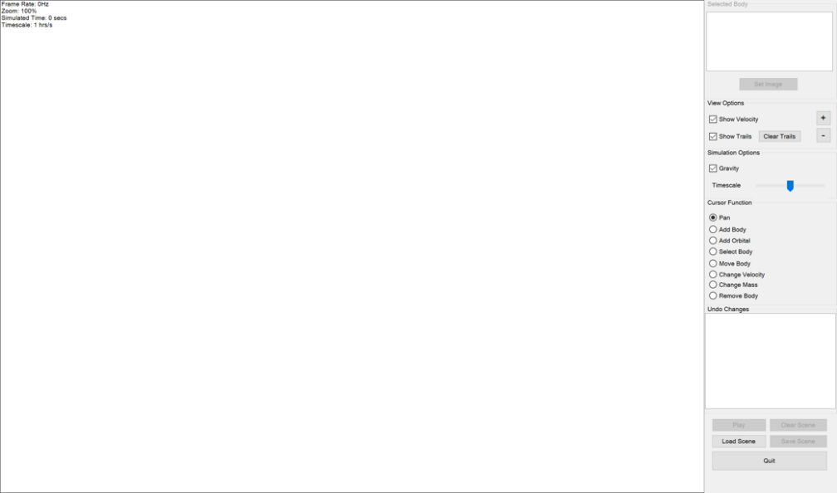

I changed it to look like this:

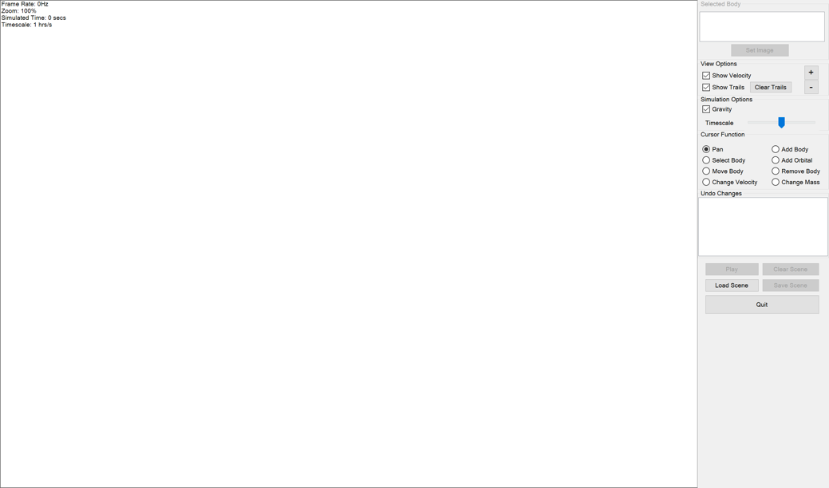

This resulted in a much better appearence on the school projector as shown below:

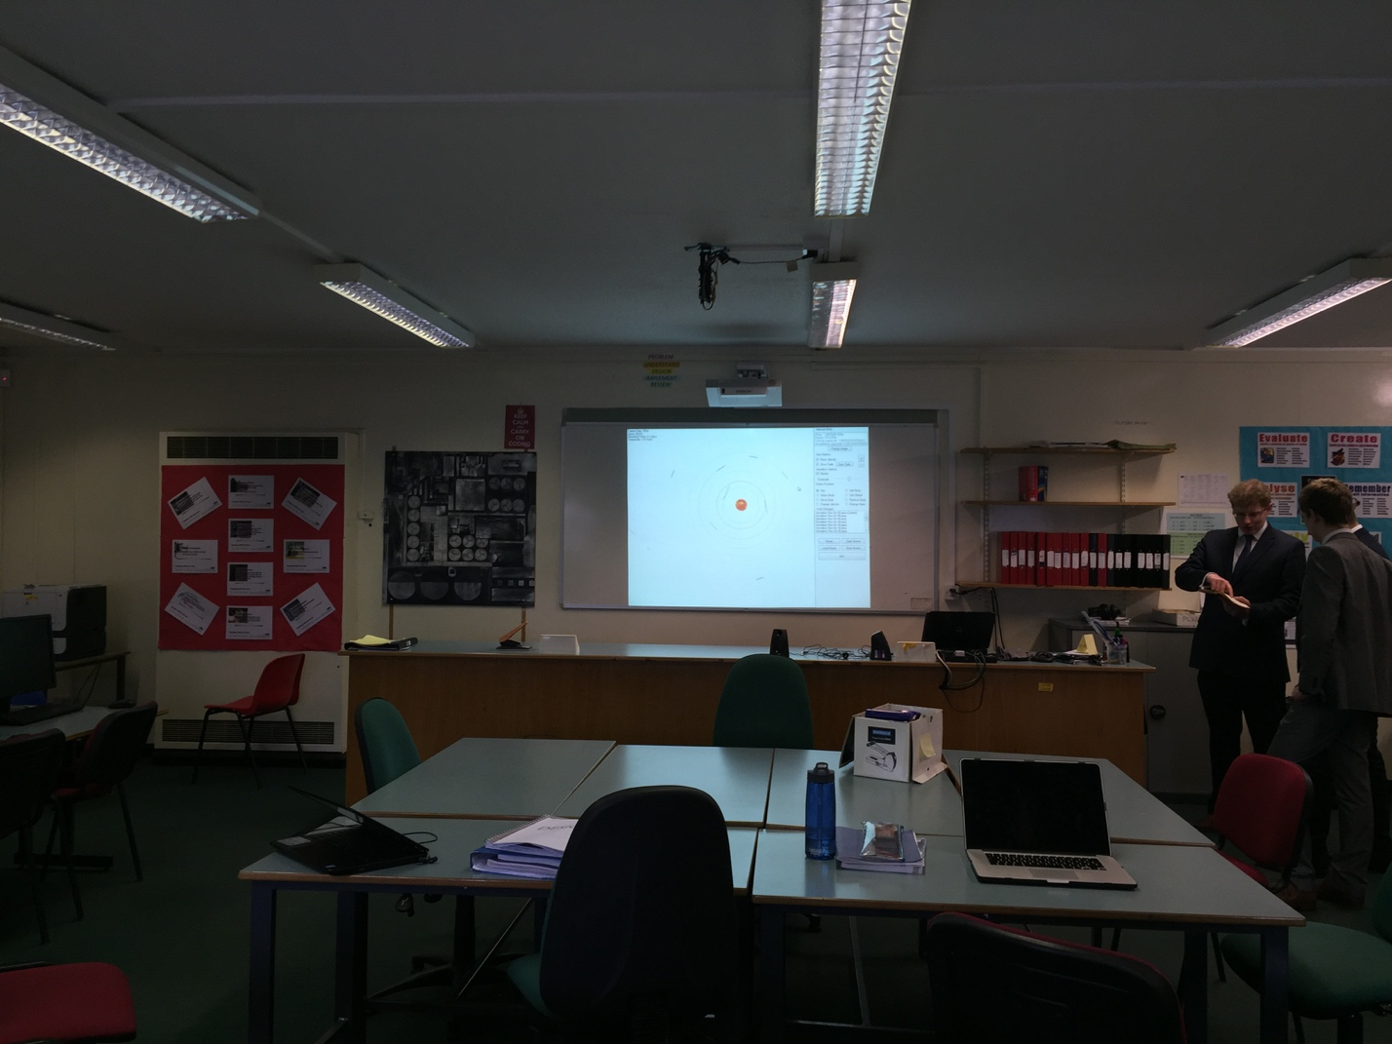

The new form design means that when being used on a school projector (the primary display), the user doesn’t have to scroll up and down to access controls which would be a nuisance.

A possible improvement to the project would be to have different configurations of locations of controls depending on how tall the resolution is. I do not need to do this now though because the program will primarily be used on a projector which this is now designed for.

## Recovery Testing

To perform recovery testing, I shall throw an exception on when the “Set Image” button is pressed. The exception will contain a message and then the exception details will be sent to my email address. I will then check that I receive an email and it contains all the necessary details in order to debug the exception.

This is the original code for the “Set Image” button click event handler:

|  |
| --- |
| ProcessSelectImage() |

All it does is calls a procedure which is located in the FileHandling module. I then changed this to:

|  |
| --- |
| Throw New Exception("This is a test exception to check that the global error handling works correctly.")  ProcessSelectImage() |

I then tested out this code by clicking “Set Image” after the program has loaded and I’d created a body (the button cannot be clicked without having any bodies). I first tried to run the program using Visual Studio which I found automatically brings up any unhandled exceptions in the IDE because it is attached to the program as a debugger. So in order to test properly, I had to rebuild the solution using VS and then located the executable in the “bin\Debug” folder which resided under the project folder.

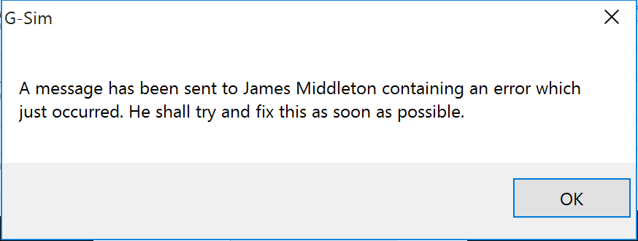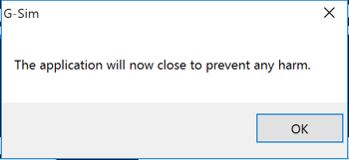

These message boxes appeared as expected and the application closed, I then proceeded to check my emails.

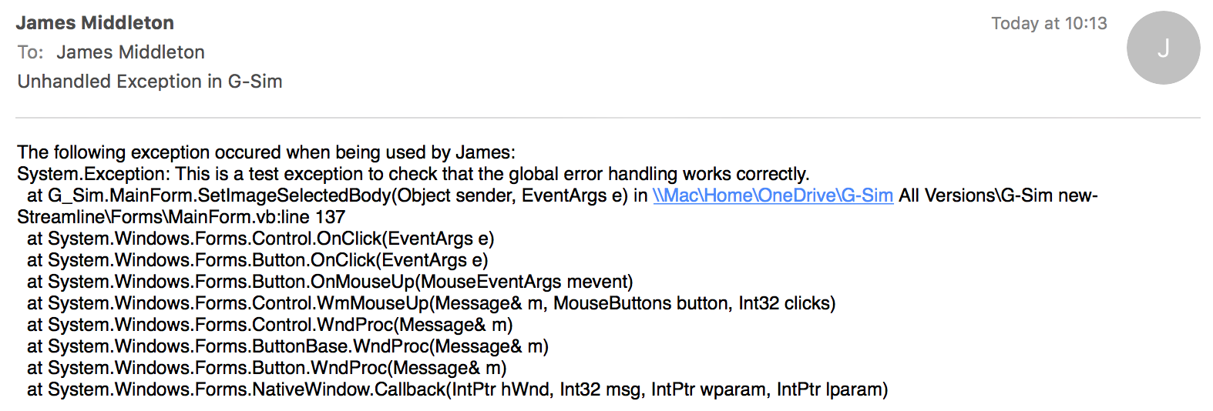

The email appeared in my inbox as it was supposed to containing all the necessary details to debug. If I find in the future that I need to include the value of some important variables then I will do so but for now, this will allow me to debug any simple bugs that I need to.

Also, a future feature which could be implemented is to dump the scene to a file which the program tries to load on the next time it is run.

# System Maintenance

## System Overview

The system will be run as a portable application; it will be a single standalone file. This application can only be run on Windows as it was developed using Visual Basic which can only be compiled to a Windows executable at the time of writing this.

The only dependency of the application is the .NET framework version 4.0. This is preinstalled with newer builds of Windows 7 and on all Windows 10 builds.

The program requires a small amount of disk space - around 10MB for the executable and then an additional 10MB for the scenes and images. This required space will increase over time as new features, scenes and images are added. At the moment, it is a lightweight application.

When the form first loads up, the scenes and images are copied into a folder called “G-Sim” which resides in Windows’ “AppData/Roaming” folder.

For the time being, the program is being hosted at mega.nz. There is a link to this on my website, jamesmiddleton.esy.es. The website is currently very basic with no styling at all, in the future a full website should be made for the project.

The application checks for newer versions by itself, by referencing a php script on the same website which I have to update manually. If there is a newer version, then the application informs the user and lets them open a link to my website. From there, they are forwarded to mega.nz where they can download the newest version.

When the form is shown, it starts with a view which is blank (apart from the top-left info area) and with all of the controls on the right side. The user can then proceed by choosing their mouse function to perform particular tasks in order to create a scene which they can then simulate. Instead of creating a scene, they can also choose to load a scene from a file which contains a scene created by the application.

### Conventions

While creating the application, I have tried to maintain some conventions throughout.

#### Control Naming

The first convention which I will discuss is naming the controls on the form. As you can see in “Form Navigation Overview” later in the section, the names are prefaced with a (usually) 3 letter lowercase string which states what type of control it is. The prefaces are listed below:

* TextBox -> txt
* Label -> lbl
* ListBox -> lb
* Button -> btn
* RadioButton -> radio
* TrackerBar -> tracker
* GroupBox -> grp
* Panel -> pnl

When coding with these names, it is much easier to distinguish between controls.

#### Method And Variable Names

The vast majority of methods and variable seen within the source will be in a format like the examples below:

Public Sub ClearBuffer()

All method declarations will contain brackets after the name of the method. Some will contain the access modifier (Public, Private, Friend etc.).

Public Function BufferEmpty() As Boolean

All functions (i.e. not voids) will be declared with an explicit returning type.

Private InitialHeaderRowString As String = "viewport,zoom,timescale:"

All global or locally global variables will have a type explicitly stated within their definition. Also, instance variables will always have an explicitly defined type. Ocasionally, variables declared within a method will not be defined with a type if their type is obvious such as an incrementing index being used by a for loop.

Also note that not all declarations state an access modifier, which in VB.NET will default to Public.

#### Modular Approach

I have attempted to keep code tidy by splitting code of certain categories or functions into modules with other parts of code of the same general function. Code has been split into the following modules/code bases (note that classes declared Shared mean they are non-instantiable):

* MainForm (Form)
* Body (Class)
* Vector (Class)
* Changes (Shared Class)
  + Change (Private Class within Changes)
* GameLoop (Shared Class)
* Trails (Shared Class)
* BodyMethods (Module)
* FileHandling (Module)
* GraphicsMethods (Module)
* MouseMethods (Module)
* OtherMethods (Module)
* PaintingMethods (Module)
* SceneMethods (Module)
* UpdatesAndErrors (Module)
* UpdatingMethods (Module)

Almost all of these are self-explanatory with regards to what they contain but you can find a description of each field and method in “Methods and Variables Overview” sorted by code base.

I have also tried to hide as many fields and methods within their code bases (Private) if they are not required externally. This both reduces the change of using the wrong field or method and also it makes it much easier to find the one that you want.

## Form Navigation Overview

There is only one form in the project and it is referred to as the “Main Form”. This is what it looks like:

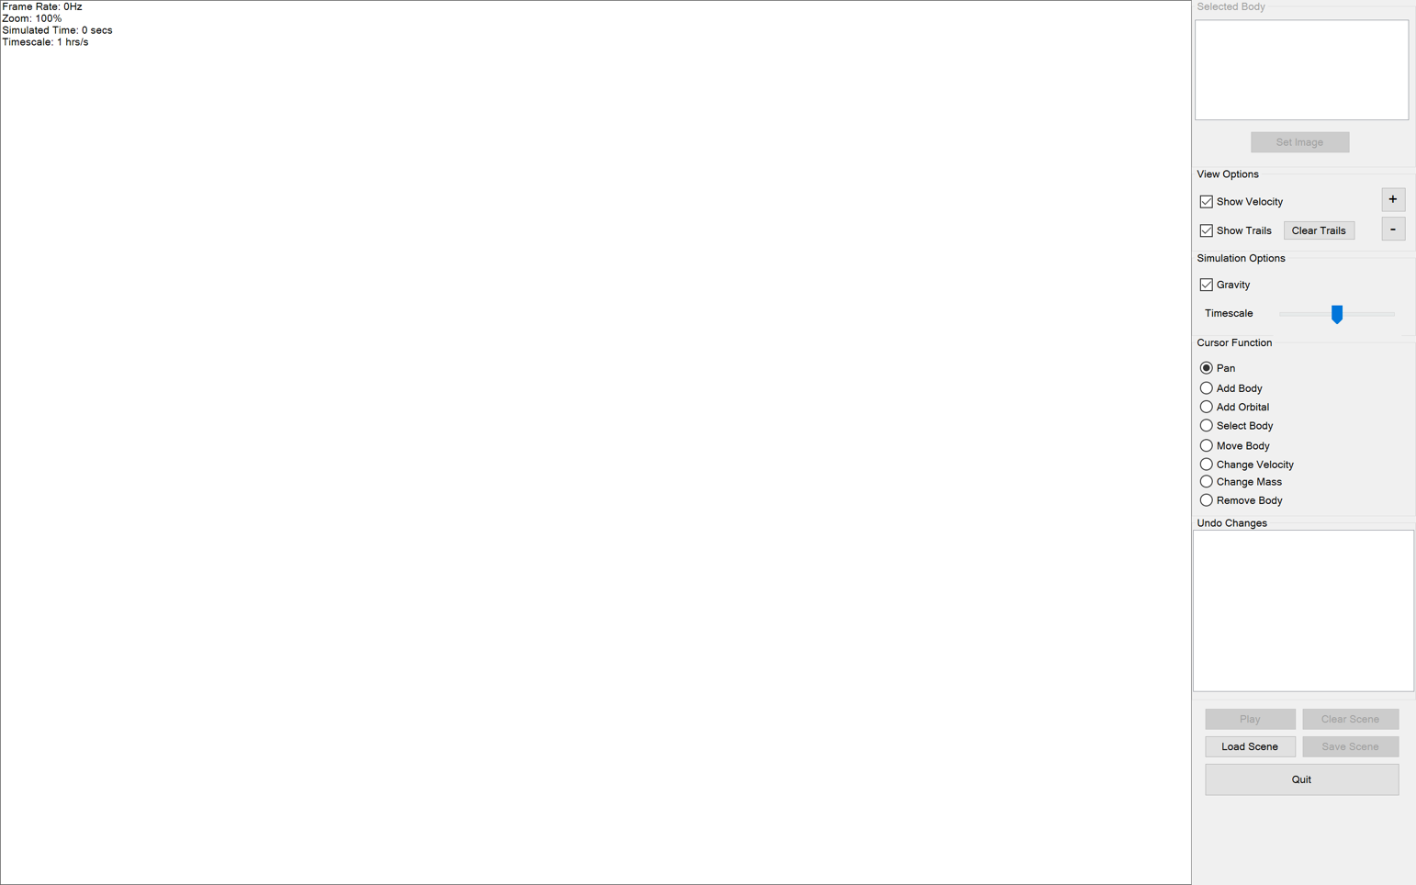

Then this is a diagram (on the following page) showing the names of each control on the form:



Note that as stated in the diagram, the info area is not a control, just painted onto pnlRender when the form loads and thereafter. Also keep in mind that the controls beginning with “grp” are group boxes and hold many different components within them (these are annotated by a square box instead of the usual rounded box). For group boxes, I shall point toward the heading of the box.

## Detailed Walkthrough Of System

A brief overview can be found above under “System Overview” but this explores the application in more depth including the calculations it has to perform and how it works.

### Starting The System

The program loads by showing a form which contains a blank view (pnlRender) and all of the controls which are on the right side of the form. As the application loads, it copies all of its resources including planet images and example scenes into the user’s AppData folder.

### Viewing The Scene

The view is where the scene is displayed (pnlRender), it can be moved around by using the Pan tool (radioPan) or zoomed by using the mouse wheel or by using the plus or minus buttons (btnViewZoomIn/Out). Every time the view changes, everything has to be re-rendered by calling Paint() which can be found in PaintingMethods.

### Editing The Scene

When creating or editing the scene, everything is done with the mouse by clicking inside the view. To change the task which the mouse performs, different ‘cursor functions’ can be chosen. These are a list of radiobuttons found in the groupbox with the header “Mouse Functions”.

### System Files

The user can save a scene that they’ve created by clicking the “Save Scene” button (btnSaveScene). They can also load a scene which they’ve created by clicking the “Load Scene” button (btnLoadScene). The files stored contain: an initial/settings header row, the initial/settings row, the body header row and then all of the body rows.

Below are the contents of one of the scene files which are bundled with the application. The parts in brackets in normal font are to annotate the scene data.

|  |
| --- |
| (Initial/settings header row)  viewport,zoom,timescale:  (Initial/settings row)  -5.234438E+08|2.31034E+08,4.101968E-06,4935.387  (Body header row)  velocity,position,mass,colour,size,isusingbitmap,bitmap:  (Body rows)  -1981.66909438485|1815.7700701372,-2.211066E+08|4.00162E+08,7.243254E+25,-11816900,3.02451E+07,False,  10087.830453137|2333.32648488658,-1.983008E+08|3.636148E+08,3.392632E+24,-3666624,1.090242E+07,False, |

### Game Loop

The simulation can then be played by clicking the play button (btnPlayPause). This triggers what is referred to as the *game loop* to begin. Although the application is not technically a game, it functions in the same way with regards to updating, rendering, painting and requiring inputs. Game loop is the name of the loop which runs in the background while the simulation is running. The game loop does not run on a timer and instead, runs on a separate thread which uses Visual Basic’s Task class.

### Updating The Scene

The calculations performed upon every update include calculating new positions, joining intersecting bodies and then updating the bodies’ trails. Calculating positions is done by first calculating the force on each body by using the *inverse-square law* for every other body which can give the net acceleration to work out velocity and then position. Bodies are joined by summing their masses (which also gives size), mixing their colours and then calculating velocity by using momentum conservation in both planes. This can be seen in the code for more detail in Update() within UpdatingMethods.

## Comparison Of Designed And Implemented Methods And Variables

For each code base, I shall include a copy of the class diagram from the Design stage and then two tables which have the following headings for both methods and variables. Keep in mind that the class diagram for a code base is not necessarily up-to-date with the implementation as it has been taken from Design.

As for fields which use Visual Basic’s Property type, I will split these among methods and variables depending on whether they require any special code in their get or set parts.

|  |  |  |
| --- | --- | --- |
| Method Design Declaration | Method Implementation Declaration | Purpose |
| Public Method MyMethod : Void | Public Sub MyMethod() | An example method used to demonstrate how my table will be laid out for each method. |

|  |  |  |
| --- | --- | --- |
| Variable Design Declaration | Variable Implementation Declaration | Purpose |
| Public Variable MyVariable : String | Public MyVariable As String = "" | An example variable which holds the value of the example variable comparison table. |

### Main Form (Form/Class)



|  |  |  |
| --- | --- | --- |
| Variable Design Declaration | Variable Implementation Declaration | Purpose |
| Private Variable Selected Body Refresh Timer : Timer | Private WithEvents SelectedBodyRefreshTimer As New Timer() | Updates the selected body information on every tick. |
| Private Variable Check Cursor Leave View Timer : Timer | Private WithEvents CheckCursorLeaveViewTimer As New Timer() | Used when “Add Orbital” is selected to know when to stop showing orbital ring in view. |
| Private Variable Zoom In Timer : Timer | Private WithEvents ZoomInTimer As New Timer() | Used to repeatedly zoom in while the “+” button is being held down. |
| Private Variable Zoom Out Timer: Timer | Private WithEvents ZoomOutTimer As New Timer() | Used to repeatedly zoom in while the “-” button is being held down. |
| Private Variable Timescale Timer: Timer | Private WithEvents TimescaleTimer As New Timer() | Used to repeatedly change the timescale depending on how much the timescale slider is displaced. |
| Private Variable Auto Store Simulation Changes Timer : Timer | Private WithEvents AutoStoreSimulationChangesTimer As New Timer() | While the simulation is playing, every 5 seconds the timer adds a “Simulation Run” change. |

| Method Design Declaration | Method Implementation Declaration | Purpose |
| --- | --- | --- |
| Private Method Load : Void | Private Sub LoadApplication(sender As Object, e As EventArgs) Handles MyBase.Load | Handles loading of the form. Add the global error handling handler, sets the global RenderBoxSize, copies resources (images and scenes), sets up the graphics buffer, sets up the timers and then disables the appropriate controls to start with (calls UpdateUI). |
| Private Method Shown : Void | Private Sub MainForm_Shown(sender As Object, e As EventArgs) Handles MyBase.Shown | Handles the shown event of the form. Paints a blank view (otherwise the view starts grey) and then checks for newer versions, informing the user if any are found). |
| Private Method Closing : Void | Private Sub MainForm_FormClosing(sender As Object, e As FormClosingEventArgs) Handles MyBase.FormClosing | Handles the closing event of the form.Stops the graphics loop as the form is closed (otherwise doesn’t close properly). |
| Public Method UpdateUI : Void | Public Sub UpdateUI() | Depending on whether there are any bodies in the scene disables / enables: selected body group, play button, save scene button, clear simulation button. Then paints a single frame. |
| Private Method Select Image Button Click : Void | Private Sub SetImageSelectedBody(sender As Object, e As EventArgs) Handles btnSelectedBodySetImage.Click | Handles the set image button. Calls ProcessSelectImage in FileHandling. |
| Private Method Refresh Current Body Info Timer Tick : Void | Private Sub RefreshCurrentBodyInfo() Handles SelectedBodyRefreshTimer.Tick | Handles the SelectedBodyRefreshTimer tick. Updates the selected body info and the set image button’s text. |
| Private Method Show Velocity Checkbox Checked Changed : Void | Private Sub ShowVelocity_CheckedChanged(sender As Object, e As EventArgs) Handles chkShowVelocity.CheckedChanged | Handles the corresponding checkbox. Sets the ShowVelocity, ShowTrails or GravitationEnabled globals equal to the corresponding checkbox’s checked property. |
| Private Method Show Trails Checkbox Checked Changed : Void | Private Sub ShowTrails_CheckedChanged(sender As Object, e As EventArgs) Handles chkShowTrails.CheckedChanged |
| Private Method Enable Gravity Checkbox Checked Changed : Void | Private Sub EnableGravitation_CheckedChanged(sender As Object, e As EventArgs) Handles chkGravitation.CheckedChanged |
| Private Method Clear All Trails Button Click : Void | Private Sub ClearAllTrails(sender As Object, e As EventArgs) Handles btnClearTrails.Click | Handles the “Clear Trails” button. Calls the ClearAllTrails method in the Trails class. |
| Private Method Zoom In Button Down : Void | Private Sub btnViewZoomIn_Click(sender As Object, e As EventArgs) Handles btnViewZoomIn.MouseDown | Handles the mouse down event of the corresponding button. Enables the corresponding timer. |
| Private Method Zoom Out Button Down : Void | Private Sub btnViewZoomOut_Click(sender As Object, e As EventArgs) Handles btnViewZoomOut.MouseDown |
| Private Method Zoom In Timer Tick : Void | Private Sub ZoomInTick() Handles ZoomInTimer.Tick | Handles the corresponding timer’s tick event. Calls the ZoomInOut method in MouseMethods to either zoom in or out using the center point. |
| Private Method Zoom Out Timer Tick : Void | Private Sub ZoomOutTick() Handles ZoomOutTimer.Tick |
| Private Method Zoom In Button Up : Void | Private Sub btnViewZoomIn_MouseUp(sender As Object, e As MouseEventArgs) Handles btnViewZoomIn.MouseUp | Stops the corresponding timer. |
| Private Method Zoom Out Button Up : Void | Private Sub btnViewZoomOut_MouseUp(sender As Object, e As MouseEventArgs) Handles btnViewZoomOut.MouseUp |
| Private Method Timescale Slider Mouse Down : Void | Private Sub trackerTimescale_MouseDown() Handles trackerTimescale.MouseDown | Enables TimescaleTimer. |
| Private Method Timescale Slider Timer Tick : Void | Private Sub TimescaleTimer_Tick() Handles TimescaleTimer.Tick | Changes the value of the timescale with a rate of change which has respect to the displacement of the timescale slider. |
| Private Method Timescale Slider Mouse Up : Void | Private Sub trackerTimescale_MouseUp() Handles trackerTimescale.MouseUp | Disables TimescaleTimer and resets the slider back to the center position. |
| Public Method Change List Changed : Void | Public Sub ChangeListHasChanged() | Called by the Changes class. Clears and then updates the changes in the changes listbox. |
| Private Method Listbox Selected Index Changed : Void | Private Sub Changes_SelectedIndexChanged() Handles lbChanges.SelectedIndexChanged | Handles the SelectedIndexChanged event of the changes listbox. Pauses the game loop and then plays again at the end of the method if it was playing before. Rollsback to the change which was selected in the listbox and then deselects any item in the listbox. Calls UpdateUI. |
| Private Method Auto Store Change Timer Tick : Void | Private Sub AutoStoreSimulationWhileRunning() Handles AutoStoreSimulationChangesTimer.Tick | Handles the tick event of AutoStoreSimulationChangesTimer. Adds a change of type “SimulationRunTime” so that the user can replay parts of the simulation. |
| Private Method Play Button Click : Void | Private Sub TogglePlayPause(sender As Object, e As EventArgs) Handles btnPlayPause.Click | Plays if paused and pauses if playing. Upon a pause, it also adds a change of type “SimulationPaused” |
| Public Method Game loop Playing Changed : Void | Public Sub GameLoopStateChanged() | Called by the GameLoop class when the state of the game loop is changed. Sets the value of the play/pause button to say either “Play” or “Pause” to indicate the action it will perform. Also starts or stops AutoStoreSimulationChangesTimer depending on whether the simulation is playing or not. |
| Private Method Clear Scene Button Click : Void | Private Sub ClearScene(sender As Object, e As EventArgs) Handles btnClearSimulation.Click | Handles the click event of the clear scene button. Sets the body array to empty, calls ClearAllTrails in the Trails class, resets the simulated time and then adds a change of type “ClearSimulation” and calls UpdateUI. |
| Private Method Load Scene Button Click : Void | Private Sub LoadScene(sender As Object, e As EventArgs) Handles btnLoadScene.Click | Handles the load scene button click. Guides the user through loading a scene file and then loads it. |
| Private Method Save Scene Button Click : Void | Private Sub SaveScene(sender As Object, e As EventArgs) Handles btnSaveScene.Click | Handles the save scene button click. Guides the user through saving the current scene into a file. |
| Private MethodQuit Button Click : Void | Private Sub Quit(sender As Object, e As EventArgs) Handles btnQuit.Click | Handles the quit button click. Exits the application. |
| Private Method Set Selected Cursor Function : Void | Private Sub SetSelectedCursorFunction() | Used to set the SelectedRadio global in MouseMethods so that MouseMethods knows what function to execute when mouse actions occur on the view. |
| Private Method Scene View Mouse Down : Void | Private Sub View_MouseDown(sender As Object, e As MouseEventArgs) Handles pnlRender.MouseDown | Handles the MouseDown event of the view. Calls the RunCursorSub procedure in MouseMethods letting it know that the mouse has been pressed down. |
| Private Method Scene View Mouse Move : Void | Private Sub View_MouseMove(sender As Object, e As MouseEventArgs) Handles pnlRender.MouseMove | Handles the MouseMove event of the view. Calls the RunCursorSub procedure in MouseMethods letting it know that the mouse has been moved. |
| Private Method Scene View Mouse Up : Void | Private Sub View_MouseUp(sender As Object, e As MouseEventArgs) Handles pnlRender.MouseUp | Handles the MouseUp event of the view. Calls the RunCursorSub procedure in MouseMethods letting it know that the mouse has been released. |
| Private Method Check Cursor Leave View Timer Tick : Void | Private Sub CheckCursorStillInView() Handles CheckCursorLeaveViewTimer.Tick | Handles the CheckCursorLeaveViewTimer tick. Checks if the mouse is still in the view and if not then stops displaying orbital rings and the mouse label. |
| Private Method View Scene Scroll : Void | Private Sub View_MouseWheel(sender As Object, e As MouseEventArgs) Handles pnlRender.MouseWheel | Handles the wheel event on the view. Calls the ZoomInOut procedure in MouseMethods passing the delta of the wheel to let it know how much to zoom in or out. |

### Changes (Shared Class)

This is the class diagram copied from Designbut note that “Change : Class” is treated as a separate class in the comparison and has its own sub heading. It can be found after “Body (Class) ”.



|  |  |  |
| --- | --- | --- |
| Variable Design Declaration | Variable Implementation Declaration | Purpose |
| Private Variable Change List : Array : Change | Private Shared ChangeList As New List(Of Change) | The list which holds all of the changes. |
| Private Variable Current Index : Integer | Private Shared CurrentIndex As Integer = -1 | Holds the index of the change which represents the current state of the BodyDatas array. It also represents the change which is marked with a “(Current)”. |
| **Not Declared**  No custom events were considered during Design. | Private Shared Event ListChanged() | The event which is raised upon changing of ChangeList. More specifically, when the changes listbox needs to be updated on the main form. |
| Private Variable Max Stored Changes : Integer | Private Const MaxStoredChanges As Byte = 100 | Holds the amount of changes which will be stored in ChangeList and so the changes listbox on the main form. After this number of changes is reached, the oldest are removed. |
| Public Variable Auto Store Interval : Integer | Public Const AutoStoreWhileRunningIntervalMilliseconds As Integer = 5000 | Holds the amount of milliseconds there should be between each automatic “Simulation Run” change. |
| **Not Declared**  This variable was only created during implementation to stop the need for dividing the “Milliseconds” version by 1000 every time. No functionality change. | Private Const AutoStoreWhileRunningIntervalSeconds As Integer = AutoStoreWhileRunningIntervalMilliseconds / 1000 | Used locally within Changes as a representation of the variable above in terms of seconds as opposed to milliseconds. |
| Type ChangeType : Enum | Public Enum ChangeType | Holds the types of change which a change can have. Used to give the changes in the changes listbox on the main form a description. |

| Method Design Declaration | Method Implementation Declaration | Purpose |
| --- | --- | --- |
| Public Method Add Change : Void | Public Shared Sub AddChange(ChangeType As ChangeType) | Adds a change of the specified type to ChangeList and then updates changes list on the main form. The new change becomes the current change. |
| Public Method Rollback : Void | Public Shared Sub RollbackChanges(OldestToNewestIndex As Integer) | Undoes or redoes changes depending on the specified index. BodyDatas becomes equal to the selected change’s stored BodyDatas. |
| Public Method Remove Newer : Void | Public Shared Sub RemoveNewerChanges(AfterIndex As Integer) | When the current change is not the most recent change and then a new change is added, this is called. Simply removes any changes which are newer than the specified index. |
| Public Method Remove Excess : Void | Public Shared Sub RemoveExcess() | Removes the oldest changes if the number of changes exceeds the MaxStoredChanges value. |
| Public Method Into Listbox : Void | Public Shared Sub ChangesIntoListBox(ByRef lb As ListBox) | Called by the main form to enumerate the changes into the listbox on the form. It adds them starting with the newest (the last change in ChangeList) so that the newest change appears on the top of the listbox. |
| Private Method Get Change String : String | Private Shared Function GetChangeString(change As Change) As String | Returns the corresponding description string for the inputted change. References its ChangeType property to decide on which description to use. |
| **Not Declared**  No custom events *or their handlers* were considered during Design. | Private Shared Sub ListHasChanged() Handles Me.ListChanged | Simply invokes the ChangeListHasChanged on the main form’s thread to update the change list in the main form. |

### Game Loop (Shared Class)



|  |  |  |
| --- | --- | --- |
| Variable Design Declaration | Variable Implementation Declaration | Purpose |
| **Not Declared**  This holds the value for the “Running” property. | Private Shared _Running As Boolean = False | Stores the value of the state of the gameloop. |
| Public Variable Simulated Time : Integer | Public Shared Property SimulatedTime As Double = 0 | Stores the value of “Simulated Time” in terms of seconds. |
| Public Variable FPS : Integer | Public Shared FPS As Integer = 0 | Stored the “FPS” value in the info part of the main form. |
| Private Variable Frame Milliseconds : Integer | Private Shared Property FrameMilliseconds As Integer = 0 | Holds the amount of time taken to calculate and paint for the current frame in terms of milliseconds. |
| Private Variable Frame Stopwatch : Boolean | Private Shared FrameStopwatch As New Stopwatch() | The stopwatch which records the value of FrameMilliseconds |
| Private Variable Second Stopwatch : Stopwatch | Private Shared SecondStopwatch As New Stopwatch() | The stopwatch which is used to detect if a second has passed. |
| Private Variable Frames In Second : Integer | Private Shared FramesInSecond As Integer = 0 | Stores the amount of frames which have been rendered within the current second interval. |
| Private Variable Background Loop : Task | Private Shared bgLoop As Task | The task which allows the game loop to be run as a separate (background) thread. |
| **Not Declared**  This variable was only created to save unnecessary lines of code. | Private Shared StoredState As Boolean = False | Stores the state of the game loop before StoreAndPause was called. |

| Method Design Declaration | Method Implementation Declaration | Purpose |
| --- | --- | --- |
| Public Variable Running : Boolean | Public Shared Property Running As Boolean | Get: returns the value of _Running (the current state of the game loop). Set (Private only): Sets the value of _Running and then calls GameLoopStateChanged in the main form to update the play button’s text. |
| Private Methods Game Loop : Void | Private Shared Sub Game_Loop() | The procedure from which the simulation is run and progressed. |
| **Not Declared**  This was created to split up the start sub into two parts (perhaps superfluous). This part sets the background task equal to a new instance of the game loop method. | Private Shared Sub StartLoop() | Reassigns Game_Loop to the bgLoop task and then starts it. |
| Public Method Start : Void | Shared Sub Start() | Starts the loop running if it has not already been. |
| Public Method Stop : Void | Shared Sub Pause() | Pauses the loop’s continuation and waits for the current iteration to finish. |
| Private Method Wait For Finish : Void | Private Shared Sub Wait() | Waits for the loop to finish. |
| Public Method Paint Once : Void | Shared Sub PaintOnce() | Paints a single frame if the loop is not running. |
| Public Method Reset Simulated Time : Void | Shared Sub ResetSimulatedTime() | Sets SimulatedTime to zero. |
| **Not Declared**  These methods were made to accompany the “Stored State” variable further through Design. They store the state and pause, and continue from stored state respectively, both using the “Stored State” variable. | Public Shared Sub StoreAndPause() | Stores the current state of the loop in StoredState and then pauses. |
| Public Shared Sub ContinueStored() | If the stored state differs from the current state then continue from (restore) the stored state. |

### Trails (Shared Class)



|  |  |  |
| --- | --- | --- |
| Variable Design Declaration | Variable Implementation Declaration | Purpose |
| Private Vaiable Scene Points : Array : Array : Point | Private Shared ScenePoints As New List(Of List(Of PointF)) | Stores the points for each body’s trail. |
| **Not Declared**  This constant was created to keep a record of the start or maximum value which “Max Points” could have in order for Smart Trails (created in Testing) to function correctly. | **Declared During Testing**  Public Const MaxBodyPointsStartValue As Integer = 1000 | Holds the constant which is the orgional value for MaxBodyPoints. Also the value which MaxBodyPoints cannot exceed. |
| Public Variable Max Points : Integer | **Edited During Testing**  Public Shared MaxBodyPoints As Integer = MaxBodyPointsStartValue  **Origional Implementation Declaration:**  Public Shared MaxBodyPoints As Integer = 1000 | Stores the maximum amount of points which can be stored per body. |

| Method Design Declaration | Method Implementation Declaration | Purpose |
| --- | --- | --- |
| Public Method Update Trails : Void | Shared Sub UpdateTrails() | Adds all of the current positions (centers) of each body to the corresponding list in ScenePoints. |
| Public Method Remove Excess : Void | Private Shared Sub RemoveExcessPoints(ScenePointsIndex As Integer) | Removes the excess points which are furthest away from the body (the oldest points) if the total number of points for a body exceeds MaxBodyPoints. |
| Public Method Add New Trail : Void | Shared Sub AddBodyTrail() | Adds a new list of points to ScenePoints, declaring space for a new body. |
| Public Method Remove Trail : Void | Shared Sub RemoveBodyTrail(index As UShort) | Removes a specific body’s trail (list of points) from ScenePoints. |
| **Not Declared**  This method was created during implementation to use when all trails needed to be removed at once (e.g. on “Clear Scene” press). | Shared Sub RemoveAllTrails() | Clears the contents of ScenePoints. |
| Public Method Render Trails : Void | Shared Sub RenderTrails() | Renders all of the trails to the main form’s view. |
| Public Method Clear Trail : Void | Shared Sub ClearTrail(i As Integer) | Clears all of the points from a specific trail. |
| Public Method Clear All Trails : Void | Shared Sub ClearAllTrails() | Removes all points from each body’s trails but keeps the list structure intact. |

### Body (Class)



|  |  |  |
| --- | --- | --- |
| Variable Design Declaration | Variable Implementation Declaration | Purpose |
| **Not Declared**  These variables were created to hold the values of their corresponding properties (of the Body instance). | Private _Velocity As Vector | Used to hold the values of the corresponding properties which require additional code in their get or set parts. |
| Private _Center As PointF |
| Private _Mass As Single |
| Private _Image As Image |
| Public ReadOnly Property Dominant Image Colour : Colour | **Changed to a variable instead of a property during implementation**  Private _DominantImageColour As Color |
| Public Property Acceleration : Vector | Property Acceleration() As Vector | Holds the value of the acceleration of the body in terms of scene units. |
| Public Property Size : Float | Property Size() As Single | Holds the value of the height/width of the body in terms of scene units. |
| Public Property Colour : Colour | Property Colour() As Color | Holds the value of the colour of the body. |
| Public Property Is Using Bitmap : Boolean | Property IsUsingBitmap() As Boolean | The flag which states whether the body should be rendered using its stored bitmap or not (its solid colour). |

| Method Design Declaration | Method Implementation Declaration | Purpose |
| --- | --- | --- |
| Public Method New : Void | Sub New() | Initialises an instance of the body class creating all blank values. |
| Public Method Clone : Body | Function Clone() As Body | Returns a shallow clone of the instance (Body). Used to remove object reference when creating a change (otherwise Changes doesn’t work properly). |
| Public Property Velocity : Vector | Property Velocity(Optional ThrowExceptionOnOutOfBounds As Boolean = False) As Vector | Get: returns the stored velocity (Vector). Set: sets the velocity of the body, throwing an exception if out of bounds and the Boolean parameter is True. |
| Public Property Center : PointF | Property Center(Optional ThrowExceptionOnOutOfBounds As Boolean = False) As PointF | Get: returns the stored center (PointF). Set: sets the center value of the body, throwing an exception if out of bounds and the Boolean parameter is True. |
| Public Property Mass : Float | Property Mass(Optional ThrowExceptionOnOutOfBounds As Boolean = False) As Single | Get: returns the mass of the body (Single). Set: sets the mass of the body, throwing an exception if out of bounds and the Boolean parameter is True. |
| Public Property Image : Image | Property Image() As Image | Get: gets the image of the body. Set: sets the image of the body and then calls UpdateDominantImageColour to calculate the dominant image colour. |
| Public ReadOnly Property Top Left : PointF | ReadOnly Property TopLeft() As PointF | Get: calculates the top-left point of the body (PointF) and then returns it. |
| Public ReadOnly Property Radius : Float | ReadOnly Property Radius() As Single | Get: returns the size halved (Single). |
| **Not Declared**  This method was created during implementation to reduce the amount of code in the set part of the Colour property (perhaps superfluous). | Private Sub UpdateDominantImageColour() | Calculates the dominant image colour and then sets it. |
| Public Shared Method Get Size From Mass : Float | Shared Function GetSizeFromMass(mass As Single) As Single | Takes in a mass as a parameter and gives out the corresponding size. |
| Public Shared Method Get Mass From Size : Float | Shared Function GetMassFromSize(radius As Single) As Single | Takes in a size as a parameter and gives out the corresponding mass. |
| **Not Declared**  The “Dominant Image Colour” variable is now a private variable as opposed to a property so requires a method to return its value externally to the instance. | Public Function GetDominantImageColour() As Color | Returns the stored dominant image colour. |
| Public Shared Method Get Dominant Image Colour : Colour | Private Shared Function GetDominantImageColourFromBitmap(bmp As Bitmap) As Color | Takes in a bitmap and returns the mathematically average colour of the image. |
| Public Method Intersecting : Boolean | Public Function Intersecting(bodyToTest As Body) As Boolean | Takes in body and returns a Boolean value saying if that body is intersecting with this body instance. |
| Public Method Visible In View : Boolean | Public Function VisibleInView() As Boolean | Calculates and returns a value sayng whether this body is visible within the view (reduces computation in paint). |
| Public Method Get Scene Rectangle : Rectangle | Public Function GetSceneRectangle() As RectangleF | Returns the scene rectangle of the body. |
| **Not Declared**  This method was created in order to reduce code. | Public Function RenderRectangle() As RectangleF | Returns the render rectangle of the body. |

### Change (Private Class Within Changes)

The elements in ChangeList in Changes are instances of this class.



|  |  |  |
| --- | --- | --- |
| Variable Design Declaration | Variable Implementation Declaration | Purpose |
| Public Property Change Type : ChangeType | Public ChangeType As ChangeType | Stores the type of change which this change is. |
| Public Property Body Datas : Array : Body | Public BodyDatas As Body() | This is the copy of the BodyDatas stored by the change at the moment that the change was created. |
| Public Property Run Time : Integer | Public RunTime As Long | When the change is of the type “SimulationRun”, this stores the time in seconds which the simulation had been running for when the change was created. Otherwise this variable is set to be zero. |

|  |  |  |
| --- | --- | --- |
| Method Design Declaration | Method Implementation Declaration | Purpose |
| Public Method New : Void | Sub New(ChangeType As ChangeType, BodyDatas As Body(), RunTime As Long) | Initialises and sets the values of the change in one go. |

### Vector (Class)

This class is instantised by velocity, accelerations and used a few times throughout the project for other calculations.



|  |  |  |
| --- | --- | --- |
| Variable Design Declaration | Variable Implementation Declaration | Purpose |
| Public Variable x : Double | Property x As Double | Stores the x component of the vector. |
| Public Variable y : Double | Property y As Double | Stores the y component of the vector. |

| Method Design Declaration | Method Implementation Declaration | Purpose |
| --- | --- | --- |
| Public Method New : Void | Sub New(Optional xValue As Double = 0, Optional yValue As Double = 0) | Initialises an instance of Vector, allowing passing of the components. |
| Public Shared Method Vector Between Two Points : Vector | Public Shared Function VectorBetween(p1 As PointF, p2 As PointF) As Vector | Calculates and returns a vector from p1 (point 1) to p2 (point 2). |
| Public Method Get Unit Vector : Vector | Function UnitVector() As Vector | Returns the unit vector of this vector. |
| **Not Declared**  This method was only created to reduce computation during tasks involving Pythagoras’ theorem. | Function MagnitudeSquared() As Double | Calculates and returns the squared magnitude. Used when comparing against some variables, reduces computation because the computer will not have to perform a square root. |
| Public Method Get Magnitude : Float | Function Magnitude() As Double | Calculates and returns the magnitude of the vector. |
| Public Method Change Magnitude : Vector | Function ChangeMagnitude(magnitude As Double) As Vector | Allows to change the distance of the vector while maintaining its direction. Returns the new vector, does not replace the instance. |
| Public Method Get Tangent : Vector | Function Tangent() As Vector | Calculates and returns the clockwise tangent vector of the vector. |
| **Not Declared**  This method was created only for extensibility and is currently not used. | Function SecondaryTangent() As Vector | Calculates and returns the anti-clockwise tangent vector of the vector. (Not used in the program yet). |
| Operator Add Two Vectors : Vector | Shared Operator +(left As Vector, right As Vector) As Vector | Adds two vectors together and then returns the result. |
| Operator Add Vector To PointF : PointF | Shared Operator +(left As PointF, right As Vector) As PointF | Adds a vector to a PointF record structure and returns the result. |
| Shared Operator +(left As Vector, right As PointF) As PointF |
| Operator Multiply By Scalar : Vector | Shared Operator *(left As Double, right As Vector) As Vector | Multiplies a vector by a scalar and returns the result. |
| Operator Divide By Scalar : Vector | Shared Operator /(left As Vector, right As Double) As Vector | Divides a vector by a scalar and returns the result. |
| **Not Declared**  This method was created only for extensibility and is currently not used. | Shared Operator /(left As Vector, right As Vector) As Vector | Divides a vector by a vector and returns the result. |
| **Not Declared**  This method was only created to reduce code by returning a vector with negated components. | Shared Operator -(right As Vector) As Vector | Negates the components of a vector and returns the result. |
| **Not Declared**  This method was only created to reduce code by subtracting the components of the two given vectors. | Shared Operator -(left As Vector, right As Vector) As Vector | Subtracts two vectors and returns the result. |

### Body Methods (Module)



|  |  |  |
| --- | --- | --- |
| Variable Design Declaration | Variable Implementation Declaration | Purpose |
| Public Variable Body Datas : Array : Body | Public BodyDatas() As Body | Stores all of the bodies in the scene. |
| Public Variable Selected Body Index : Integer | Public SelectedBodyIndex As Integer | Stores the index of the selected body. |

|  |  |  |
| --- | --- | --- |
| Method Design Declaration | Method Implementation Declaration | Purpose |
| Public Method Body Array Is Empty : Boolean | Public Function BodyArrayEmpty() As Boolean | Returns whether the body array has no bodies in. |
| Public Method Add Body : Void | Public Sub AddBody(b As Body) | Adds the passed body to the body array, declares a new trail for the body and then updates the main form. |
| Public Method Remove Body : Void | Public Sub RemoveBody(i As Integer) | Remove a body from the body array at the specified index, removes its trail and then updates the form if this sub is being called on the main thread. |

### File Handling (Module)



|  |  |  |
| --- | --- | --- |
| Variable Design Declaration | Variable Implementation Declaration | Purpose |
| **Not Declared**  These variables were only created to reduce the amount of hard-coding necessary in the main part of FileHandling. | Private InitialHeaderRowString As String = "viewport,zoom,timescale:" | Stores the string of the initial header row (header of settings). |
| Private BodyHeaderRowString As String = "velocity,position,mass,colour,size,isusingbitmap,bitmap:" | Stores the string of the body header row. |
| Private Variable AppData Folder Path : String | Private AppDataFolderPath As String | Stores the path of the application’s data folder. This is always stored in the ‘Roaming’ part of Windows’ AppData. |

| Method Design Declaration | Method Implementation Declaration | Purpose |
| --- | --- | --- |
| Private Method Body To Text : Void | Private Function GetCSVLine(b As Body) As String | Returns the CSV line of a specific body. |
| Private Method Text To Body : Void | Private Function CSVToBody(line As String) As Body | Creates and returns the body from the inputted CSV line. |
| Private Method Image To Base64 : | Private Function ImageToBase64(img As Image) As String | Converts an image to a base64 string and returns the string. |
| Private Method Base64 To Image : Image | Private Function Base64ToImage(base64 As String) As Image | Converts a base64 string back to an image and returns the image. |
| Public Method Save File : Void | Public Sub SaveCSVFile() | Guides the user through saving the current scene and then save it. |
| Public Method Load From File : Void | **Changed to return a status during implementation**  Public Function LoadCSVFile() As Boolean | Guides the user through loading the scene. If the scene loads successfully, True is returned, otherwise False. This is used to check if a change should be added after the scene is loaded. |
| Public Methods Setup Resources : Void | Public Sub SetupResources() | Copies all the necessary images and scene files into the application’s data folder. Used by the user at a later time. |
| Public Method Process Select Image : Void | Public Sub ProcessSelectImage(Optional SelfCalled As Boolean = False) | Guides the user through setting the image of the selected body. The parameter will not need to be used externally, only when the procedure calls itself. It is used to allow correct storing of the game loop state under all conditions. |

### Graphics Methods (Module)



|  |  |  |
| --- | --- | --- |
| Variable Design Declaration | Variable Implementation Declaration | Purpose |
| Public Variable Graphics Buffer : BufferedGraphics | Public g As BufferedGraphics | Stores the graphics buffer which is used to paint externally to the view in the main form. |

|  |  |  |
| --- | --- | --- |
| Method Design Declaration | Method Implementation Declaration | Purpose |
| Public Method Clear Buffer : Void | Public Sub ClearBuffer() | Clears the buffer to white. It is set when the main form loads. |
| Public Method Render Buffer : Void | Public Sub RenderBuffer() | Renders the buffer to its default graphics class (the view in the main form). |
| **Not Declared**  This method was created only to check if the “Graphics Buffer” variable is null (perhaps superfluous). | Public Function BufferEmpty() As Boolean | Returns whether the buffer is equal to null. (By ‘empty’ does not mean blank). |

### Mouse Methods (Module)



|  |  |  |
| --- | --- | --- |
| Variable Design Declaration | Variable Implementation Declaration | Purpose |
| Private Variable Mouse Is Down : Boolean | Private MouseIsDown As Boolean | Holds the Boolean value which states whether the mouse is currently being pressed. |
| Private Variable Previous Mouse Position : PointF | Private PreviousRenderMousePosition As Point | Used in Pan. Holds the previous render mouse position which can be used to work out how much the mouse has moved and so how much to move the view. |
| Private Variable Scene Point On Body : PointF | Private ScenePointOnBody As PointF | Used in move body. Holds the point on the body so that the mouse’s position on the body is maintained from when the mouse is first to pressed to when it is released. |
| **Not Declared**  During implementation, I found that this value sometimes needed to be saved across methods, so I created a global within the module. | Public RenderMouse As Point | Stores the position of the cursor in terms on render position (the position on the view). |
| **Not Declared**  This variable was created to hold the value of the cursor function to reduce computation by only updating this variable when the cursor function radio is changed (instead of finding which radio button was checked when the mouse did something in the scene view panel). | Public SelectedRadio As MouseFunction | Holds the current cursor function. |
| Private Variable Mouse Input Sub : Delegate : Void | Private Delegate Sub CursorSubDelegate(e As EventType) | A delegate for each of the cursor subs which is used in RunCursorSub to shorten code. |
| **Not Declared**  Not included in the Design class diagram. | Public Enum EventType | The enumeration which holds the different types of mouse events (Down for MouseDown, Move for MouseMove and Up for MouseUp events). |
| Public Enum MouseFunction | The enumeration which holds all of the cursor functions. There is one for each cursor function on the form. |

| Method Design Declaration | Method Implementation Declaration | Purpose |
| --- | --- | --- |
| **Not Declared**  These methods were only created to save repeating code in a number of cursor function methods in the module. | Private Function SelectBodyFromPoint(RenderMouse As Point, Optional AcceptClosestBody As Boolean = True) As Boolean | Selects a body based on the given render point, this can also select the closest body. |
| Public Sub UpdateGravitatingBody() | Updates the Orbiting Body index and changes the mouse label to display the distance between the mouse and the orbiting body. |
| Public Method Run Cursor Sub : Void | Sub RunCursorSub(e As EventType, RenderMouse As Point) | The procedure which is called by the main form which then proceeds to call the appropriate cursor sub. |
| Public Method Zoom : Void | Public Sub ZoomInOut(Delta As Integer, RenderMouse As Point) | Zooms the view in or out (depending on the passed delta value which can be positive or negative) about the given render point. |
| Private Method Pan : Void | Private Sub CursorPan(e As EventType) | Performs the necessary actions to execute the corresponding cursor function given the event type. |
| Private Method Add Body : Void | Private Sub CursorAddBody(e As EventType) |
| Private Method Add Orbital : Void | Private Sub CursorAddOrbitalBody(e As EventType) |
| Private Method Move Body : Void | Private Sub CursorMoveBody(e As EventType) |
| Private Method Select Body : Void | Private Sub CursorSelectBody(e As EventType) |
| Private Method Change Velocity : Void | Private Sub CursorChangeVelocity(e As EventType) |
| Private Method Change Mass : Void | Private Sub CursorChangeMass(e As EventType) |
| Private Method Remove Body : Void | Private Sub CursorRemoveBody(e As EventType) |

Note that this row is has its right cell as a continuation of the large cell on the right of the previous page.

### Other Methods (Module)

There are no variables global/locally global variables within the OtherMethods module.



|  |  |  |
| --- | --- | --- |
| Method Design Declaration | Method Implementation Declaration | Purpose |
| Public Method Get Time String : String | Function GetTimeString(seconds As Double, decimals As Integer) As String | Returns the time (given in seconds) as a more appropriate unit as the amount of seconds increases. The largest unit is years. |
| Public Method Force Max Bounds : Boolean | Function ForceMaxBounds(ByRef value As Double, ByVal Maximum As Double, ByVal CheckNegative As Boolean) As Boolean | Forces a maximum limit on the value passed by reference. Maximum is the maximum value that value can have. The CheckNegative flag indicates whether the value can ever be negative. |
| Function ForceMaxBounds(ByRef value As Single, ByVal Maximum As Single, ByVal CheckNegative As Boolean) As Boolean |
| Public Method Force Min Bounds : Boolean | Function ForceMinBound(ByRef value As Double, ByVal Minimum As Double) As Boolean | Forces a minimum limit on the value passed by reference. Minimum is the minimum value that value can have. |
| Public Method Random Colour : Colour | Function GetRandomColour() As Color | Simply generates a colour with random colour components bt a full alpha (transparency) channel (value of 255) so that the colour is solid. |
| **Not Declared**  This had a method created for it to reduce code. | Public Function RandomNumber(lowerBound As Single, upperBound As Single) As Single | Generates a (pseudo) random Single number between the specified bounds. |

### Painting Methods (Module)



|  |  |  |
| --- | --- | --- |
| Variable Design Declaration | Variable Implementation Declaration | Purpose |
| Public Variable Paint Orbital : Boolean | Public PaintOrbital As Boolean = False | Stores the Boolean value of whether the orbital ring should be drawn on the view. This should only ever be True when the user is adding an orbital and they have their mouse over the view. |
| Public Variable Orbiting Body Index : Integer | Public OrbitingBodyIndex As Integer = -1 | Stores the index of the body which the user is currently creating an orbital around. |
| Public Variable Show Mouse Label : Boolean | Public ShowMouseLabel As Boolean = False | Stores the value of whether the mouse label should be drawn onto the view. |
| Public Variable Show Mouse Label : Boolean | Public MouseLabelText As String = "" | Holds the text which is drawn to the mouse label when ShowMouseLabel is True. |

| Method Design Declaration | Method Implementation Declaration | Purpose |
| --- | --- | --- |
| Public Method Paint : Void | Sub Paint() | Runs all the necessary procedures to paint a single frame to the view. |
| Private Method Draw Bodies : Void | Private Sub DrawBodies() | Draws all of the bodies to the view. |
| Private Method Draw Orbital Ring : Void | Private Sub DrawOrbitalRing() | Draws the orbital ring to the view. It draws it around the body who’s index is OrbitingBodyIndex and it draw it so that the edge is where the mouse currently is. |
| Private Method Draw Velocities : Void | Private Sub DrawVelocities() | Draws the velocity lines. These are drawn to represent the amount of distance a body will move in an hour. |
| Private Method Draw Mouse Label : Void | Private Sub DrawMouseLabel() | Draws the mouse label next to the mouse with text of the value of MouseLabelText. |
| Private Method Draw Top-Left String : Void | Private Sub DrawTopLeftString() | Draws the info string which can be seen in the top-left of the form/view. |

### Scene Methods (Module)



|  |  |  |  |
| --- | --- | --- | --- |
| Variable Design Declaration | Variable Implementation Declaration | Purpose | |
| **Not Declared**  These variables were created to hold the values of their corresponding properties. | Private _ZoomScale As Single = 10 ^ -5 | Holds the value of the corresponding properties. | |
| Private _ViewPosition As New PointF(0, 0) |
| Private _Timescale As Single = 3600 |
| Private _ShowVelocity As Boolean = True |
| Public Variable Gravitational Constant : Float | Public Const BigG As Single = 6.6740831 * 10 ^ -11 | Holds the constant value of the Universal Gravitational Constant. | |
| Public Variable Render Box Size : Size | Public RenderBoxSize As New Size() | Holds the size of the render panel in the main form. | These values prevent the need for trying to access UI values on another thread. |
| Public Variable Show Trails : Boolean | Public ShowTrails As Boolean = True | Holds the checked state of the “Show Trails” checkbox on the main form. |
| Public Variable Gravity Enabled : Boolean | Public GravitationEnabled As Boolean = True | Holds the checked state of the “Enable Gravity” checkbox on the main form. |

| Method Design Declaration | Method Implementation Declaration | Purpose |
| --- | --- | --- |
| Public Variable Zoom Scale : Float | Public Property ZoomScale As Single | Get: returns the value of _ZoomScale. Set: sets the value of ZoomScale only if it is between the bounds of 10E-8 and 10E-3. |
| Public Method Get Zoom Percentage : Float | Public Function GetZoomScalePercentage() As Single | Returns the current ZoomScale as a percentage of the original value (10^-5). |
| Public Variable View Position : PointF | Public Property ViewPosition As PointF | Get: returns the value of _ViewPosition Set: ensures the the value trying to be set does not allow any of the outer-scene-boundary areas to be made visible (±10^35 in either axis) and then sets the value if not. |
| Public Variable Time Scale : Integer | Public Property Timescale As Single | Get: returns the value of _Timescale. Set: sets the value of _Timescale if the value trying to be set is less than 50 years per second and more than 1 second per second. |
| Public Variable Show Velocity : Boolean | Public Property ShowVelocity As Boolean | Get: returns the value of _ShowVelocity. Set: sets the value of _ShowVelocity if it is less than the speed of light. |
| Public Method Scene Point To Render Point : PointF | Function ScenePointToRenderPoint(scenePoint As PointF) As PointF | Converts a point on the scene grid to the pixel which represents it. |
| Public Method Render Point To Scene Point : PointF | Function RenderPointToScenePoint(renderPoint As PointF) As PointF | Converts a pixel (render) point into the scene pont which it represents. |
| Public Method Scene Distance To Render Distance : Float | Function SceneDistanceToRenderDistance(SceneDistance As Single) As Integer | Converts a distance on the scene grid to the equivalent distance when rendered. |
| Public Method Render Distance To Scene Distance : Float | Function RenderDistanceToSceneDistance(RenderDistance As Integer) As Single | Converts a distance on the screen’s pixel (render) grid to the distance represented by it on the scene. |
| Public Method Distance Between Points : Float | Function DistanceBetween(p1 As PointF, p2 As PointF) As Single | Calculates and returns the distance between two points by using Pythagoras. |
| Public Method Get Most Forceful Body : Integer | Public Function GetMostForcefulBody(ScenePoint As PointF) As Integer | Calculates which body exerts the greates gravitational force on the given point. An index of the body is returned. Used during Add Orbital. |
| Public Method Inside Rectangle : Boolean | Public Function InsideRectangle(pt As PointF, rect As RectangleF) As Boolean | Calculates and returns whether the specified point is within the specified rectangle. |
| **Not Declared**  This method was created during implementation to aid in reducing computation in parts of the project. | Public Function GetViewportSceneRectangle() As RectangleF | Calculates and returns the rectangle which the view represents of the scene grid. |
| Public Method Get Closest Body : Integer | **Not Declared**  This method was only required in the MouseMethods module and so became part of the SelectBodyFromPoint method in that module because the necessary calculation were already being performed in the method, a couple of lines just needed to be added to extract the information. | Calculates and returns the index of the body which is closest to the specified scene point. |

### Updates And Errors (Module)

There are no global/locally global variables within the UpdatesAndErrors module.



|  |  |  |
| --- | --- | --- |
| Method Design Declaration | Method Implementation Declaration | Purpose |
| Public Method Unhandled Exception : Void | Public Sub MyApplication_UnhandledException(ByVal sender As Object, ByVal e As ApplicationServices.UnhandledExceptionEventArgs) | The procedure which handles unhandled exceptions. It is assigned as a handler when the form first loads. It is used to send an email containing exception details to my email address and then close down the application. |
| Public Method Check Version : Void | Public Sub CheckVersion() | Checks for later versions of the application than that currently downloaded. Guides the user through downloading if a newer version is found. |

### Updating Methods (Module)



|  |  |  |
| --- | --- | --- |
| Variable Design Declaration | Variable Implementation Declaration | Purpose |
| Public Variable Currently Moving Body : Boolean | Public MovingBody As Boolean = False | Stores a Boolean value indicating whether the user is currently moving the selected body. If so then its velocity does not change its position. |

| Method Design Declaration | Method Implementation Declaration | Purpose |
| --- | --- | --- |
| Public Method Update : Void | Sub Update(delta As Single) | The publicly accessible way to perform updates. This calls all the necessary procedures required to update the scene once. This requires a delta (with respect to time, in seconds) which is use to know how much to progress the scene so that the application can keep in sync with real time. It ensures that the timescale is indeed a factor of real time. |
| **Not Declared**  This method was created during implementation by splitting part of the code from the “Update Accelerations” method because the code was required independently by another part of the project (when the gravity was disabled). | Private Sub ResetAccelerations() | Sets all of the accelerations to a vector where both components are 0. |
| Private Method Update Accelerations : Void | Private Sub UpdateAccelerations() | Calculates the forces which each body pair exert on each other and then calculates the individual acceleration from each individual force. These accelerations are then summed (with both compoenents) and then set on each body. |
| Private Method Updates Velocities : Void | Private Sub UpdateVelocitiesFromAccelerations(delta As Single) | Calculates the new velocities of the bodies using their acceleration which has already been calculated by this point. |
| Private Method Update Positions : Void | Private Sub UpdatePositions(delta As Single) | Calculates and updates the positions of each body using their velocities which have already been calculated. |
| Private Methods Join Bodies : Void | Public Function JoinBodies() As Boolean | Runs through all body pairs and checks for any intersections. If any intersections occur, this function returns True, otherwise False. Any intersections will cause JoinTwoBodies to be called which joins the two bodies. |
| Private Method Join Two Bodies : Void | Private Sub JoinTwoBodies(i1 As Integer, i2 As Integer) | Joins two bodies together. It adds up their masses, calculates velocity from momenta, then the new position and colour with respect to the two masses. The body at index i1 becomes set as the joined body and body i2 becomes set to null. |
| Private Method Mix Body Colours : Colour | Private Function MixBodyColours(body1 As Body, body2 As Body) As Color | Mixes two colours of two bodies where each is weighted by the respective mass. |

### Download (PHP Page)

This page contains no methods or variables.

### Version Check (PHP Page)

This page contains no methods or variables.

## Comparison Of Pseudo And Real Code

In this section, I shall compare and explain the changes in the code from the pseudo code when the program was being designed to how the code is now. I shall do this for every method in the program and will be under heading of their respective code bases.

Usually changes occur from either converting general pseudo-code to specific Visual Basic code, realising that the pseudo-code didn’t work as intended, or unintended behaviour in the “System Testing” section.

Each of the methods will be shown in a table like below:

|  |  |
| --- | --- |
| Pseudo Code | Real Code (Visual Basic) |
| [This is where the pseudo code will go] | [This is where the real Visual Basic code will go] |
| This cell will explain the differences between the two codes. | |

They will be headed up with the name for the method before the table (not the declaration). The method declarations will be included within the table cells.

### Main Form (Form/Class)

|  |  |
| --- | --- |
| Pseudo Code | Real Code (Visual Basic) |
| PROCEDURE LoadApplication() Handles application load  Add handler to the global unhandled exception event  Set RenderBoxSize = pnlRender.Size  Call SetupResources()  Initialise the graphics buffer  Enable anti-aliasing on the buffer  Clear the buffer with white  Set CurrentBodyRefreshTimer.Interval = 500  Start CurrentBodyRefreshTimer  Set CheckCursorLeaveViewTimer.Interval = 50  Start CheckCursorLeaveViewTimer  Set TimescaleTimer.Interval = 200  Set ZoomInTimer.Interval = 50  Set ZoomOutTimer.Interval = 50  Set AutoStoreSimulationChangesTimer.Interval = 5000  Call UpdateUI()  END PROCEDURE | Private Sub LoadApplication(sender As Object, e As EventArgs) Handles MyBase.Load  'Add the unhandled exception handler before anything else is done  AddHandler My.Application.UnhandledException, AddressOf MyApplication_UnhandledException  'Set the name of the thread (used by some functions because of multithreading)  Threading.Thread.CurrentThread.Name = "MainForm Thread"  'Set the global RenderBoxSize  RenderBoxSize = pnlRender.Size  'Copies the resources into the AppData folder  SetupResources()  'Sets up the graphics buffer and allocate it to pnlRender  g = BufferedGraphicsManager.Current.Allocate(pnlRender.CreateGraphics(), pnlRender.DisplayRectangle)  g.Graphics.InterpolationMode = Drawing2D.InterpolationMode.Low  g.Graphics.SmoothingMode = Drawing2D.SmoothingMode.AntiAlias  ClearBuffer()  'Setup the timers  SelectedBodyRefreshTimer.Interval = 500  SelectedBodyRefreshTimer.Start()  CheckCursorLeaveViewTimer.Interval = 50  CheckCursorLeaveViewTimer.Start()  TimescaleTimer.Interval = 200  ZoomInTimer.Interval = 50  ZoomOutTimer.Interval = 50  AutoStoreSimulationChangesTimer.Interval = Changes.AutoStoreWhileRunningIntervalMilliseconds  'Disable the necessary controls to start  UpdateUI()  End Sub |
| Applied the procedure to handle the correct event. Set the name of the thread which the main form is run on so that parts of the code could detect if it was being run by the main (UI) thread or not. Also, I made the ‘auto store interval’ a constant in Changes to make changing it easier if required (its used a few times in the code). | |

|  |  |
| --- | --- |
| Pseudo Code | Real Code (Visual Basic) |
| PROCEDURE ShownHandler() Handles application shown  Call GameLoop.PaintOnce()  Call UpdatesAndErrors.CheckVersion()  END PROCEDURE | Private Sub MainForm_Shown(sender As Object, e As EventArgs) Handles MyBase.Shown  'Show a blank view (otherwise starts grey)  GameLoop.PaintOnce()  'Check for updates  CheckVersion()  End Sub |
| Applied the procedure to handle the correct event. | |

|  |  |
| --- | --- |
| Pseudo Code | Real Code (Visual Basic) |
| PROCEDURE ExitHandler() Handles application exit  Call GameLoop.Pause()  END PROCEDURE | Private Sub MainForm_FormClosing(sender As Object, e As FormClosingEventArgs) Handles MyBase.FormClosing  GameLoop.Pause()  End Sub |
| Applied the procedure to handle the correct event. | |

|  |  |
| --- | --- |
| Pseudo Code | Real Code (Visual Basic) |
| PROCEDURE UpdateUI()  IF BodyArrayEmpty() THEN  Disable grpSelectedBody  Disable btnPlayPause  Disable btnSaveScene  Disable btnClearScene  ELSE  Enable grpSelectedBody  Enable btnPlayPause  Enable btnSaveScene  Enable btnClearScene  END IF  Call GameLoop.PaintOnce()  END PROCEDURE | Public Sub UpdateUI()  If BodyArrayEmpty() Then 'There are no bodies  'Disable current body controls  grpSelectedBody.Enabled = False  'Disable the Play and SaveScene buttons  btnPlayPause.Enabled = False  btnSaveScene.Enabled = False  'Disable Clear Scene button  btnClearSimulation.Enabled = False  Else 'There are bodies  'Enable current body controls  grpSelectedBody.Enabled = True  'Enable the Play and SaveScene buttons  btnPlayPause.Enabled = True  btnSaveScene.Enabled = True  'Enable Clear Scene button  btnClearSimulation.Enabled = True  End If  'Update the render panel  GameLoop.PaintOnce()  End Sub |
| Nothing changed. | |

|  |  |
| --- | --- |
| Pseudo Code | Real Code (Visual Basic) |
| PROCEDURE SetImageSelectedBody()  Call ProcessSelectImage()  END PROCEDURE | Private Sub SetImageSelectedBody(sender As Object, e As EventArgs) Handles btnSelectedBodySetImage.Click  ProcessSelectImage()  End Sub |
| Nothing changed. Assigned the procedure to an event which I missed in the pseudo code. | |

|  |  |
| --- | --- |
| Pseudo Code | Real Code (Visual Basic) |
| PROCEDURE RefreshCurrentBodyInfo() Handles SelectedBodyRefreshTimer.Tick    IF BodyArrayEmpty() THEN  Clear lbSelectedBodyInfo  Set btnSelectedBodySetImage.Text = "Set Image"  RETURN  END IF  Clear lbSelectedBodyInfo  Add BodyDatas(SelectedBodyIndex).Mass to lbSelectedBodyInfo  Add BodyDatas(SelectedBodyIndex).Radius to lbSelectedBodyInfo  Add BodyDatas(SelectedBodyIndex).Velocity.Magnitude to lbSelectedBodyInfo  Add BodyDatas(SelectedBodyIndex).Acceleration.Magnitude to lbSelectedBodyInfo  IF BodyDatas(SelectedBodyIndex).IsUsingBitmap THEN  Set btnSelectedBodySetImage.Text = "Change Image"  ELSE  Set btnSelectedBodySetImage.Text = "Set Image"  END IF  END PROCEDURE | Private Sub RefreshCurrentBodyInfo() Handles SelectedBodyRefreshTimer.Tick  If BodyArrayEmpty() Then  lbSelectedBodyInfo.Items.Clear()  btnSelectedBodySetImage.Text = "Set Image"  Return  End If  Dim UsingBody As Body  Try  UsingBody = BodyDatas(SelectedBodyIndex).Clone()  Catch ex As Exception  'Catches an exception which is thrown when two threads are accessing the same element  Return  End Try  'Clear the previous information  lbSelectedBodyInfo.Items.Clear()  'Declare a lambda to shorten code and improve readability  Dim AddLine = Sub(x As String)  lbSelectedBodyInfo.Items.Add(x)  End Sub  'Update the information  With UsingBody  AddLine("Mass: " + .Mass.ToString + "Kg")  AddLine("Radius: " + .Radius.ToString + "m")  AddLine("Velocity magnitude: " + .Velocity.Magnitude.ToString + "m/s")  AddLine("Acceleration magnitude: " + .Acceleration.Magnitude.ToString + "m/s²")  End With  'Update the selected body image button text  If UsingBody.IsUsingBitmap Then  btnSelectedBodySetImage.Text = "Change Image"  Else  btnSelectedBodySetImage.Text = "Set Image"  End If  End Sub |
| I found that sometimes (during implementation), cross threading errors occurred when referencing the selected body. To get around this, I made the code only reference the selected body a single time by cloning it into a variable. I was also able to catch if any exceptions were thrown when doing this (notice the try block which returns upon an exception). I also declared a lambda to shorten code and make the code following more readable. | |

|  |  |
| --- | --- |
| Pseudo Code | Real Code (Visual Basic) |
| PROCEDURE ShowVelocity_CheckedChanged() Handles chkShowVelocity.CheckedChanged  Set ShowVelocity = chkShowVelocity.Checked  Call GameLoop.PaintOnce()  END PROCEDURE | Private Sub ShowVelocity_CheckedChanged(sender As Object, e As EventArgs) Handles chkShowVelocity.CheckedChanged  ShowVelocity = chkShowVelocity.Checked  GameLoop.PaintOnce()  End Sub |
| Nothing changed. | |

|  |  |
| --- | --- |
| Pseudo Code | Real Code (Visual Basic) |
| PROCEDURE ShowTrails_CheckedChanged() Handles "Show Trails" checked changed  Set ShowTrails = “Show Trails” checked property  Call GameLoop.PaintOnce()  END PROCEDURE | Private Sub ShowTrails_CheckedChanged(sender As Object, e As EventArgs) Handles chkShowTrails.CheckedChanged  ShowTrails = chkShowTrails.Checked  GameLoop.PaintOnce()  End Sub |
| Nothing changed. | |

|  |  |
| --- | --- |
| Pseudo Code | Real Code (Visual Basic) |
| PROCEDURE ClearAllTrails() Handles "Clear Trails" button click  Call Trails.ClearAllTrails()  Call GameLoop.PaintOnce()  END PROCEDURE | Private Sub ClearAllTrails(sender As Object, e As EventArgs) Handles btnClearTrails.Click  Trails.ClearAllTrails()  GameLoop.PaintOnce()  End Sub |
| Nothing changed. | |

|  |  |
| --- | --- |
| Pseudo Code | Real Code (Visual Basic) |
| PROCEDURE ZoomIn_MouseDown() Handles ZoomIn button MouseDown  Start ZoomInTimer  END PROCEDURE | Private Sub btnViewZoomIn_MouseDown(sender As Object, e As EventArgs) Handles btnViewZoomIn.MouseDown  ZoomInTimer.Start()  End Sub |
| Nothing changed. | |

|  |  |
| --- | --- |
| Pseudo Code | Real Code (Visual Basic) |
| PROCEDURE ZoomInTick() Handles ZoomInTimer.Tick  Call ZoomInOut(1, RenderBoxSize.Width / 2, RenderBoxSize.Height / 2)  END PROCEDURE | Private Sub ZoomInTick() Handles ZoomInTimer.Tick  ZoomInOut(-1, New PointF(RenderBoxSize.Width / 2, RenderBoxSize.Height / 2))  GameLoop.PaintOnce()  End Sub |
| It turned out that I had understood the delta to be in reverse which I discovered during implementation. The delta became negative to zoom in. I also missed a call to the paint in the pseudo code. | |

|  |  |
| --- | --- |
| Pseudo Code | Real Code (Visual Basic) |
| PROCEDURE ZoomIn_MouseUp() Handles ZoomIn button MouseUp  Stop ZoomInTimer  END PROCEDURE | Private Sub btnViewZoomIn_MouseUp(sender As Object, e As MouseEventArgs) Handles btnViewZoomIn.MouseUp  ZoomInTimer.Stop()  End Sub |
| Nothing changed. | |

|  |  |
| --- | --- |
| Pseudo Code | Real Code (Visual Basic) |
| PROCEDURE ZoomOut_MouseDown() Handles ZoomOut button MouseDown  Start ZoomOutTimer  END PROCEDURE | Private Sub btnViewZoomOut_MouseDown(sender As Object, e As EventArgs) Handles btnViewZoomOut.MouseDown  ZoomOutTimer.Start()  End Sub |
| Nothing changed. | |

|  |  |
| --- | --- |
| Pseudo Code | Real Code (Visual Basic) |
| PROCEDURE ZoomOutTick() Handles ZoomOutTimer.Tick  Call ZoomInOut(-1, RenderBoxSize.Width / 2, RenderBoxSize.Height / 2)  END PROCEDURE | Private Sub ZoomOutTick() Handles ZoomOutTimer.Tick  ZoomInOut(1, New PointF(RenderBoxSize.Width / 2, RenderBox­Size.Height / 2))  GameLoop.PaintOnce()  End Sub |
| It turned out that I had understood the delta to be in reverse which I discovered during implementation. The delta became positive to zoom in. I also missed a call to the paint in the pseudo code. | |

|  |  |
| --- | --- |
| Pseudo Code | Real Code (Visual Basic) |
| PROCEDURE ZoomOut_MouseUp() Handles ZoomOut button MouseUp  Stop ZoomOutTimer  END PROCEDURE | Private Sub btnViewZoomOut_MouseUp(sender As Object, e As MouseEventArgs) Handles btnViewZoomOut.MouseUp  ZoomOutTimer.Stop()  End Sub |
| Nothing changed. | |

|  |  |
| --- | --- |
| Pseudo Code | Real Code (Visual Basic) |
| PROCEDURE Gravity_CheckedChanged() Handles "Gravity" checkbox's CheckedChanged  Set GravitationEnabled = “Enable Gravity” checkbox 's checked property  Call GameLoop.PaintOnce()  END PROCEDURE | Private Sub EnableGravitation_CheckedChanged(sender As Object, e As EventArgs) Handles chkGravitation.CheckedChanged  GravitationEnabled = chkGravitation.Checked  GameLoop.PaintOnce()  End Sub |
| Nothing changed. | |

|  |  |
| --- | --- |
| Pseudo Code | Real Code (Visual Basic) |
| PROCEDURE trackerTimescale_MouseDown() Handles trackerTimescale.MouseDown  Start TimescaleTimer  END PROCEDURE | Private Sub trackerTimescale_MouseDown() Handles trackerTimescale.MouseDown  TimescaleTimer.Start()  End Sub |
| Nothing changed. | |

|  |  |
| --- | --- |
| Pseudo Code | Real Code (Visual Basic) |
| PROCEDURE TimescaleTimer_Tick() Handles TimescaleTimer.Tick  Set Timescale *= 1 + (its value / 50)  Call GameLoop.PaintOnce()  END PROCEDURE | Private Sub TimescaleTimer_Tick() Handles TimescaleTimer.Tick  Timescale *= 1 + trackerTimescale.Value / 50  GameLoop.PaintOnce()  End Sub |
| Nothing changed. | |

|  |  |
| --- | --- |
| Pseudo Code | Real Code (Visual Basic) |
| PROCEDURE trackerTimescale_MouseUp() Handles trackerTimescale.MouseUp  Stop TimescaleTimer  Set Timescale slider 's value to 0  Defocus the slider 'so it cannot be changed with arrow keys  END PROCEDURE | Private Sub trackerTimescale_MouseUp() Handles trackerTimescale.MouseUp  TimescaleTimer.Stop()  trackerTimescale.Value = 0  pnlRender.Select()  End Sub |
| I found during implementation that there was not a defocus function in TrackerBar so I had to focus another control so I chose pnlRender. | |

|  |  |
| --- | --- |
| Pseudo Code | Real Code (Visual Basic) |
| PROCEDURE ChangeListHasChanged()  Clear lbChanges  Call Changes.ChangesIntoListbox(lbChanges)  END PROCEDURE | Public Sub ChangeListHasChanged()  lbChanges.Items.Clear()  Changes.ChangesIntoListBox(lbChanges)  End Sub |
| Nothing changed. | |

|  |  |
| --- | --- |
| Pseudo Code | Real Code (Visual Basic) |
| PROCEDURE Changes_SelectedIndexChanged() Handles lbChanges.SelectedIndexChanged  //Don't run this if its set to -1 (see below where the index is changed)  IF lbChanges.SelectedIndex = -1 THEN RETURN  Call GameLoop.StoreAndPause()  DECLARE OldestToNewestIndex As Integer = (length of UndoChanges list box) – 1 – (SelectedIndex)  Call Changes.RollbackChanges(OldestToNewestIndex)  Set lbChanges.SelectedIndex = -1 //to deselect the selected item  Call UpdateUI()  Call GameLoop.ContinueStored()  END PROCDURE | Private Sub Changes_SelectedIndexChanged() Handles lbChanges.SelectedIndexChanged  If lbChanges.SelectedIndex = -1 Then Return  GameLoop.StoreAndPause()  Dim OldestToNewestIndex = lbChanges.Items.Count - 1 - lbChanges.SelectedIndex  Changes.RollbackChanges(OldestToNewestIndex)  lbChanges.SelectedIndex = -1  'Performs single paint within this call  UpdateUI()  GameLoop.ContinueStored()  End Sub |
| Nothing changed. | |

|  |  |
| --- | --- |
| Pseudo Code | Real Code (Visual Basic) |
| PROCEDURE AutoStoreSimulationWhileRunning() Handles AutoStoreSimulationChangesTimer.Tick  Call Changes.AddChange(ChangeType.SimulationRun)  END PROCEDURE | Private Sub AutoStoreSimulationWhileRunning() Handles AutoStoreSimulationChangesTimer.Tick  Try  Changes.AddChange(Changes.ChangeType.SimulationRunTime)  Catch ex As Exception  End Try  End Sub |
| The “SimulationRun” value of the ChangeType enumeration was changed part way through implementation to “SimulationRunTime”. Also, adding changes while the simulation was running caused exceptions so I put a TRY block around the call to Changes. | |

|  |  |
| --- | --- |
| Pseudo Code | Real Code (Visual Basic) |
| PROCEDURE TogglePlayPause() Handles btnPlayPause.Click  IF GameLoop.Playing Then  Call GameLoop.Pause()  Call Changes.AddChange(ChangeType.SimulationPaused)  ELSE  Call GameLoop.Start()  END IF  END PROCEDURE | Private Sub TogglePlayPause(sender As Object, e As EventArgs) Handles btnPlayPause.Click  If GameLoop.Running() Then  GameLoop.Pause()  Changes.AddChange(Changes.ChangeType.SimulationPaused)  Else  GameLoop.Start()  End If  End Sub |
| Nothing changed. | |

|  |  |
| --- | --- |
| Pseudo Code | Real Code (Visual Basic) |
| PROCEDURE GameLoopStateChanged()  IF GameLoop.Running Then  Set btnPlayPause.Text = "Pause"  Start AutoStoreChangesTimer  ELSE  Set btnPlayPause.Text = "Play"  Stop AutoStoreChangesTimer  END IF  END PROCEDURE | Public Sub GameLoopStateChanged()  If GameLoop.Running Then  btnPlayPause.Text = "Pause"  AutoStoreSimulationChangesTimer.Start()  Else  btnPlayPause.Text = "Play"  AutoStoreSimulationChangesTimer.Stop()  End If  End Sub |
| Nothing changed. | |

|  |  |
| --- | --- |
| Pseudo Code | Real Code (Visual Basic) |
| PROCEDURE ClearScene() Handles btnClearSimulation.Click  Call GameLoop.Pause()  Set BodyDatas = NULL  Call Trails.ClearAllTrails()  Call GameLoop.ResetSimulatedTime()  Call Changes.AddChange(ChangeType.ClearSimulation)  Call UpdateUI()  END PROCEDURE | Private Sub ClearScene(sender As Object, e As EventArgs) Handles btnClearSimulation.Click  GameLoop.Pause()  BodyDatas = Nothing  Trails.ClearAllTrails()  GameLoop.ResetSimulatedTime()  Changes.AddChange(Changes.ChangeType.ClearSimulaton)  UpdateUI()  End Sub |
| Nothing changed. | |

|  |  |
| --- | --- |
| Pseudo Code | Real Code (Visual Basic) |
| PROCEDURE LoadScene() Handles btnLoadScene.Click  Call FileHandling.LoadCSVFile()  Call Change.AddChange(ChangeType.LoadScene)  Call UpdateUI()  END PROCEDURE | Private Sub LoadScene(sender As Object, e As EventArgs) Handles btnLoadScene.Click  GameLoop.StoreAndPause()  'The scene is already cleared within LoadCSVFile()  If LoadCSVFile() Then  Changes.AddChange(Changes.ChangeType.LoadScene)  UpdateUI()  Else  GameLoop.ContinueStored()  End If  End Sub |
| I found that when implementing the pseudo code, when there was an error with the file which was being loaded or I cancelled part-way through selecting a file, a “LoadScene” change would always be added. To combat this, I changed the LoadCSVFile function to return a Boolean indicating whether a file was loaded successfully (the function was a void before). I then tested for this and if it successfully loaded a file, only then would a change be added. | |

|  |  |
| --- | --- |
| Pseudo Code | Real Code (Visual Basic) |
| PROCEDURE SaveScene() Handles btnSaveScene.Click  Call SaveCSVFile()  END PROCEDURE | Private Sub SaveScene(sender As Object, e As EventArgs) Handles btnSaveScene.Click  SaveCSVFile()  End Sub |
| Nothing changed. | |

|  |  |
| --- | --- |
| Pseudo Code | Real Code (Visual Basic) |
| PROCEDURE Quit() Handles btnQuit.Click  Exit Application  END PROCEDURE | Private Sub Quit(sender As Object, e As EventArgs) Handles btnQuit.Click  Application.Exit()  End Sub |
| Nothing changed. | |

|  |  |
| --- | --- |
| Pseudo Code | Real Code (Visual Basic) |
| PROCEDURE SetSelectedCursorFunction()  //Runs through each radio in mouse function and returns the MouseFunction corresponding to the selected radio  IF radioAddBody.Checked Then  Set SelectedRadio = MouseFunction.AddBody  ELSEIF radioAddOrbital.Checked Then  Set SelectedRadio = MouseFunction.AddOrbital  ELSEIF radioChangeMass.Checked Then  Set SelectedRadio = MouseFunction.ChangeMass  ELSEIF radioChangeVelocity.Checked Then  Set SelectedRadio = MouseFunction.ChangeVelocity  ELSEIF radioMoveBody.Checked Then  Set SelectedRadio = MouseFunction.MoveBody  ELSEIF radioMoveView.Checked Then  Set SelectedRadio = MouseFunction.Pan  ELSEIF radioRemoveBody.Checked Then  Set SelectedRadio = MouseFunction.RemoveBody  ELSEIF radioSelectBody.Checked Then  Set SelectedRadio = MouseFunction.SelectBody  END IF  END PROCEDURE | Private Sub SetSelectedCursorFunction()  'Runs through each radio in mouse function and returns the MouseFunction corresponding to the selected radio  If radioAddBody.Checked Then  SelectedRadio = MouseFunction.AddBody  ElseIf radioAddOrbital.Checked Then  SelectedRadio = MouseFunction.AddOrbital  ElseIf radioChangeMass.Checked Then  SelectedRadio = MouseFunction.ChangeMass  ElseIf radioChangeVelocity.Checked Then  SelectedRadio = MouseFunction.ChangeVelocity  ElseIf radioMoveBody.Checked Then  SelectedRadio = MouseFunction.MoveBody  ElseIf radioMoveView.Checked Then  SelectedRadio = MouseFunction.Pan  ElseIf radioRemoveBody.Checked Then  SelectedRadio = MouseFunction.RemoveBody  ElseIf radioSelectBody.Checked Then  SelectedRadio = MouseFunction.SelectBody  End If  End Sub |
| Nothing changed. | |

|  |  |
| --- | --- |
| Pseudo Code | Real Code (Visual Basic) |
| PROCEDURE View_MouseDown() Handles pnlRender.MouseDown  Call SetSelectedCursorFunction()  Call RunCursorSub(EventType.Down, Cursor.Location)  Call UpdateUI()  END PROCEDURE | Private Sub View_MouseDown(sender As Object, e As MouseEventArgs) Handles pnlRender.MouseDown  SetSelectedCursorFunction()  RunCursorSub(EventType.Down, e.Location)  UpdateUI()  End Sub |
| Nothing changed apart from use of the MouseEventArgs, e. | |

|  |  |
| --- | --- |
| Pseudo Code | Real Code (Visual Basic) |
| PROCEDURE View_MouseMove() Handles pnlRender.MouseMove  Call SetSelectedCursorFunction()  Call RunCursorSub(EventType.Move, Cursor.Location)  Call UpdateUI()  END PROCEDURE | Private Sub View_MouseMove(sender As Object, e As MouseEventArgs) Handles pnlRender.MouseMove  SetSelectedCursorFunction()  RunCursorSub(EventType.Move, e.Location)  UpdateUI()  End Sub |
| Nothing changed apart from use of the MouseEventArgs, e. | |

|  |  |
| --- | --- |
| Pseudo Code | Real Code (Visual Basic) |
| PROCEDURE View_MouseUp() Handles pnlRender.MouseUp  Call SetSelectedCursorFunction()  Call RunCursorSub(EventType.Up, Cursor.Location)  Call UpdateUI()  END PROCEDURE | Private Sub View_MouseUp(sender As Object, e As MouseEventArgs) Handles pnlRender.MouseUp  SetSelectedCursorFunction()  RunCursorSub(EventType.Up, e.Location)  UpdateUI()  End Sub |
| Nothing changed apart from use of the MouseEventArgs, e. | |

|  |  |
| --- | --- |
| Pseudo Code | Real Code (Visual Basic) |
| PROCEDURE CheckCursorStillInView() Handles CheckCursorLeaveViewTimer.Tick  DECLARE MousePosition As PointF = Cursor.Position    IF NOT InsideRectangle(MousePosition, Rectangle(PointF(0, 0), RenderBoxSize)) THEN  Set PaintOrbital = False  Set ShowMouseLabel = False  Call GameLoop.PaintOnce()  END IF  END PROCEDURE | Private Sub CheckCursorStillInView() Handles CheckCursorLeaveViewTimer.Tick  Dim MousePosition As PointF = Cursor.Position  If Not InsideRectangle(MousePosition, New Rectangle(New PointF(0, 0), RenderBoxSize)) Then  PaintingMethods.PaintOrbital = False  PaintingMethods.ShowMouseLabel = False  GameLoop.PaintOnce()  End If  End Sub |
| Nothing changed. | |

|  |  |
| --- | --- |
| Pseudo Code | Real Code (Visual Basic) |
| PROCEDURE View_MouseWheel() Handles pnlRender.MouseWheel  DECLARE Delta As Integer = GetMouseDelta()  Call ZoomInOut(Delta, Cursor.Location)  Call GameLoop.PaintOnce()  END PROCEDURE | Private Sub View_MouseWheel(sender As Object, e As MouseEventArgs) Handles pnlRender.MouseWheel  ZoomInOut(e.Delta, e.Location)  GameLoop.PaintOnce()  End Sub |
| Nothing changed apart from use of the MouseEventArgs, e. | |

### Changes (Shared Class)

|  |  |
| --- | --- |
| Pseudo Code | Real Code (Visual Basic) |
| PROCEDURE AddChange(ChangeType As ChangeType)  Call RemoveNewerChanges(CurrentIndex)  DECLARE BodyDatas As Body()  IF BodyArrayEmpty() THEN  Set the size of BodyDatas (local) to 0  ELSE  Set the size of BodyDatas (local) to (BodyMethods.BodyDatas.Length - 1)  FOR i As Integer = 0 to BodyDatas.Length - 1  BodyDatas(i) = BodyMethods.BodyDatas(i).Clone()  Next  END IF  DECLARE RunTime = 0  IF ChangeType = ChangeType.SimulationRunTime THEN  Set RunTime = AutoStoreWhileRunningIntervalSeconds  DECLARE i = ChangeList.Count - 1  WHILE ChangeList(i).ChangeType = ChangeType.SimulationRunTime And i > 0  Set RunTime += AutoStoreWhileRunningIntervalSeconds  Set i -= 1  ENDWHILE  END IF  Add Change(ChangeType, BodyDatas, RunTime) to ChangeList  Call RemoveExcess()  Set CurrentIndex = ChangeList.Count - 1  Raise the ListChanged event  END PROCEDURE | Public Shared Sub AddChange(ChangeType As ChangeType)  'If they are adding a change and the current state is part way through the array and not at the end then remove the newer changes  RemoveNewerChanges(CurrentIndex)  'Used in the next-code block  Dim BodyDatas As Body()  'If the current array is empty  If BodyArrayEmpty() Then  'Set the BodyDatas array to empty  ReDim BodyDatas(0)  Else  'Otherwise fill up the array with shallow-cloned bodies. This prevents object reference  ReDim BodyDatas(BodyMethods.BodyDatas.Length - 1)  For i As Integer = 0 To BodyDatas.Length - 1  BodyDatas(i) = BodyMethods.BodyDatas(i).Clone()  Next  End If  'Used in the next code-block  Dim RunTime As Long = 0  'If it is a simulation run time change then calculate the seconds which should be displayed  If ChangeType = ChangeType.SimulationRunTime Then  'Find how long the simulation has been running for  RunTime = AutoStoreWhileRunningIntervalSeconds  Dim i = ChangeList.Count - 1  Do While ChangeList(i).ChangeType = ChangeType.SimulationRunTime And i > 0  RunTime += AutoStoreWhileRunningIntervalSeconds  i -= 1  Loop  End If  'Add the new change to the array  ChangeList.Add(New Change(ChangeType, BodyDatas, RunTime))  'Removes the oldest changes if the list is greater than the specified max  RemoveExcess()  'Update the current index to show that the current state it the latest added change  CurrentIndex = ChangeList.Count - 1  'Raise the event so that mainform updates its list box of changes  RaiseEvent ListChanged()  End Sub |
| Nothing changed. | |

|  |  |
| --- | --- |
| Pseudo Code | Real Code (Visual Basic) |
| PROCEDURE RollbackChanges(OldestToNewestIndex As Integer)  Call Trails.RemoveAllTrails()  IF NOT ChangeList(OldestToNewestIndex).BodyDatas.Count = 0 THEN  FOR BodyDatasIndex As Integer = 0 TO ChangeList(OldestToNewestIndex).BodyDatas.Count - 1  Set BodyDatas(BodyDatasIndex) = ChangeList(OldestToNewestIndex).BodyDatas(BodyDatasIndex).Clone()  END FOR  END IF  IF NOT BodyArrayEmpty() THEN  FOR i As Integer = 0 TO BodyDatas.Length - 1  Call Trails.AddBodyTrail()  Next  END IF  Set CurrentIndex = OldestToNewestIndex  Raise the ListChanged event  END PROCEDURE | Public Shared Sub RollbackChanges(OldestToNewestIndex As Integer)  Trails.RemoveAllTrails()  If Not IsNothing(ChangeList(OldestToNewestIndex).BodyDatas) Then  If Not ChangeList(OldestToNewestIndex).BodyDatas.Count = 0 Then  ReDim BodyDatas(ChangeList(OldestToNewestIndex).BodyDatas.Count - 1)  For BodyDatasIndex As Integer = 0 To ChangeList(OldestToNewestIndex).BodyDatas.Count - 1  BodyDatas(BodyDatasIndex) = ChangeList(OldestToNewestIndex).BodyDatas(BodyDatasIndex).Clone()  Next  End If  Else  ReDim BodyDatas(0)  End If  If Not BodyArrayEmpty() Then  For Each body In BodyDatas  Trails.AddBodyTrail()  Next  End If  CurrentIndex = OldestToNewestIndex  RaiseEvent ListChanged()  End Sub |
| I found for some reason that the BodyDatas of changes were sometimes null instead of empty and so when I tried to check how many elements were in the array, it would throw an ObjectReferenceException. To combat this, I had to first check if the array was null and if so then set the scene to have no bodies. | |

|  |  |
| --- | --- |
| Pseudo Code | Real Code (Visual Basic) |
| PROCEDURE RemoveNewerChanges(AfterIndex As Integer)  IF NOT AfterIndex = ChangeList.Count - 1 THEN  Remove (ChangeList.Count - AfterIndex - 1) changes from ChangeList starting from (AfterIndex + 1)  Raise the ListChanged event  END IF  END PROCEDURE | Public Shared Sub RemoveNewerChanges(AfterIndex As Integer)  'If there are elements in the array after the specified index  If Not AfterIndex = ChangeList.Count - 1 Then  'Remove a range starting from the element at the index after AfterIndex and remove the amount of elements which is the difference between the last index and AfterIndex  ChangeList.RemoveRange(AfterIndex + 1, ChangeList.Count - AfterIndex - 1)  RaiseEvent ListChanged()  End If  End Sub |
| Nothing changed. | |

|  |  |
| --- | --- |
| Pseudo Code | Real Code (Visual Basic) |
| PROCEDURE RemoveExcess()  IF ChangeList.Count > MaxStoredChanges THEN  Remove (ChangeList.Count - MaxStoredChanges) changes from ChangeList starting at 0  END IF  END PROCEDURE | Public Shared Sub RemoveExcess()  If ChangeList.Count > MaxStoredChanges Then  ChangeList.RemoveRange(0, ChangeList.Count - MaxStoredChanges)  End If  End Sub |
| Nothing changed. | |

|  |  |
| --- | --- |
| Pseudo Code | Real Code (Visual Basic) |
| PROCEDURE ChangesIntoListBox(ByRef lb As ListBox)  IF ChangeList.Count = 0 THEN RETURN  FOR i = (ChangeList.Count - 1) TO 0 Step -1  IF i = CurrentIndex THEN  Add (GetChangeString(ChangeList(i)) + " (Current)") to lb  ELSE  Add GetChangeString(ChangeList(i)) to lb  END IF  Next  END PROCEDURE | Public Shared Sub ChangesIntoListBox(ByRef lb As ListBox)  If ChangeList.Count = 0 Then Return  For i = ChangeList.Count - 1 To 0 Step -1  If i = CurrentIndex Then  lb.Items.Add(GetChangeString(ChangeList(i)) + " (Current)")  Else  lb.Items.Add(GetChangeString(ChangeList(i)))  End If  Next  End Sub |
| Nothing changed. | |

|  |  |
| --- | --- |
| Pseudo Code | Real Code (Visual Basic) |
| FUNCTION GetChangeString(change As Change) As String  SELECT Case change.ChangeType  Case ChangeType.AddBody  RETURN "Added Body"  Case ChangeType.AddOrbital  RETURN "Added Orbital"  Case ChangeType.MoveBody  RETURN "Moved Body"  Case ChangeType.ChangeVelocity  RETURN "Changed Velocity"  Case ChangeType.ChangeMass  RETURN "Changed Mass"  Case ChangeType.RemoveBody  RETURN "Removed Body"  Case ChangeType.SimulationRunTime  RETURN "Simulation Run For " + GetTimeString(change.RunTime, 1)  Case ChangeType.SimulationPaused  RETURN "Simulation Paused"  Case ChangeType.ClearSimulation  RETURN "Cleared Scene"  Case ChangeType.LoadScene  RETURN "Loaded Scene"  Case ELSE  RETURN ""  END SELECT  END FUNCTION | Private Shared Function GetChangeString(change As Change) As String  Dim RunTime As Long = change.RunTime  Select Case change.ChangeType  Case ChangeType.AddBody  Return "Added Body"  Case ChangeType.AddOrbital  Return "Added Orbital"  Case ChangeType.MoveBody  Return "Moved Body"  Case ChangeType.ChangeVelocity  Return "Changed Velocity"  Case ChangeType.ChangeMass  Return "Changed Mass"  Case ChangeType.RemoveBody  Return "Removed Body"  Case ChangeType.SimulationRunTime  Return "Simulation Run For " + GetTimeString(RunTime, 1)  Case ChangeType.SimulationPaused  Return "Simulation Paused"  Case ChangeType.ClearSimulaton  Return "Cleared Scene"  Case ChangeType.LoadScene  Return "Loaded Scene"  Case Else  Return ""  End Select  End Function |
| Nothing changed. | |

|  |  |
| --- | --- |
| Pseudo Code | Real Code (Visual Basic) |
| ENUM ChangeType  AddBody  AddOrbital  MoveBody  ChangeVelocity  ChangeMass  RemoveBody  SimulationRunTime  SimulationPaused  ClearSimulation  LoadScene  END ENUM | Public Enum ChangeType  AddBody  AddOrbital  MoveBody  ChangeVelocity  ChangeMass  RemoveBody  SimulationRunTime  SimulationPaused  ClearSimulaton  LoadScene  End Enum |
| Nothing changed. | |

|  |  |
| --- | --- |
| Pseudo Code | Real Code (Visual Basic) |
| PROCEDURE ListHasChanged() handles the ListChanged event  Call MainForm.ChangeListHasChanged()  END PROCEDURE | Private Shared Sub ListHasChanged() Handles Me.ListChanged  MainForm.Invoke(New MethodInvoker(AddressOf MainForm.ChangeListHasChanged))  End Sub |
| Because sometimes this code is called from a thread different to the main form thread, I thought it was safer to invoke the mainform to call its own method. | |

### Game Loop (Shared Class)

|  |  |
| --- | --- |
| Pseudo Code | Real Code (Visual Basic) |
| FUNCTION get_Running() RETURNS Boolean  RETURN _Running  END FUNCTION  PROCEDURE set_Running(value As Boolean)  Set _Running = value  Call MainForm.GameLoopStateChanged()  END Set | Public Shared Property Running As Boolean  Get  Return _Running  End Get  Private Set(value As Boolean)  _Running = value  MainForm.GameLoopStateChanged()  End Set  End Property |
| Nothing changed. | |

|  |  |
| --- | --- |
| Pseudo Code | Real Code (Visual Basic) |
| PROCEDURE Game_Loop()  Restart SecondStopwatch  WHILE Running  Restart FrameStopwatch  Call Update(FrameMilliseconds / 1000)  Paint()  Set FramesInSecond += 1  IF SecondStopwatch.ElapsedMilliseconds > 999 THEN  Set FPS = 1000 * FramesInSecond / SecondStopwatch.ElapsedMilliseconds  Set FramesInSecond = 0  Set SimulatedTime += Timescale * SecondStopwatch.ElapsedMilliseconds / 1000  Restart SecondStopwatch  END IF  Set FrameMilliseconds = FrameStopwatch.ElapsedMilliseconds  ENDWHILE  Stop SecondStopwatch  Stop FrameStopwatch  END PROCEDURE | Private Shared Sub Game_Loop()  SecondStopwatch.Restart()  While Running  FrameStopwatch.Restart()  Update(CSng(FrameMilliseconds / 1000))  Paint()  FramesInSecond += 1  If SecondStopwatch.ElapsedMilliseconds > 999 Then  FPS = CInt(1000 * FramesInSecond / SecondStopwatch.ElapsedMilliseconds)  FramesInSecond = 0  SimulatedTime += Timescale * SecondStopwatch.ElapsedMilliseconds / 1000  If ShowTrails Then  If FPS < 10 And Trails.MaxBodyPoints >= 200 Then  Trails.MaxBodyPoints -= 100  ElseIf FPS < 20 And Trails.MaxBodyPoints >= 110 Then  Trails.MaxBodyPoints -= 10  ElseIf FPS > 60 And Trails.MaxBodyPoints <= Trails.MaxBodyPointsStartValue - 100 Then  Trails.MaxBodyPoints += 100  ElseIf FPS > 50 And Trails.MaxBodyPoints <= Trails.MaxBodyPointsStartValue - 10 Then  Trails.MaxBodyPoints += 10  End If  End If  SecondStopwatch.Restart()  End If  FrameMilliseconds = FrameStopwatch.Elapsed.Milliseconds  End While  SecondStopwatch.Stop()  FrameStopwatch.Stop()  End Sub |
| Added a number of explicit type conversions. I also added in a bit of code which changes the max length of the trails of the bodies if the frame rate is too low. This code addition occurred in testing when the performance of a simulation decreased badly when there were lots of bodies who’s trails were very long. | |

|  |  |
| --- | --- |
| Pseudo Code | Real Code (Visual Basic) |
| PROCEDURE Start()  IF NOT Running THEN  Set Running = True  Set bgLoop = new background thread using Game_Loop()  Start bgLoop on separate thread  END IF  END PROCEDURE | Shared Sub Start()  If Running = False Then  Running = True  StartLoop()  End If  End Sub |
| Introduced a new private method (StartLoop) which handles the setting up of the bgLoop. | |

|  |  |
| --- | --- |
| Pseudo Code | Real Code (Visual Basic) |
|  | Private Shared Sub StartLoop()  bgLoop = New Task(AddressOf Game_Loop)  bgLoop.Start()  End Sub |
| This is a new method which is almost superfluous. It reassigns the bgLoop to a new instance of a task and then starts it. It is called by Start. | |

|  |  |
| --- | --- |
| Pseudo Code | Real Code (Visual Basic) |
| PROCEDURE Wait()  IF bgLoop IS NULL THEN  RETURN  END IF  Wait bgLoop  END PROCEDURE | Private Shared Sub Wait()  If bgLoop Is Nothing Then  Return  End If  bgLoop.Wait()  End Sub |
| Nothing changed. | |

|  |  |
| --- | --- |
| Pseudo Code | Real Code (Visual Basic) |
| PROCEDURE Pause()  IF Running THEN  Set Running = False  Call Wait()  END IF  END PROCEDURE | Shared Sub Pause()  If Running Then  Running = False  Wait()  End If  End Sub |
| Nothing changed. | |

|  |  |
| --- | --- |
| Pseudo Code | Real Code (Visual Basic) |
| PROCEDURE PaintOnce()  IF NOT Running And NOT GraphicsMethods.BufferEmpty() THEN  Set FPS = 0  Set FramesInSecond = 0  Call PaintingMethods.Paint()  END IF  END PROCEDURE | Shared Sub PaintOnce()  If Not Running And Not BufferEmpty() Then  FPS = 0  FramesInSecond = 0  PaintingMethods.Paint()  End If  End Sub |
| Nothing changed. | |

|  |  |
| --- | --- |
| Pseudo Code | Real Code (Visual Basic) |
| PROCEDURE ResetSimulatedTime()  Set SimulatedTime = 0  END PROCEDURE | Shared Sub ResetSimulatedTime()  SimulatedTime = 0  End Sub |
| Nothing changed. | |

|  |  |
| --- | --- |
| Pseudo Code | Real Code (Visual Basic) |
| PROCEDURE StoreAndPause()  Set StoredState = Running  Call Pause()  END PROCEDURE | Public Shared Sub StoreAndPause()  StoredState = Running  Pause()  End Sub |
| Nothing changed. | |

|  |  |
| --- | --- |
| Pseudo Code | Real Code (Visual Basic) |
| PROCEDURE ContinueStored()  IF NOT StoredState = Running THEN  IF StoredState THEN  Call Start()  END IF  END IF  END PROCEDURE | Public Shared Sub ContinueStored()  If Not StoredState = Running Then  If StoredState Then  Start()  End If  End If  End Sub |
| Nothing changed. | |

### Trails (Shared Class)

|  |  |
| --- | --- |
| Pseudo Code | Real Code (Visual Basic) |
| PROCEDURE UpdateTrails()  IF BodyArrayEmpty() THEN  RETURN  END IF  FOR BodyDatasIndex = 0 TO BodyDatas.Length - 1  DECLARE ScenePointsIndex = BodyDatasIndex  DECLARE SceneCenterPoint As PointF = BodyDatas(BodyDatasIndex).Center  Add SceneCenterPoint to ScenePoints(ScenePointsIndex)  Call RemoveExcessPoints(ScenePointsIndex)  Next  END PROCEDURE | Shared Sub UpdateTrails()  'Return if there are no bodies present as there is nothing to update  If BodyArrayEmpty() Then  Return  End If  'First add new points and remove excess  Try  For BodyDatasIndex = 0 To BodyDatas.Length - 1  Dim ScenePointsIndex = BodyDatasIndex  Dim SceneCenterPoint As PointF = BodyDatas(BodyDatasIndex).Center  ScenePoints(ScenePointsIndex).Add(SceneCenterPoint)  RemoveExcessPoints(ScenePointsIndex)  Next  Catch ex As Exception  End Try  End Sub |
| I found sometimes that due to multithreading, accessing a bodies center property caused an exception. I put a try around the code to prevent an unhandled exception. | |

|  |  |
| --- | --- |
| Pseudo Code | Real Code (Visual Basic) |
| PROCEDURE RemoveExcessPoints(ScenePointsIndex As Integer)  DECLARE NumberOfPointsToRemove = ScenePoints(ScenePointsIndex).Count - MaxBodyPoints  IF NumberOfPointsToRemove > 0 THEN  FOR n = 0 TO NumberOfPointsToRemove  ScenePoints(ScenePointsIndex).RemoveAt(0)  Next  END IF  END PROCEDURE | Private Shared Sub RemoveExcessPoints(ScenePointsIndex As Integer)  Dim NumberOfPointsToRemove As Short = ScenePoints(ScenePointsIndex).Count - MaxBodyPoints  If NumberOfPointsToRemove > 0 Then  For n = 0 To NumberOfPointsToRemove  ScenePoints(ScenePointsIndex).RemoveAt(0)  Next  End If  End Sub |
| Nothing changed. | |

|  |  |
| --- | --- |
| Pseudo Code | Real Code (Visual Basic) |
| PROCEDURE AddBodyTrail()  Add a new list of points to ScenePoints  END PROCEDURE | Shared Sub AddBodyTrail()  ScenePoints.Add(New List(Of PointF))  End Sub |
| Used the correct VB code to achieve adding a list. | |

|  |  |
| --- | --- |
| Pseudo Code | Real Code (Visual Basic) |
| PROCEDURE RemoveBodyTrail(index As UShort)  Remove a list of points from ScenePoints at index  END PROCEDURE | Shared Sub RemoveBodyTrail(index As UShort)  ScenePoints.RemoveAt(index)  End Sub |
| Used the correct VB code to achieve removing the points. | |

|  |  |
| --- | --- |
| Pseudo Code | Real Code (Visual Basic) |
| PROCEDURE RemoveAllTrails()  Remove all points from ScenePoints  END PROCEDURE | Shared Sub RemoveAllTrails()  ScenePoints.Clear()  End Sub |
| Used the correct VB code to achieve removing the points. | |

|  |  |
| --- | --- |
| Pseudo Code | Real Code (Visual Basic) |
| PROCEDURE RenderTrails()  Remove all points from RenderPoints  FOR ScenePointsIndex = 0 TO ScenePoints.Count - 1  Add a new list of points to RenderPoints  IF SceneDistanceToRenderDistance(BodyDatas(ScenePointsIndex).Size) > 2 THEN  FOR PointIndex = 0 TO ScenePoints(ScenePointsIndex).Count - 1  DECLARE RenderPoint As PointF = ScenePointtoRenderPoint(ScenePoints(ScenePointsIndex)(PointIndex))  Add RenderPoint to RenderPoints(ScenePointsIndex)  Next  END IF  ENDFOR  FOR RenderPointsIndex = 0 TO RenderPoints.Count - 1  IF RenderPoints(RenderPointsIndex).Count >= 2 THEN  DECLARE BodyIndex = RenderPointsIndex  DECLARE BaseColour  IF BodyDatas(BodyIndex).IsUsingBitmap THEN  Set BaseColour = BodyDatas(BodyIndex).GetDominantImageColour()  ELSE  Set BaseColour = BodyDatas(BodyIndex).Colour  END IF  DECLARE RenderingColour = BaseColour with (alpha = BaseAlpha)  Draw a line connecting all of the points in RenderPoints(RenderPoints) with (colour = RenderingColour, width = 1)  END IF  ENDFOR  END PROCEDURE | Shared Sub RenderTrails()  Dim RenderPoints As New List(Of List(Of Point))  'Run through each body in the ScenePointsIndexArray  For ScenePointsIndex = 0 To ScenePoints.Count - 1  'Create a new list for the body  RenderPoints.Add(New List(Of Point))  'If the body is really small then don't bother calculating render points  If SceneDistanceToRenderDistance(BodyDatas(ScenePointsIndex).Size) > 2 Then  'Go through each scene point for the current body and calculate render points for that body  For PointIndex = 0 To ScenePoints(ScenePointsIndex).Count - 1  'Convert scene point to render point  Dim RenderPoint As Point = Point.Round(ScenePointToRenderPoint(ScenePoints(ScenePointsIndex)(PointIndex)))  'Add to RenderPoints list  RenderPoints(ScenePointsIndex).Add(RenderPoint)  Next  End If  Next  'Run through each body which has points stored in the RenderPoints array  For RenderPointsIndex As Integer = 0 To RenderPoints.Count - 1  If RenderPoints(RenderPointsIndex).Count >= 2 Then  Dim BodyIndex As Integer = RenderPointsIndex  Dim BaseColour As Color  If BodyDatas(BodyIndex).IsUsingBitmap Then  BaseColour = BodyDatas(BodyIndex).GetDominantImageColour()  Else  BaseColour = BodyDatas(BodyIndex).Colour  End If  Dim BaseLineAlphaPercentage As Single =  SceneDistanceToRenderDistance(BodyDatas(BodyIndex).Size) / 10  Dim BaseLineAlpha As Byte    If BaseLineAlphaPercentage > 1 Then  BaseLineAlpha = 255  Else  BaseLineAlpha = 255 * BaseLineAlphaPercentage  End If  For i As Integer = 1 To RenderPoints(RenderPointsIndex).Count - 1  Dim LineSegmentAlpha As Byte = BaseLineAlpha * i / RenderPoints(RenderPointsIndex).Count  Dim LineSegmentColour As Color = Color.FromArgb(LineSegmentAlpha, BaseColour)  g.Graphics.DrawLine(  New Pen(LineSegmentColour),  RenderPoints(RenderPointsIndex)(i - 1),  RenderPoints(RenderPointsIndex)(i)  )  Next  End If  Next  End Sub |
| Used the correct graphics functions, reduced computation by only rendering a body’s trail if the body was being rendered at greater than 2 pixels. I also changed RenderPoints from being a local global to being a variable only inside this function because it is the only place where it is needed. | |

|  |  |
| --- | --- |
| Pseudo Code | Real Code (Visual Basic) |
| PROCEDURE ClearTrail(i As Integer)  Remove all points in ScenePoints(i)  END PROCEDURE | Shared Sub ClearTrail(i As Integer)  ScenePoints(i).Clear()  End Sub |
| Used the correct VB code to achieve removing the points. | |

|  |  |
| --- | --- |
| Pseudo Code | Real Code (Visual Basic) |
| PROCEDURE ClearAllTrails()  Remove all lists in ScenePoints  IF NOT BodyArrayEmpty() THEN  IF BodyDatas.Length > 0 THEN  FOREACH Body IN BodyDatas  Add a new list to ScenePoints  END FOREACH  END IF  END IF  END PROCEDURE | Shared Sub ClearAllTrails()  ScenePoints.Clear()  If Not IsNothing(BodyDatas) Then  If BodyDatas.Length > 0 Then  For n = 1 To BodyDatas.Length  ScenePoints.Add(New List(Of PointF))  Next  End If  End If  End Sub |
| Nothing (function-wise) changed. | |

### Body (Class)

|  |  |
| --- | --- |
| Pseudo Code | Real Code (Visual Basic) |
| PROCEDURE New()  Set Velocity = Vector()  Set Acceleration = Vector()  Set Center = Position()  Set Mass = 0  Set IsUsingBitmap = False  Set Image = NULL  Set Colour = NULL  END PROCEDURE | Sub New()  Velocity = New Vector()  Acceleration = New Vector()  Center = New PointF(0, 0)  Mass = 0  IsUsingBitmap = False  Image = Nothing  Colour = Color.Empty  End Sub |
| Nothing changed. | |

|  |  |
| --- | --- |
| Pseudo Code | Real Code (Visual Basic) |
| PROCEDURE Clone()  RETURN (language defined clone function)  END PROCEDURE | Function Clone() As Body  Return DirectCast(MemberwiseClone(), Body)  End Function |
| Implemented the VB clone function which I found here[12]. | |

|  |  |
| --- | --- |
| Pseudo Code | Real Code (Visual Basic) |
| FUNCTION get_Velocity()  RETURN _Velocity  END FUNCTION  PROCEDURE set_Velocity(value As Vector, Optional ThrowExceptionOnOutOfBounds As Boolean = False)    IF value.Magnitude() > 299792458 THEN  Set _Velocity = value.ChangeMagnitude(299792458)  IF ThrowExceptionOnOutOfBounds THEN  Throw a new exception  END IF  ELSE  Set _Velocity = value  END IF  END PROCEDURE | Property Velocity(Optional ThrowExceptionOnOutOfBounds As Boolean = False) As Vector  Get  Return _Velocity  End Get  Set(value As Vector)  If value.Magnitude > 299792458 Then  _Velocity = value.ChangeMagnitude(299792458)  If ThrowExceptionOnOutOfBounds Then  Throw New OverflowException()  End If  Else  _Velocity = value  End If  End Set  End Property |
| Nothing changed. | |

|  |  |
| --- | --- |
| Pseudo Code | Real Code (Visual Basic) |
| FUNCTION get_Acceleration()  RETURN _Acceleration  END FUNCTION  PROCEDURE set_Acceleration(value As Vector)  Set _Acceleration = value  END PROCEDURE | Property Acceleration() As Vector |
| Used Visual Basic’s Auto-Implemented Properties. | |

|  |  |
| --- | --- |
| Pseudo Code | Real Code (Visual Basic) |
| FUNCTION get_Center()  RETURN _Center  END FUNCTION  PROCEDURE set_Center(value As PointF, Optional ThrowExceptionOnOutOfBounds As Boolean = False)  DECLARE x = value.X  DECLARE y = value.Y  DECLARE xChanged As Boolean = Not ForceMaxBounds(x, 10 ^ 35, True)  DECLARE yChanged As Boolean = Not ForceMaxBounds(y, 10 ^ 35, True)  _Center = New PointF(x, y)  IF (xChanged OR yChanged ) AND ThrowExceptionOnOutOfBounds THEN  Throw a new exception  END IF  END PROCEDURE | Property Center(Optional ThrowExceptionOnOutOfBounds As Boolean = False) As PointF  Get  Return _Center  End Get  Set(value As PointF)  Dim x As Single = value.X  Dim y As Single = value.Y  Dim ValueChanged = Not ForceMaxBounds(x, 10 ^ 35, True) Or Not ForceMaxBounds(y, 10 ^ 35, True)  _Center = New PointF(x, y)  If ValueChanged And ThrowExceptionOnOutOfBounds Then  Throw New OverflowException()  End If  End Set  End Property |
| Just simplified code slightly by changing the individual xChanged and yChanged to a ValueChanged. Functions exactly the same way. | |

|  |  |
| --- | --- |
| Pseudo Code | Real Code (Visual Basic) |
| FUNCTION get_Size()  RETURN _Center  END FUNCTION  PROCEDURE set_Size(value As Single)  Set _Center = value  END PROCEDURE | Property Size() As Single |
| Used Visual Basic’s Auto-Implemented Properties. | |

|  |  |
| --- | --- |
| Pseudo Code | Real Code (Visual Basic) |
| FUNCTION get_Mass()  RETURN _Mass  END FUNCTION  PROCEDURE set_Mass(value, Optional ThrowExceptionOnOutOfBounds As Boolean = False)  DECLARE ValueChanged = Not ForceMaxBounds(value, 10 ^ 35, False)  Set _Mass = value  Set Size = GetSizeFromMass(Mass)  IF ValueChanged AND ThrowExceptionOnOutOfBounds THEN  Throw a new exception  END IF  END PROCEDURE | Property Mass(Optional ThrowExceptionOnOutOfBounds As Boolean = False) As Single  Get  Return _Mass  End Get  Set(value As Single)  Dim ValueChanged As Boolean = Not ForceMaxBounds(value, 10 ^ 35, False)  'Update the mass variable to hold the new value  _Mass = value  'Set the size from the new mass  Size = GetSizeFromMass(Mass)  If ValueChanged And ThrowExceptionOnOutOfBounds Then  Throw New OverflowException()  End If  End Set  End Property |
| Nothing changed. | |

|  |  |
| --- | --- |
| Pseudo Code | Real Code (Visual Basic) |
| FUNCTION get_Colour()  RETURN _Colour  END FUNCTION  PROCEDURE set_Colour(value)  Set _Colour = value  END PROCEDURE | Property Colour() As Color |
| Used Visual Basic’s Auto-Implemented Properties. | |

|  |  |
| --- | --- |
| Pseudo Code | Real Code (Visual Basic) |
| FUNCTION get_IsUsingBitmap()  RETURN _IsUsingBitmap  END FUNCTION  PROCEDURE set_IsUsingBitmap(value)  Set _IsUsingBitmap = value  END PROCEDURE | Property IsUsingBitmap() As Boolean |
| Used Visual Basic’s Auto-Implemented Properties. | |

|  |  |
| --- | --- |
| Pseudo Code | Real Code (Visual Basic) |
| FUNCTION get_Image()  RETURN _Image  END FUNCTION  PROCEDURE set_Image(value As Image)  Set _Image = value  IF _Image IS NOT NULL THEN  _DominantImageColour = GetDominantImageColour(Image)  END IF  END PROCEDURE | Property Image() As Image  Get  Return _Image  End Get  Set(value As Image)  _Image = value  If Image IsNot Nothing Then  UpdateDominantImageColour()  End If  End Set  End Property |
| Made a method called UpdateDominantImageColour which itself handles setting of the dominant image colour (this can be seen further down). | |

|  |  |
| --- | --- |
| Pseudo Code | Real Code (Visual Basic) |
| FUNCTION get_TopLeft()  RETURN (  Center.X - Radius,  Center.Y - Radius  )  END FUNCTION | ReadOnly Property TopLeft() As PointF  Get  Return New PointF(Center.X - Radius, Center.Y - Radius)  End Get  End Property |
| Nothing changed. | |

|  |  |
| --- | --- |
| Pseudo Code | Real Code (Visual Basic) |
| FUNCTION get_Radius()  RETURN (Size / 2)  END FUNCTION | ReadOnly Property Radius() As Single  Get  Return Size / 2  End Get  End Property |
| Nothing changed. | |

|  |  |
| --- | --- |
| Pseudo Code | Real Code (Visual Basic) |
|  | Private Sub UpdateDominantImageColour()  If Image Is Nothing Then  Throw New Exception()  Return  End If  Dim bmp As New Bitmap(Image)  _DominantImageColour = GetDominantImageColourFromBitmap(bmp)  End Sub |
| This is a new method which handles setting of the dominant image colour. It calls GetDominantImageColourFromBitmap which can be seen below. | |

|  |  |
| --- | --- |
| Pseudo Code | Real Code (Visual Basic) |
| PROCEDURE GetDominantImageColour(img As Image)  DECLARE totalR = 0  DECLARE totalG = 0  DECLARE totalB = 0  DECLARE totalPixels = 0  For y = 0 to number of vertical pixels in Image  For x = 0 to number of horizontal pixels in Image  DECLARE pixel = get colour of current pixel (x, y) in img  IF pixel.A > 200 THEN  totalR += pixel.R  totalG += pixel.G  totalB += pixel.B  totalPixels += 1  END IF  IF totalPixels = 0 THEN  Throw a new exception  RETURN Color.Grey  END IF  DECLARE averageR = totalR / totalPixels  DECLARE averageG = totalG / totalPixels  DECLARE averageB = totalB / totalPixels  RETURN a colour with R = averageR, G = averageG, B = averageB  END PROCEDURE | Private Shared Function GetDominantImageColourFromBitmap(bmp As Bitmap) As Color  Dim totalR As ULong = 0  Dim totalG As ULong = 0  Dim totalB As ULong = 0  Dim totalPixels As Long = 0  For y = 0 To bmp.Height - 1 Step 4  For x = 0 To bmp.Width - 1 Step 4  Dim pixel As Color = bmp.GetPixel(x, y)  If pixel.A > 200 Then  totalR += pixel.R  totalG += pixel.G  totalB += pixel.B  totalPixels += 1  End If  Next  Next  If totalPixels = 0 Then  Throw New Exception("Failure reading image")  Return Color.Gray  End If  Dim averageR As Byte = CByte(totalR / totalPixels)  Dim averageG As Byte = CByte(totalG / totalPixels)  Dim averageB As Byte = CByte(totalB / totalPixels)  Return Color.FromArgb(averageR, averageG, averageB)  End Function |
| I found that an individual pixel could not be read directly from the image type so I changed the parameter of this method so that its type was bitmap instead of image. I also stepped the for loops by 4 so that it calculated the colour quicker because I found that it took a considerable amount of time. This decreased the time taken by 16 times (42). I also added some explicit type conversions so that the compiler didn’t pick me up on implying conversions. | |

|  |  |
| --- | --- |
| Pseudo Code | Real Code (Visual Basic) |
| FUNCTION GetSizeFromMass(mass As Float)  Return 2 * Math.Power(3 * mass / (4 * π * 5000), 1 / 3)  END FUNCTION | Shared Function GetSizeFromMass(mass As Single) As Single  Return CSng(2 * Math.Pow(3 * mass / (4 * Math.PI * 5000), 1 / 3))  End Function |
| Added explicit type conversions and used the pi constant in the Math namespace. | |

|  |  |
| --- | --- |
| Pseudo Code | Real Code (Visual Basic) |
| FUNCTION GetMassFromSize(radius As Float)  Return 4 / 3 * π * radius ^ 3 * 5000  END FUNCTION | Shared Function GetMassFromSize(radius As Single) As Single  Return CSng(4 / 3 * Math.PI * radius ^ 3 * 5000)  End Function |
| Added explicit type conversions and used the pi constant in the Math namespace. | |

|  |  |
| --- | --- |
| Pseudo Code | Real Code (Visual Basic) |
| FUNCTION Intersecting(bodyIntersectingWith)  DECLARE SumRadiiSquared = (Radius + bodyIntersectingWith.Radius) ^ 2  DECLARE DistanceCentersSquared = (Center.X - bodyIntersectingWith.Center.X) ^ 2 + (Center.Y - bodyIntersectingWith.Center.Y) ^ 2  RETURN (DistanceCentersSquared <= SumRadiiSquared)  END FUNCTION | Public Function Intersecting(bodyToTest As Body) As Boolean  Dim SumRadiiSquared As Double = (Radius + bodyToTest.Radius) ^ 2  Dim DistanceCentersSquared As Double = (Center.X - bodyToTest.Center.X) ^ 2 + (Center.Y - bodyToTest.Center.Y) ^ 2  Return DistanceCentersSquared <= SumRadiiSquared  End Function |
| Added a type to the parameter. | |

|  |  |
| --- | --- |
| Pseudo Code | Real Code (Visual Basic) |
| FUNCTION VisibleInView() returns Boolean  DECLARE topLeft As PointF = (Center.X - Radius, Center.Y - Radius)  DECLARE topRight As PointF = (Center.X + Radius, Center.Y - Radius)  DECLARE bottomRight As PointF = (Center.X + Radius, Center.Y + Radius)  DECLARE bottomLeft As PointF = (Center.X - Radius, Center.Y + Radius)  DECLARE ViewportSceneRect As Rectangle = GetViewportSceneRectangle()  FOREACH p As PointF IN {topLeft, topRight, bottomRight, bottomLeft}  IF InsideRectangle(p, ViewportSceneRect) THEN  RETURN True  END IF  ENDFOREACH  DECLARE ScenePointCenterViewport As PointF = (  (ViewportSceneRect.Left + ViewportSceneRect.Right) / 2,  (ViewportSceneRect.Top + ViewportSceneRect.Bottom) / 2  )  DECLARE BodySceneRectangle As Rectangle = (topLeft, Size(Size, Size))  IF InsideRectangle(ScenePointCenterViewport, GetSceneRectangle()) THEN  RETURN True  END IF  RETURN False  END FUNCTION | Public Function VisibleInView() As Boolean  Dim topLeft As New PointF(Center.X - Radius, Center.Y - Radius)  Dim topRight As New PointF(Center.X + Radius, Center.Y - Radius)  Dim bottomRight As New PointF(Center.X + Radius, Center.Y + Radius)  Dim bottomLeft As New PointF(Center.X - Radius, Center.Y + Radius)  Dim ViewportSceneRect As RectangleF = GetViewportSceneRectangle()  For Each p As PointF In {topLeft, topRight, bottomRight, bottomLeft}  If InsideRectangle(p, ViewportSceneRect) Then  Return True  End If  Next  Dim ScenePointCenterViewport As New PointF(  (ViewportSceneRect.Left + ViewportSceneRect.Right) / 2,  (ViewportSceneRect.Top + ViewportSceneRect.Bottom) / 2  )  Dim BodySceneRectangle As New RectangleF(topLeft, New SizeF(Size, Size))  If InsideRectangle(ScenePointCenterViewport, GetSceneRectangle()) Then  Return True  End If  Return False  End Function |
| Rectangle was changed to RectangleF because it used floating point values. | |

|  |  |
| --- | --- |
| Pseudo Code | Real Code (Visual Basic) |
| FUNCTION GetSceneRectangle() As Rectangle  RETURN Rectangle(  TopLeft,  New SizeF(Size, Size)  )  END FUNCTION | Public Function GetSceneRectangle() As RectangleF  Return New RectangleF(  TopLeft,  New SizeF(Size, Size)  )  End Function |
| Rectangle was changed to RectangleF because it used floating point values. | |

|  |  |
| --- | --- |
| Pseudo Code | Real Code (Visual Basic) |
| FUNCTION RenderRectangle() As Rectangle  DECLARE RenderDistance As Integer = SceneDistanceToRenderDistance(Size)  RETURN Rectangle(  ScenePointToRenderPoint(TopLeft),  Size(RenderDistance, RenderDistance)  )  END FUNCTION | Public Function RenderRectangle() As Rectangle  Dim RenderDistance As Integer = SceneDistanceToRenderDistance(Size)  Return New Rectangle(  Point.Round(ScenePointToRenderPoint(TopLeft)),  New Size(RenderDistance, RenderDistance)  )  End Function |
| Added a point conversion. | |

### Change (Private Class Within Changes)

|  |  |
| --- | --- |
| Pseudo Code | Real Code (Visual Basic) |
| PROCEDURE New(ChangeType As ChangeType, BodyDatas As Body(), RunTime As Integer)  Set this.ChangeType = ChangeType  Set this.BodyDatas = BodyDatas  Set this.RunTime = RunTime  END PROCEDURE | Sub New(ChangeType As ChangeType, BodyDatas As Body(), RunTime As Long)  Me.ChangeType = ChangeType  Me.BodyDatas = BodyDatas  Me.RunTime = RunTime  End Sub |
| Changed ‘this’ in pseudo for VB’s Me. These are both ways of referencing the instance in which the code is being executed. | |

### Vector (Class)

|  |  |
| --- | --- |
| Pseudo Code | Real Code (Visual Basic) |
| PROCEDURE New(Optional xValue = 0, Optional yValue = 0)  x = xValue  y = yValue  END PROCEDURE | Sub New(Optional xValue As Double = 0, Optional yValue As Double = 0)  x = xValue  y = yValue  End Sub |
| Added types to the parameters. | |

|  |  |
| --- | --- |
| Pseudo Code | Real Code (Visual Basic) |
| FUNCTION VectorBetween(p1 As PointF, p2 As PointF) As Vector  DECLARE changeX = p2.X - p1.X  DECLARE changeY = p2.Y - p1.Y  RETURN Vector(changeX, changeY)  END FUNCTION | Public Shared Function VectorBetween(p1 As PointF, p2 As PointF) As Vector  Dim changeX As Double = p2.X - p1.X  Dim changeY As Double = p2.Y - p1.Y  Return New Vector(  changeX,  changeY  )  End Function |
| Nothing changed. | |

|  |  |
| --- | --- |
| Pseudo Code | Real Code (Visual Basic) |
| FUNCTION UnitVector() As Vector  DECLARE magnitude = Magnitude()  DECLARE xValue  DECLARE yValue  IF magnitude = 0 THEN  Set xValue = 0  Set yValue = 0  ELSE  Set xValue = x  Set yValue = y  END IF  RETURN Vector(xValue, yValue)  END FUNCTION | Function UnitVector() As Vector  Dim magnitude As Double = Me.Magnitude()  Return New Vector(  IIf(x = 0 And magnitude = 0, 0, x / magnitude),  IIf(y = 0 And magnitude = 0, 0, y / magnitude)  )  End Function |
| Shortened code using IIf functions. The first parameter of these is the expression to check, it returns the second parameter if it is true or the second parameter if its false. | |

|  |  |
| --- | --- |
| Pseudo Code | Real Code (Visual Basic) |
| FUNCTION MagnitudeSquared() As Double  RETURN x^2 + y^2  END FUNCTION | Function MagnitudeSquared() As Double  Return x ^ 2 + y ^ 2  End Function |
| Nothing changed. | |

|  |  |
| --- | --- |
| Pseudo Code | Real Code (Visual Basic) |
| FUNCTION Magnitude() As Double  RETURN Sqrt(x ^ 2 + y ^ 2)  END FUNCTION | Function Magnitude() As Double  Return Math.Sqrt(x ^ 2 + y ^ 2)  End Function |
| Nothing changed apart from using the correct function within math. | |

|  |  |
| --- | --- |
| Pseudo Code | Real Code (Visual Basic) |
| FUNCTION ChangeMagnitude(magnitude As Double) As Vector  DECLARE UnitVector As Vector = Me.UnitVector()  RETURN magnitude * UnitVector  END FUNCTION | Function ChangeMagnitude(magnitude As Double) As Vector  Dim UnitVector As Vector = Me.UnitVector()  Return magnitude * UnitVector  End Function |
| Nothing changed. | |

|  |  |
| --- | --- |
| Pseudo Code | Real Code (Visual Basic) |
| FUNCTION Tangent() As Vector  RETURN Vector(-y, x)  END FUNCTION | Function Tangent() As Vector  Return New Vector(-y, x)  End Function |
| Nothing changed. | |

|  |  |
| --- | --- |
| Pseudo Code | Real Code (Visual Basic) |
| OPERATOR +(left As Vector, right As Vector) As Vector  RETURN Vector(  left.x + right.x,  left.y + right.y  )  END OPERATOR | Shared Operator +(left As Vector, right As Vector) As Vector  Return New Vector(  left.x + right.x,  left.y + right.y  )  End Operator |
| Nothing changed. | |

|  |  |
| --- | --- |
| Pseudo Code | Real Code (Visual Basic) |
| OPERATOR +(left As PointF, right As Vector) As PointF  RETURN PointF(  left.X + right.x,  left.Y + right.y  )  END OPERATOR | Shared Operator +(left As PointF, right As Vector) As PointF  Return New PointF(  left.X + right.x,  left.Y + right.y  )  End Operator |
| Nothing changed. | |

|  |  |
| --- | --- |
| Pseudo Code | Real Code (Visual Basic) |
| OPERATOR *(left As Double, right As Vector) As Vector  RETURN Vector(  left * right.x,  left * right.y  )  END OPERATOR | Shared Operator *(left As Double, right As Vector) As Vector  Return New Vector(  left * right.x,  left * right.y  )  End Operator |
| Nothing changed. | |

|  |  |
| --- | --- |
| Pseudo Code | Real Code (Visual Basic) |
| OPERATOR /(left As Vector, right As Double) As Vector  RETURN Vector(  left.x / right,  left.y / right  )  END OPERATOR | Shared Operator /(left As Vector, right As Double) As Vector  Return New Vector(  left.x / right,  left.y / right  )  End Operator |
| Nothing changed. | |

|  |  |
| --- | --- |
| Pseudo Code | Real Code (Visual Basic) |
| OPERATOR /(left As Vector, right As Vector) As Vector  RETURN Vector(  left.x / right.x,  left.y / right.y  )  END OPERATOR | Shared Operator /(left As Vector, right As Vector) As Vector  Return New Vector(  left.x / right.x,  left.y / right.y  )  End Operator |
| Nothing changed. | |

|  |  |
| --- | --- |
| Pseudo Code | Real Code (Visual Basic) |
| OPERATOR -(right As Vector) As Vector  RETURN Vector(-right.x, -right.y)  END OPERATOR | Shared Operator -(right As Vector) As Vector  Return New Vector(-right.x, -right.y)  End Operator |
| Nothing changed. | |

|  |  |
| --- | --- |
| Pseudo Code | Real Code (Visual Basic) |
| OPERATOR -(left As Vector, right As Vector) As Vector  RETURN Vector(  left.x - right.x,  left.y - right.y  )  END OPERATOR | Shared Operator -(left As Vector, right As Vector) As Vector  Return New Vector(  left.x - right.x,  left.y - right.y  )  End Operator |
| Nothing changed. | |

### Body Methods (Module)

|  |  |
| --- | --- |
| Pseudo Code | Real Code (Visual Basic) |
| FUNCTION BodyArrayEmpty() As Boolean  IF BodyDatas IS NULL THEN  RETURN True  ELSEIF BodyDatas.Length = 0 THEN  RETURN True  END IF  RETURN False  END FUNCTION | Public Function BodyArrayEmpty() As Boolean  If IsNothing(BodyDatas) Then  Return True  ElseIf BodyDatas.Length = 0 Then  Return True  End If  Return False  End Function |
| Nothing changed. | |

|  |  |
| --- | --- |
| Pseudo Code | Real Code (Visual Basic) |
| PROCEDURE AddBody(b As Body)  IF BodyDatas IS NULL THEN  Change size of BodyDatas to 1  Set BodyDatas(0) = b  ELSE  Change size of BodyDatas to (current size + 1)  BodyDatas(BodyDatas.Length - 1) = b  END IF  IF SelectedBodyIndex = -1 THEN  SelectedBodyIndex = BodyDatas.Length - 1  END IF  Call Trails.AddBodyTrail()  Call MainForm.UpdateUI()  END PROCEDURE | Public Sub AddBody(b As Body)  'Resize the body array to fit the new body  If IsNothing(BodyDatas) Then  ReDim BodyDatas(0)  BodyDatas(0) = b  Else  ReDim Preserve BodyDatas(BodyDatas.Length)  BodyDatas(BodyDatas.Length - 1) = b  End If  'The value is -1 when there are no bodies in the array so select the just-added body  If SelectedBodyIndex = -1 Then  SelectedBodyIndex = BodyDatas.Length - 1  End If  'Declare in Trails that there is a new body  Trails.AddBodyTrail()  'Show the changes on the form  MainForm.UpdateUI()  End Sub |
| Nothing changed. | |

|  |  |
| --- | --- |
| Pseudo Code | Real Code (Visual Basic) |
| PROCEDURE RemoveBody(i As Integer)  Call Trails.RemoveBodyTrail(i)  Remove body from BodyDatas at i  IF SelectedBodyIndex >= BodyDatas.Length THEN  Set SelectedBodyIndex = BodyDatas.Length - 1  END IF  Call MainForm.UpdateUI()  END PROCEDURE | Public Sub RemoveBody(i As Integer)  'Let Trails know that a body is to be removed  Trails.RemoveBodyTrail(i)  'Convert the body array to a list in order to remove List's RemoveAt method  Dim asList As List(Of Body) = BodyDatas.ToList()  asList.RemoveAt(i)  'Convert it back and update the array  BodyDatas = asList.ToArray()  'Ensure that the currently selected body is in the bounds of the array  If SelectedBodyIndex >= BodyDatas.Length Then  SelectedBodyIndex = BodyDatas.Length - 1  End If  'Fixes a bug caused because the program made a new instance of MainForm when MainForm was referenced. This made it set the checked properties of the checkboxes, the handler of these checkbox's CheckedChanged event set a global (shared) variable equal to its checked property. This changed the global variables read by the simulation so for example, the velocity lines would show and the gravity become enabled regardless of the state of the checkboxes on the main MainForm instance.  If Threading.Thread.CurrentThread.Name = "MainForm Thread" Then  MainForm.UpdateUI()  End If  End Sub |
| I found that the best way to remove an element from an array was to convert it to a list so that I could use its RemoveAt method. This removes an element and shuffles the rest down in one function. I also added a bug fix which is explained in the code but I have copied into this cell:  Fixes a bug caused because the program made a new instance of MainForm when MainForm was referenced. This made it set the checked properties of the checkboxes and so the handler of these checkbox's CheckedChanged event set a global (shared) variable equal to its checked property. This changed the global variables read by the simulation so for example, the velocity lines would show and the gravity become enabled regardless of the state of the checkboxes on the main MainForm instance.  Complicated, I know. Basically to stop this I had to check if the code was being executed on the main form thread and if so, I would call UpdateUI(). UpdateUI was not required when the code was not run on the main thread and was causing issues so I found a way to get around it. | |

### File Handling (Module)

|  |  |
| --- | --- |
| Pseudo Code | Real Code (Visual Basic) |
| PROCEDURE SaveCSVFile()  DECLARE sfd As (a system-defined save file dialog)  WITH sfd  Set the initial directory to be the desktop  Set the extension to be ".gsim"  Set the default filename to be the time and date  Set title to be "Save G-Sim Scene Information"  END WITH  IF sfd "Save" was clicked THEN  DECLARE stringToWrite As String = ""  //Define lambdas to simplifying following code  DECLARE add = PROCEDURE(x As String)  stringToWrite += x  END PROCEDURE  DECLARE newLine = PROCEDURE()  add(the newLine constant for the system)  END PROCEDURE  Call add(InitialHeaderRowString)  Call newLine()  FOR i As Integer = 1 TO 3  SELECT Case i  Case 1 //viewport  Call add(ViewPosition.X + "|" + ViewPosition.Y)  Case 2 //zoom  Call add(ZoomScale)  Case 3 //timescale  Call add(Timescale)  END SELECT  IF NOT i = 3 THEN  Call add(",")  END IF  END FOR  Call newLine()  Call add(BodyHeaderRowString)  Call newLine()  For Each b As Body In BodyDatas  Call add(GetCSVLine(b))  Call newLine()  Next  TRY  Write stringToWrite to the file specified in sfd  CATCH Exception  Call MessageBox("The file is currently in use by another process. Try again after closing the process.")  RETURN  END TRY  Call MessageBox("Scene saved successfully")  Show the saved file in the file explorer  END IF  END PROCEDURE | Public Sub SaveCSVFile()  Dim sfd As New SaveFileDialog()  With sfd  .InitialDirectory = My.Computer.FileSystem.SpecialDirectories.Desktop  .DefaultExt = ".gsim"  .Filter = "G-Sim Scene Information (*.gsim)|*.gsim"  .FileName = DateTime.Now.ToString("dd-MM-yyyy") & "_" & DateTime.Now.ToString("HH-mm-ss") & ".gsim"  .Title = "Save G-Sim Scene Information"  End With  If sfd.ShowDialog = DialogResult.OK Then  Dim stringToWrite As String = ""  Dim add = Sub(x As String) stringToWrite &= x  Dim newLine = Sub() add(Environment.NewLine)  add(InitialHeaderRowString)  newLine()  For i As Integer = 1 To 3  Select Case i  Case 1 'viewport  add(ViewPosition.X.ToString() & "|" &  ViewPosition.Y.ToString())  Case 2 'zoom  add(ZoomScale.ToString())  Case 3 'timescale  add(Timescale.ToString())  End Select  If Not i = 3 Then  add(",")  End If  Next  newLine()  add(BodyHeaderRowString)  newLine()  For Each b As Body In BodyDatas  add(GetCSVLine(b))  newLine()  Next  Dim sw As StreamWriter  Try  sw = New IO.StreamWriter(sfd.FileName, False)  Catch ex As IOException  MsgBox("The file is currently being used by another process. Try again after exiting that process.")  Return  End Try  sw.Write(stringToWrite)  sw.Close()  If MsgBox("Scene information saved successfully") = MsgBoxResult.Ok Then  Process.Start("""" & IO.Path.GetDirectoryName(sfd.FileName) & """")  End If  End If  End Sub |
| Implemented a StreamWriter to write the file. Everything else is the same. | |

|  |  |
| --- | --- |
| Pseudo Code | Real Code (Visual Basic) |
| PROCEDURE LoadCSVFile()  DECLARE ofd As (a system defined open file dialog)  WITH ofd  Set initial directory to the desktop  Set the extensions to ".gsim"  Set the title to "Load G-Sim Scene Information"  END WITH  IF ofd "Open" was clicked THEN  DECLARE fileContents As String = file contents of the file specified in ofd  DECLARE lines As String() = split fileContents into each line  DECLARE LinesIndex As Integer = 0  DO UNTIL LinesIndex = lines.Count  Set lines(LinesIndex) = trim spaces from lines(LinesIndex)  IF lines(LinesIndex) is empty THEN  Remove string from lines at LinesIndex  LinesIndex -= 1  END IF  LinesIndex += 1  END DO  DECLARE InitialHeaderRowIndex As Integer = find which element in lines contains InitialHeaderRowString  IF InitialHeaderRowIndex = -1 THEN  Call MessageBox("Initial header row corrupt in " + ofd.SafeFileName)  RETURN  END IF  DECLARE BodyHeaderRowIndex As Integer = find which element in lines contains BodyHeaderRowString  IF BodyHeaderRowIndex = -1 THEN  Call MessageBox("Body header row corrupt in " + ofd.SafeFileName)  RETURN  END IF  DECLARE SettingsValues As String() = split lines(InitialHeaderRowIndex + 1) using ","  DECLARE ViewportSplitValues As String() = split SettingsValues(0) using "|"  ViewPosition = PointF(  ViewportSplitValues(0),  ViewportSplitValues(1)  )  ZoomScale = SettingsValues(1)  Timescale = SettingsValues(2)  FOR i As Integer = (BodyHeaderRowIndex + 1) TO (lines.Length - 1)  DECLARE addingBody As Body = CSVToBody(lines(i))  IF addingBody IS NULL THEN  //There was an error reading this line  Call MessageBox("Line " + i + " containing a body is corrupted")  ELSE  //This line is okay  AddBody(addingBody)  END IF  END FOR  Call MessageBox("Load completed")  END IF  END PROCEDURE | Public Function LoadCSVFile() As Boolean  Dim ofd As New OpenFileDialog()  With ofd  .InitialDirectory = AppDataFolderPath & "\Scenes"  .DefaultExt = ".gsim"  .Filter = "G-Sim Scene Information (*.gsim)|*.gsim"  .FileName = "scene.gsim"  .Title = "Load G-Sim Scene Information"  End With  If ofd.ShowDialog() = DialogResult.OK Then  Dim sr As New IO.StreamReader(ofd.FileName)  Dim fileContents As String = sr.ReadToEnd()  sr.Close()  Dim lines As String() = fileContents.Split(vbCrLf)  Dim LinesIndex As Integer = 0  Do Until LinesIndex = lines.Count  lines(LinesIndex) = lines(LinesIndex).Trim()  If lines(LinesIndex) = Environment.NewLine Or lines(LinesIndex) = "" Or lines(LinesIndex) = Nothing Then  Dim list As List(Of String) = lines.ToList  list.RemoveAt(LinesIndex)  lines = list.ToArray()  LinesIndex -= 1  End If  LinesIndex += 1  Loop  Dim InitialHeaderRowIndex As Integer = Array.IndexOf(lines, InitialHeaderRowString)  If InitialHeaderRowIndex = -1 Then  MsgBox("Initial header row corrupt in " & ofd.SafeFileName, MsgBoxStyle.Critical)  Return False  End If  Dim BodyHeaderRowIndex As Integer = Array.IndexOf(lines, BodyHeaderRowString)  If BodyHeaderRowIndex = -1 Then  MsgBox("Body header row corrupt in " & ofd.SafeFileName, MsgBoxStyle.Critical)  Return False  End If  Dim SettingsValues As String() = lines(InitialHeaderRowIndex + 1).Split(",")  Dim ViewportSplitValues As String() = SettingsValues(0).Split("|")  ViewPosition = New PointF(  ViewportSplitValues(0),  ViewportSplitValues(1)  )  ZoomScale = SettingsValues(1)  Timescale = SettingsValues(2)  'Clear the scene  BodyDatas = Nothing  Trails.ClearAllTrails()  GameLoop.ResetSimulatedTime()  'Add each body line  For i As Integer = BodyHeaderRowIndex + 1 To lines.Length - 1  Dim addingBody As Body = CSVToBody(lines(i))  If IsNothing(addingBody) Then  MsgBox("Line " & i & " containing a body is corrupt", MsgBoxStyle.Exclamation)  Else  AddBody(addingBody)  End If  Next  MsgBox("Load completed")  Return True  End If  Return False  End Function |
| Nothing changed. | |

|  |  |
| --- | --- |
| Pseudo Code | Real Code (Visual Basic) |
| PROCEDURE SetupResources()  Set AppDataFolderPath = (user application data) + "\G-Sim"  DECLARE resources As Dictionary = dictionary of project resources  FOREACH dictEntry As DictionaryElement IN resources  IF dictEntry is an image THEN  DECLARE FilePath As String = AppDataFolderPath + "\Images\" + dictEntry.Key + ".png"  IF NOT a file exists at FilePath THEN  Save dictEntry.Value as an image to FilePath  END IF  ELSEIF dictEntry is a byte array THEN  DECLARE FilePath As String = AppDataFolderPath + "\Scenes\" + dictEntry.Key + ".gsim"  IF NOT a file exists at FilePath THEN  Save dictEntry.Value as plaintext to FilePath  END IF  END IF  END FOREACH  END SUB | Public Sub SetupResources()  AppDataFolderPath = Environment.GetFolderPath(Environment.SpecialFolder.ApplicationData) + "\G-Sim"  Directory.CreateDirectory(AppDataFolderPath)  Directory.CreateDirectory(AppDataFolderPath & "\Images")  Directory.CreateDirectory(AppDataFolderPath & "\Scenes")  Dim runTimeResourceSet As Resources.ResourceSet =  My.Resources.ResourceManager.GetResourceSet(Globalization.CultureInfo.CurrentCulture, True, True)  Dim dictEntry As DictionaryEntry  For Each dictEntry In runTimeResourceSet  If dictEntry.Value.GetType() Is GetType(Bitmap) Then  Dim FilePath As String = AppDataFolderPath & "\Images\" & dictEntry.Key.ToString() & ".png"  If Not File.Exists(FilePath) Then  Dim bmp As Bitmap = dictEntry.Value  bmp.Save(FilePath, bmp.RawFormat)  End If  ElseIf dictEntry.Value.GetType() Is GetType(Byte()) Then  Dim FilePath As String = AppDataFolderPath & "\Scenes\" & dictEntry.Key.ToString() & ".gsim"  If Not File.Exists(FilePath) Then  Dim array As Byte() = dictEntry.Value  Dim stream As New FileStream(FilePath, FileMode.Create)  stream.Write(array, 0, array.Length)  stream.Close()  End If  End If  Next  End Sub |
| I firstly found that I had to create the directories before I could write to them (not just the end directory but also containing directories). Part way through implementing, I found out how to execute a for each of the resources, I was unsure before. | |

|  |  |
| --- | --- |
| Pseudo Code | Real Code (Visual Basic) |
| PROCEDURE ProcessSelectImage(Optional SelfCalled As Boolean = False)  //Lets the procedure call itself while GameLoop retains the correct original state  IF NOT SelfCalled THEN  Call GameLoop.StoreAndPause()  END IF  IF NOT BodyDatas(SelectedBodyIndex).IsUsingBitmap THEN  IF MessageBox(  "A box will appear after clicking 'OK' for you to select the image file.  Supported file types are BMP, GIF, JPEG/JPG, PNG, TIFF.  You can find image files to download by searching online.  Try not to use JPEG/JPG files as they do not support transparency and will result in a white square being shown around the body.  Also, try and find images which are circular and who 's edges are close to the edge of the image.  A folder has been created which holds the images for all planets in the Solar System apart from Saturn. You can use these or you can find your own.  Press 'OK' to continue.") with "Ok" and "Cancel" buttons = "Cancel" result THEN  Call GameLoop.ContinueStored()  RETURN  END IF  DECLARE ofd As (a system defined open file dialog)  WITH ofd  Set the filter to open only image files  Set the initial directory to AppImagesFolderPath  Set the title to "Select an Image"  END WITH  IF ofd "Cancel" is clicked THEN  Call GameLoop.ContinueStored()  RETURN  END IF  DECLARE NewImage As Bitmap  TRY  DECLARE OrigImage As Image = create an image from the file specified in ofd  //Lower resolution of image to reduce computation  NewImage = Bitmap using OrigImage of size (200, 200)  CATCH Exception  //Error reading specified image  Call MessageBox("Failure reading the specified image. Either try loading it again, re-download the image or find a new image.")  Call GameLoop.ContinueStored()  RETURN  END TRY  Set BodyDatas(SelectedBodyIndex).Image = NewImage  Set BodyDatas(SelectedBodyIndex).IsUsingBitmap = True  ELSE  //The body already has an image  DECLARE result = MessageBox("Do you want to set a new image (Yes), remove the current image (No) or keep the image as it is (Cancel)?") with "Yes", "No" and "Cancel" buttons  IF result = MsgBoxResult.Yes THEN  Set BodyDatas(SelectedBodyIndex).IsUsingBitmap = False  Call ProcessSelectImage(True)  RETURN  ELSEIF result = MsgBoxResult.No THEN  Set BodyDatas(SelectedBodyIndex).IsUsingBitmap = False  Set BodyDatas(SelectedBodyIndex).Image = NULL  END IF  END IF  Call GameLoop.PaintOnce()  Call GameLoop.ContinueStored()  END PROCEDURE | Public Sub ProcessSelectImage(Optional SelfCalled As Boolean = False)  'Lets the sub call itself while GameLoop retains the correct original state  If Not SelfCalled Then  GameLoop.StoreAndPause()  End If  'If the body /doesn't have/ an image then let the user give it an image  If Not BodyDatas(SelectedBodyIndex).IsUsingBitmap Then  'Display a message box announcing the details about adding an image  If MsgBox(  "A box will appear after clicking 'OK' for you to select the image file.  Supported file types are BMP, GIF, JPEG/JPG, PNG, TIFF.  You can find image files to download by searching online.  Try NOT to use JPEG/JPG files As they do not support transparency and will result in a white square being shown around the body.  Also, try and find images which are circular and who 's edges are close to the edge of the image.  A folder has been created which holds the images for all planets in the Solar System apart from Saturn. You can use these or you can find your own.  Press 'OK' to continue.",  MsgBoxStyle.OkCancel, "Select an Image") = MsgBoxResult.Cancel Then  'If they cancel adding of the image then leave the sub and continue the loop  GameLoop.ContinueStored()  Return  End If  'Otherwise carry on to add an image  'Declare the OpenFileDialog and prepare it to open the correct file types (images)  Dim ofd As New OpenFileDialog()  With ofd  .CheckFileExists = True  .Filter = "Supported Image Files (*.bmp, *.gif, *.jpeg, *.jpg, *.png, *.tiff)|*.bmp;*.gif;*.jpeg;*.jpg;*.png;*.tiff"  .InitialDirectory = AppDataFolderPath & "\Images"  .Title = "Select an Image"  End With  'If they cancel opening an image then leave the sub and continue the loop  If ofd.ShowDialog() = DialogResult.Cancel Then  GameLoop.ContinueStored()  Return  End If  'Declare this variable outside of the try block so that the body image can be set out of the try block because I like to try and have the least amount of code take place in the TRY block as possible  Dim NewImage As Bitmap  'Put the image reading/manipulating code into a TRY block so that if the application attempts to read a corrupt image then it can be handled within the code by a message box saying there was an issue  Try  'Read the image from a file into a variable  Dim OrigImage As Image = Image.FromFile(ofd.FileName)  'Resize the image to reduce computation when rendering  NewImage = New Bitmap(OrigImage, 200, 200)  Catch ex As Exception  'Alert the user of the error and return from the sub  MsgBox("Failure reading the specified image. Either try loading it again, re-download the image or find a new image.", MsgBoxStyle.Exclamation)  GameLoop.ContinueStored()  Return  End Try  'Set the new image and set that the body will be rendered using the bitmap  BodyDatas(SelectedBodyIndex).Image = NewImage  BodyDatas(SelectedBodyIndex).IsUsingBitmap = True  Else  'Let the user know the possible options  Dim result = MsgBox("Do you want to set a new image (Yes), remove the current image (No) or keep the image as it is (Cancel)?", MsgBoxStyle.YesNoCancel, "Change Image")  'Opt to set a new image  If result = MsgBoxResult.Yes Then  'Run the sub again thinking that the body has no image assigned to it  BodyDatas(SelectedBodyIndex).IsUsingBitmap = False  ProcessSelectImage(True)  Return  'Opt to remove the image  ElseIf result = MsgBoxResult.No Then  'Remove the image  BodyDatas(SelectedBodyIndex).IsUsingBitmap = False  BodyDatas(SelectedBodyIndex).Image = Nothing  End If  'If they say cancel then continue running to the end of the sub  End If  'Refresh changes and continue loop  GameLoop.PaintOnce()  GameLoop.ContinueStored()  End Sub |
| Nothing changed. | |

|  |  |
| --- | --- |
| Pseudo Code | Real Code (Visual Basic) |
| FUNCTION GetCSVLine(b As Body) As String  DECLARE ReturnString As String = ""  DECLARE numElements = 7  For i As Integer = 1 TO numElements  SELECT Case i  Case 1 //velocity  Set ReturnString += (  b.Velocity.x & "|" &  b.Velocity.y  )  Case 2 //position  Set ReturnString += (  b.Center.X & "|" &  b.Center.Y  )  Case 3 //mass  Set ReturnString += b.Mass  Case 4 //colour  Set ReturnString += convert b.Colour to a string  Case 5 //size  Set ReturnString += b.Size  Case 6 //isusingbitmap  Set ReturnString += b.IsUsingBitmap  Case 7 //image  IF NOT b.Image IS NULL THEN  Set ReturnString += ImageToBase64(b.Image)  END IF  END SELECT  IF NOT i = numElements THEN  Set ReturnString += ","  END IF  Next  RETURN ReturnString  END FUNCTION | Private Function GetCSVLine(b As Body) As String  Dim returnString As String = ""  Dim numElements = 7  For i As Integer = 1 To numElements  Select Case i  Case 1 'velocity  returnString &= (  b.Velocity.x.ToString() & "|" &  b.Velocity.y.ToString()  )  Case 2 'position  returnString &= (  b.Center.X.ToString() & "|" &  b.Center.Y.ToString()  )  Case 3 'mass  returnString &= (b.Mass.ToString())  Case 4 'colour  If Not IsNothing(b.Colour) Then  returnString &= (b.Colour.ToArgb().ToString())  End If  Case 5 'size  returnString &= (b.Size.ToString())  Case 6  returnString &= b.IsUsingBitmap.ToString()  Case 7  If Not IsNothing(b.Image) Then  returnString &= ImageToBase64(b.Image)  End If  End Select  If Not i = numElements Then  returnString &= (",")  End If  Next  Return returnString  End Function |
| Nothing changed. | |

|  |  |
| --- | --- |
| Pseudo Code | Real Code (Visual Basic) |
| FUNCTION CSVToBody(line As String) As Body  DECLARE rtnBody As Body  TRY  DECLARE elements As String() = split line using ","  FOR i As Integer = 0 TO elements.Count - 1  Set elements(i) = trim spaces from elements(i)  END FOR  DECLARE SplitVelocityValues As String() = split elements(0) using "|"  Set rtnBody.Velocity = Vector(  SplitVelocityValues(0),  SplitVelocityValues(1)  )  DECLARE SplitCenterValues As String() = split elements(1) using "|"  Set rtnBody.Center = PointF(  SplitCenterValues(0),  SplitCenterValues(1)  )  Set rtnBody.Mass = elements(2)  Set rtnBody.Colour = convert elements(3) to a colour  Set rtnBody.Size = elements(4)  Set rtnBody.IsUsingBitmap = parse a Boolean from elements(5))  TRY  Set rtnBody.Image = Base64ToImage(elements(6))  CATCH Exception  //The image was either null or has become corrupted  Set rtnBody.Image = NULL  Set rtnBody.IsUsingBitmap = False  END TRY  CATCH Exception  //This is checked for to prevent null bodies being added to the BodyDatas array  RETURN NULL  END TRY  RETURN rtnBody  END FUNCTION | Private Function CSVToBody(line As String) As Body  Dim rtnBody As New Body()  Try  Dim elements As String() = line.Split(",")  Array.ForEach(elements, Sub(s) s.Trim())  With rtnBody  .Velocity = New Vector(  elements(0).Split("|")(0),  elements(0).Split("|")(1)  )  .Center = New PointF(  elements(1).Split("|")(0),  elements(1).Split("|")(1)  )  .Mass = elements(2)  .Colour = Color.FromArgb(elements(3))  .Size = elements(4)  .IsUsingBitmap = Boolean.Parse(elements(5))  Try  .Image = Base64ToImage(elements(6))  Catch ex As Exception  .Image = Nothing  .IsUsingBitmap = False  End Try  End With  Catch ex As Exception  Return Nothing  End Try  Return rtnBody  End Function |
| Nothing changed apart from reducing code by using a With block. | |

|  |  |
| --- | --- |
| Pseudo Code | Real Code (Visual Basic) |
| FUNCTION ImageToBase64(img As Image) As String  DECLARE byteArray As Byte() = get bytes from img  DECLARE base64 As String = convert byteArray to base64  RETURN base64  END FUNCTION | Private Function ImageToBase64(img As Image) As String  Dim ms As New IO.MemoryStream()  img.Save(ms, Imaging.ImageFormat.Png)  Return Convert.ToBase64String(ms.ToArray())  End Function |
| Found out how to do this properly and implemented it. | |

|  |  |
| --- | --- |
| Pseudo Code | Real Code (Visual Basic) |
| FUNCTION Base64ToImage(base64 As String) As Image  DECLARE imageBytes As Byte() = convert base64 to byte array  DECLARE img As Image = convert byteArray to Image  RETURN img  END FUNCTION | Private Function Base64ToImage(base64 As String) As Image  Dim imageBytes As Byte() = Convert.FromBase64String(base64)  Dim MS As New MemoryStream(imageBytes, 0, imageBytes.Length)  MS.Write(imageBytes, 0, imageBytes.Length)  Return Image.FromStream(MS)  End Function |
| Found out how to do this properly and implemented it. | |

### Graphics Methods (Module)

|  |  |
| --- | --- |
| Pseudo Code | Real Code (Visual Basic) |
| PROCEDURE ClearBuffer()  Clear g with white  END PROCEDURE | Public Sub ClearBuffer()  g.Graphics.Clear(Color.White)  End Sub |
| Nothing changed. | |

|  |  |
| --- | --- |
| Pseudo Code | Real Code (Visual Basic) |
| PROCEDURE RenderBuffer()  Render g to Rendering panel  END PROCEDURE | Public Sub RenderBuffer()  g.Render()  End Sub |
| Nothing changed. | |

|  |  |
| --- | --- |
| Pseudo Code | Real Code (Visual Basic) |
| FUNCTION BufferEmpty() As Boolean  RETURN (g IS NULL)  END FUNCTION | Public Function BufferEmpty() As Boolean  Return IsNothing(g)  End Function |
| Nothing changed. | |

### Mouse Methods (Module)

|  |  |
| --- | --- |
| Pseudo Code | Real Code (Visual Basic) |
| ENUM MouseFunction  MoveView  AddBody  AddOrbital  SelectBody  MoveBody  ChangeVelocity  ChangeMass  RemoveBody  END ENUM | Public Enum MouseFunction  Empty = 0  Pan  AddBody  AddOrbital  SelectBody  MoveBody  ChangeVelocity  ChangeMass  RemoveBody  End Enum |
| Added an empty option in case it were required somewhere in the code. | |

|  |  |
| --- | --- |
| Pseudo Code | Real Code (Visual Basic) |
| PROCEDURE RunCursorSub(e As EventType, RenderMouse As PointF)  Set MouseMethods.RenderMouse = RenderMouse  IF e = EventType.Down THEN  Set MouseIsDown = True  ELSEIF e = EventType.Up THEN  IF MouseIsDown THEN  Set MouseIsDown = False    ELSE  RETURN  END IF  ELSEIF e = EventType.Move THEN  //Handled within the procedures themselves  END IF  DECLARE ProcedureToExecute As CursorProcedureDelegate  SELECT Case SelectedRadio  Case MouseFunction.MoveView  Set ProcedureToExecute = reference of CursorPanAround  Case MouseFunction.AddBody  Set ProcedureToExecute = reference of CursorAddBody  Case MouseFunction.AddOrbital  Set ProcedureToExecute = reference of CursorAddOrbitalBody  Case MouseFunction.SelectBody  Set ProcedureToExecute = reference of CursorSelectBody  Case MouseFunction.MoveBody  Set ProcedureToExecute = reference of CursorMoveBody  Case MouseFunction.ChangeVelocity  Set ProcedureToExecute = reference of CursorChangeVelocity  Case MouseFunction.ChangeMass  Set ProcedureToExecute = reference of CursorChangeMass  Case MouseFunction.RemoveBody  Set ProcedureToExecute = reference of CursorRemoveBody  END SELECT  ProcedureToExecute(e)  END PROCEDURE | Sub RunCursorSub(e As EventType, RenderMouse As Point)  MouseMethods.RenderMouse = RenderMouse  If e = EventType.Down Then  MouseIsDown = True  ElseIf e = EventType.Up Then  If MouseIsDown Then  MouseIsDown = False  Else  Return  End If  ElseIf e = EventType.Move Then  'Whether the mouse is down or not is handled within the cursor subs  End If  Dim SubToExecute As CursorSubDelegate  Select Case SelectedRadio  Case MouseFunction.Pan  SubToExecute = AddressOf CursorPan  Case MouseFunction.AddBody  SubToExecute = AddressOf CursorAddBody  Case MouseFunction.AddOrbital  SubToExecute = AddressOf CursorAddOrbitalBody  Case MouseFunction.SelectBody  SubToExecute = AddressOf CursorSelectBody  Case MouseFunction.MoveBody  SubToExecute = AddressOf CursorMoveBody  Case MouseFunction.ChangeVelocity  SubToExecute = AddressOf CursorChangeVelocity  Case MouseFunction.ChangeMass  SubToExecute = AddressOf CursorChangeMass  Case MouseFunction.RemoveBody  SubToExecute = AddressOf CursorRemoveBody  End Select  SubToExecute(e)  End Sub |
| Nothing changed. | |

|  |  |
| --- | --- |
| Pseudo Code | Real Code (Visual Basic) |
| PROCEDURE UpdateGravitatingBody()  IF NOT MouseIsDown THEN  DECLARE SceneMouse As PointF = RenderPointToScenePoint(RenderMouse)  Set OrbitingBodyIndex = GetMostForcefulBody(SceneMouse)  Set MouseLabelText = DistanceBetween(BodyDatas(OrbitingBodyIndex).Center, SceneMouse) + "m"  END IF  END PROCEDURE | Public Sub UpdateGravitatingBody()  'If the user has the mouse held down dragging a body and then moves their mouse near a different body, then do not update to set that body as the orbiting body  If Not MouseIsDown Then  Dim SceneMouse As PointF = RenderPointToScenePoint(RenderMouse)  OrbitingBodyIndex = GetMostForcefulBody(SceneMouse)  MouseLabelText = DistanceBetween(BodyDatas(OrbitingBodyIndex).Center, SceneMouse).ToString + "m"  End If  End Sub |
| Nothing changed. | |

|  |  |
| --- | --- |
| Pseudo Code | Real Code (Visual Basic) |
| PROCEDURE ZoomInOut(Delta As Integer, RenderMouse As PointF)  DECLARE ScenePointCursorBeforeZoom As PointF = RenderPointToScenePoint(RenderMouse)  IF Delta < 0 THEN  ZoomScale *= 1 + 1 / 50  ELSEIF Delta > 0 THEN  ZoomScale /= 1 + 1 / 50  ELSEIF Delta = 0 THEN  RETURN  END IF  DECLARE ScenePointCursorAfterZoom As PointF = ScenePointCursorBeforeZoom  DECLARE RenderPointCursorAfterZoom As PointF = ScenePointToRenderPoint(ScenePointCursorAfterZoom)  DECLARE RenderPointTopLeftAfterZoom As PointF = PointF(  RenderPointCursorAfterZoom.X - RenderMouse.X,  RenderPointCursorAfterZoom.Y - RenderMouse.Y  )  Set ViewPosition = RenderPointToScenePoint(RenderPointTopLeftAfterZoom)  END PROCEDURE | Public Sub ZoomInOut(Delta As Integer, RenderMouse As Point)  Dim ScenePointCursorBeforeZoom As PointF = RenderPointToScenePoint(RenderMouse)  If Delta < 0 Then  ZoomScale *= 1 + 1 / 50  ElseIf Delta > 0 Then  ZoomScale /= 1 + 1 / 50  ElseIf Delta = 0 Then  Return  End If  Dim ScenePointCursorAfterZoom = ScenePointCursorBeforeZoom  Dim RenderPointCursorAfterZoom As PointF = ScenePointToRenderPoint(ScenePointCursorAfterZoom)  Dim RenderPointTopLeftAfterZoom As New PointF(  RenderPointCursorAfterZoom.X - RenderMouse.X,  RenderPointCursorAfterZoom.Y - RenderMouse.Y  )  ViewPosition = RenderPointToScenePoint(RenderPointTopLeftAfterZoom)  End Sub |
| Nothing changed. | |

|  |  |
| --- | --- |
| Pseudo Code | Real Code (Visual Basic) |
| FUNCTION SelectBodyFromPoint(RenderMouse As PointF, Optional AcceptClosestBody As Boolean = True) As Boolean  DECLARE SceneMouse As PointF = RenderPointToScenePoint(RenderMouse)  DECLARE ClosestBody As Integer = -1  DECLARE ClosestDistanceSquared As Double = -1  FOR i As Integer = 0 TO BodyDatas.Length - 1  DECLARE DistanceSquared As Double = Vector.VectorBetween(SceneMouse, BodyDatas(i).Center).MagnitudeSquared()  IF DistanceSquared < BodyDatas(i).Radius ^ 2 THEN  Set SelectedBodyIndex = i  RETURN True  END IF  DECLARE SetBodyAsClosest = PROCEDURE()  Set ClosestDistanceSquared = DistanceSquared  Set ClosestBody = i  END PROCEDURE  IF ClosestDistanceSquared = -1 THEN  Call SetBodyAsClosest()  ELSE  IF DistanceSquared < ClosestDistanceSquared THEN  Call SetBodyAsClosest()  END IF  END IF  Next  IF AcceptClosestBody THEN  Set SelectedBodyIndex = ClosestBody  RETURN True  END IF  RETURN False  END FUNCTION | Private Function SelectBodyFromPoint(RenderMouse As Point, Optional AcceptClosestBody As Boolean = True) As Boolean  Dim SceneMouse As PointF = RenderPointToScenePoint(RenderMouse)  Dim ClosestBody As Integer = -1  Dim ClosestDistanceSquared As Double = -1  For i As Integer = 0 To BodyDatas.Length - 1  Dim DistanceSquared As Double = Vector.VectorBetween(SceneMouse, BodyDatas(i).Center).MagnitudeSquared  If DistanceSquared < BodyDatas(i).Radius ^ 2 Then  SelectedBodyIndex = i  Return True  End If  Dim SetBodyAsClosest = Sub()  ClosestDistanceSquared = DistanceSquared  ClosestBody = i  End Sub  If ClosestDistanceSquared = -1 Then  SetBodyAsClosest()  Else  If DistanceSquared < ClosestDistanceSquared Then  SetBodyAsClosest()  End If  End If  Next  If AcceptClosestBody Then  SelectedBodyIndex = ClosestBody  Return True  End If  Return False  End Function |
| Nothing changed. | |

|  |  |
| --- | --- |
| Pseudo Code | Real Code (Visual Basic) |
| PROCEDURE CursorPanAround(e As EventType)  IF e = EventType.Down THEN  Set PreviousMousePosition = RenderMouse  ELSEIF e = EventType.Move And MouseIsDown THEN  DECLARE RenderMouseChange As SizeF = SizeF(  RenderMouse.X - PreviousMousePosition.X,  RenderMouse.Y - PreviousMousePosition.Y  )  Set ViewPosition = PointF(  ViewPosition.X - RenderDistanceToSceneDistance(RenderMouseChange.Width),  ViewPosition.Y - RenderDistanceToSceneDistance(RenderMouseChange.Height)  )  Set PreviousMousePosition = RenderMouse  ELSEIF e = EventType.Up THEN  //Nothing needs to happen  END IF  END PROCEDURE | Private Sub CursorPan(e As EventType)  If e = EventType.Down Then  PreviousRenderMousePosition = RenderMouse  ElseIf e = EventType.Move And MouseIsDown Then  Dim RenderMouseChange As New Size(  RenderMouse.X - PreviousRenderMousePosition.X,  RenderMouse.Y - PreviousRenderMousePosition.Y  )  ViewPosition = New PointF(  ViewPosition.X - RenderDistanceToSceneDistance(RenderMouseChange.Width),  ViewPosition.Y - RenderDistanceToSceneDistance(RenderMouseChange.Height)  )  PreviousRenderMousePosition = RenderMouse  ElseIf e = EventType.Up Then  End If  End Sub |
| Nothing changed. | |

|  |  |
| --- | --- |
| Pseudo Code | Real Code (Visual Basic) |
| PROCEDURE CursorAddBody(e As EventType)  IF e = EventType.Down THEN  Call GameLoop.StoreAndPause()  IF NOT BodyArrayEmpty() THEN  DECLARE SceneMouse As PointF = RenderPointToScenePoint(RenderMouse)  FOR i = 0 TO BodyDatas.Length - 1  IF DistanceBetween(SceneMouse, BodyDatas(i).Center) < BodyDatas(i).Radius THEN  Call MessageBox("Creating a body inside another body gives unexpected results so it has been disabled in this application.")  Set MouseIsDown = False  Call GameLoop.ContinueStored()  RETURN  END IF  ENDFOR  END IF  DECLARE body As Body  Set body.Colour = GetRandomColour()  Set body.Mass = 0  TRY  Set body.Center(True) = RenderPointToScenePoint(RenderMouse)  CATCH Exception  Call MessageBox("You can't create a body here. The point you have selected is out of bounds of the simulation.")  Set MouseIsDown = False  Call GameLoop.ContinueStored()  RETURN  END TRY  Set body.Velocity = New Vector(0, 0)  Call AddBody(body)  Set SelectedBodyIndex = BodyDatas.Count - 1  Set MouseLabelText = ""  Set ShowMouseLabel = True  ELSEIF e = EventType.Move And MouseIsDown THEN  Call CursorChangeMass(EventType.Move)  ELSEIF e = EventType.Up THEN  Set ShowMouseLabel = False  IF BodyDatas(SelectedBodyIndex).Mass = 0 THEN  Call RemoveBody(SelectedBodyIndex)  Call GameLoop.PaintOnce()  Call MessageBox("You cannot create a body with mass 0Kg. To create a body, move your cursor to where you want the center of the body to be and THEN drag to define its mass.")  ELSE  Call Changes.AddChange(Changes.ChangeType.AddBody)  END IF  Call GameLoop.PaintOnce()  Call GameLoop.ContinueStored()  END IF  END PROCEDURE | Private Sub CursorAddBody(e As EventType)  If e = EventType.Down Then  GameLoop.StoreAndPause()  'Check if they're trying to add a body inside a body and stop them if so  If Not BodyArrayEmpty() Then  Dim SceneMouse As PointF = RenderPointToScenePoint(RenderMouse)  For i = 0 To BodyDatas.Length - 1  If DistanceBetween(SceneMouse, BodyDatas(i).Center) < BodyDatas(i).Radius Then  MsgBox("Creating a body inside another body gives unexpected results so it has been disabled in this application.")  MouseIsDown = False  GameLoop.ContinueStored()  Return  End If  Next  End If  Dim body As New Body()  With body  .Colour = GetRandomColour()  .Mass = 0  Try  .Center(True) = RenderPointToScenePoint(RenderMouse)  Catch ex As OverflowException  MsgBox("You can't create a body here. The maximum position of the center is +/- 10 ^ 35 in either the x or the y direction.")  MouseIsDown = False  GameLoop.ContinueStored()  Return  End Try  .Velocity = New Vector(0, 0)  End With  AddBody(body)  SelectedBodyIndex = BodyDatas.Count - 1  MouseLabelText = ""  ShowMouseLabel = True  ElseIf e = EventType.Move And MouseIsDown Then  CursorChangeMass(EventType.Move)  ElseIf e = EventType.Up Then  ShowMouseLabel = False  If BodyDatas(SelectedBodyIndex).Mass = 0 Then  RemoveBody(SelectedBodyIndex)  GameLoop.PaintOnce()  MsgBox("You cannot create a body with mass 0Kg. To create a body, move your cursor to where you want the center of the body to be and then drag to define its mass.", MsgBoxStyle.Information)  Else  Changes.AddChange(Changes.ChangeType.AddBody)  End If  GameLoop.PaintOnce()  GameLoop.ContinueStored()  End If  End Sub |
| Nothing changed. | |

|  |  |
| --- | --- |
| Pseudo Code | Real Code (Visual Basic) |
| PROCEDURE CursorAddOrbitalBody(e As EventType)  IF BodyArrayEmpty() THEN RETURN  DECLARE SceneMouse As PointF = RenderPointToScenePoint(RenderMouse)  IF e = EventType.Move And NOT MouseIsDown THEN  Set PaintOrbital = True  Set ShowMouseLabel = True  Set UpdateGravitatingBody()  ELSEIF e = EventType.Down THEN  Call CursorAddBody(EventType.Down)  //Loop is also paused within this method  Set PaintOrbital = False  Set ShowMouseLabel = False  ELSEIF e = EventType.Move And MouseIsDown THEN  Call CursorChangeMass(EventType.Move)  ELSEIF e = EventType.Up THEN  IF BodyDatas(SelectedBodyIndex).Mass = 0 THEN  Call RemoveBody(SelectedBodyIndex)  Call MessageBox("You cannot create a body with mass 0Kg. To create a body, move your cursor to where you want the center of the body to be and THEN drag to define its mass.")  ELSE  DECLARE VectorBodyToCursor As Vector = Vector.VectorBetween(BodyDatas(OrbitingBodyIndex).Center, SceneMouse)  DECLARE OrbitalVelocityMagnitude As Float = Math.Sqrt(BigG * BodyDatas(OrbitingBodyIndex).Mass / VectorBodyToCursor.Magnitude)  DECLARE RelativeVelocity As Vector = VectorBodyToCursor.Tangent.ChangeMagnitude(OrbitalVelocityMagnitude)  Set BodyDatas(SelectedBodyIndex).Velocity = RelativeVelocity + BodyDatas(OrbitingBodyIndex).Velocity  Call Changes.AddChange(Changes.ChangeType.AddOrbital)  END IF  Call GameLoop.ContinueStored()  END IF  END PROCEDURE | Private Sub CursorAddOrbitalBody(e As EventType)  If BodyArrayEmpty() Then Return  Dim SceneMouse As PointF = RenderPointToScenePoint(RenderMouse)  If e = EventType.Move And Not MouseIsDown Then  PaintOrbital = True  ShowMouseLabel = True  UpdateGravitatingBody()  ElseIf e = EventType.Down Then  'The loop is paused in this method  CursorAddBody(EventType.Down)  PaintOrbital = False  ShowMouseLabel = False  ElseIf e = EventType.Move And MouseIsDown Then  CursorChangeMass(EventType.Move)  ElseIf e = EventType.Up Then  If BodyDatas(SelectedBodyIndex).Mass = 0 Then  RemoveBody(SelectedBodyIndex)  MsgBox("You cannot create a body with mass 0Kg. To create a body, move your cursor to where you want the center of the body to be and then drag to define its mass.", MsgBoxStyle.Information)  Else  'Make a new vector from the orbiting body to the center of the orbital  Dim VectorBodyToCursor As Vector = Vector.VectorBetween(BodyDatas(OrbitingBodyIndex).Center, SceneMouse)  'Calculates the magnitude of the velocity of the orbital using v = √(GM/r)  Dim OrbitalVelocityMagnitude As Single = Math.Sqrt(BigG * BodyDatas(OrbitingBodyIndex).Mass / VectorBodyToCursor.Magnitude)  'Finds the velocity relative to the body that it is orbiting. Gets the tangent of the vector from the orbiting to the orbital and then makes the magnitude equal to the orbital velocity magnitude  Dim RelativeVelocity As Vector = VectorBodyToCursor.Tangent.ChangeMagnitude(OrbitalVelocityMagnitude)  'Set the new velocity as the calculated relative velocity plus the orbiting body velocity to make it an absolute value  BodyDatas(SelectedBodyIndex).Velocity = RelativeVelocity + BodyDatas(OrbitingBodyIndex).Velocity  Changes.AddChange(Changes.ChangeType.AddOrbital)  End If  GameLoop.ContinueStored()  End If  End Sub |
| Nothing changed. | |

|  |  |
| --- | --- |
| Pseudo Code | Real Code (Visual Basic) |
| PROCEDURE CursorMoveBody(e As EventType)  IF BodyArrayEmpty() THEN RETURN  IF e = EventType.Down THEN  Call GameLoop.StoreAndPause()  Set MovingBody = True  IF NOT SelectBodyFromPoint(RenderMouse, False) THEN  Set MovingBody = False  Set MouseIsDown = False  RETURN  END IF  DECLARE SceneMouse As PointF = RenderPointToScenePoint(RenderMouse)  Set ScenePointOnBody = PointF(  SceneMouse.X - BodyDatas(SelectedBodyIndex).Center.X,  SceneMouse.Y - BodyDatas(SelectedBodyIndex).Center.Y  )  ELSEIF e = EventType.Move And MouseIsDown THEN  DECLARE SceneMouse As PointF = RenderPointToScenePoint(RenderMouse)  Set BodyDatas(SelectedBodyIndex).Center = PointF(  SceneMouse.X - ScenePointOnBody.X,  SceneMouse.Y - ScenePointOnBody.Y  )  Call JoinBodies()  Call Trails.ClearTrail(SelectedBodyIndex)  ELSEIF e = EventType.Up THEN  Set MovingBody = False  Call Changes.AddChange(Changes.ChangeType.MoveBody)  Call GameLoop.ContinueStored()  END IF  END PROCEDURE | Private Sub CursorMoveBody(e As EventType)  If BodyArrayEmpty() Then Return  If e = EventType.Down Then  GameLoop.StoreAndPause()  MovingBody = True  If Not SelectBodyFromPoint(RenderMouse, False) Then  MovingBody = False  MouseIsDown = False  Return  End If  Dim SceneMouse As PointF = RenderPointToScenePoint(RenderMouse)  'Find where the mouse is on the body (from the center)  ScenePointOnBody = New PointF() With {  .X = SceneMouse.X - BodyDatas(SelectedBodyIndex).Center.X,  .Y = SceneMouse.Y - BodyDatas(SelectedBodyIndex).Center.Y  }  ElseIf e = EventType.Move And MouseIsDown Then  'Move the body to the correct place according to where the mouse is placed on it  Dim SceneMouse = RenderPointToScenePoint(RenderMouse)  BodyDatas(SelectedBodyIndex).Center = New PointF(  SceneMouse.X - ScenePointOnBody.X,  SceneMouse.Y - ScenePointOnBody.Y  )  JoinBodies()  Trails.ClearTrail(SelectedBodyIndex)  ElseIf e = EventType.Up Then  MovingBody = False  Changes.AddChange(Changes.ChangeType.MoveBody)  GameLoop.ContinueStored()  End If  End Sub |
| Nothing changed. | |

|  |  |
| --- | --- |
| Pseudo Code | Real Code (Visual Basic) |
| PROCEDURE CursorSelectBody(e As EventType)  IF BodyArrayEmpty() THEN RETURN  IF e = EventType.Down THEN  //Do nothing  ELSEIF e = EventType.Move And MouseIsDown THEN  //Do nothing  ELSEIF e = EventType.Up THEN  Call SelectBodyFromPoint(RenderMouse, False)  END IF  END PROCEDURE | Private Sub CursorSelectBody(e As EventType)  If BodyArrayEmpty() Then Return  If e = EventType.Down Then  ElseIf e = EventType.Move And MouseIsDown Then  ElseIf e = EventType.Up Then  SelectBodyFromPoint(RenderMouse, False)  End If  End Sub |
| Nothing changed. | |

|  |  |
| --- | --- |
| Pseudo Code | Real Code (Visual Basic) |
| PROCEDURE CursorChangeVelocity(e As EventType)  IF BodyArrayEmpty() THEN RETURN  IF e = EventType.Down THEN  Call GameLoop.StoreAndPause()  Call SelectBodyFromPoint(RenderMouse)  Set ShowMouseLabel = True  Call CursorChangeVelocity(EventType.Move)  ELSEIF e = EventType.Move And MouseIsDown THEN  DECLARE RenderVelocityEndPoint As PointF = RenderMouse  DECLARE SceneVelocityEndPoint As PointF = RenderPointToScenePoint(RenderVelocityEndPoint)  DECLARE VelocityVector As Vector = Vector.VectorBetween(BodyDatas(SelectedBodyIndex).Center, SceneVelocityEndPoint)  TRY  Set BodyDatas(SelectedBodyIndex).Velocity(True) = 1 / 3600 * VelocityVector  CATCH Exception  //The velocity is greater than the maximum  Set MouseIsDown = False  Set ShowMouseLabel = False  Call GameLoop.PaintOnce()  Call MessageBox("The maximum magnitude of velocity which can be set is the speed of light (299792458m/s).")  END TRY  Set MouseLabelText = BodyDatas(SelectedBodyIndex).Velocity.Magnitude + "m/s"  ELSEIF e = EventType.Up THEN  Set ShowMouseLabel = False  Call GameLoop.PaintOnce()  Call Changes.AddChange(Changes.ChangeType.ChangeVelocity)  GameLoop.ContinueStored()  END IF  END PROCEDURE | Private Sub CursorChangeVelocity(e As EventType)  If BodyArrayEmpty() Then Return  If e = EventType.Down Then  GameLoop.StoreAndPause()  SelectBodyFromPoint(RenderMouse)  ShowMouseLabel = True  CursorChangeVelocity(EventType.Move)  ElseIf e = EventType.Move And MouseIsDown Then  Dim RenderVelocityEndPoint As PointF = RenderMouse  Dim SceneVelocityEndPoint As PointF = RenderPointToScenePoint(RenderVelocityEndPoint)  Dim VelocityVector As Vector = Vector.VectorBetween(BodyDatas(SelectedBodyIndex).Center, SceneVelocityEndPoint)  Try  BodyDatas(SelectedBodyIndex).Velocity(True) = 1 / 3600 * VelocityVector  Catch ex As Exception  'If this code runs then the velocity is out of bounds  MouseIsDown = False  ShowMouseLabel = False  GameLoop.PaintOnce()  MsgBox("The maximum magnitude of velocity which can be set is the speed of light (299792458m/s).", MsgBoxStyle.Information)  End Try  MouseLabelText = BodyDatas(SelectedBodyIndex).Velocity.Magnitude.ToString + "m/s"  ElseIf e = EventType.Up Then  ShowMouseLabel = False  GameLoop.PaintOnce()  Changes.AddChange(Changes.ChangeType.ChangeVelocity)  GameLoop.ContinueStored()  End If  End Sub |
| Nothing changed. | |

|  |  |
| --- | --- |
| Pseudo Code | Real Code (Visual Basic) |
| PROCEDURE CursorChangeMass(e As EventType)  IF BodyArrayEmpty() THEN RETURN  IF e = EventType.Down THEN  Call GameLoop.StoreAndPause()  Call SelectBodyFromPoint(RenderMouse)  Set MouseLabelText = ""  Set ShowMouseLabel = True  ELSEIF e = EventType.Move And MouseIsDown THEN  DECLARE SceneMousePosition As PointF = RenderPointToScenePoint(RenderMouse)  DECLARE RadiusVector As Vector = Vector(  SceneMousePosition.X - BodyDatas(SelectedBodyIndex).Center.X,  SceneMousePosition.Y - BodyDatas(SelectedBodyIndex).Center.Y  )  DECLARE Radius As Float = RadiusVector.Magnitude()  TRY  Set BodyDatas(SelectedBodyIndex).Mass(True) = Body.GetMassFromSize(Radius)  CATCH Exception  //Mass is greater than the maximum  Set MouseIsDown = False  Set ShowMouseLabel = False  Call Changes.AddChange(Changes.ChangeType.ChangeMass)  Call GameLoop.PaintOnce()  Call MessageBox("The maximum mass supported by the application is 10 ^ 35Kg. The body will be created with mass 10 ^ 35Kg.")  END TRY  Set MouseLabelText = BodyDatas(SelectedBodyIndex).Mass + "Kg"  IF JoinBodies() THEN  Set ShowMouseLabel = False  Set MouseIsDown = False  Call GameLoop.PaintOnce()  Call MessageBox("One or more bodies have joined. To prevent undesired changes, I have paused what you were doing.")  END IF  ELSEIF e = EventType.Up THEN  Set ShowMouseLabel = False  IF BodyDatas(SelectedBodyIndex).Mass = 0 THEN  Invoke an action on the MainForm which selects the most recent change in the change-list box  Call GameLoop.PaintOnce()  Call MessageBox("You cannot set the mass of a body to be 0Kg. The body has been restored to how it was before changing the mass.")  RETURN  END IF  Call Changes.AddChange(Changes.ChangeType.ChangeMass)  Call GameLoop.ContinueStored()  END IF  END PROCEDURE | Private Sub CursorChangeMass(e As EventType)  If BodyArrayEmpty() Then Return  If e = EventType.Down Then  GameLoop.StoreAndPause()  SelectBodyFromPoint(RenderMouse)  MouseLabelText = ""  ShowMouseLabel = True  ElseIf e = EventType.Move And MouseIsDown Then  Dim SceneMousePosition As PointF = RenderPointToScenePoint(RenderMouse)  Dim RadiusVector As New Vector(  SceneMousePosition.X - BodyDatas(SelectedBodyIndex).Center.X,  SceneMousePosition.Y - BodyDatas(SelectedBodyIndex).Center.Y  )  Dim Radius As Single = RadiusVector.Magnitude()  Try  BodyDatas(SelectedBodyIndex).Mass(True) = Body.GetMassFromSize(Radius)  Catch ex As Exception  'Stop the mouse input subs thinking that the mouse is still down  'Otherwise this code would run every time the cursor was moved  MouseIsDown = False  ShowMouseLabel = False  Changes.AddChange(Changes.ChangeType.ChangeMass)  'Update the view  GameLoop.PaintOnce()  'Alert the user of the maximum error  MsgBox("The maximum mass supported by the application is 10 ^ 35Kg. The body will be created with mass 10 ^ 35Kg.", MsgBoxStyle.Information)  End Try  MouseLabelText = BodyDatas(SelectedBodyIndex).Mass.ToString + "Kg"  If JoinBodies() Then  ShowMouseLabel = False  MouseIsDown = False  GameLoop.PaintOnce()  MsgBox("One or more bodies have joined. To prevent undesired changes, G-Sim has paused what you were doing.", MsgBoxStyle.Information)  End If  ElseIf e = EventType.Up Then  ShowMouseLabel = False  If BodyDatas(SelectedBodyIndex).Mass = 0 Then  My.Forms.MainForm.Invoke(Sub()  My.Forms.MainForm.lbChanges.SelectedIndex = 0  End Sub)  GameLoop.PaintOnce()  MsgBox("You cannot set the mass of a body to be 0Kg. The body has been restored to how it was before changing the mass.", MsgBoxStyle.Information)  Return  End If  Changes.AddChange(Changes.ChangeType.ChangeMass)  GameLoop.ContinueStored()  End If  End Sub |
| Nothing changed. | |

|  |  |
| --- | --- |
| Pseudo Code | Real Code (Visual Basic) |
| PROCEDURE CursorRemoveBody(e As EventType)  IF BodyArrayEmpty() THEN RETURN  IF e = EventType.Down THEN  Call GameLoop.StoreAndPause()  ELSEIF e = EventType.Move THEN  //Don't do anything  ELSEIF e = EventType.Up THEN  IF SelectBodyFromPoint(RenderMouse, False) THEN  Call RemoveBody(SelectedBodyIndex)  END IF  Call Changes.AddChange(Changes.ChangeType.RemoveBody)  Call GameLoop.ContinueStored()  END IF  END PROCEDURE | Private Sub CursorRemoveBody(e As EventType)  If BodyArrayEmpty() Then Return  If e = EventType.Down Then  GameLoop.StoreAndPause()  ElseIf e = EventType.Move And MouseIsDown Then  ElseIf e = EventType.Up Then  If SelectBodyFromPoint(RenderMouse, False) Then  RemoveBody(SelectedBodyIndex)  Changes.AddChange(Changes.ChangeType.RemoveBody)  End If  GameLoop.ContinueStored()  End If  End Sub |
| In the pseudo, I mistakenly placed the AddChange call outside of the if statement so that when I clicked in white space, it added a change which hadn’t actually changed anything. | |

### Other Methods (Module)

|  |  |
| --- | --- |
| Pseudo Code | Real Code (Visual Basic) |
| FUNCTION GetTimeString(seconds, decimals As Integer) As String  DECLARE NegativeTime = (seconds < 0)  DECLARE time = Math.Abs(seconds)  DECLARE returnValue =  FUNCTION() As String  DECLARE multiply As Integer  IF NegativeTime THEN  Set multiply = -1  ELSEIF  Set multiply = 1  END IF  RETURN (round time to value of decimals dp) * multiply  END FUNCTION  IF time < 60 THEN  RETURN returnValue() + " secs"  ELSE  time /= 60  END IF  IF time < 60 THEN  RETURN returnValue() + " mins"  ELSE  time /= 60  END IF  IF time < 24 THEN  RETURN returnValue() + " hrs"  ELSE  time /= 24  END IF  IF time < 365 THEN  RETURN returnValue() + " days"  ELSE  time /= 365  END IF  RETURN returnValue() + " years"  END FUNCTION | Function GetTimeString(seconds As Double, decimals As Integer) As String  'Store whether the value is negative  Dim NegativeTime As Boolean = seconds < 0  'Use the absolute value in calculations below because it simplifies the code  Dim time As Double = Math.Abs(seconds)  'Return the value rounded to the specified dp  Dim returnValue As Func(Of String) =  Function()  Return (Math.Round(time, decimals) * IIf(NegativeTime, -1, 1)).ToString()  End Function  'In seconds  If time < 60 Then  Return returnValue() + " secs"  Else  time /= 60  End If  'In minutes  If time < 60 Then  Return returnValue() + " mins"  Else  time /= 60  End If  'In hours  If time < 24 Then  Return returnValue() + " hrs"  Else  time /= 24  End If  'In days  If time < 365 Then  Return returnValue() + " days"  Else  time /= 365  End If  'In years  Return returnValue() + " years"  End Function |
| Nothing changed. | |

|  |  |
| --- | --- |
| Pseudo Code | Real Code (Visual Basic) |
| FUNCTION ForceMaxBounds(ByRef value As Double, ByVal Maximum As Double, ByVal CheckNegative As Boolean) As Boolean  IF value > Maximum THEN  Set value = Maximum  RETURN False  ELSEIF CheckNegative AND value < -Maximum THEN  Set value = -Maximum  RETURN False  END IF  RETURN True  END FUNCTION | Function ForceMaxBounds(ByRef value As Double, ByVal Maximum As Double, ByVal CheckNegative As Boolean) As Boolean  If value > Maximum Then  value = Maximum  Return False  ElseIf CheckNegative And value < -Maximum Then  value = -Maximum  Return False  End If  Return True  End Function |
| Nothing changed. | |

|  |  |
| --- | --- |
| Pseudo Code | Real Code (Visual Basic) |
| FUNCTION ForceMinBound(ByRef value As Double, ByVal Minimum As Double) As Boolean  IF value < Minimum THEN  Set value = Minimum  RETURN False  END IF  RETURN True  END FUNCTION | Function ForceMinBound(ByRef value As Double, ByVal Minimum As Double) As Boolean  If value < Minimum Then  value = Minimum  Return False  End If  Return True  End Function |
| Nothing changed. | |

|  |  |
| --- | --- |
| Pseudo Code | Real Code (Visual Basic) |
| FUNCTION GetRandomColour() As Color  DECLARE R As Integer = Math.Floor(RandomNumber(0, 255))  DECLARE G As Integer = Math.Floor(RandomNumber(0, 255))  DECLARE B As Integer = Math.Floor(RandomNumber(0, 255))  RETURN Color(R, G, B)  END FUNCTION | Function GetRandomColour() As Color  Dim R As Integer = Math.Floor(RandomNumber(0, 255))  Dim G As Integer = Math.Floor(RandomNumber(0, 255))  Dim B As Integer = Math.Floor(RandomNumber(0, 255))  Return Color.FromArgb(R, G, B)  End Function |
| Nothing changed. | |

|  |  |
| --- | --- |
| Pseudo Code | Real Code (Visual Basic) |
| FUNCTION RandomNumber(lowerBound As Double, upperBound As Double) As Double  Randomize()  DECLARE Random As Double = system defined random function  RETURN (upperBound - lowerBound + 1) * Random + lowerBound  END FUNCTION | Public Function RandomNumber(lowerBound As Single, upperBound As Single) As Single  Randomize()  Return (upperBound - lowerBound + 1) * Rnd() + lowerBound  End Function |
| Used the Rnd() function in VB. | |

### Painting Methods (Module)

|  |  |
| --- | --- |
| Pseudo Code | Real Code (Visual Basic) |
| PROCEDURE Paint()  Call ClearBuffer()  IF BodyArrayEmpty() THEN  //Render a blank view with info  Call DrawInfo()  Call RenderBuffer()  RETURN  END IF  IF ShowTrails THEN  Call Trails.RenderTrails()  END IF  IF PaintOrbital THEN  Call DrawOrbitalRing()  END IF  Call DrawBodies()  IF ShowVelocity THEN  Call DrawVelocities()  END IF  IF ShowMouseLabel THEN  Call DrawMouseLabel()  END IF  Call DrawInfo()  Call RenderBuffer()  END PROCEDURE | Sub Paint()  ClearBuffer()  'Render an empty scene (with information) if there are no bodies in the array  If BodyArrayEmpty() Then  DrawTopLeftString()  RenderBuffer()  Return  End If  'Draw trails on bottom  If ShowTrails Then  Trails.RenderTrails()  End If  'Draw orbit circle just above trails  If PaintOrbital Then  DrawOrbitalRing()  End If  'Draw bodies above trails and orbital ring  DrawBodies()  'Draw velocity arrow on top of bodies  If ShowVelocity Then  DrawVelocities()  End If  'Draw mouse label on top of everything else  If ShowMouseLabel Then  DrawMouseLabel()  End If  'Draw technical information on the top  DrawTopLeftString()  'Paint the buffer to the panel  RenderBuffer()  End Sub |
| Nothing changed apart from DrawInfo being renamed to DrawTopLeftString. | |

|  |  |
| --- | --- |
| Pseudo Code | Real Code (Visual Basic) |
| PROCEDURE DrawBodies()  FOR i = 0 TO BodyDatas.Length - 1  //Reduces useless computation  IF BodyDatas(i).VisibleInView THEN  IF BodyDatas(i).IsUsingBitmap THEN  //Draw body using image  g.Graphics.DrawImage(BodyDatas(i).Image, BodyDatas(i).RenderRectangle)  ELSE  //Draw body using solid colour  g.Graphics.FillEllipse(New SolidBrush(BodyDatas(i).Colour), BodyDatas(i).RenderRectangle)  END IF  END IF  ENDFOR  END PROCEDURE | Private Sub DrawBodies()  For i = 0 To BodyDatas.Length - 1  'Don't render body if it's not visible (reduces processing)  If BodyDatas(i).VisibleInView Then  If BodyDatas(i).IsUsingBitmap Then  g.Graphics.DrawImage(BodyDatas(i).Image, BodyDatas(i).RenderRectangle)  Else  g.Graphics.FillEllipse(New SolidBrush(BodyDatas(i).Colour), BodyDatas(i).RenderRectangle)  End If  End If  Next  End Sub |
| Nothing changed. | |

|  |  |
| --- | --- |
| Pseudo Code | Real Code (Visual Basic) |
| PROCEDURE DrawOrbitalRing()  DECLARE RenderCenter As PointF  TRY  Set RenderCenter = ScenePointToRenderPoint(BodyDatas(OrbitingBodyIndex).Center)  CATCH Exception  //BodyDatas has been changed mid paint iteration  RETURN  END TRY  DECLARE RenderRadius As Integer = DistanceBetween(RenderCenter, RenderMouse)  DECLARE RenderRectangle As Rectangle = Rectangle(  RenderCenter.X - RenderRadius,  RenderCenter.Y - RenderRadius,  RenderRadius * 2, RenderRadius * 2  )  Draw hollow circle with a blue colour and using RenderRectangle  END PROCEDURE | Private Sub DrawOrbitalRing()  Dim RenderCenter As Point  Try  RenderCenter = Point.Round(ScenePointToRenderPoint(BodyDatas(OrbitingBodyIndex).Center))  Catch ex As IndexOutOfRangeException  Return  End Try  Dim RenderRadius As Integer = DistanceBetween(RenderCenter, RenderMouse)  Dim RenderRectangle As New Rectangle(  RenderCenter.X - RenderRadius, RenderCenter.Y - RenderRadius,  RenderRadius * 2, RenderRadius * 2  )  g.Graphics.DrawEllipse(Pens.Blue, RenderRectangle)  End Sub |
| Nothing changed. | |

|  |  |
| --- | --- |
| Pseudo Code | Real Code (Visual Basic) |
| PROCEDURE DrawVelocities()  FOR i As Integer = 0 TO BodyDatas.Length - 1  DECLARE RenderCenter As PointF = ScenePointToRenderPoint(BodyDatas(i).Center)  DECLARE RenderVelocity As Vector = 3600 * ZoomScale * BodyDatas(i).Velocity  Draw a blue line of width 1 from RenderCenter to (RenderCenter + RenderVelocity)  ENDFOR  END PROCEDURE | Private Sub DrawVelocities()  For i As Integer = 0 To BodyDatas.Length - 1  Dim RenderCenter As PointF = ScenePointToRenderPoint(BodyDatas(i).Center)  Dim RenderVelocity As Vector = 3600 * ZoomScale * BodyDatas(i).Velocity  g.Graphics.DrawLine(  New Pen(Color.Blue, 1),  RenderCenter,  RenderCenter + RenderVelocity  )  Next  End Sub |
| Nothing changed. | |

|  |  |
| --- | --- |
| Pseudo Code | Real Code (Visual Basic) |
| PROCEDURE DrawMouseLabel()  DECLARE StringSize = get size of MouseLabelText if it were rendered  DECLARE RenderPoint As PointF = PointF(RenderMouse.X, RenderMouse.Y - StringSize.Height)  Draw a filled white rectangle at RenderPoint with size StringSize  Draw a black string with text of MouseLabelText at RenderPoint  END PROCEDURE | Private Sub DrawMouseLabel()  Dim StringSize = g.Graphics.MeasureString(MouseLabelText, Control.DefaultFont)  Dim RenderPoint = New Point(RenderMouse.X, RenderMouse.Y - StringSize.Height)  g.Graphics.FillRectangle(New SolidBrush(Color.White), New Rectangle(RenderPoint, Size.Round(StringSize)))  g.Graphics.DrawString(MouseLabelText, Control.DefaultFont, New SolidBrush(Color.Black), RenderPoint)  End Sub |
|  | |

|  |  |
| --- | --- |
| Pseudo Code | Real Code (Visual Basic) |
| PROCEDURE DrawInfo()  DECLARE StringValue As String =  "Frame Rate: " + GameLoop.FPS + "Hz" + newLine +  "Zoom: " + GetZoomScalePercentage() + "%" + newLine +  "Simulated Time: " + GetTimeString(GameLoop.SimulatedTime, 1) + newLine +  "Time Scale: " + GetTimeString(Timescale, 2) + "/s"  Draw a black string with text StringValue in the top left (0, 0)  END PROCEDURE | Private Sub DrawTopLeftString()  g.Graphics.DrawString(  "Frame Rate: " + GameLoop.FPS.ToString + "Hz" + vbCrLf +  "Zoom: " + Math.Round(GetZoomScalePercentage(), 1, MidpointRounding.AwayFromZero).ToString + "%" + vbCrLf +  "Simulated Time: " + GetTimeString(GameLoop.SimulatedTime, 1) + vbCrLf +  "Timescale: " + GetTimeString(Timescale, 2).ToString + "/s",  Control.DefaultFont, New SolidBrush(Color.Black), New Point()  )  End Sub |
| The method was renamed part way through implementation. Also, use of the plus (+) resulted in the code trying to add a number and a string so I had to use the ToString method. | |

### Scene Methods (Module)

|  |  |
| --- | --- |
| Pseudo Code | Real Code (Visual Basic) |
| FUNCTION get_ZoomScale() As Float  RETURN _ZoomScale  END FUNCTION  PROCEDURE set_ZoomScale(value As Float)  ForceMinBound(value, 10 ^ -8)  ForceMaxBounds(value, 10 ^ -3, False)  Set _ZoomScale = value  END PROCEDURE | Public Property ZoomScale As Single  Get  Return _ZoomScale  End Get  Set(value As Single)  ForceMinBound(value, 10 ^ -8)  ForceMaxBounds(value, 10 ^ -3, False)  _ZoomScale = value  End Set  End Property |
| Nothing changed. | |

|  |  |
| --- | --- |
| Pseudo Code | Real Code (Visual Basic) |
| FUNCTION get_ViewPosition() As PointF  RETURN _ViewPosition  END FUNCTION  PROCEDURE set_ViewPosition(value As PointF)  DECLARE ViewSceneWidth As Float = RenderDistanceToSceneDistance(RenderBoxSize.Width)  DECLARE ViewSceneHeight As Float = RenderDistanceToSceneDistance(RenderBoxSize.Height)  DECLARE NewSceneViewRectangle As Rectangle =  Rectangle(value.X, value.Y, ViewSceneWidth, ViewSceneHeight)  IF NewSceneViewRectangle.Left < -10 ^ 35 THEN  Set NewSceneViewRectangle.X = -10 ^ 35  ELSEIF NewSceneViewRectangle.Right > 10 ^ 35 THEN  Set NewSceneViewRectangle.X = 10 ^ 35 - ViewSceneWidth  END IF  IF NewSceneViewRectangle.Top < -10 ^ 35 THEN  Set NewSceneViewRectangle.Y = -10 ^ 35  ELSEIF NewSceneViewRectangle.Bottom > 10 ^ 35 THEN  Set NewSceneViewRectangle.Y = 10 ^ 35 - ViewSceneHeight  END IF  Set _ViewPosition = NewSceneViewRectangle.Location  END PROCEDURE | Public Property ViewPosition As PointF  Get  Return _ViewPosition  End Get  Set(value As PointF)  Dim ViewSceneWidth As Single = RenderDistanceToSceneDistance(RenderBoxSize.Width)  Dim ViewSceneHeight As Single = RenderDistanceToSceneDistance(RenderBoxSize.Height)  Dim NewSceneViewRectangle As New RectangleF(value.X, value.Y, ViewSceneWidth, ViewSceneHeight)  If NewSceneViewRectangle.Left < -10 ^ 35 Then  NewSceneViewRectangle.X = -10 ^ 35  ElseIf NewSceneViewRectangle.Right > 10 ^ 35 Then  NewSceneViewRectangle.X = 10 ^ 35 - ViewSceneWidth  End If  If NewSceneViewRectangle.Top < -10 ^ 35 Then  NewSceneViewRectangle.Y = -10 ^ 35  ElseIf NewSceneViewRectangle.Bottom > 10 ^ 35 Then  NewSceneViewRectangle.Y = 10 ^ 35 - ViewSceneHeight  End If  _ViewPosition = NewSceneViewRectangle.Location  End Set  End Property |
| Nothing changed. | |

|  |  |
| --- | --- |
| Pseudo Code | Real Code (Visual Basic) |
| FUNCTION get_Timescale() As Float  RETURN _Timescale  END FUNCTION  PROCEDURE set_Timescale(value As Float)  ForceMaxBounds(value, 1576800000)  ForceMinBounds(value, 1)  _Timescale = value  END PROCEDURE | Public Property Timescale As Single  Get  Return _Timescale  End Get  Set(value As Single)  ForceMaxBounds(value, 1576800000, False)  ForceMinBound(value, 1)  _Timescale = value  End Set  End Property |
| Nothing changed apart from the extra parameter of ForceMaxBounds which tells it that value cannot go negative. | |

|  |  |
| --- | --- |
| Pseudo Code | Real Code (Visual Basic) |
| FUNCTION GetZoomScalePercentage() As Float  RETURN ZoomScale / (10 ^ -5) * 100  END FUNCTION | Public Function GetZoomScalePercentage() As Single  Return ZoomScale / (10 ^ -5) * 100  End Function |
| Nothing changed. | |

|  |  |
| --- | --- |
| Pseudo Code | Real Code (Visual Basic) |
| FUNCTION ScenePointToRenderPoint(scenePoint As PointF) As PointF  RETURN PointF(  ZoomScale * (scenePoint.X - ViewPosition.X),  ZoomScale * (scenePoint.Y - ViewPosition.Y)  )  END FUNCTION | Function ScenePointToRenderPoint(scenePoint As PointF) As PointF  Return New PointF(  ZoomScale * (scenePoint.X - ViewPosition.X),  ZoomScale * (scenePoint.Y - ViewPosition.Y)  )  End Function |
| Nothing changed. | |

|  |  |
| --- | --- |
| Pseudo Code | Real Code (Visual Basic) |
| FUNCTION RenderPointToScenePoint(RenderPoint As PointF) As PointF  RETURN PointF(  (RenderPoint.X / ZoomScale) + ViewPosition.X,  (RenderPoint.Y / ZoomScale) + ViewPosition.Y  )  END FUNCTION | Function RenderPointToScenePoint(renderPoint As PointF) As PointF  Return New PointF(  (renderPoint.X / ZoomScale) + ViewPosition.X,  (renderPoint.Y / ZoomScale) + ViewPosition.Y  )  End Function |
| Nothing changed. | |

|  |  |
| --- | --- |
| Pseudo Code | Real Code (Visual Basic) |
| FUNCTION SceneDistanceToRenderDistance(SceneDistance As Float) As Integer  RETURN Math.Round(SceneDistance * ZoomScale)  END FUNCTION | Function SceneDistanceToRenderDistance(SceneDistance As Single) As Integer  Return Math.Round(SceneDistance * ZoomScale)  End Function |
| Nothing changed. | |

|  |  |
| --- | --- |
| Pseudo Code | Real Code (Visual Basic) |
| FUNCTION RenderDistanceToSceneDistance(RenderDistance As Integer) As Float  RETURN RenderDistance / ZoomScale  END FUNCTION | Function RenderDistanceToSceneDistance(RenderDistance As Integer) As Single  Return RenderDistance / ZoomScale  End Function |
| Nothing changed. | |

|  |  |
| --- | --- |
| Pseudo Code | Real Code (Visual Basic) |
| FUNCTION DistanceBetween(p1 As PointF, p2 As PointF) As Float  RETURN Vector.VectorBetween(p1, p2).Magnitude  END FUNCTION | Function DistanceBetween(p1 As PointF, p2 As PointF) As Single  Return Vector.VectorBetween(p1, p2).Magnitude  End Function |
| Nothing changed. | |

|  |  |
| --- | --- |
| Pseudo Code | Real Code (Visual Basic) |
| FUNCTION GetMostForcefulBody(ScenePoint As PointF) As Integer  DECLARE BodyGreatestForce As Integer = -1  DECLARE GreatestForce As Float = -1  For i As Integer = 0 TO BodyDatas.Count - 1  DECLARE CenterBody As PointF = BodyDatas(i).Center  DECLARE DistanceSquared As Float = Vector.VectorBetween(CenterBody, ScenePoint).MagnitudeSquared  DECLARE ForceMagnitude As Float = BodyDatas(i).Mass / DistanceSquared  IF GreatestForce = -1 THEN  Set GreatestForce = ForceMagnitude  Set BodyGreatestForce = i  ELSE  IF ForceMagnitude > GreatestForce THEN  Set GreatestForce = ForceMagnitude  Set BodyGreatestForce = i  END IF  END IF  Next  RETURN BodyGreatestForce  END FUNCTION | Public Function GetMostForcefulBody(ScenePoint As PointF) As Integer  Dim BodyGreatestForce As Integer = -1  Dim GreatestForce As Single = -1  For i As Integer = 0 To BodyDatas.Count - 1  Dim CenterBody As PointF = BodyDatas(i).Center  Dim DistanceSquared As Single = Vector.VectorBetween(CenterBody, ScenePoint).MagnitudeSquared  Dim ForceMagnitude As Single = BodyDatas(i).Mass / DistanceSquared  If GreatestForce = -1 Then  GreatestForce = ForceMagnitude  BodyGreatestForce = i  Else  If ForceMagnitude > GreatestForce Then  GreatestForce = ForceMagnitude  BodyGreatestForce = i  End If  End If  Next  Return BodyGreatestForce  End Function |
| Nothing changed. | |

|  |  |
| --- | --- |
| Pseudo Code | Real Code (Visual Basic) |
| FUNCTION InsideRectangle(pt As PointF, rect As Rectangle) As Boolean  IF pt.X > rect.Left AND pt.X < rect.Right AND  pt.Y > rect.Top AND pt.Y < rect.Bottom THEN  RETURN True  END IF  RETURN False  END FUNCTION | Public Function InsideRectangle(pt As PointF, rect As RectangleF) As Boolean  If pt.X > rect.Left And pt.X < rect.Right And  pt.Y > rect.Top And pt.Y < rect.Bottom Then  Return True  End If  Return False  End Function |
| Nothing changed. | |

|  |  |
| --- | --- |
| Pseudo Code | Real Code (Visual Basic) |
| FUNCTION GetViewportSceneRectangle() As Rectangle  RETURN Rectangle(  ViewPosition.X,  ViewPosition.Y,  RenderDistanceToSceneDistance(RenderBoxSize.Width),  RenderDistanceToSceneDistance(RenderBoxSize.Height)  )  END FUNCTION | Public Function GetViewportSceneRectangle() As RectangleF  Return New RectangleF(  ViewPosition.X,  ViewPosition.Y,  RenderDistanceToSceneDistance(RenderBoxSize.Width),  RenderDistanceToSceneDistance(RenderBoxSize.Height)  )  End Function |
| Nothing changed. | |

### Updates And Errors (Module)

|  |  |
| --- | --- |
| Pseudo Code | Real Code (Visual Basic) |
| PROCEDURE UnhandledException_Handler()  DECLARE exInfo As String = GetExceptionInformation()  DECLARE Smtp_Server As (a system defined smtp server class)  DECLARE e_mail As (a system defined mail message class)  //I will be using the iCloud smtp server details  Set credentials of Smtp_Server to be a valid account and password  Set the port of Smtp_Server to 587  Set the ssl of Smtp_Server to True  Set the host of Smtp_Server to "smtp.mail.me.com"  //I shall be sending the email to my own email address  Set the from address to "jamesmiddleton1@me.com"  Set the to address to "jamesmiddleton1@me.com"  Set the subject to "Unhandled Exception in G-Sim"  Set the body to ("The following exception occurred when being used by " & GetCurrentUserName() & ":" + newLine + exInfo)  TRY  Send e_mail using Smtp_Server  CATCH Exception  //No internet connection  Call MessageBox("An unhandled exception just occurred but you are not connected to the Internet so the developer cannot be contacted.")  Exit application  END TRY  Call MessageBox("A message has been sent to James Middleton containing an error which just occurred. He shall try and fix this as soon as possible.")  Call MessageBox("The application will now close to prevent any harm.")  Exit application  END PROCEDURE | Public Sub MyApplication_UnhandledException(  ByVal sender As Object,  ByVal e As ApplicationServices.UnhandledExceptionEventArgs  )  Dim Smtp_Server As New SmtpClient  Dim e_mail As New MailMessage()  Smtp_Server.UseDefaultCredentials = False  Smtp_Server.Credentials = New Net.NetworkCredential("jamesmiddleton1@me.com", "password")  Smtp_Server.Port = 587  Smtp_Server.EnableSsl = True  Smtp_Server.Host = "smtp.mail.me.com"  e_mail = New MailMessage()  e_mail.From = New MailAddress("jamesmiddleton1@me.com")  e_mail.To.Add("jamesmiddleton1@me.com")  e_mail.Subject = "Unhandled Exception in G-Sim"  e_mail.IsBodyHtml = False  e_mail.Body = "The following exception occurred when being used by " & Environment.UserName & ":" + vbCrLf + e.Exception.ToString()  Try  Smtp_Server.Send(e_mail)  Catch ex As Exception  MsgBox("An unhandled exception just occurred but as you are not connected to the internet, the details have not been sent to the developer.")  MsgBox("The application will now close to prevent any harm.")  e.ExitApplication = True  Return  End Try  MsgBox("A message has been sent to the developer containing details of an error which just occurred. This bug will be fixed as soon as possible.")  MsgBox("The application will now close to prevent any harm.")  e.ExitApplication = True  End Sub |
| I removed my name from the message box because I felt it to be unprofessional. Didn’t consider adding the password to the user credentials in the pseudo code. | |

|  |  |
| --- | --- |
| Pseudo Code | Real Code (Visual Basic) |
| PROCEDURE CheckVersion()  DECLARE RecentVersion As (a system defined version class)  TRY  Set RecentVersion equal to the parsed version of the response from "http://jamesmiddleton.esy.es/G-Sim/versioncheck.php"  CATCH ex As WebException  Print "No internet connection" to the debug log  RETURN  END TRY  DECLARE CurrentVersion As (a system defined version class) = current version of application  IF RecentVersion > CurrentVersion THEN  IF MessageBox(  "There is a more up-to-date version of this application.  This version is " + CurrentVersion + ".  The newer version is " + RecentVersion + ".  Click Ok to go to download the new application.") with "Ok" and "Cancel" buttons has its "Ok" clicked THEN  Open "http://jamesmiddleton.esy.es/G-Sim/download.php" in the default web browser  END IF  END IF  END PROCEDURE | Public Sub CheckVersion()  Dim RecentVersion As Version  Dim wResponse As WebResponse  'Catch the connection to server error in the try block  Try  wResponse = WebRequest.Create("http://jamesmiddleton.esy.es/G-Sim/versioncheck.php").GetResponse()  Catch ex As WebException  Debug.Print("No internet connection")  Return  End Try  Dim sr As New StreamReader(wResponse.GetResponseStream())  Dim page As String = sr.ReadToEnd()  Dim browser As New WebBrowser()  browser.DocumentText = page  browser.Document.OpenNew(True)  browser.Document.Write(page)  browser.Refresh()  RecentVersion = Version.Parse(browser.Document.GetElementById("version").InnerText)  Dim CurrentVersion As Version = My.Application.Info.Version  If RecentVersion > CurrentVersion Then  If MsgBox(  "There is a more up-to-date version of this application.  This version is " & CurrentVersion.ToString & ".  The newer version is " & RecentVersion.ToString & ".  Click Ok to go to download the new application.", MsgBoxStyle.OkCancel, "New Update") = MsgBoxResult.Ok Then  Process.Start("http://jamesmiddleton.esy.es/G-Sim/download.php")  End If  End If  End Sub |
| Had to implement a WebBrowser to correctly find the version number on the webpage as well as using a StreamReader to read the response from the webpage. | |

### Updating Methods (Module)

|  |  |
| --- | --- |
| Pseudo Code | Real Code (Visual Basic) |
| PROCEDURE Update(delta As Float)  IF SelectedRadio = MouseFunction.AddOrbital  Call UpdateGravitatingBody()  END IF  Call ResetAccelerations()  IF BodyArrayEmpty() THEN RETURN  //Consider Timescale in calculations as well as frame interval  Set delta *= Timescale  IF GravitationEnabled THEN  Call UpdateAccelerations()  Call UpdateVelocitiesFromAccelerations(delta)  END IF  Call UpdatePositions(delta)  Call JoinBodies()  Call Trails.UpdateTrails()  END PROCEDURE | Sub Update(delta As Single)  'Update the orbiting body if the simulation is playing but the mouse is idle  If SelectedRadio = MouseFunction.AddOrbital Then  UpdateGravitatingBody()  End If  'Set all accelerations to 0  ResetAccelerations()  'Stops graphics loop if there are no bodies to render  If BodyArrayEmpty() Then Return  'Multiply delta by the time factor so speed up or slow down  delta *= Timescale  'Calculate net forces -> calculate accelerations then update body velocities from newly calculated accelerations  If GravitationEnabled Then  UpdateAccelerations()  UpdateVelocitiesFromAccelerations(delta)  End If  'Update the positions from the bodies' velocities  UpdatePositions(delta)  'Manage collisions if collisions are checked on the UI  JoinBodies()  'Update trails buffer  Trails.UpdateTrails()  End Sub |
| Nothing changed. | |

|  |  |
| --- | --- |
| Pseudo Code | Real Code (Visual Basic) |
| FUNCTION JoinBodies() As Boolean  DECLARE Result As Boolean = False  //This value becomes true if a body has been joined  DECLARE i1 As Integer = 0  WHILE i1 < (BodyDatas.Length - 1)  DECLARE i2 = i1 + 1  WHILE i2 < BodyDatas.Length  IF BodyDatas(i1).Intersecting(BodyDatas(i2)) THEN  Call JoinTwoBodies(i1, i2)  Set Result = True  Set i2 -= 1  END IF  Set i2 += 1  END WHILE  Set i1 += 1  END WHILE  RETURN Result  END FUNCTION | Public Function JoinBodies() As Boolean  'This variable was needed to check if any joining occurred  Dim Result As Boolean = False  Dim i1 = 0  While i1 < BodyDatas.Length - 1  Dim i2 = i1 + 1  While i2 < BodyDatas.Length  If BodyDatas(i1).Intersecting(BodyDatas(i2)) Then  JoinTwoBodies(i1, i2)  'Update the result to say that bodies have joined  Result = True  'bodyi2 becomes removed so the index needs to decrement  i2 -= 1  End If  i2 += 1  End While  i1 += 1  End While  Return Result  End Function |
| Nothing changed. | |

|  |  |
| --- | --- |
| Pseudo Code | Real Code (Visual Basic) |
| PROCEDURE ResetAccelerations()  FOR i As Integer = 0 TO (BodyDatas.Count - 1)  Set BodyDatas(i).Acceleration = Vector(0, 0)  END FOR  END PROCEDURE | Private Sub ResetAccelerations()  Array.ForEach(BodyDatas, Sub(x) x.Acceleration = New Vector())  End Sub |
| Found a simpler way by using an inline lambda with Array’s ForEach function. | |

|  |  |
| --- | --- |
| Pseudo Code | Real Code (Visual Basic) |
| PROCEDURE UpdateAccelerations()  FOR i1 As Integer = 0 TO (BodyDatas.Length - 2)  For i2 As Integer = (i1 + 1) TO (BodyDatas.Length - 1)  DECLARE p1 As PointF = BodyDatas(i1).Center  DECLARE p2 As PointF = BodyDatas(i2).Center  DECLARE p1p2 As Vector = Vector.VectorBetween(p1, p2)  DECLARE p1p2Distance = p1p2.Magnitude()  DECLARE m1 As Float = BodyDatas(i1).Mass  DECLARE m2 As Float = BodyDatas(i2).Mass  DECLARE forceConstantVector As Vector  IF p1p2Distance = 0 THEN  //Prevent infinite result  Set forceConstantVector = Vector(0, 0)  ELSE  Set forceConstantVector = (BigG / p1p2Distance ^ 3) * p1p2  END IF  Set BodyDatas(i1).Acceleration += m2 * forceConstantVector  Set BodyDatas(i2).Acceleration += -m1 * forceConstantVector  ENDFOR  ENDFOR  END PROCEDURE | Private Sub UpdateAccelerations()  For i1 As Integer = 0 To BodyDatas.Length - 2  For i2 As Integer = i1 + 1 To BodyDatas.Length - 1  'Declare the two centres of body1 and body2  Dim p1 As PointF = BodyDatas(i1).Center  Dim p2 As PointF = BodyDatas(i2).Center  'Vector from body1 to body2  Dim p1p2 As Vector = Vector.VectorBetween(p1, p2)  'Distance between body1 and body2 centres  Dim p1p2Distance = p1p2.Magnitude()  'Declare the two masses  Dim m1 As Single = BodyDatas(i1).Mass  Dim m2 As Single = BodyDatas(i2).Mass  'ForceConstantVector allows calculating the top part of the force for two bodies only once (reduces calculations)  Dim ForceConstantVector As Vector  If p1p2Distance = 0 Then  'Prevents divide by 0 error. If it is being divided by 0 then just return 0. Note that this shouldn't ever happen but just to be safe  ForceConstantVector = New Vector()  Else  'Set the top of the equation  ForceConstantVector = (BigG / p1p2Distance ^ 3) * p1p2  End If  'Perform calculations for the body pair to reduce computation by a half  BodyDatas(i1).Acceleration += m2 * ForceConstantVector  BodyDatas(i2).Acceleration += -m1 * ForceConstantVector  Next  Next  End Sub |
| Nothing changed. | |

|  |  |
| --- | --- |
| Pseudo Code | Real Code (Visual Basic) |
| PROCEDURE UpdateVelocitiesFromAccelerations(delta As Float)  FOR i As Integer = 0 TO (BodyDatas.Length - 1)  BodyDatas(i).Velocity += delta * BodyDatas(i).Acceleration  ENDFOR  END PROCEDURE | Private Sub UpdateVelocitiesFromAccelerations(delta As Single)  For i As Integer = 0 To BodyDatas.Length - 1  BodyDatas(i).Velocity += delta * BodyDatas(i).Acceleration  Next  End Sub |
| Nothing changed. | |

|  |  |
| --- | --- |
| Pseudo Code | Real Code (Visual Basic) |
| PROCEDURE UpdatePositions(delta As Float)  DECLARE i As Integer = 0  WHILE i < BodyDatas.Count  IF NOT (MovingBody AND i = SelectedBodyIndex) THEN  //The user is not currently moving this body  TRY  Set BodyDatas(i).Center += delta * BodyDatas(i).Velocity  CATCH Exception  Call RemoveBody(i)  Set i -= 1  END TRY  END IF  Set i += 1  END WHILE  END PROCEDURE | Private Sub UpdatePositions(delta As Single)  'This procedure uses a WHILE loop instead of a for because the number of iterations can change part way through if a body has moved outside of the scene bounds (1E35 units)  Dim i = 0  While i < BodyDatas.Count  'This IF statement checks if this is the body which is currently being moved by the user, doesn't change the position if so  If Not (MovingBody And i = SelectedBodyIndex) Then  Try  'Try to update the position with the exception flag as True  BodyDatas(i).Center(True) += delta * BodyDatas(i).Velocity  Catch ex As OverflowException  'So that if an exception is caught then it means that the body has moved outside of the scene bounds  RemoveBody(i)  i -= 1  End Try  End If  i += 1  End While  End Sub |
| I forgot to include checking if the body had moved out of bounds in the pseudo code so I added this to the implementation. | |

|  |  |
| --- | --- |
| Pseudo Code | Real Code (Visual Basic) |
| PROCEDURE JoinTwoBodies(i1 As Integer, i2 As Integer)  DECLARE SumOfMasses As Float = BodyDatas(i1).Mass + BodyDatas(i2).Mass  DECLARE NewVelocity As Vector = (BodyDatas(i1).Mass * BodyDatas(i1).Velocity + BodyDatas(i2).Mass * BodyDatas(i2).Velocity) / SumOfMasses  DECLARE VectorBody1Body2 As Vector = Vector.VectorBetween(BodyDatas(i1).Center, BodyDatas(i2).Center)  DECLARE Body1DisplaceVector As Vector = VectorBody1Body2.ChangeMagnitude(BodyDatas(i2).Mass / SumOfMasses * VectorBody1Body2.Magnitude)  DECLARE NewPosition As PointF = Body1DisplaceVector + BodyDatas(i1).Center  DECLARE NewColour As Color = MixBodyColours(BodyDatas(i2), BodyDatas(i1))  //Update body1 to be the joined body  BodyDatas(i1).Mass = SumOfMasses  BodyDatas(i1).Velocity = NewVelocity  BodyDatas(i1).Center = NewPosition  BodyDatas(i1).Colour = NewColour  RemoveBody(i2)  END PROCEDURE | Private Sub JoinTwoBodies(i1 As Integer, i2 As Integer)  'Calculate the mass of the new body (add two body's masses)  Dim SumOfMasses As Single = BodyDatas(i1).Mass + BodyDatas(i2).Mass  'Add the momentums of each body to calculate the new momentum. Divide the new momentum by the new mass (p=mv) to get the new velocity  Dim NewVelocity As Vector = (BodyDatas(i1).Mass * BodyDatas(i1).Velocity + BodyDatas(i2).Mass * BodyDatas(i2).Velocity) / SumOfMasses  'Calculate the unit normal (direction of movement)  Dim VectorBody1Body2 As Vector = Vector.VectorBetween(BodyDatas(i1).Center, BodyDatas(i2).Center)  'Calculate by how much the large body should move by using proportions  Dim Body1DisplaceVector As Vector = VectorBody1Body2.ChangeMagnitude(BodyDatas(i2).Mass / SumOfMasses * VectorBody1Body2.Magnitude)  'Add vector displacement to position  Dim NewPosition As PointF = Body1DisplaceVector + BodyDatas(i1).Center  'Calculate new colour by mixing the two colours weighted by their radii  Dim NewColour As Color = MixBodyColours(BodyDatas(i2), BodyDatas(i1))  'If the more massive body is using an image then preserve that image for the joined body  Dim NewIsUsingBitmap As Boolean  Dim NewImage As Image  If BodyDatas(i1).Mass > BodyDatas(i2).Mass And BodyDatas(i1).IsUsingBitmap Then  NewIsUsingBitmap = True  NewImage = BodyDatas(i1).Image  ElseIf BodyDatas(i2).Mass > BodyDatas(i1).Mass And BodyDatas(i2).IsUsingBitmap Then  NewIsUsingBitmap = True  NewImage = BodyDatas(i2).Image  End If  'Set body1 equal to the joined body  With BodyDatas(i1)  .Mass = SumOfMasses  .Velocity = NewVelocity  .Center = NewPosition  .Colour = NewColour  .IsUsingBitmap = NewIsUsingBitmap  If NewIsUsingBitmap Then  .Image = NewImage  End If  End With  'Then remove the second body  RemoveBody(i2)  End Sub |
| Nothing changed. | |

|  |  |
| --- | --- |
| Pseudo Code | Real Code (Visual Basic) |
| FUNCTION MixBodyColours(body1 As Body, body2 As Body) As Color  DECLARE r1 As Float = body1.Radius  DECLARE r2 As Float = body2.Radius  DECLARE c1 As Color = body1.Colour  DECLARE c2 As Color = body2.Colour  DECLARE SumOfRadii As Float = r1 + r2  DECLARE R As Integer = (c1.R * r1 + c2.R * r2) / SumOfRadii  DECLARE G As Integer = (c1.G * r1 + c2.G * r2) / SumOfRadii  DECLARE B As Integer = (c1.B * r1 + c2.B * r2) / SumOfRadii  RETURN (colour with components R, G, B and a full alpha)  END FUNCTION | Private Function MixBodyColours(body1 As Body, body2 As Body) As Color  Dim r1 = body1.Radius  Dim r2 = body2.Radius  Dim c1 = body1.Colour  Dim c2 = body2.Colour  Dim SumOfRadii As Double = r1 + r2  Dim R = (c1.R * r1 + c2.R * r2) / SumOfRadii  Dim G = (c1.G * r1 + c2.G * r2) / SumOfRadii  Dim B = (c1.B * r1 + c2.B * r2) / SumOfRadii  Return Color.FromArgb(R, G, B)  End Function |
| Nothing changed apart from using the correct colour function. | |

### Download (PHP Page)

As this page is very simple and only consists of a small amount of HTML code, no pseudo code was designed. The real code can be seen below. (Note that this page is not currently PHP for its features but to allow future improvements.)

This is the page which the user is forwarded to when they choose to download a more up-to-date version of the application. It simply has a link to a folder hosted on mega.nz which contains all of the versions of G-Sim (try the link and have a look).

|  |
| --- |
| Real Code (HTML) |
| <html>  <body>  <div id="download-link"><a href="https://mega.nz/#F!XNwClKBQ!qn7Ls_GS3ZcNpRPjcDxvVw">View Downloads</a></div>  </body>  </html> |

### Version Check (PHP Page)

As this page is very simple and only consists of a small amount of HTML code, no pseudo code was designed. The real code can be seen below. (Note that this page is not currently PHP for its features but to allow future improvements.)

This is the page which the application references on start-up to check if it is up-to-date. At the moment, this is changed manually when a newer version of the application is created although it may be possible to integrate it with Visual Studio so that it changes when the project ‘Assembly Version’ is changed.

|  |
| --- |
| Real Code (HTML) |
| <html>  <body>  <div id="version">1.3.1.0</div>  </body>  </html> |

# Appraisal

## Checking Objectives

In this section, I will go through each of the objectives set for my project in the Analysis in a table. Also in the table I will include a description about how well I’ve achieved the objective alongside a column which says in one word whether I’ve achieved the objective or not.

Black Box Testing tests will be referenced in the table quite often because they show proof that many aspects function correctly. These tests will be referenced as “BB#” where # is the number of the test. The Black Box screenshots will be referred to as “BBS#”, these are located in Appendix 2.

### Required Objectives

| Objective Number | Objective Description | Achievement Description and Evidence | Achieved? |
| --- | --- | --- | --- |
|  | The program must have a GUI (Graphical User Interface) and be intuitive and clearly visible for all users. The appearance of the controls on the program must be uniform with those used in windows to make it easiest for the users. | The program certainly does have a GUI (BBS1). Also, I can conclude from the Usability Testing that all of the users find the program easy to use. The program also used standard windows controls as stated in the objective. | Achieved. |
|  | The view of the simulation and the simulation itself must be 2D. | The simulation coordinates use a 2D plane and is shown in 2D (BBS60). | Achieved. |
|  | The simulation must allow for multiple bodies (at least 10). | Evidence of this can be found in the “Many Bodies” test under “Stress Testing”. | Achieved. |
|  | The simulation must include any sort of collision detection and handling so that the simulation doesn’t have to stop when bodies collide. | The collisions in the simulation make the colliding bodies join together. In “Stress Testing”, I performed a test involving a simulation involving 589 bodies, the test shows the simulation progressing and all of the bodies collide and join. | Achieved. |
|  | The simulation must be smooth (minimum of 20 fps) whilst simulating a scene with 10 bodies on a school computer. | This was tested in “Performance Testing”. When having 10 bodies in the simulation, the computer would give an FPS of around 40Hz. | Achieved. |
|  | The simulation must display the amount of frames per second which it is calculating and rendering. | Every black box test screenshot shows that the FPS is displayed in the top-left of the form, however in most of these, the simulation is paused so the frame rate is shown to be 0. An example of a real frame rate is in BBS103. | Achieved. |
|  | The user must be able to select a pre-set simulation which does interesting things. These include:   1. a (general) solar system, 2. a planet with its moon, 3. a planet with its moon who also has its own moon, 4. a number of more interesting orbits. | Under “Technical Solution”, see the “Resources” section, this includes all of the scenes which I have made and shows that this objective has been achieved. | Achieved. |
|  | The simulation must be able to have its timescale changed from 1 second per second up to the maximum decided later on in the “Validation Design” section of the Design. | BB16 and BB17 shows that the timescale can be changed by using the timescale slider (trackerTimescale). BB66 demonstrates that the timescale can reach both of its bounds (1s/s and 50yrs/s). | Achieved. |
|  | The user must be able to replay the scene with visually similar results. | The user is able to replay the scene with almost exact results with the *changes* feature so they will definitely appear *visually* similar at the least. | Achieved. |
|  | The user must be able to zoom in and out. | BB12 and BB13 show the zoom buttons in action. | Achieved. |
|  | The user must be able to pan around the scene. | BB21 shows the pan tool working correctly. | Achieved. |
|  | The user must be able to pause (and then play) the simulation. | BB52 and BB53 show that the play/pause button can be used to successfully pause and play the simulation. | Achieved. |
|  | The simulation must allow the user to add and remove bodies both before the simulation is started and after it has started. | Adding bodies is achieved through the use of the “Add Body” tool and the “Add Orbital” and removing bodies using “Remove Body”. These are demonstrated in BB24, BB28 and BB47 respectively.  Use of the cursor functions (editing the scene) after the scene has been started is shown in BB67 (after it has been paused) and BB68 (while the scene is still playing). | Achieved. |
|  | The user must be able to edit the properties of each body. Including:   1. Position, 2. Mass, 3. Velocity. | The position is changed by using the “Move Body” tool, mass with “Change Mass” an velocity with “Change Velocity”. These are demonstrated in BB35, BB43 (and BB42) and BB38 (and BB39) respectively. | Achieved. |
|  | The user must have to only set one property of a body out of size and mass. One should be calculated from the other. | There is a constant density of bodies across the simulation which is 5000. This means that as the mass is changed using “Change Mass” (BB43), “Add Body” (BB24) or “Add Orbital” (BB28), the size is changed accordingly. Only one is required to create or change a body. | Achieved. |
|  | The simulation must allow for an option to show vector arrows (most likely just lines) of velocity of each body. This must be able to be toggled on and off. | The velocity lines can be seen in BBS100. The option to turn them off and on is demonstrated in BB7 and BB8 respectively. | Achieved. |

### Potential Objectives

The objectives below were not requirements, they were potential additions given enough time.

| Objective Number | Objective Description | Achievement Description and Evidence | Achieved? |
| --- | --- | --- | --- |
|  | Allow the scene to be saved for future viewing (and if so allow loading of the scene). | Saving a scene is demonstrated in BB58 and loading a scene in BB57. | Achieved. |
|  | Anti-alias the display of the sprites to smoothen the simulation. | I have created a comparison between the two to show that the simulation’s graphics do use anti-aliasing and are smooth. I also show what the graphics would look like without anti-aliasing. This can be found in Appendix 4. | Achieved. |
|  | Allows the scene to hold (and display) trails and have a toggle for visibility of trails on the UI.   1. Possibly make the trails become more transparent as parts of the trail become older. | Trails can be seen in most black box screenshots where a body has moved, an example is BBS 22. Toggling the trails off and on is demonstrated in BB9 and BB10 respectively.  I have only recently implemented fading trails, after writing and testing the original “Technical Solution”. The “Technical Solution” has now been updated to include this code but the test screenshots have not been. I have included a screenshot of the fading trails to show that they are working. This can be found in Appendix 5. | Achieved. |
|  | Allow the body to have its individual colour so that all bodies are not the same. This does not need to be able to be changed individually. | The bodies do have their own colour and is randomly generated when the body is first created. This can be seen in many screenshots, an example is BBS59. | Achieved. |
|  | Allow the user to disable and re-enable gravity in the simulation. | The user is able to disable and re-enable the gravity as demonstrated in BB14 and BB15. | Achieved. |

## User Feedback

For a final review from Dr. McKenna, I have given him some questions to answer digitally to understand what he thought of the current state of the project and where he wanted the project to go in the future in terms of improvements.

The answered document can be found in Appendix 6, but here I will summarise the points that he made.

### Positives

* Use as a teaching aid
* Information provided on the form
* Customisation of the scene view
* Variety of cursor functions
* The Undo Changes feature
* File handling
* Representation of bodies and trails
* Zooming

### Improvements

1. Switching of spacings/positions of controls (for projector and non-projector)
2. Bodies with pre-loaded properties
3. Allow recovering of a crashed simulation
4. Changing length of velocity lines

These will be fed into the “Possible Improvements” section of the Appraisal in addition to the improvements that I think of.

## Possible Improvements

In this section, I will discuss the extensions which can be made to the program and the features which can still be added. Each will be titled with an appropriate descriptor as well as who’s idea it was – so you can track it back to other parts of the document.

Here is a list of the improvements discussed within this section:

* User’s
  + Bodies with pre-loaded properties
  + Length of velocity lines
  + Recovering a scene from a crash
  + Self-scaling controls
* Developer’s
  + Prompting a save upon exit
  + More realistic collisions
  + Percentage error
  + Additions to saved files
  + Storing trails in Changes
  + Variable zoom speed

### User Ideas

Dr. McKenna was asked to answer some final review questions in the previous section “User Feedback”, where his responses are summarised into “Positives” and “Improvements”. The improvements from this review have been included here. His responses in full can be found in Appendix 6.

#### Bodies WIth Pre-Loaded Properties

In the final review (Appendix 6), Dr. McKenna explained that he would find it useful if there were a set of bodies with pre-loaded properties (i.e. mass/size [maybe density] and image) which he could drag into the simulation.

One way of implementing this would be to have a file which stored the properties of a body (with a different extension to the normal “gsim” extension such as “.gsimbody”). Then the user would be able to click a button on the form which allowed them to select a body to import into the current scene.

#### Length Of Velocity Lines

In the review (Appendix 6), Dr. McKenna said that sometimes the velocity lines can become too long (which I can agree with – see “Many Bodies” in the “Stress Testing” part of Testing).

He also included a solution to the problem which involved adding a slider (like that of the timescale) to the form which allows the user to change the proportion of velocity to velocity line length. At the moment, the proportion is fixed and is equal to the amount that the body would move in an hour.

#### Recovering a Scene From a Crash

One way to extend the program would be to allow the user to recover their scene after the program has crashed.

This could be done by dumping the scene to a file inside the global exception handler. Then when the user next loads the program, it would attempt to load the file. There is a chance that the scene may not be recovered but the user would prefer it greatly to having the program close regardless and ignore the scene that had been created.

#### Self-Scaling Controls

In “Visibility Testing”, I squished all of the controls up together so that they could fit on the screen all at once because the projector has a very low resolution. I found that doing this left the form looking rather obscure on higher resolution (or larger) displays. This gave me an idea for an extension which is to have two or maybe more pre-set locations of controls on the form and then each of them becomes set when the appropriate resolution is used.

### Developer Ideas

These are the ideas which I have thought of.

#### Prompting a Save Upon Exit

At the moment, when the user clicks the quit button, the application closes immediately. Ideally, the user should be prompted whether they want to save the scene that is loaded in case they had clicked the button by accident.

This would be rather similar to the dialog that appears in Microsoft Word when you have unsaved changes in a document and try to quit. It gives you the option to cancel quitting (return to the document), save the changes or not save the changes. This feature would follow the same idea.

#### More Realistic Collisions

I understand that the sole purpose of the simulation is to demonstrate Newton’s Law of Gravitation and that collisions are not the main priority. It’s just that the collisions at the moment are very simple, primitive and are not realistic in any sense.

The simplest way to do this would be to not join bodies as soon as they touch and instead, let the smaller one enter the larger one and be absorbed over time.

#### Percentage Error

Back in the Analysis stage, in one of the existing system called ‘Astra’, then you can find a label on the screenshot (copied below) with the text “∆E%”. This refers to the percentage error of the simulation (presumably for each time step).



I have no idea how this would be implemented but it would give the user a better understanding of where the timescale should be as well as the accuracy of the simulation as a whole.

#### Additions to Saved Files

At the time being, when fields are saved within the program, only the bodies, the timescale, the viewport position and the zoom are saved. This saves the majority of important aspects of the scene but does not cover all of them.

The following list shows the potential additions to the stored files:

* Simulated Time value
* Trails array
* “Show Velocity” value
* “Show Trails” value
* “Enable Gravity” value
* Changes array
* Selected Body Index value
* Selected Cursor Function value

#### Storing Trails In Changes

Currently, the only information stored in each change is change type, run time and a copy of the BodyDatas array. Whenever a change is selected, the trails are cleared.

Ideally, the changes should store the data for all of the trails as well. This shouldn’t be too difficult to achieve, just add a new field to the Change class and then perform a shallow-clone of the trails array into the field.

#### Variable Zoom Speed

At the moment, the view is zoomed at a constant rate regardless of how fast the mouse is scrolled. Ideally, the rate of change of zoom should change with respect to the scrolling speed.

This is the current code which changes the zoom scale:

|  |
| --- |
| If Delta < 0 Then  ZoomScale *= 1 + 1 / 50  ElseIf Delta > 0 Then  ZoomScale /= 1 + 1 / 50  ElseIf Delta = 0 Then  Return  End If |

To implement this feature, the code should look like this:

|  |
| --- |
| If Delta < 0 Then  ZoomScale *= 1 + Delta / 50  ElseIf Delta > 0 Then  ZoomScale /= 1 + Delta / 50  ElseIf Delta = 0 Then  Return  End If |

The only reason that I didn’t implement this feature was because I hadn’t thought about it whilst coding.

# Appendices

## Appendix 1 - Answers To User Requirements

**The application needs to be easy to use by all users. Who will be using the application other than you, perhaps other students?**

Typically Physics staff and Year 13 students.

**You will be able to choose how many bodies/objects are on the screen and each must have a position in space and a velocity with direction. Are there any other properties that you wish for the bodies to have?**

The bodies would obviously also need a mass and a size too but there should be no need to change one while keeping the other constant – it should be quick so set up. It would also be nice if all of the bodies were not the same colour but there should be no need to change the colour individually.

**Do you wish to be able to save the state of the current or start configuration so that the properties of each body is saved and can be loaded at a later date?**

It would be very useful to have a set of bodies with preset properties which I could play in class instantly. It would also be useful to be able to save a custom set of bodies which could be loaded up at a later time.

**Do you wish for the timescale to be adjustable (speed up or slow down movements)?**

Yes – accelerated timeframes may allow for predictions to be made and tested.

**Do you wish to be able to zoom into and out of the scene so you can see reactions in detail?**

This is not hugely important so long as the display is clear – if it is overly crowded it would be good to look at/focus on a local area.

**Are there any other ‘musts’ for features which I haven’t asked questions about?**

It would be very useful if a steady state condition could be shown/formed and then additional bodies introduced to observe the effect they have. I assume you can add vector arrows to the bodies to show net force or movement/velocity too, as this would be a good feature. It would also useful to have a feature to review motion – particularly if there were perturbations. A feature for zooming should also be included in case the simulation was overly crowded to focus on a particular area.

**Are there any other potential features, which you would like me to implement in the project?**

If it was possible to toggle gravitational forces on and off, then that would be nice to have. Nothing else obvious – however if during the development you think of improvements, please do add them. This could be a very useful tool.

**If it is not possible to include collision handling then would it be acceptable to stop the simulation upon a collision occurring?**

No – this could make using the program in class very difficult. The simulation must allow for collisions.

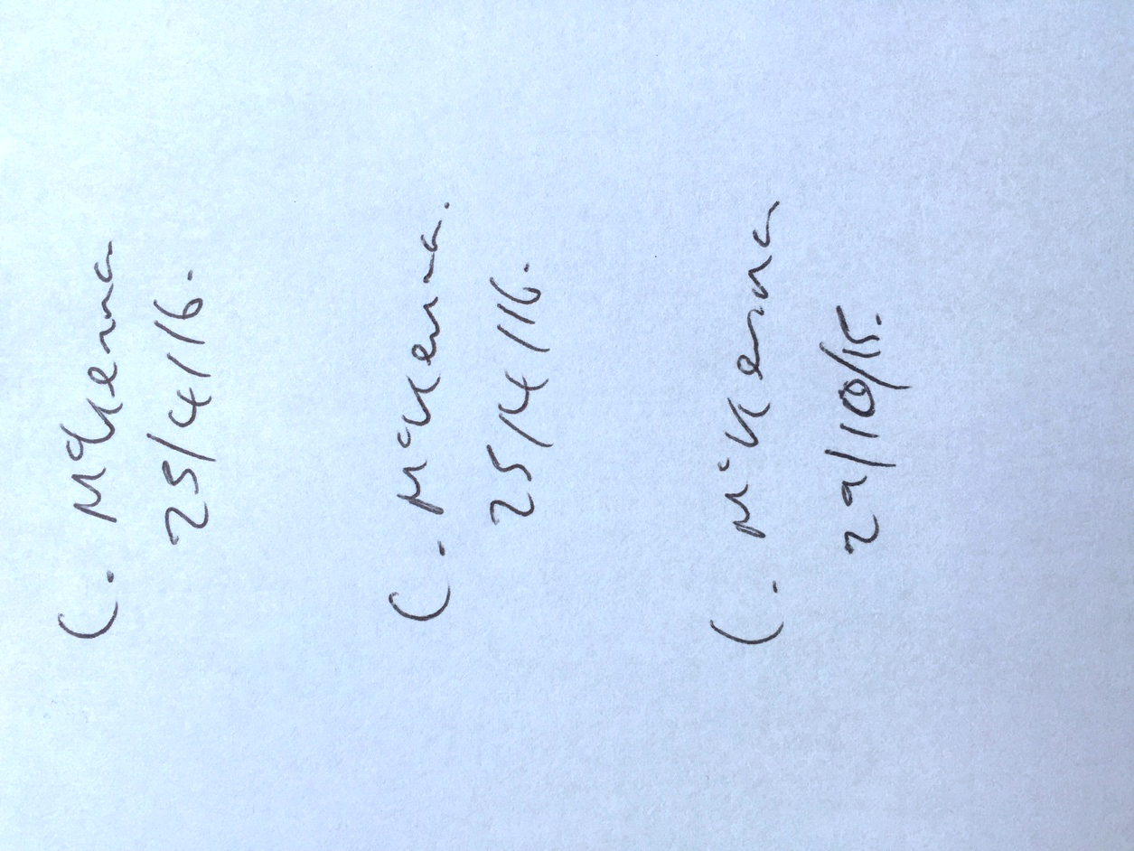

## Appendix 2 - Black Box Screenshots

1. 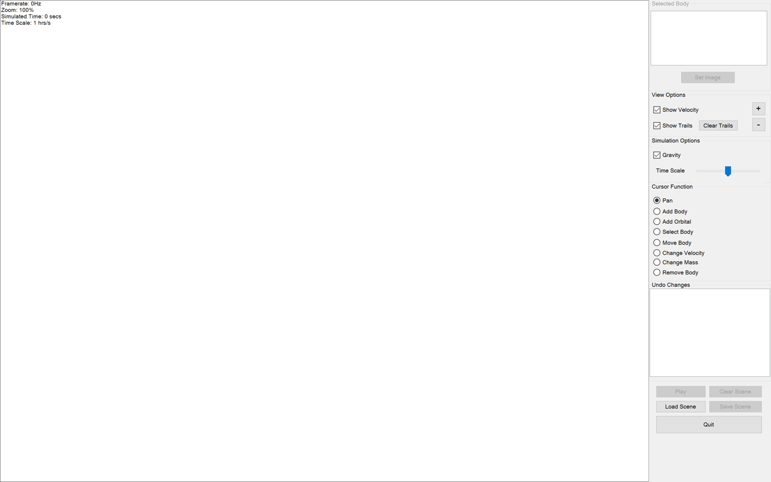
2. 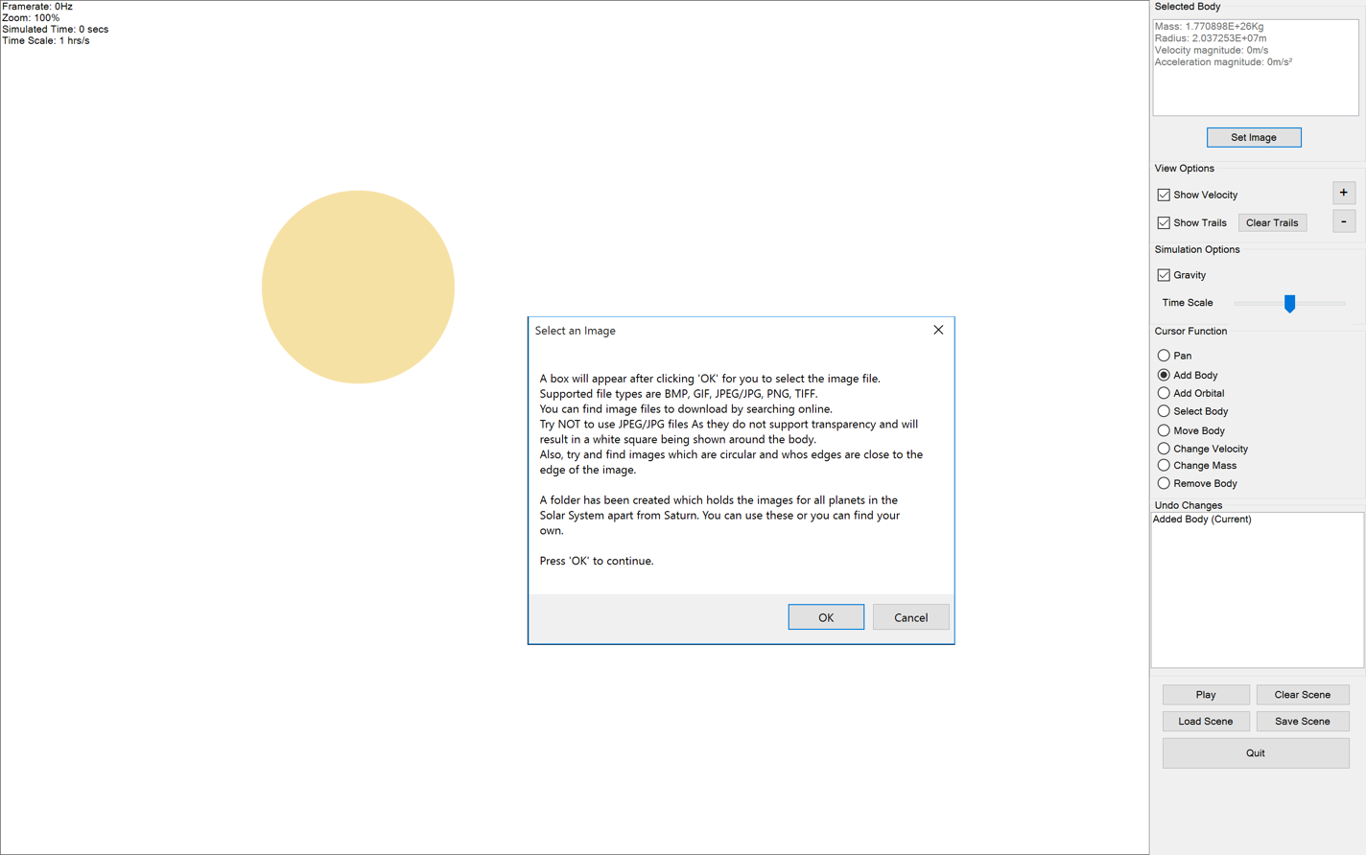
3. 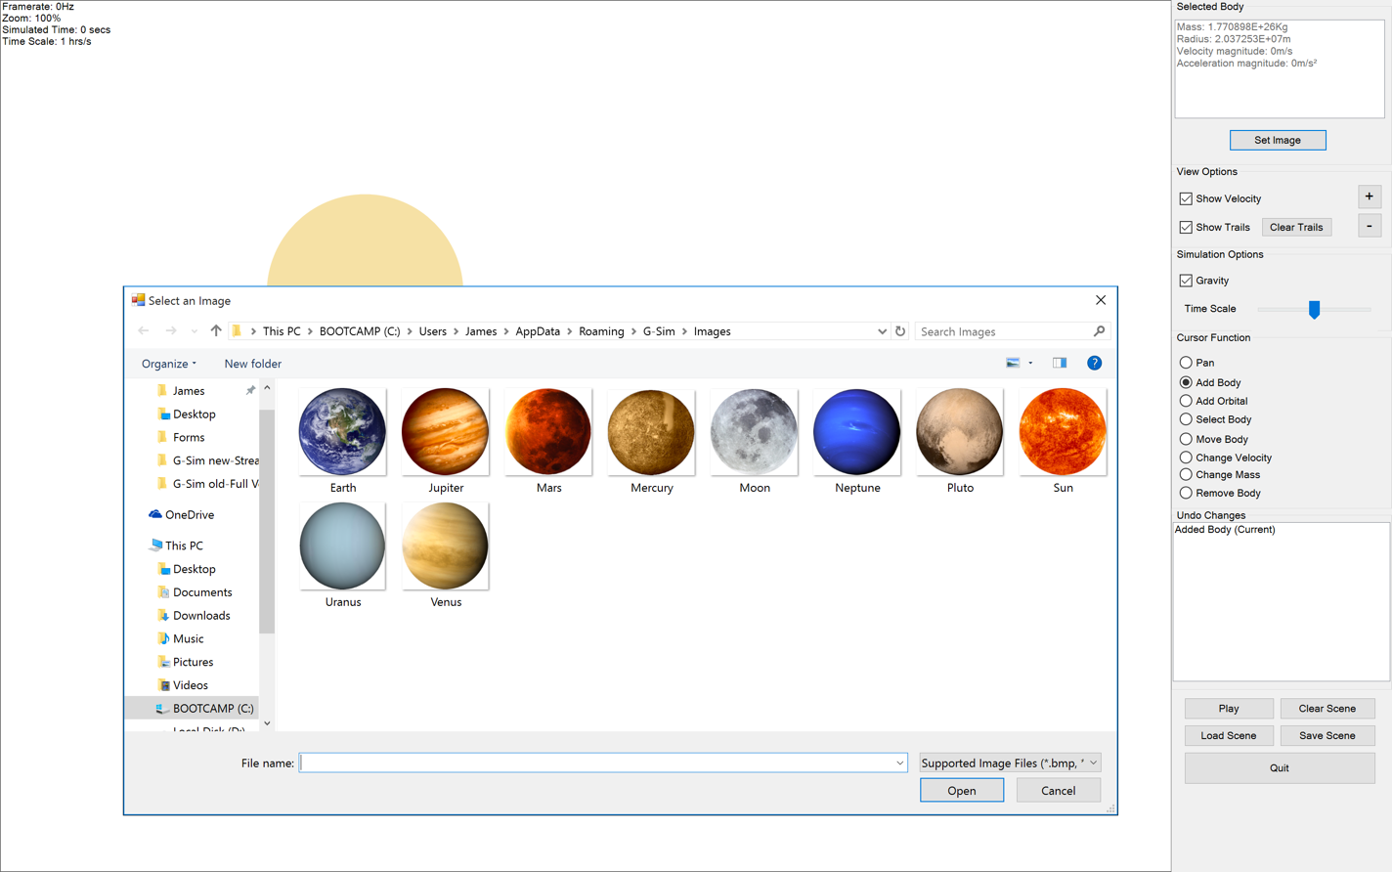
4. 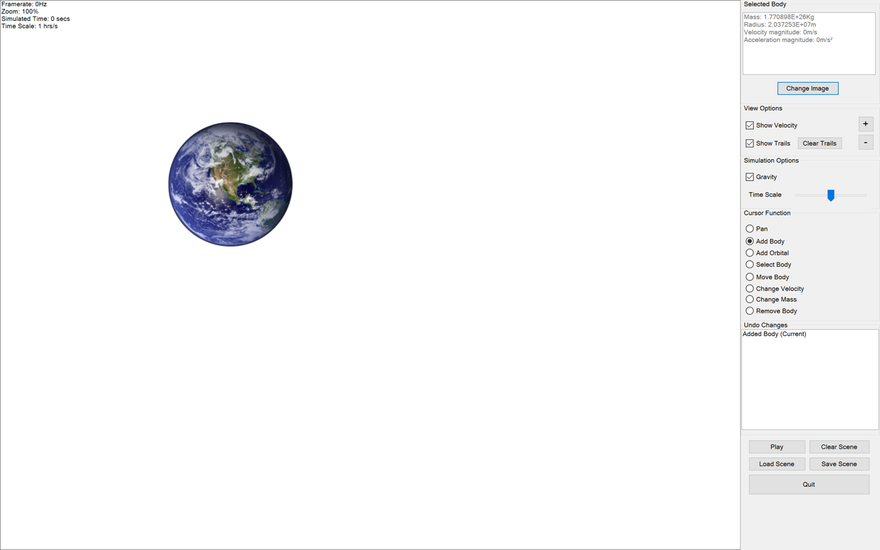
5. 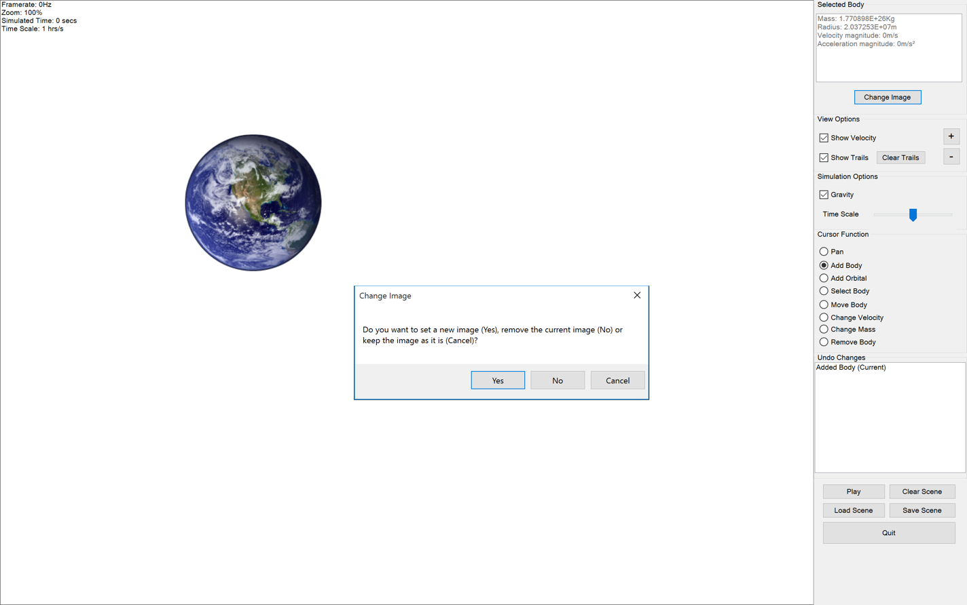
6. 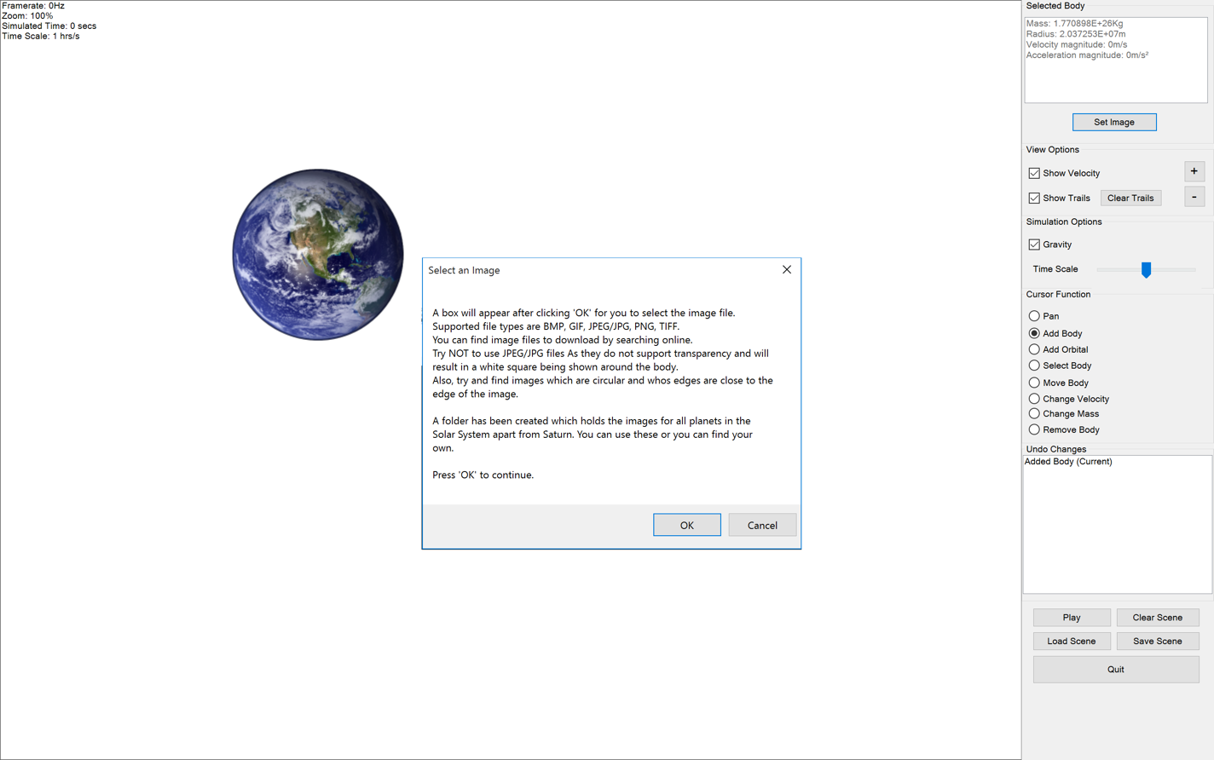
7. 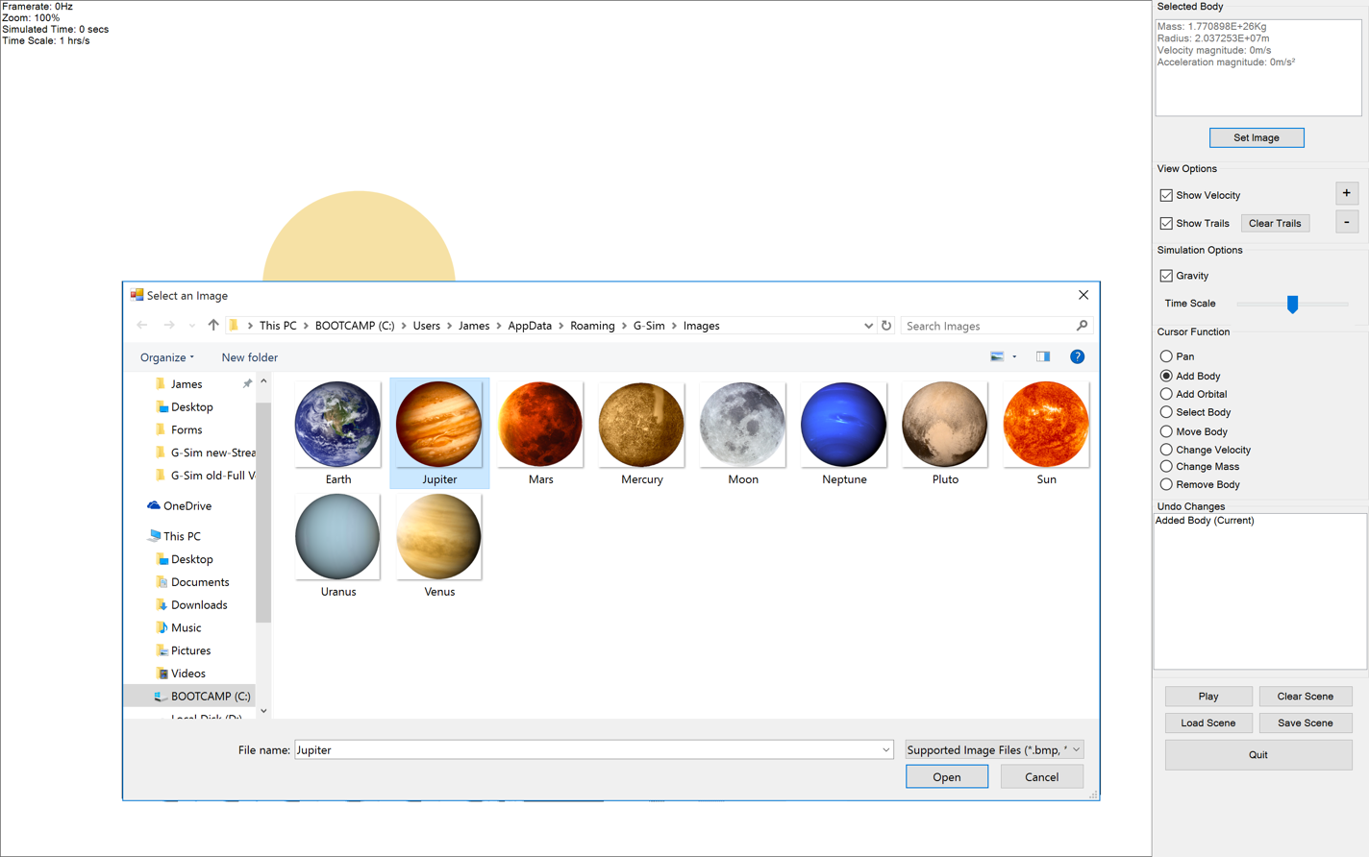
8. 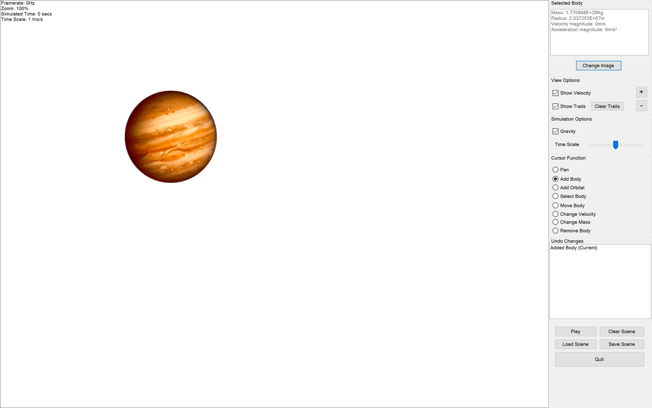
9. 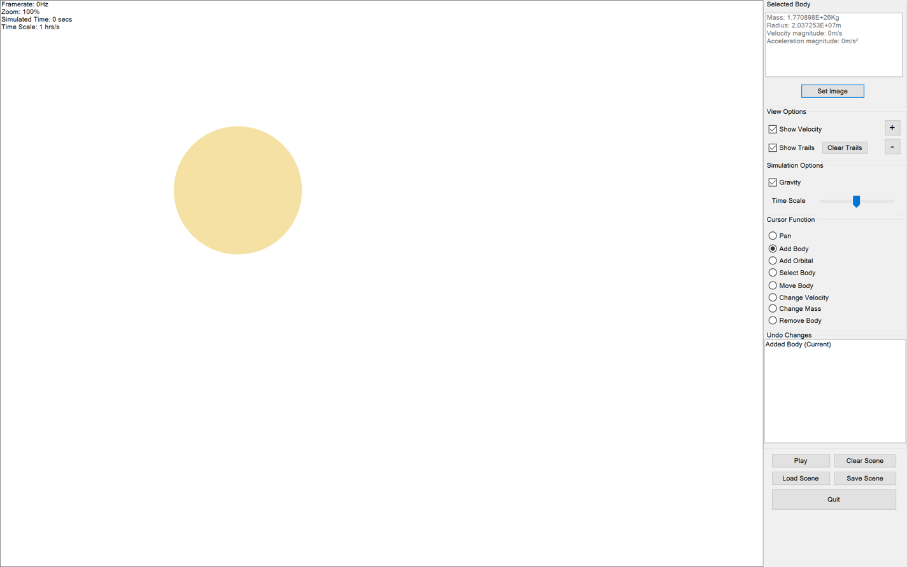
10. 
11. 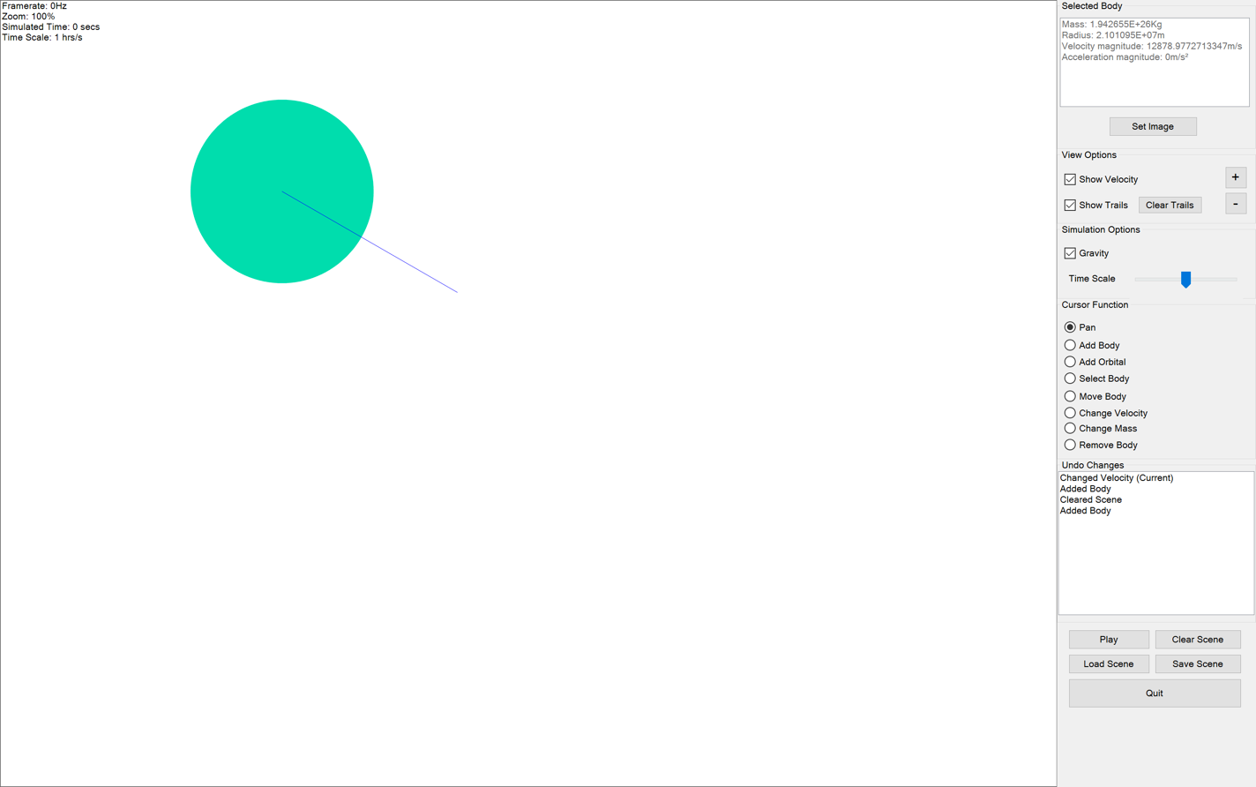
12. 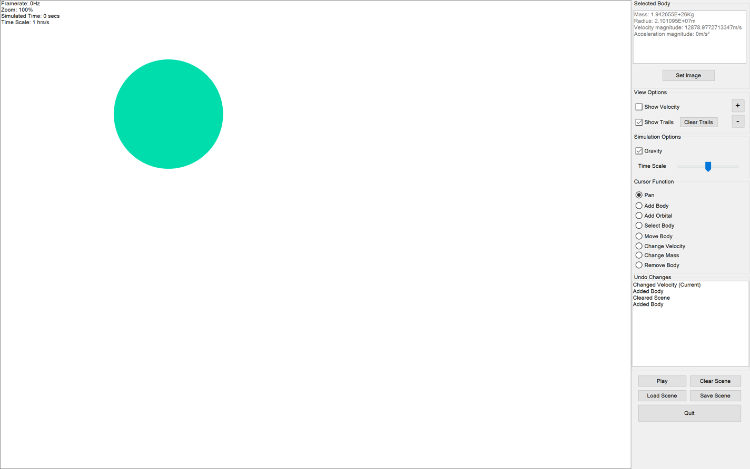
13. 
14. 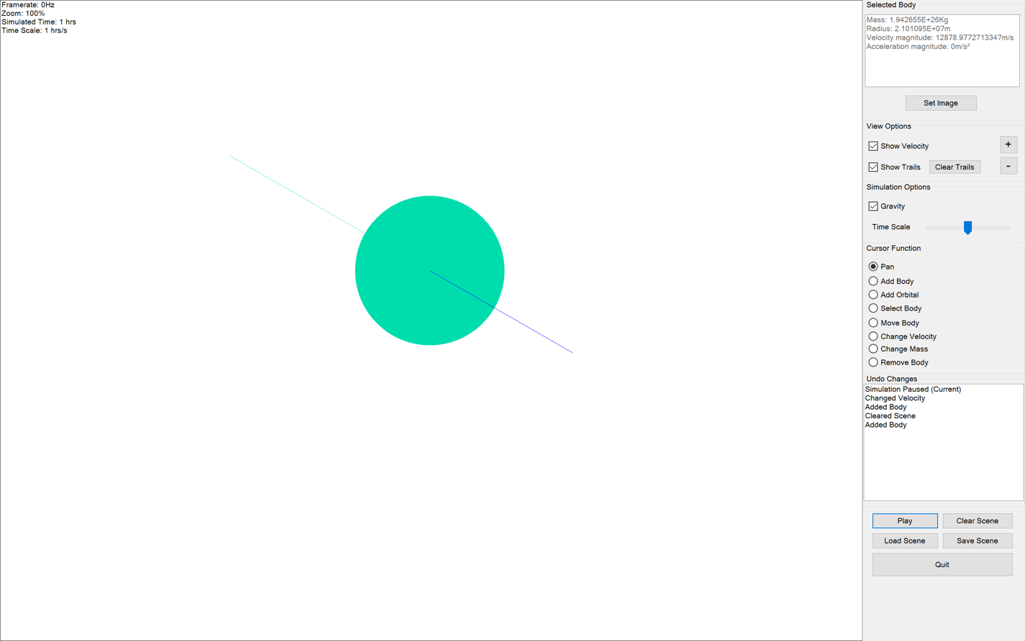
15. 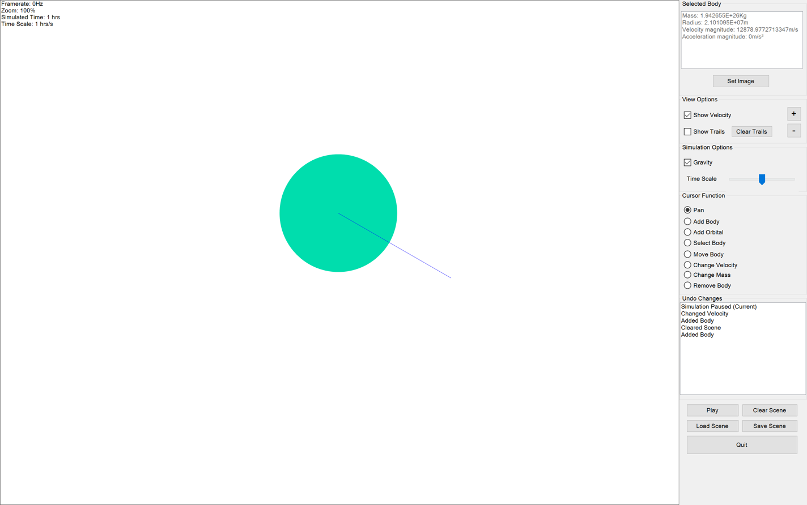
16. 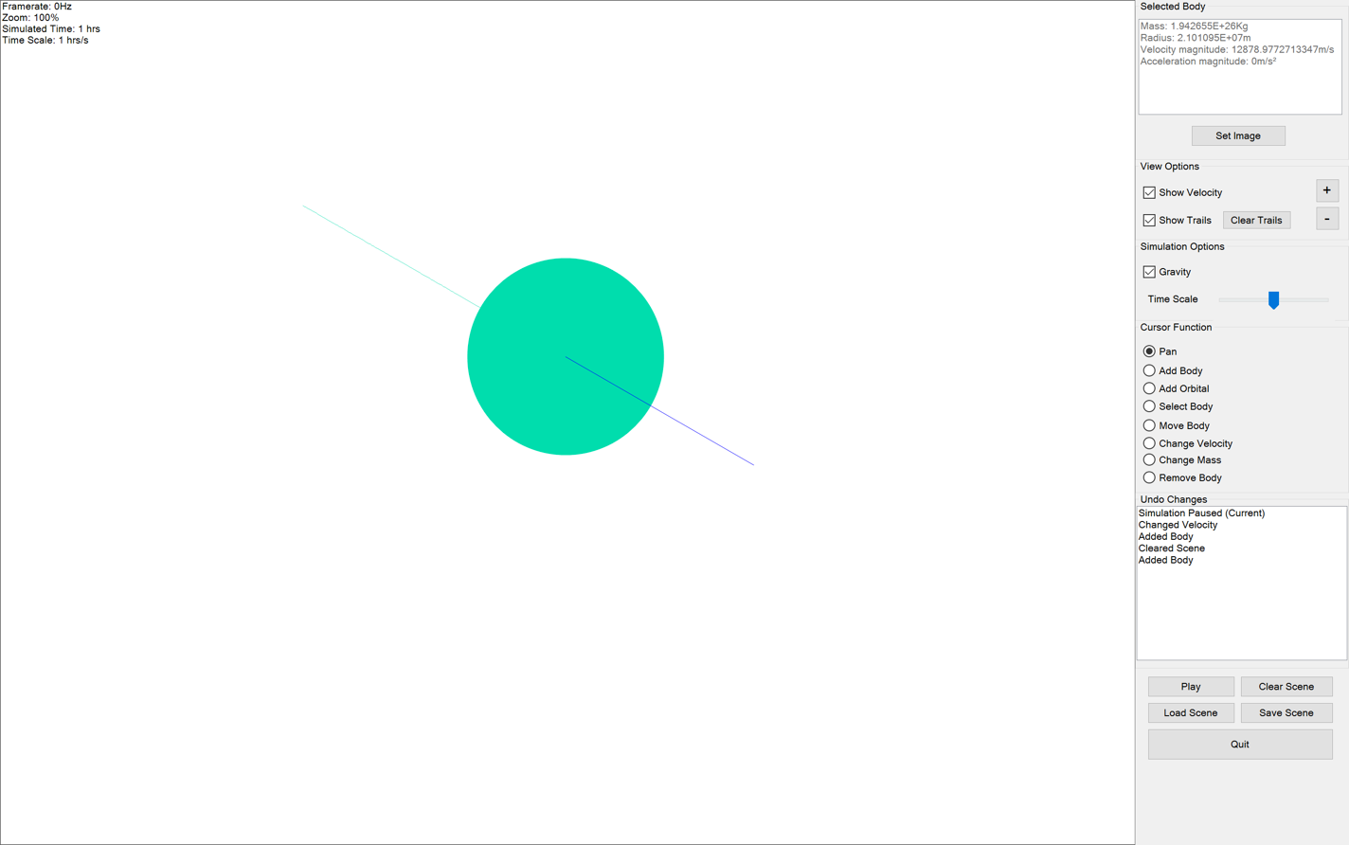
17. 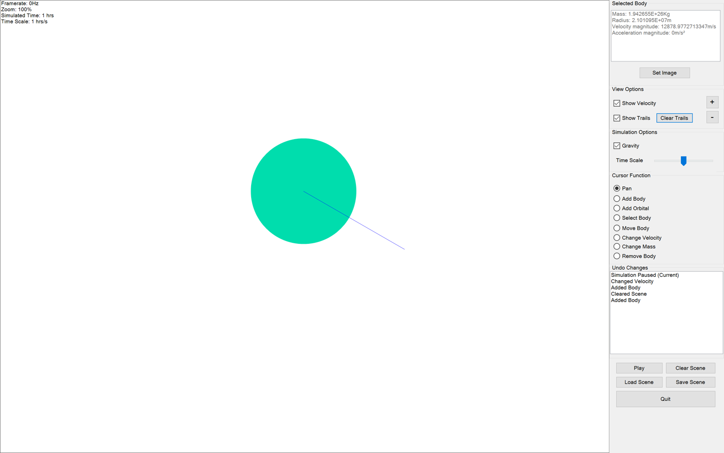
18. 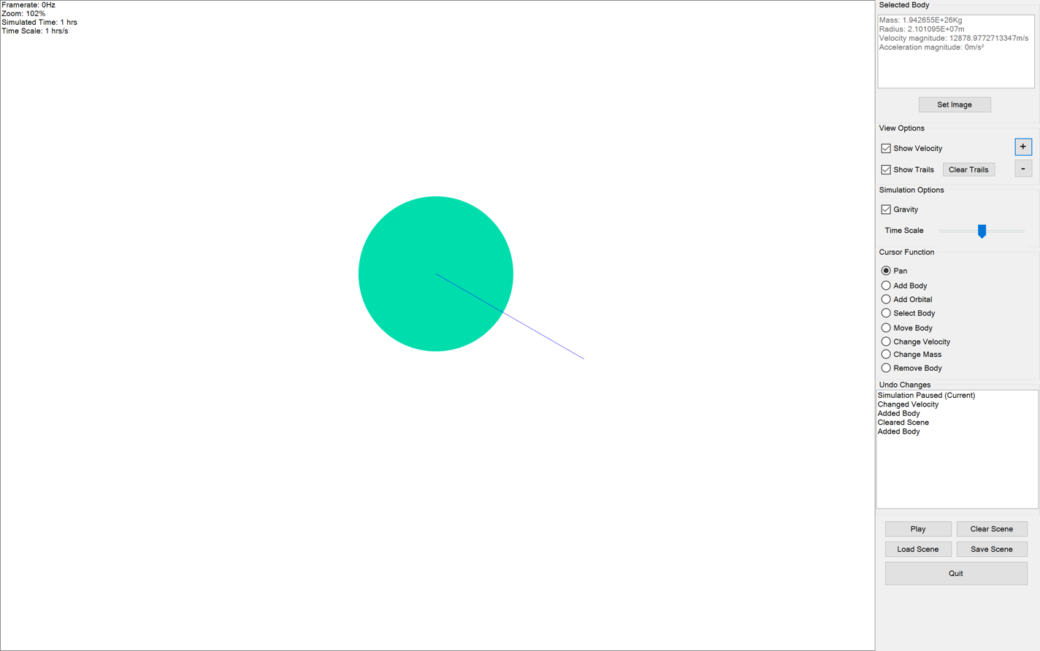
19. 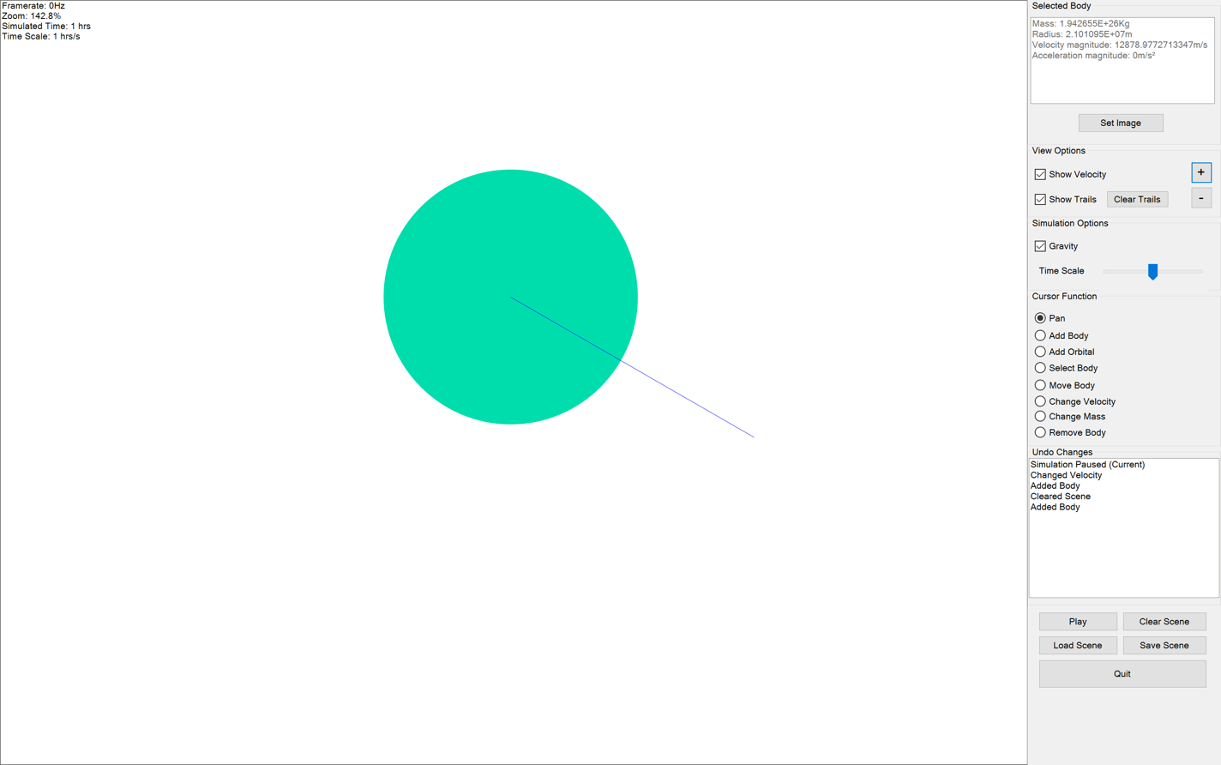
20. 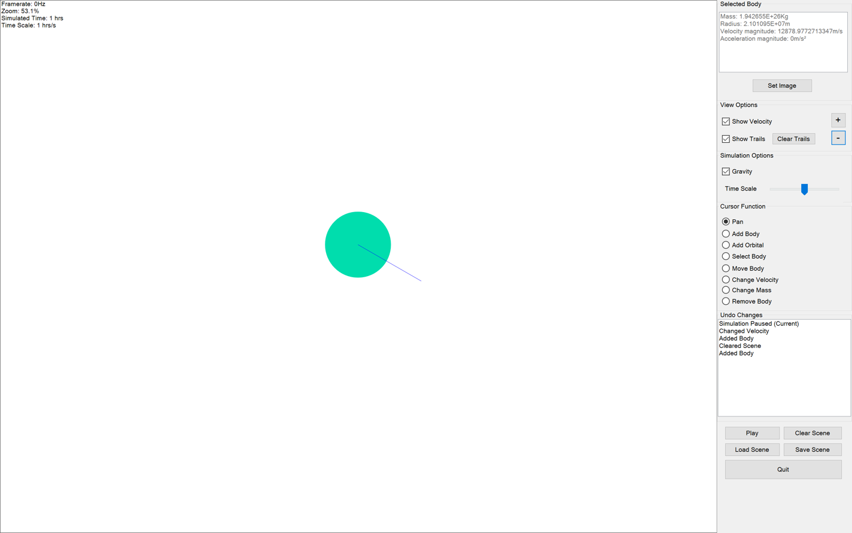
21. 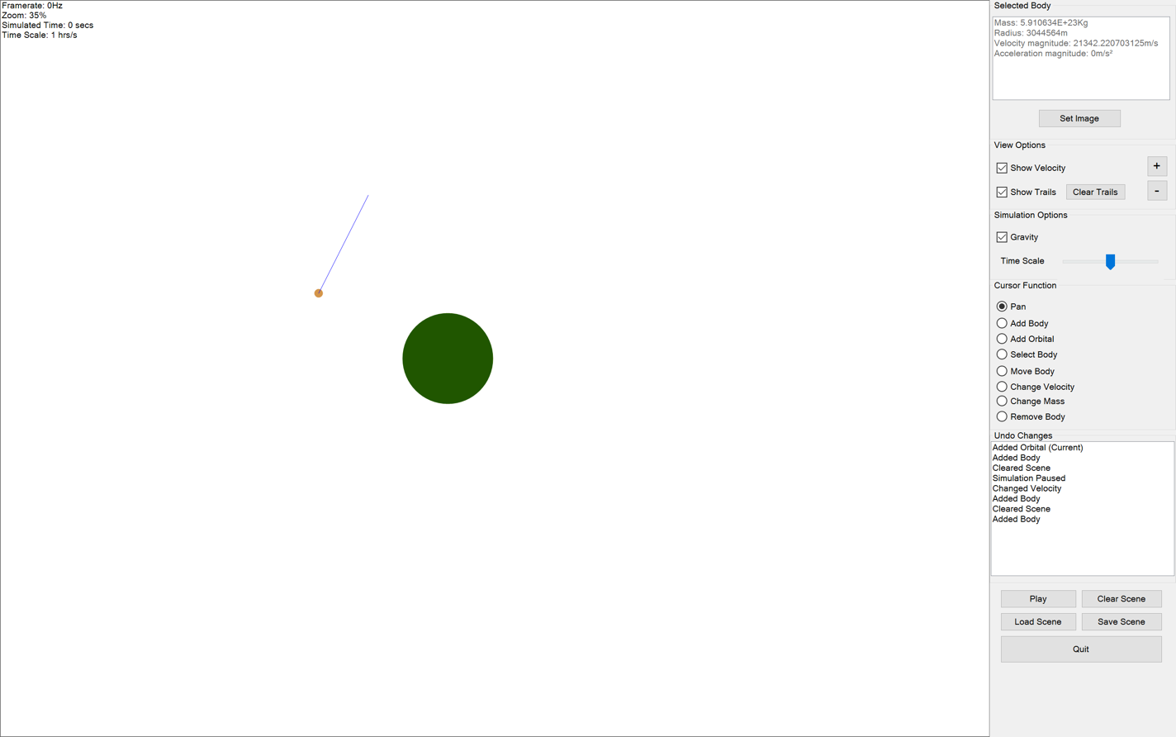
22. 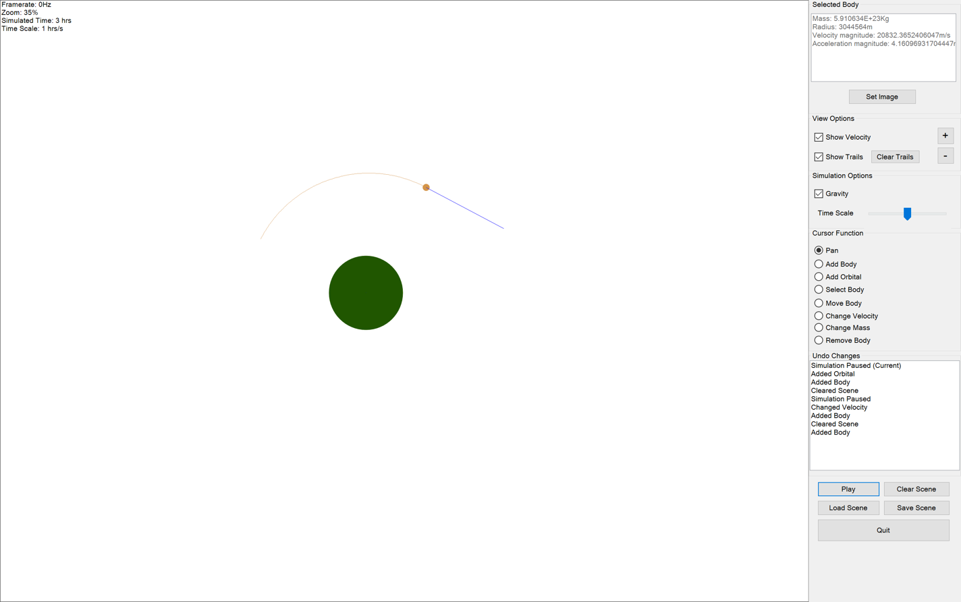
23. 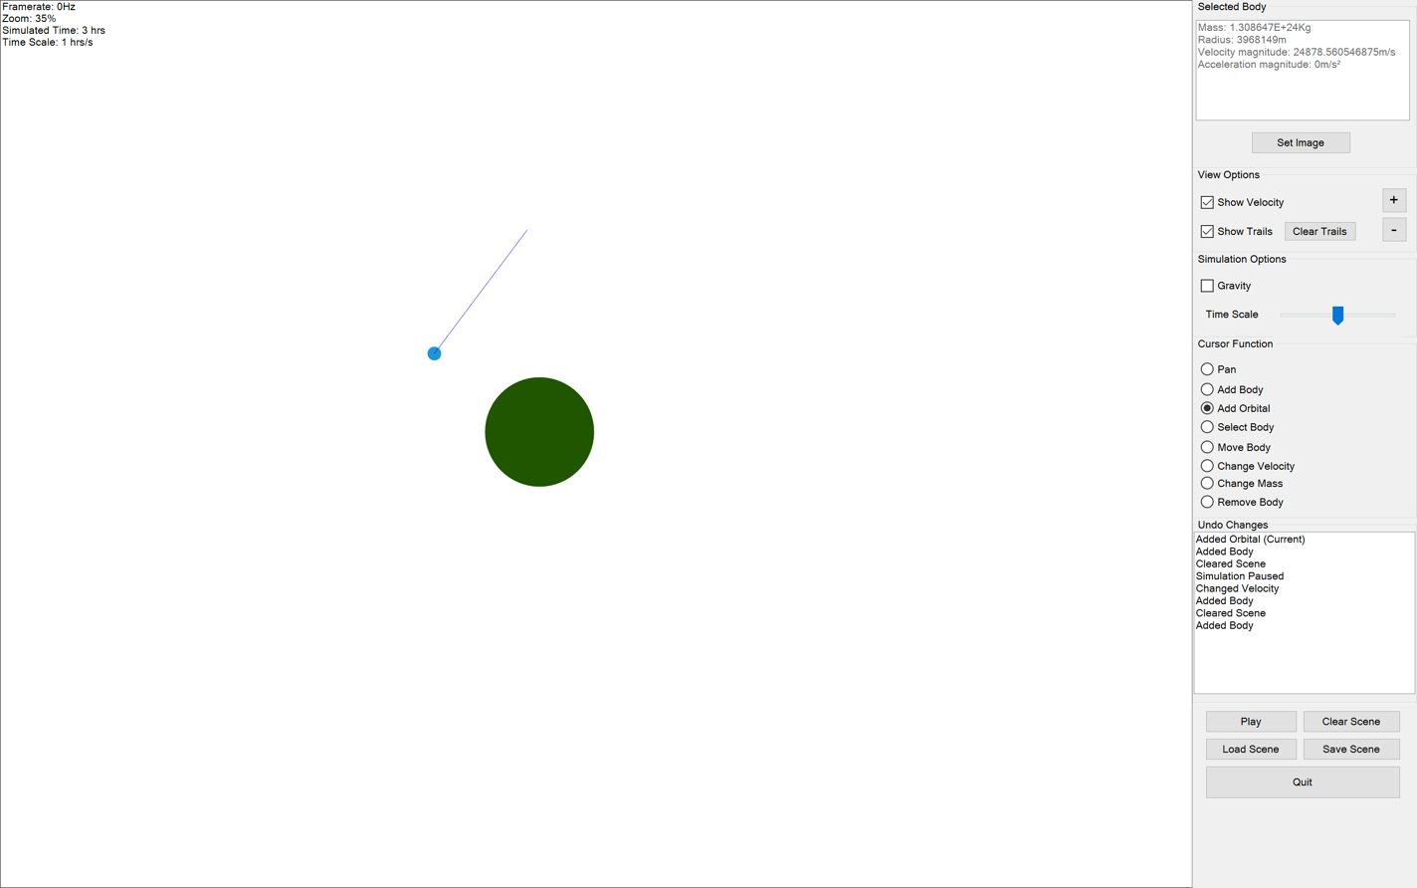
24. 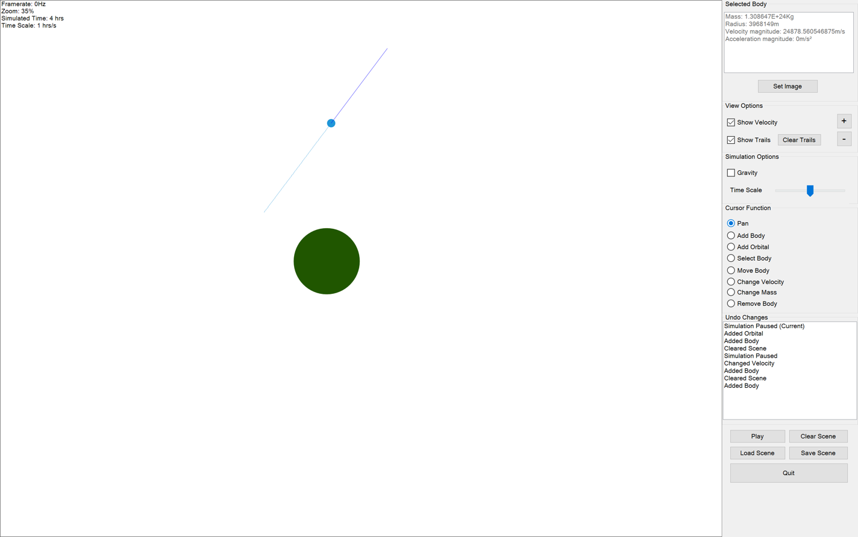
25. 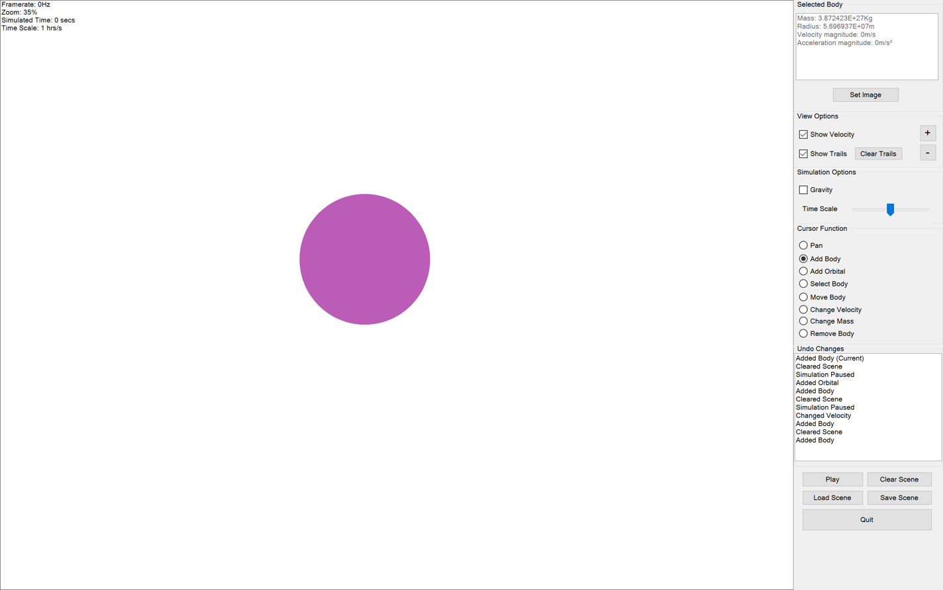
26. 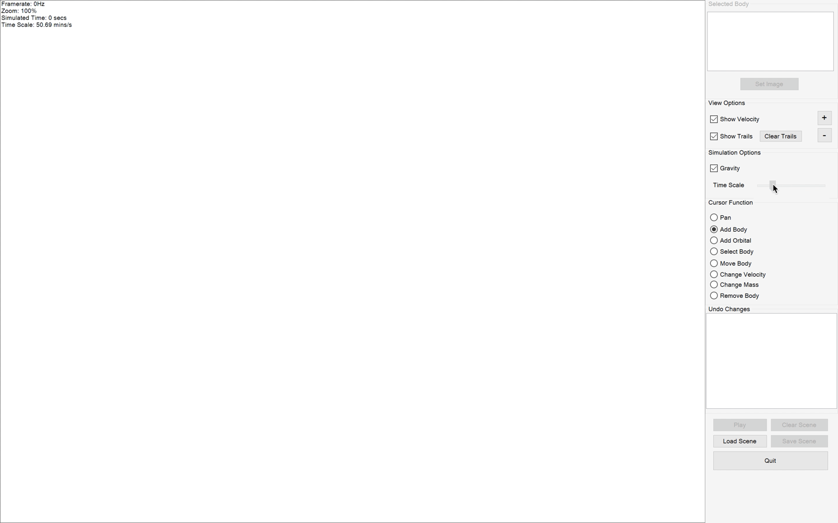
27. 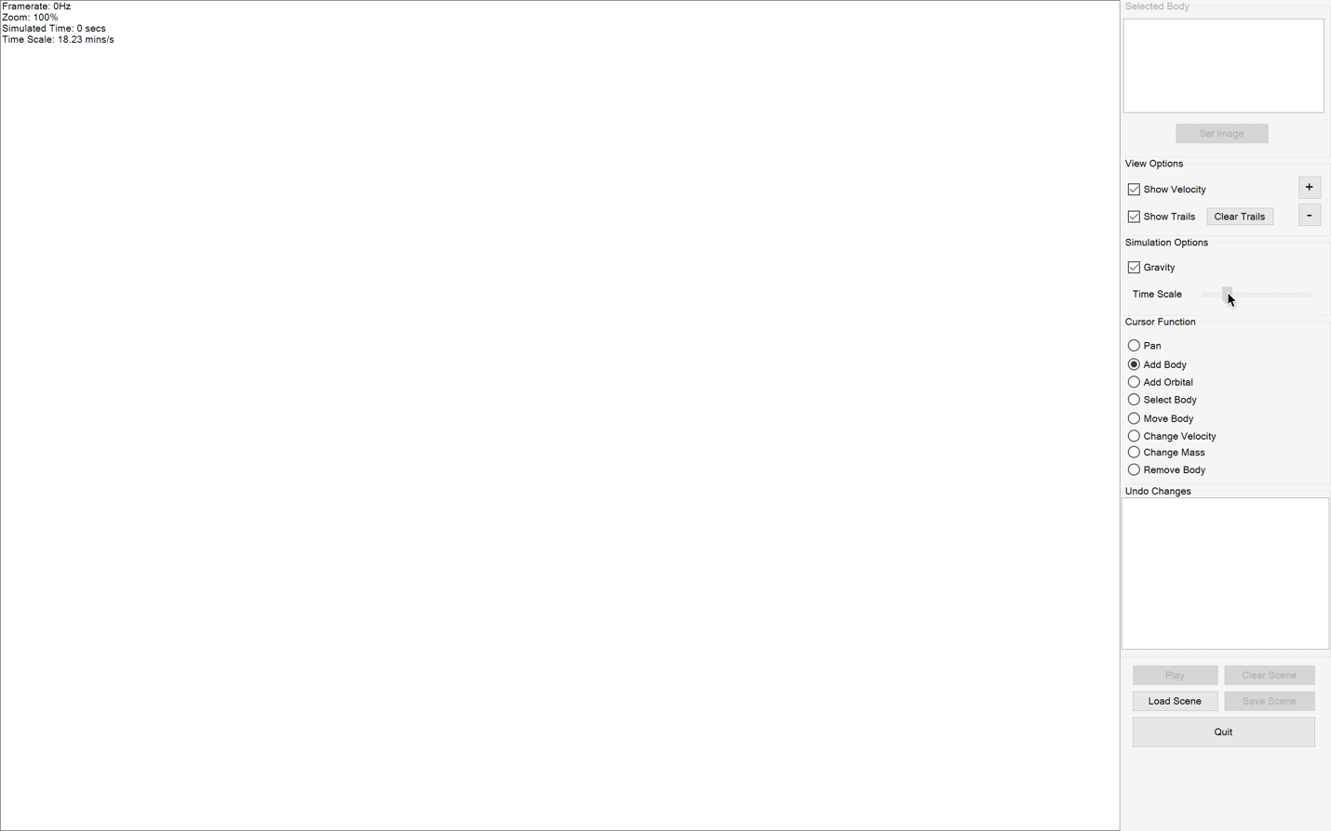
28. 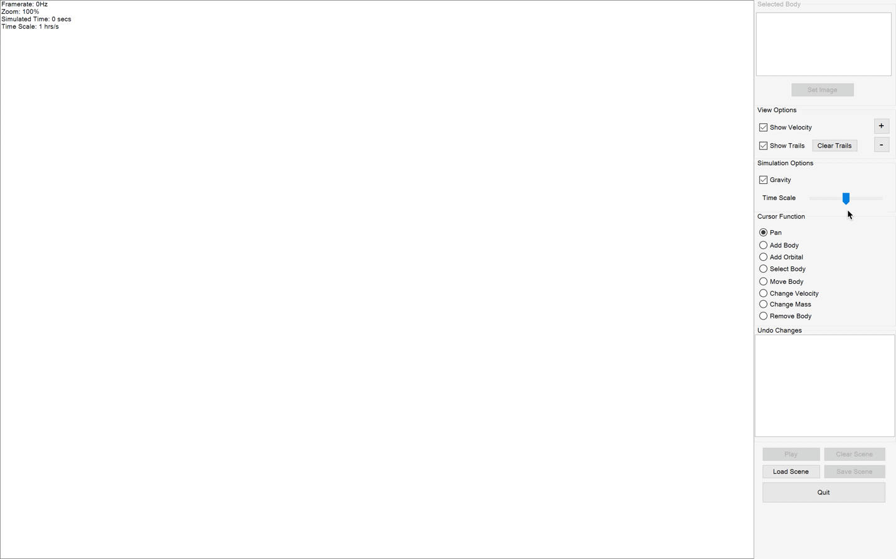
29. 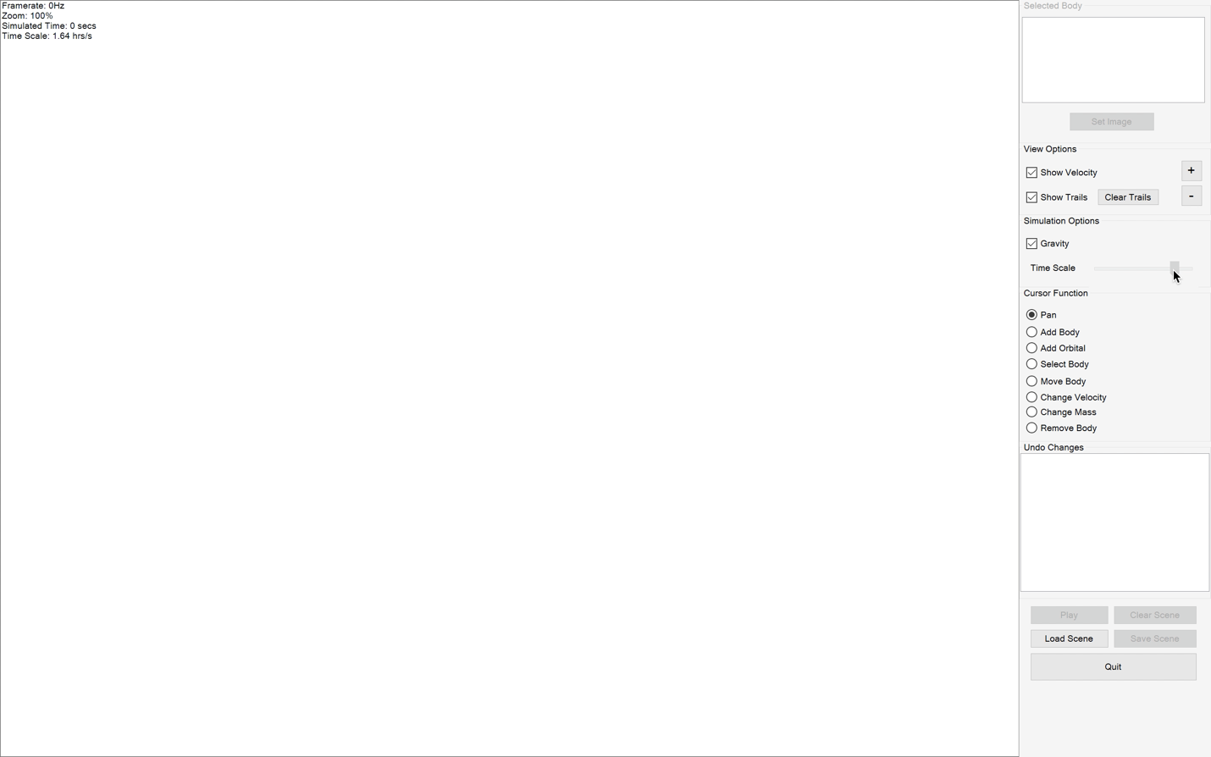
30. 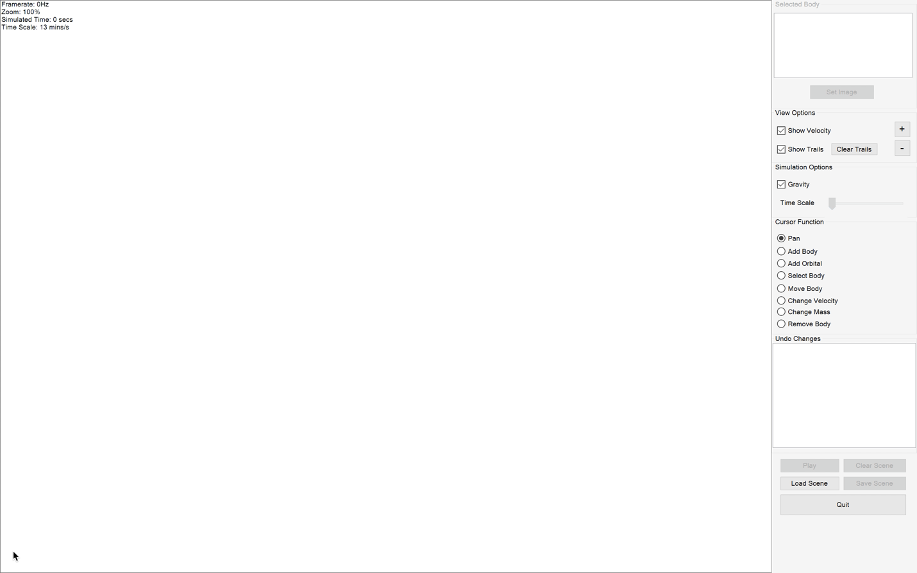
31. 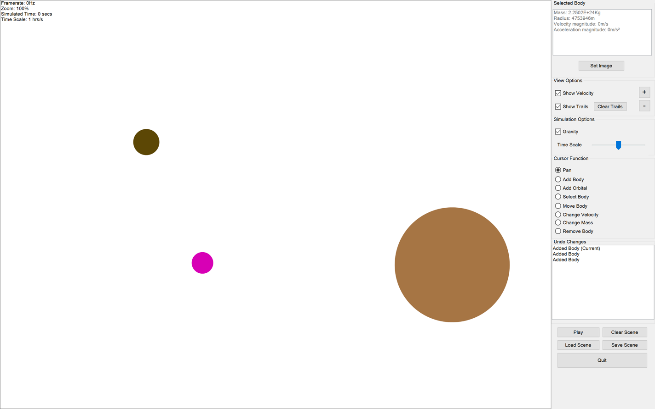
32. 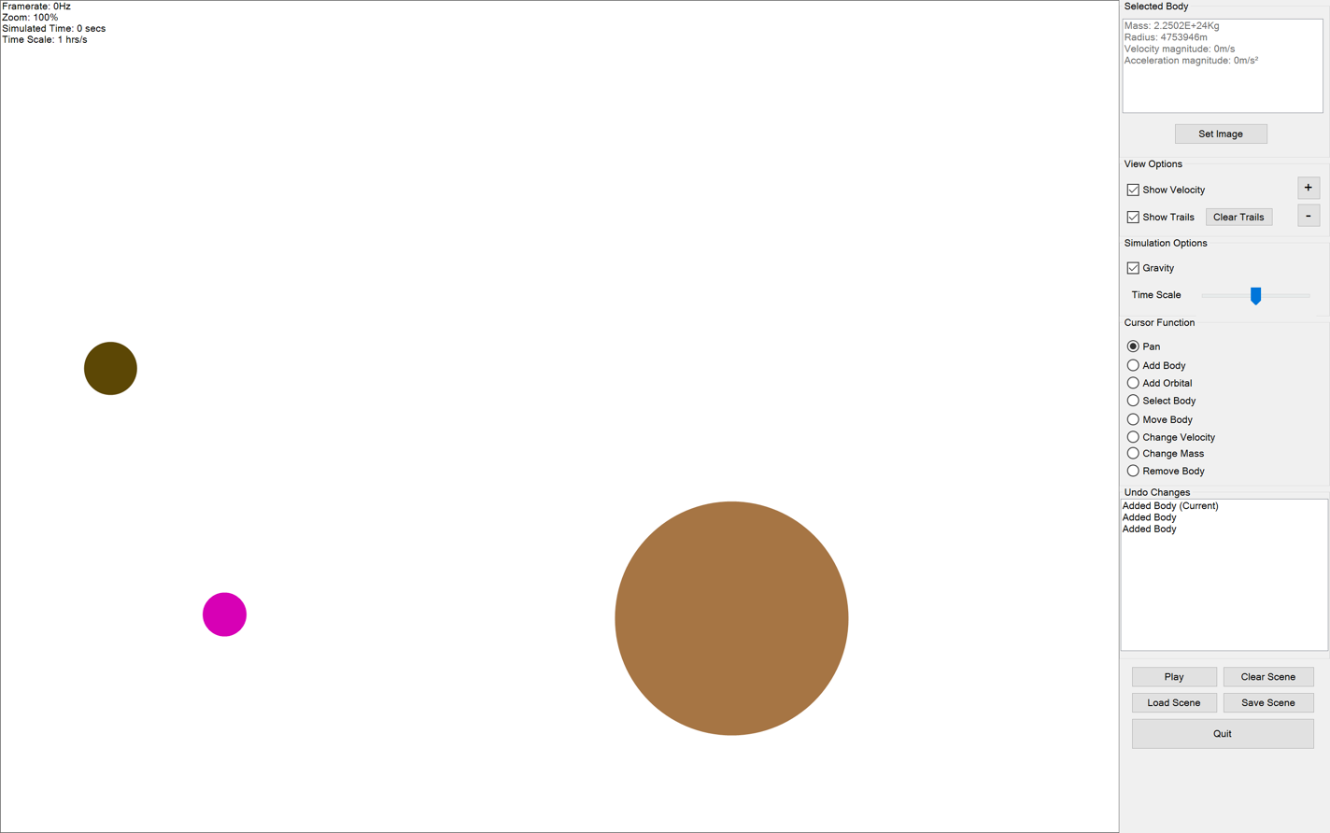
33. 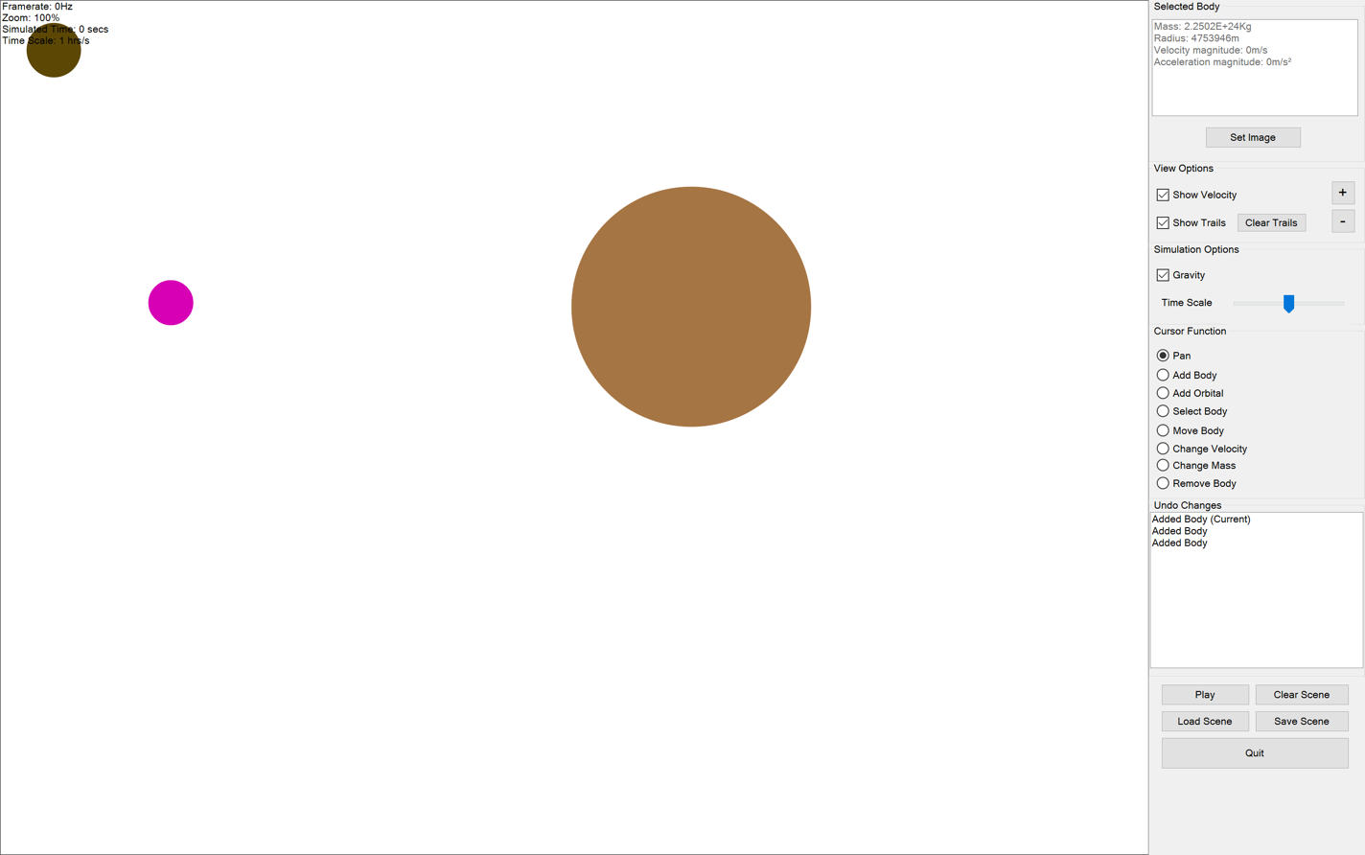
34. 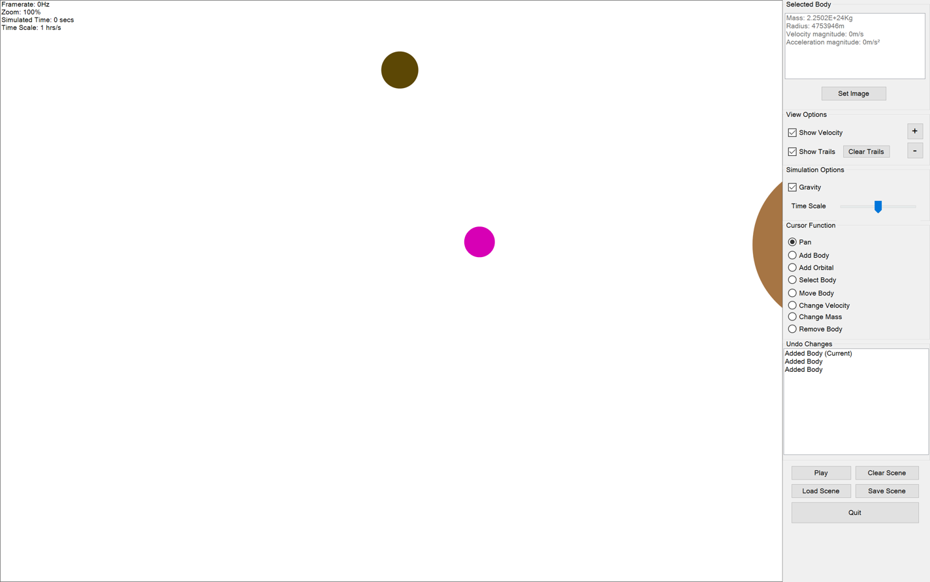
35. 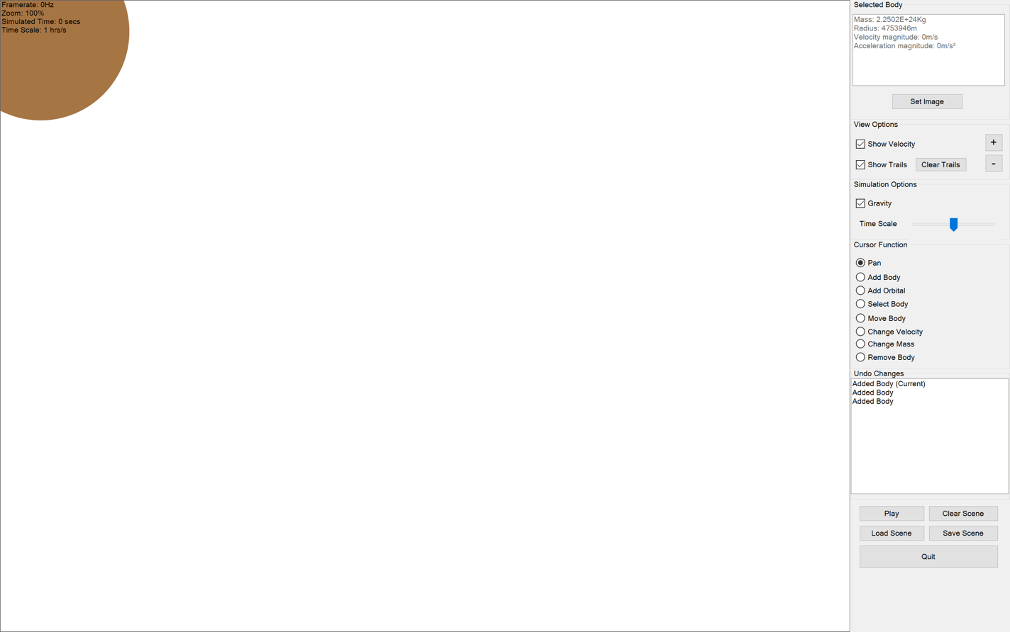
36. 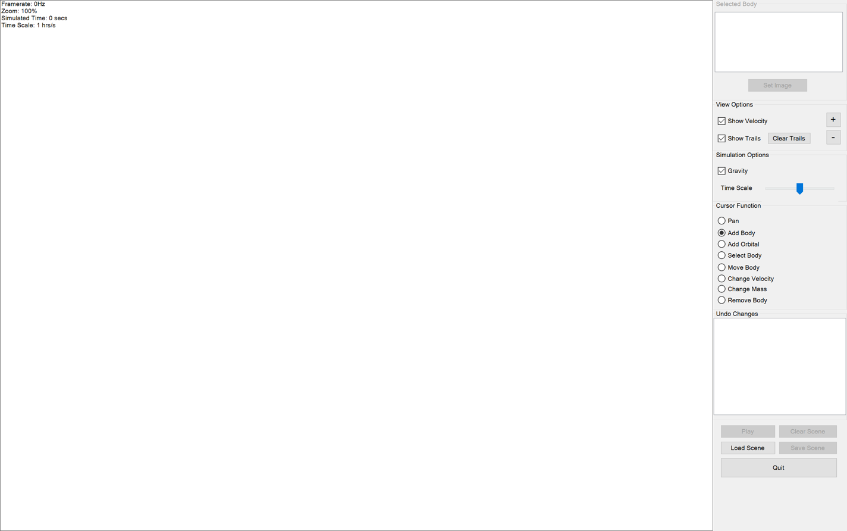
37. 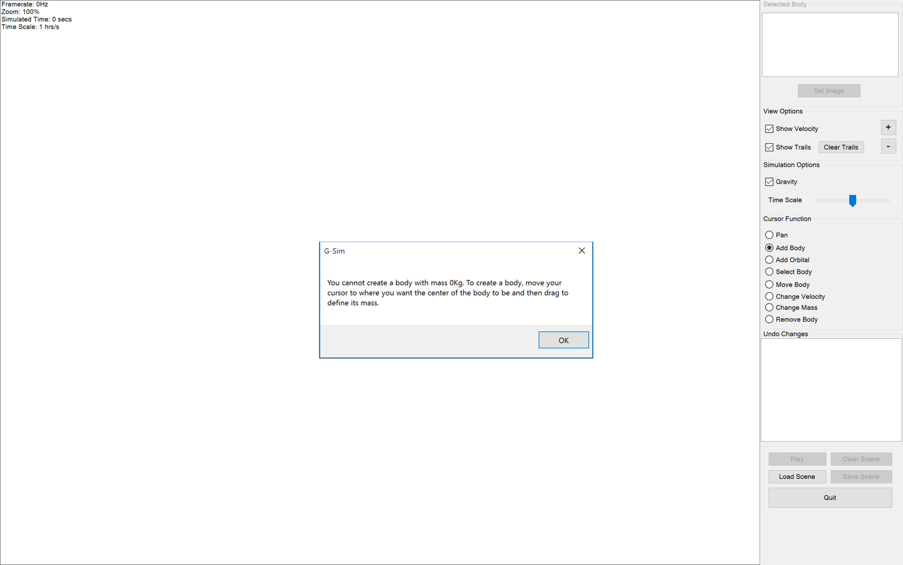
38. 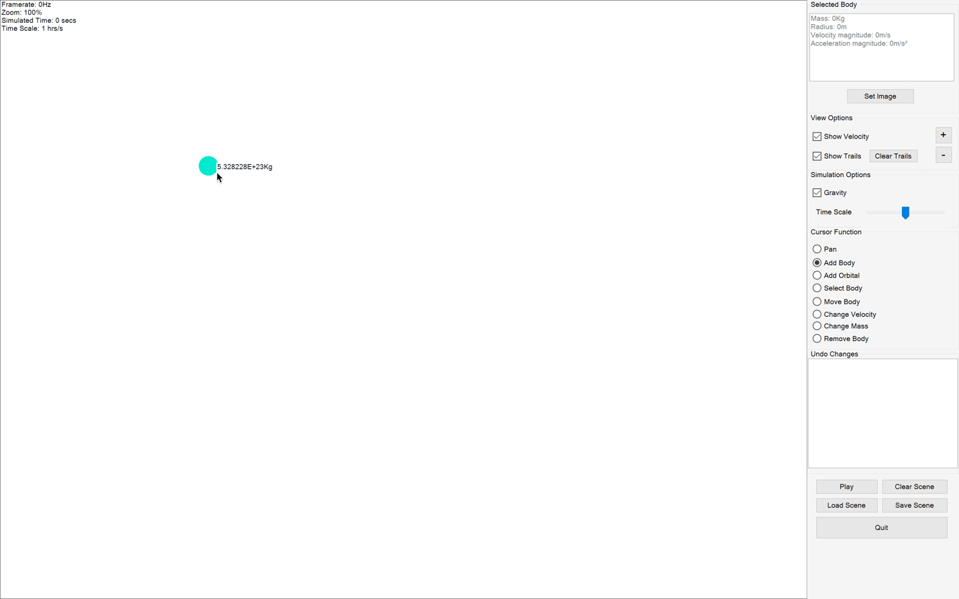
39. 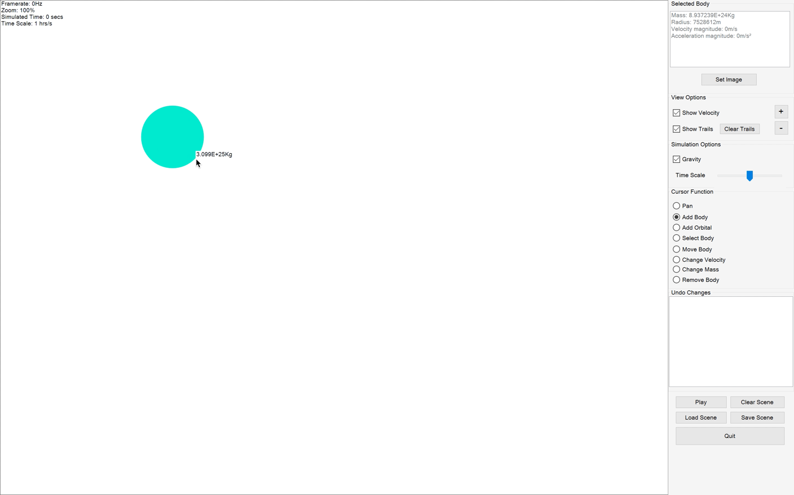
40. 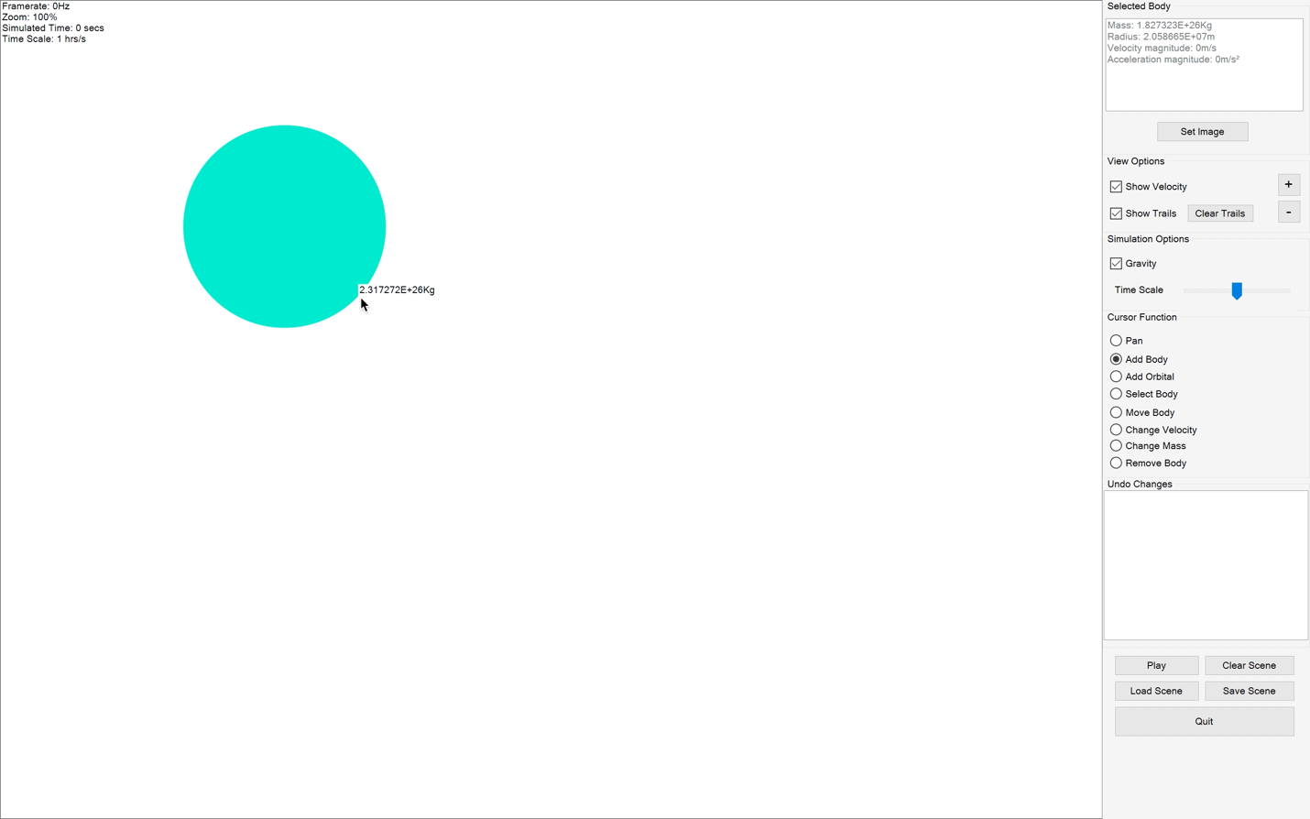
41. 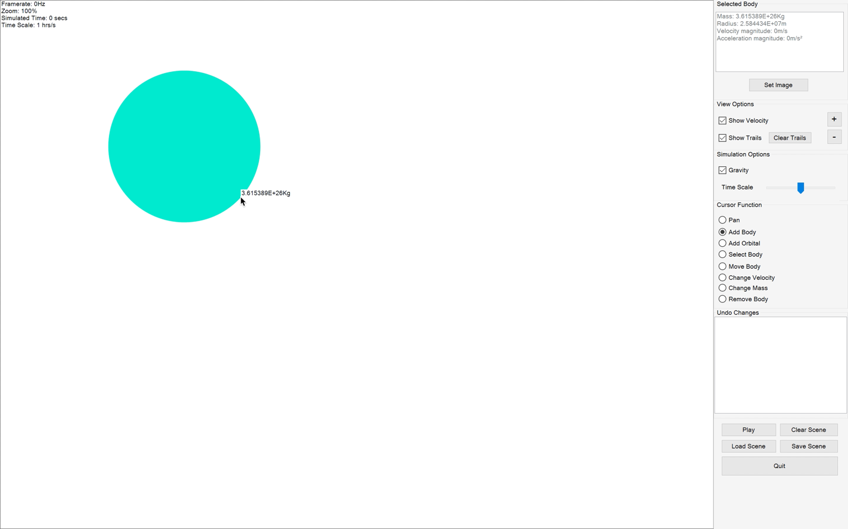
42. 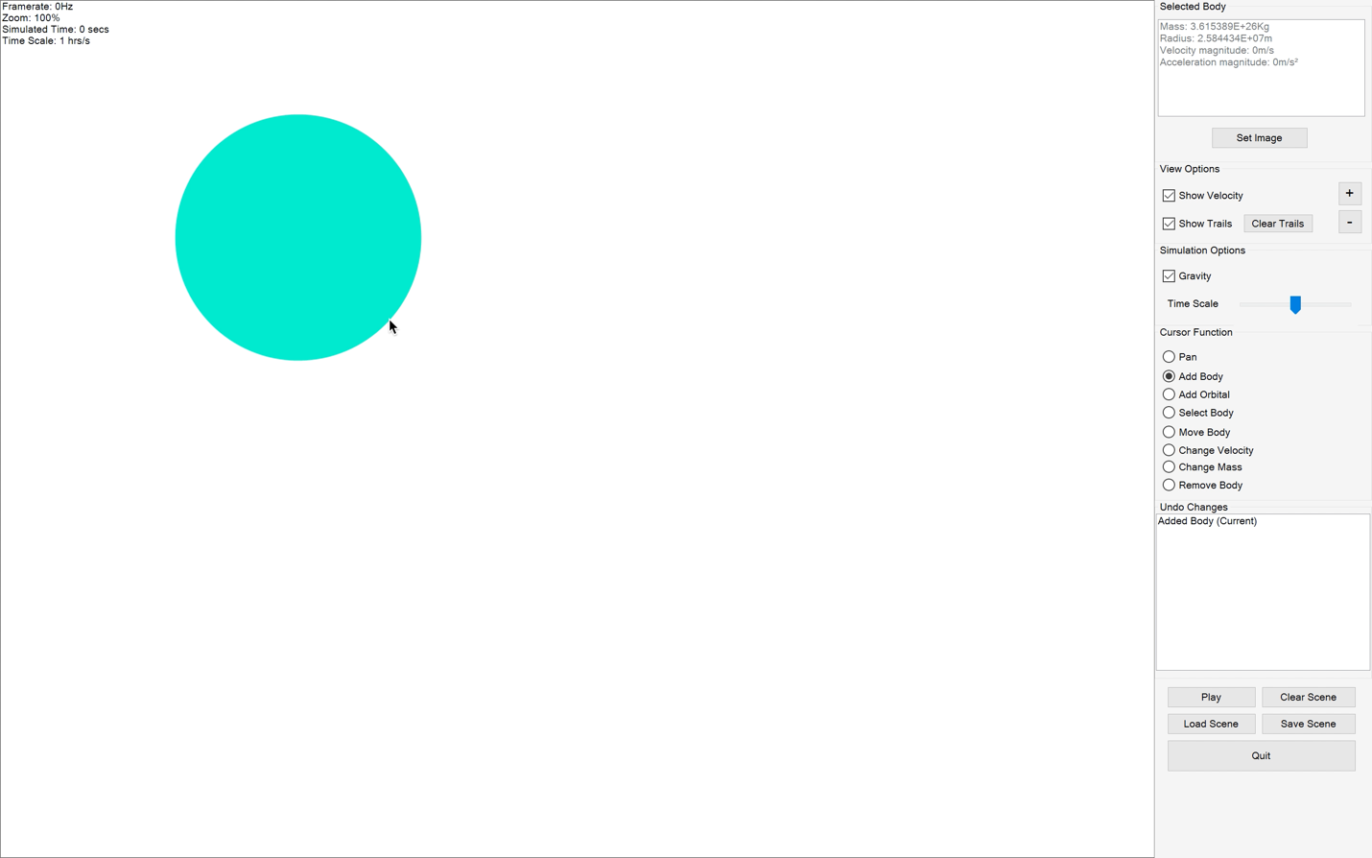
43. 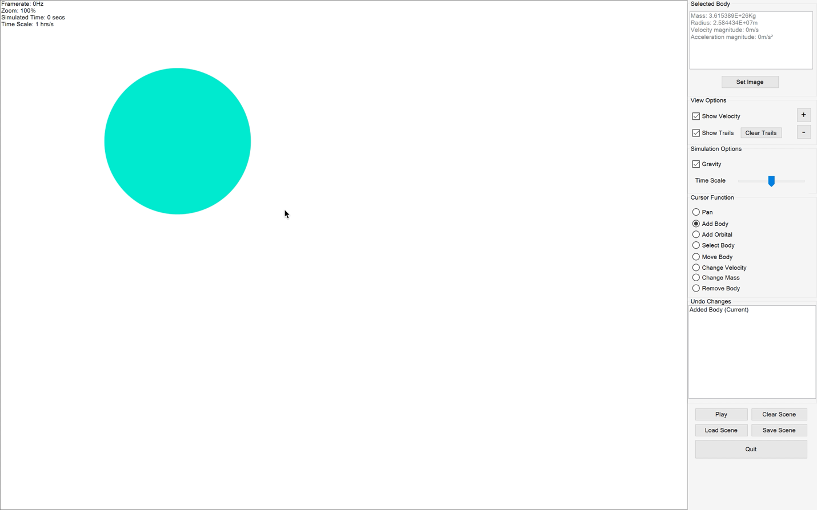
44. 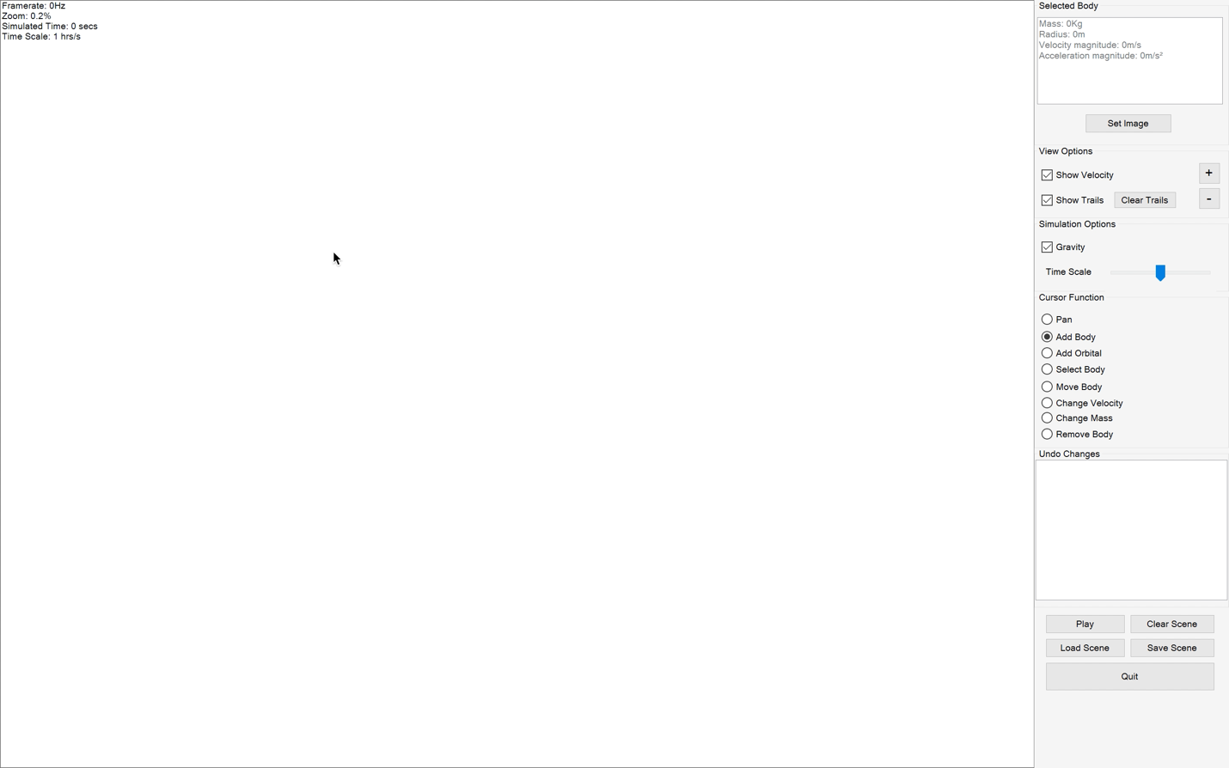
45. 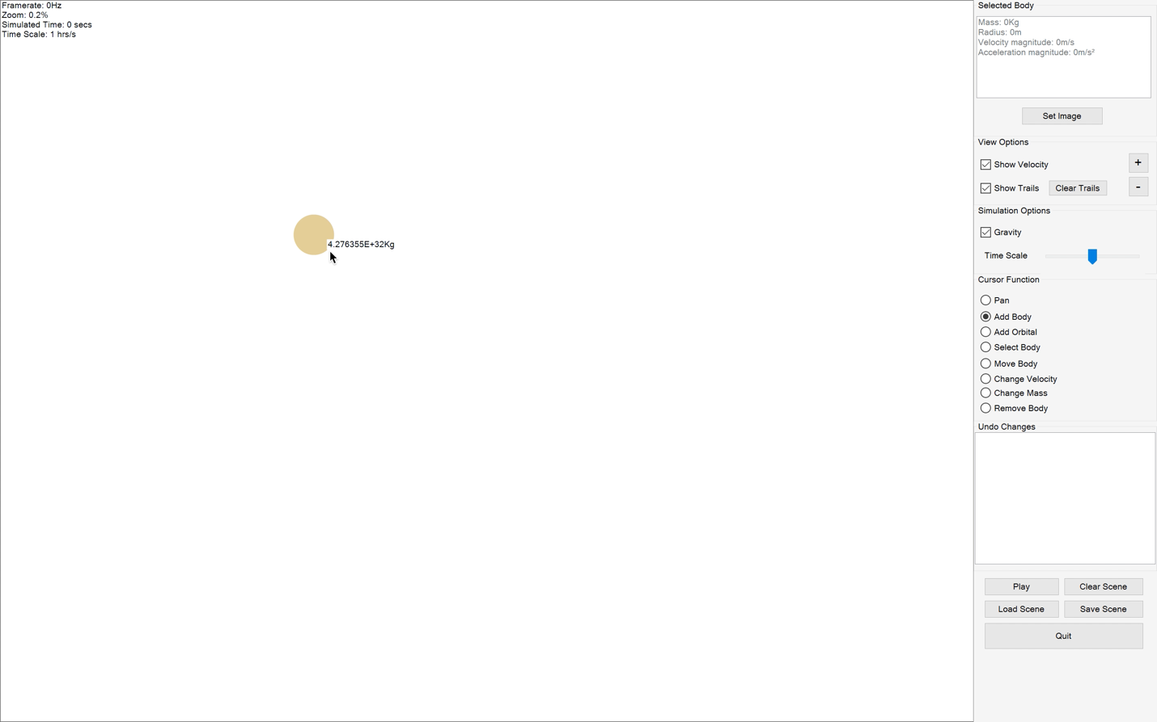
46. 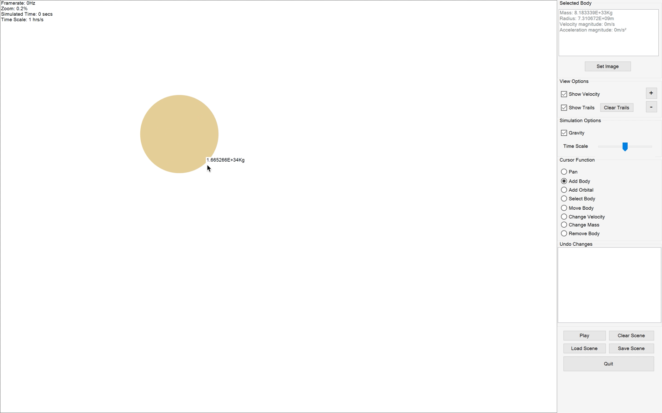
47. 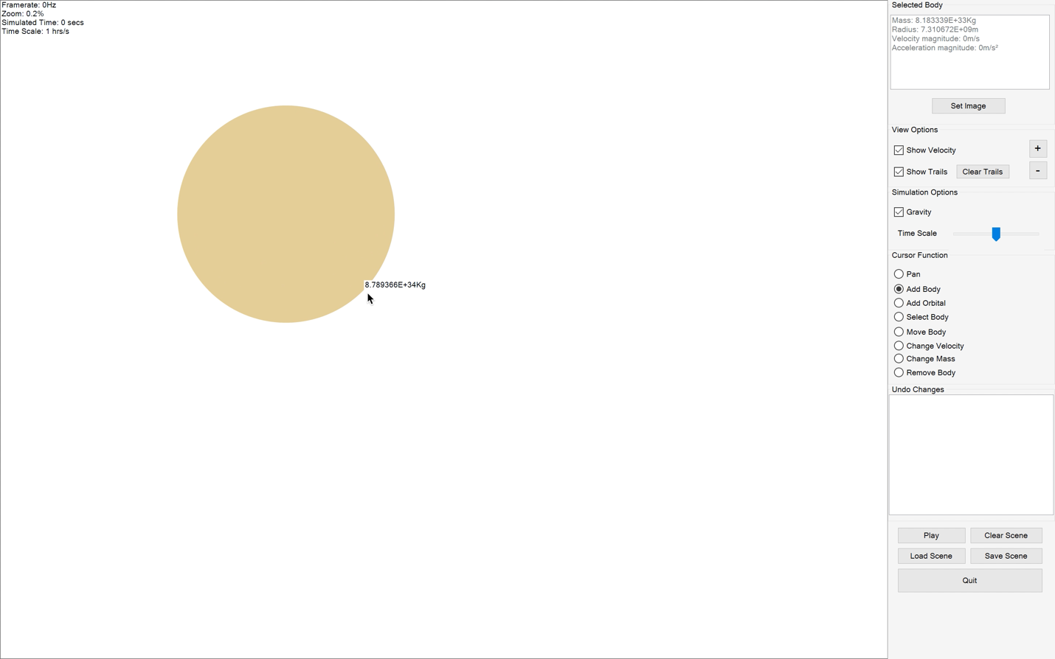
48. 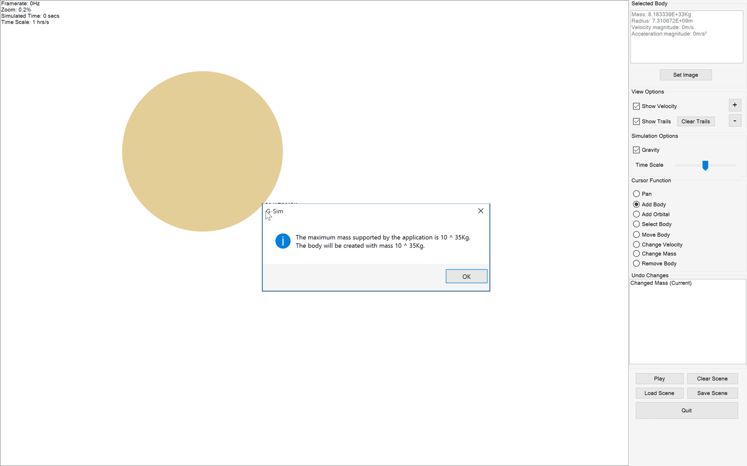
49. 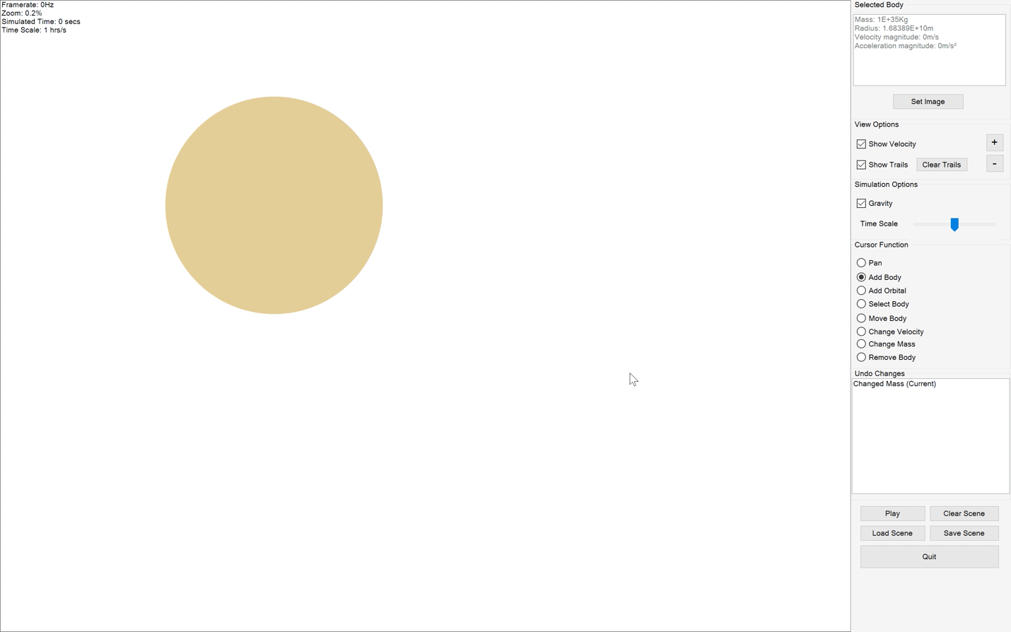
50. 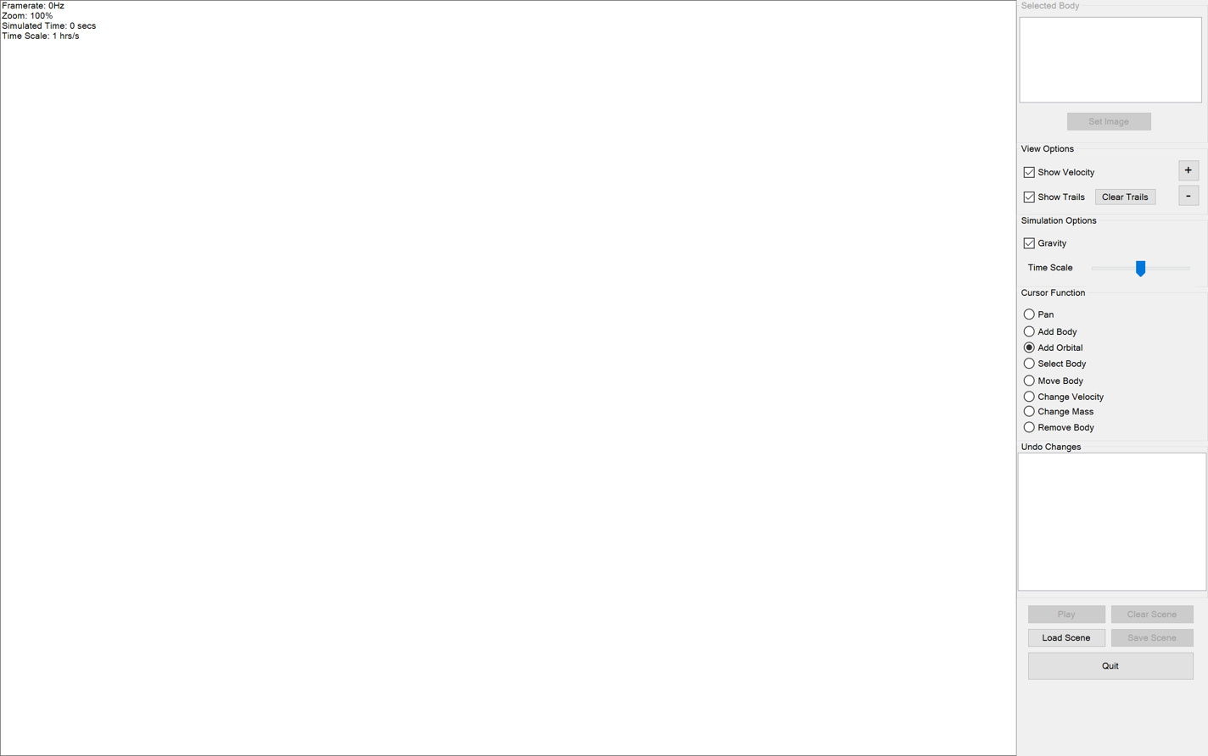
51. 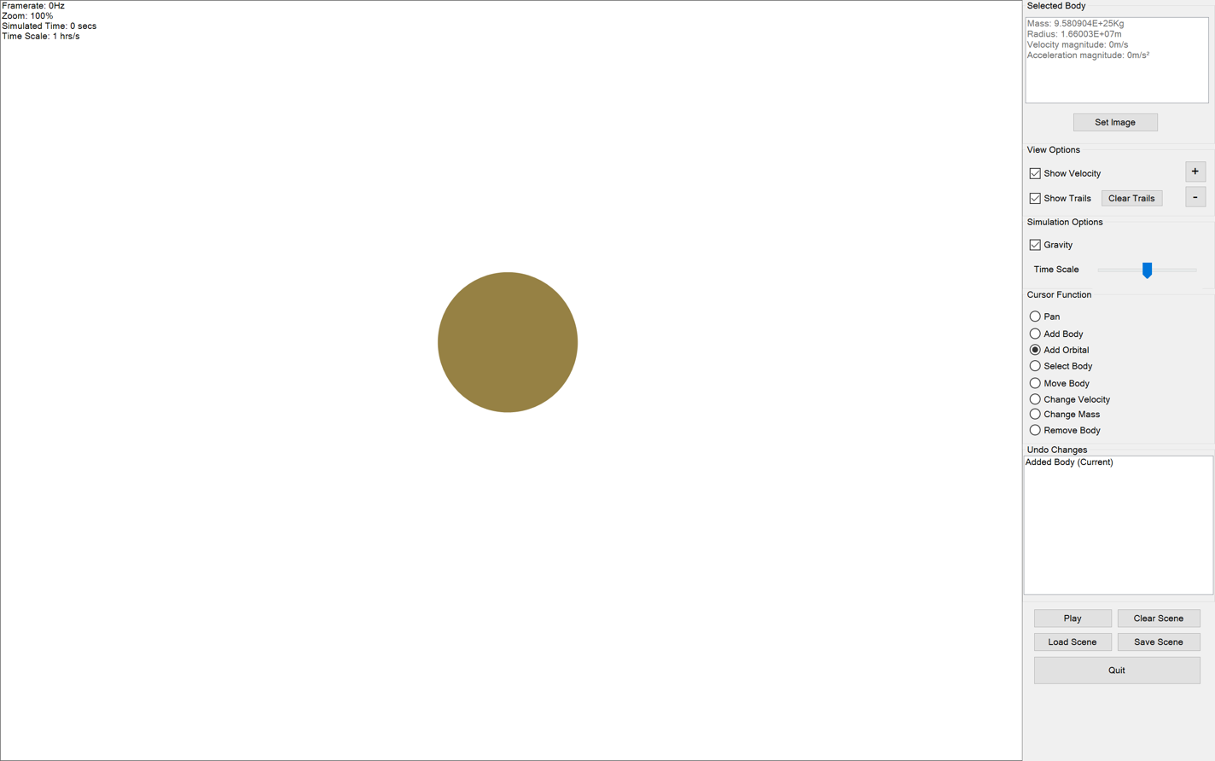
52. 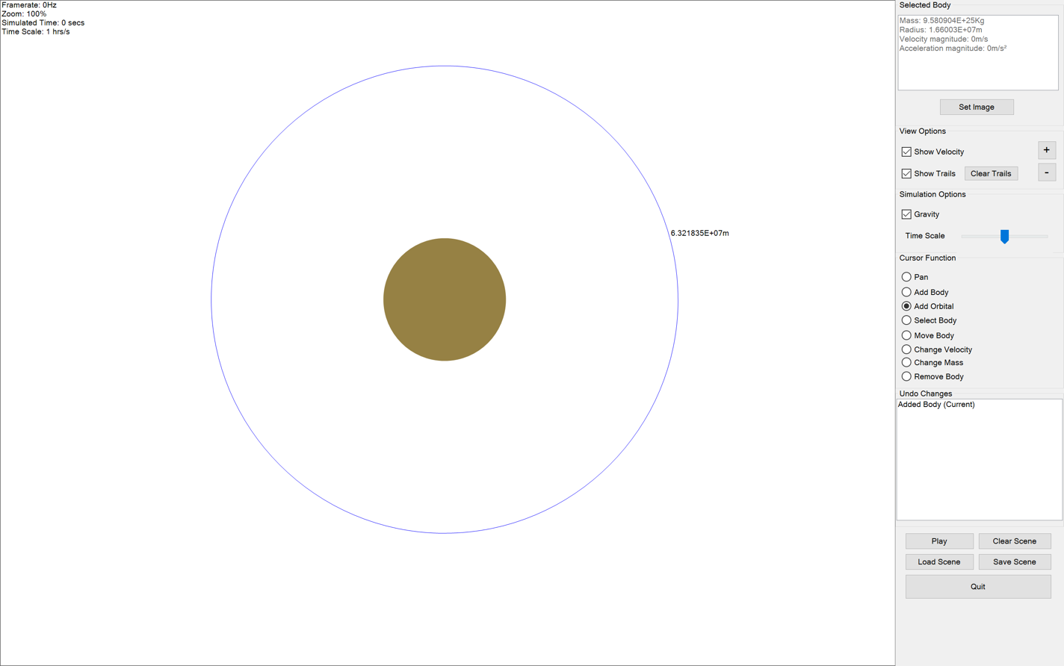
53. 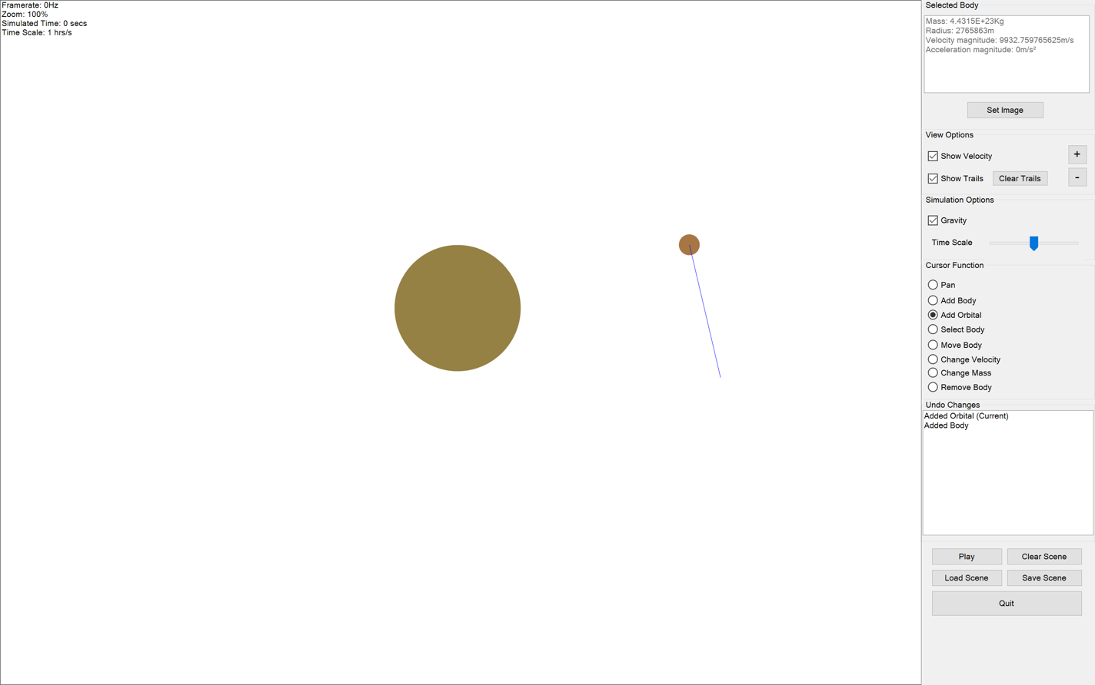
54. 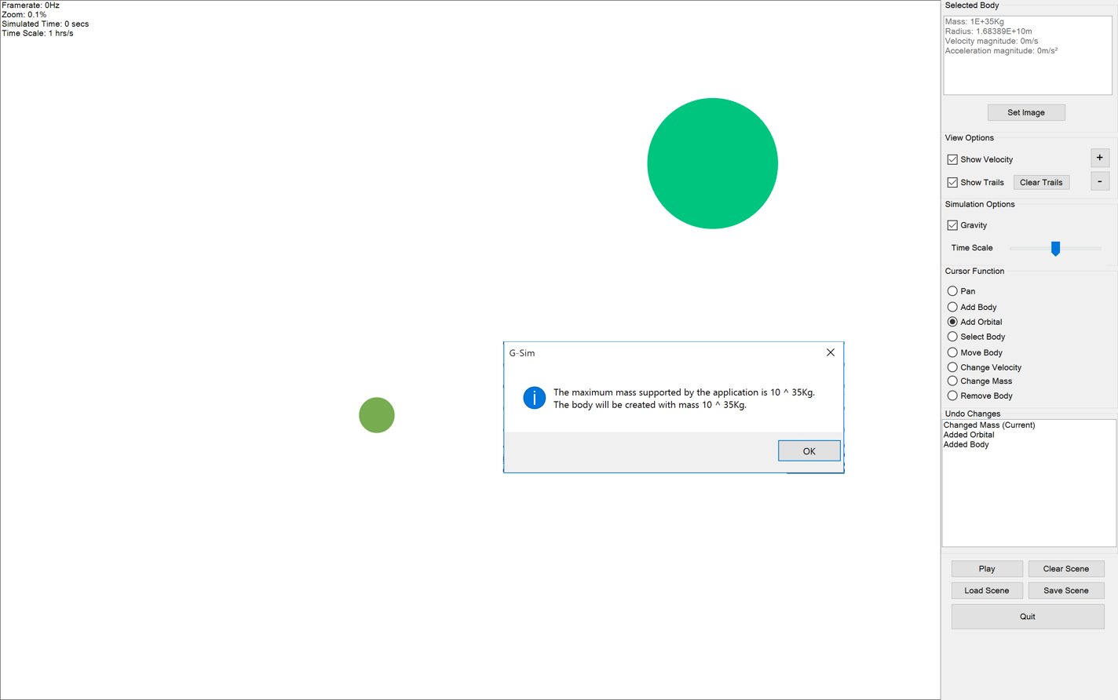
55. 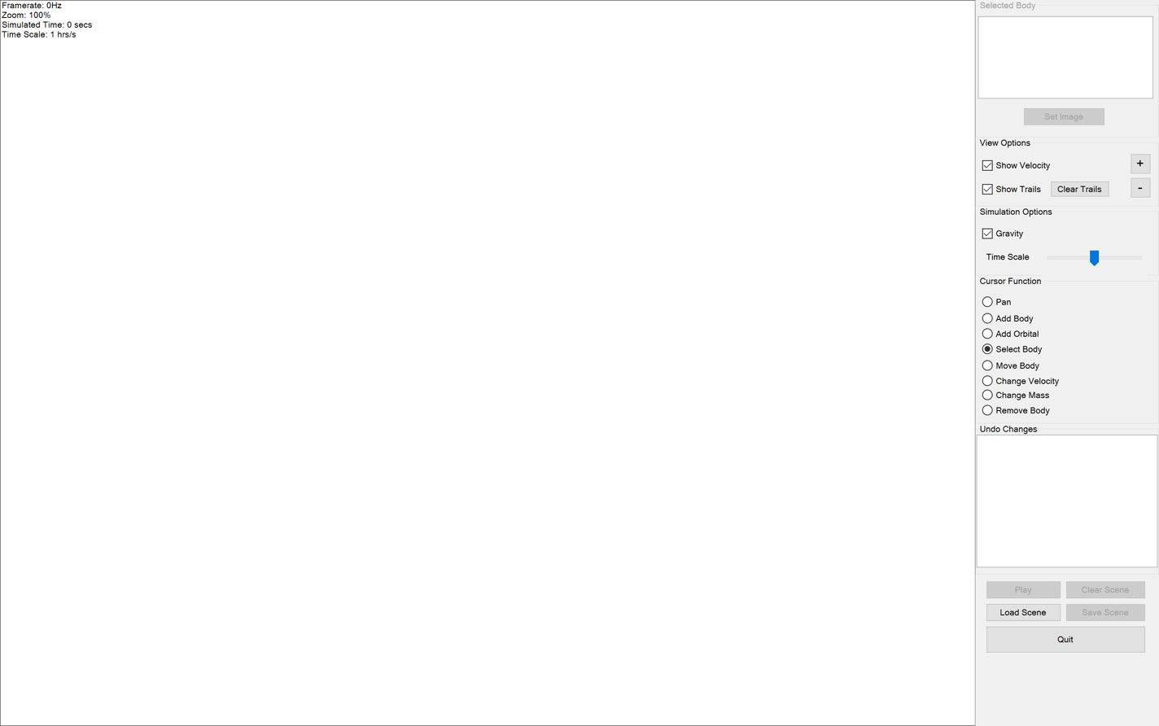
56. 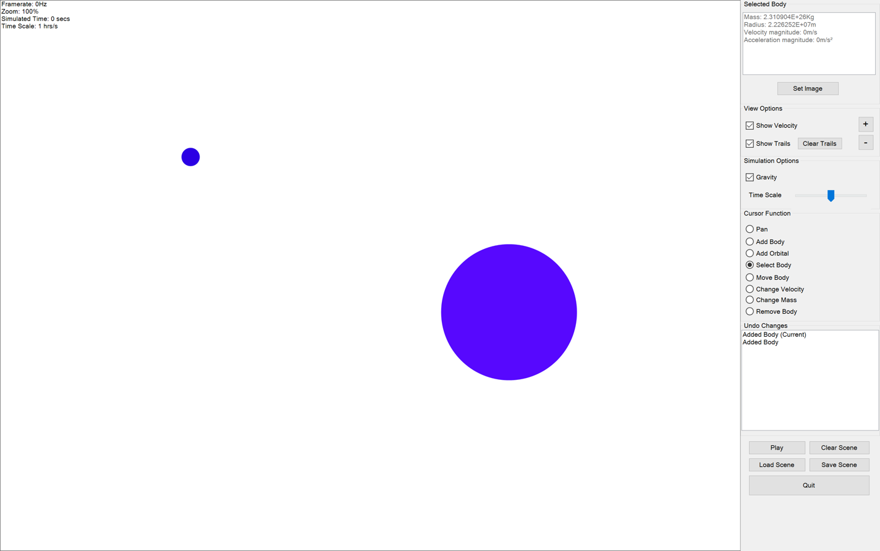
57. 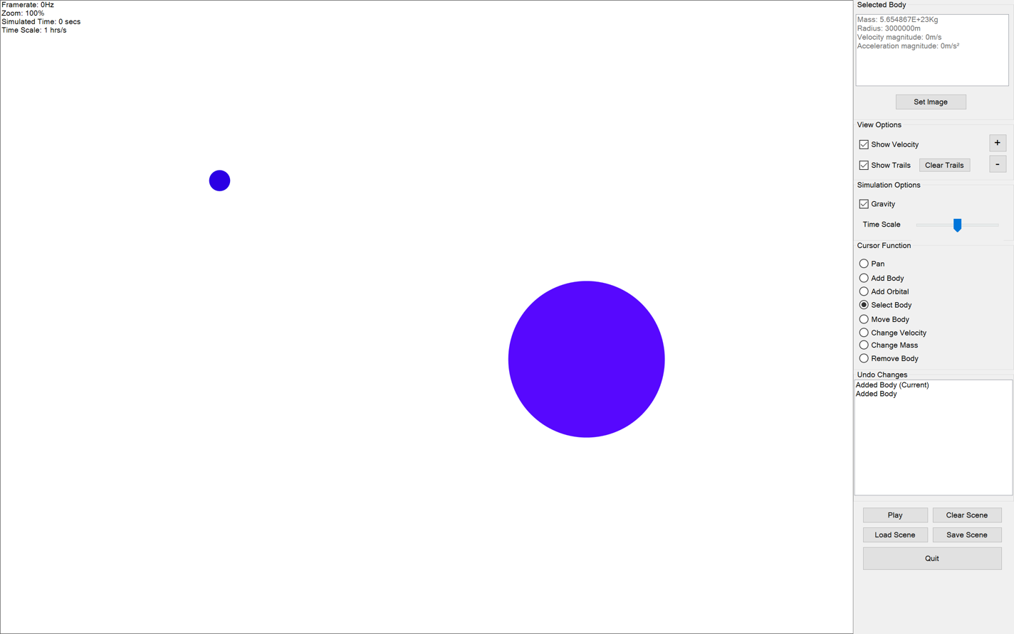
58. 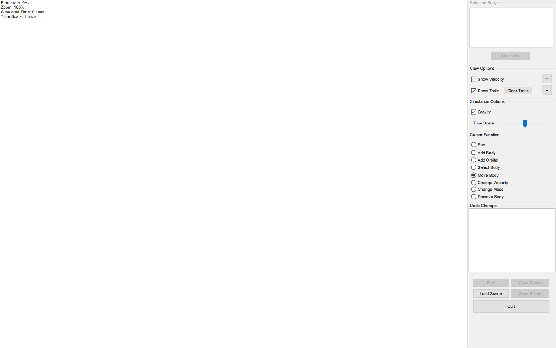
59. 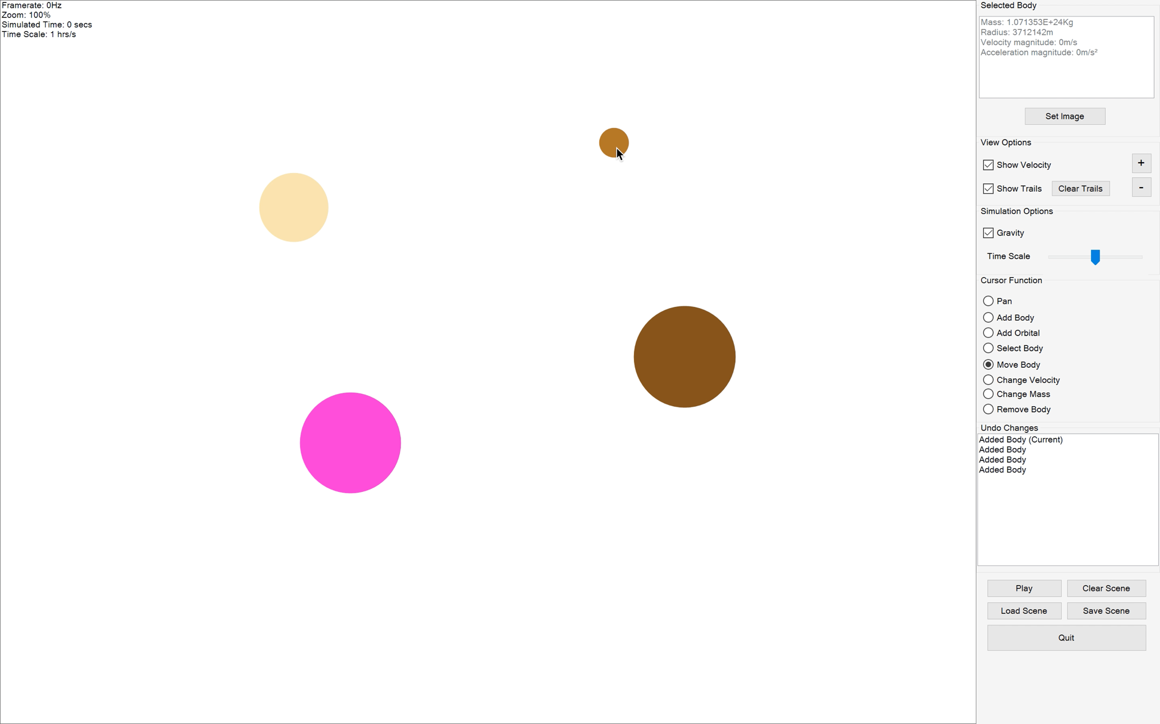
60. 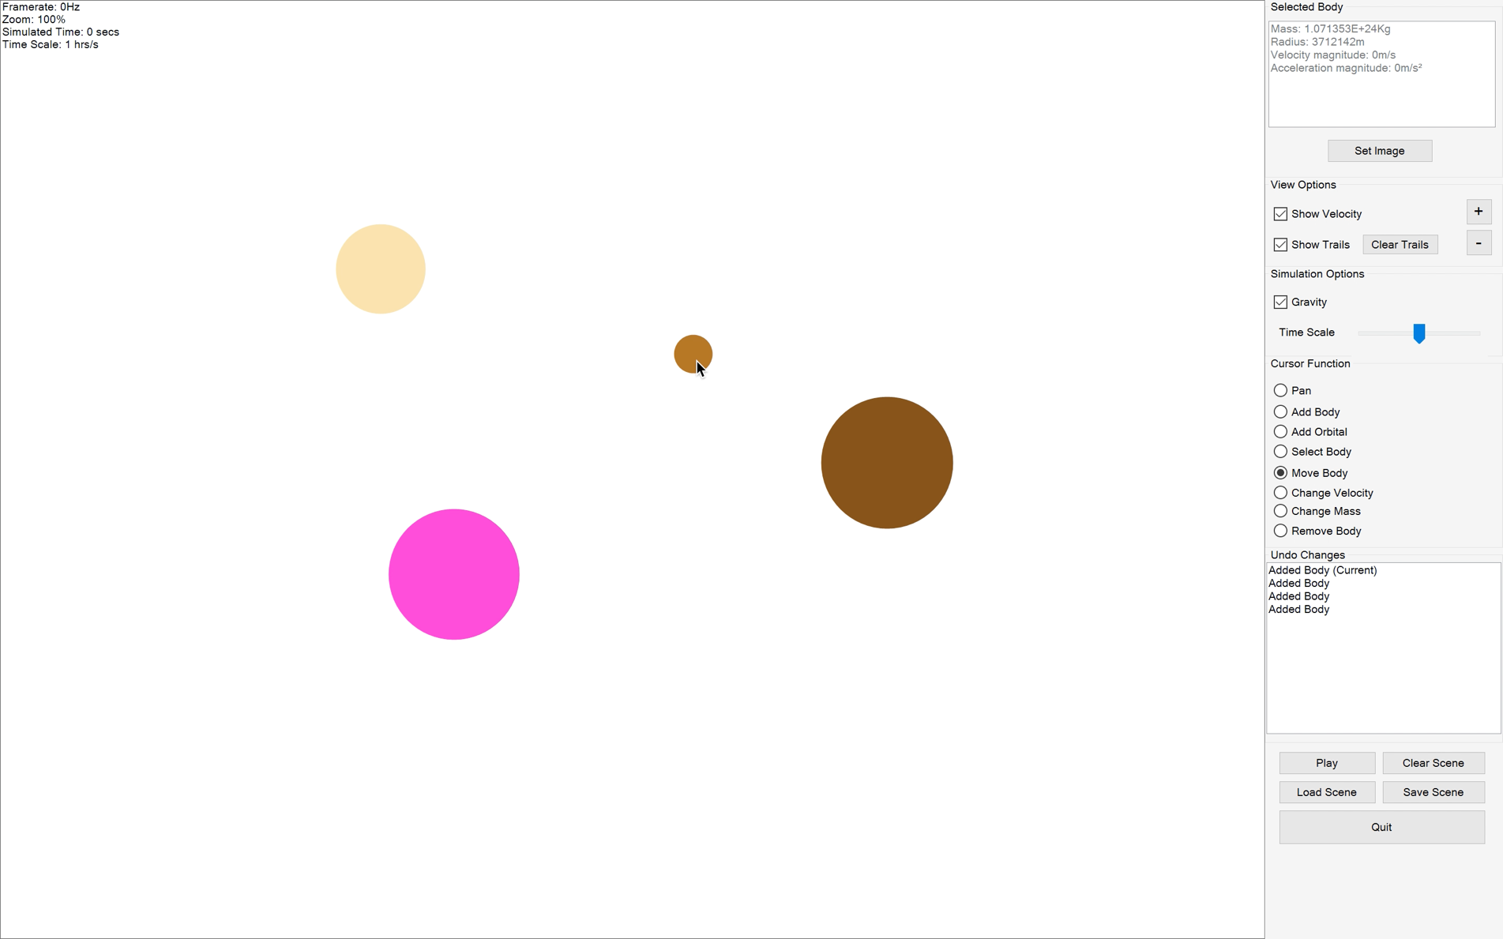
61. 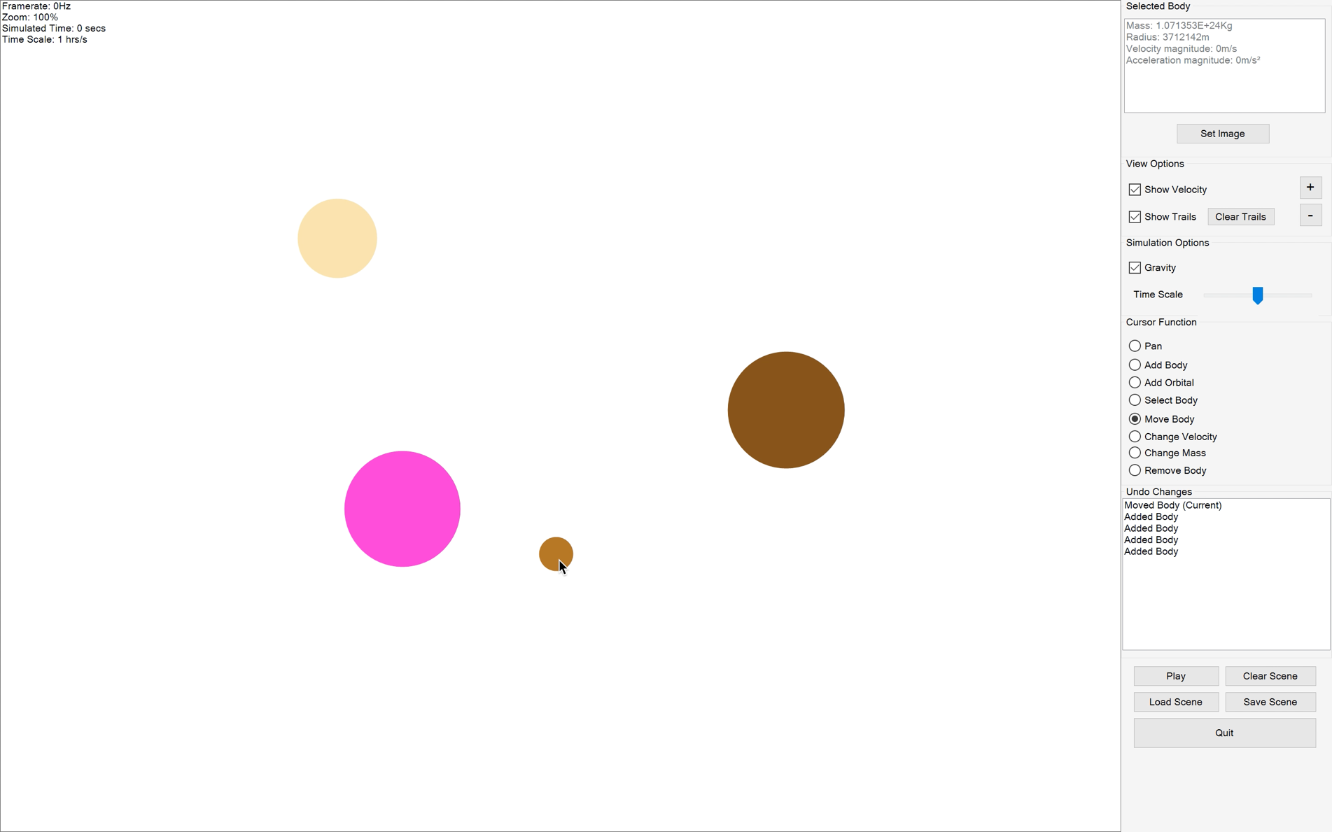
62. 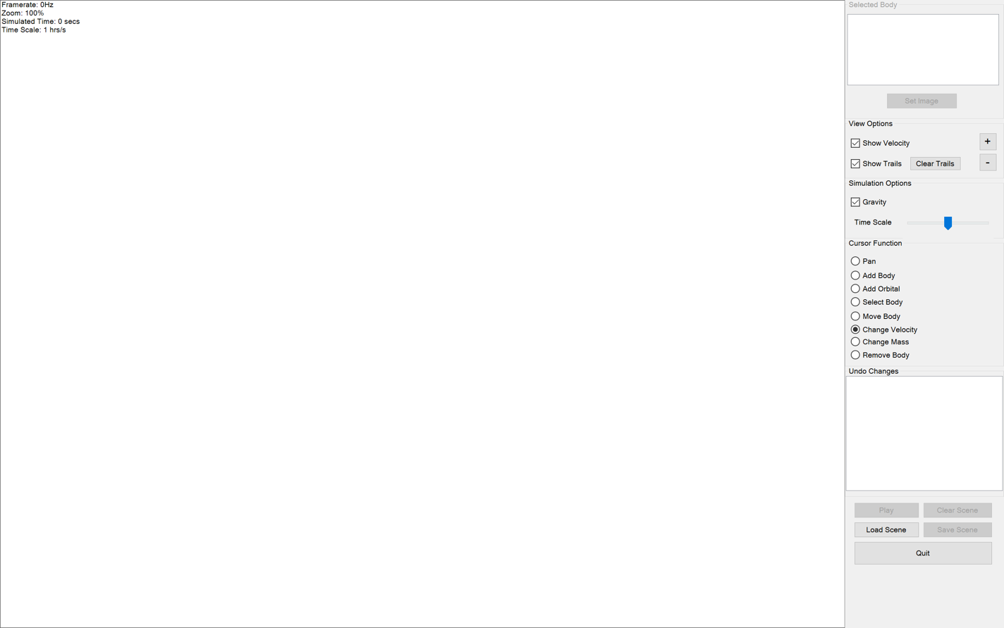
63. 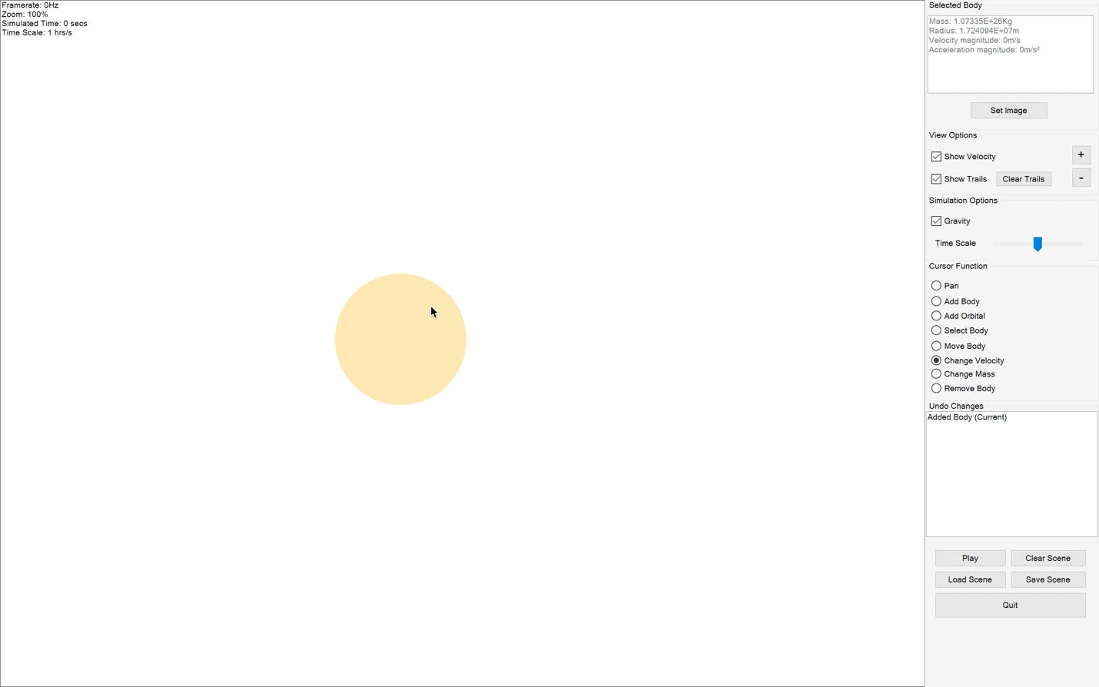
64. 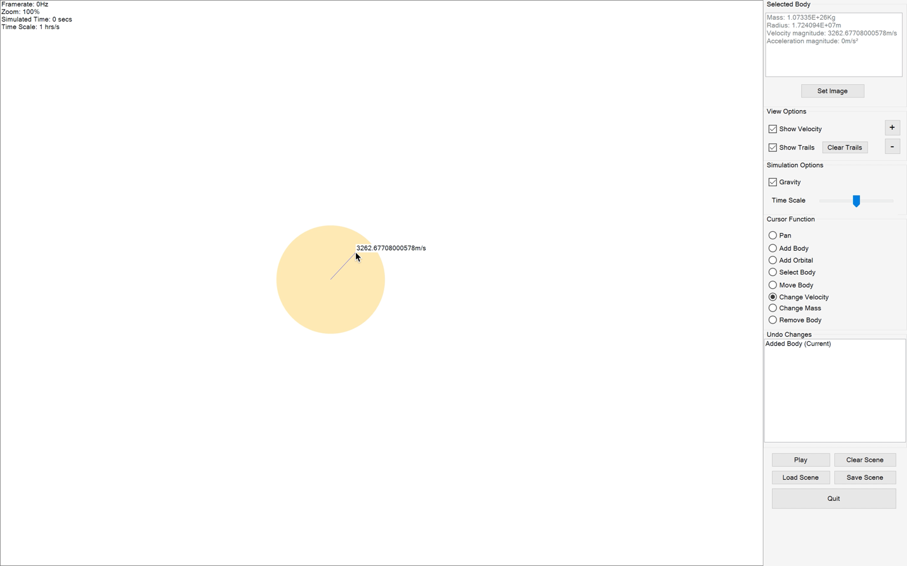
65. 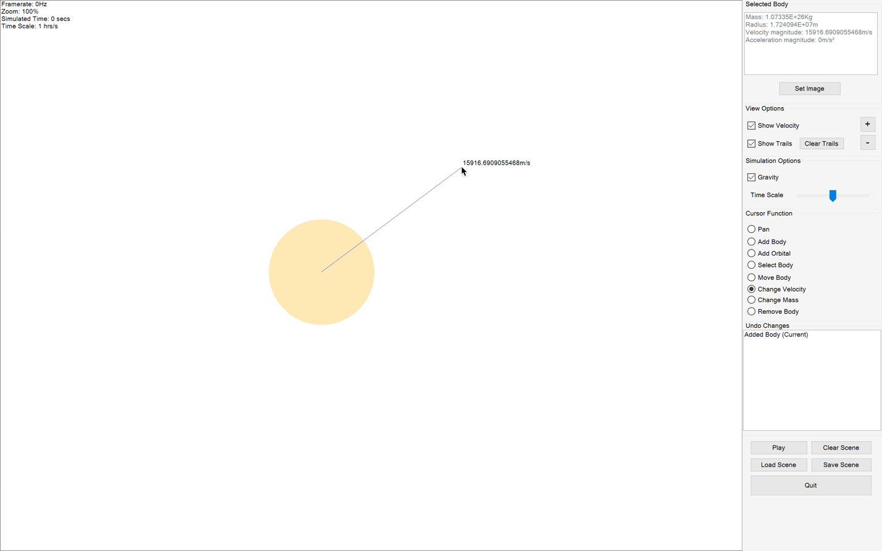
66. 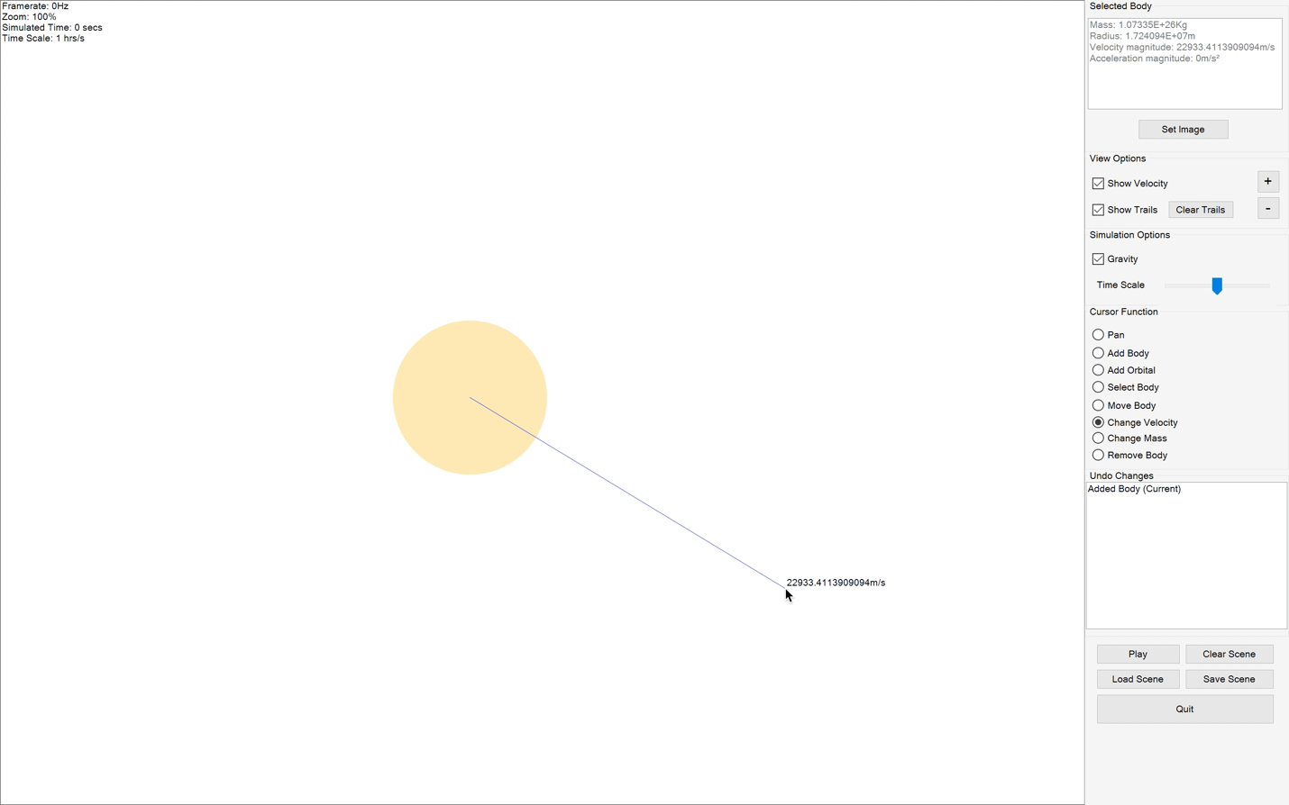
67. 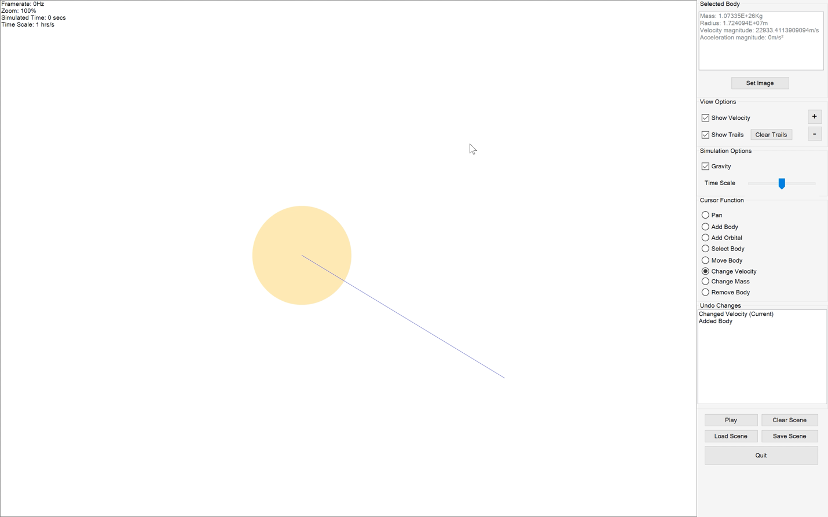
68. 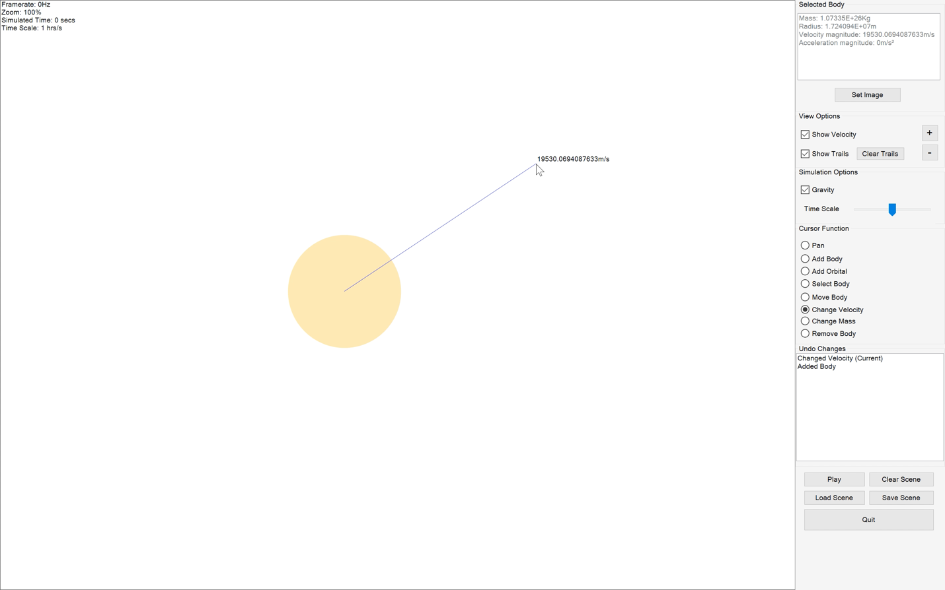
69. 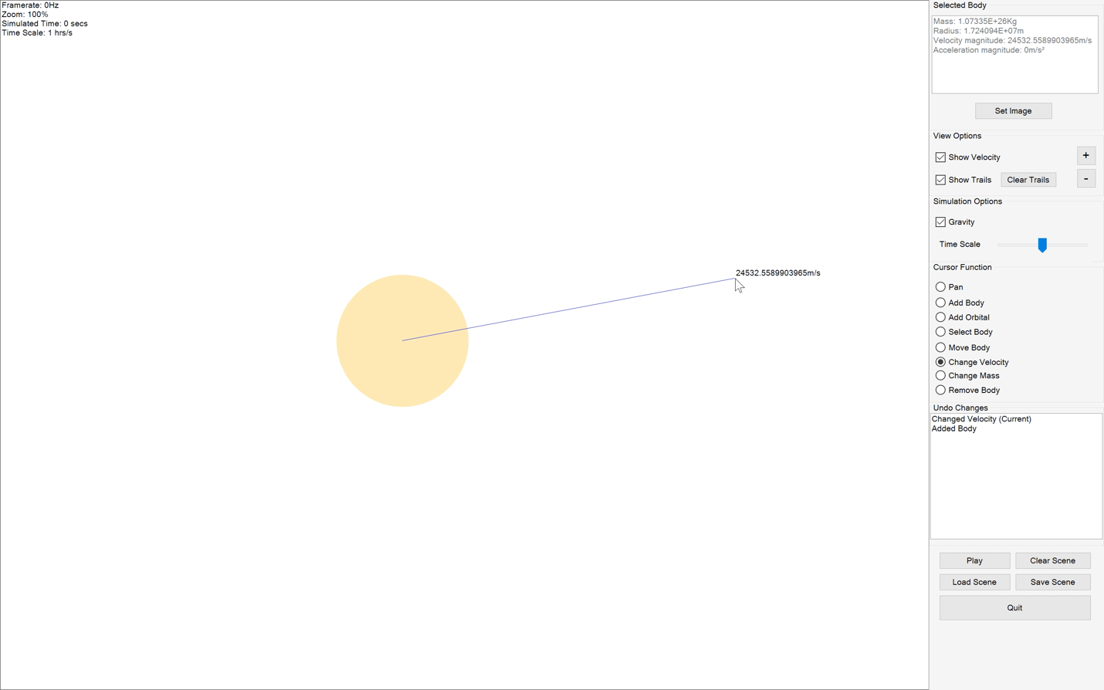
70. 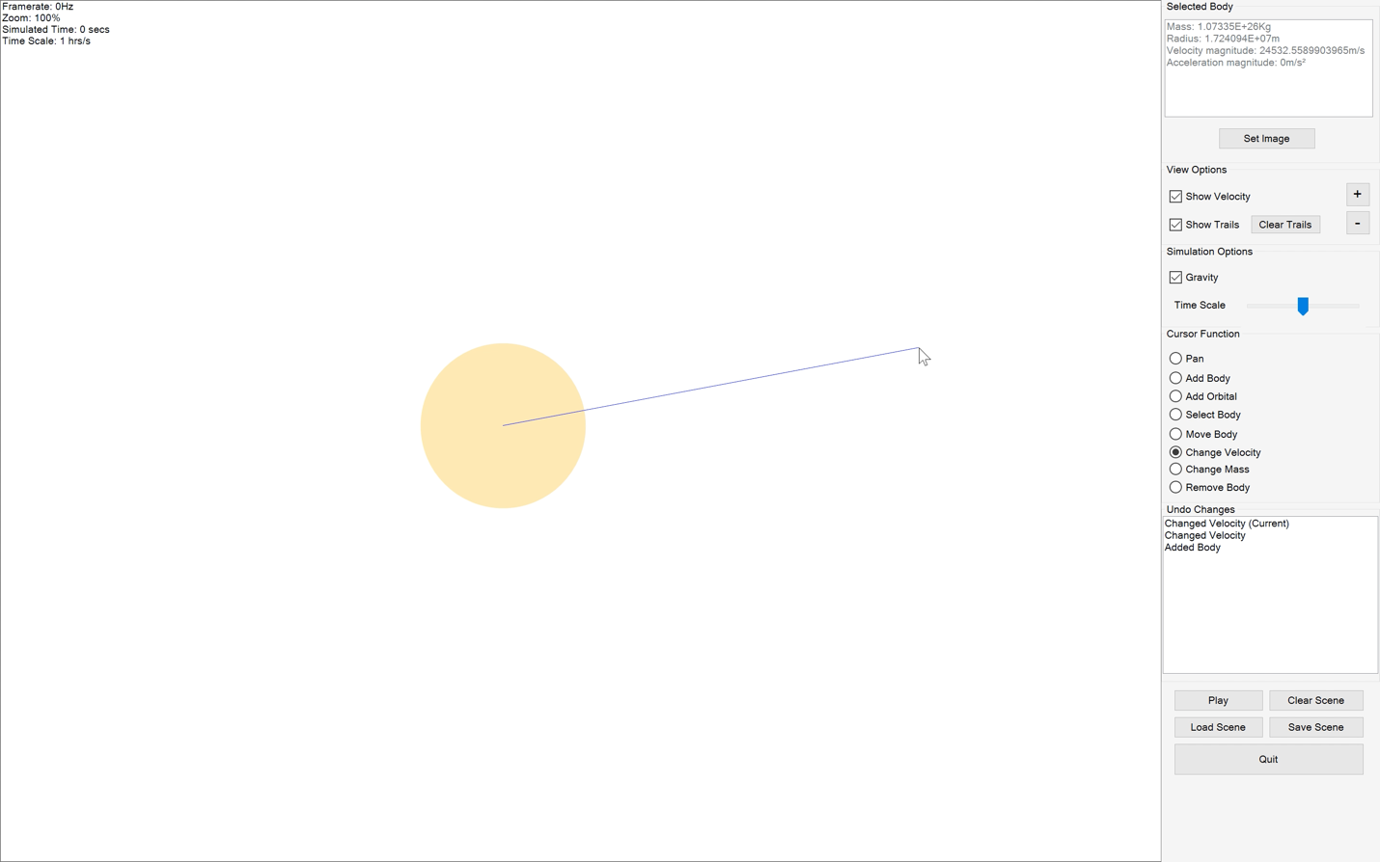
71. 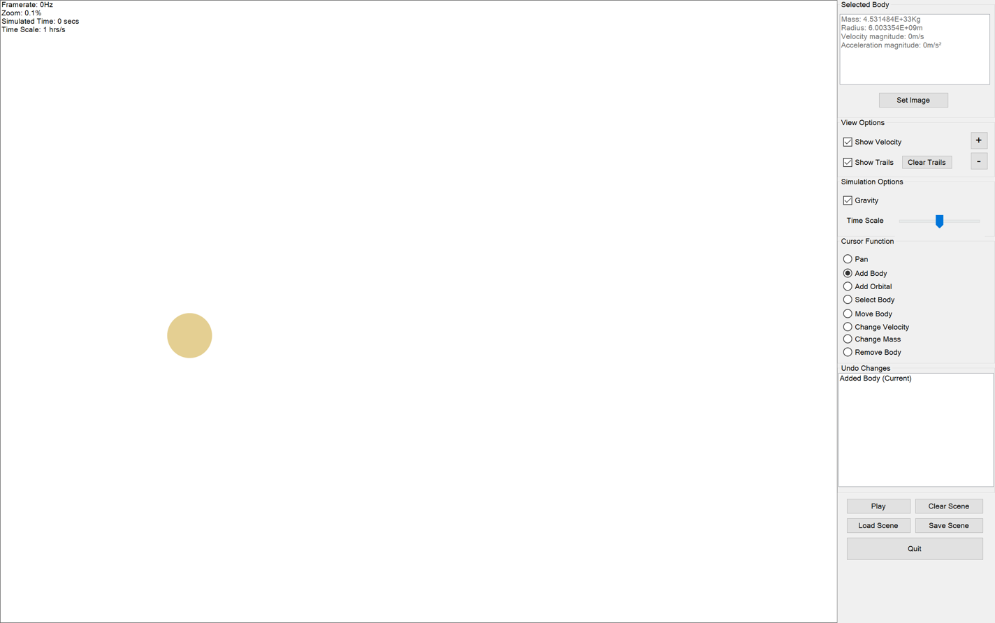
72. 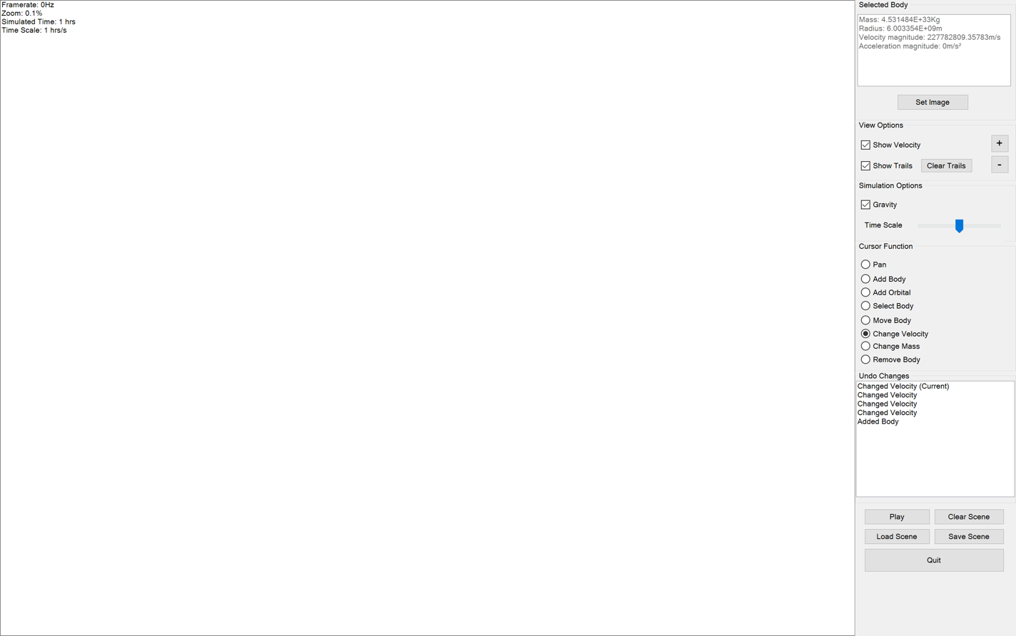
73. 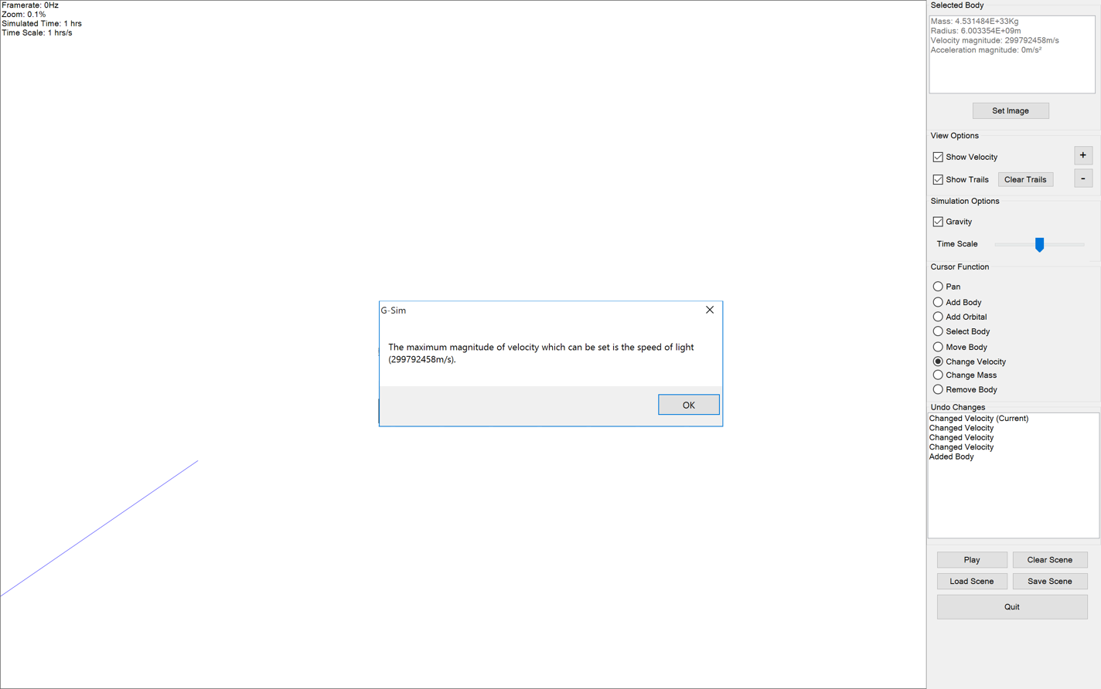
74. 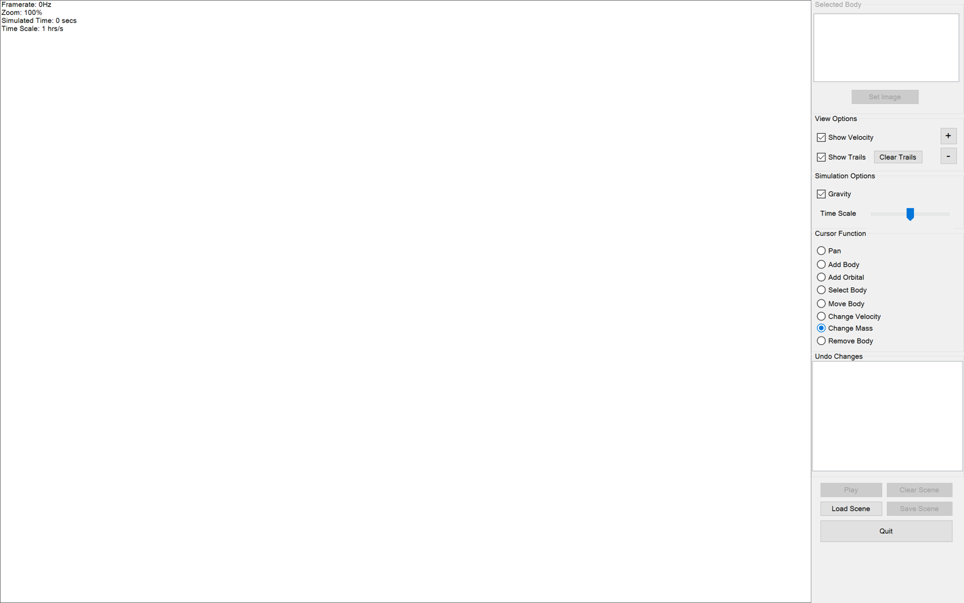
75. 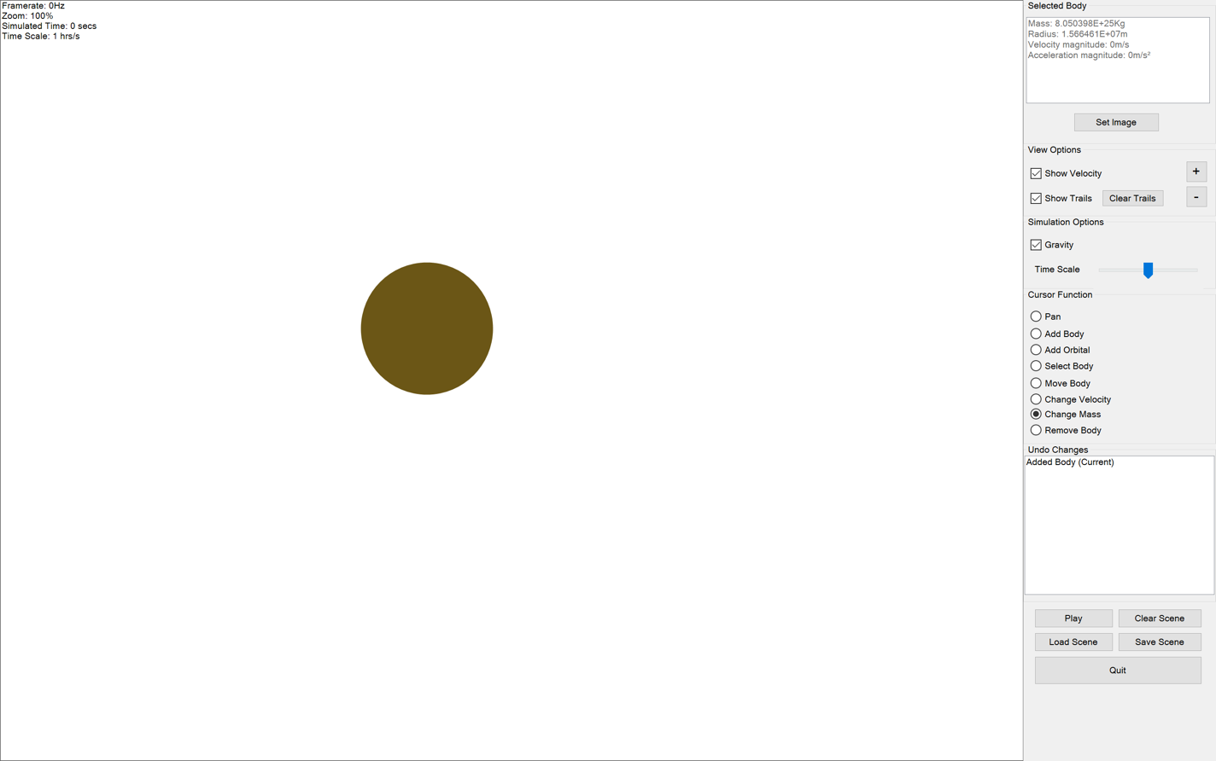
76. 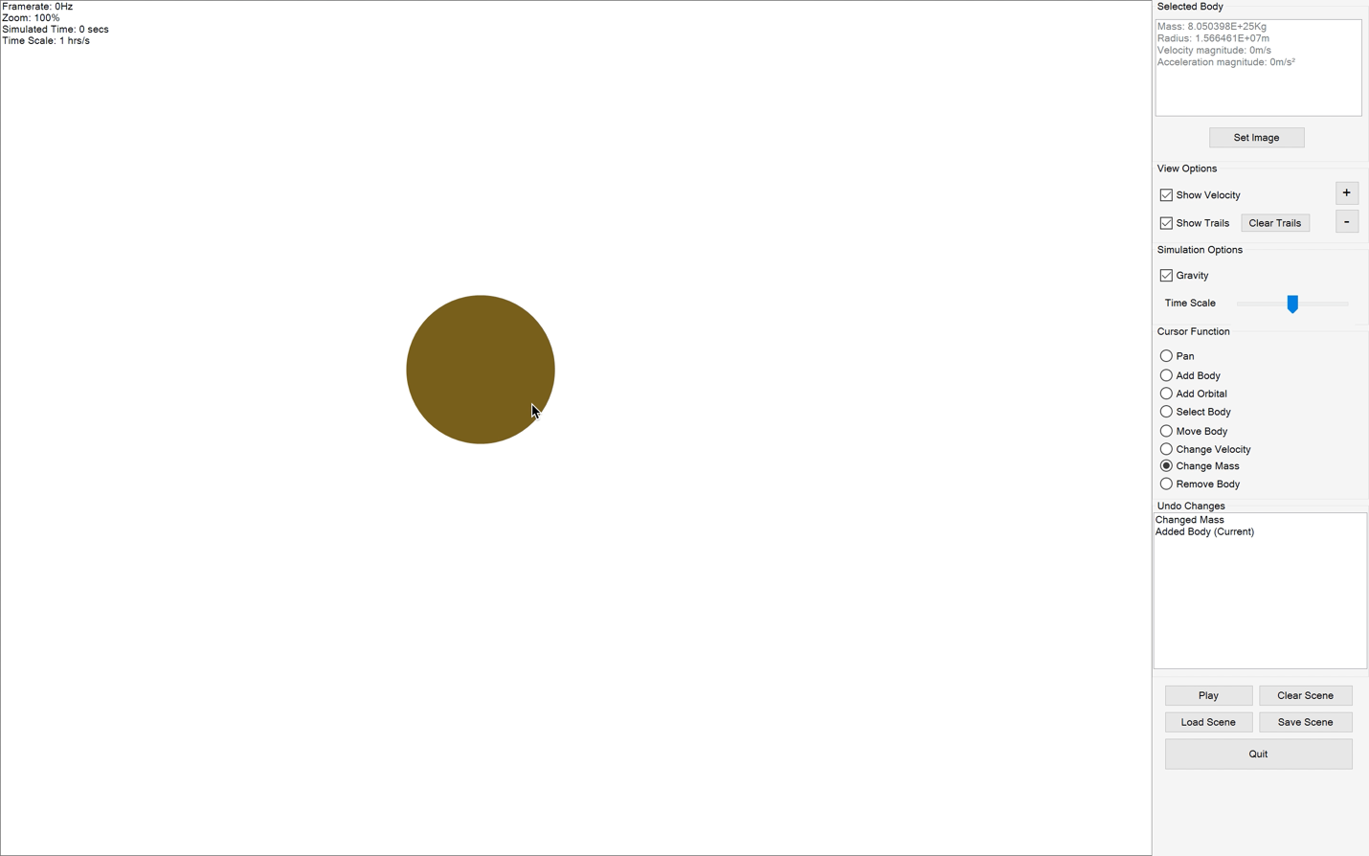
77. 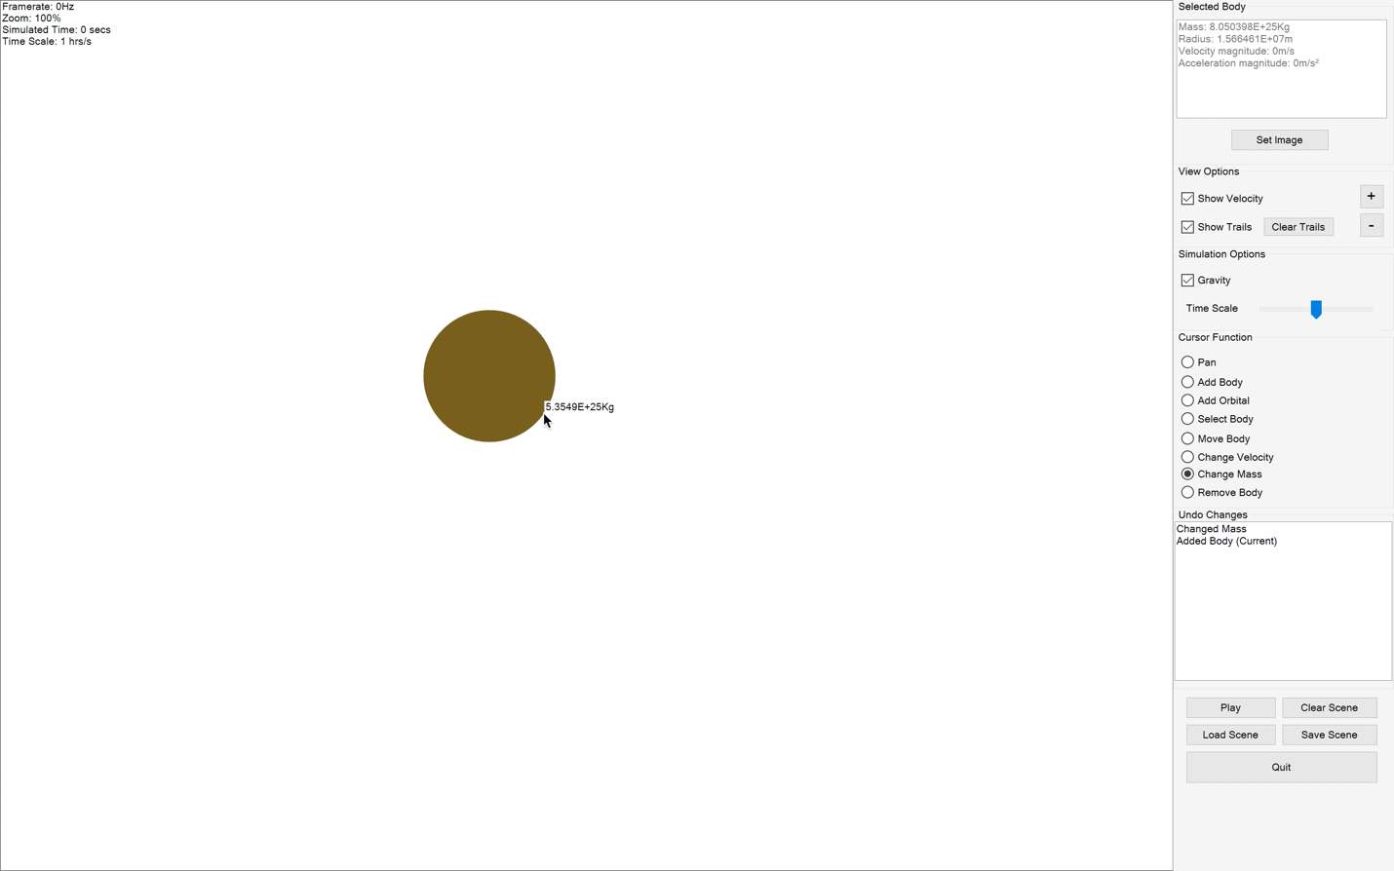
78. 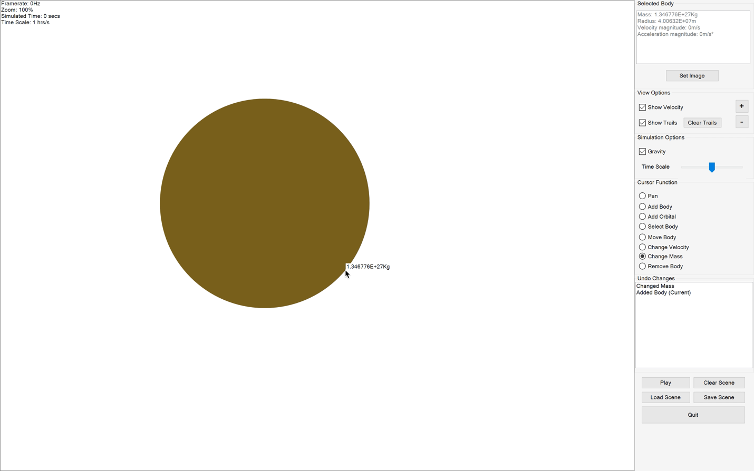
79. 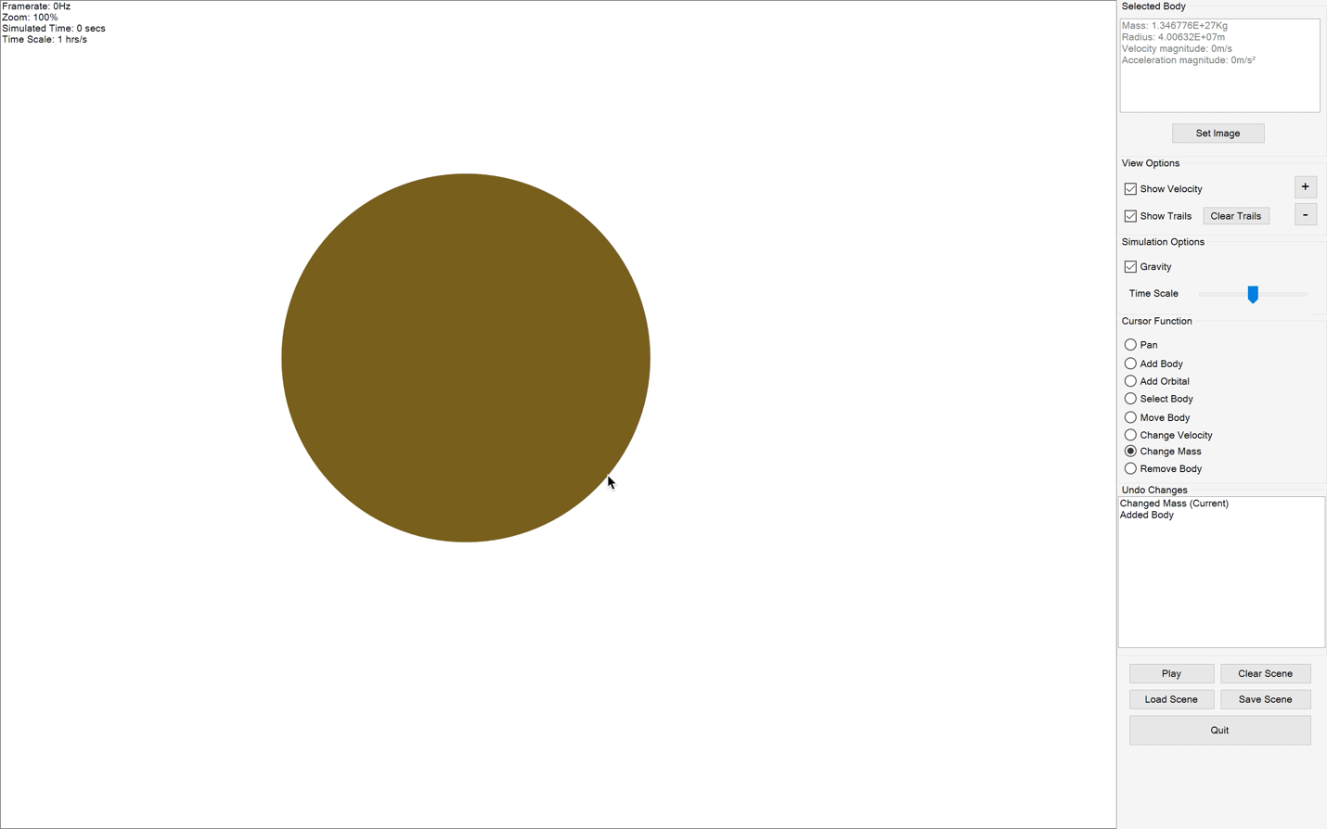
80. 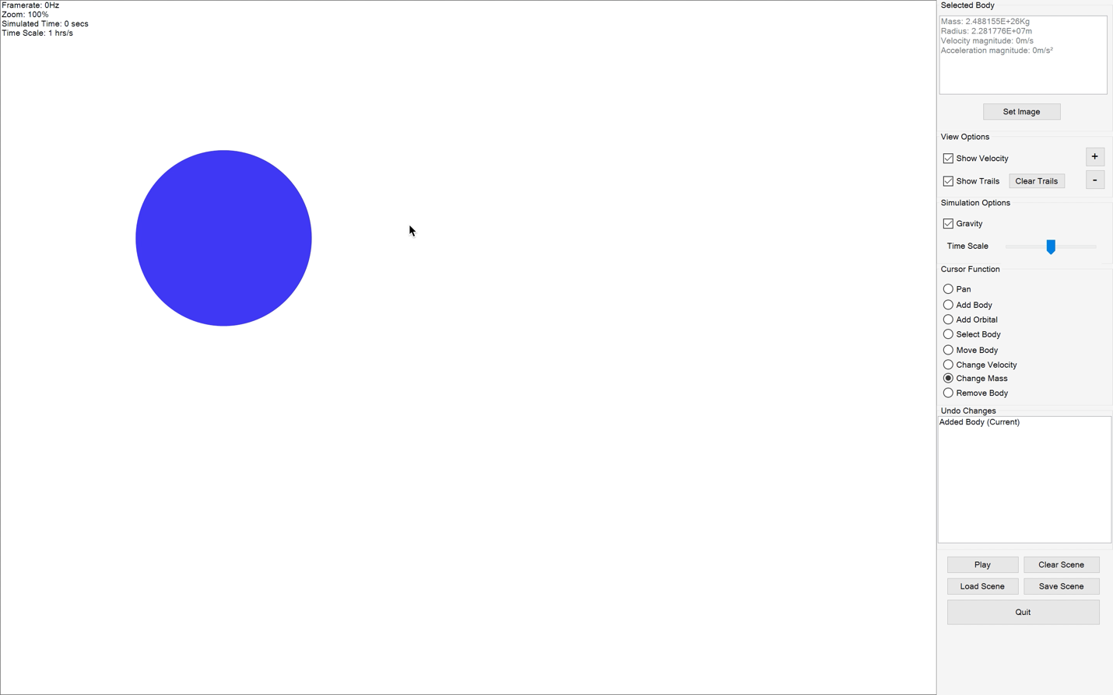
81. 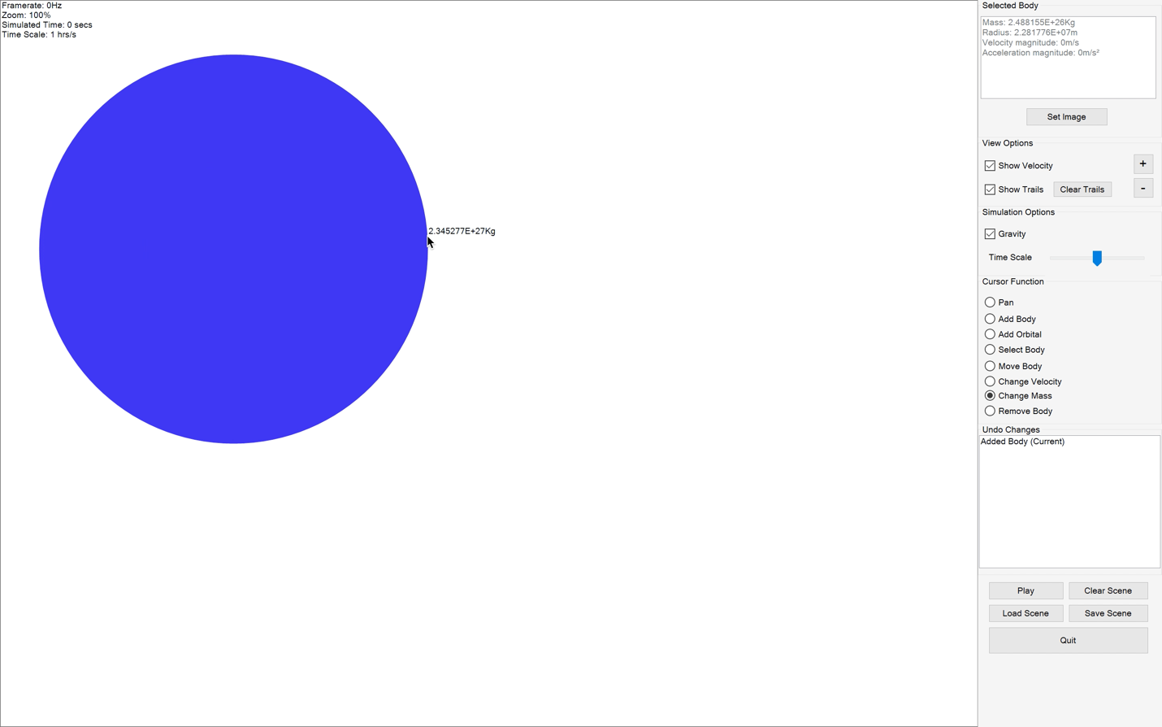
82. 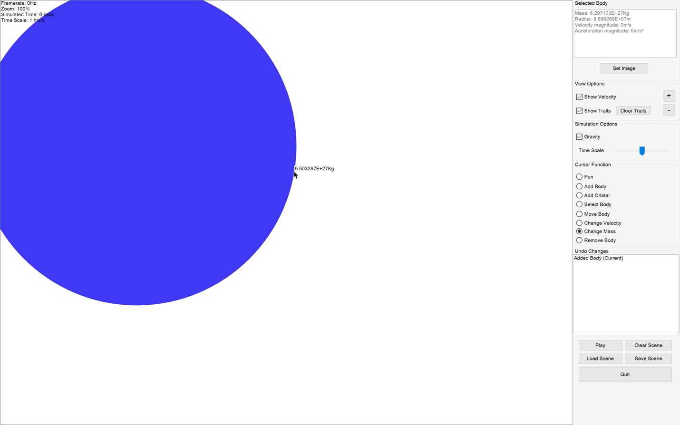
83. 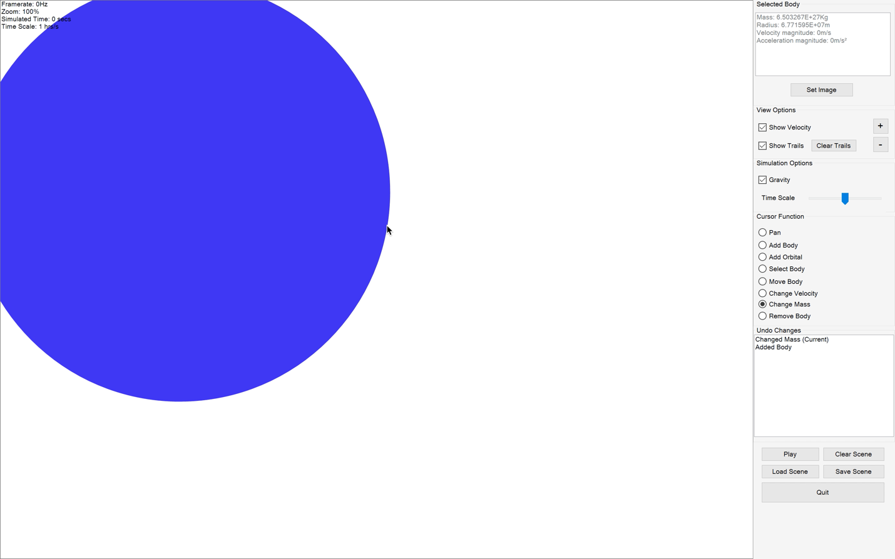
84. 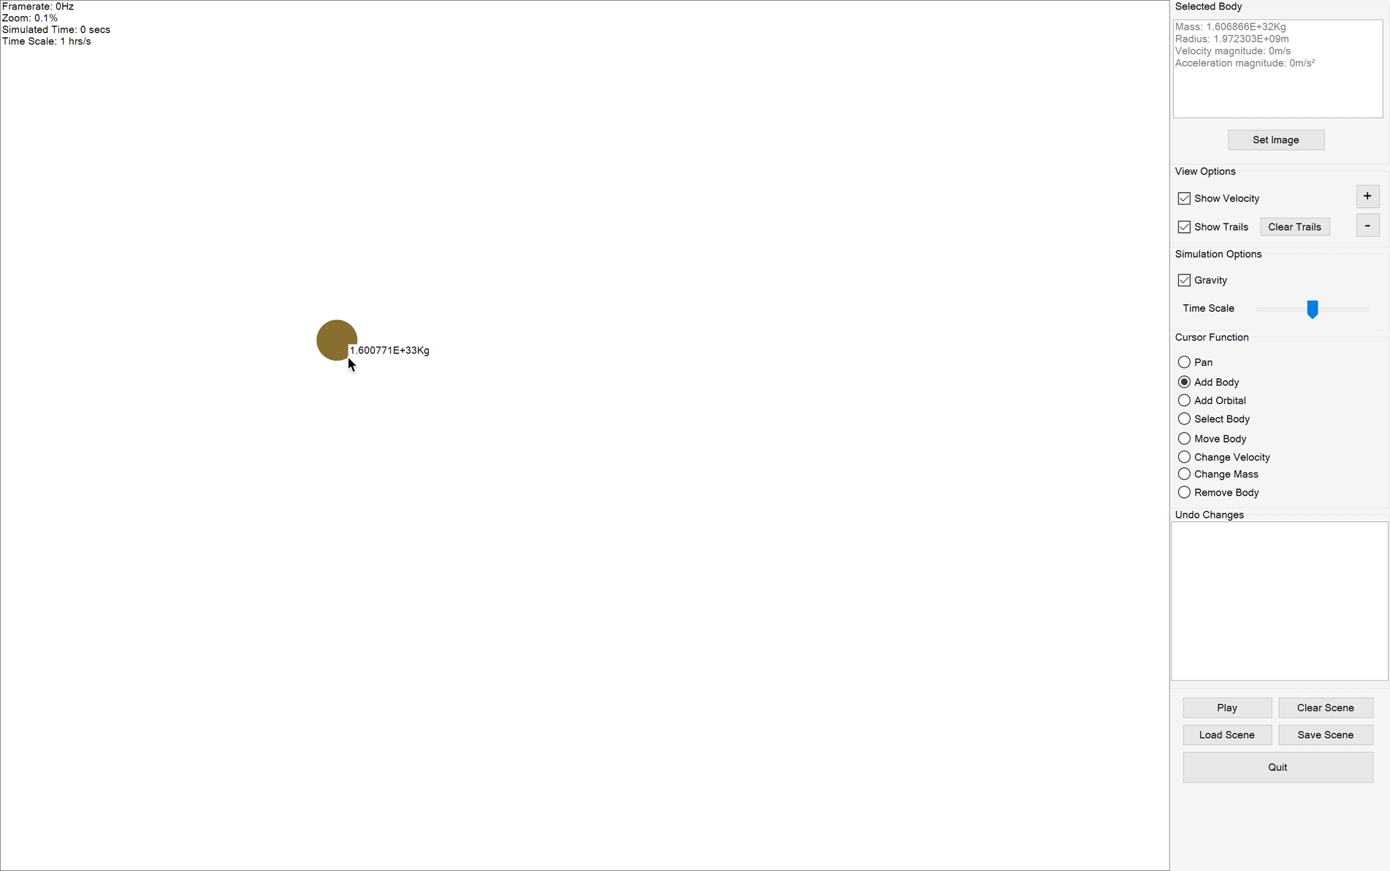
85. 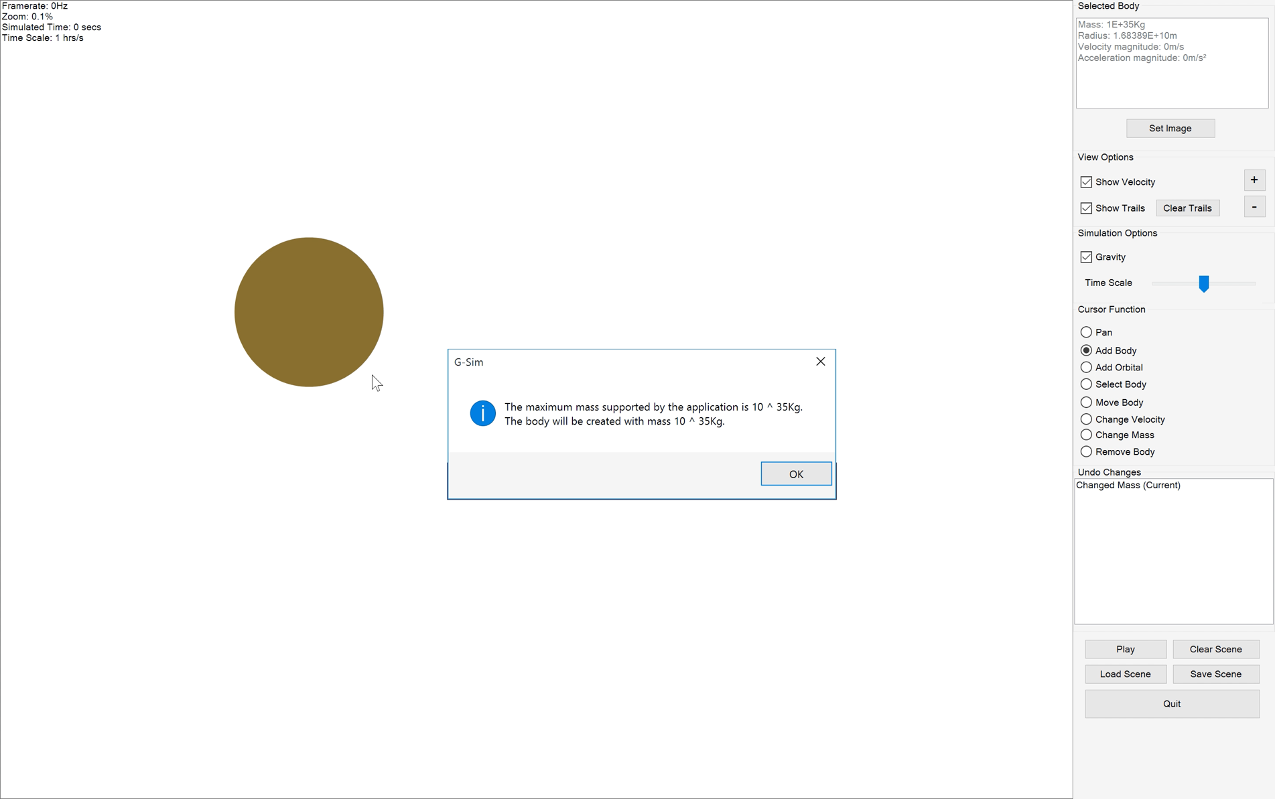
86. 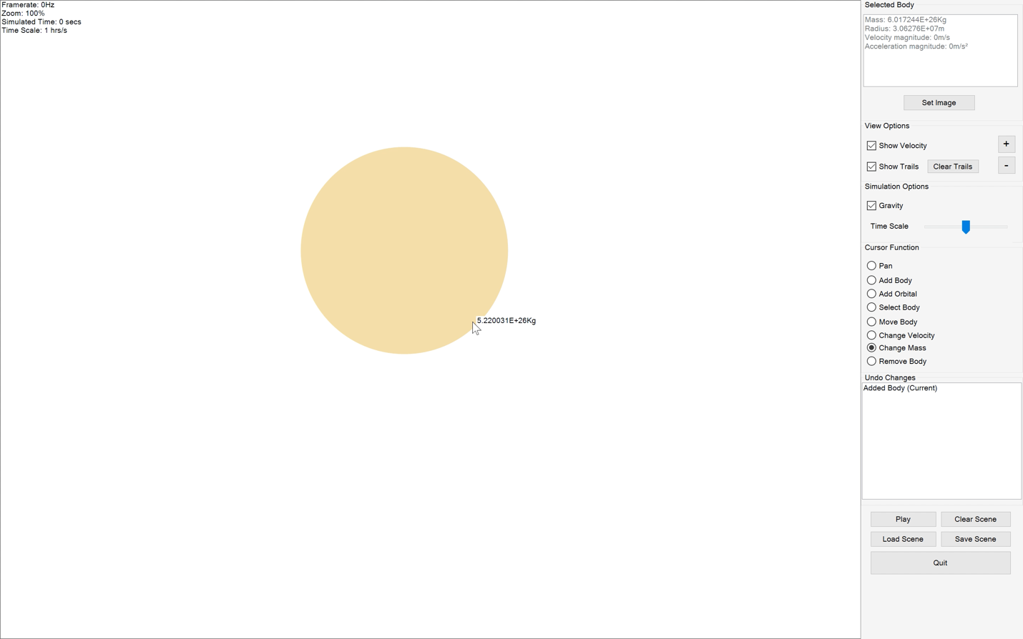
87. 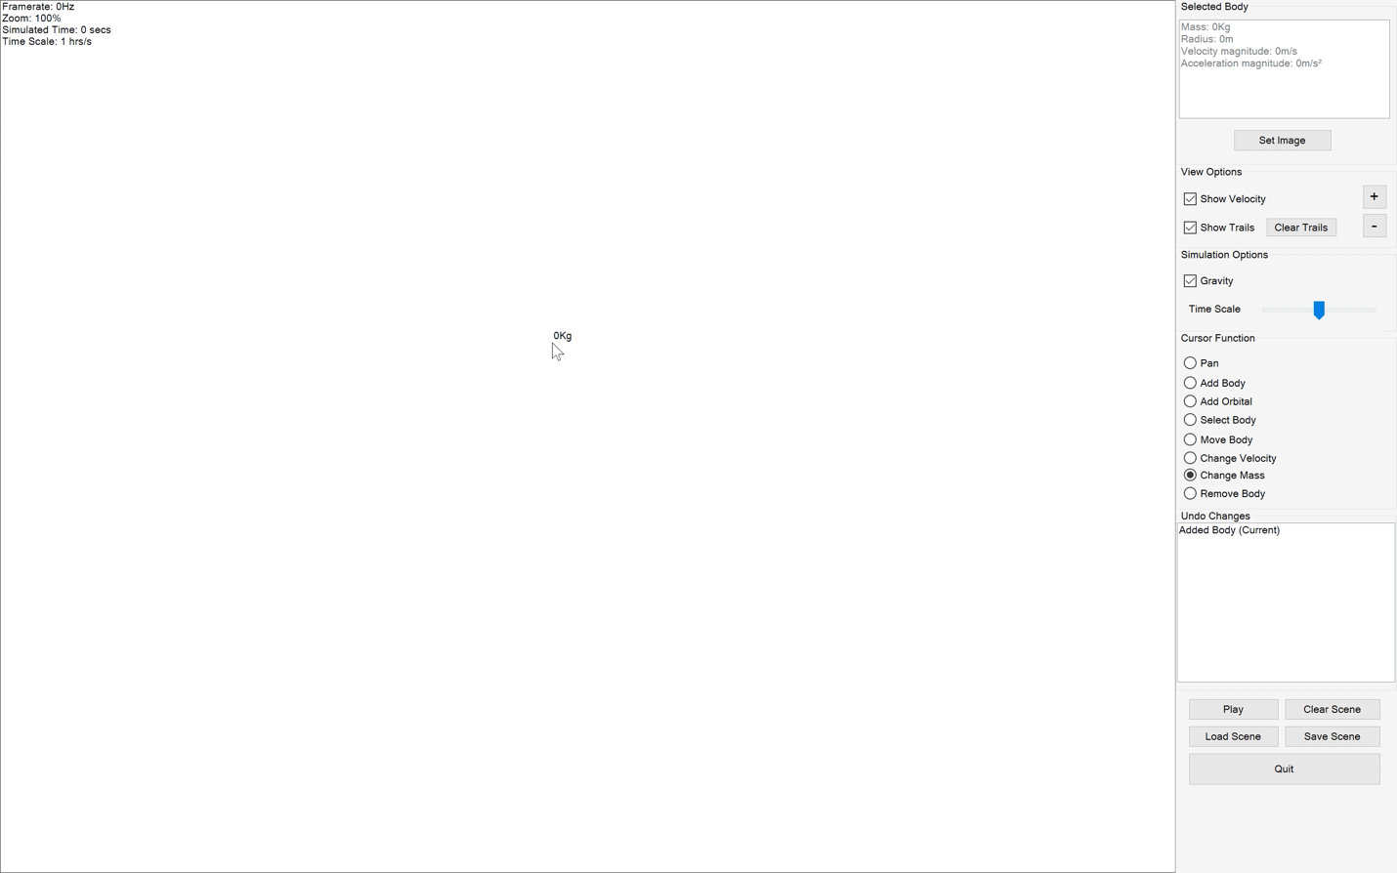
88. 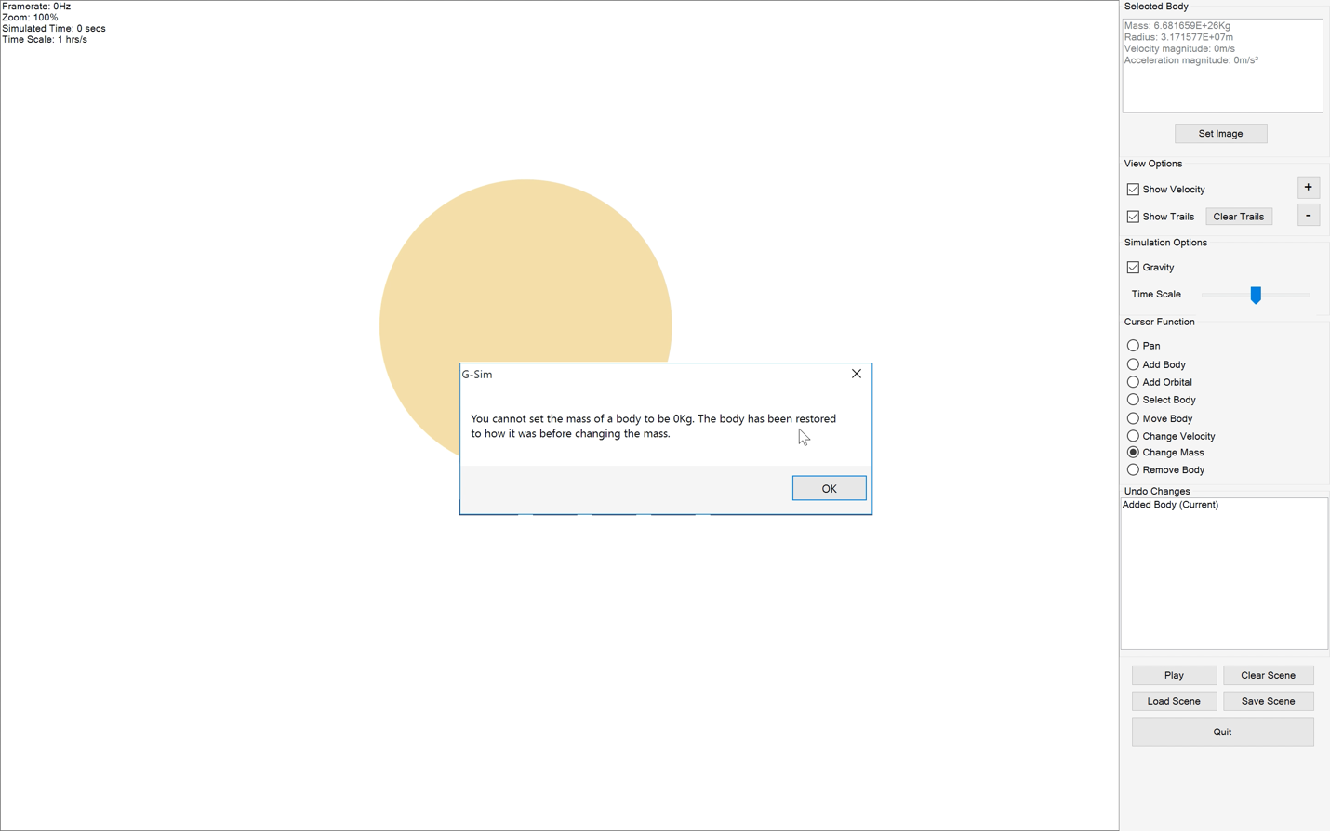
89. 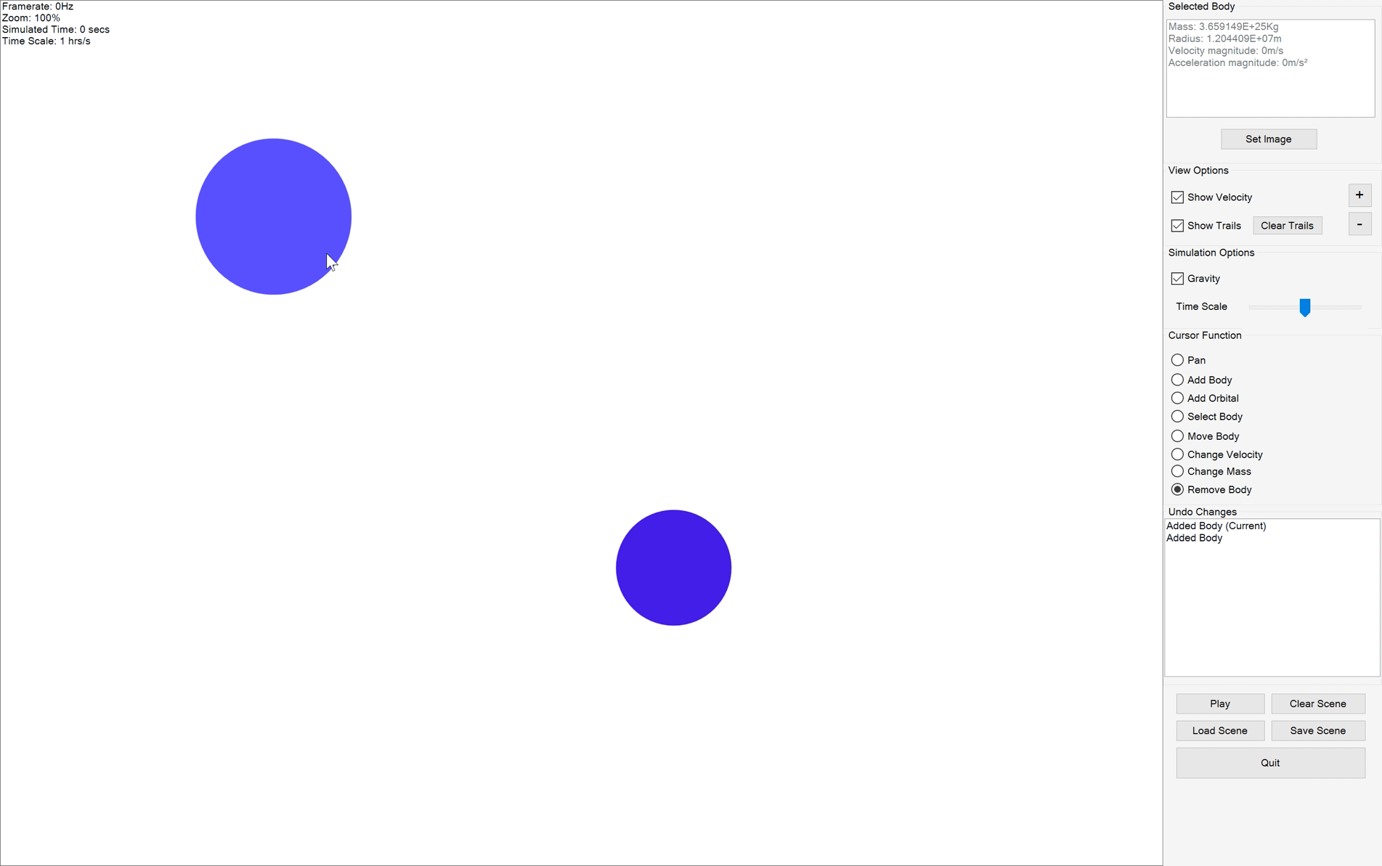
90. 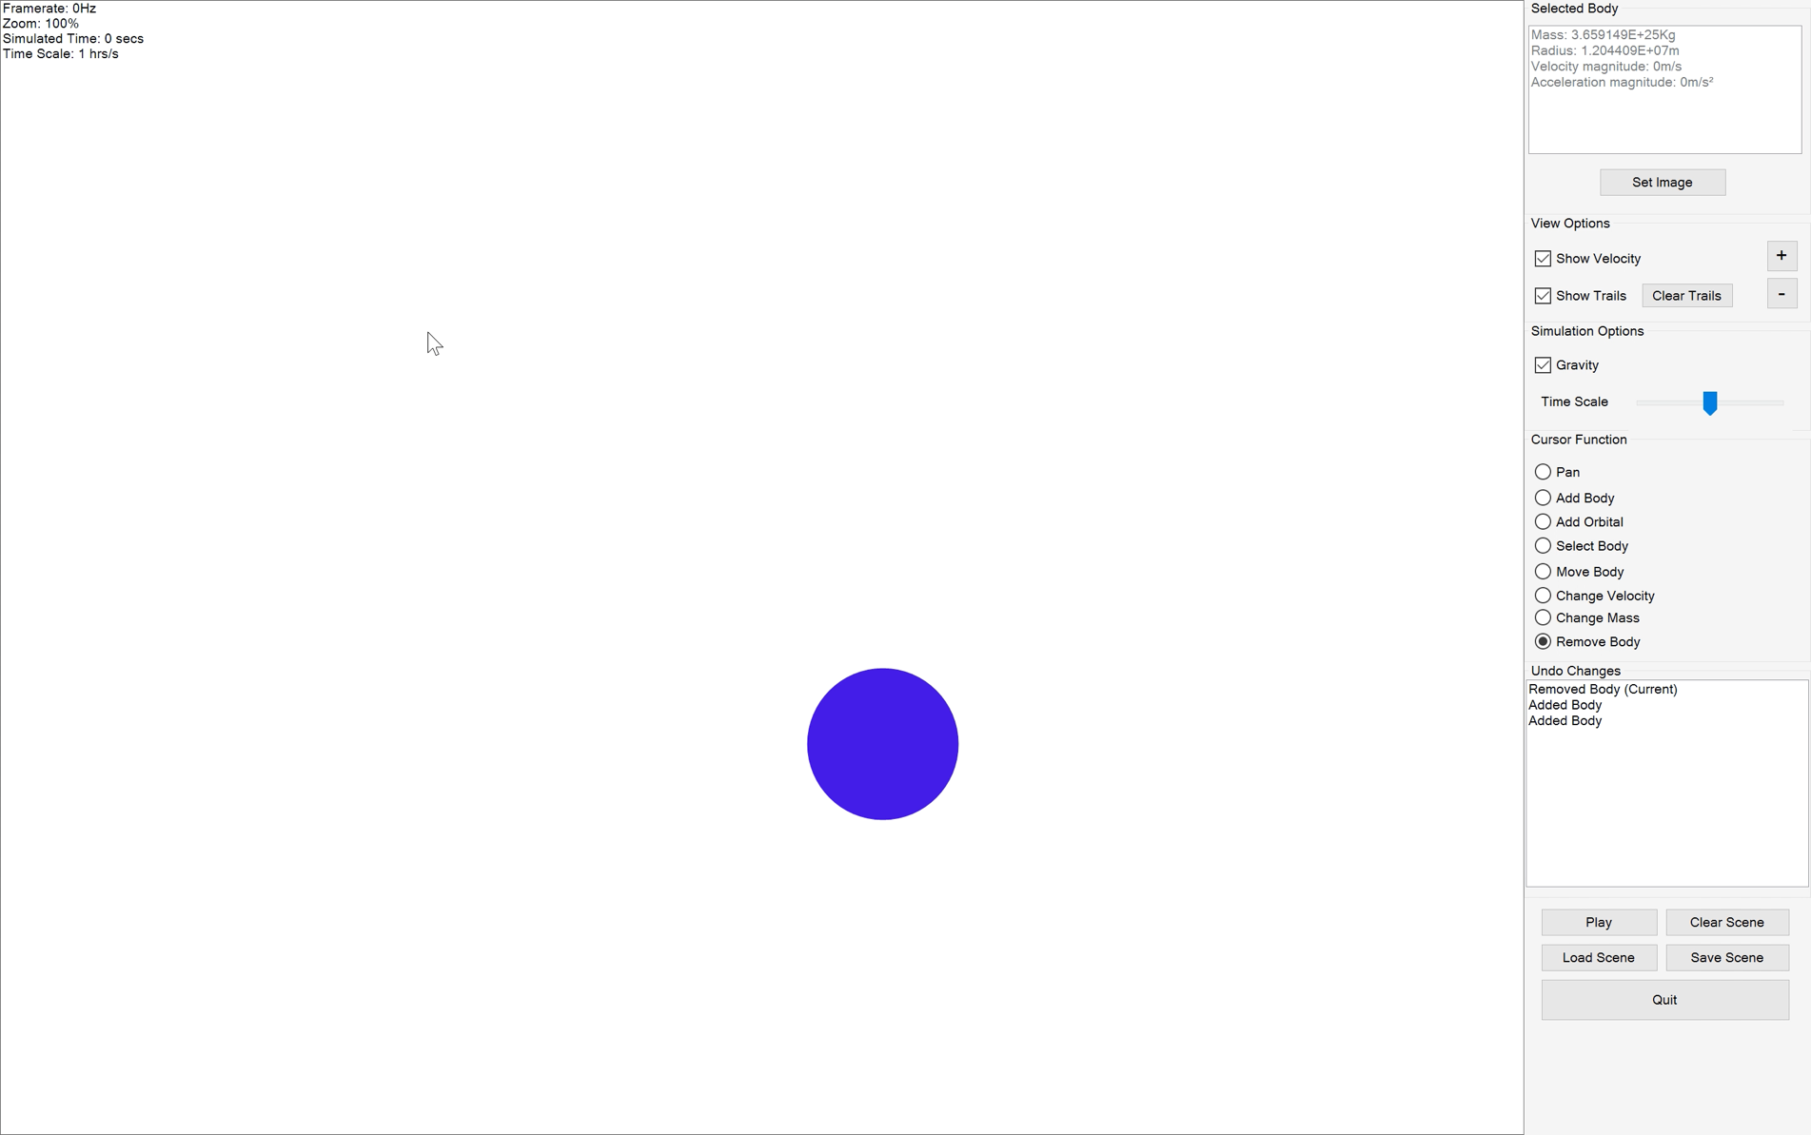
91. 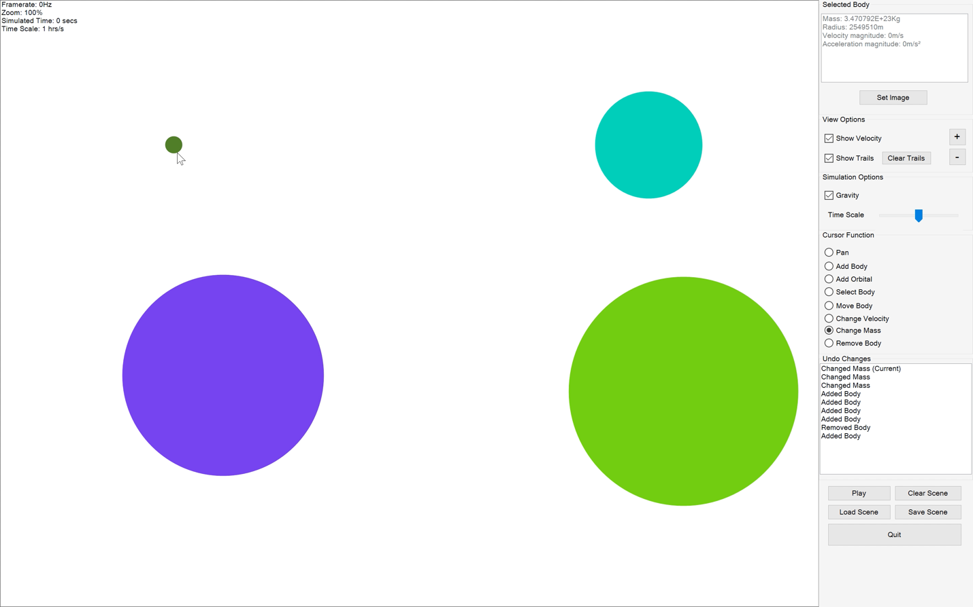
92. 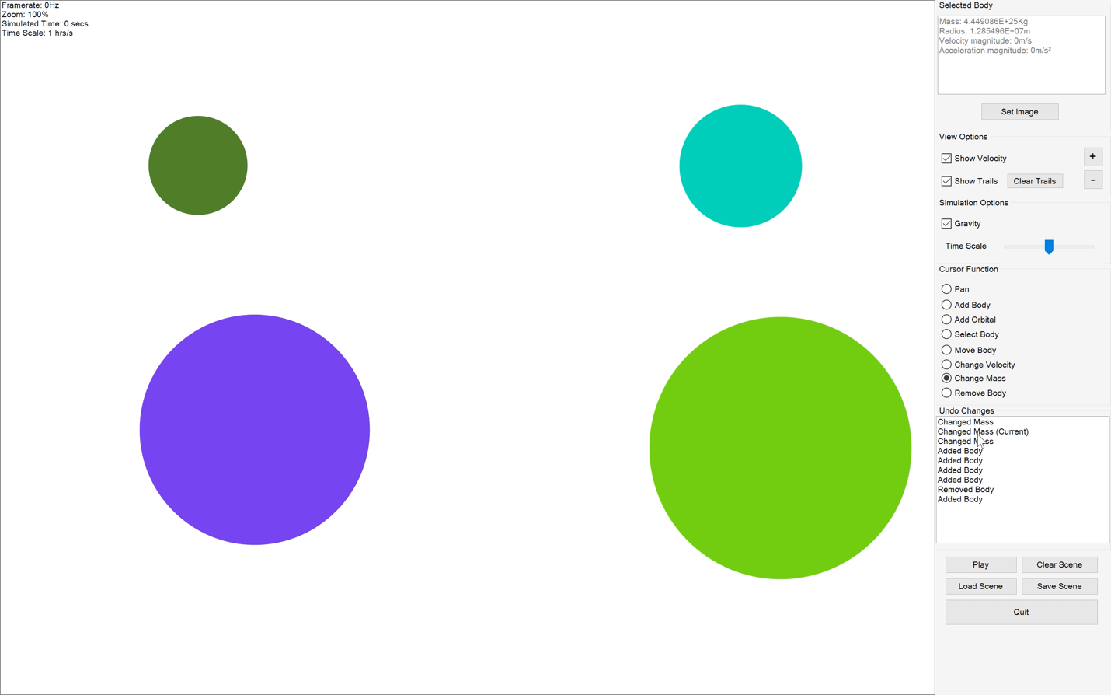
93. 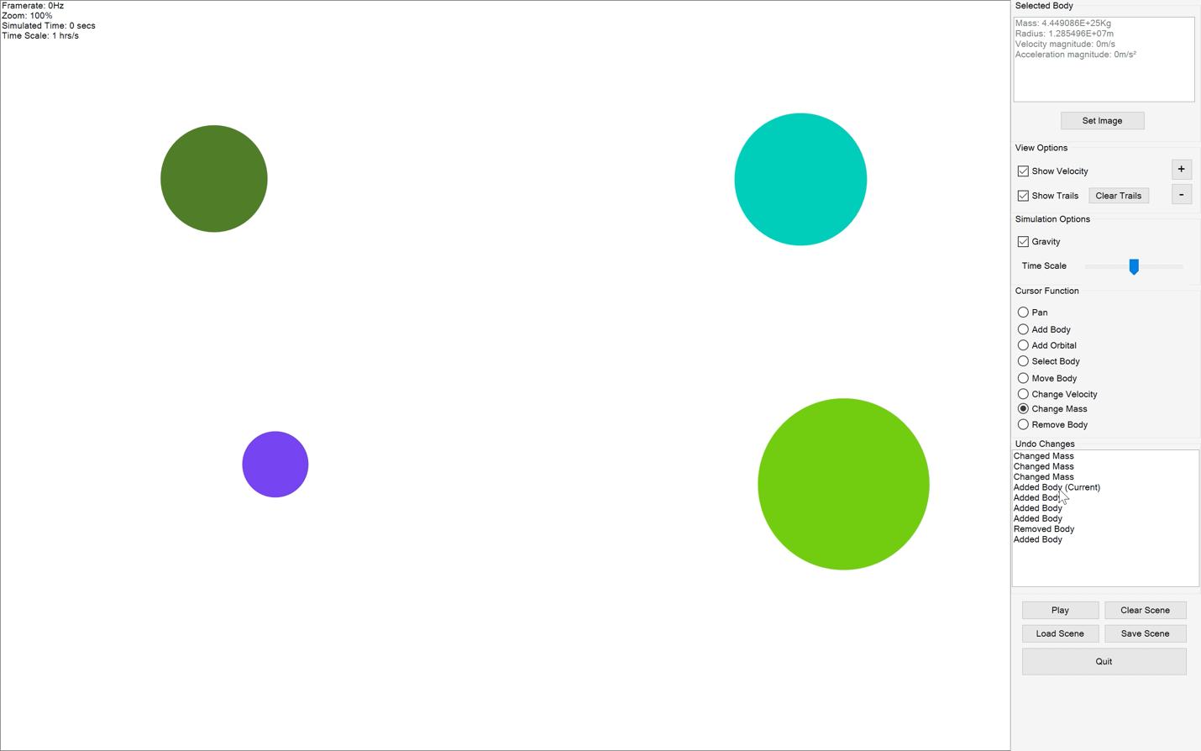
94. 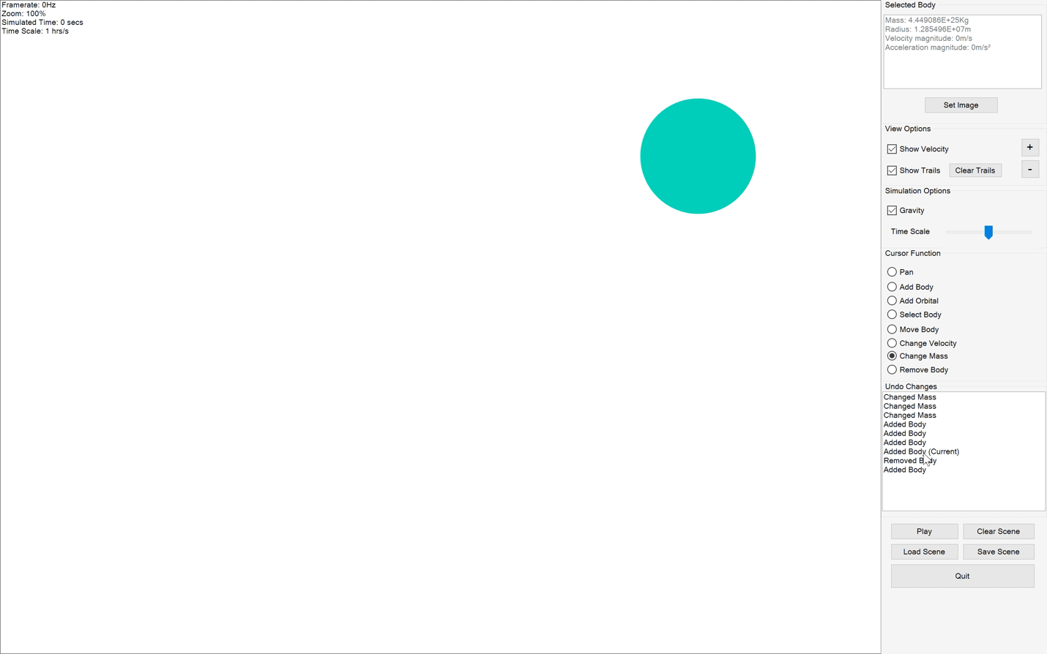
95. 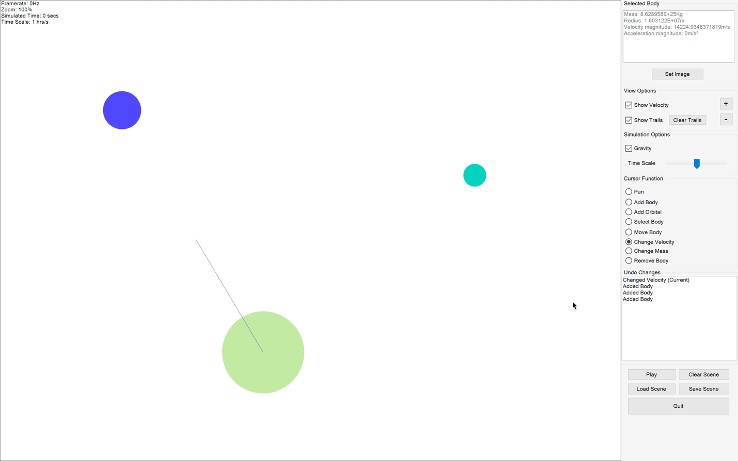
96. 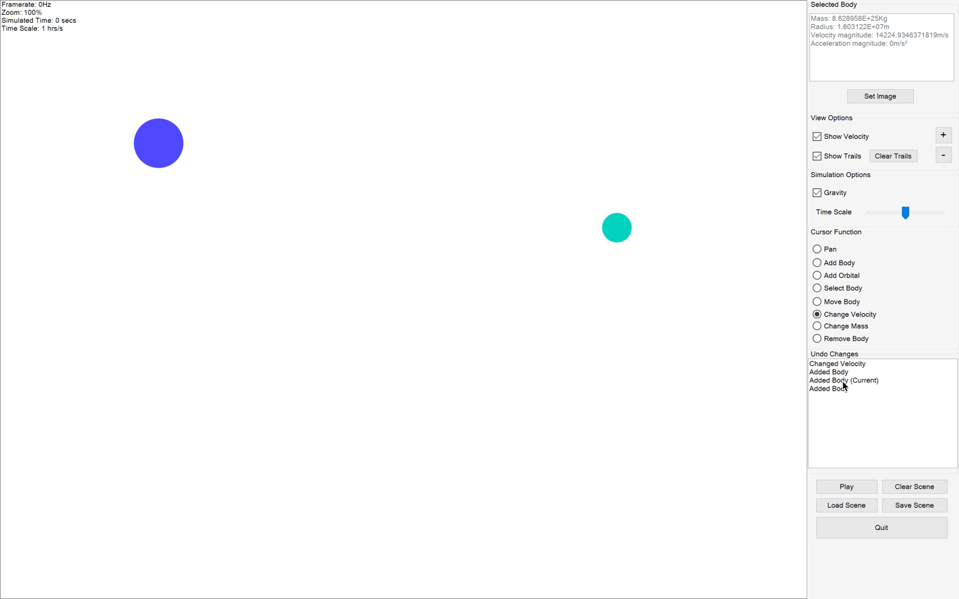
97. 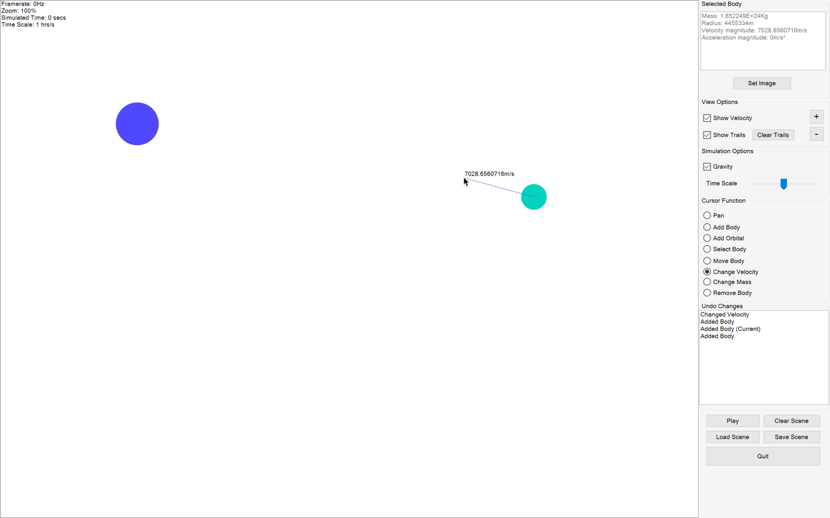
98. 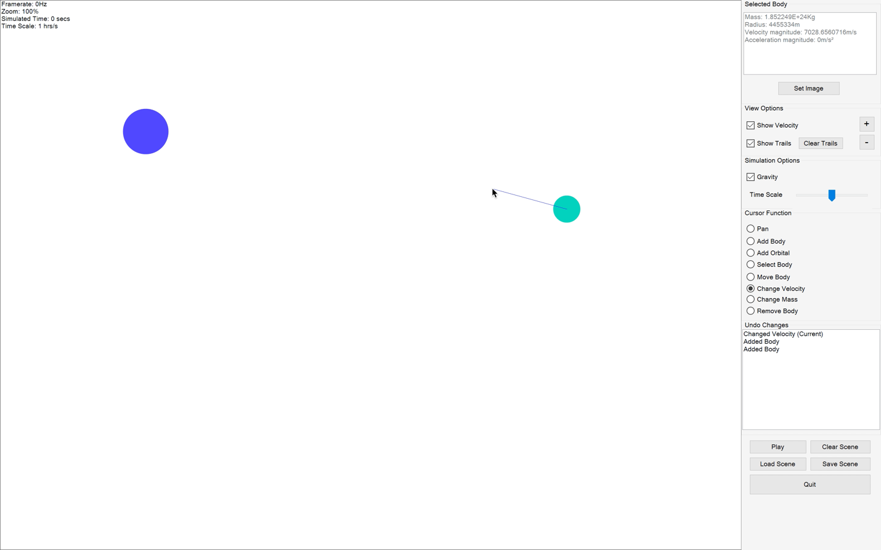
99. 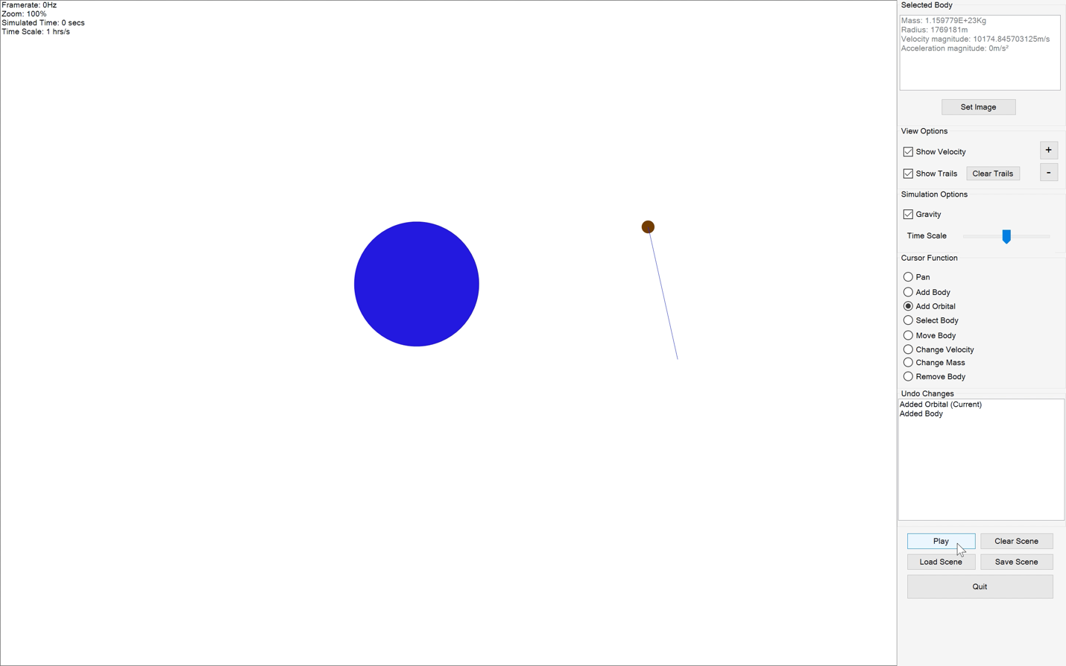
100. 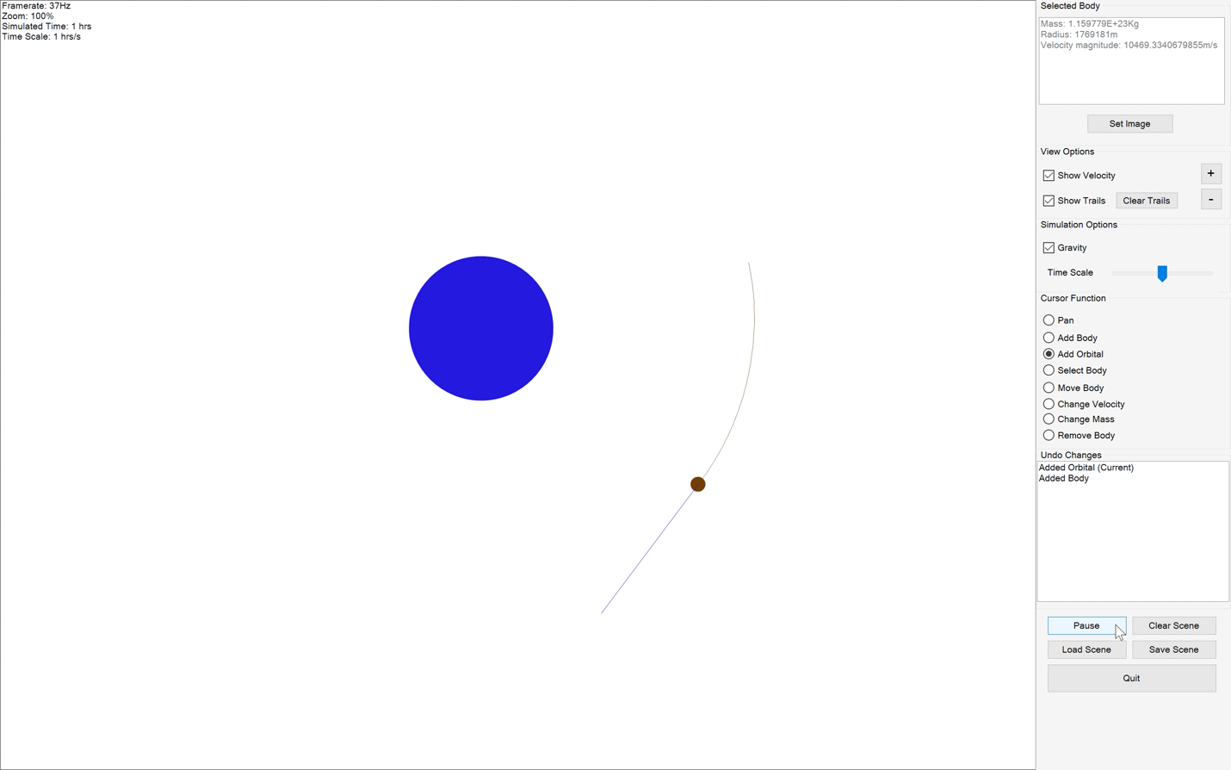
101. 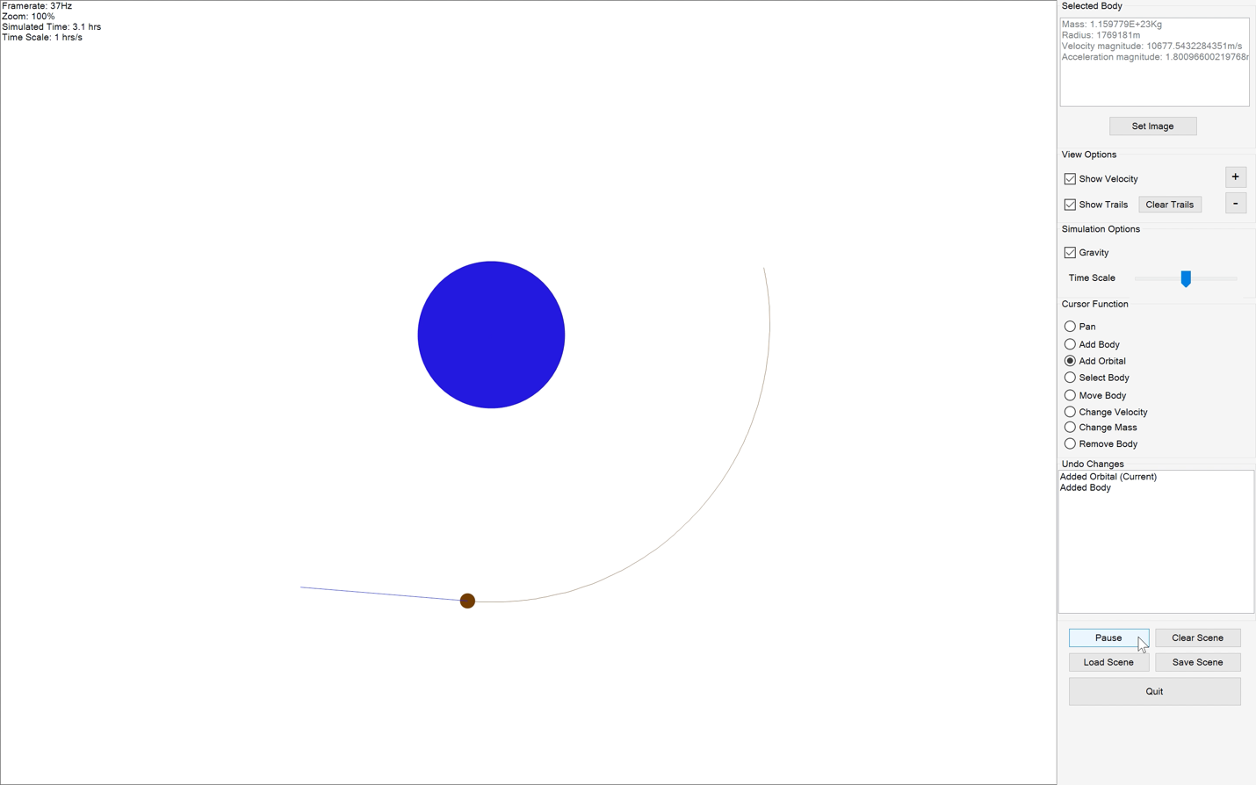
102. 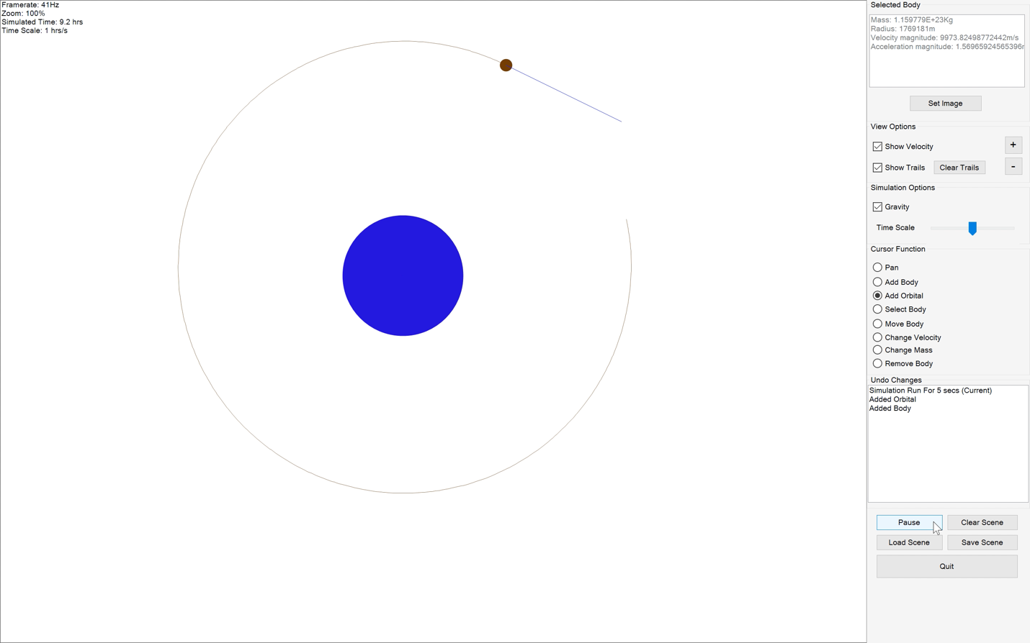
103. 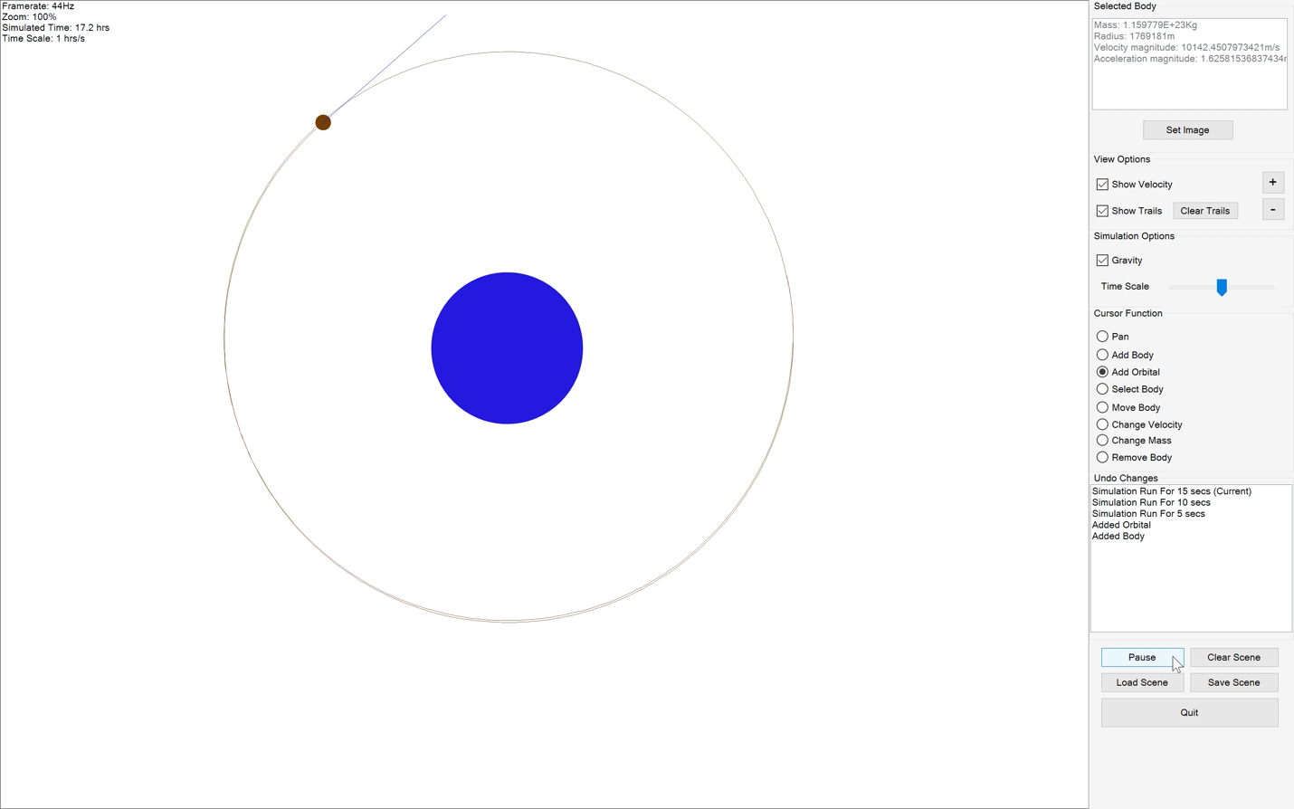
104. 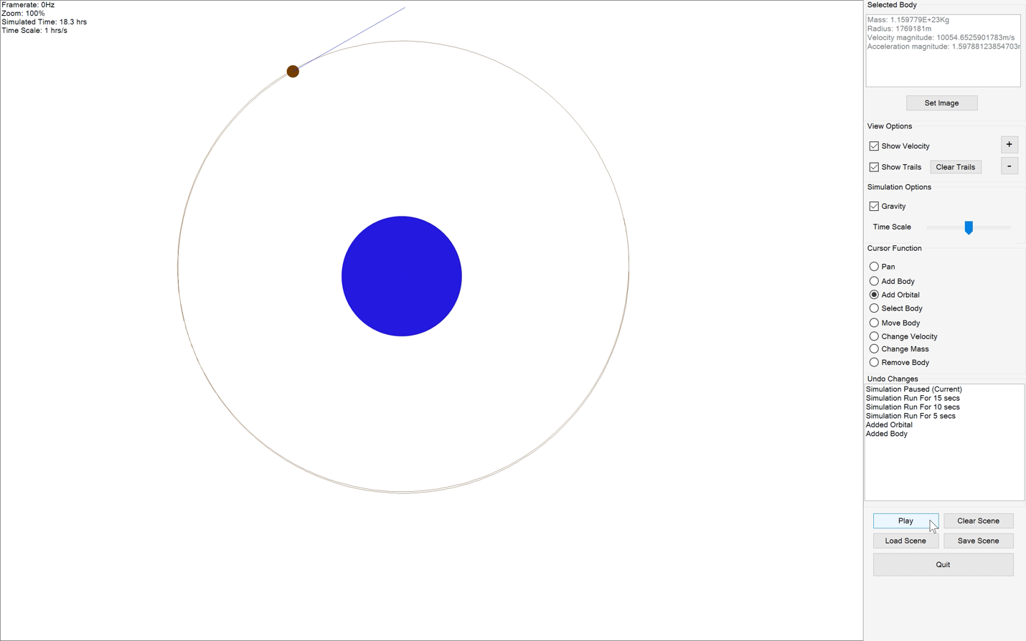
105. 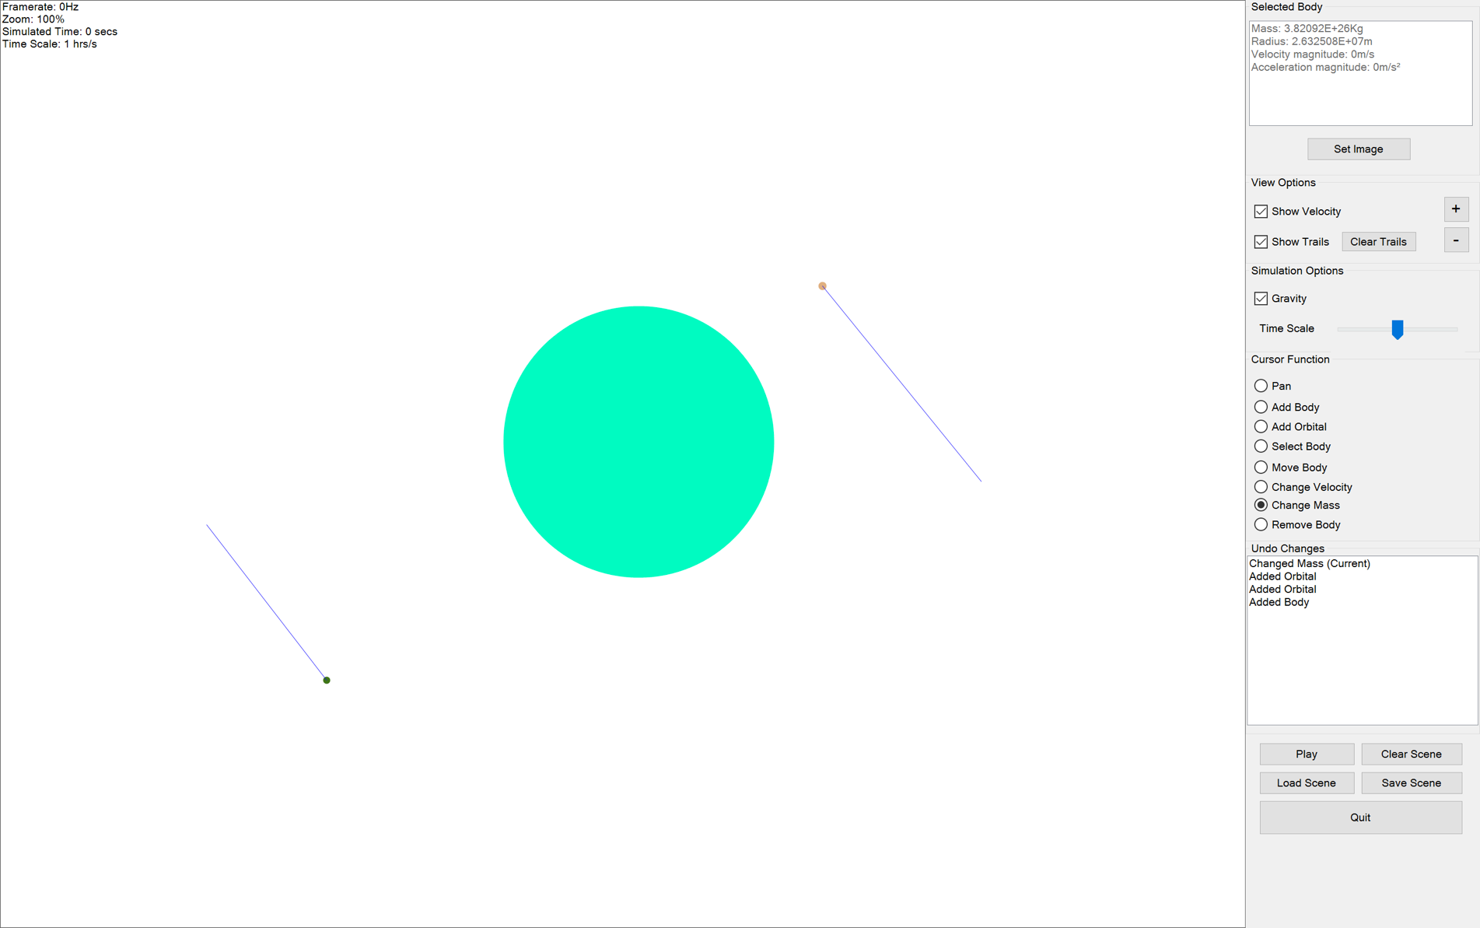
106. 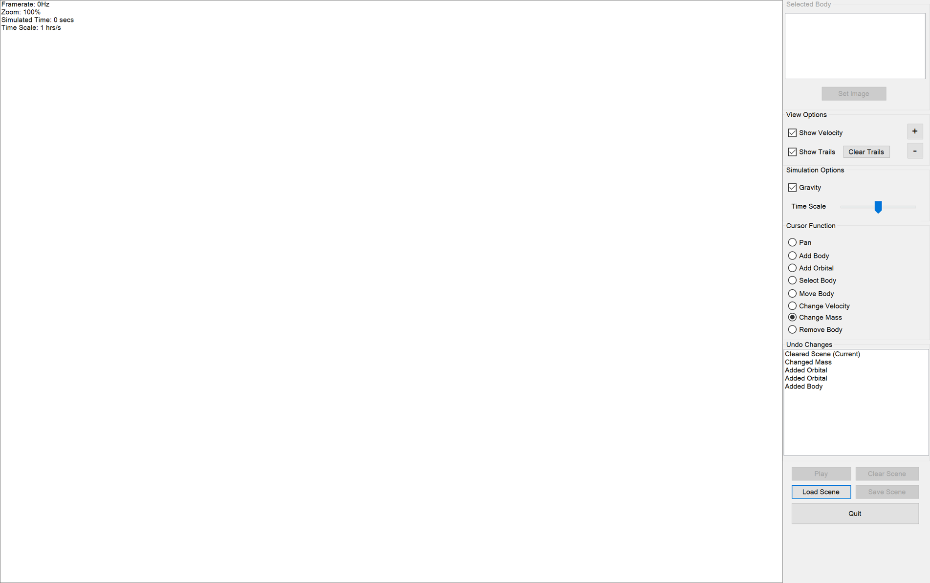
107. 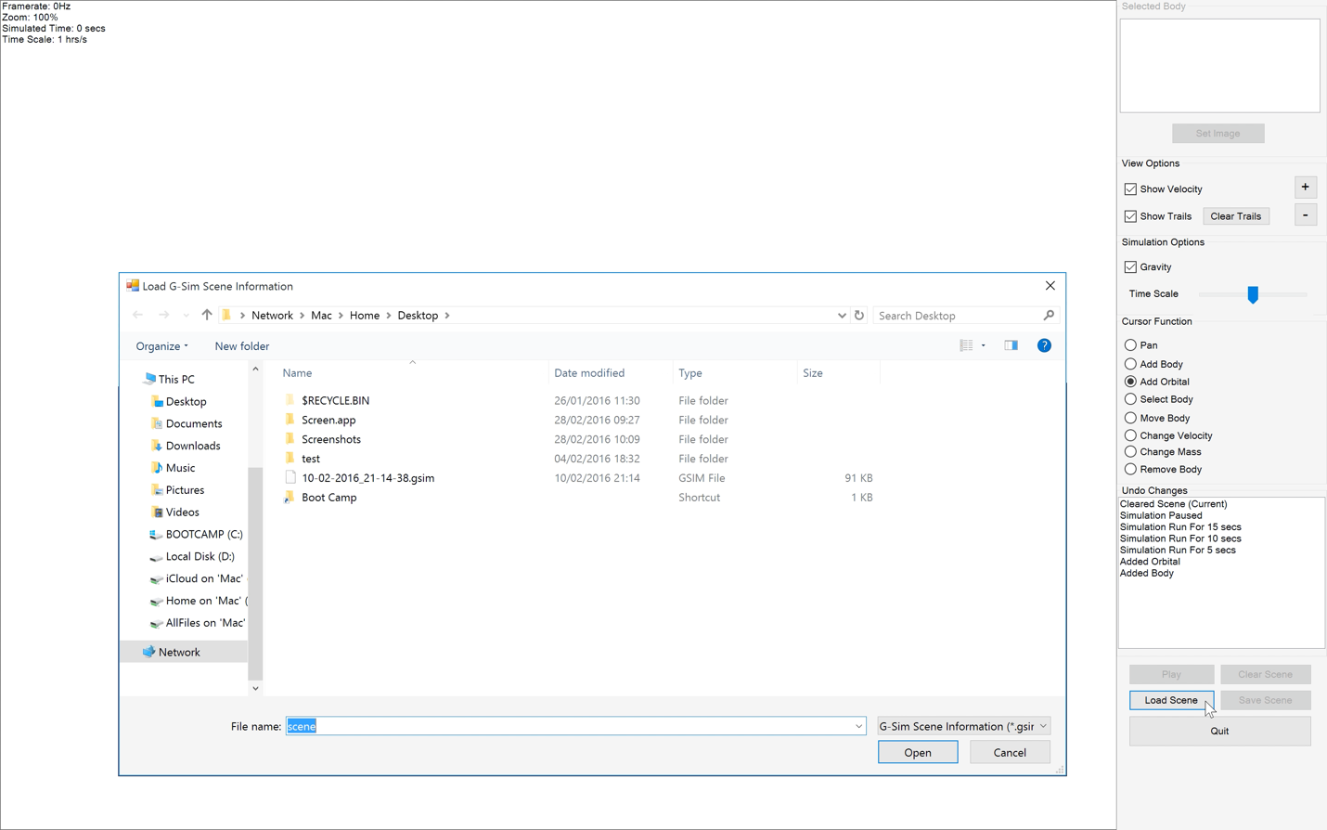
108. 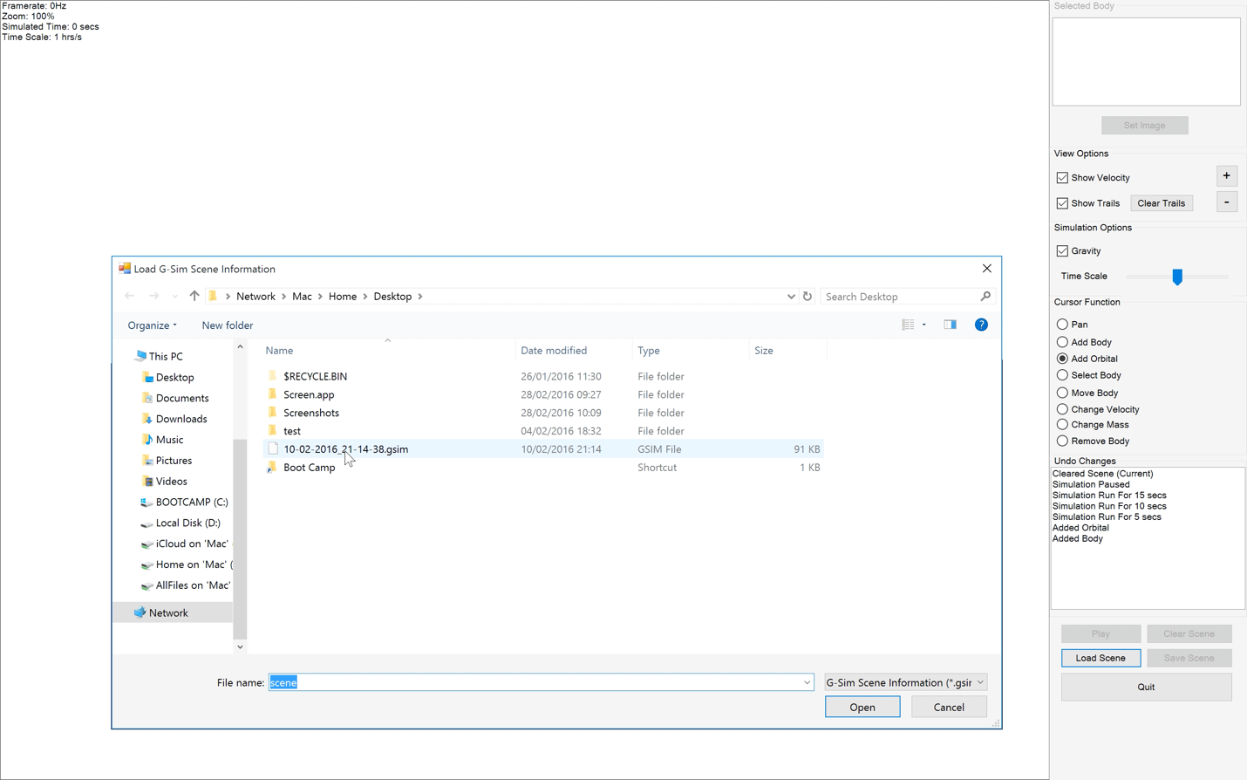
109. 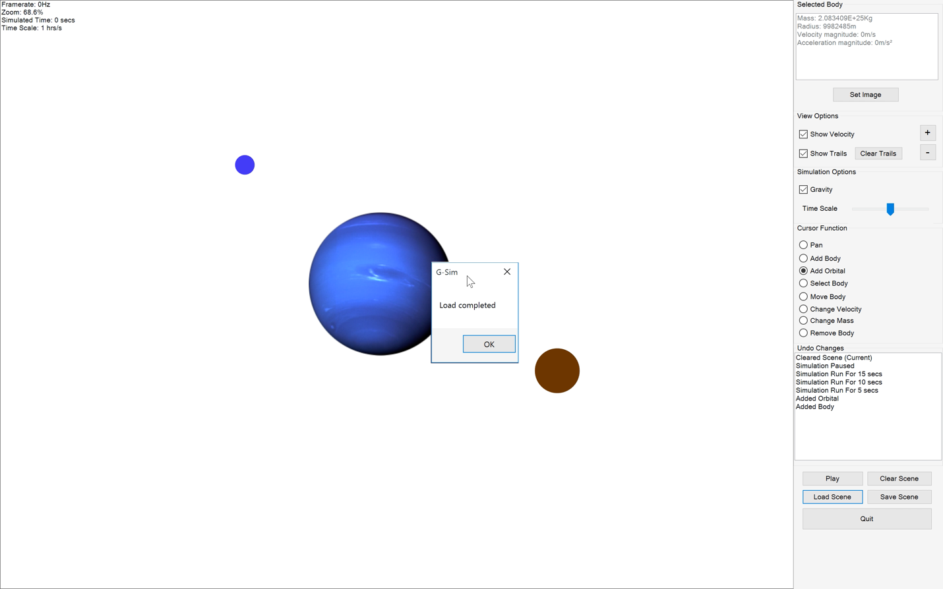
110. 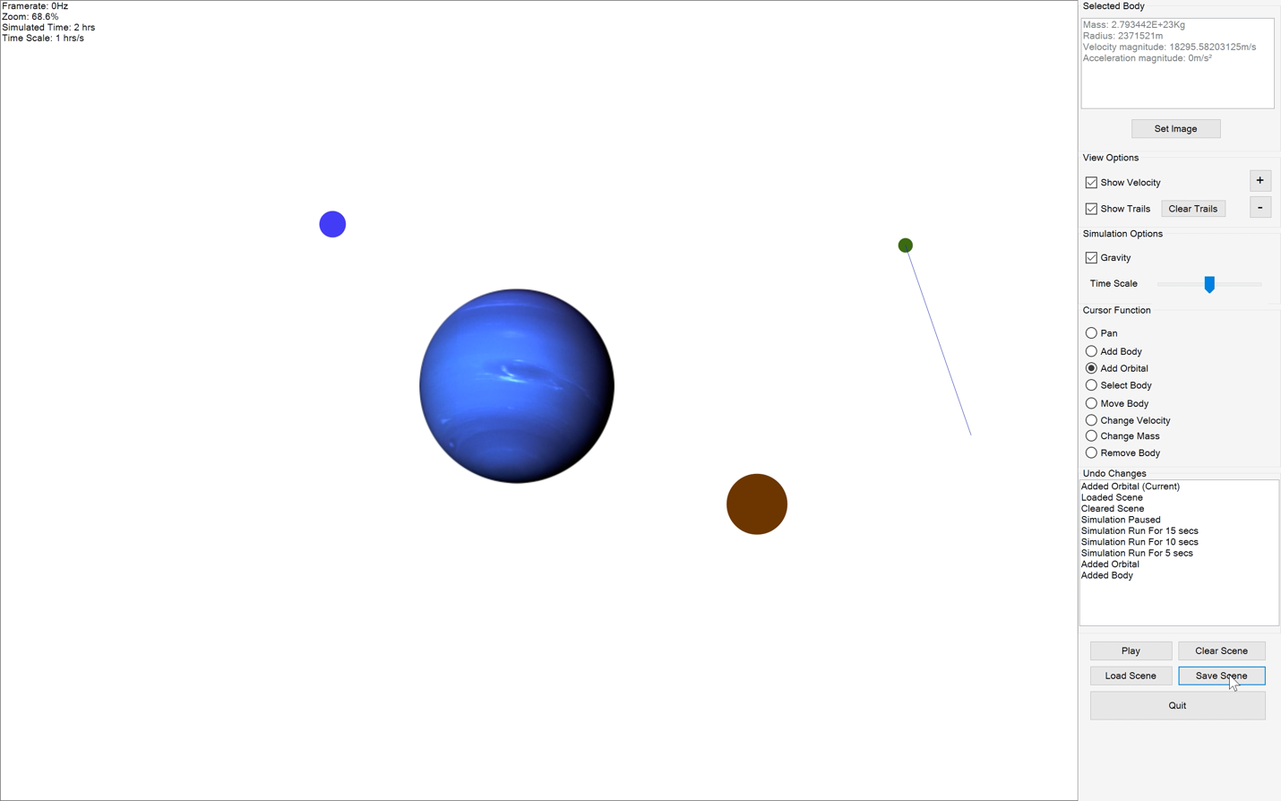
111. 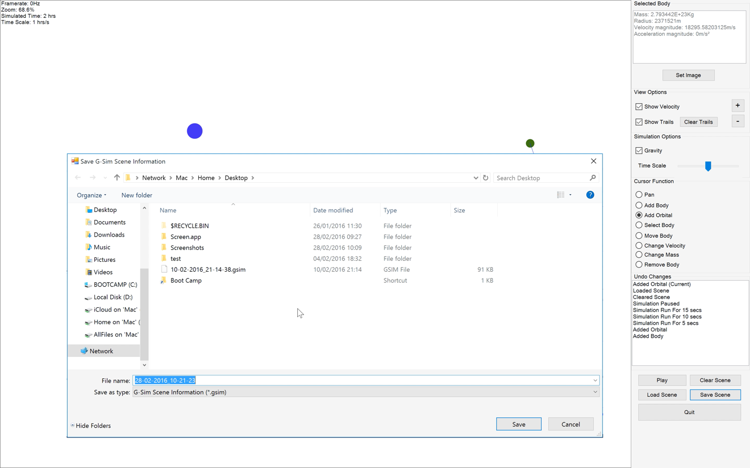
112. 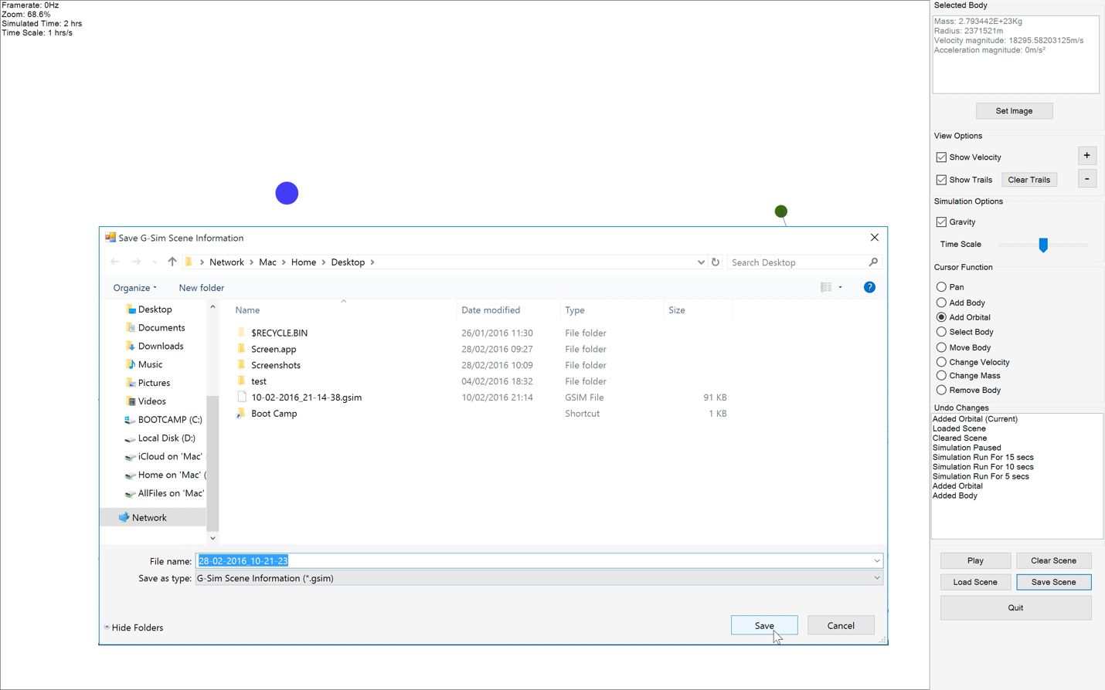
113. 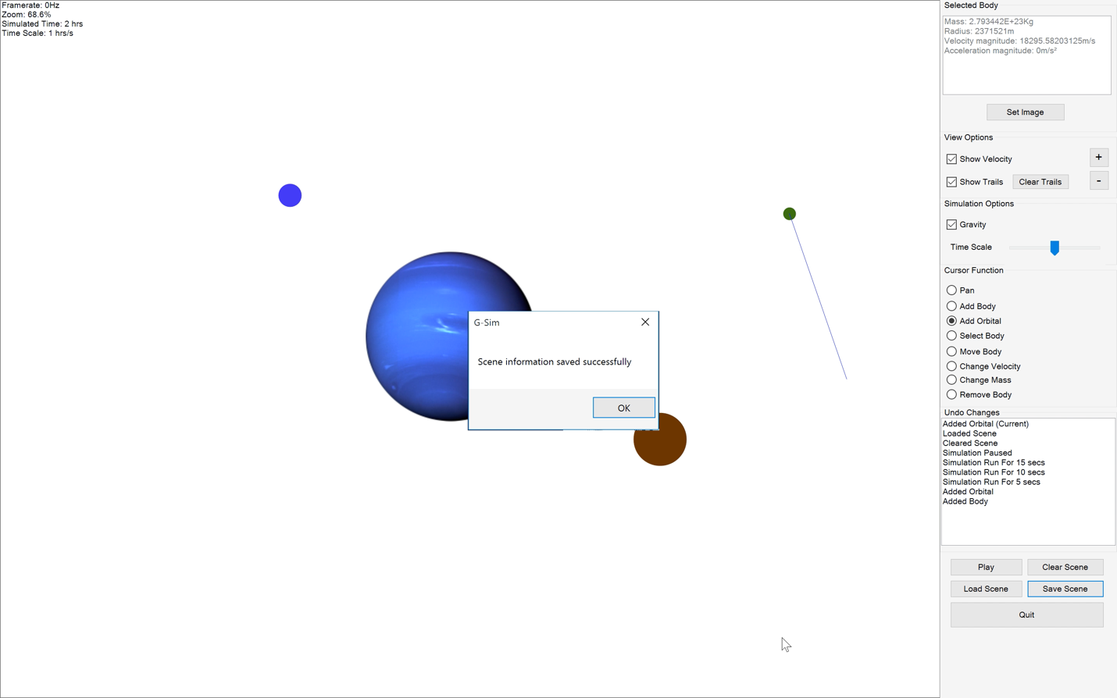
114. 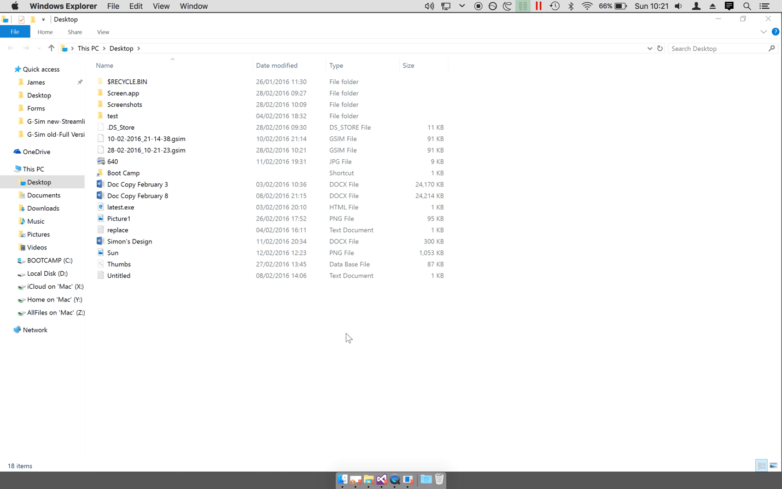
115. 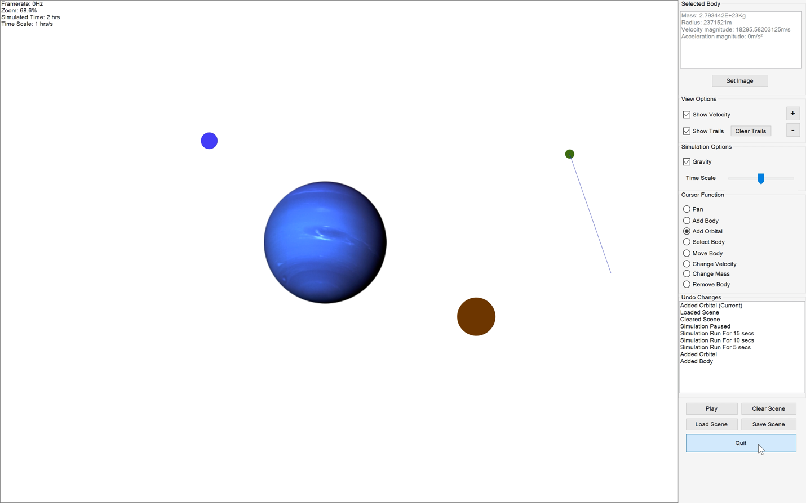
116. 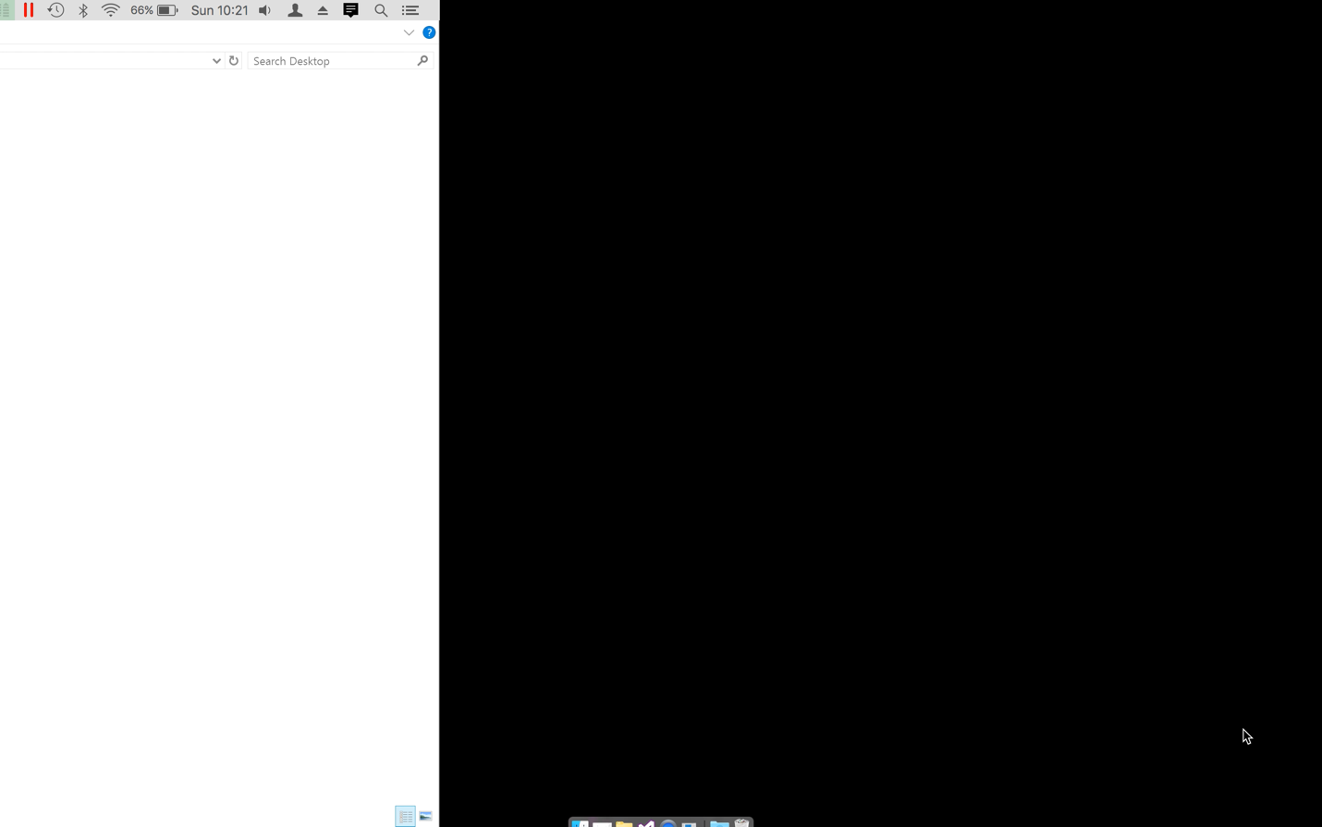
117. 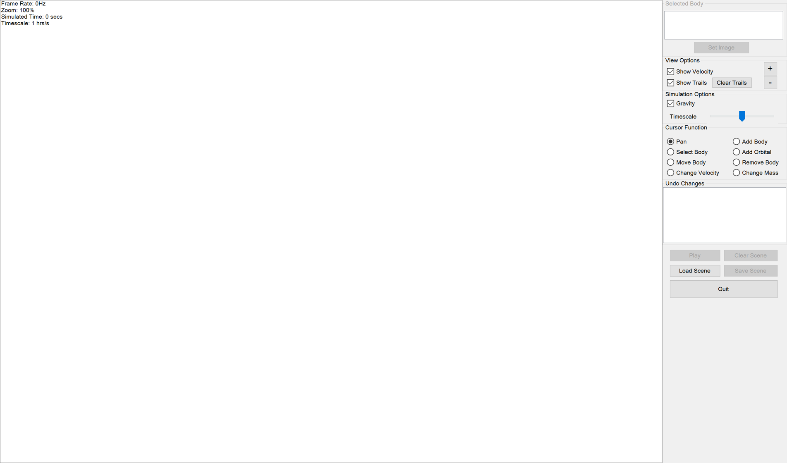
118. 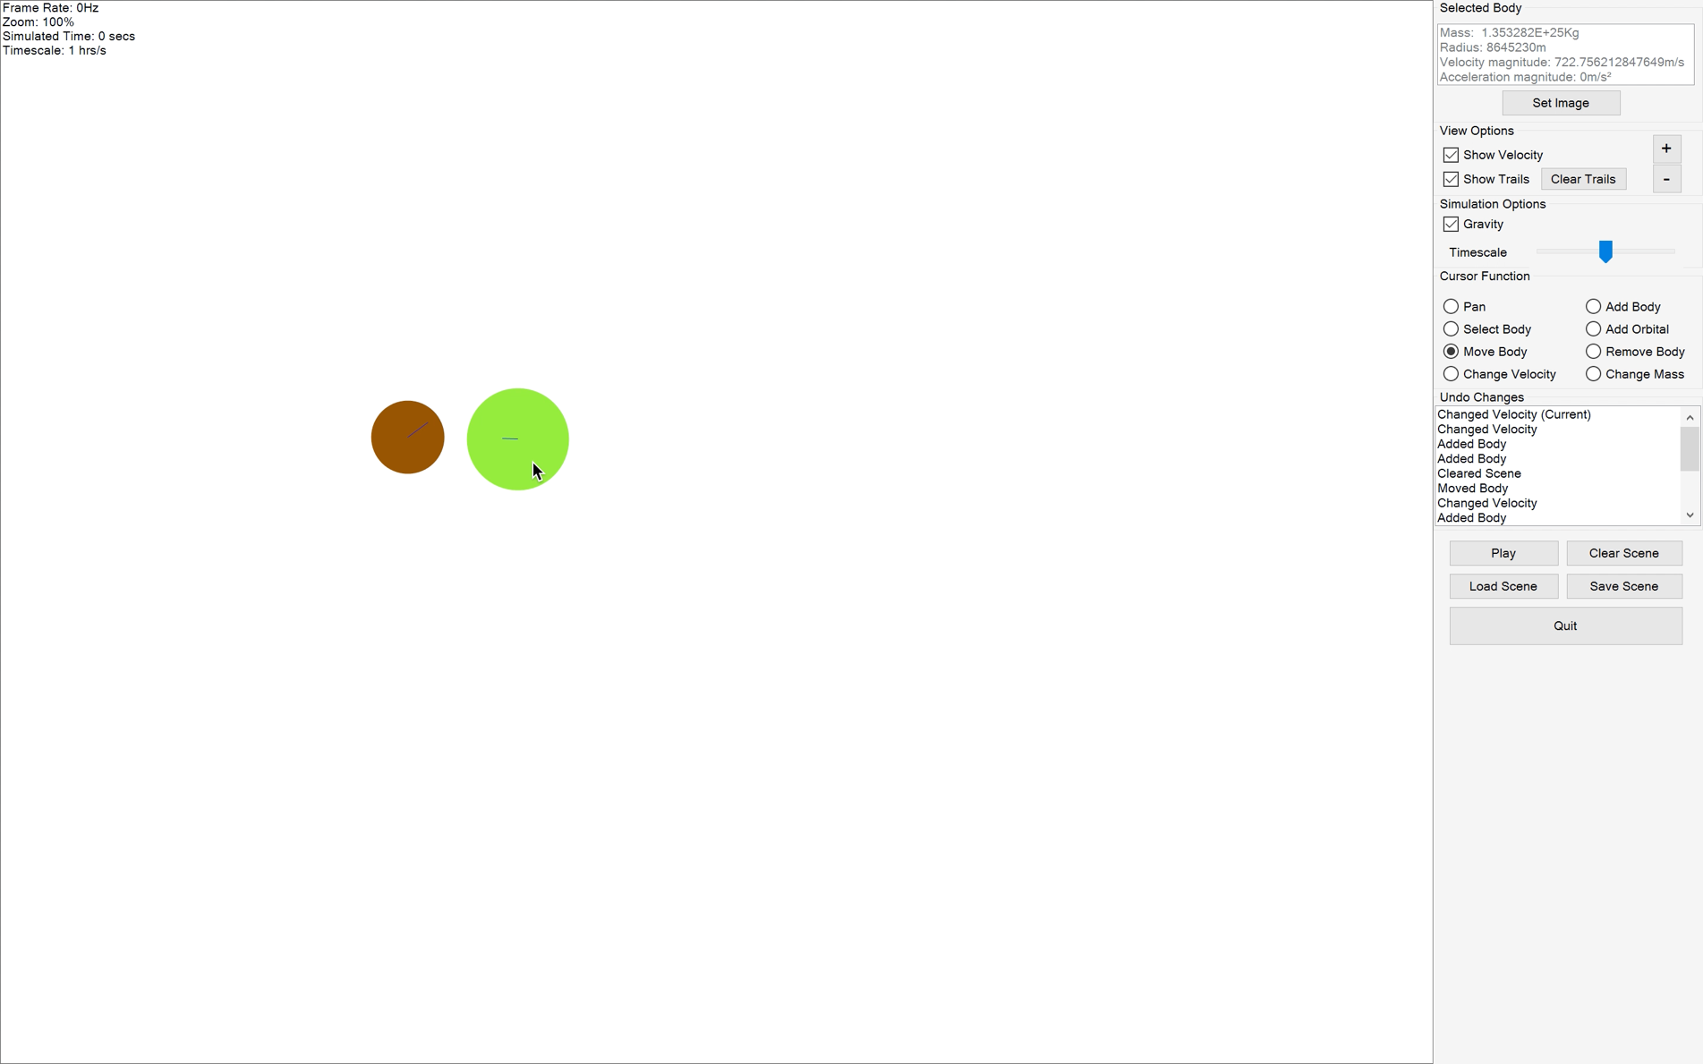
119. 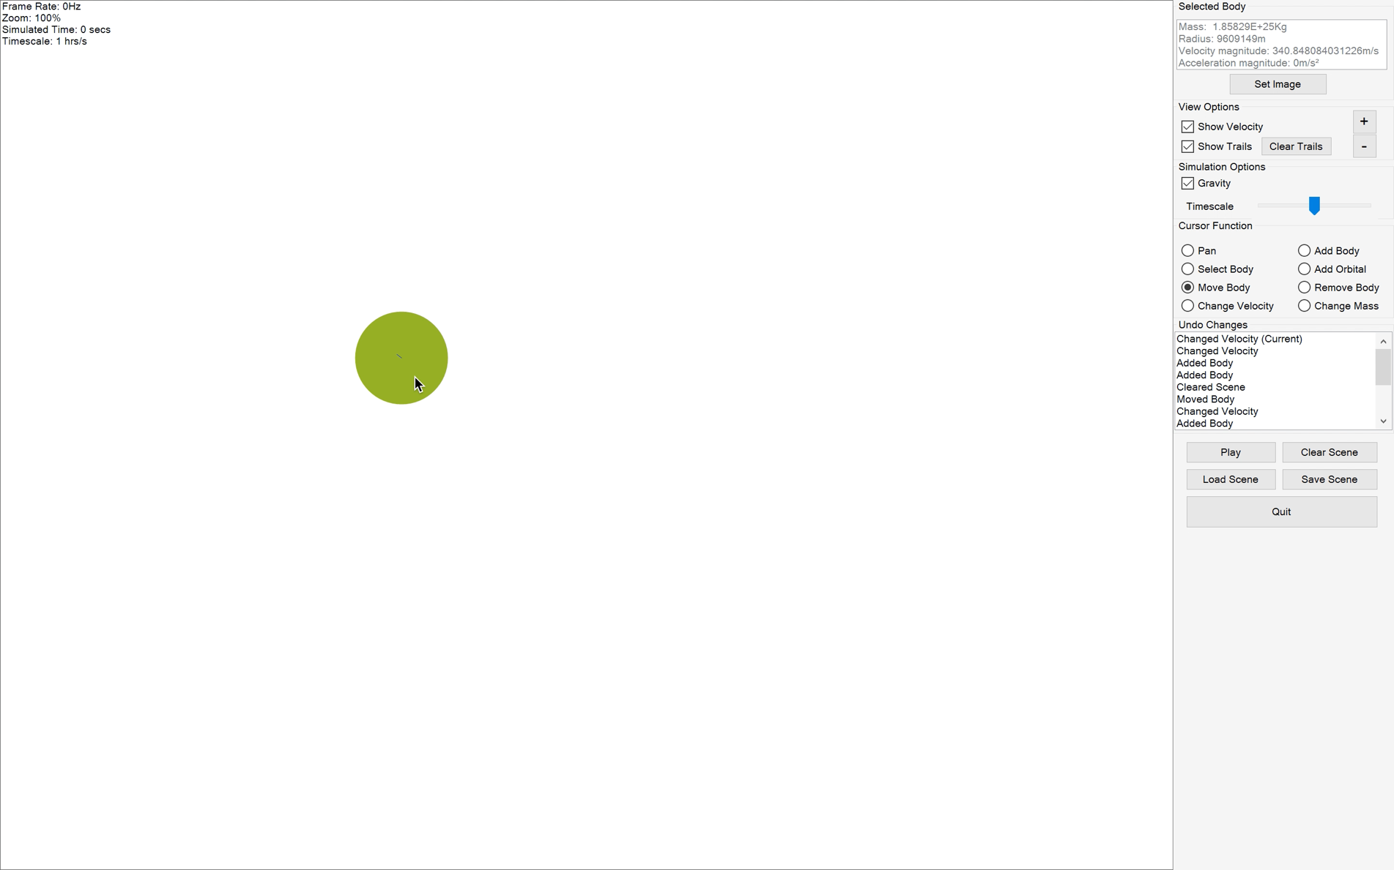
120. 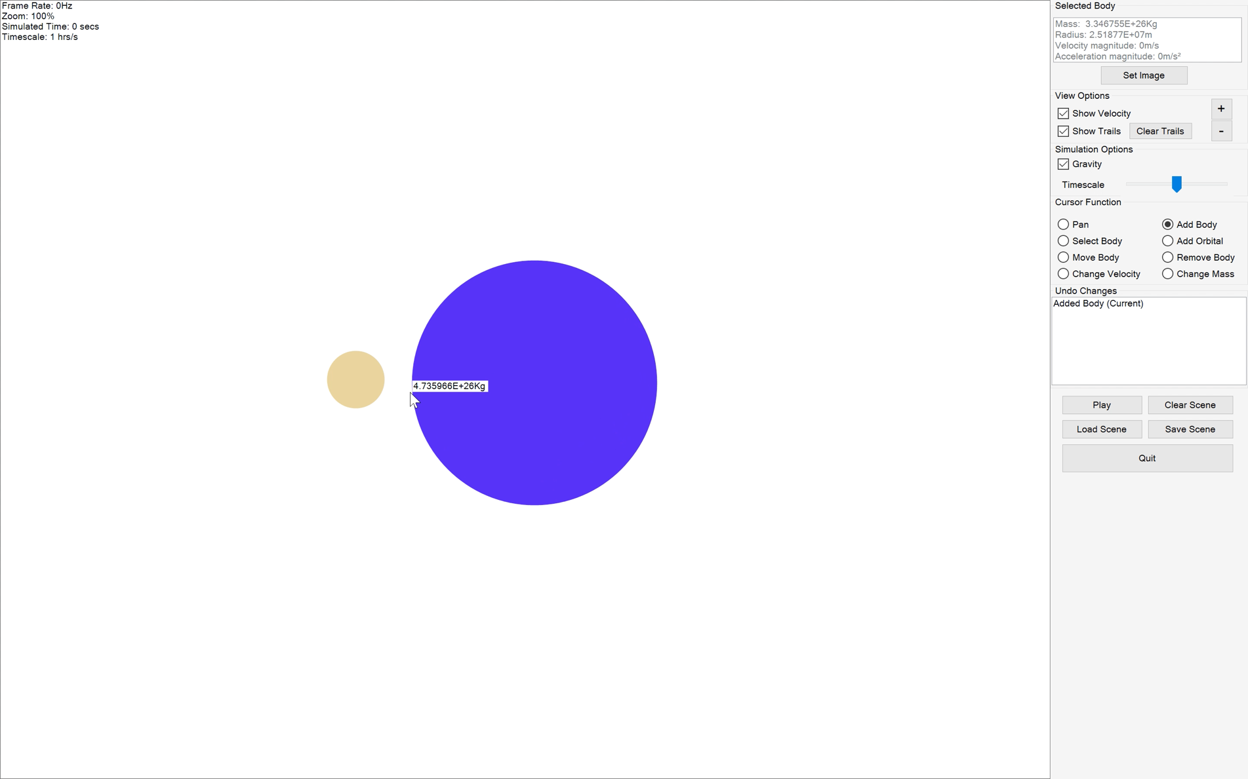
121. 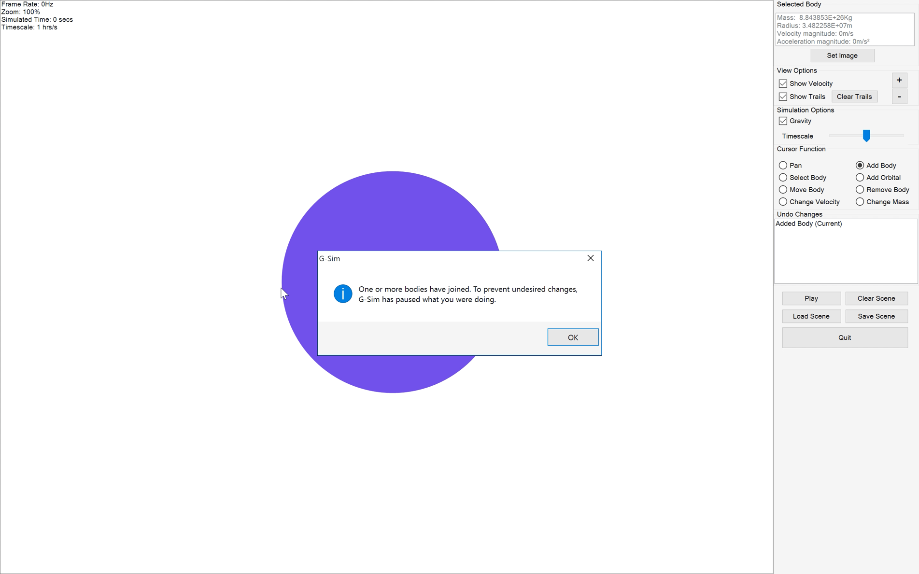
122. 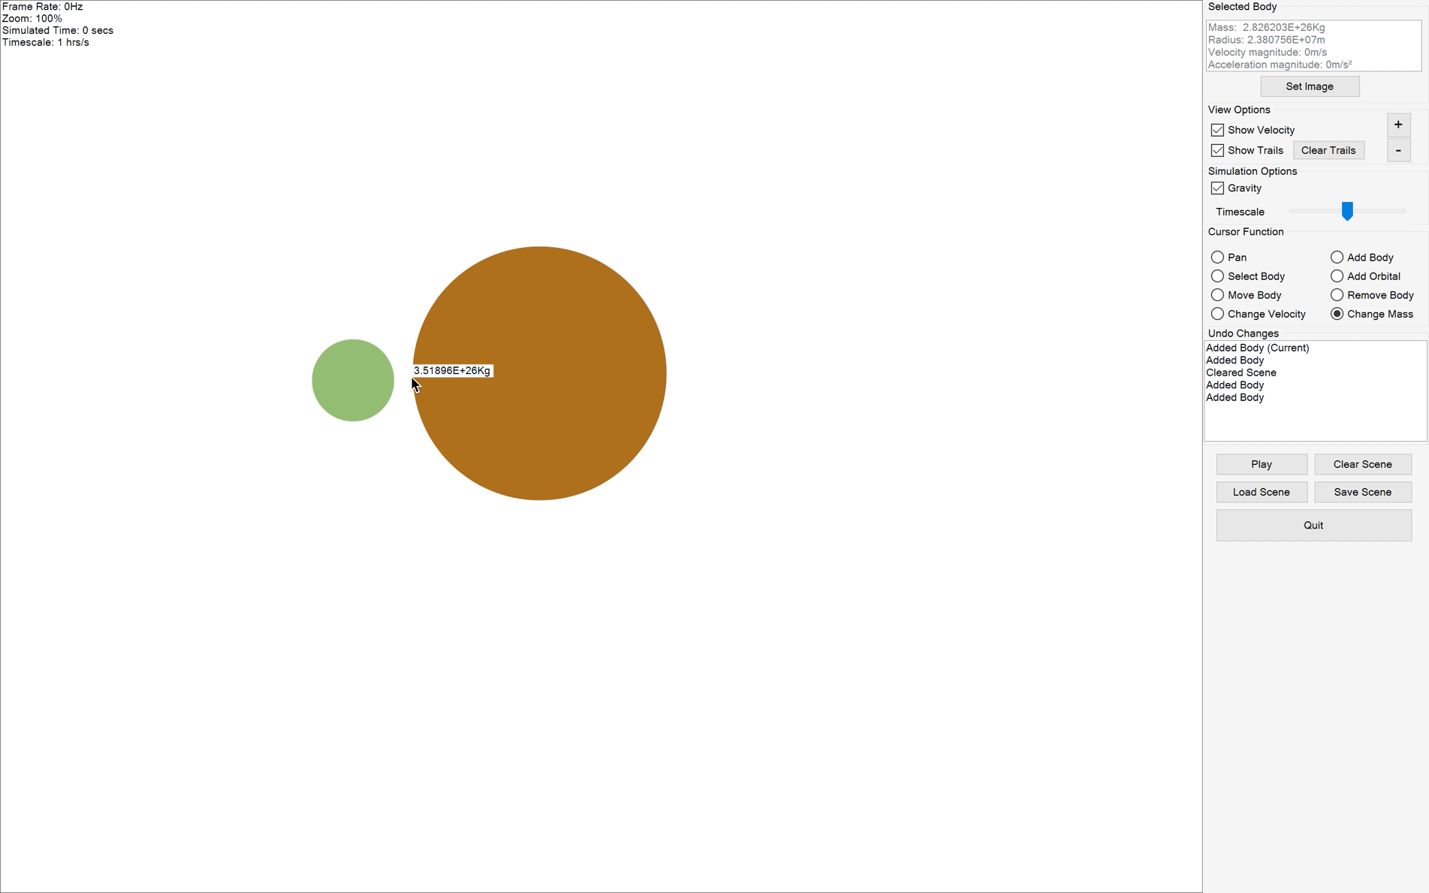
123. 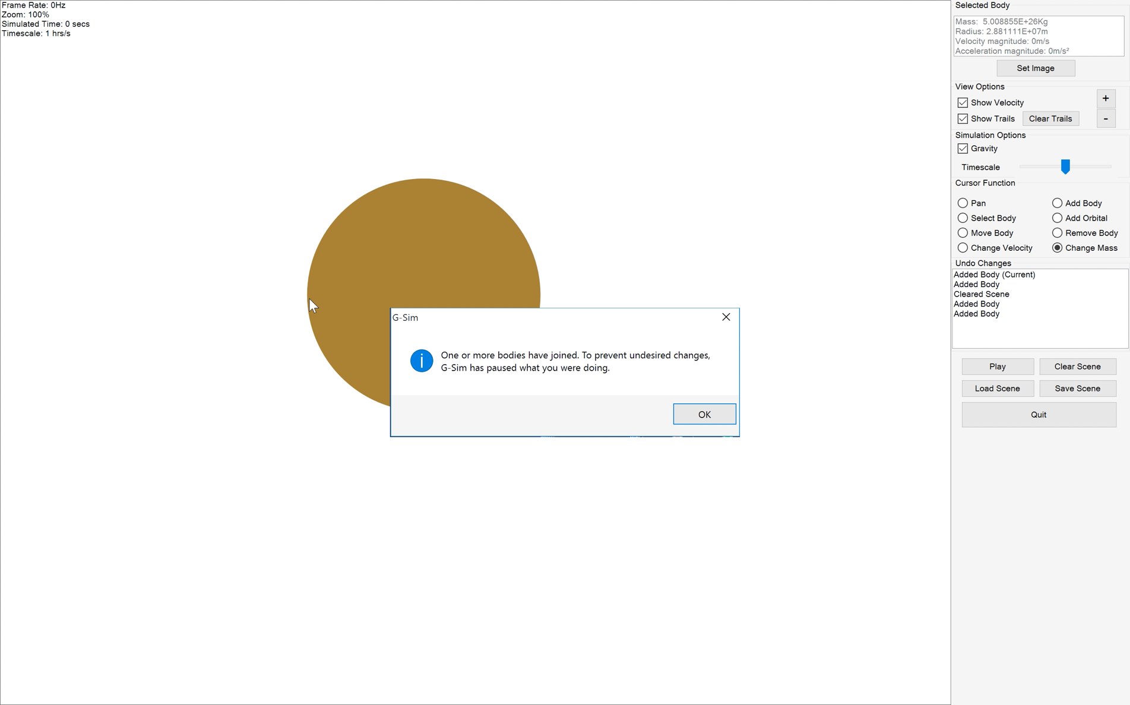
124. 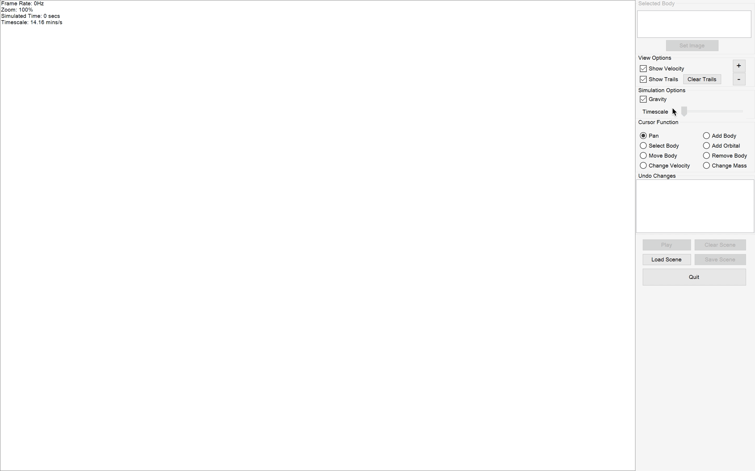
125. 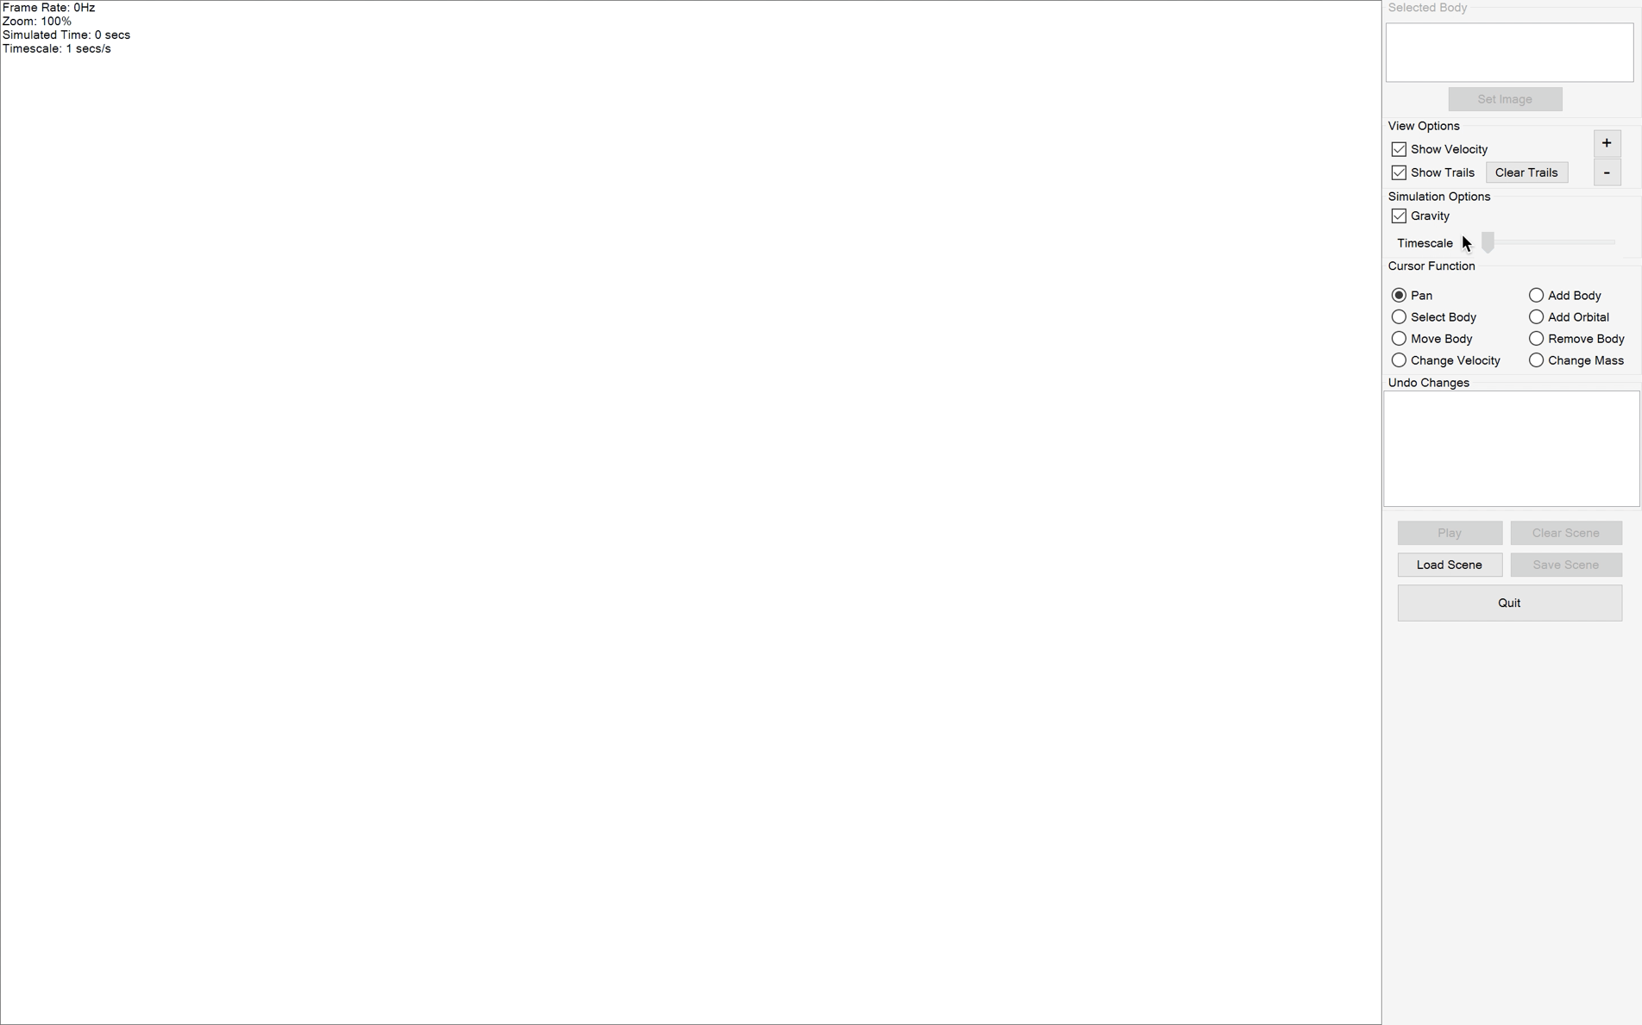
126. 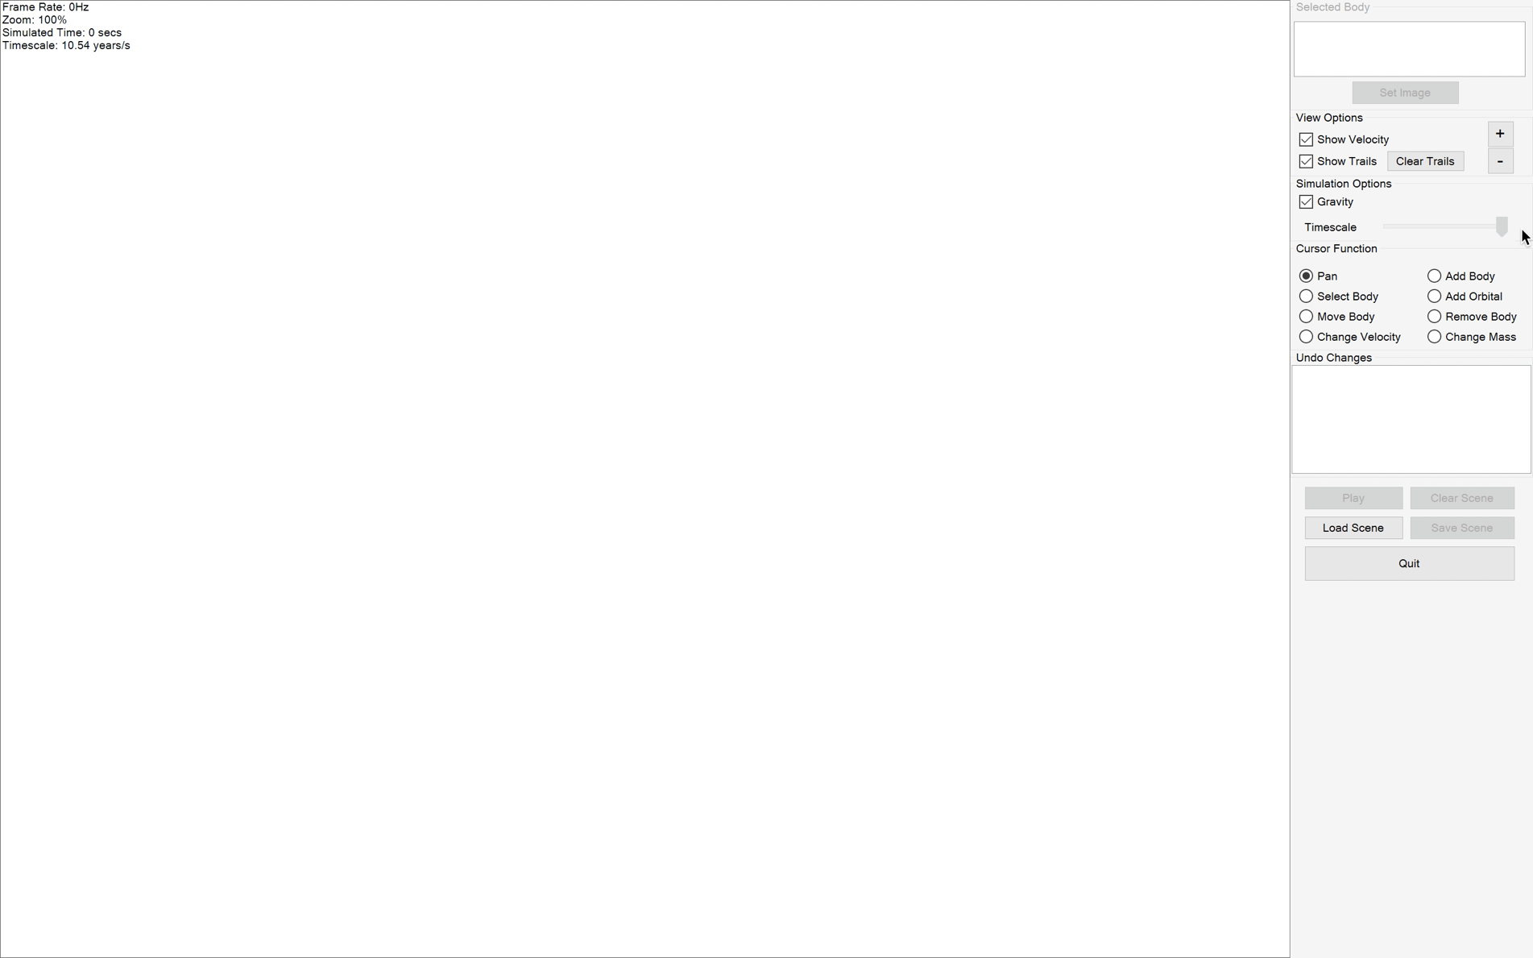
127. 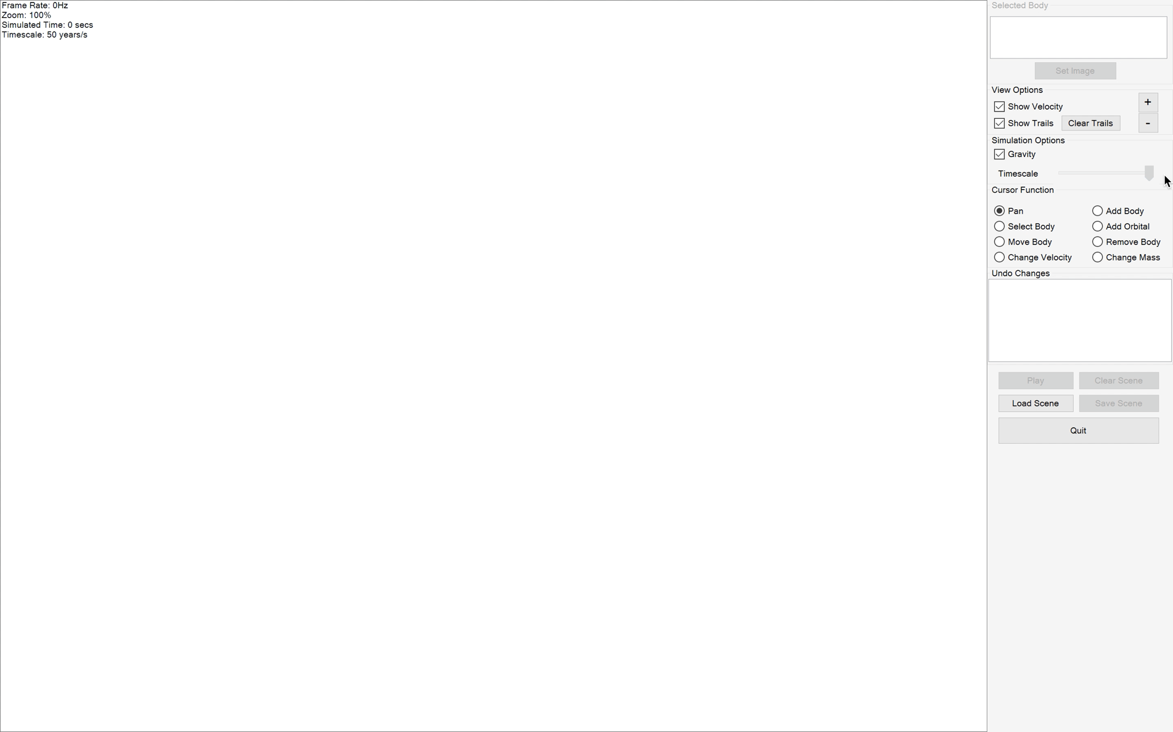
128. 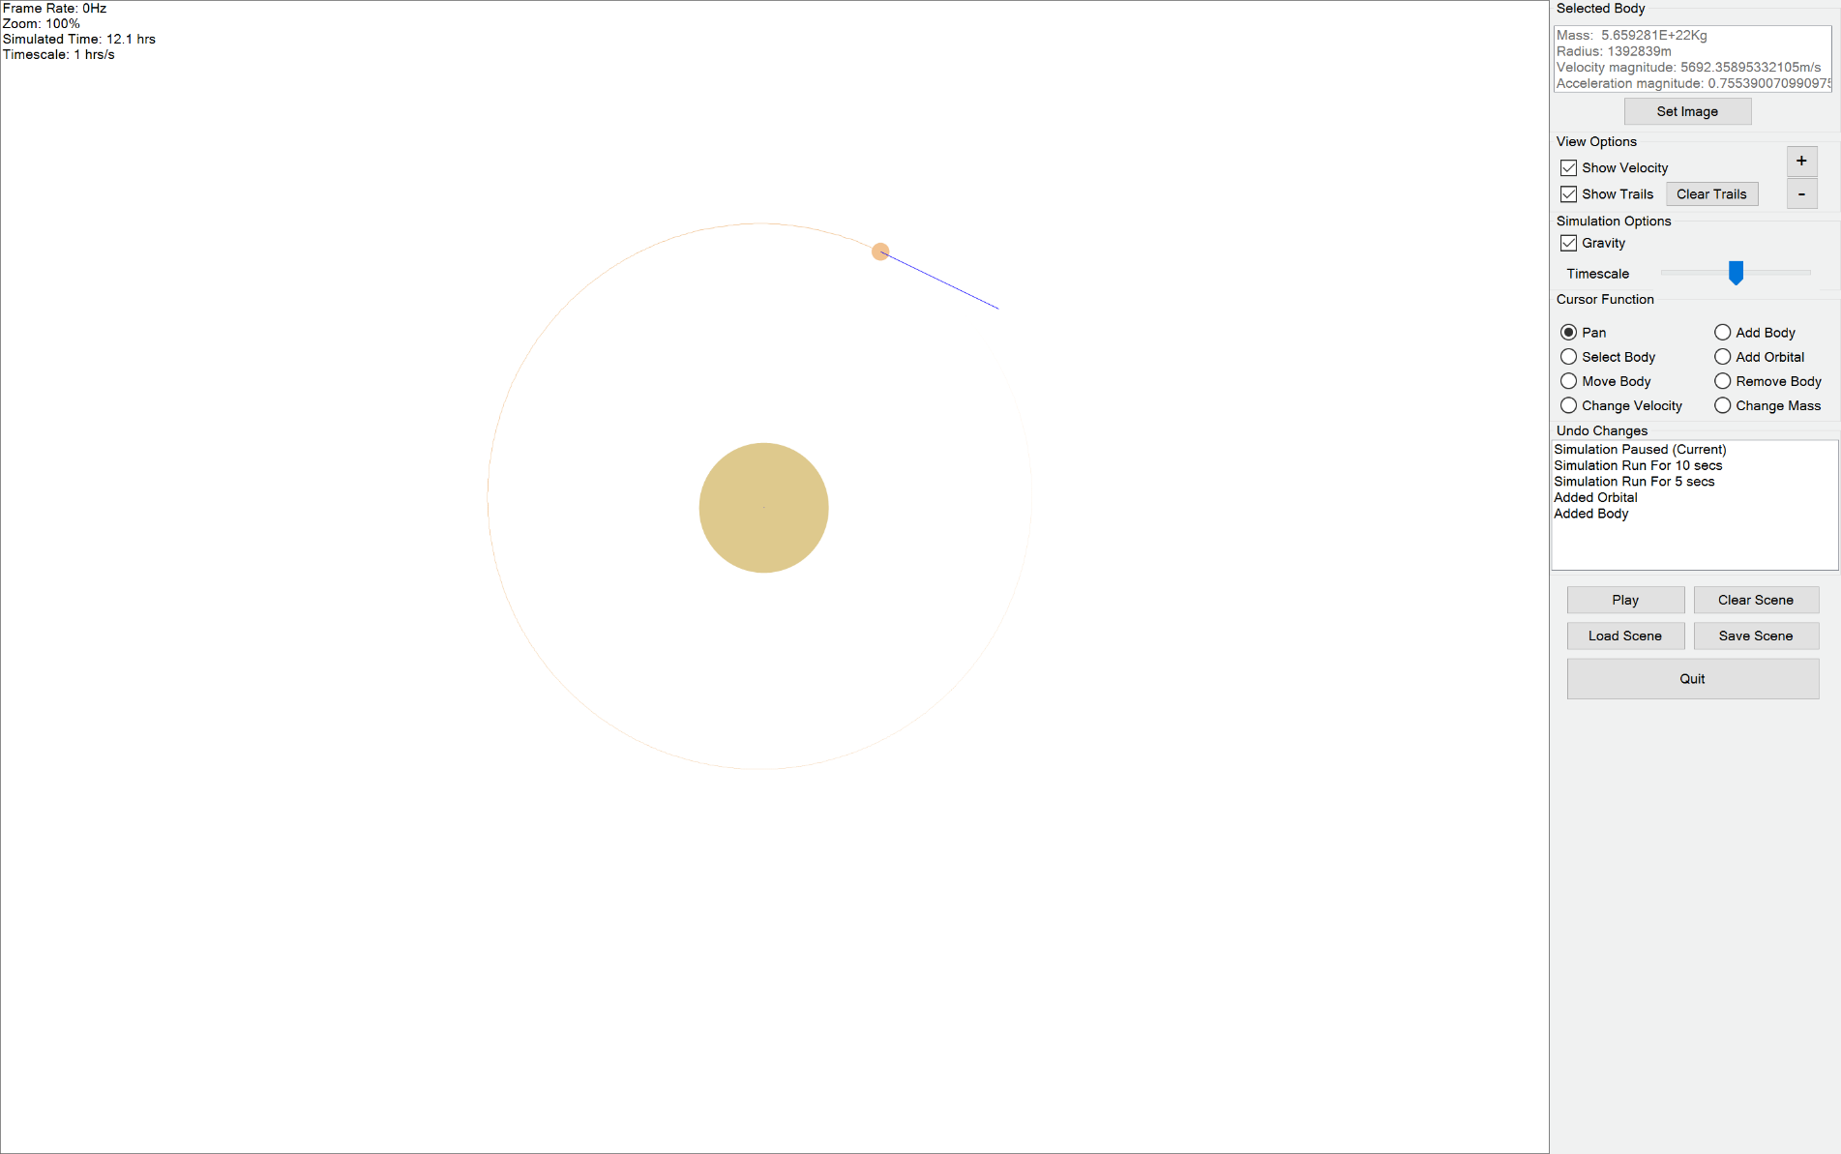
129. 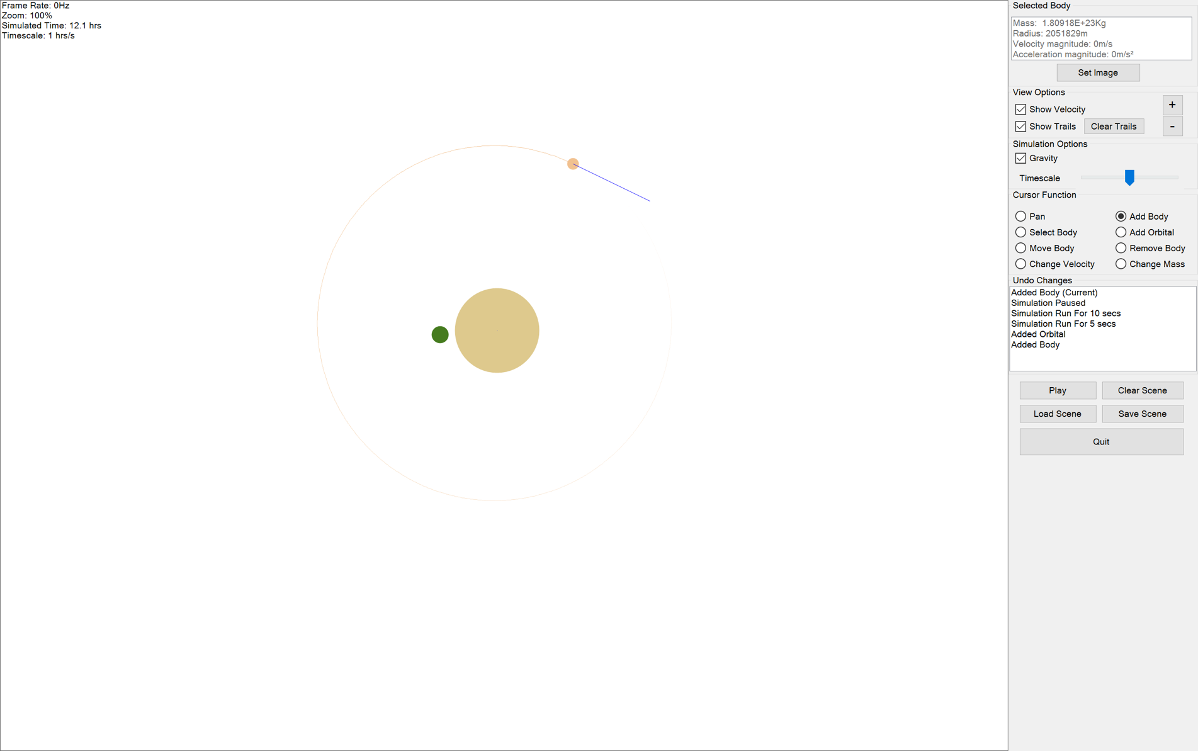
130. 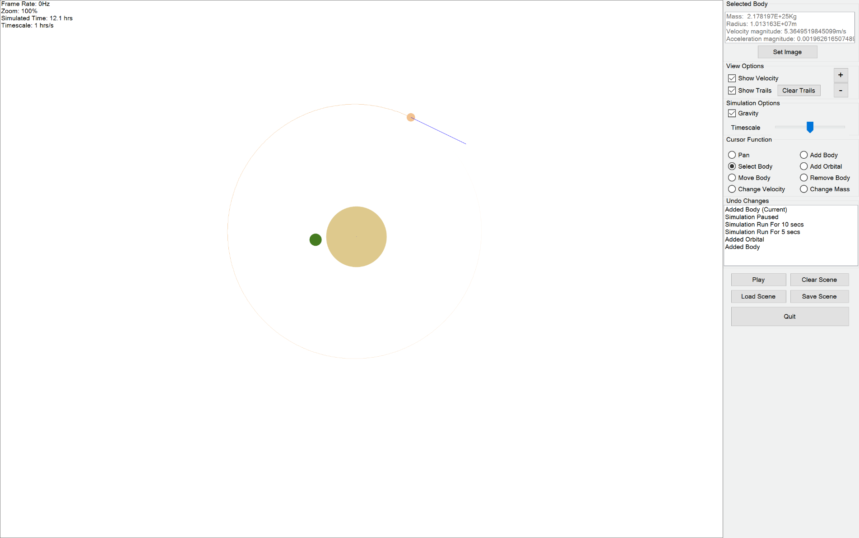
131. 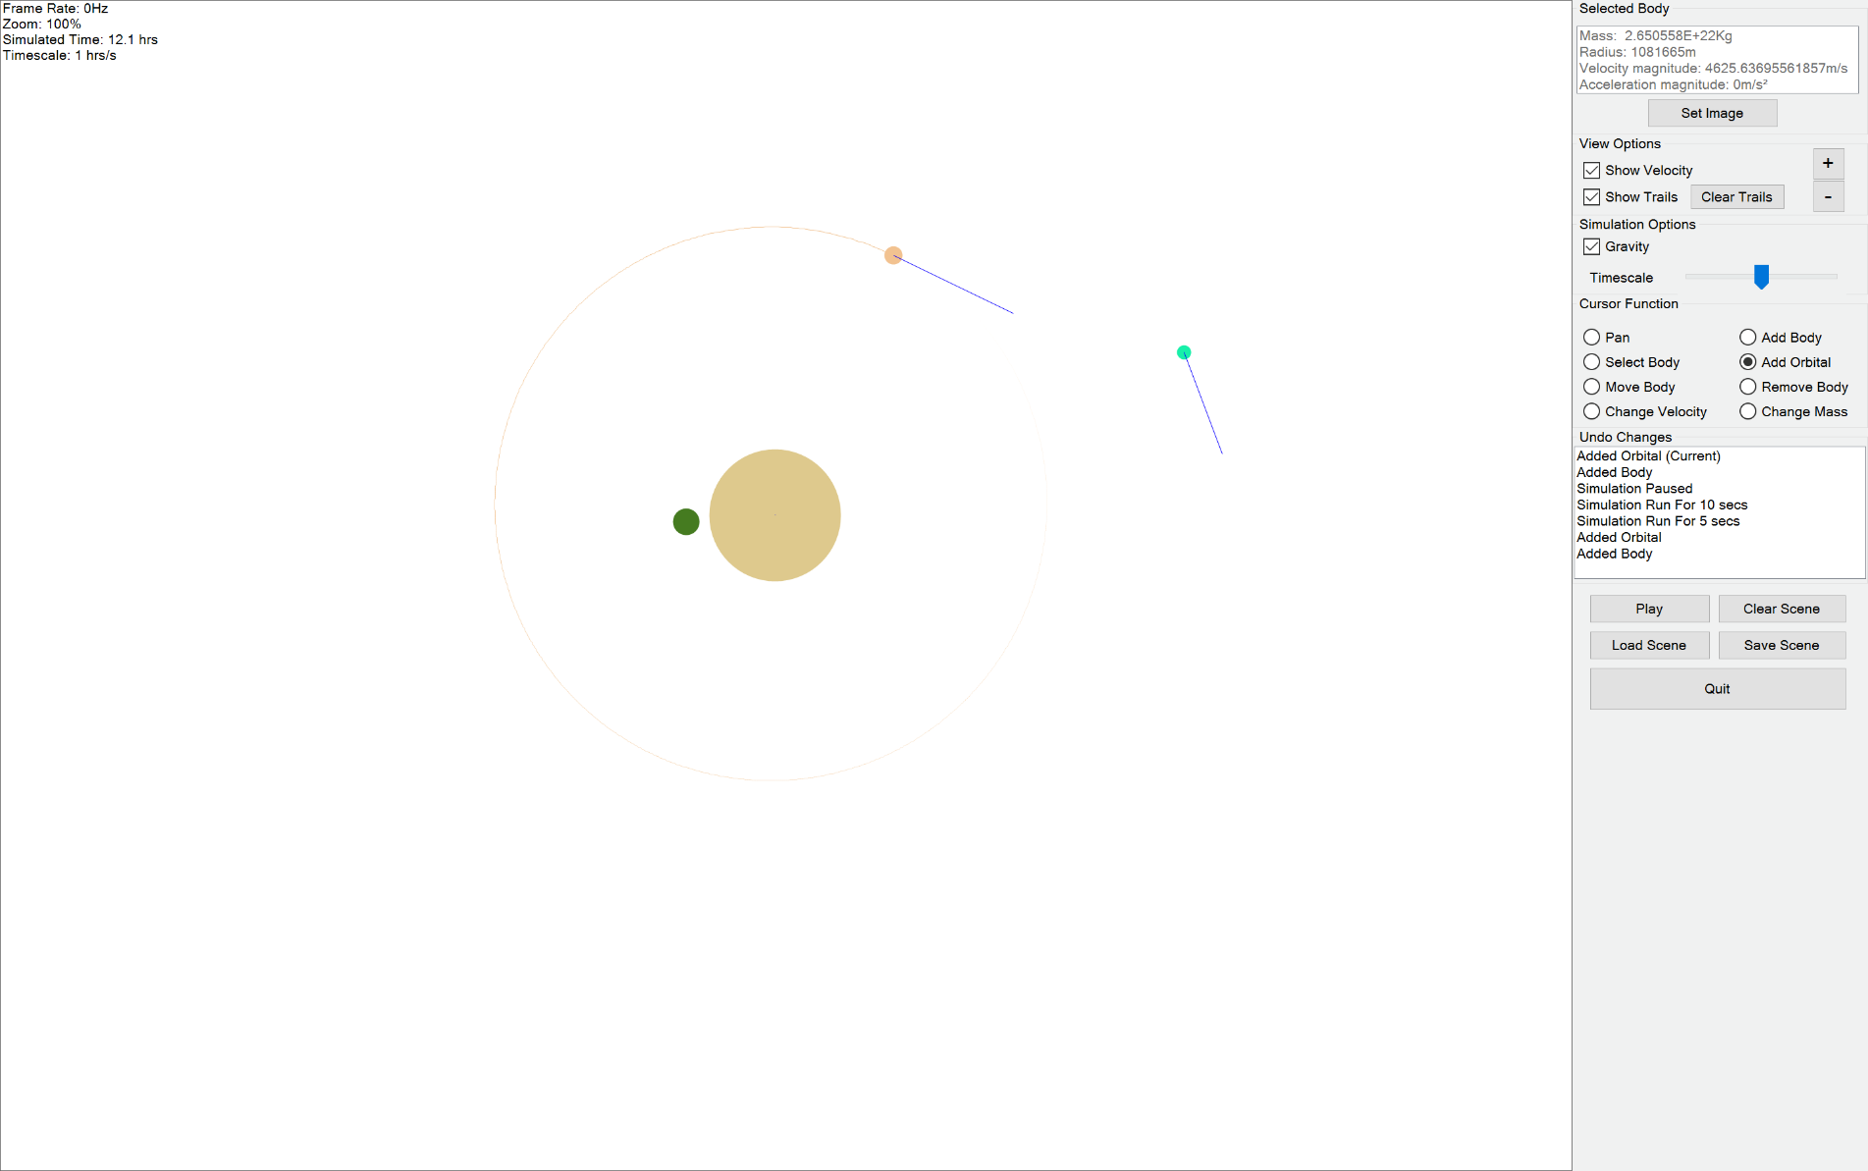
132. 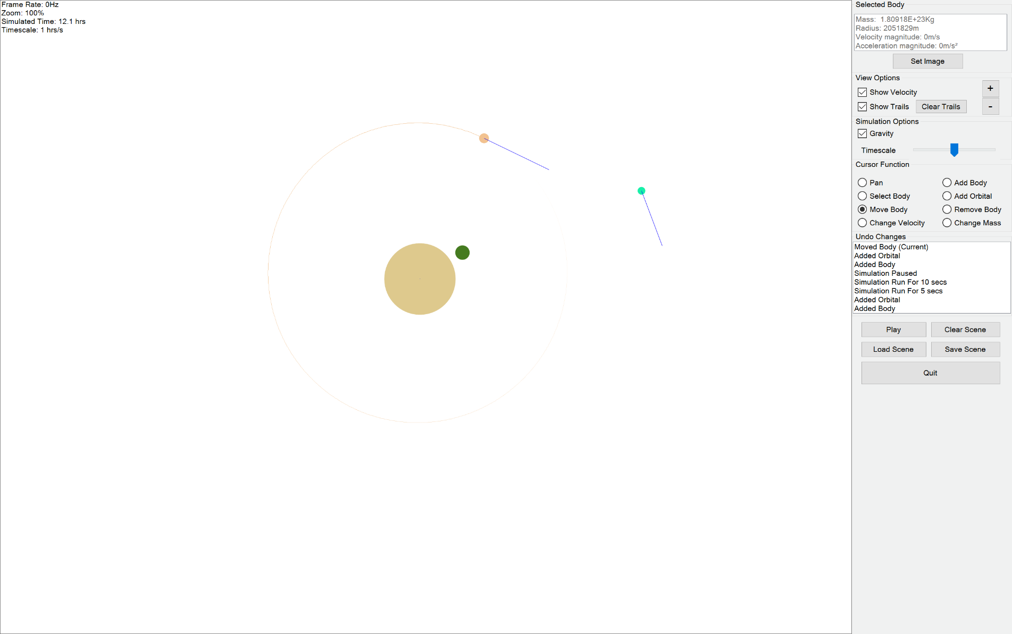
133. 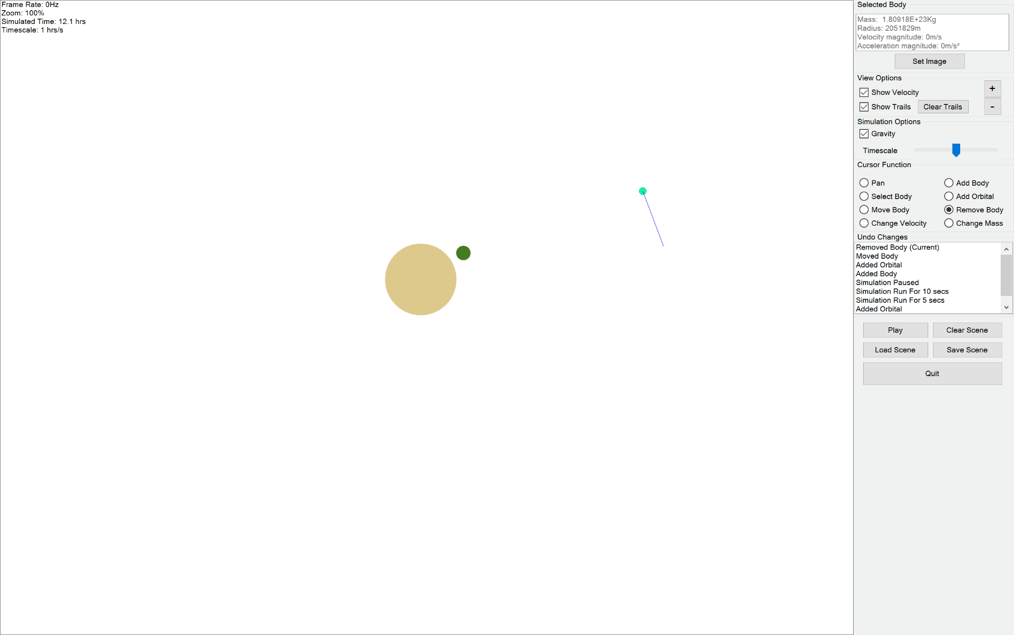
134. 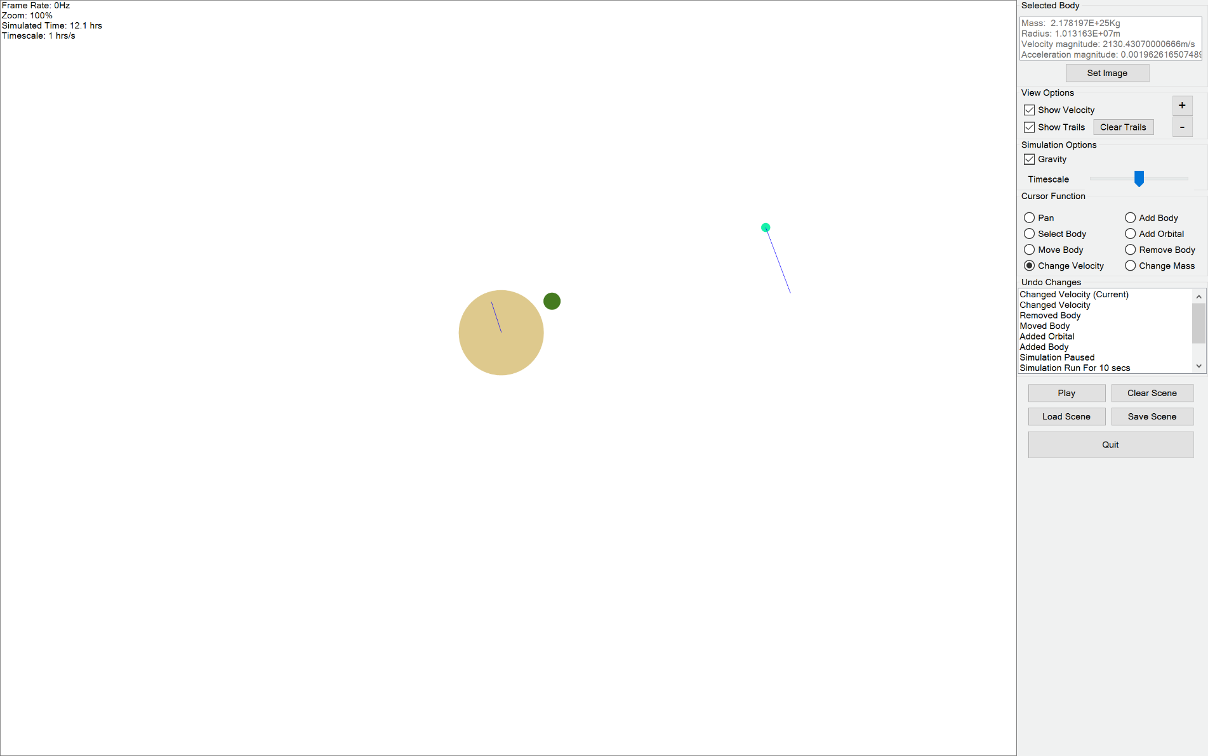
135. 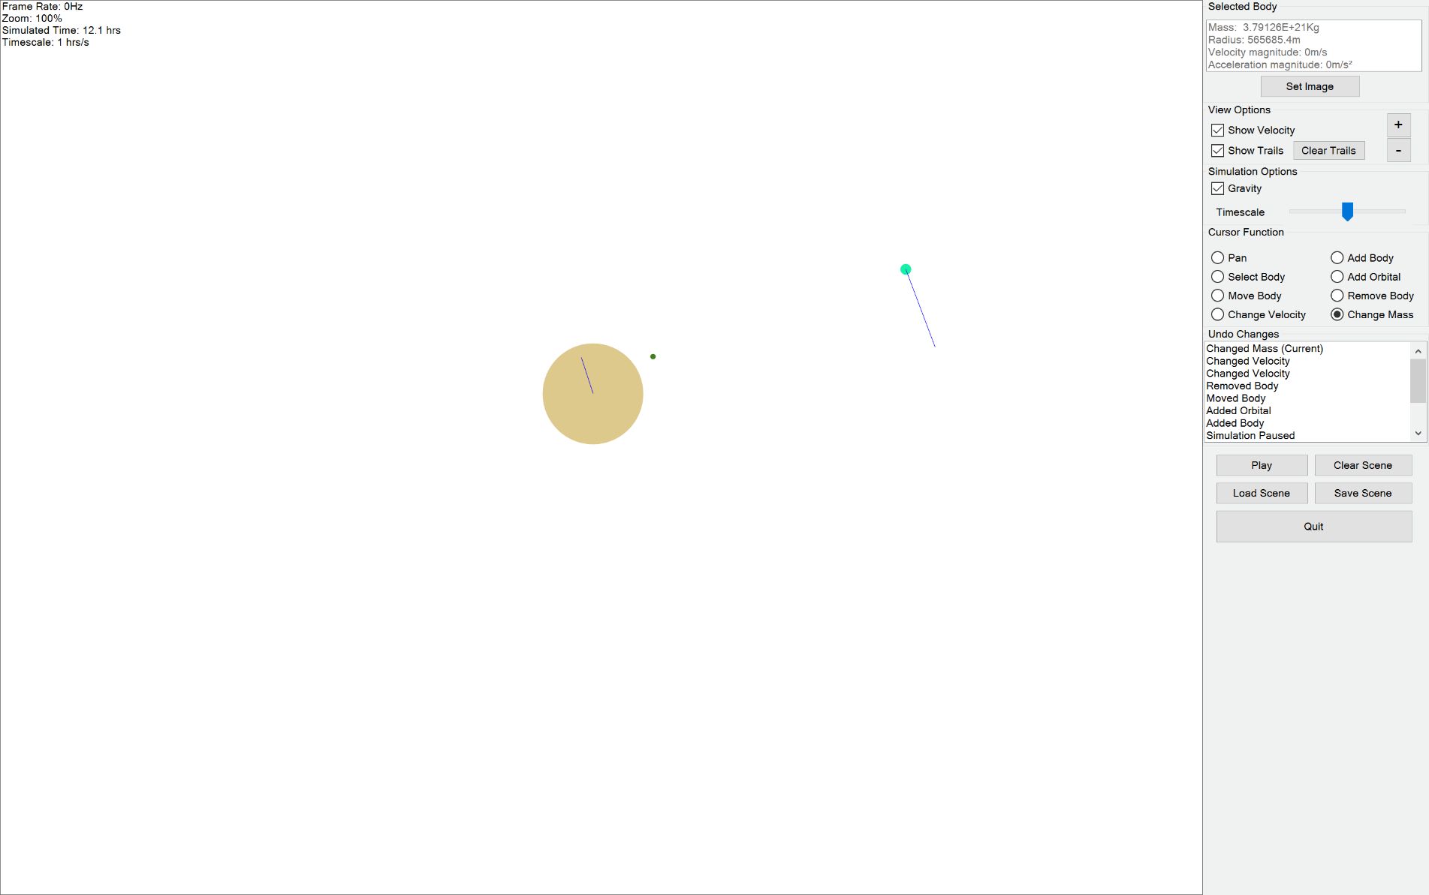
136. 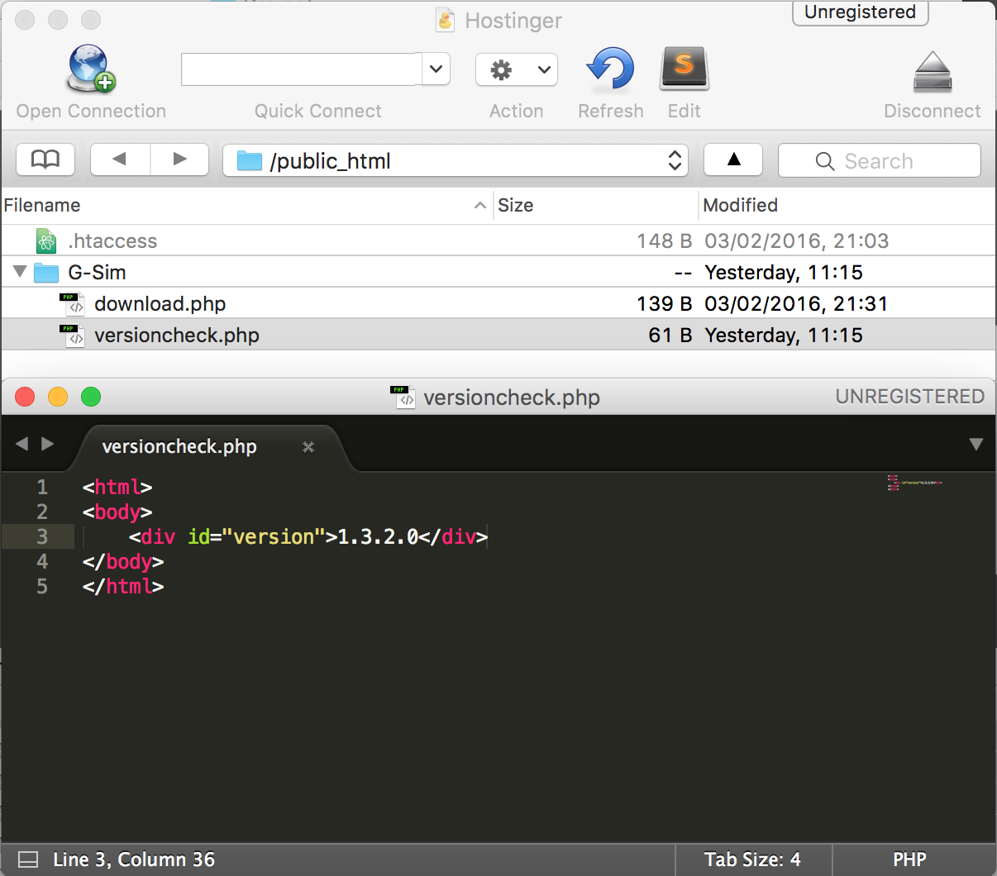
137. 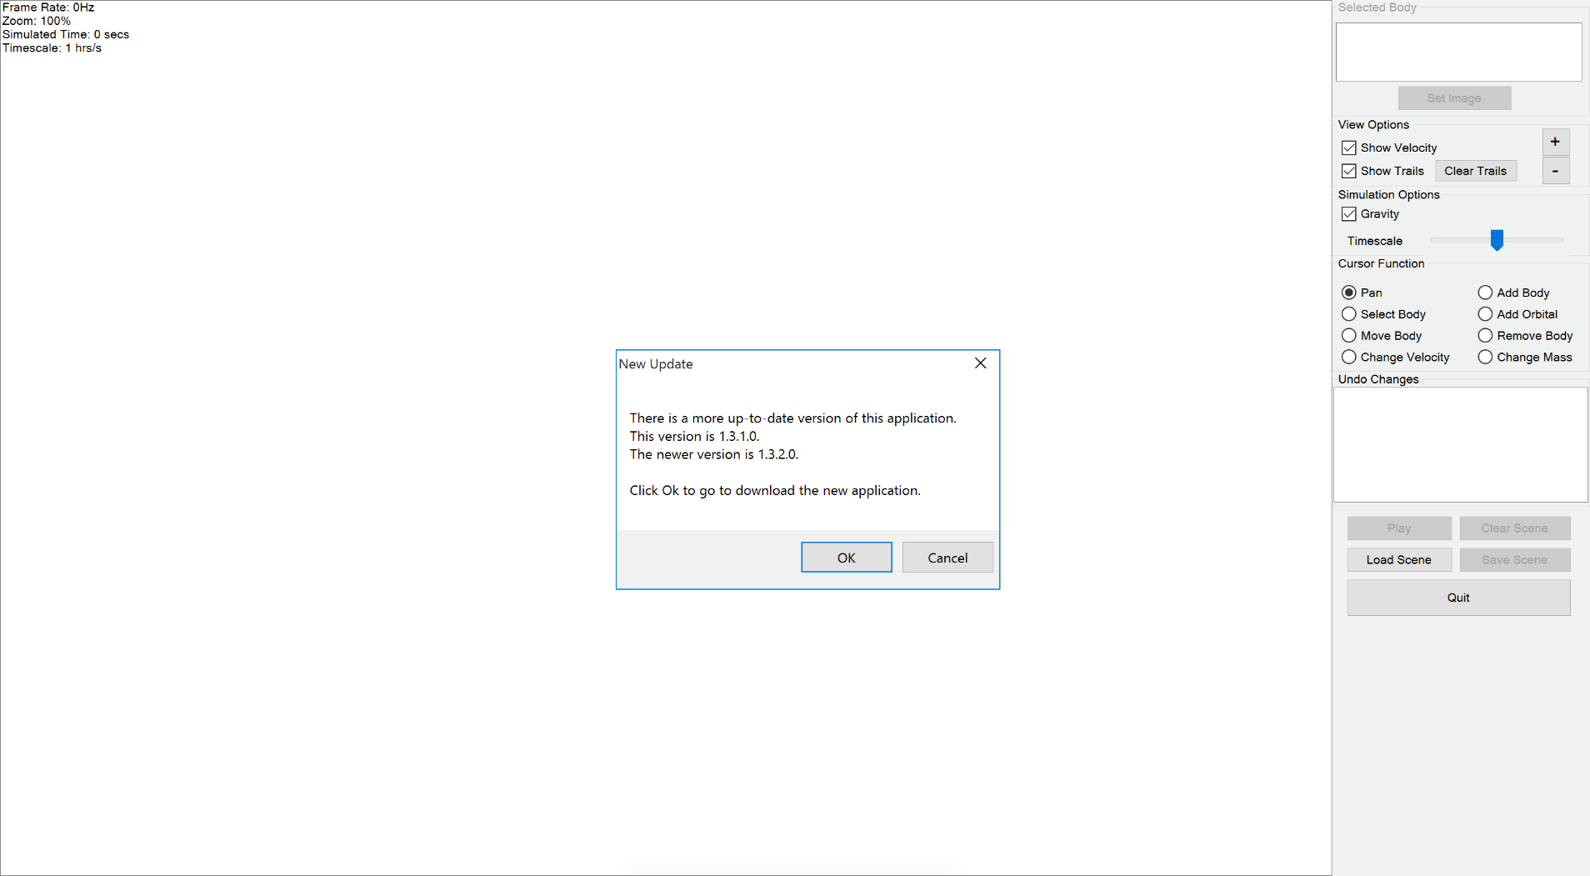
138. 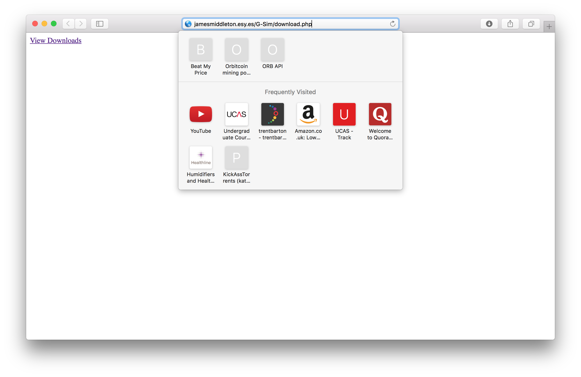
139. 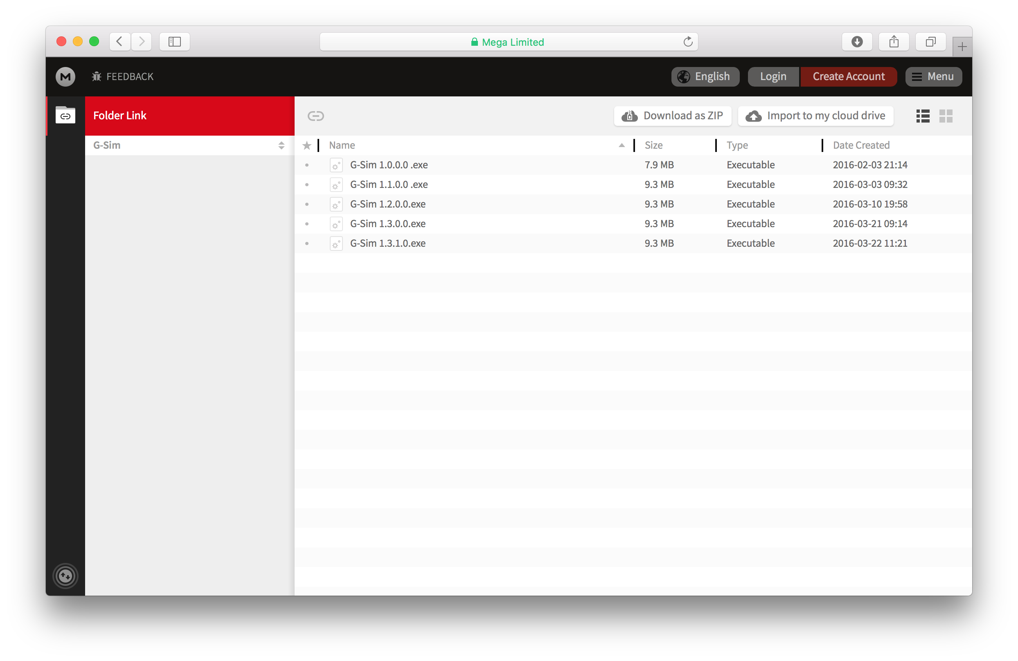
140. 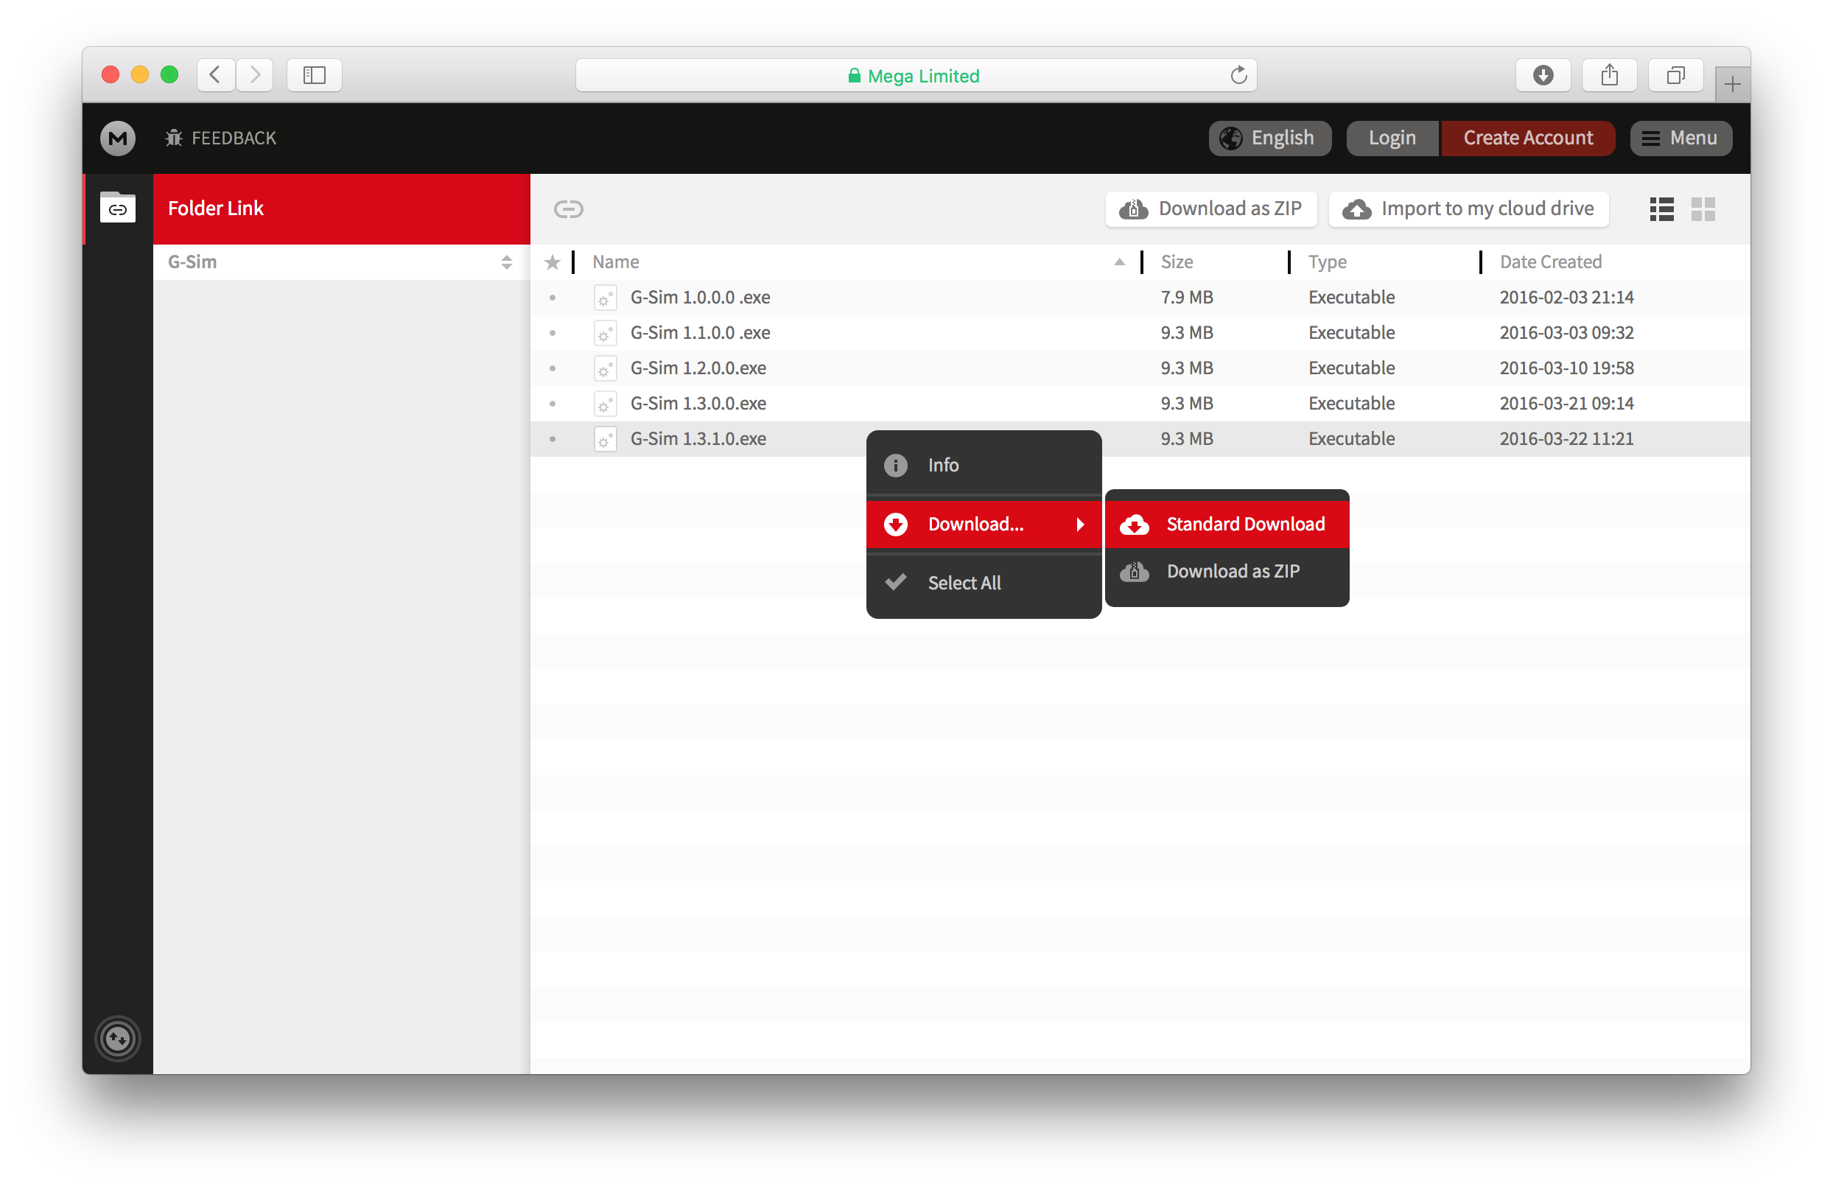

## Appendix 3 - Answers To Usability Questions From Primary User

**What was your initial impression of the program?**

The program looked quite professional and clean – there was not a lot of unnecessary extraneous visualisations to distract the user. The motion of the masses was impressive, particularly the apparently accurate spiralling motion as bodies orbited and eventually coalesced.

**Is the application intuitive for a new user like yourself? Did all of the buttons in the program do what you thought they would do?**

The application seemed perfectly intuitive except for the add body function. The error message that popped up when trying to use the add body function did not give sufficient information for the error to be easily resolved.

**Is there any way that I can improve the look of the program with respect to where things are placed? Are there any other things which you would want changing in the program that you don’t like?**

The placement of the buttons etc. is fine but a user glossary would be useful. Perhaps a simulation using standard values (for the Earth/Sun etc.) could be included so a new user, or person new to the subject, could get a feel for the simulation before being let loose on it.

**Do you feel that the application has all of the necessary features that you need in order to simulate gravitational forces?**

Yes. There does not seem to be any important feature missing.

**Have you encountered any issues during your experience with the application?**

Just the add body problem.

**Do you feel that the application serves its purpose as a teaching aid? Is there any way that I can improve it in this respect?**

I will definitely use the simulation as a teaching aid. I particularly like the velocity information regarding elliptical orbits. It would be best, in my opinion, not to change the user interface too much or clutter up the screen as this would distract from the teaching emphasis.

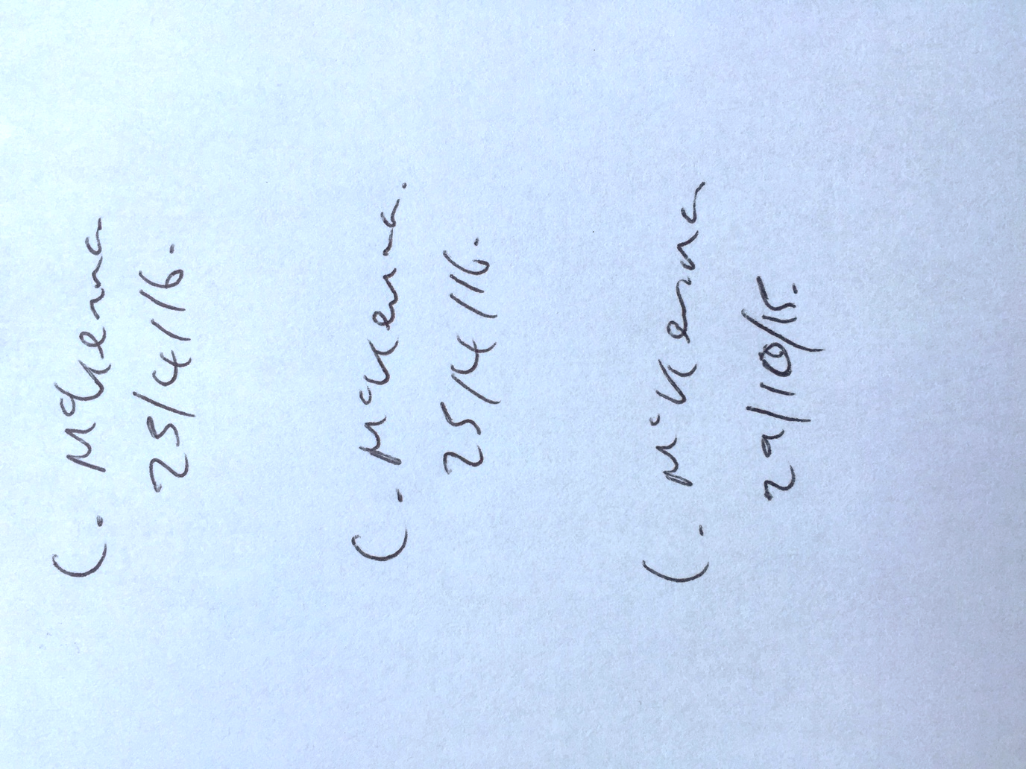

## Appendix 4 - Comparison Of Anti-Aliased Vs Non-AntiAliased Graphics

The code which sets the graphics of the view to be anti-aliased is located inside the application load handler at the beginning of the “Main Form” class. This is the line of code which does this:

|  |
| --- |
| g.Graphics.SmoothingMode = Drawing2D.SmoothingMode.AntiAlias |

To create a comparison, I removed this line to de-anti-alias the graphics. I also made sure that it was exactly the same body which was screenshotted by saving it to file which I then loaded after removing the line.

With anti-aliasing:



Without anti-aliasing:



Although Microsoft Word will slightly anti-alias the images automatically when I enlarge them, the difference is still noticeable. You can see that the edges are jagged when there is no anti-aliasing and smooth with it.

## Appendix 5 - Proof Of Fading Trails Implementation

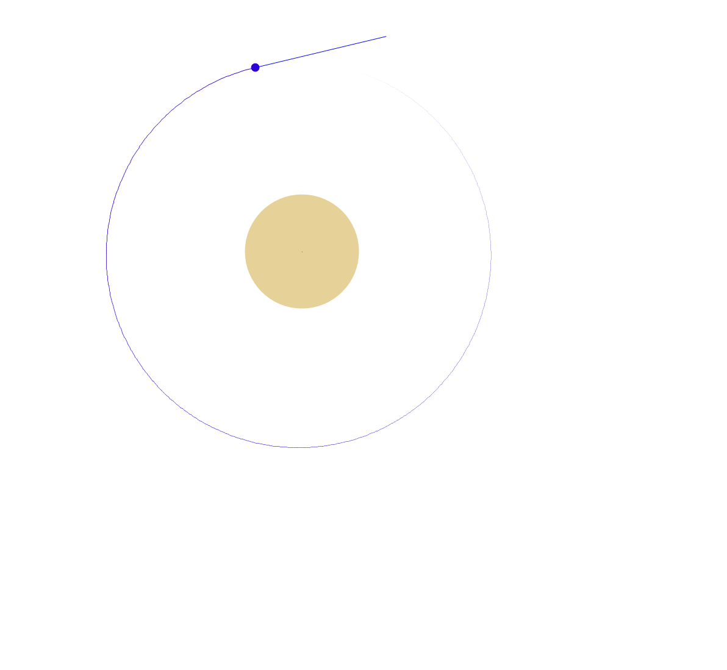

## Appendix 6 - Final Review Of System

**What’s your final view of the project?**

I like it. I think the included features work very well and that the simulation will help to aid learning in class.

**Please rate the following out of 5:**

| Subject | Rating /5 | Notes/Improvements (optional) |
| --- | --- | --- |
| Placement of controls | 4 | The controls have been moved closer together and I understand why now that you have explained about the issue with the projector but I think it should be possible to switch between the two spacings. |
| Ease of use | 4 | It would be nice to have some bodies with pre-loaded properties which can be dragged into the simulation. |
| Use as a teaching aid | 5 |  |
| Information provided by message boxes (i.e. when an error occurs, an update is published or a limit tries to be passed) | 4 | The error message box is pointless (see below). |
| Information provided on the form at all times (e.g. mass, radius, frame rate) | 5 |  |
| Customisation (i.e. show/hide velocity lines/trails, setting images of bodies) | 5 |  |
| The variety of “Cursor Function”s | 5 |  |
| The “Undo Changes” feature | 5 |  |
| File handling features (i.e. save/load scene) | 5 |  |
| Representation of bodies | 5 |  |
| Representation of trails | 5 |  |
| Representation of velocities | 4 | The velocity lines can sometimes become slightly too long so it would be nice to have a slider (like the timescale) which changed the ratio of velocity to velocity line length. |
| The Zoom feature | 5 |  |

**What features (as well as those already mentioned) would you like to see in the future?**

It would be very useful to be able to recover a simulation after an error occurs.

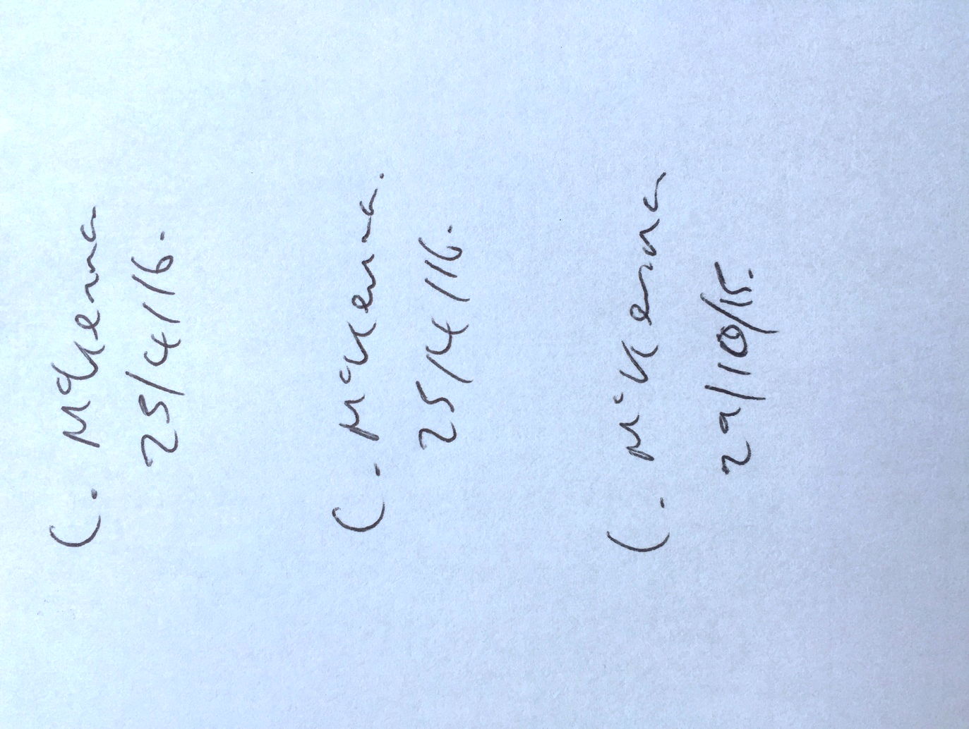

## Appendix 7 - Credits (Endnotes)

1. seenjs.io/demo-gravity.html
2. contland.net23.net/astra/play?n=prototype102
3. portillo.ca/nbody/barnes-hut
4. physics.buffalo.edu/phy410-505/topic5
5. physics.buffalo.edu/phy410-505/topic5
6. msdn.microsoft.com/en-us/library/3a02k5s0
7. stackoverflow.com/questions/6069791/timer-tick-event-in-separate-thread
8. stackoverflow.com/questions/3744032
9. msdn.microsoft.com/en-us/library/system.diagnostics.stopwatch
10. maryor.nl/blog/tabid/268/entryid/24/convert-an-image-to-a-base64-string-and-vice-versa.aspx
11. msdn.microsoft.com/en-us/library/system.single.maxvalue
12. msdn.microsoft.com/en-us/library/system.object.memberwiseclone